**Name: Jayesh Krishnamurthy Naidu**

**ASU ID: 1233830964**

**Date: 01/09/2024**

**Professor: Dinesh Sthapith**

**Subject: IFT 510**

**Module 1: Lab 2 - Exploring Computer Systems Concepts, Computer Architecture and IT System Concepts**

Part 1:

**Objective:** Students will gain an understanding of basic computer system concepts such as CPU, memory, and input/output operations through a simple Python program.

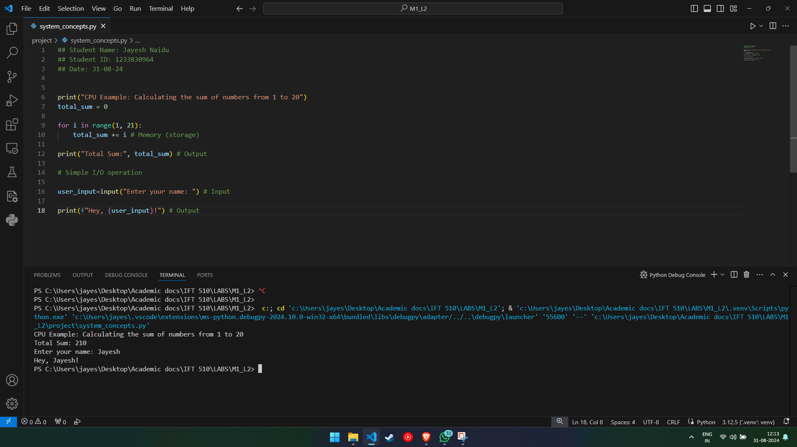

This Python code initially calculates and prints the sum of numbers 1 through 20, demonstrating fundamental arithmetic and memory usage. It then conducts a simple input/output function, inviting the user to provide their name and returning a personalized greeting. The code demonstrates core topics including loops, user input, and string formatting.

Part 2:

**Objective:** Students will explore basic computer architecture concepts, such as how the CPU executes instructions and how memory is accessed, using Python code.

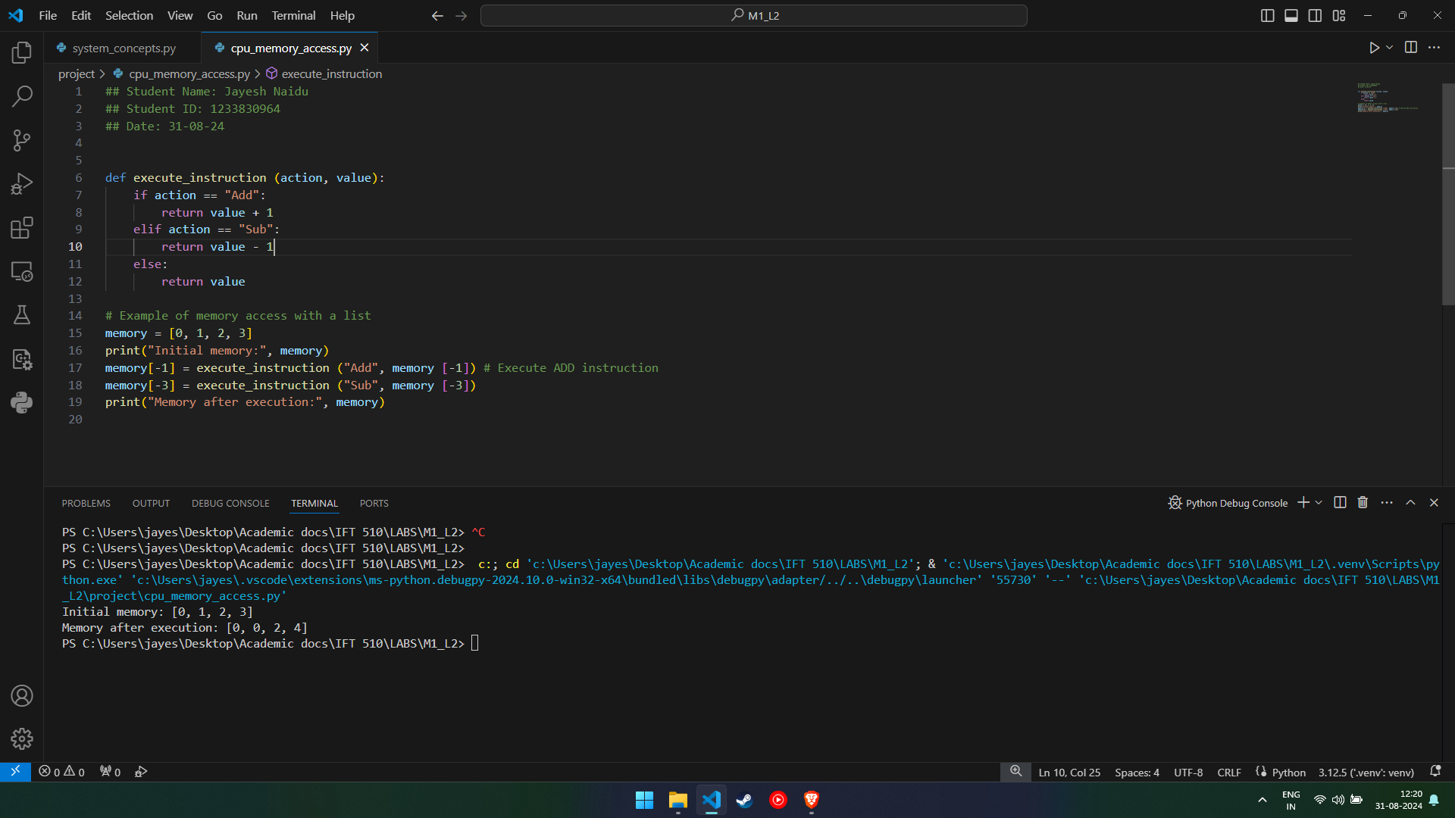

This Python code implements a function 'execute_instruction' that alters a value based on the provided action: it increases the value if the action is "Add", decreases it if the action is "Sub", and leaves it unaltered otherwise. The code then shows how this method can be used to alter a list named'memory'. Initially, the list includes '[0, 1, 2, 3]'. The last element is increased, while the second element is decreased, so the modified list is written as '[0, 0, 2, 4]'.

Part 3:

**Objective:** Students will explore IT system concepts, such as networking and system communication, using simple Python code.

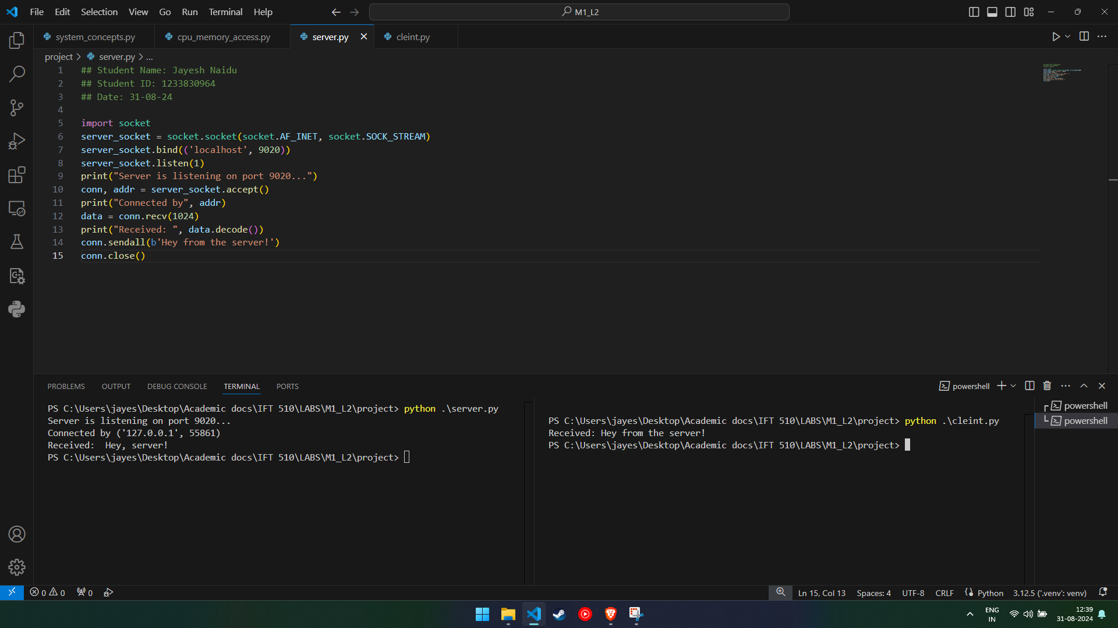

The code establishes a client-server connection where the server listens for incoming connections on port 9020. The client initiates communication by creating a socket and connecting to the server through the same port. Upon successful connection, the server acknowledges by sending a confirmation message, such as “Connected by (127.0.0.1, 55861)”. The client then sends messages to the server, which the server displays. The communication continues until either party decides to close the connection, at which point both sockets are properly closed, ending the session.

Part 4:

**Objective:** Students will relate the concepts learned in the previous sections to real-world computer systems by modifying the Python code examples.

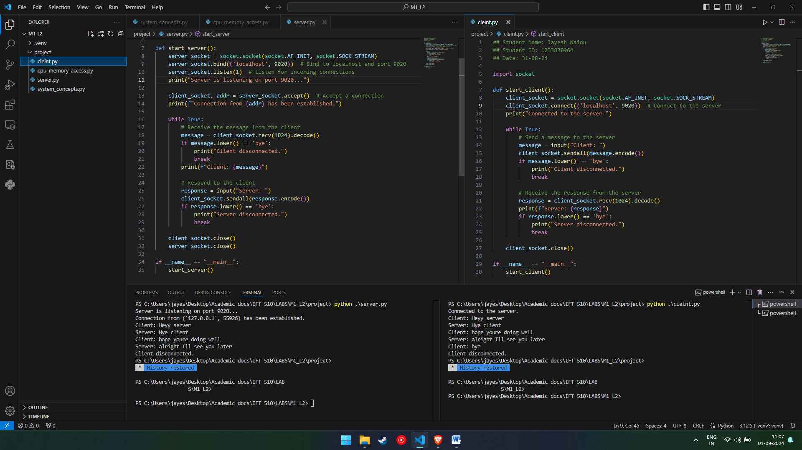

The client-server code depicts a basic chat system in which the server waits for a connection from the client. Once connected, the client and server can communicate in real time. The conversation loops until either side sends the message "bye," which closes the connection and ends the session. This arrangement represents a simple, interactive client-server communication architecture.