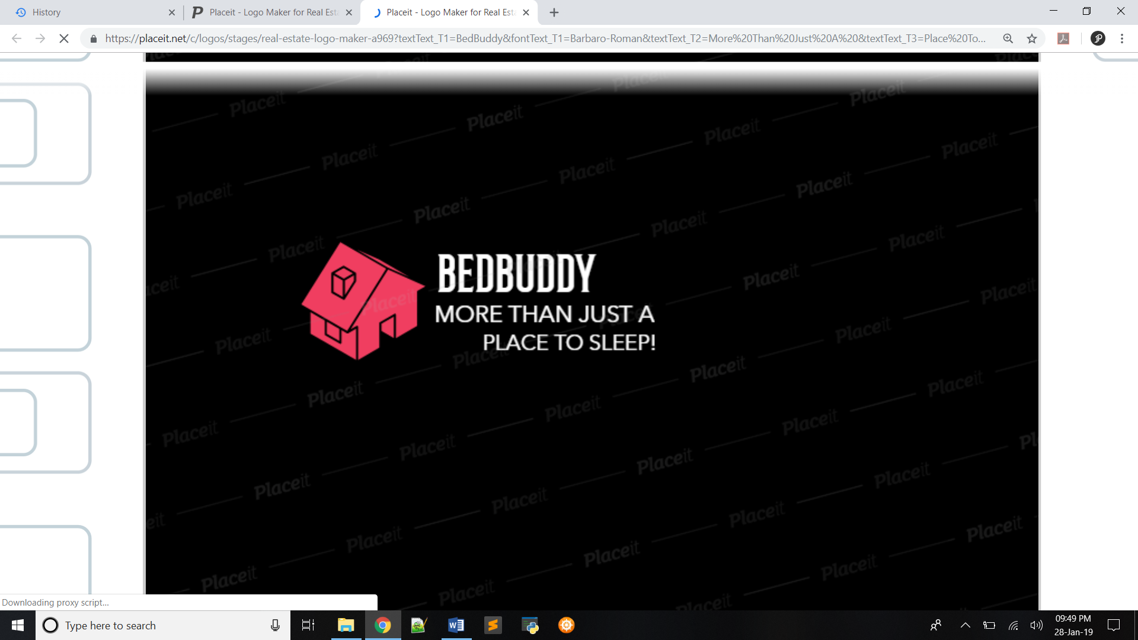

**Home**

Address

Contact Number

LOGO

Authorities

Contact

Rules

Gallery

Activities

Facilities

About Us

Home

A place where we learn lot of things,

And how to conduct ourselves.

We are not alone or lonely,

More students to give company and love.

Far away from parents,

Feel home sick,

Nothing to be worried of.

Don’t understand anything,

The teachers will help.

Make us study well,

and learn

How to stand on our own legs.

It is a home away from home.

~ Ben Lerner



**About Us**

Authorities

Contact

Rules

Gallery

Activities

Facilities

About Us

Home

**About Us**

The AYKA Foundation campus on the Mumbai Goa Road is rapidly emerging as one of the most sought educational campus in the Maharashtra. In view of this the Institute has large number of students coming from various parts of the country. The hostel facilities at the campus are built tastefully to satisfy the personal aspiration of the residents and our first hostel in Pune was estabilished in 1989.

**Our Mission**

” Secure, hygienic and cozy.” Our main motto is to deliver efficient services and a cozy ambiance guarded with professional security and surveillance round the clock, to ensure your peace of mind, comfortable living and study environment to the residents. Our Mission to offer home-like accommodation to students who live away from their homes. We believe, however good and expensive the school/college education may be, good living conditions are very relevant for the development of the students into enlightened citizens for the future of the country. In one earnest effort to provide the best in quality, we have sought to facilitate our residents with comfort and convenience. We try our best to live up to our “More Than Just A Place To Sleep!” tag by organizing sport fests, planning fun events and by celebrating festivals with full spirit and thus keeping the “JOSH” high. Our management team is always at your service, to resolve all your issues or for your general assistance during your stay with us.

**Our Vision**

” A home away from home” When you are away from home, it is comforting to know that the warmest and friendliest of welcome awaits you at a strategically located home in Mumbai. Also we aim to rise standards of hostel accommodation in the city.

Image With Position fixed placed which will not move while scrolling the page

**Rules**

Authorities

Contact

Rules

Gallery

Activities

Facilities

About Us

Home

**RULES AND DISCIPLINE**

* Student residing in the flat shall strictly observe all the Rules and Regulations in force from time to time. Breach of rules / regulations may invite rustication / fine.
* Smoking, consumption of alcoholic drinks, drugs, spitting and MALE /FEMALE FRIENDS are strictly prohibited in the flat premises. Strict action will be taken against defaulter (as per rule).
* No guest or visitor of the inmate will be permitted to visit the premises.
* Every student shall be in his / room by 10.30 p.m. Students, the deadline for entering the premises are 10.00 pm. If he / she have to stay out after the said timing owing to any special reason, he / she must obtain prior permission from the Administrator and Parents. The application for leave of absence from the hostel shall be made in writing. Late entry will be permitted only through permission form  & call from parents.
* Every case of illness and accident must be reported immediately to Host of premises.
* Charges for any damages to the property as well as to the furniture and fixtures caused by student/students negligence will be recovered from the student/students staying in the said premises.
* If any student is found misbehaving and misconducting himself, he/she will be expelled from the Accommodation immediately and the fees paid by him / her will be forfeited.
* Permission for night outs (only for local guardian and parent’s house) should be taken from administrator and the call by parents should be made before 8.30pm.
* Room is required to be vacated with luggage in every summer vacation.
* Ragging is strictly prohibited inside the premises.



**Amenities and Facilities**

Authorities

Contact

Rules

Gallery

Activities

Facilities

About Us

Home

***Facilities:***

Centralized Air Condition for your Comfort

24 x 7 High Speed Internet to stay connected with the World

TV with D2H for your movies and entertainment

Projection Room

Gym with Trainer to stay fit

Indoor games for Recreation

Purified Water

Round the clock security

Housekeeping

Laundromat

Daily Newspaper

Hot Water

**Activities**

Sports training programmes, for all games, through the season!

**Our Mission:**

Our hostel has been promoting and encouraging students to take part in sports and games ever since it was founded in 2007. The endeavour of the Sports Academy is to provide state-of-the-art sports and recreational facilities to students, and to provide the best possible coaching and mentoring to them.

It is a proven fact that schools that promote sports also do well academically. Students, who excel at academics, therefore, need sports – at the recreational or at the competitive level – to open up their minds to new possibilities and to face the challenges that life throws at them. The concept of ‘healthy mind in a healthy body’ is more than an adage, it is a way of life!

Sport is a year-round programme for us, A lot of effort goes into devising programmes in cricket, football, basketball, volleyball etc., besides dancing, music, trekking etc. The school teams are entered in MSSA and DSO tournaments, while class teams play intra-school competitions.

Finally, our institutions have always been known for their excellence in academics. Very soon, these institutions will also be known for churning out well mannered, highly motivated and confident youngsters, ready to take on the challenges thrown at them.

Would you not like your child to be in that group?

**Activities Conducted:**

* Athletics
* Hockey
* Badminton
* Cricket
* Chess
* Skating
* Football
* Throwball
* Table-Tennis
* Basketball
* Kabaddi
* Taekwondo
* Volleyball
* Gymnastics
* Fine Arts

**Program Highlights:**

July: We conduct Monsoon trekking

August: We arranges Picnics for 5th to 10th standards students. One day picnic at Karjat Dursheet, Vangani, Kondana Caves, etc. Participates near about 600 students.

**Contact**

Google Map Link

How to reach us from the nearest airport/station

Address

Contact Number