1. UREA :

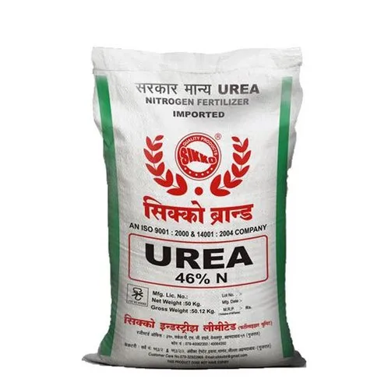

Dear Farmking,

According to your soil analysis and crop type the best suited fertilizer is **UREA.**

Urea is the most important nitrogenous fertilizer in the market, with the highest Nitrogen content.

* Urea should be applied at the time of sowing. It should not come in contact with the seeds. It also can be applied as a top dressing.
* Since Urea is highly Nitrogen-concentrated, it should be used in combination with earth or sand before its application.
* Urea should not be applied when the soil contains free water or likely to remain wet for three or four days after application.

Urea can easily be blended with Mono-ammonium Phosphate (MAP) or Di-ammonium Phosphate (DAP). However, Urea must not be mixed with any superphosphate unless applied immediately after blending as Urea reacts with superphosphate liberating water molecules. This will produce a damp material that is hard to store and apply.

**Advantages of Urea Fertilizer**

* Superior Nitrogen content
* Low production cost, as source is natural
* Non-flammable and risk-free storage
* Wide application range, for all types of crops and soils
* Neutral pH and harmless to crops and soil

1. **DAP**

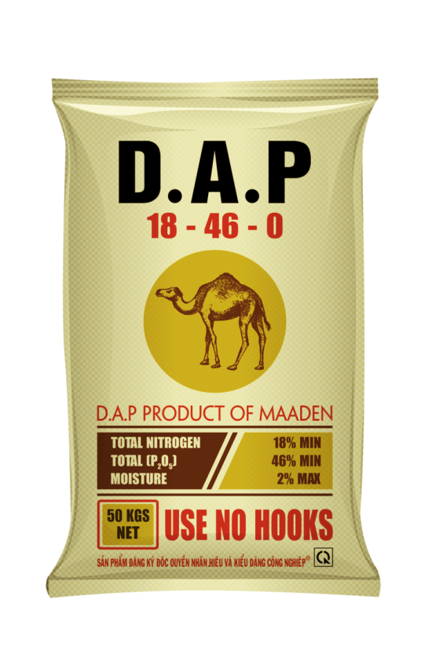

Dear Farmking,

According to your soil analysis and crop type the best suited fertilizer is **DAP.**

Di-ammonium Phosphate popularly known as DAP is a preferred fertilizer in India because it contains both Nitrogen and Phosphorus which are primary macro-nutrients and part of 18 essential plant nutrients.

* **Soil Testing:** For efficient use of this fertilizer, soil must be tested for nitrogen and phosphorus content in order to determine the required amount of DAP.
* **Basal Dose:** DAP is the best suited fertilizer for basal dose as through this we can apply full dose of phosphorus and one-third to half dose of nitrogen. Remaining dosage of nitrogen can be applied through splits of urea at other stages of crop . So DAP gives the best combination with urea fertilizer. DAP is also the best fertilizer for pulses where less nitrogen and higher phosphorus is needed as starter dose.
* **Placement of DAP:** Since phosphorus is immobile in soil, its source (DAP) should be placed at a distance where plant roots can easily reach. Improper application of DAP may cause seedling injury due to release of ammonia. DAP should be placed below seed, slightly to one side.
* **Soil Amendments:**Nitrogen as well as phosphorus, give best results in neutral soils. But in case of alkaline, volatilization losses of ammonia are higher. So nitrogen use efficiency is reduced. Similarly excessive presence of calcium in alkaline soils, makes complexes with phosphorus and ultimately results in poor phosphorus recovery. So bringing soil pH to neutral by adding gypsum and leaching can only improve N and P use efficiency of DAP.

1. 17-17-17

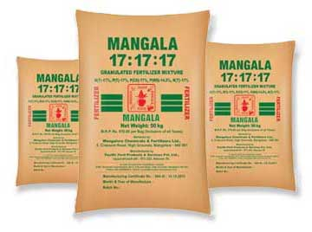

Dear Farmking,

According to your soil analysis and crop type the best suited fertilizer is **17-17-17.**

In short, 17 17 17 is a balanced fertilizer (potash) used for many plants, grasses, and shrubs. There are other similar fertilizers, like fertilizer with npk 15 15 15, but if you need slightly higher mineral concentrations, use triple 17.

Once your soil test has concluded that the soil needs balanced fertilizer, it’s time to apply 17 17 17.

However, if your plant lacks some nutrients, you can add other soil amendments like foliar fertilizers alongside the triple 17 fertilizer.

There are two methods to apply this fertilizer to the soil.

The first method includes using granular fertilizer (triple 17) and water. The amount of water you should add is written on the packaging (product specifications). Mix 17 17 17 with water, fill a spray bottle with the mixture, and spray the soil. If the plants you want to fertilize are in raised beds or containers, use a garden hose to apply the triple 17.

The second method involves using triple 17 in crystal form.

You can add slow-release crystals in two ways:

1. Add crystals to the surrounding topsoil of the plant.

2. Mix crystals with the soil before planting.

When adding triple 17 granules (compound fertilizers npk 17 17 17) to the soil, make sure you spread them evenly.

The frequency of application depends on the type of triple 17 fertilizer you intend to use.

If you use a water-soluble fertilizer, you can apply it during the growing season.

1. 20-20

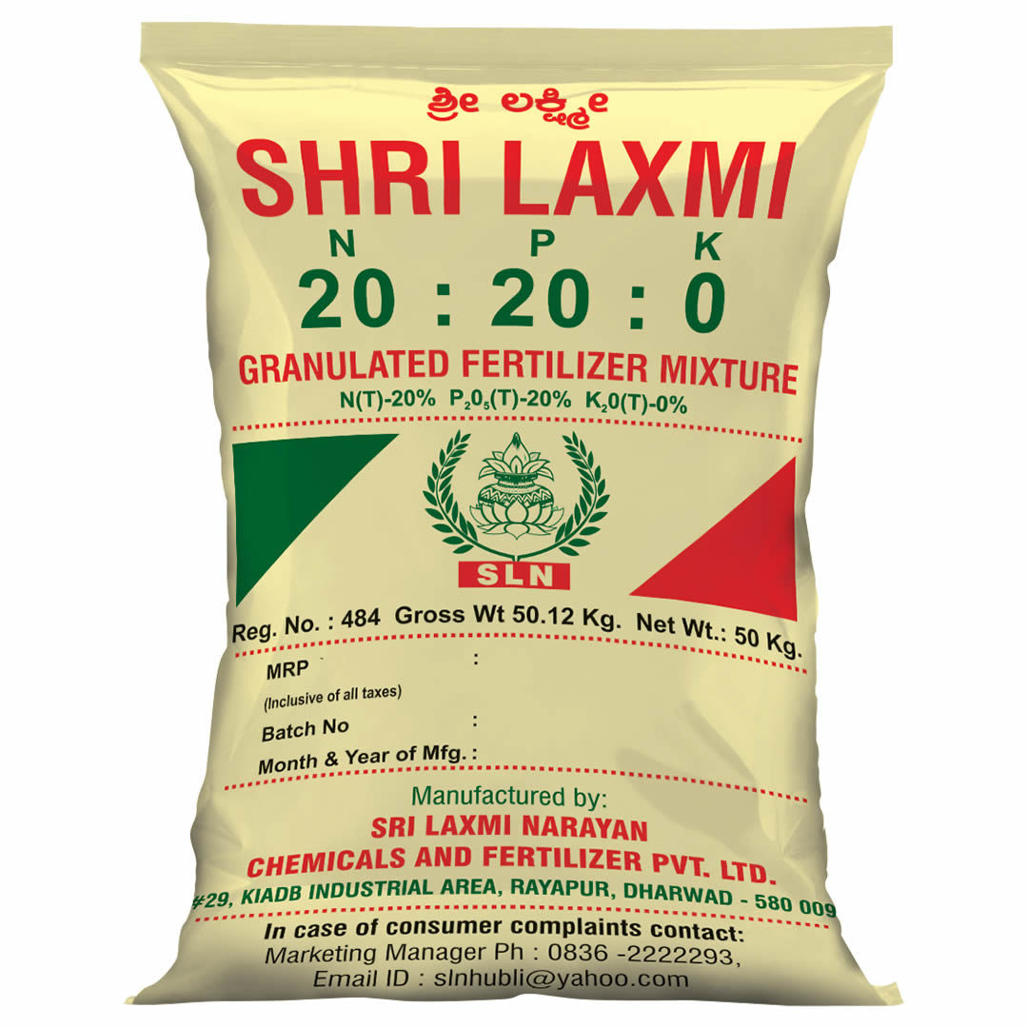

Dear Farmking,

According to your soil analysis and crop type the best suited fertilizer is **20-20.**

The 20-20-20 fertilizer is an all-purpose mix that works well for nearly everything that has green leaves and grows in the dirt. The number signifies that the fertilizer product contains 20% of all [three major nutrients](https://theyardandgarden.com/triple-20-20-20-fertilizer/) needed by plants (nitrogen, phosphorous, and potassium).

Using 20-20-20 fertilizer every week or using it every month or two (depending on the product) is a safe way to make sure that your plants are healthy and thriving (even when you haven’t done such a great job with keeping your soil maintained).

**20-20-20 Fertilizer: How To Use**

To use 20-20-20 fertilizer, simply:

1. Read the manufactures instructions (find out how many teaspoons per measurement of water is needed).
2. Carefully mix the proper number of teaspoons into the correct amount of water.
3. Mix the ingredients together thoroughly.
4. Pour the water into your water can.
5. Apply the mixture straight to the soil/root zone of your plants.

### **Benefits of 20-20-20 Fertilizer**

The benefits of using a 20-20-20 type fertilizer are fairly straightforward:

* 20-20-20 blends are well balanced and provide universal nutrients to plants.
* They help your plants thrive and may increase yield size as well.
* They aren’t species-specific, so you can use them on almost everything.
* Plants uptake more water and nutrients because they are healthier in general.
* They are natural and organic (if you buy certain types of 20-20-20 products).

5.28-28

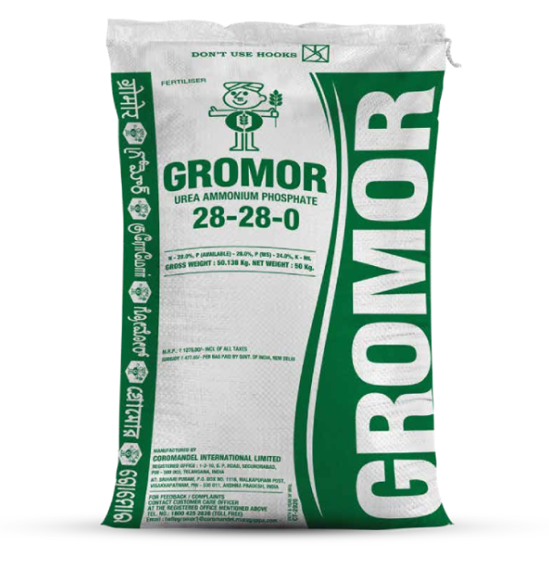

Dear Farmking,

According to your soil analysis and crop type the best suited fertilizer is **28-28.**

* This is the highest Nitrogen containing complex fertiliser with 28%.
* Nitrogen in two different forms through longer period of time. 19% of Nitrogen is in Urea form and 9% is in Ammoniacal form.
* 25.2% out of 28% Phosphate is in water soluble form and easily available to plants.
* Ammonium Phosphate is coated over Urea prill, due to which the losses from Urea will be minimised.
* Unique grade offered exclusively by Coromandel.
* Complex with highest N & P in 1:1 ratio.
* Unique granulation by coating prilled urea with Ammonium Phosphate layer.
* Such granule configuration ensures efficient utilisation of nutrients.
* Highly suitable for Paddy & Wheat.
* GROMOR 28-28-0 is complex fertiliser containing two major nutrients viz. Nitrogen and Phosphorus.
* This is the highest Nitrogen containing Complex fertiliser with 28%. 19% of Nitrogen is in Urea form and 9% is in Ammonical form.
* Ammonium Phosphate is coated over Urea prill, due to which the losses from Urea will be minimized.
* 25.2% out of 28% Phosphate is in water soluble form and easily available to plants.
* It does not contain any filler and it has 100% nutrient containing material having secondary and micronutrients such as Sulphur, Calcium and Iron.
* It is an ideal complex fertiliser for all crops for basal application.
* It gives instantaneous and prolonged greenness.
* It is most suitable fertiliser for crops like Paddy, Cotton, Chillies, Sugarcane and Vegetables etc.

Dosage and Application (kg per acre)

It is the most suitable fertiliser for crops like Paddy, Cotton, Chillies, Sugarcane, Vegetables etc. Kharif Paddy: 75-85 kg, Rabi paddy: 90-100 kg, Cotton: 175-200 kg, Chilly: 85-100 kg, Vegetables: 100-200 kg.

6.14-35-14

Dear Farmking,

According to your soil analysis and crop type the best suited fertilizer is **14-35-14.**

14-35-14 is a complex fertiliser containing all major nutrients viz. Nitrogen, Phosphorous and Potassium. High in Phosphorous content (35%). The only complex having highest total nutrient content among the NPK complex fertilisers. (Total nutrients are 63%). N&P are available in 1:2. 5 ratio as in the case of DAP. But GROMOR 14-35-14 has 14% of Potassium additionally. It is the highest Phosphate (35%) containing complex compared to any other NPK complexes. Entire Nitrogen is available in Ammonical form. 29% out of 35% Phosphate and entire Potash is available in water-soluble form and therefore, easily available to crops. The NPK ratio 1:2. 5:1 is a scientific combination for basal application to all crops and all the nutrients are chemically combined and interaction is synergic. It does not contain any filler and it has 100% nutrient containing material having secondary and micro-nutrients such as Sulphur, Calcium, Magnesium and Iron. GROMOR 14-35-14 is a suitable complex for all soils since it is neutral in nature and does not leave any acidity or alkalinity in soil. It is an ideal and suitable complex for all crops for basal application. GROMOR 14-35-14 is an ideal complex particularly for Rice, Cotton, groundnut, chillies, Soya bean, Potato and other commercial crops which require high Phosphate initially.

However for chlorine sensitive crops like tobacco and grapes, application of 14-35-14 is not advisable.

1. 10-26-26

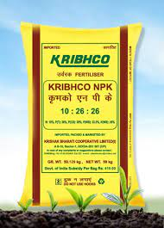

Dear Farmking,

According to your soil analysis and crop type the best suited fertilizer is **10-26-26.**

### **Traits:**

* Contains Nitrogen(10%), P2O5(26%) and K2O(26%)
* Granules are uniform and between 1mm and 4 mm size
* It has good storage properties.
* All major nutrients NPK are present in a single product.
* Improves bearing of flowers and fruits, and improves quality
* High concentration of nutrients makes packing, storage and transport cost cheaper.

### **Recommendations :**

* Suitable for all crops both for initial application and top dressing
* Application is recommended in split doses for better use efficiency