Containerization Assignment
Q4

Create dockerfile to install Nginx and Edit the index.html to Show hostname.
Create Docker image and push to GCR.
Open console of Google Kubernetes Engine
Create cluster

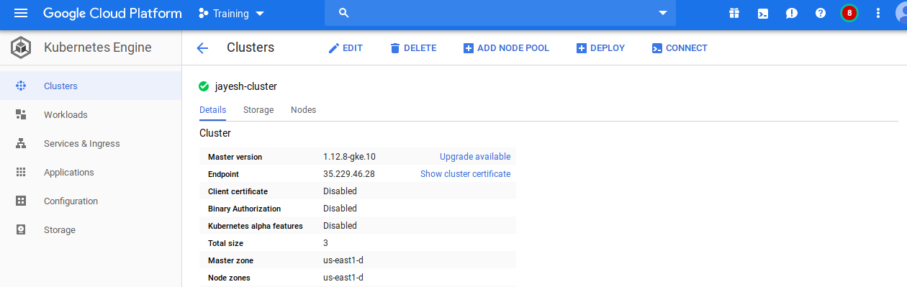
Go to Workloads tab
Clickon on Deploy, select image from GCR and Choose cluster.
Using action ->expose the Load balncer, Cluster IP, NodePort services.
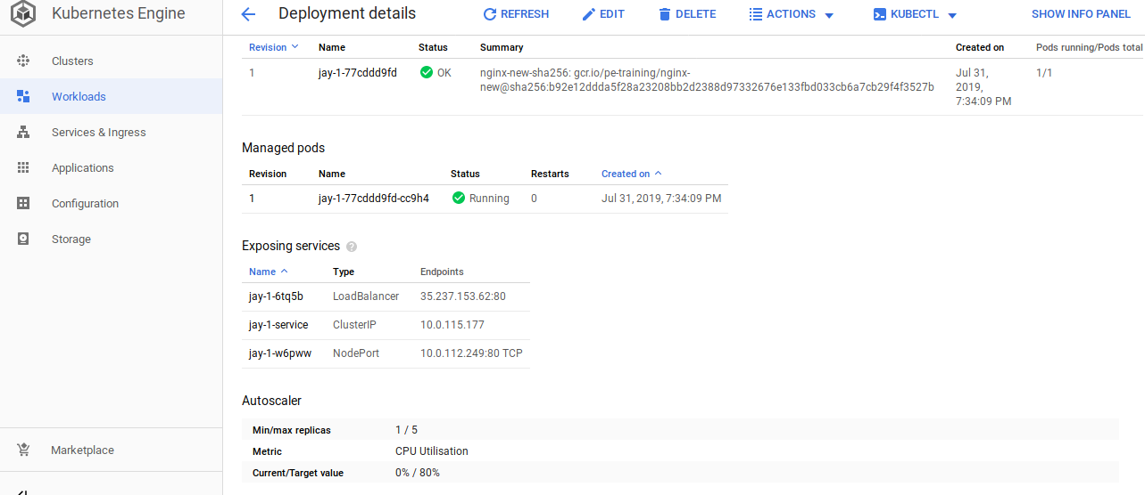
Open the Load Balncrers Endpoint in Browser.

