**Deploy a website on an EC2 instance and configure it using Route53 with our domain name (jayeshchaudhari.tech)**

* **Pre-requisites:**
* Amazon Web Service Account
* GitHub Account
* Domain
* **Steps to creating the infrastructure in this pipeline/module**
* Creating and launching an EC2 Instance with AMI – Amazon Linux 2
* Installing GIT, httpd and related repos
* Creating EIP for launching the output of the project statically
* Configuring Route53 using Domain name
* **Procedure**
* First launch an EC2 Instance with Amazon Linux – 2 Ami
* Allow SSH, HTTP, HTTPS ports from security group

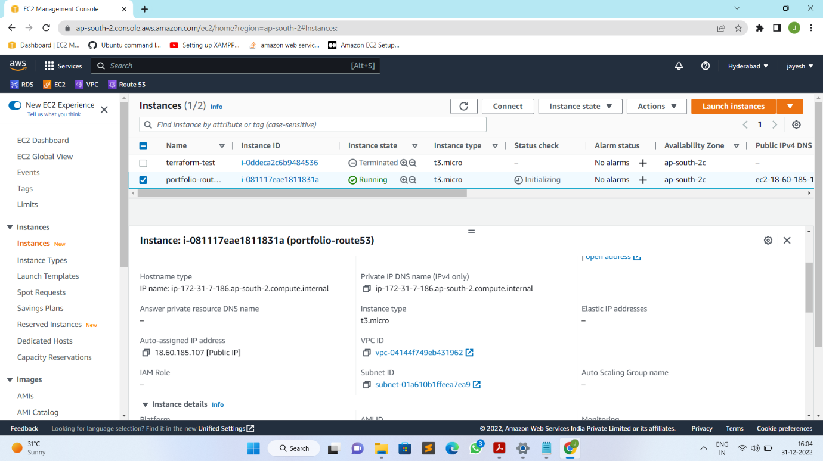

* Connect with instance through Terminal using SSH
* ssh -I jc.pem ec2-user@ 18.60.185.107

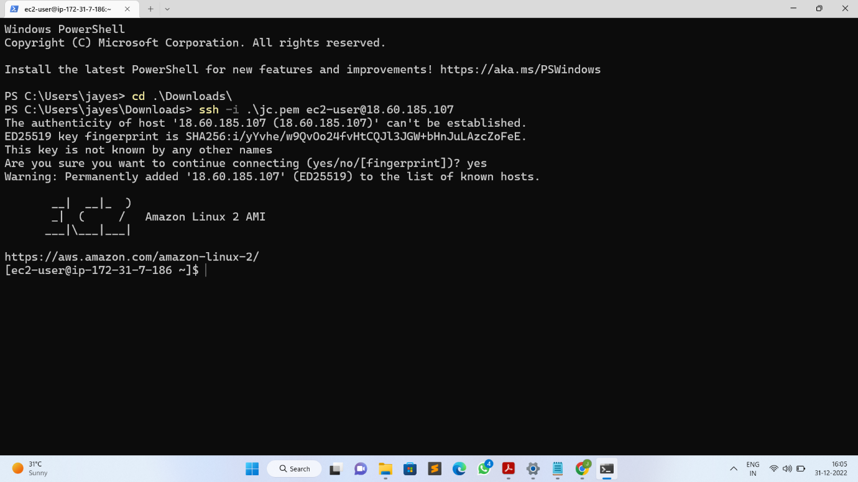

* Install git using below command:
* sudo yum -y install git

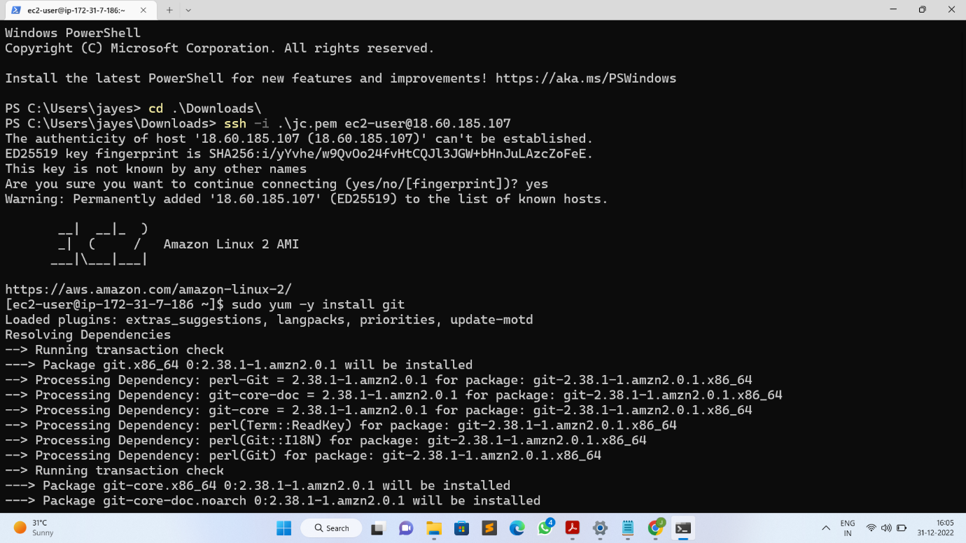

* After installation check for git version by below command:
* git version

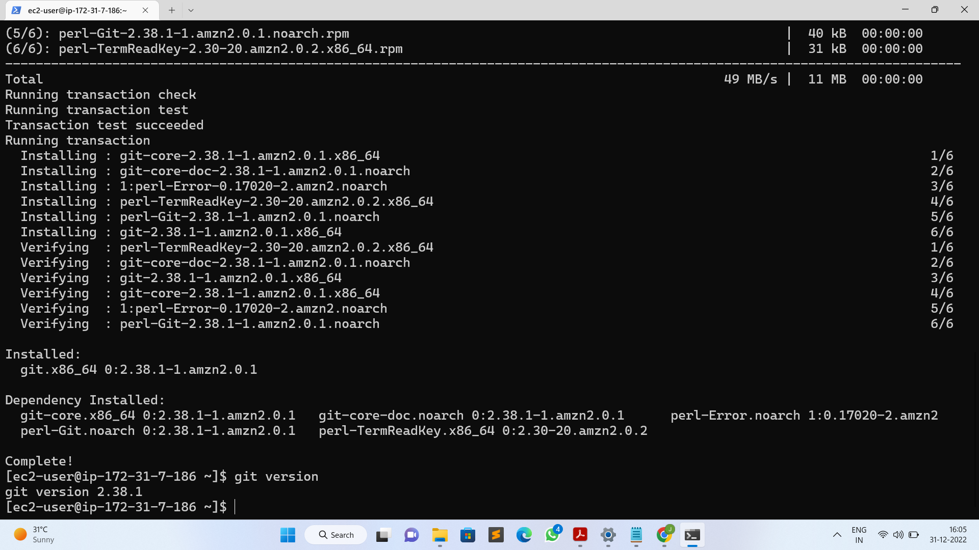

* To run our site on http install httpd using below command:
* sudo yum -y install httpd

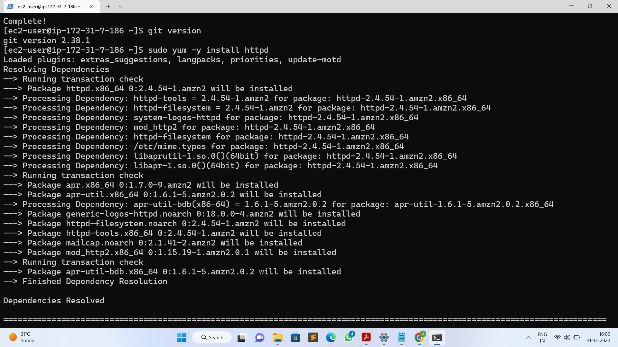

* Start the httpd service after installation
* sudo systemctl start httpd

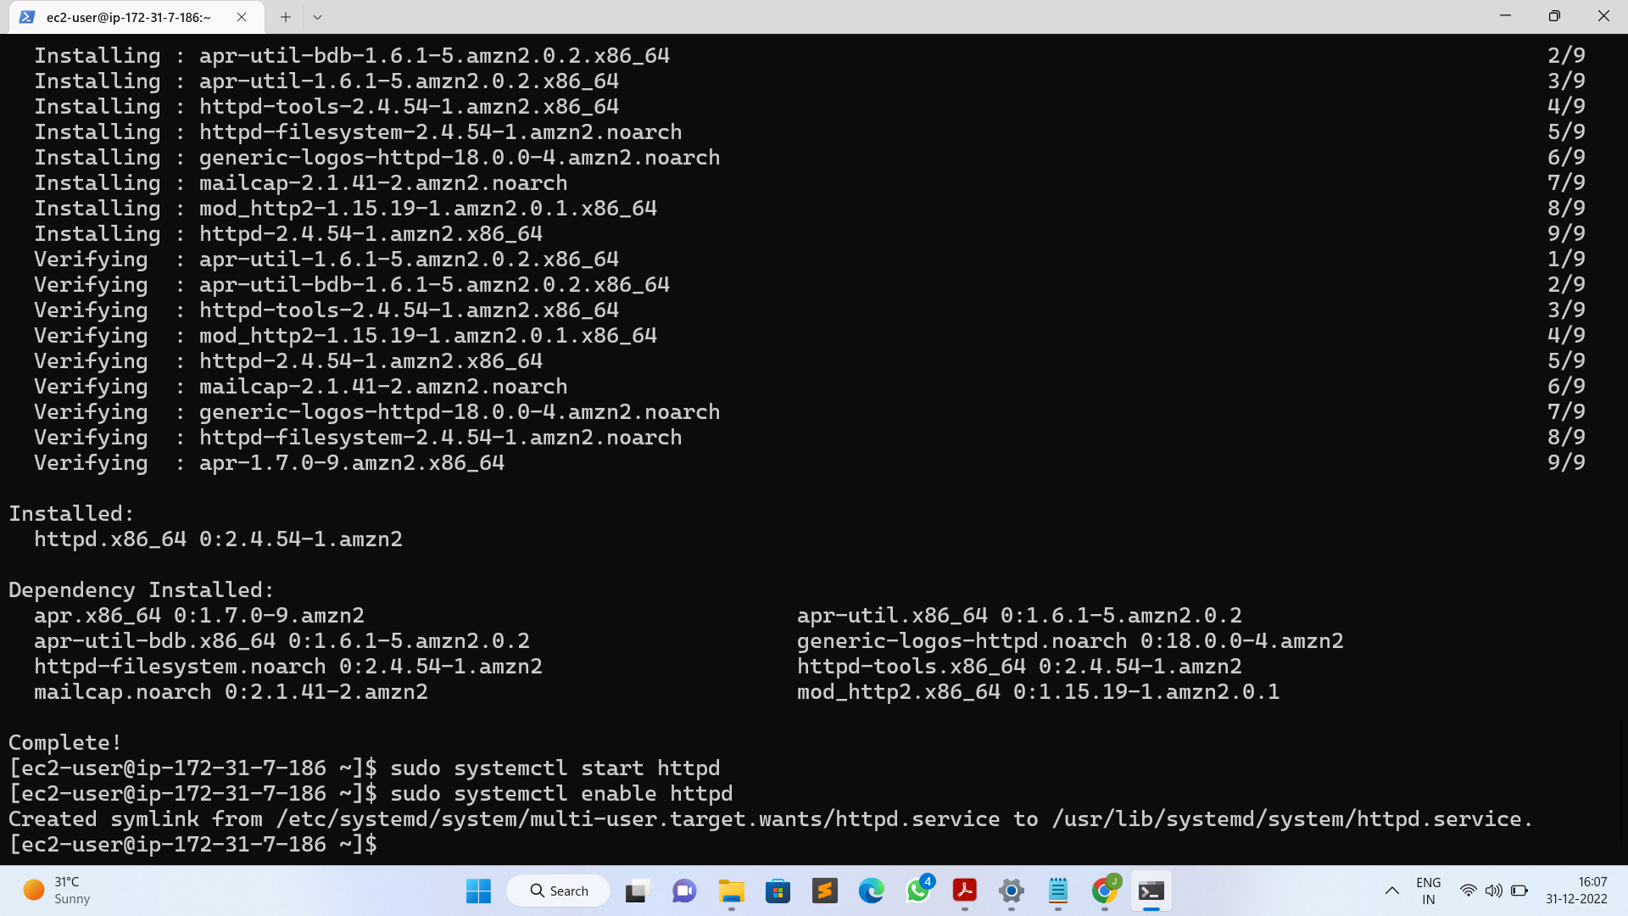

* Enable httpd service
* sudo systemctl enable httpd



* Then check the status of httpd if it is running or not
* sudo systemctl status httpd

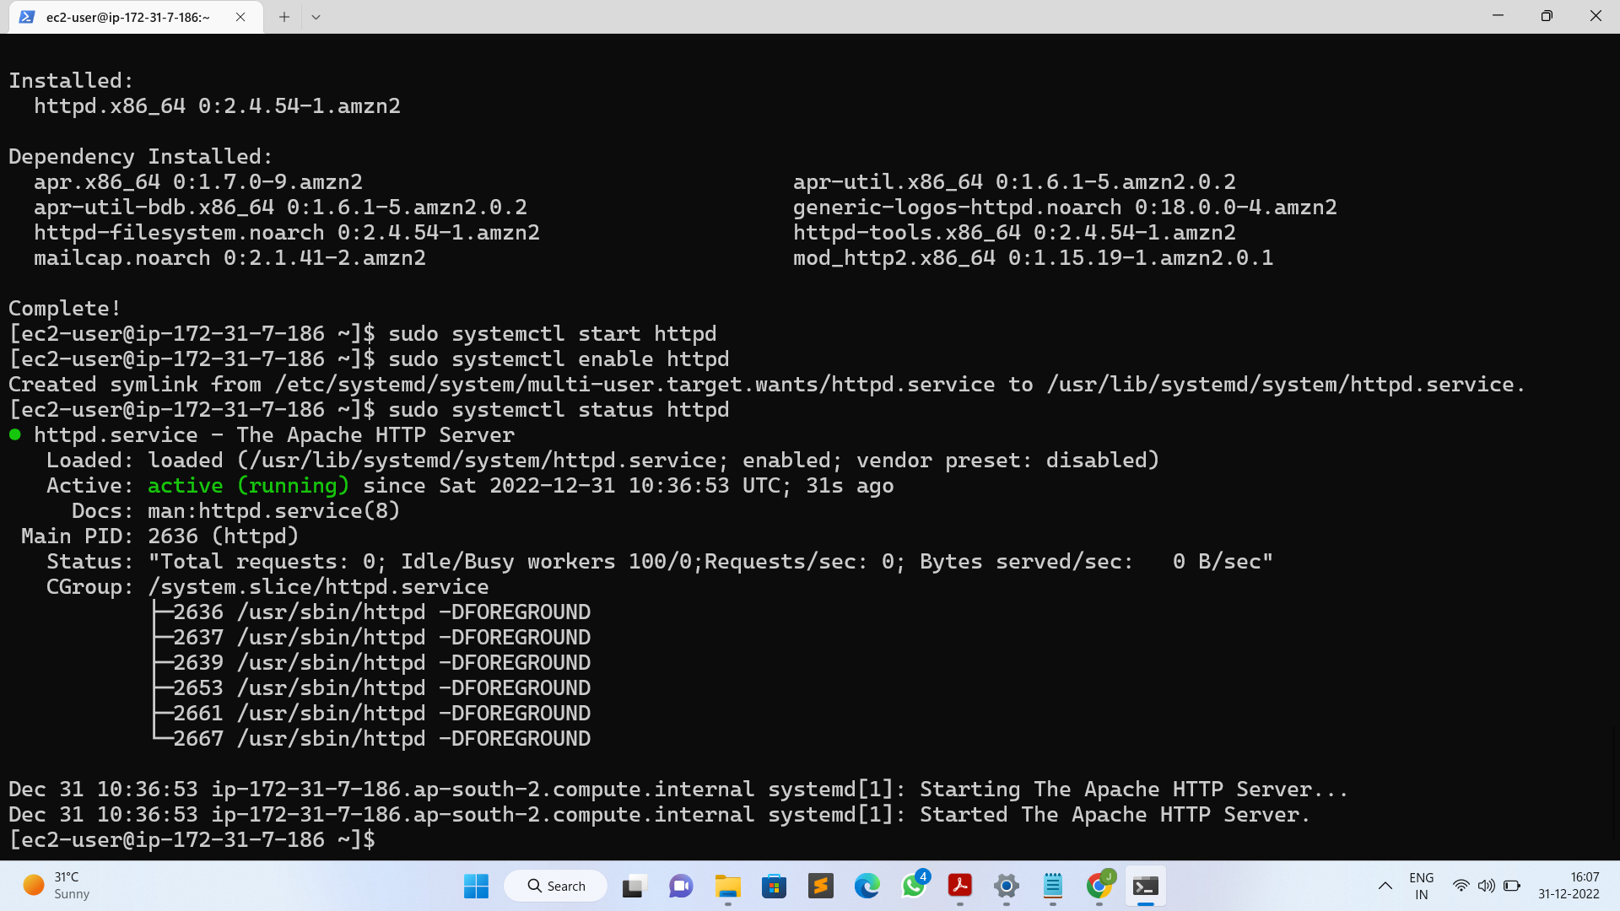

* After installing and starting of httpd go to browser and paste your instance public Ip to check httpd is working or not

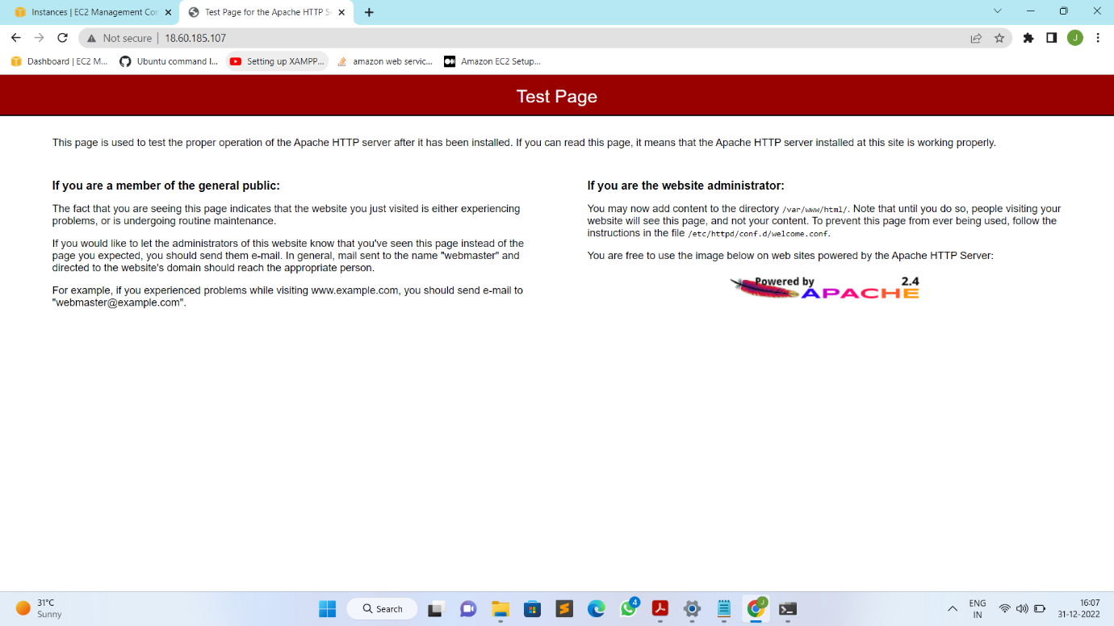

* Then clone your site code to html directory to run our website
* sudo git clone <https://github.com/jayeshrocks34/jayeshrocks34.github.io.git> /var/www/html

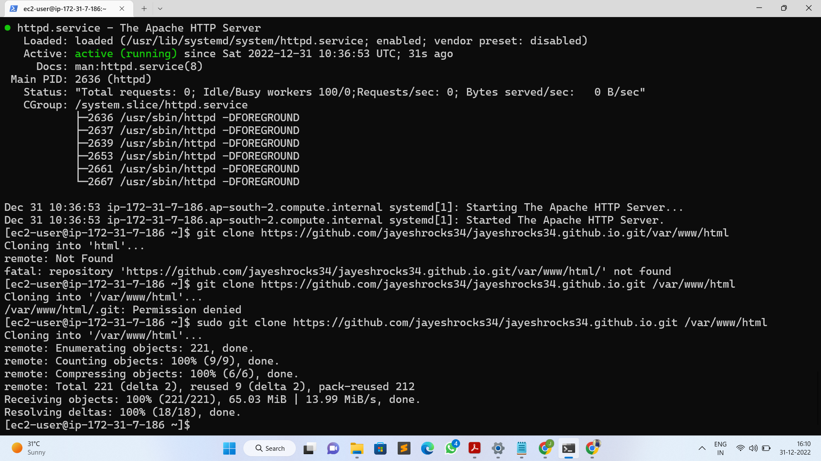

* Then go to browser and refresh the page you have searched using your public Ip address
* Your website should be visible there

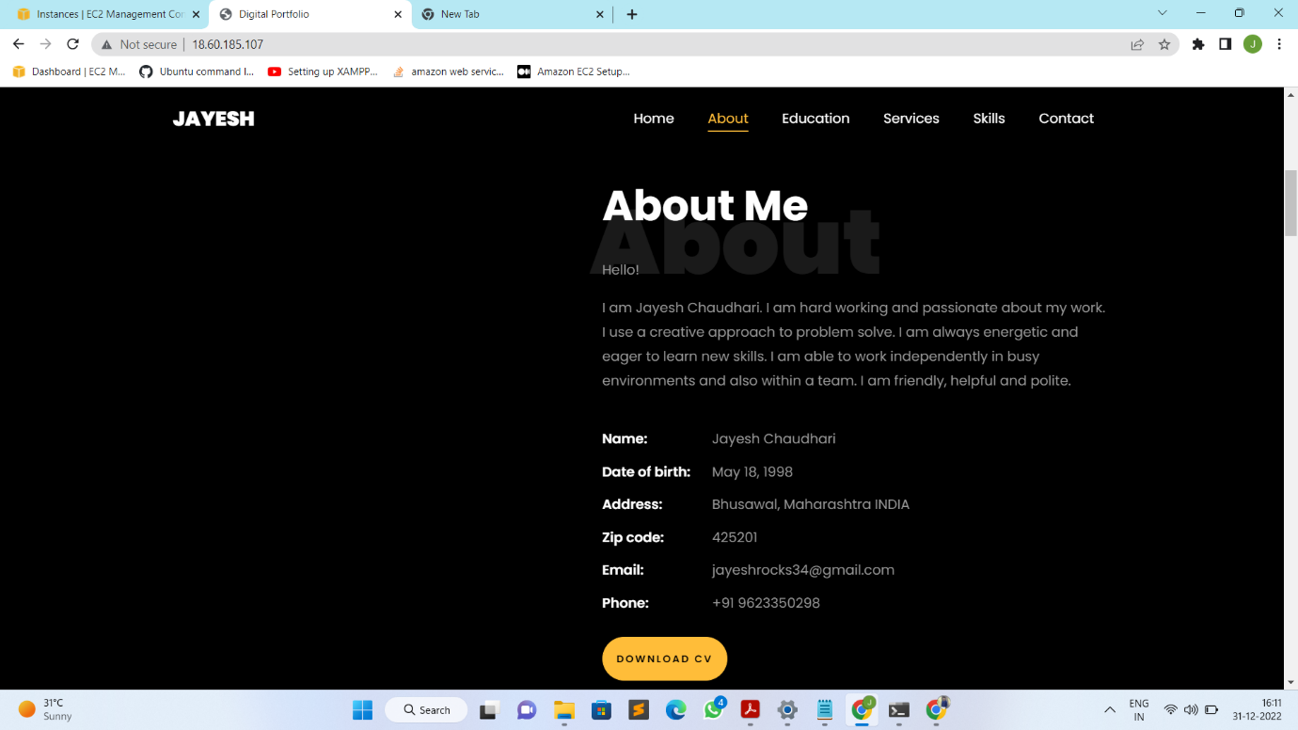

* Then allocate Elastic IP address and attach it to your running instance

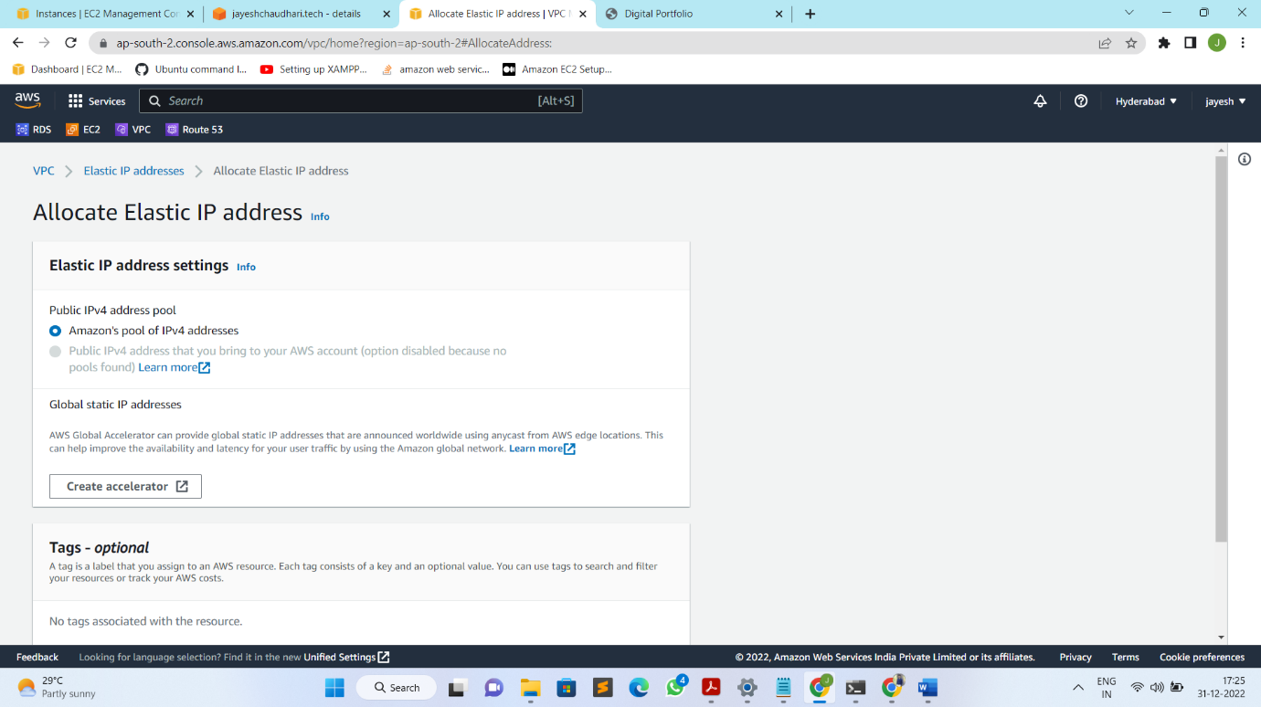

* Then go and log in to your domain purchased website and click on manage for hosting the site on it.

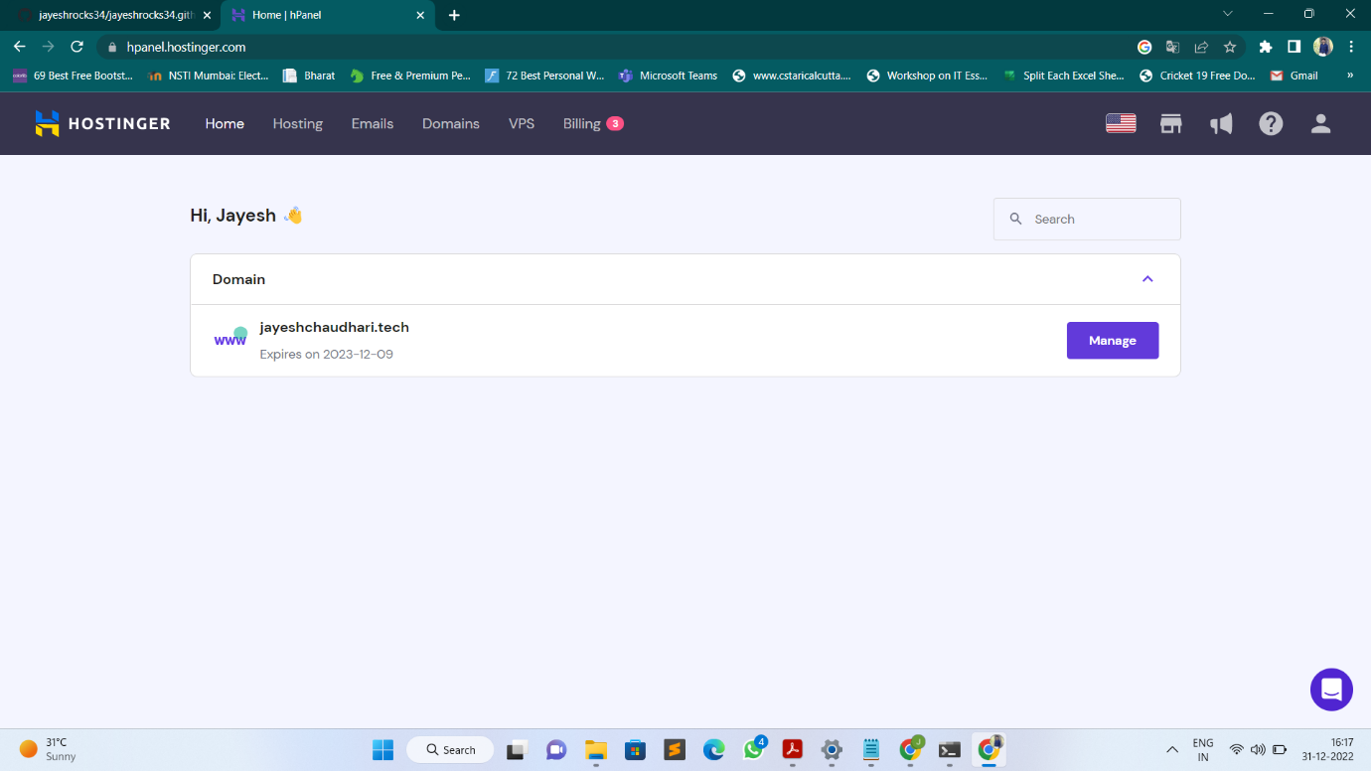

* At the same time go to Route53 services in your amazon account.
* Create a Hosted zone with your domain name(example – jayeshchaudhari.tech)

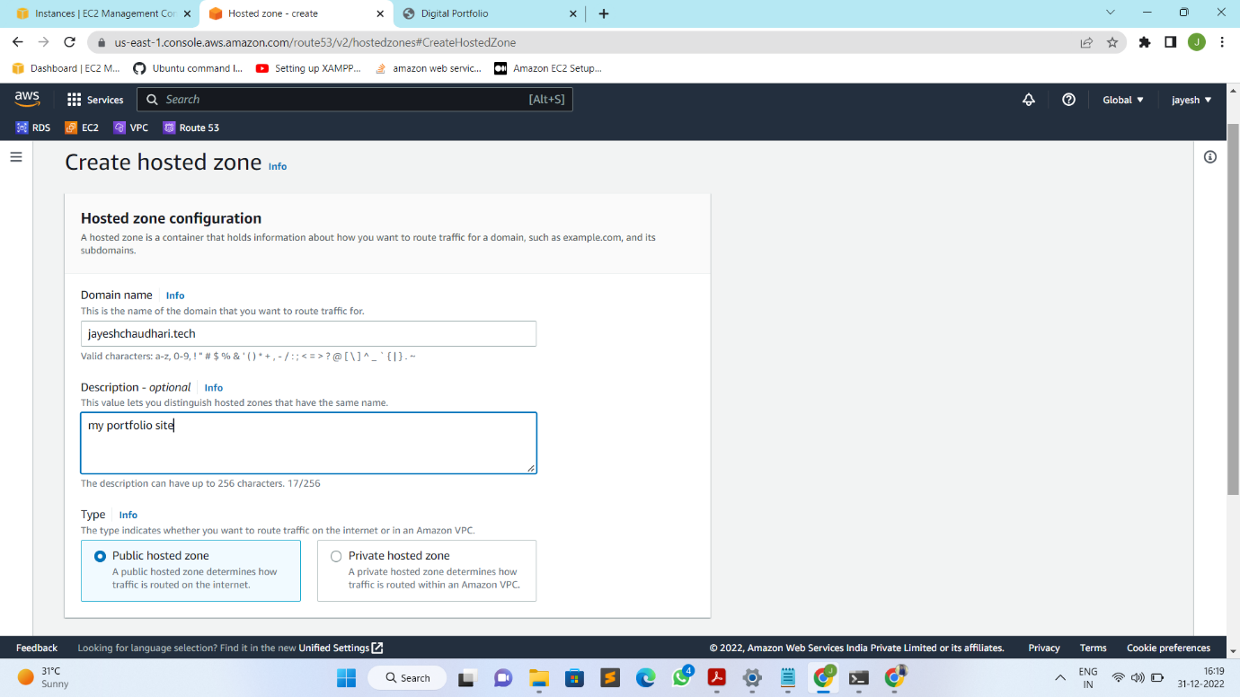

* Then in the next window click on create records

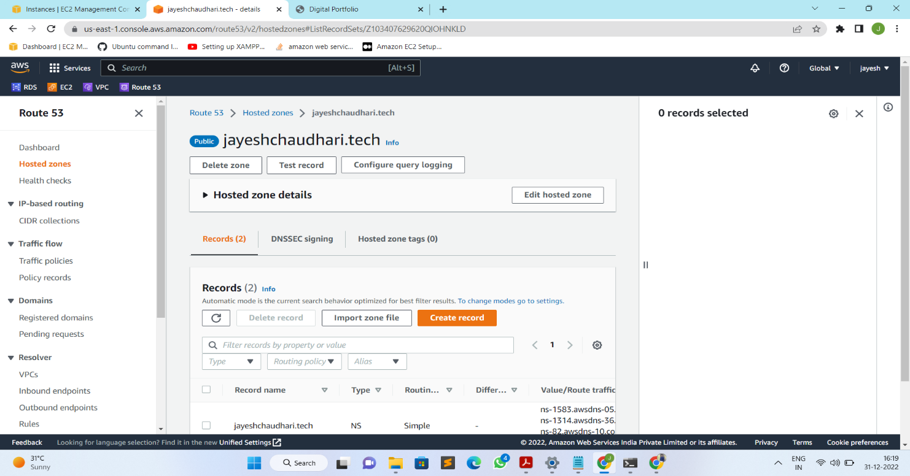

* Create records and give the value (public IP address of instance)

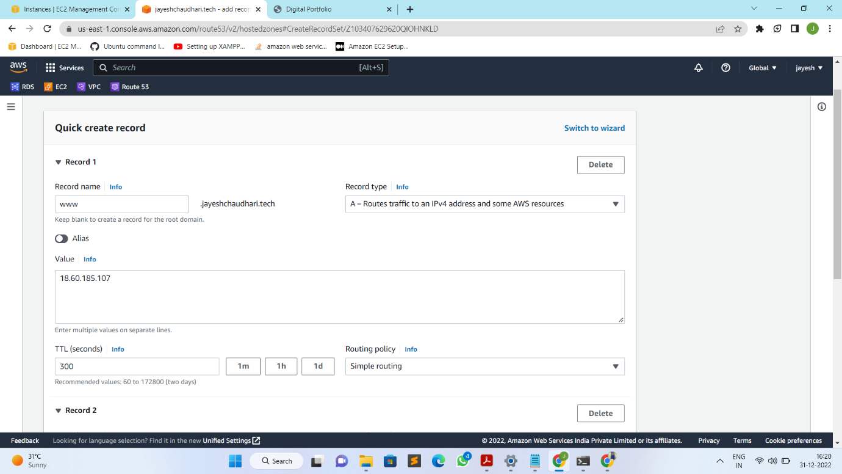

* Then go to domain purchased website we have logged in earlier and click on Change Nameservers.
* Copy the values from Route53 services records and paste then one by one and save it.

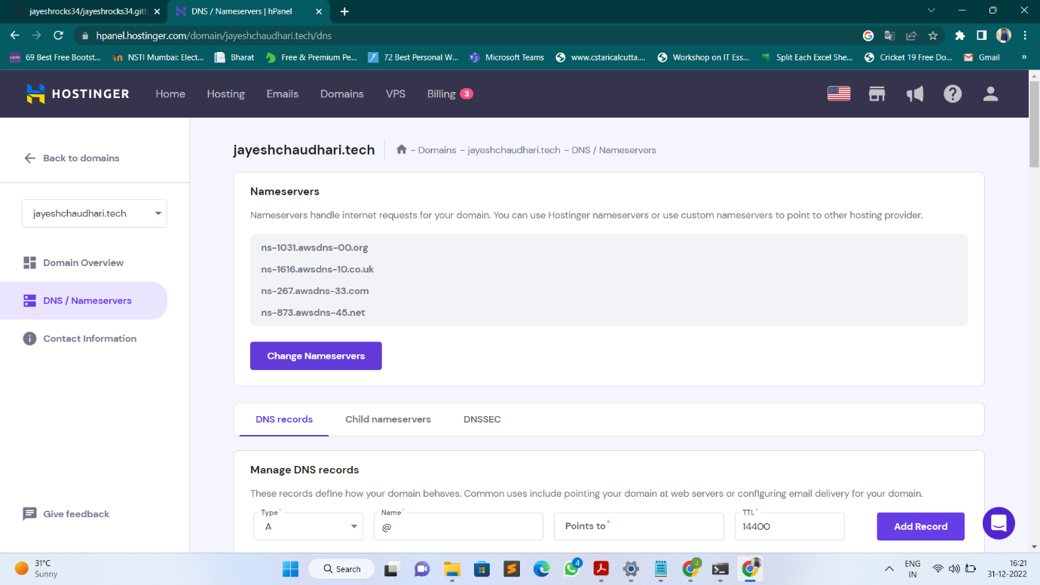

* Then create a record on domain manage site give public IP if instance and save it.
* Then site is successfully configured with domain and go to browser and search for your domain and see the output

