EXPERIMENT NO.6

VHDL CODE

library IEEE;
use IEEE.STD_LOGIC_1164.ALL; use IEEE.STD_LOGIC_ARITH.ALL;
use IEEE.STD_LOGIC_UNSIGNED.ALL;
entity lcd is
Port ( clk,reset : in std_logic; RS,EN : out std_logic;
data : out std_logic_vector(7 downto 0));
end lcd;
architecture Behavioral of lcd is
type state_type is (s0,s1,s2,s3,s4,s5,s6,s7,s8,s9,s10,s11, s12,s13,s14,s15,s16,s17,s18,s19,s20,s21,s22,s23);
signal state:state_type; begin
process(clk, reset, state) begin
if reset = '1' then
state <= s0;
elsif rising_edge(clk) then if state = s0 then
state <= s1;
RS<='0'; -- Write commands to LCD. EN <= '1';
data <= "00110000"; -- Function set for 8 bit interface, 1 line mode and 5x7 dot matrix.
end if;
if state = s1 then
state <= s2; EN <= '0';
ON.
end if;
if state = s2 then
state <= s3; EN <= '1';
data <= "00001111"; -- Display cursor and blinking

end if;
if state = s3 then
state <= s4; EN <= '0';
end if;
if state = s4 then
state <= s5; EN <= '1';
data <= "00000001"; -- Clear display.
end if;
if state = s5 then
state <= s6; EN <= '0';
end if;
if state = s6 then

end if;

state <= s7; EN <= '1';
data <= "10000100"; -- Display address.

if state = s7 then
state <= s8; EN <= '0';
end if;
if state = s8 then
RS <= '1'; -- Write data to LCD. state <= s9;
EN <= '1';
data <= "01010111"; --W
end if;
if state = s9 then
state <= s10; EN <= '0';
end if;
if state = s10 then
state <= s11; EN <= '1';
data <= "01000101"; --E
end if;
if state = s11 then
state <= s12; EN <= '0';
end if;
if state = s12 then
state <= s13; EN <= '1';
data <= "01001100"; --L
end if;
if state = s13 then
state <= s14; EN <= '0';
end if;
if state = s14 then
state <= s15; EN <= '1';
data <= "10110000"; --(-)
end if;
if state = s15 then
state <= s16; EN <= '0';
end if;
if state = s16 then
state <= s17; EN <= '1';
data <= "01000011"; --C
end if;

if state = s17 then
state <= s18; EN <= '0';
end if;
if state = s18 then
state <= s19; EN <= '1';
data <= "01001111"; --O
end if;
if state = s19 then
state <= s20; EN <= '0';
end if;
if state = s20 then
state <= s21; EN <= '1';
data <= "01001101"; --M
end if;
if state = s21 then
state <= s22; EN <= '0';
end if;
if state = s22 then
state <= s23; EN <= '1';
data <= "01000101"; --E
end if;
if state = s23 then
EN <= '0';
end if;
end if; end process;
end Behavioral;

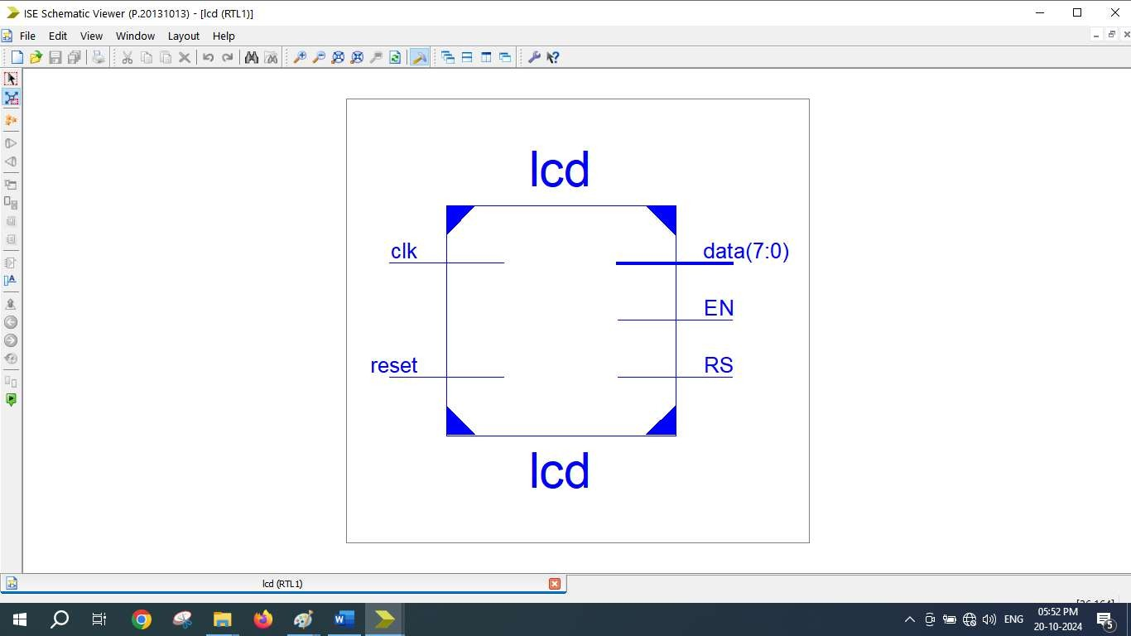
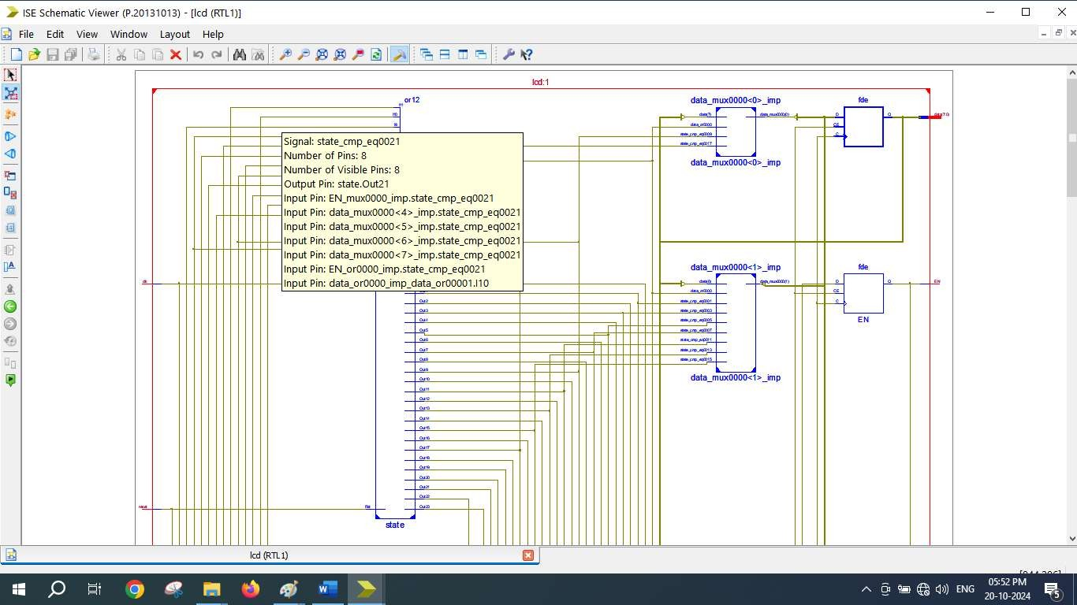

=========================================================================
* Final Report *
=========================================================================
Final Results
RTL Top Level Output File Name : lcd.ngr Top Level Output File Name : lcd
Output Format : NGC
Optimization Goal : Speed
Keep Hierarchy : No

Design Statistics
# IOs : 12

Cell Usage :
# BELS : 30
# GND : 1
# INV : 1
# LUT2_L : 2
# LUT3 : 1
# LUT3_D : 1
# LUT3_L : 3
# LUT4 : 17
# LUT4_L : 3
# VCC : 1
# FlipFlops/Latches : 34
# FDC : 22
# FDCE : 1
# FDE : 10
# FDP : 1
# Clock Buffers : 1
# BUFGP : 1
# IO Buffers : 11
# IBUF : 1
# OBUF : 10
=========================================================================

Device utilization summary:

Selected Device : 3s250epq208-5

Number | of | Slices: | 24 | out | of | 2448 | 0%
Number | of | Slice Flip Flops: | 34 | out | of | 4896 | 0%
Number | of | 4 input LUTs: | 28 | out | of | 4896 | 0%
Number | of | IOs: | 12
Number | of | bonded IOBs: | 12 | out | of | 158 | 7%
Number | of | GCLKs: | 1 | out | of | 24 | 4%

