EXPERIMENT NO.4

- VHDL CODE:

-- Experiment No 4 – Mod-N Counter
-- Name : Ritesh Machindra Todmal
-- Roll No. : 404C001
-- Teacher Name: Dr.D.G.Ganage
-- Batch : C1

library IEEE;
use IEEE.std_logic_1164.all;
use IEEE.std_logic_unsigned.all;

entity counter is
port ( CLK : in std_logic;
RST : in std_logic; -- Synchronous reset input RST active

high

end counter;

Q : out std_logic_vector(3 downto 0));

architecture counter_arch of counter is signal TEMP_Q : std_logic_vector(3 downto 0); begin
process(CLK) begin
if rising_edge(CLK) then -- if clk'event and clk = '1' then
if RST = '1' then -- active high and it is inside clock therfore its synchronous reset
TEMP_Q <= (others => '0'); -- TEMP_Q <= "0000"
else
if (TEMP_Q = "1001") then
TEMP_Q <= (others => '0'); -- TEMP_Q <= "0000"
else
TEMP_Q <= TEMP_Q + 1; -- up counting end if ;
end if ; end if;
end process; Q <= TEMP_Q;
end counter_arch;

- VHDL TESTBENCH:

-- Experiment No 4 – Mod N Counter
-- Name : Ritesh Machindra Todmal
-- Roll No. : 404C001
-- Teacher Name: Dr.D.G.Ganage
-- Batch : C1

LIBRARY ieee;
USE ieee.std_logic_1164.ALL;

ENTITY counter_tb IS END counter_tb;

ARCHITECTURE behavior OF counter_tb IS
-- Component Declaration for the Unit Under Test (UUT) COMPONENT counter
PORT(
CLK : IN std_logic; RST : IN std_logic;
Q : OUT std_logic_vector(3 downto 0)
);
END COMPONENT;

--Inputs
signal CLK : std_logic := '0'; signal RST : std_logic := '0';

--Outputs
signal Q : std_logic_vector(3 downto 0);

-- Clock period definitions BEGIN

-- Instantiate the Unit Under Test (UUT) uut: counter PORT MAP (
CLK => CLK, RST => RST, Q => Q
);

-- Clock process definitions CLK_process :process
begin

end process;
CLK <= '0';
wait for 5 ns; CLK <= '1';
wait for 5 ns;

-- Stimulus process stim_proc: process begin
-- hold reset state for 100 ns.

RST | <= | '1';
 |  | wait | for | 20 ns;
RST | <= | '0';
 |  | wait | for | 200 ns;
RST | <= | '1';
 |  | wait | for | 10 ns;
RST | <= | '0';
 |  | wait | for | 300 ns;
end process; END

- SIMULATION RESULT

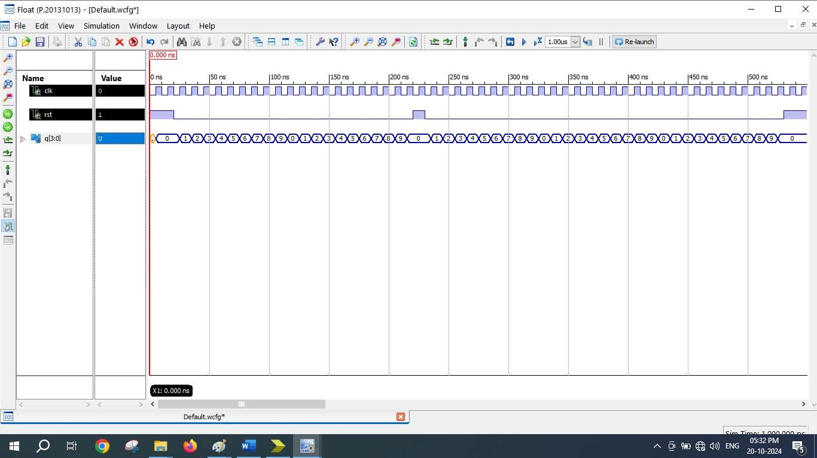

- SCHEMATICS (RTL Technology)
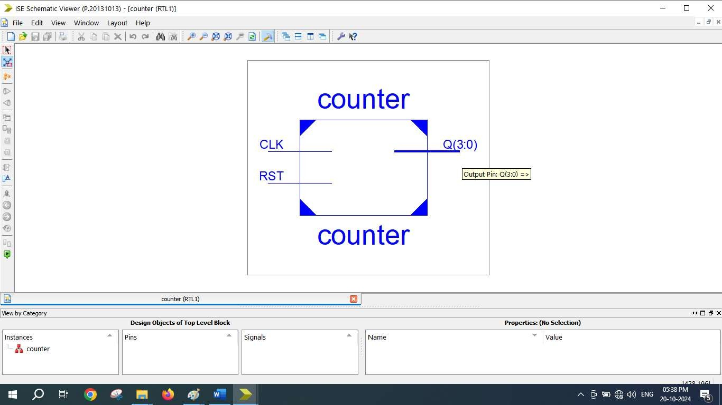

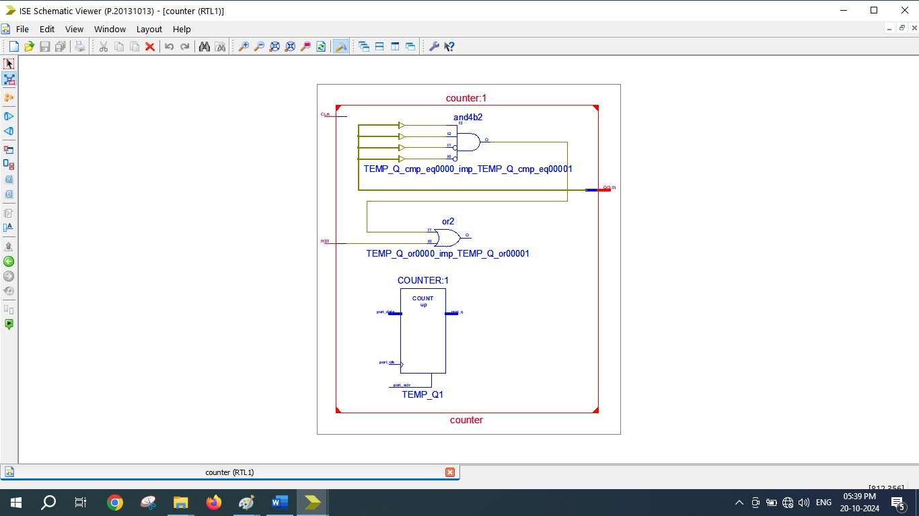
=========================================================================
* Final Report *
=========================================================================
Final Results
RTL Top Level Output File Name : counter.ngr Top Level Output File Name : counter
Output Format : NGC
Optimization Goal : Speed
Keep Hierarchy : No

Design Statistics
# IOs : 6

Cell Usage :
# BELS : 6
# INV : 1
# LUT2 : 1
# LUT2_L : 1
# LUT3 : 1
# LUT4 : 2
# FlipFlops/Latches : 4
# FDR : 4
# Clock Buffers : 1
# BUFGP : 1
# IO Buffers : 5
# IBUF : 1
# OBUF : 4
=========================================================================

Device utilization summary:

Selected Device : 3s250epq208-5

Number | of | Slices: | 3 | out | of | 2448 | 0%
Number | of | Slice Flip Flops: | 4 | out | of | 4896 | 0%
Number | of | 4 input LUTs: | 6 | out | of | 4896 | 0%
Number | of | IOs: | 6
Number | of | bonded IOBs: | 6 | out | of | 158 | 3%
Number | of | GCLKs: | 1 | out | of | 24 | 4%

