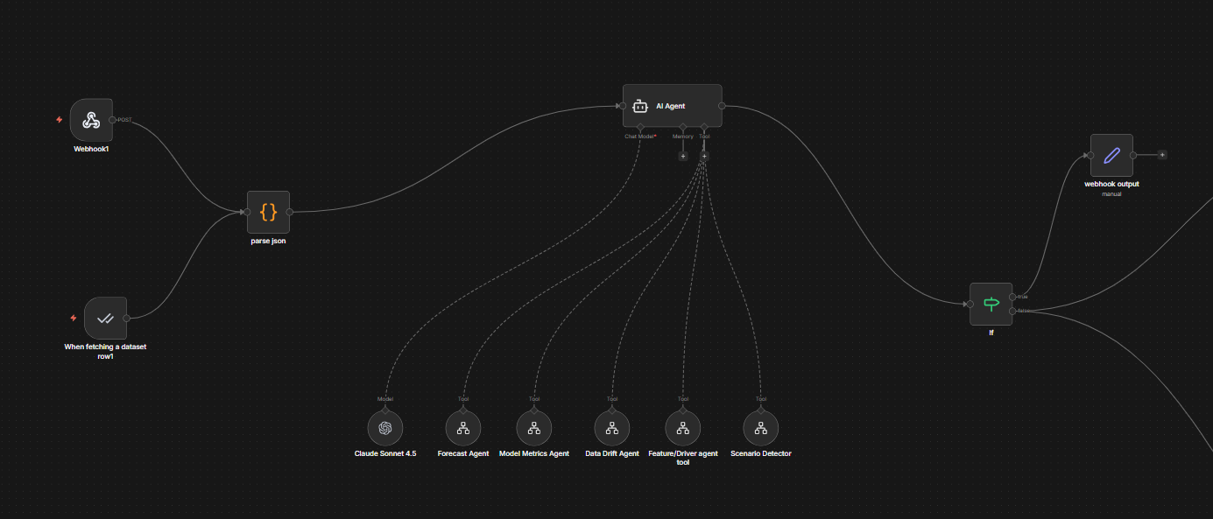main agent demand analyst agent
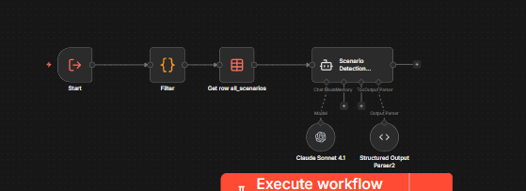Sc
Scenario agent
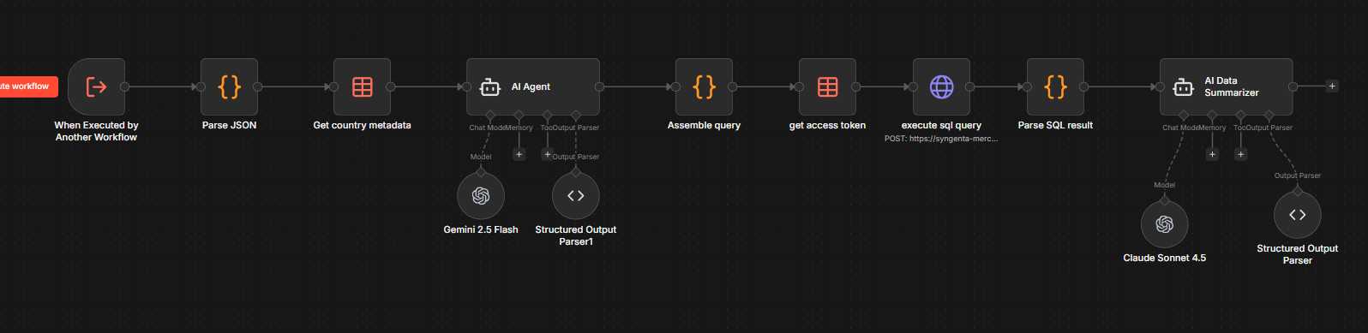driver agent
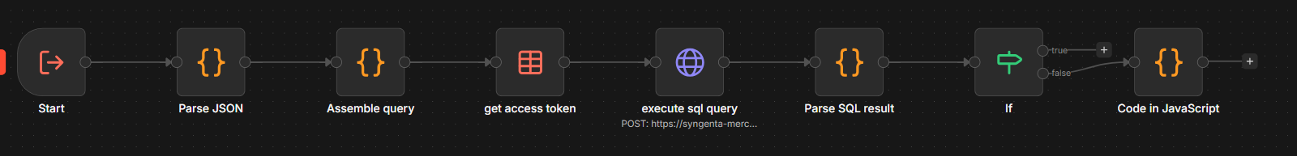data drift agent
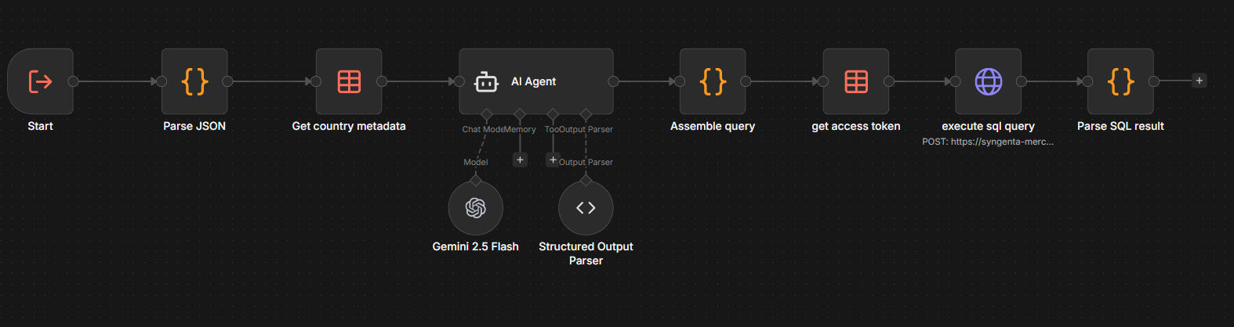model metric agent
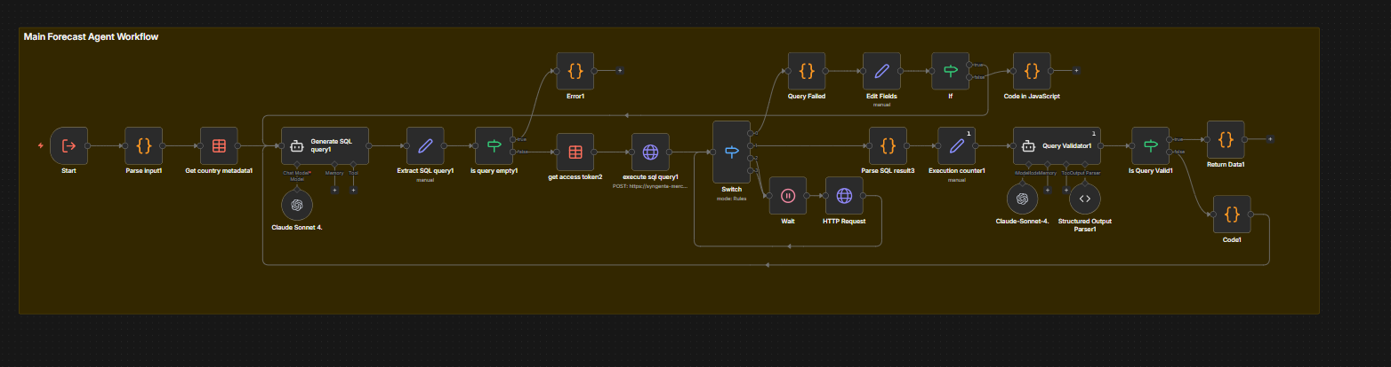forecast agent

