(TOTAL HEALTHCARE SOLUTIONS PROVIDER)

P. O. Box GP 2821 Email: beautifulcreationsgh@yahoo.com
Accra - Ghana bcclgh@gmail.com
Tel 1: (233) 0302 667171 Website: www.bcmedicals.com
Tel 2: (233) 0302 677222 www.beautifulcreationsgh.com
Hotline: (233) 0244316616

Your Ref: Our Ref: Date: 19th February, 2026

SQ NO.: CR/SLCH/GD/001/25
TENDER FORM

ST. LUKE’S CATHOLIC HOSPITAL
P. O. BOX AP 5,
APAM
CENTRAL REGION

Gentlemen and/or Ladies:

Having examined the Tender documents, we, the undersigned, offer to supply and deliver NON-DRUG CONSUMABLES in conformity with the said Tender documents for the sum of FOUR MILLION, SEVEN HUNDRED AND FORTY SIX THOUSAND, EIGHT HUNDRED AND EIGHTY ONE GHANA CEDIS, FIFTY GHANA PESEWAS ONLY (GH¢ 4,746,881.50) or such other sums as may be ascertained in accordance with the Schedule of Prices attached herewith and made part of this Tender.
We undertake, if our Tender is accepted, to deliver the goods and services in accordance with the delivery schedule specified in the Schedule of Requirements.

If our Tender is accepted, we will provide a Bank Guarantee acceptable to the Purchaser in a sum equivalent to Two percent of the Contract Price for the due performance of the Contract, in the form prescribed by the Purchaser.

We agree to abide by this Tender for a period of 90 days from the date fixed for Deadline for Tender submission, and it shall remain binding upon us and may be accepted at any time before the expiration of that period.
Commissions or gratuities, if any, paid or to be paid by us to agents relating to this Tender, and to contract execution if we are awarded the contract, are listed below:

(TOTAL HEALTHCARE SOLUTIONS PROVIDER)

Name and address of Amount and Purpose of
agent Currency Commission or gratuity

None GH¢ 4,746,881.50 None

(if none, state “none”)

Until a formal Contract is prepared and executed, this Tender, together with your written acceptance thereof and your notification of award, shall constitute a binding Contract between us.

We understand that you are not bound to accept the lowest or any Tender you may receive.

We certify/confirm that we comply with the eligibility requirements as per ITT Clause 2 of the Tender documents.

Dated this 19th day of February 2026.
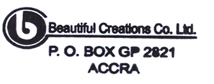
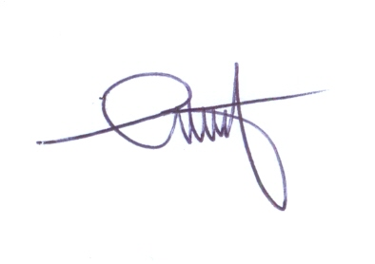
SAM D. ANSONG
[signature] MANAGING DIRECTOR
[in the capacity of]

Duly authorized to sign Tender for and on behalf of Beautiful Creations Ltd

