(TOTAL HEALTHCARE SOLUTIONS PROVIDER)

P. O. Box GP 2821 Email: beautifulcreationsgh@yahoo.com
Accra - Ghana bcclgh@gmail.com
Tel 1: (233) 0302 667171 Website: www.bcmedicals.com
Tel 2: (233) 0302 677222
Hotline: (233) 0244316616

Your Ref: Our Ref: Date: 19th February, 2026

SQ NO.: CR/SLCH/GD/001/25

Statement on warranty
We warrant that the Equipment supplied under the contract is new, unused, of the most recent or current models and that they incorporate all recent improvements in design and materials unless provided otherwise in the contract.

We warrant that all goods to be supplied under this contract have no defect, arising from design, materials, or workmanship (except when the design and/or material is required by the purchaser’s specifications) or from any act or omission that may develop under normal use of the supplied goods in the conditions prevailing in the country of final destination.

The warranty shall remain valid for twenty-four (24) months of operation or 27 months from the date of acceptance of the goods or 27 months from the date of shipment, whichever occurs earlier.

We also comply with the performance and/or consumption guarantees specified under the contract.
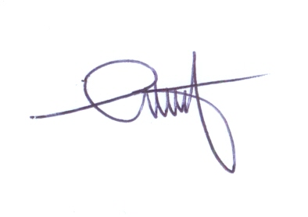



………………………………
SAM. D. ANSONG
MANAGING DIRECTOR

