***Scattering Mediated Hot Electron Transfer in Photodynamic Therapy: A Novel Approach***

Proposal written by

**GOOD PROPOSAL WRITTER**

Under the supervision of

**Dr. Jay J. Foley IV**

Department of Chemistry

William Paterson University of New Jersey

300 Pompton Road, Wayne, NJ

Spring 2016

**Abstract:**

Photodynamic therapy has been proven to be a useful therapy for the palliative and curative treatment of many diseases with varying degrees of mortality. Because it harnesses the energy given off by light to excite a molecule – causing it to ultimately generate singlet oxygen or other ROS species that lead to cell death – one can change the efficacy of the treatment simply by altering the material absorbing the light.[1] Thus it has many benefits over more traditional therapies and treatments. Scattering Mediated Hot Electron Transfer refers to a potential phenomenon that arises in hierarchical nanoparticles containing a dielectric core decorated with small metal nanoparticles embedded somewhere just below the surface of the dielectric core.[2] By tuning the size ratio and placement of the smaller metal nanoparticles, one can induce sharp scattering mediated absorption peaks in the metals that only arise when it is part of this hierarchical nanoparticle.2 This enables the metal to absorb light it wouldn’t normally absorb as a sole nanoparticle.2 This paper aims to show the potential benefits of applying the newly characterized phenomena of scattering mediated hot electron transfer of hierarchical nanoparticles to photodynamic therapy.

**Background:**

Photodynamic therapy [PDT] is a well–established field, and is an important therapy for the managements and treatment of multiple pathologies. It is currently used to treat ailments such as acne, actinic keratosis, psoriasis, and infections such as periodontitis.[3] These are all ailments where the disease is close to the surface of the organ it belongs to. Additionally, more mortal indications include certain cancers such as lung cancer, Barrett’s esophagus, bladder cancer, head and neck cancers.[4] [5] [6] [7] PDT is the go-to treatment for skin cancers, due to the nature of the disease that it is on the surface of the skin or otherwise in superficial tissue.[8] It is used as a secondary or backup treatment of malignant tumors in the brain where removal of part of the organ is required, and also in focal tumors where less than half of the tissue is affected.3 It is used both to cure and to manage the pain that these diseases bring.

PDT works using a method in which a photosensitizer molecule is targeted to the diseased tissue, after which the tissue is exposed to a predetermined wavelength of light which excites the photosensitizer into either its singlet or triplet state. If the photosensitizer is excited to its singlet state (Type II reaction), then it produces singlet oxygen, which has a short lifetime and short diffusion distance meaning that the damage it can cause is limited both in duration and location.[9] If it is excited into its triplet state (Type I reaction), then it causes the formation of reactive radicals which can react with molecular oxygen in its ground–state to form peroxides and superoxide anion and hydroxyl radicals.[10] [11] Both reactions cause damage to the cell’s organelles, mainly the mitochondria and endoplasmic reticulum and most parts of the endomembrane system.[12] This leads to the cell either entering into an apoptosis pathway, or being detected by phagocytes of the immune system, both ultimately leading to cell death.[13]

PDT is a useful technique for treating diseases, but it is not without its drawbacks. It is currently limited to indications that are superficial due to the extinction of most visible light through human tissues. Additionally, decreasing the amount of photosensitizer used can aid in reducing overall toxicity, and this can be done by increasing the efficiency of singlet oxygen generation. Additionally, more specific targeting of the photosensitizer to only be endocytosed by diseased tissue is attainable by creating a photosensitizer–nanoparticle complex and conjugating ligands to the nanoparticle with strong binding affinity to only those cells. Finally, PDT can be better differentiated by which reaction type is generating the ROS, be it Type II or Type I. Scattering mediated absorption could potentially allow for just this by generating hot electrons of a specific energy that would only go towards one of the reaction types.

Nanoparticles are currently being used in PDT along with many other therapies, due to their array of unique properties: high surface area to volume ratio, ability to transport hydrophobic drugs in the blood, controlled release of drugs, large volumes of distribution, efficient uptake into cells, and multiple synthetic pathways to name a few.3 [14] [15] [16] In PDT, there are two broad categories nanoparticles can fall into, based upon how they function.[17] The first is passive nanoparticles, where they do not actively participate in the excitation of the photosensitizer. These can further be classified as biodegradable, where they are used to carry and transport the drug or photosensitizer to the specified tissue, and they are characterized by their ability to degrade and slowly release the drug in a controllable fashion.3 Non–biodegradable nanoparticles are used to control the extent of usage of free photosensitizer, either by permanently binding the photosensitizer to the nanoparticle’s surface, or by doping the nanoparticle with the photosensitizer.3

The second broad category is that of active nanoparticles, where the nanoparticle can play many different roles in the therapy. They can function as a replacement or enhancer of the photosensitizers, as a light source, or as an absorber of low wavelength light for use in deeper tissues. Photosensitizer nanoparticles are quantum dots which can transfer the energy they get from light to molecular oxygen, essentially acting in the same way as a photosensitizer molecule such as porphyrins do.[18] [19] However, their yield of singlet oxygen is low compared to traditional photosensitizers so they can have photosensitizers bound to their surface to increase their yield.18 [20] [21]

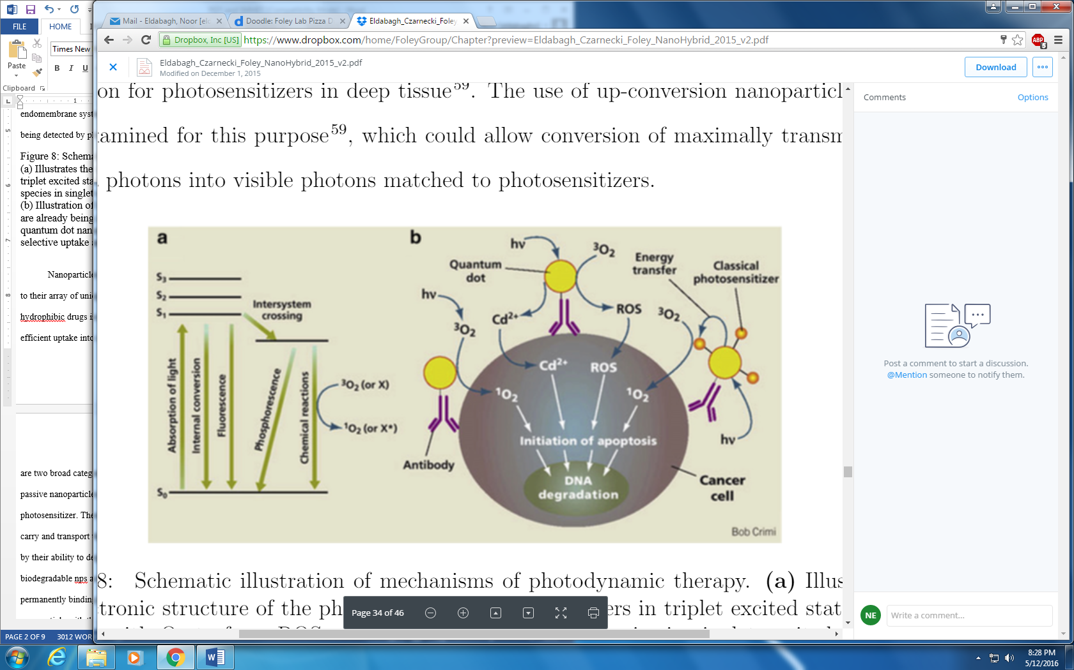Self–lighting nanoparticles act as a persistently luminescent light source for photosensitizers that are attached to their surface, hence there is a persistent source of light for the nanoparticles to generate singlet oxygen and other ROS with.[22] These nanoparticles, when exposed to ionizing radiation such as that from X–Rays, luminesce and excite the photosensitizers. By using this therapy in conjunction with radiation therapy for cancer, which contrarily to this does not discriminate between healthy or diseased tissue, one may reduce the dosage of radiation any one patient receives.3

***Figure 1:*** *Schematic illustration of mechanisms of photodynamic therapy.*

(a) Illustrates the electronic structure of the photosensitizer. Photosensitizers in triplet excited states can interact with O2 to form ROS, which are various oxygen species in singlet excited-states.

(b) Illustration of several ways PDT can initiate cell death. Hybrid nanostructures are already being investigated for PDT, including photosensitizers composed of quantum dot nanoparticles functionalized with small molecules to aid their selective uptake and binding. Illustration reproduced with permission from Ref.3

Finally, upconverting nanoparticles are able to absorb low energy radiation and emit higher energy light.[23] In doing so, they are able to absorb low energy radiation which would not excite a photosensitizer on its own, and convert it into light that can indeed excite photosensitizers. This means that one can increase the range of PDT uses from only being used on clinical indications that are superficial on the skin or mucosa or otherwise endoscopically accessible, to include deeper tissues that cannot necessarily be treated by conventional PDT. The material with the highest upconversion efficiency were found to be Er3+/Yb3+ or Tm3+/Yb3+ co–doped hexagonal NaYF4.[24]

Scattering mediated hot electron transfer is a phenomenon that occurs in hierarchical nanoparticles which have a dielectric core with small metal nanoparticles decorating its surface which is then encapsulated with a dielectric shell. When light is shone at the nanoparticle, the dielectric core scatters it, allowing most of the light to pass through but trapping a certain intensity of light within the core, causing it to travel around the nanoparticle with whispering gallery mode patterns. This low intensity light remains in the nanoparticle for 10-1000 times longer than a plasmon, enabling the metal nanoparticles on its surface to be exposed to it for longer, and to absorb its photons. This gives the metal new absorption peaks that are unique to what a solitary metal nanoparticle of that size would exhibit; thus this geometry induces scattering mediated absorption [SMA] in metals. Furthermore, this has been demonstrated in plasmonic metals, which have a very strong intrinsic absorption at certain wavelengths of light, as well as non–plasmonic metals, which only exhibit broad absorption characteristic of all metals. Specifically, this characteristic can be utilized to generate hot electrons of a very specific energy, which can be used for any chemical reaction or otherwise that requires a specific energy imparted into it.

This paper proposes to set up a project which will determine whether using these hierarchical nanoparticles in PDT yields any of the above mentioned advantages, and to what extent. This will be done by designing computer simulations and models which capture the essential photophysics of hierarchical nanoparticles, and by formulating figures of merit that relate these photophysical properties to desired characteristics of photosensitizers for PDT.

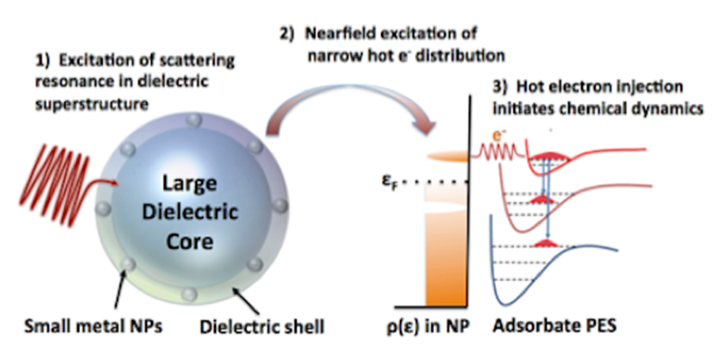

***Figure 2:*** *Overview of hot electron generation in hierarchical nanoparticles.*

Illustrates the process of generation of hot electrons by hierarchical nanoparticles and demonstrates a schematic for their specific energy level.

First, we will set up a way to calculate the time-dependent distributions of hot electrons produced as a result of SMA. This will be done by solving the time-dependent Schrödinger equation driven by the scattered field from SMA.[25] Further, we would need to set up a method to determine how much of the hot electrons can feasibly be used for generating singlet oxygen from molecular oxygen as it would be found in the tissues of the body.

We will benchmark our methodology by comparing the results it yields about a solitary metal nanoparticle in terms of scattering and absorption to the true values one obtains, and if they are in alignment then we can proceed with using the code to answer our questions.

**Preliminary Results:**

Scattering mediated hot electron transfer is a phenomenon that occurs in hierarchical nanoparticles which consist of a dielectric core with small metal nanoparticles decorating its surface which is then encapsulated with a dielectric shell when light is shone at them. The interplay of the geometry of the hierarchical nanoparticle causes low intensity light to be trapped within the dielectric core and causes it to travel in a pattern called whispering gallery modes.2 The light has been found to remain in the nanoparticle for 10–1000 times longer than a plasmon would.2 This light is absorbed broadly by all metals, and generates plasmon resonances in plasmonic metals. Our results have found that due to the unique properties that this layered nanoparticle has, one can induce strong absorption peaks that are not intrinsic to the metals.2 This allows one to excite a large quantity of hot electrons with a specific energy level, which can be exploited in a multitude of beneficial ways.

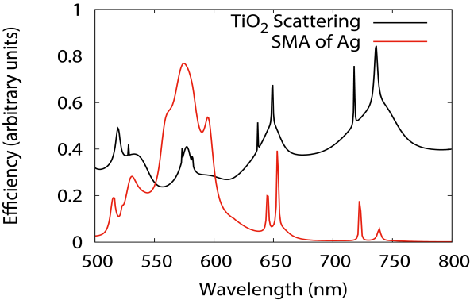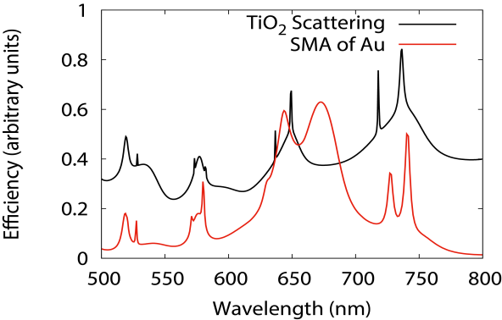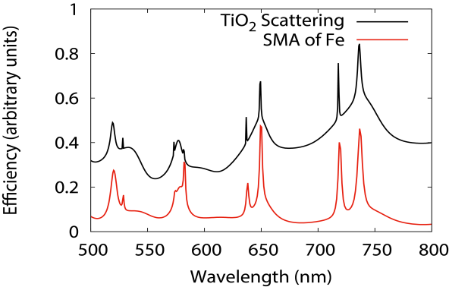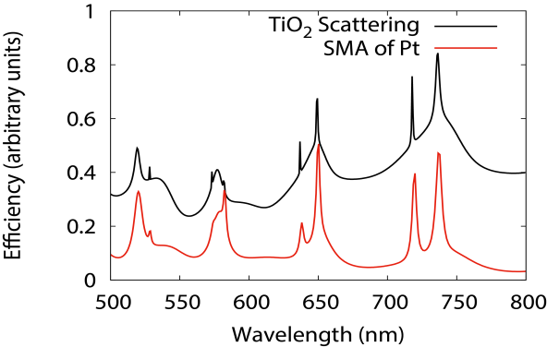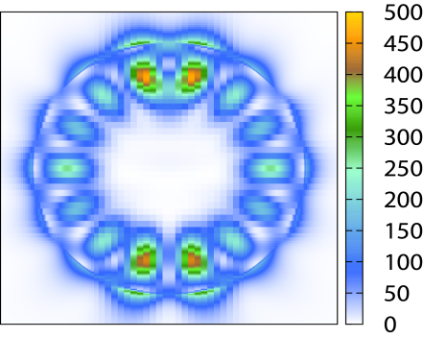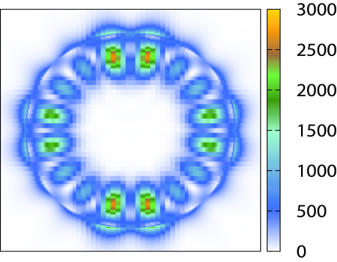

**a.**

**b.**

***Figure 3:*** *Absorption spectra of metals in comparison with scattering spectra of TiO2. hierarchical nanoparticles, Whispering gallery modes of TiO2nanoparticle.*

(a) Shows the scattering mediated absorption observed in all metals, along with plasmon resonances in plasmonic metals.

(b) Shows the whispering gallery modes from the scattering of a dielectric nanoparticle (d = 808 nm) when irradiated with incident light of wavelengths of 531 nm and 584 nm, respectively from top to bottom.

**Research Plan:**

***Methods:***

We have previously developed code that enables us to model our hierarchical nanoparticles by using Mie Theory to analyze the scattering and absorption in response to light. Because Mie Theory is only valid for spherical particles, a core shell model which homogenizes the outer dielectric shell layer with the metal nanoparticles was used. By using Maxwell–Garnett Theory, we were able to obtain a dielectric constant for this mixture of TiO2 and the metal. In order to test whether our model gave us correct values, we used Finite Difference Time Domain to find the exact electromagnetic fields of the hierarchical nanoparticle, with distinct metal nanoparticles covered with the dielectric shell layer.

We shall develop the required tools to solve the Time Dependent Schrodinger Equation [TDSE] numerically. Since the TDSE equation is the imaginary part of the integral of the time dependent coefficient matrix multiplied by the time dependent Hamiltonian. We shall first calculate the electric field as a function of time, by using Lumerical to place field monitors near the metal nanoparticles surface in the hierarchical nanoparticle when exposed to incident light. This will be used to find the time dependent Hamiltonian which is equal to The time dependent Hamiltonian is equal to the dipole operator at t=0, multiplied by the Electric field as a function of time. The H0 and mu 0 are constant given they are at t=0. Once this is found, we will use it to solve TDSE by using a symplectic integrator. From the results, we will be able to analyze energies, lifetimes of excitation of electrons.

**The time dependent coefficient is found by ???**

**Subtracted from the electronic Hamiltonian which is unique to the type of metal, the nanoparticle size and the number of electrons it contains.**

We will elaborate on this previously written code and programs in order to produce a program that will enable us to find the following information: how many hot electrons are generated by the hierarchical nanoparticle, and how many are generated in an isolated metal nanoparticle of similar dimensions in comparison and what energy level those hot electrons are at. We will also create simulations of a simple PDT reaction, such as the transfer of energy from the photosensitizer to the molecular oxygen; modifying it only to replace the photosensitizer with our hierarchical nanoparticle. From this we will obtain information about the transfer efficiency of hot electrons from the hierarchical nanoparticle to the molecular oxygen.

***Milestones:***

1. Create computer code or program that can determine the information about the hot electrons generated
2. Test verity of code by using finite difference time domain calculations
3. Calculate quantity and energy of hot electrons generated by hierarchical nanoparticle
4. Determine transfer efficiency of hot electrons generated by hierarchical nanoparticle
5. Simulate SMHET between hierarchical nanoparticles and molecular oxygen/precursors to ROS

***Expected Outcomes:***

Oo, et al. found that by using metal nanoparticles as an enhancer of photosensitizers rather than simply as a drug delivery system, if the plasmon resonance overlaps with the absorbance band of the photosensitizer and not its emission band, then the amount of singlet oxygen increases with increasing plasmonic strength.[26] Additionally, El-Sayed et al. furthered this finding by demonstrating that the tunability of the plasmon is a characteristic that makes use of metal nanoparticles in PDT important, as one can increase the absorption of the photosensitizer, thus increasing all subsequent consequences of the absorption as well.[27] They also showed that best plasmonic enhancement occurs when photosensitizer is bound covalently and closely to the np surface, due to the strong electromagnetic field generated on the surface of metal nps.27 In vitro experiments showed that silver and gold nanoparticles with photosensitizer bound to their surfaces were able induce more cell death at lower concentrations that photosensitizer alone.27 This is most likely due to the fact that the plasmon generates a very strong electromagnetic field due to the oscillation of the electrons. This can either excite hot electrons to jump to the photosensitizer, or perhaps it directly causes the photosensitizer’s electrons to get excited and jump out of their ground state.27

Since our hierarchical nanoparticles are able to absorb light and induce new sharp and strong absorption peaks in the metal nanoparticles, which in turn can generate hot electrons of a very precise energy level, we expect that this will increase upon the results observed in plasmonically enhanced systems. We anticipate that because of the increased specificity in energy of generated hot electrons, we will be able to concentrate the electrons generated to ensure that they only contribute to the excitation of the photosensitizer. We also expect that there will be increased efficiency of hot electrons transfer into the photosensitizer, since the energy level can be tailored to suit one’s needs. We plan to simulate this SMHET between our hierarchical nanoparticles and the photosensitizer or directly to molecular oxygen/precursors to ROS, and expect to see enhanced singlet oxygen generation.

**References:**

1. N. Eldabagh, J. Czarnecki, J. J. Foley IV, “Nanophotonics with Hybrid Nanostructures: New Phenomena and New Possibilities” (Accepted for publication in Novel Nanoscale Hybrids, Wiley, 2016)
2. N. Zhang, C. Han, Y.-H. Xu, J. J. Foley IV , D. Zhang, J. Codrington , S. K. Gray, Y. Sun, Nature Photon. (2016), "Near-field dielectric scattering promotes optical absorption by platinum nanoparticles"
3. Chatterjee, D. K.; Fong, L. S.; Zhang, Y. Nanoparticles in Photodynamic Therapy: An Emerging Paradigm. Advanced Drug Delivery Reviews 2008, 60, 1627–1637.
4. H. Kato, Photodynamic therapy for lung cancer — a review of 19 years' experience, J. Photochem. Photobiol., B 42 (1998) 96–99.
5. C. Hur, N.S. Nishioka, G.S. Gazelle, Cost-effectiveness of photodynamic therapy for treatment of Barrett's esophagus with high grade dysplasia, Dig. Dis. Sci. 48 (2003) 1273–1283.
6. R.J. Skyrme, A.J. French, S.N. Datta, R. Allman, M.D. Mason, P.N. Matthews, A phase-1 study of sequential mitomycin C and 5-aminolaevulinic acid-mediated photodynamic therapy in recurrent superficial bladder carcinoma, BJU Int. 95 (2005) 1206–1210.
7. D.E. Schuller, J.S. McCaughan Jr., R.P. Rock, Photodynamic therapy in head and neck cancer, Arch. Otolaryngol. 111 (1985) 351–355.
8. L.E. Rhodes, M. de Rie, Y. Enstrom, R. Groves, T. Morken, V. Goulden, G.A. Wong, J.J. Grob, S. Varma, P. Wolf, Photodynamic therapy using topical methyl aminolevulinate vs surgery for nodular basal cell carcinoma: results of a multicenter randomized prospective trial, Arch. Dermatol. 140 (2004) 17–23.
9. S. Hatz, J.D. Lambert, P.R.Ogilby, Measuring the lifetime of singlet oxygen in a single cell: addressing the issue of cell viability, Photochem. Photobiol. Sci. 6 (2007) 1106–1116.
10. C.S. Foote, Definition of type I and type II photosensitized oxidation, Photochem. Photobiol. 54 (1991) 659.
11. M. Niedre, M.S. Patterson, B.C. Wilson, Direct near-infrared luminescence detection of singlet oxygen generated by photodynamic therapy in cells in vitro and tissues in vivo, Photochem. Photobiol. 75 (2002) 382–391.
12. E. Buytaert, M. Dewaele, P. Agostinis, Molecular effectors of multiple cell death pathways initiated by photodynamic therapy, Biochim. Biophys. Acta 1776 (2007) 86–107.
13. M. Triesscheijn, P. Baas, J.H. Schellens, F.A. Stewart, Photodynamic therapy in oncology, Oncologist 11 (2006) 1034–1044.
14. P. Courvreur, L. Grislain, V. Lenaerts, F. Brasseur, P. Guiot, A. Biornacki, Biodegradable polymeric nanoparticles as drug carrier for antitumor agents, in: P Guiot, P. Corvreur (Eds.), Polymeric Nanoparticles and Microspheres, Boca Raton, CRC Press; 1986, pp. 27–93.
15. A.T. Florence, N. Hussain, Transcytosis of nanoparticle and dendrimer delivery systems: evolving vistas, Adv. Drug Deliv. Rev. 50 (Suppl 1) (2001) S69–S89.
16. Teuscher, N. Understanding volume of distribution http://learnpkpd.com/2010/06/05/understanding-volume-of-distribution/ (accessed May 11, 2016).
17. Y.N. Konan, R. Gurny, E. Allemann, State of the art in the delivery of photosensitizers for photodynamic therapy, J. Photochem. Photobiol., B 66 (2002) 89–106.
18. A.C. Samia, X. Chen, C. Burda, Semiconductor quantum dots for photodynamic therapy, J. Am. Chem. Soc. 125 (2003) 15736–15737.
19. R. Bakalova, H. Ohba, Z. Zhelev, M. Ishikawa, Y. Baba, Quantum dots as photosensitizers? Nat. Biotechnol. 22 (2004) 1360–1361.
20. J.M. Hsieh, M.L. Ho, et al. "Iridium-complex modified CdSe/ZnS quantum dots; a conceptual design for bi-functional toward imaging and photosensitization", Chem Commun (Camb) 6 (2006) 615–617.
21. L. Shi, B. Hernandez, et al. "Singlet oxygen generation fromwater-soluble quantum dot-organic dye nanocomposites", J Am Chem Soc 128 (19) (2006) 6278–6279.
22. W. Chen, J. Zhang, Using nanoparticles to enable simultaneous radiation and photodynamic therapies for cancer treatment, J. Nanosci. Nanotechnology 6 (2006) 1159–1166.
23. Boyer, J.-C.; Vetrone, F.; Cuccia, L. A.; Capobianco, J. A. Synthesis of Colloidal Upconverting NaYF4 Nanocrystals Doped with Er3+, Yb3+ and Tm3+, Yb3+ via Thermal Decomposition of Lanthanide Trifluoroacetate Precursors. J. Am. Chem. Soc. 2006, 128, 7444–7445.
24. S. Heer, K. Kompe, H.U. Gudel, M. Haase, Highly efficient multicolour upconversion emission in transparent colloids of lanthanide-doped NaYF4 nanocrystals, Adv. Mater. 16 (2004) 2102–2105.
25. C. F. Bohren, D. R. Huffman, Absorption and Scattering of Light by Small Particles, (Wiley, 1998).
26. M. Khaing Oo, Y. Yang, Y. Hu, M. Gomez, H. Du, H. Wang, Gold nanoparticle-enhanced and size-dependent generation of reactive oxygen species from protoporphyrin IX, ACS Nano 6 (2012) 1939–1986.
27. Hayden, S. C.; Austin, L. A.; Near, R. D.; Ozturk, R.; El-Sayed, M. A. Plasmonic Enhancement of Photodynamic Cancer Therapy. Journal of Photochemistry and Photobiology A: Chemistry 2013, 269, 34–41.