Calculating Field Enhancement of an SPP with the Transfer Matrix Method

**Transfer Matrix Equations**

SPPs can be excited on multi-layered planar structures, for example, thin metal films sandwiched between thick slabs of glass and air.

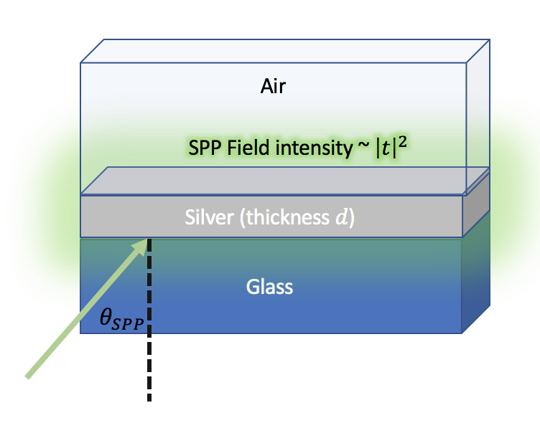

Figure 1 Illustration of Kretschmann-Raether excitation of SPPs on a silver film of thickness $d$.

The Transfer Matrix Equations5 for an *L-*layer structure with variations only along the *z*-axis can be written as

$$\left(\begin{matrix}E_{1}^{+} \\ E_{1}^{-}\end{matrix}\right)=\left(\begin{matrix}M_{1,1} & M_{1,2} \\ M_{2,1} & M_{2,2}\end{matrix}\right)\left(\begin{matrix}E_{L}^{+} \\ E_{L}^{-}\end{matrix}\right), (S10)$$

where the elements $M_{1,1}$ depend on the material properties (i.e. the refractive index *n*) and the geometry of each layer, as well as on the frequency and polarization of incident light. This formalism assumes that layer 1 and *L* are semi-infinte materials with real refractive indices; however, all intermediate layers have finite thickness and may consist of materials with complex refractive indices. The 2x2 $M$ matrix can be computed from the following product of matrices:

$$\left(\begin{matrix}M_{1,1} & M_{1,2} \\ M_{2,1} & M_{2,2}\end{matrix}\right)=D_{1}^{-1} \left(\prod_{l=2}^{L-1}{D_{l} P_{l} D_{l}^{-1}}\right)D_{L}. (S11)$$

The $P$ matrix is defined for each finite-thickness layer as

$$P_{l}=\left(\begin{matrix}\exp\left(i ϕ_{l}\right) & 0 \\ 0 & \exp\left(-i ϕ_{l}\right) \end{matrix}\right), (S12)$$

where $ϕ_{l}=k_{z,l} d_{l}$ where $d_{l}$ is the thickness of the $l^{th}$ layer of the structure,

$$k_{z,l}= \sqrt{{\left(n_{l}\frac{ω}{c}\right)}^{2}-{\left(n_{l}\sin\left(θ_{1}\right)\frac{ω}{c}\right)}^{2}}, (S13)$$

$θ_{1}$ is the angle of incidence of light at frequency $ω$ upon the structure and $n_{l}$ is the refractive index of the $l^{th}$ layer at frequency $ω.$ If the incident light is s-polarized, then the $D$ matrix for the $l^{th}$ layer has the form

$$D_{l}=\left(\begin{matrix}1 & 1 \\ n_{l}\cos\left(θ_{l}\right) & -n_{l}\cos\left(θ_{l}\right)\end{matrix}\right), (S14)$$

while if the light is p-polarized, the $D$ matrix for the $l^{th}$ layer has the form

$$D_{l}=\left(\begin{matrix}cos⁡(θ_{l}) & cos⁡(θ_{l}) \\ n_{l} & -n_{l}\end{matrix}\right), (S15)$$

where $θ_{l}$ is the refraction angle in the $l^{th}$ layer determined by Snell’s law.

The amplitudes $E_{1}^{+}$ and $E_{1}^{-}$ are interpreted as the incoming and outgoing wave amplitudes on the incident side, respectively; similarly, $E_{L}^{-}$ and $E_{L}^{+}$ are interpreted is the incoming and outgoing wave amplitudes on the terminal side, respectively. With access to the field amplitudes and wavevectors, a number of useful quantities may be computed. For example, the Fresnel reflection and transmission amplitudes may be computed as $r=\frac{E_{1}^{-}}{E_{1}^{+}}$ and $t=E_{L}^{+}$. For the analysis of reflection experiments, $E_{1}^{+}= 1$ and $E_{L}^{-}= 0$ by convention. Consideration of Eq. (S1) under these conditions leads to expressions for the reflection and transmission amplitudes in terms of the elements of the $M$ matrix,

$$r=\frac{M_{2,1}}{M_{1,1}} (S16)$$

$$t=\frac{1}{M_{1,1}}. (S17)$$

The reflection can then be calculated as $R {=\left|r\right|}^{2},$ the transmission as $T={\left|t\right|}^{2}\frac{n_{L}\cos\left(θ_{L}\right)}{n_{1} cos⁡(θ_{1})}.$ The absorption at a given frequency, which can be taken to be equal to the emissivity by Kirchoff’s law, can simply be computed as $ϵ\left(ω\right)= A\left(ω\right)= 1-T\left(ω\right)- R\left(ω\right).$ The transfer matrix equations can be used to compute the stored energy of the Bragg Relector ($P_{BR}\left(ω\right)$) as well, which is a key quantity for assessing the degree of critical coupling. Following the discussion by Piper and Fan6, the amplitude associated with the stored energy in a lossless resonant reflector ($E_{S}$) can be related to the incoming and outgoing wave amplitudes according to

$$E_{S}={\left|\frac{E_{1}^{-}+E_{1}^{+}}{\sqrt{2γ_{l}}}\right|}^{2} (S18)$$

where $γ_{l}$ is the leakage rate associated with the Bragg reflector. From Eq. S10, the stored energy spectrum can be calculated for a given frequency as

$$E_{s}=\frac{\left(r+1\right)\left(r^{*}+1\right)}{2γ_{l}}. (S19)$$

**Transmittance of SiC reference substrate**

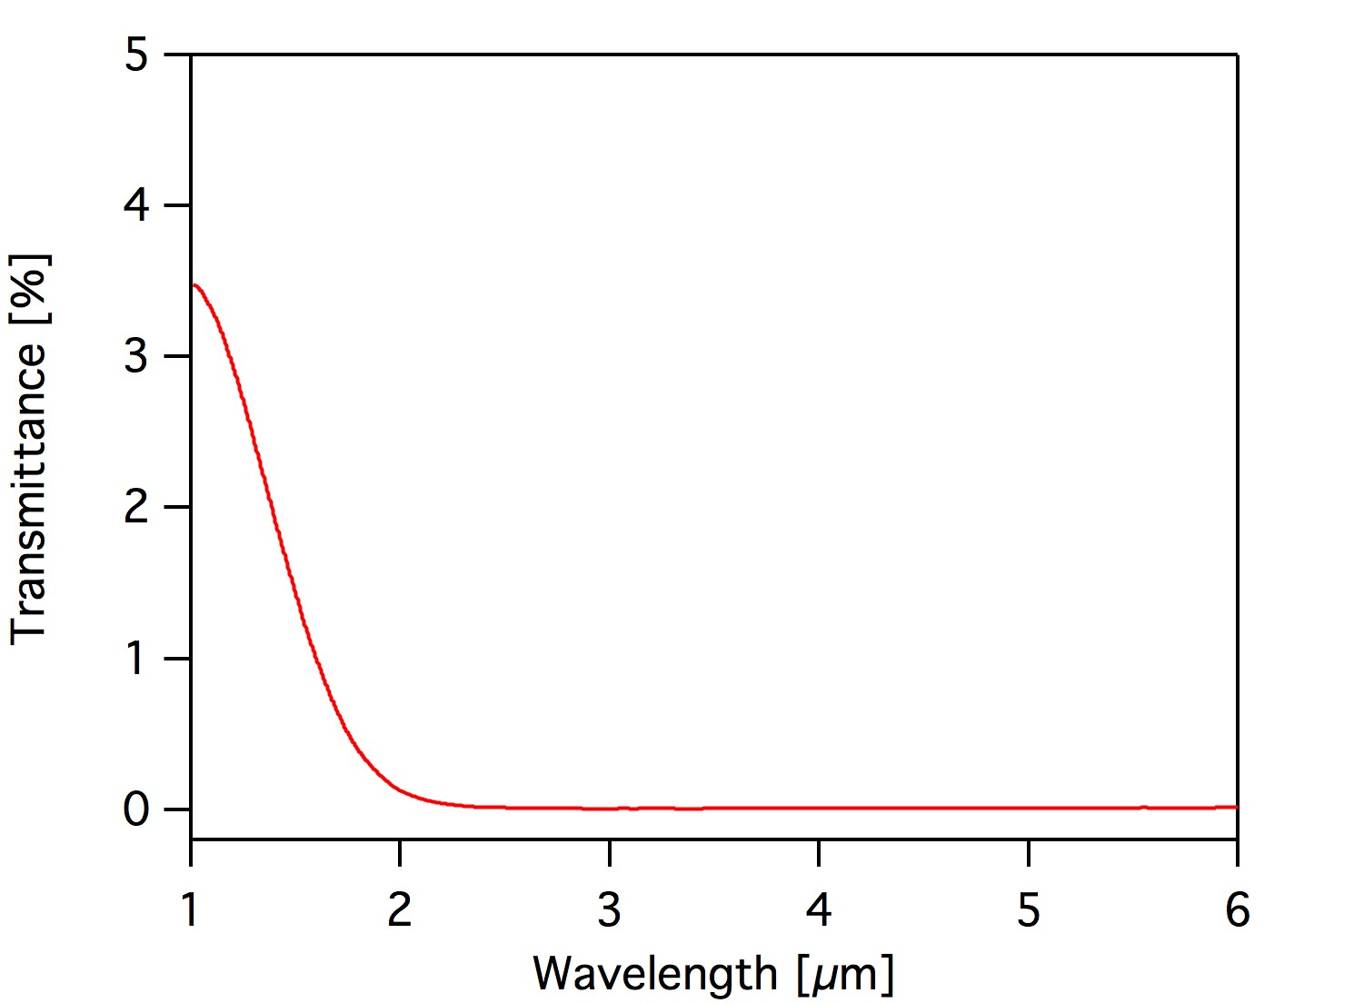

**Figure S7.** Transmittance of SiC substrate.

**Sensitivity analysis for experimental variables**

1. **Temperature**

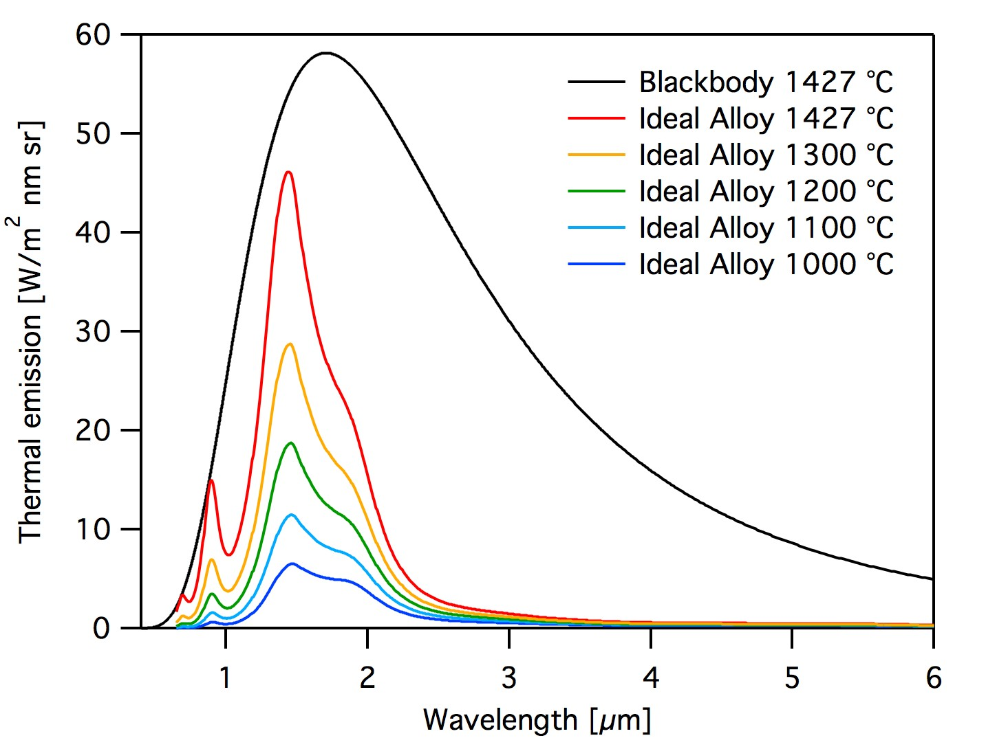

**Figure S8.** Calculated thermal emission spectra of designed alloy + 4 layer BR + W structure at varied temperatures.

|  |  |  |  |  |  |
| --- | --- | --- | --- | --- | --- |
| T [°C] | 1000 | 1100 | 1200 | 1300 | 1427 |
| *P* [W/cm2] | 2.0 | 3.3 | 5.2 | 7.8 | 12.1 |
| ηs [%] | 55.4 | 57.5 | 58.8 | 59.5 | 59.8 |

**Table S3.** Spectral density (*P*) and spectral efficiency (ηs) of alloy + BR + W at varied temperatures

As operation temperature decreases from 1427 °C to 1000 °C, the ηs decrease marginally while the *P* dramatically decreases.

1. **Oxide layer thickness**

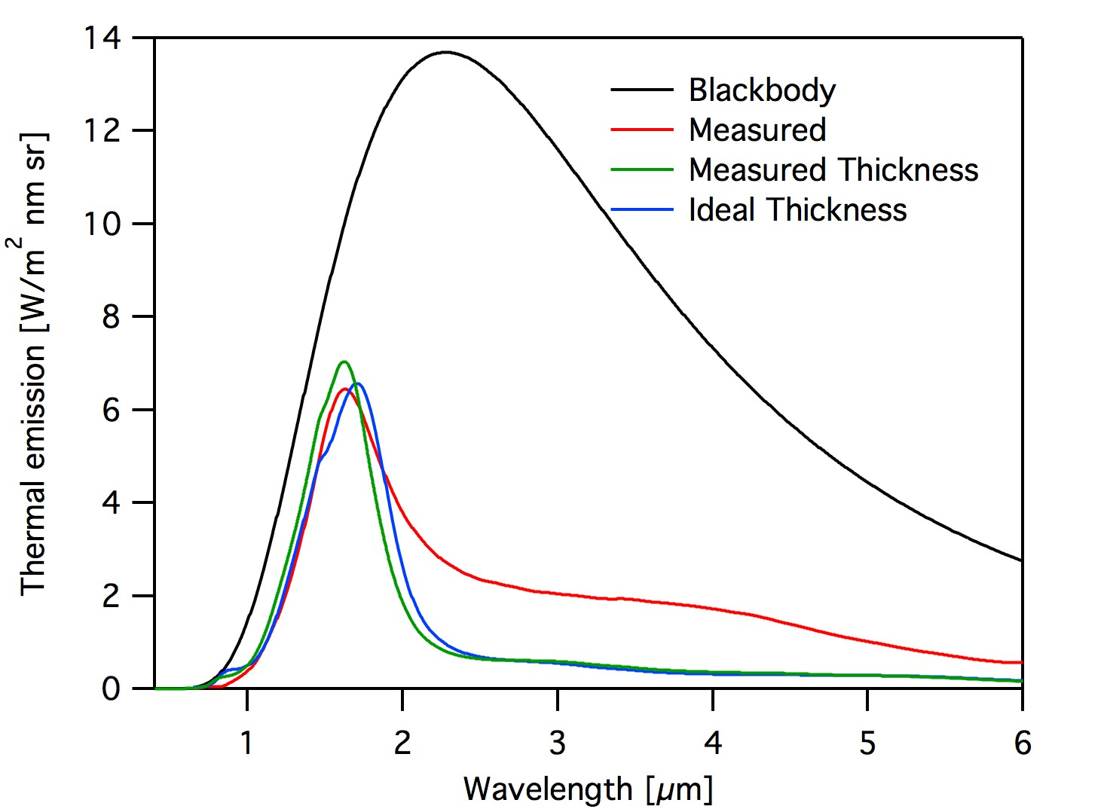

**Figure S9.** Thermal emission spectra of BR/W at 1000 °C for varied layer thickness. Red line is the measured spectrum. Green line is the spectrum calculated from the model with each layer thickness measured by spectroscopic ellipsometry. Blue line is the spectrum calculated from the model with the desired layer thickness.

|  |  |  |  |
| --- | --- | --- | --- |
| Sample | Measured  Emission | Measured Thickness | Ideal  Thickness |
| *P* [W/cm2] | 2.0 | 1.8 | 1.9 |
| ηs [%] | 34.1 | 52.6 | 54.5 |

**Table S4.** Spectral density *P* and spectral efficiency ηs of alloy/BR/W

The fabricated BR/W has slightly thinner oxide layers by ~6% on average than the intended structure. The peak emission of the fabricated sample (green curve) blueshifts by 0.09 μm compared to that of the designed structure (blue curve). As a result, both spectral density and spectral efficiency decrease by ~3 %. The measured spectrum displays undesirable thermal emission in mid IR range (> 2.3 μm, see main text), which results in a significantly reduction in ηs.

1. **Alloy model**

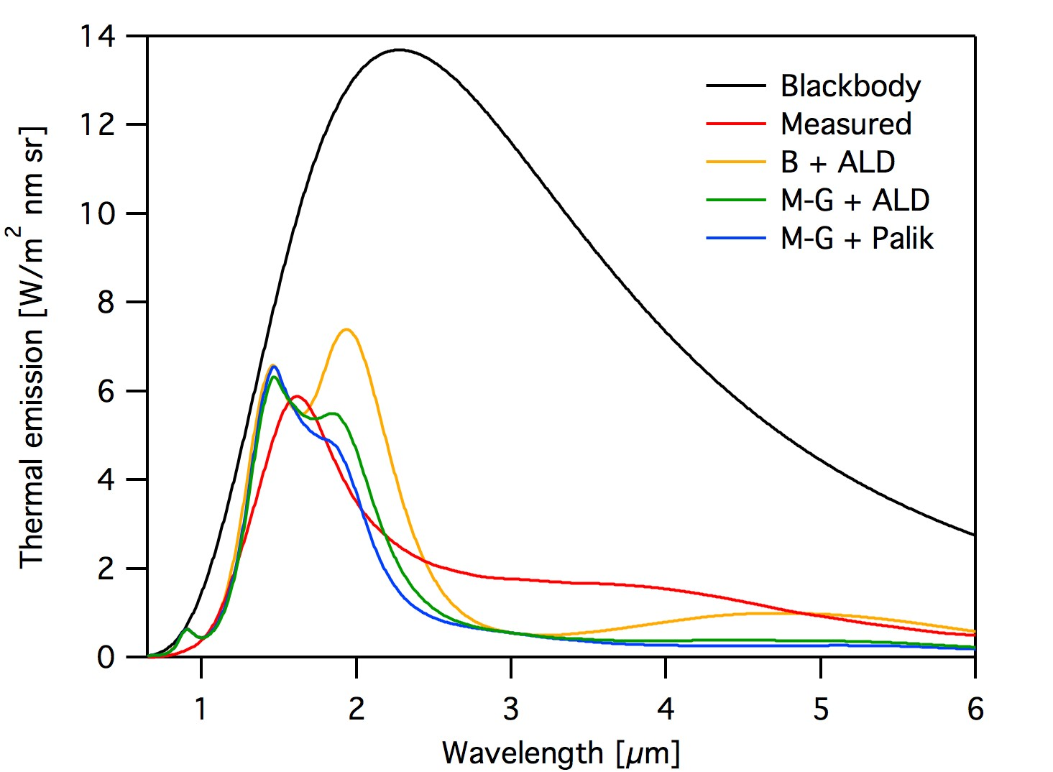

**Figure S10.** Thermal emission spectra of Alloy/BR/W at 1000 °C calculated from varied alloy models and optical constants of W. Red: measured spectrum; yellow: Bruggeman model with optical constants of ALD W, green: Maxwell-Garnett model with optical constants of ALD W; blue: Maxwell-Garnett model with optical constants of W Palik.

|  |  |  |  |  |
| --- | --- | --- | --- | --- |
| Sample | Measured | B + ALD W | M-G + ALD W | M-G + Palik W |
| *P* [W/cm2] | 3.0 | 3.1 | 2.2 | 2.0 |
| ηs [%] | 35.2 | 49.4 | 54.5 | 55.4 |

**Table S5**. Spectral density *P* and spectral efficiency ηs of alloy + BR + W

Depending on model to describe refractive index of alloy (Bruggeman vs. Maxwell-Garnett), and that of each constituting element in alloy (Palik W vs. ALD W), the spectral density and spectral selectivity may differ significantly.

**Overall Thermophotovoltaic System Efficiency**

$η_{TPV}$ as calculated here does not include other important factors in total thermophotovoltaic system efficiency such as the PV cell ($η_{PV}$) and efficiency with which the emitter structure can be heated ($η_{Q}$); the overall device efficiency will be a product of these two efficiencies with the spectral efficiency ($η_{S}$).7 The considerations that are required to determine $η_{PV}$ are complex and depend on factors including material properties of the cell, the cell temperature, as well as the properties of the incident radiation. An important contributing term to $η_{PV}$ is the ratio of the open circuit voltage to the band-gap voltage, $\frac{V_{op}}{V_{bg}},$ which increases asymptotically with increasing carrier density generated in the cell.7 This highlights the practical implications of the emitter figures of merit: a high value of $η$ will reduce thermalization losses in the cell, while a high value of $ρ$ minimizes loss of open-circuit voltage.

The thermophotovoltaic efficiency, ηtpv, of a hypothetical system may be predicted from the parameters of relevant system previously reported. ηtpv is determined by the ratio of electrical output power density from the solar cells (Pel) over radiant input power density (Prad). This is based on the assumption that the view factor from emitter to cell is unity and energy loss from the side surfaces of the emitter is negligible. The electrical output power density is defined as

*Pel* = JSCVOCFF $(S20)$

with JSC, VOC and FF, short-circuit current, open circuit voltage, and fill factor, respectively.8 JSC is given by

$$J_{SC}=\int_{0}^{λ_{g}}{E\left(λ\right)}SP\left(λ\right)dλ (S21)$$

where E(λ) and SP(λ) are the spectral distribution of emissive power density and the spectral response of the photovoltaic cell.9

**Reference**

1. Lipson, A.; Lipson, S. G.; Lipson, H., *Optical Pyhysics* (4th Edition), Cambdridge University Press: Cambridge, 2011; pp 383.

2. Lynch, D. W.; Hunter, W. R., Comments on the Optical Constants of Metals and an Introduction to the Data for Several Metals A2 - Palik, Edward D. In *Handbook of Optical Constants of Solids*, Academic Press: Burlington, 1997; pp 275-367.

3. Herzinger, C. M.; Johs, B.; McGahan, W. A.; Woollam, J. A.; Paulson, W., Ellipsometric determination of optical constants for silicon and thermally grown silicon dioxide via a multi-sample, multi-wavelength, multi-angle investigation. *Journal of Applied Physics* **1998,** *83* (6), 3323-3336.

4. Bohren, C. F.; Clothiaux, E. E.; Huffman, D. R., *Absorption and Scattering of Light by Small Particles*. Wiley-VCH: 2009.

5. Yeh, P., *Optical Waves in Layered Media*. Wiley: 2005.

6. Piper, J. R.; Fan, S., Total Absorption in a Graphene Monolayer in the Optical Regime by Critical Coupling with a Photonic Crystal Guided Resonance. *ACS Photonics* **2014,** *1* (4), 347-353.

7. Zhou, Z.; Sakr, E.; Sun, Y.; Bermel, P., Solar thermophotovoltaics: reshaping the solar spectrum. In *Nanophotonics*, 2016; Vol. 5, p 1.

8. Rephaeli, E.; Fan, S., Absorber and emitter for solar thermo-photovoltaic systems to achieve efficiency exceeding the Shockley-Queisser limit. *Opt. Express* **2009,** *17* (17), 15145-15159.

9. Qiu, K.; Hayden, A. C. S.; Mauk, M. G.; Sulima, O. V., Generation of electricity using InGaAsSb and GaSb TPV cells in combustion-driven radiant sources. *Solar Energy Materials and Solar Cells* **2006,** *90* (1), 68-81.