# Lab 7 Networking and Security Submitted by Srivatsa Lasya Priya Oruganti 110094384

In this lab, you will be able to practice the firewall commands using iptables and see its effect.

The iptables rule is specified using the following format

Here adding the rule is specified by –A. You can also change to -D for deletion or –I for insertion (at somewhere of the chain). If -t does not occur, the default table filter is assumed. Note 1: for each problem, write details and use the screenshot as evidence (for your solution). If there is no question there, explain the rule and give screenshot to show what happens if the rule is executed.

Note 2: In the following, we use sudo to show the root privilege. But if we use docker-compose to simulate VMs, VM might automatically have the root privilege and so sudo is not needed.

Note 3: In our docker-compose, we simulate two networks: 10.9.0.0/24 (hosts: 10.9.0.5,

10.9.0.11) and 192.168.60.0/24 (hosts: 192.168.60.5, 192.168.60.6, 192.168.60.7,

192.168.60.11), where 10.9.0.11 and 192.168.60.11 belong to router. You can use command route to see the routing table on each VM.

Note 4. All firewall rules are run on router VM.

1. Use the following commands on router to set the default policies for a table.

sudo iptables –P INPUT ACCEPT sudo iptables –P OUTPUT ACCEPT sudo iptables –P FORWARD DROP

Recall, INPUT is to check incoming packet; OUTPUT is to check outgoing packet; FORWARDING is to check the passing packet (at router). Further, the commands assume the default table filter (-t filter).

* On 192.168.60.6, run $ ping 10.9.0.5 and then ping 192.168.60.11. Does it succeed? Explain your observation.

We have done FORWARD DROP hence we don’t see anything on the client side

* Change DROP to ACCEPT, for FORWARD case. Try the pings in the above step again. Now does it succeed?

Yes it

s

ucceded as we d

id FORWARD ACCEPT

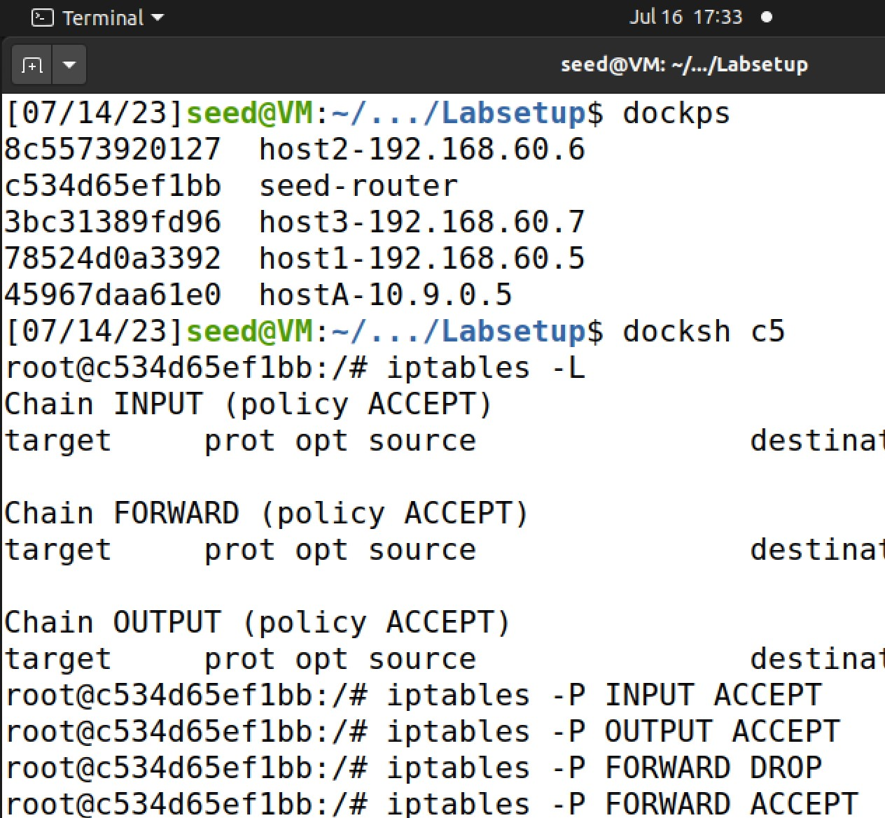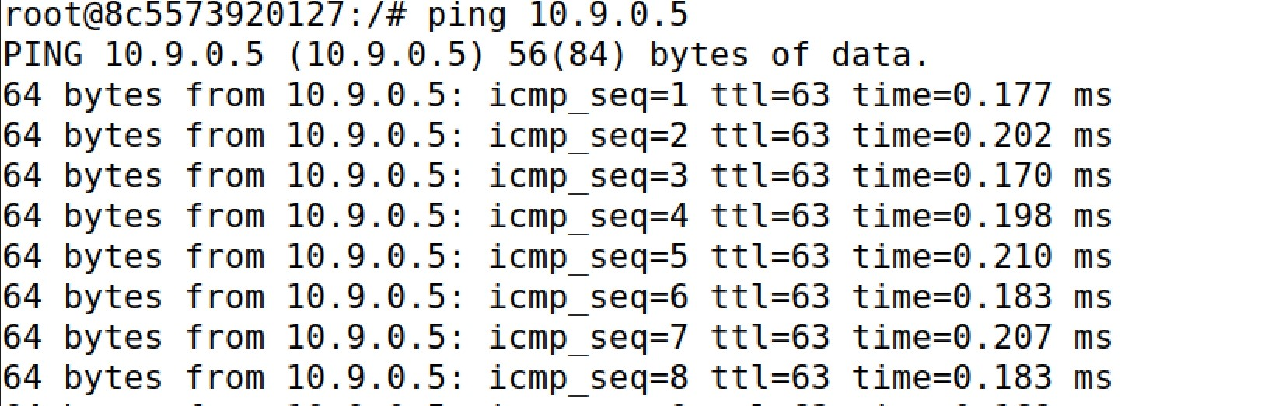

2. [blocking an IP]

• On 192.168.60.11, if we want to block packets from an ip address IP1, use command sudo iptables -A INPUT -s IP1 -j DROP

/*this uses INPUT chain because it is incoming packet*/

# SEED SERVER :-



**HOST1:-**

On IP1, ping 192.168.60.11 and what can be observed? Explain.

**This indicates that the packets from HOST1 are being blocked and discarded by the firewall rule on 192.168.60.11.**

• On 192.168.60.11, if we want to block packets to an ip address IP1, use command sudo iptables -A OUTPUT -d IP1 -j DROP

/*this uses OUTPUT chain because it is outgoing packet*/

On 192.168.60.11, ping IP1 and what can be observed? Explain

**This indicates that the packets sent to HOST1 are being blocked and discarded by the firewall rule on 192.168.60.11.**

3. [List all rules] do it on Router.

* You can see all the firewall rules by the following command $ sudo iptables -L

/* again, this assume filter table (i.e., -t filter) by default*/

* You can see all the fire rules in each chain with index number. The index will be used for other operation such as deletion later.

$ sudo iptables -L --line-number

4. [Delete a rule] on Router, delete a rule in a chain (such as INPUT) in two steps:

first, list with index:

$ sudo iptables –L INPUT --line-number

Then, delete the rule using the index:

$sudo iptables -D INPUT 1

Now use the method to delete the first rule in your current INPUT table and then $ sudo iptables -L INPUT to verify whether rule 1 is deleted or not.

5.[Delete all rules in a TABLE] On router, flush the rules in a table (e.g., filter):

$sudo iptables -t filter -F

/*again,-t filter can be omitted*/

Then, run $sudo iptables -L and you will not see any rule.

1. [Drop all incoming connections, except telnet] On router, block incoming connections to any service except for telnet. To do this, we can set default policy for INPUT chain of filter Table to be DROP and then specify a rule to accept incoming telnet connection.

$ sudo iptables -P INPUT DROP

$ sudo iptables -A INPUT -p tcp - -dport 23 -j ACCEPT

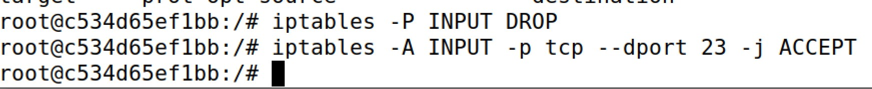

/* A default policy is applied only if all the rules in the chain have been executed without making a decision (either ACCEPT or DROP or REJECT). For example, if we ssh to router, then the rule does not ACCEPT but also not REJECT. So the default policy applies. Note: here -p stands for protocol. */

Then, ping and telnet to 192.168.60.11 (from other VM). Which succeeds (telnet or ping)?

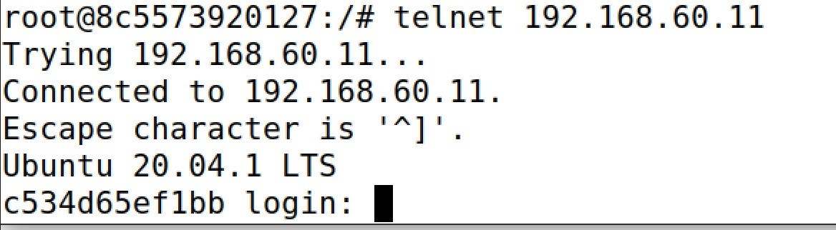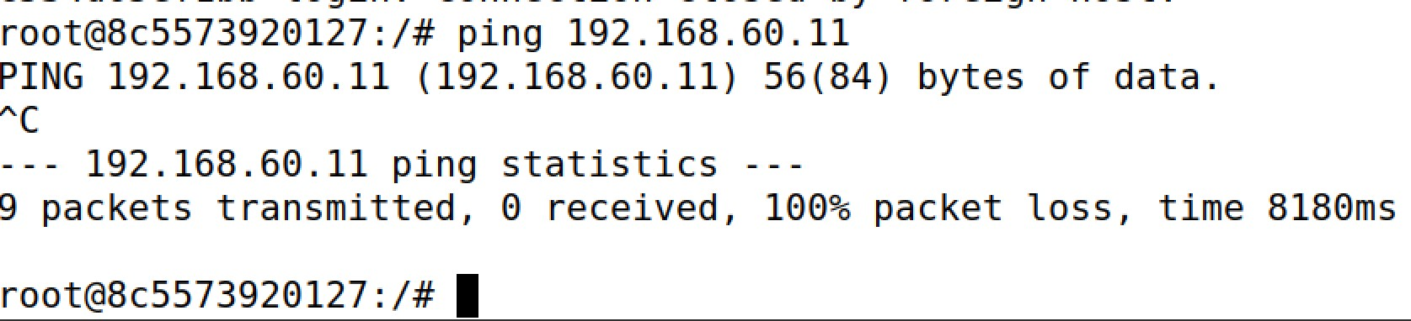

/*after this problem, run $ sudo iptables -F to flush all rules in filter table and recover the default policy: $ sudo iptables -P INPUT ACCEPT */

1. [drop outgoing DNS request to 8.8.8.8] In this case, since it is outgoing packet, we add rule to OUTPUT chain. Since it is DNS request, the destination should be the DNS server, which has a port number 53. Finally, since DNS is implemented using UDP, we use protocol UDP. Hence, we add the following rule:

$ sudo iptables -A OUTPUT -p udp - - dport 53 -d 8.8.8.8 -j DROP

Then, try $ dig www.uwindsor.ca and dig @8.8.8.8 www.uwindsor.ca. Which succeeds?

**This :- dig @8.8.8.8** [**www.uwindsor.ca**](http://www.uwindsor.ca/) **will succeed as it bypasses the firewall**

1. [block incoming ping request] You can not ping uwindsor webserver. Most likely, this is blocked by firewall of uwindsor. Here is the way to block an incoming icmp request.

$ sudo iptables -A INPUT -p icmp --icmp-type echo-request -j DROP

Run this on router and ping router from another VM. Do you get any reply? Explain.

**After adding the iptables rule to block incoming ICMP echo request packets, any attempts to ping the router from another VM will not receive a reply. The ICMP packets will be dropped by the router's firewall, effectively preventing the ICMP echo requests from reaching the router and being responded to.**

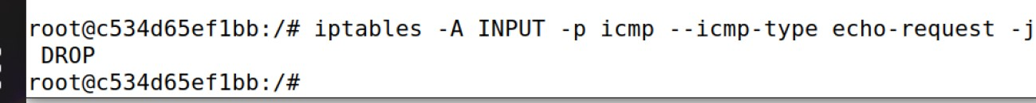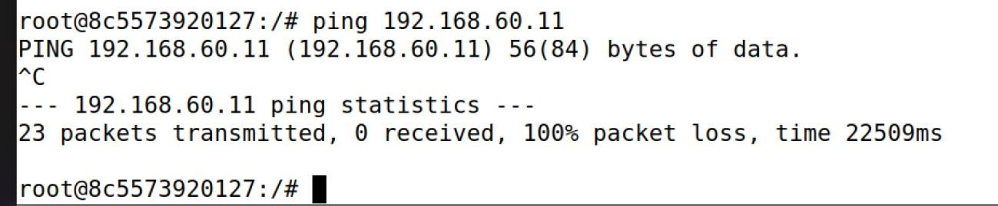

9. Suppose that you want to block all incoming connections while you do not want your visit to external servers to be affected. However, if you send a request to an external server, the server will reply to you while this packet will be blocked by your firewall. To resolve this issue, you should regard the response packet (to your request) as related to your outgoing request packet and allowed to come in. This is achieved using the conntrack module.

$ sudo iptables -P INPUT DROP

$ sudo iptables -A INPUT -p tcp -m conntrack --ctstate RELATED, ESTABLISHED -j ACCEPT

Try this on router VM. Then, telnet to a VM (e.g. 192.168.60.7).

Next, telnet from the latter (192.168.60.7) to router. Which telnet session directly succeeds?

**The telnet session initiated from the router VM to another VM is considered an outgoing connection. Since the response packets from the other VM are related to the outgoing telnet request, they are allowed to come in by the conntrack rule. Therefore, this telnet session will directly succeed, and you should be able to establish a connection.**

**The telnet session initiated from the latter VM to the router VM is considered an incoming connection. However, due to the default policy set to DROP and the conntrack rule only allowing related and established connections, this telnet session will not directly succeed** 10 (optional) [save your firewall rules and restore it] After you have done firewall, you want to save your rules to a file you can run $ sudo iptables-save >myiptables.rules

Later, you can restore your rules by running

$ sudo iptables-restore <myiptables.rules

/* to see the effect, you can flush your firewall after running iptables-save command and then

run iptables-restore command to see if you have restored your firewall *

