Story of Knowledge Graph

# A knowledge graph is a way to represent knowledge

## It helps us to easily visualize all the information in a more intuitive way

## It helps to find objects - controlled vocabularies and ontologies

## It answers questions - knowledge graph on the web: the SPARQL query language

## It generates hypotheses - knowledge plus computation = inference, the ABC model

# The objects in knowledge graphs are organized in ontologies

## An ontology is defined as “the branch of metaphysics dealing with the nature of being”

## In practice, it is a set of concepts, definitions and inter-relationships.

## There are hundreds of ontologies in biology.

# A good example of an ontology is the Gene Ontology (GO)

## Started in 1999 as a collaboration among three Model Organisms Databases

## It is a set of concepts and their relationships to each other organized within a hierarchy

## It is a way to capture biological knowledge for individual gene products in a way computers understand

### Graph GO

# GO Branches

## An ontology like GO allows to define different aspects of biological knowledge

## Molecular function - An elemental task or job

## Biological process - A commonly recognized series of events

## Cellular component - Where gene production is located

# But at times, an ontology like GO is not enough.

## Knowledge graphs, or knowledge bases, go one step further than ontologies or databases

## It is an integrated collection of claims that can be represented in a graph

## They help with the communication between machines and humans, and allows for more organic and implicit information to be interpreted

# Why knowledge graphs?

## To answer explicit questions from the user

## To uncover implicit relationships that are “hidden” within daily language and context

## To go deeper in the information provided to the user

# Some famous knowledge graphs

## Wikidata

## UniProt Knowledge Base

## Microsoft knowledge graph

## Google knowledge graph

# Example of knowledge graph

# Knowledge graphs have been recently been adopted in a wide range of applications

## Knowledge graphs are especially useful to power machine learning

## This specific knowledge graph is known as a graph neural network (GNN)

## The basic idea of a GNNs is to use a neural network to obtain a representation for a node by aggregating the representations of neighboring nodes.

## Uber Eats uses it to make restaurant recommendations

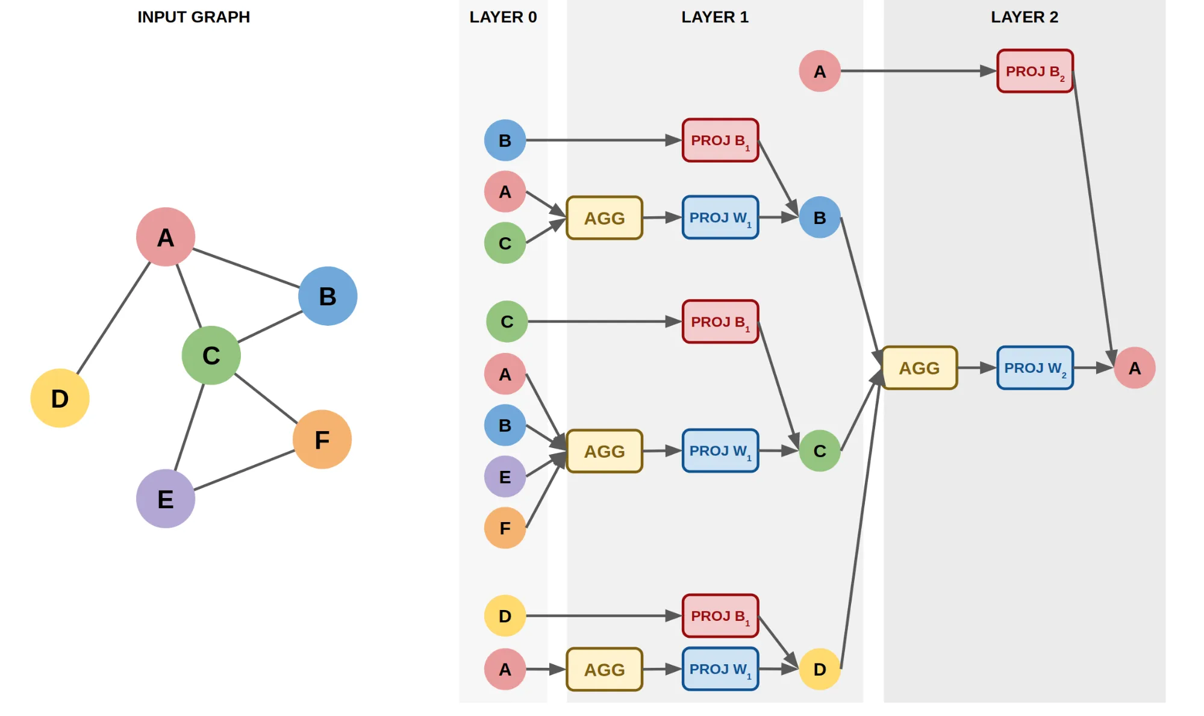

(<https://www.uber.com/en-NL/blog/uber-eats-graph-learning/>)

## NASA uses it to organize data and to make finding answers more intuitive

## Ryanair uses it to find the cheapest flights

# Ontomatica uses knowledge graphs to provide the right information regarding a product to the right user

## For example, if you are a wine lover, it can show you which wine would be best to pair with what cheese

<http://www.wineandcheesemap.com/>

## Attachment

### Wine Ontology graphs

### Cheese Ontology graphs

# But knowledge graphs can also be used for more serious applications

## One of the biggest knowledge graphs that Ontomatica uses is the PubMed knowledge graphs

<https://www.nature.com/articles/s41597-020-0543-2>

## This allows us to quickly identify reliable scientific sources

# Another useful knowledge graph is WikiPathways and Wikidata

## Wikidata is a community-maintained knowledge base that has been assembled from repositories in the fields of genomics, proteomics, genetic variants, pathways, chemical compounds, and diseases

## Building on that, the WikiPathways knowledge graphs help to visualize how genetic metabolic disorders are related.

## They explain groups of chemical reactions within their biological context.

## They offer visual representations of biological pathway diagrams, which provide intuitive ways to study the complex metabolic processes.

<https://link.springer.com/chapter/10.1007/978-3-030-67727-5_73>

# TODO

update GO

update SVGs to fit better

fish oil - wedge

# references

https://www.blog.google/products/search/introducing-knowledge-graph-things-not/

https://www.libremfg.com/reimaging-data-infrastructure-and-mes-part-1-the-manufacturing-knowledge-graph/