Document date: 2023-11-28

Story of Wheat

# Page Design

## Option 1

### Page control

#### Page background: dark

#### Background image: background-130F30-constellation

#### Page text color: light

### Grid content

#### Grid format: [value]

#### **IF**-grid diagram – persona

##### Persona gender: [value]

##### Persona attire: [value]

##### Persona hair: [value]

##### Persona hat: [value]

##### Persona accessories: [value]

#### **IF**-grid diagram – function

##### Property-1: [value]

#### Property-2: [value]

### IF-attachment

#### Attachment theme: null (white background)

#### Attachment text color: dark

#### Attachment image: [value]

#### Attachment links: [value]

### IF-outlink

#### Image: ontomatica-symbol-w33-h36-color-1F64FF-bgnd-white.svg

## Option 2

### Page control

#### Page background: light

#### Background image: fractal

#### Page text color: dark

### Grid content

#### Grid format: [value]

#### **IF**-grid diagram – persona

##### Persona gender: [value]

##### Persona attire: [value]

##### Persona hair: [value]

##### Persona hat: [value]

##### Persona accessories: [value]

#### **IF**-grid diagram – function

##### Property-1: [value]

#### Property-2: [value]

### IF-attachment

#### Attachment theme: dark

#### Attachment text color: light

#### Attachment image: [value]

#### Attachment links: [value]

### IF-outlink

#### Image: ontomatica-symbol-w33-h36-color-202125-bgnd-white.svg

# Landing Page

## Story of Wheat

### Title

#### Part of Education Series: Connect the Dots

### Page control

#### Page background: dark

#### Background image:

#### Page text color: light

# Introduction

## Issue

### There are 7 featured relationships as seen here:

#### https://afdsi.com/164189113000000061/

### The diagrams are dense and difficult to read

### Proposal

#### Use only one Relationship diagram rendered as a PNG

#### Use Panning-Media feature (similar to Constellations treatment) to zoom in on parts of the featured Relationship

#### Use Relationship Symbols (below) and Relationship thumbnails on a single page for the remaining 6 Relationships

#### Provide links to zoomable diagrams in Attachment

#### See section 8 to visualize page layout, referenced in each section below.

# Causative Relationship

## Page control

### Page background: light

### Background image: fractal

### Page text color: dark

## Grid format

### text, left; diagram, center; text right

## Relationship symbol

### Definition

#### All relationships producing an effect or being the effect of something. An expression of an agent causing or forcing a patient to perform an action (or to be in a certain condition). Functioning as an agent or cause.

### Color

#### Color-1: [value]

#### Color-2: [value]

#### Color-3: [value]

### Symbol

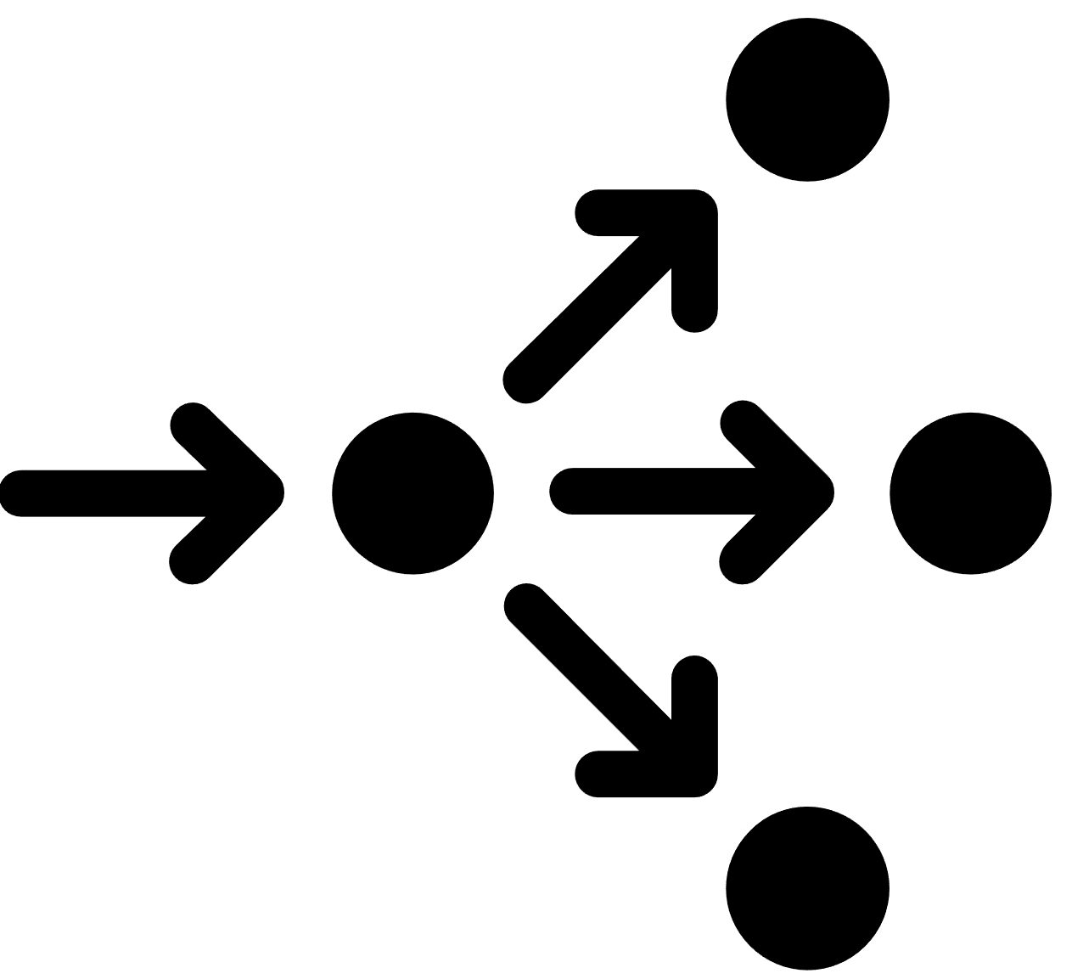

## Function diagram

### Definition

#### TBD

### Color

#### Color-1: [value]

#### Color-2: [value]

#### Color-3: [value]

### Grid content

#### Text, left (under construction)

#### Diagram, center

Function diagram

#### Text, right (under construction)

## Outlink

### Image: ontomatica-symbol-w33-h36-color-202125-bgnd-white.svg

### SVG full page

### SVG uses zoom

# Instrumental Relationship

## Page control

### Page background: light

### Background image: fractal

### Page text color: dark

## Grid format

### text, left; diagram, center; text right

## Relationship symbol

### Definition

#### Indicates all relationships serving or acting as a means or aid. By means of an instrument or an agent. The means whereby some act is accomplished.

### Color

#### Color-1: [value]

#### Color-2: [value]

#### Color-3: [value]

### Symbol



## Function diagram

### Definition

#### TBD

### Color

#### Color-1: [value]

#### Color-2: [value]

#### Color-3: [value]

### Grid content

#### Text, left (under construction)

#### Diagram, center

Function diagram

#### Text, right (under construction)

## Outlink

### Image: ontomatica-symbol-w33-h36-color-202125-bgnd-white.svg

### SVG full page

### SVG uses zoom

# Partitive Relationship

## Page control (decide)

### Page background: light

### Background image: fractal

### Page text color: dark

## Grid format

### text, left; diagram, center; text right

## Relationship symbol

### Definition

#### For continuants: C part of C' if and only if: given any c that instantiates C at a time t, there is some c' such that c' instantiates C' at time t, and c *part of* c' at t. For processes: P part of P' if and only if: given any p that instantiates P at a time t, there is some p' such that p' instantiates P' at time t, and p *part of* p' at t. (Here *part of* is the instance-level part-relation.)

### Color

#### Color-1: [value]

#### Color-2: [value]

#### Color-3: [value]

### Symbol

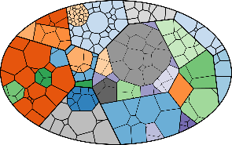

## Function diagram

### Definition

#### TBD

### Color

#### Color-1: [value]

#### Color-2: [value]

#### Color-3: [value]

### Grid content

#### Text, left (under construction)

#### Diagram, center

Function diagram

#### Text, right (under construction)

## Outlink

### Image: ontomatica-symbol-w33-h36-color-202125-bgnd-white.svg

### SVG full page

### SVG uses zoom

# Quantitative Relationship

## Page control (decide)

### Page background: light

### Background image: fractal

### Page text color: dark

## Grid format

### text, left; diagram, center; text right

## Relationship symbol

### Definition

#### All relationships involving a quantity or a measure.

### Color

#### Color-1: [value]

#### Color-2: [value]

#### Color-3: [value]

### Symbol



## Function diagram

### Definition

#### TBD

### Color

#### Color-1: [value]

#### Color-2: [value]

#### Color-3: [value]

### Grid content

#### Text, left (under construction)

#### Diagram, center

Function diagram

#### Text, right (under construction)

## Outlink

### Image: ontomatica-symbol-w33-h36-color-202125-bgnd-white.svg

### SVG full page

### SVG uses zoom

# Spatial Relationship

## Page control

### Page background: light

### Background image: fractal

### Page text color: dark

## Grid format

### text, left; diagram, center; text right

## Relationship symbol

### Definition

#### TBD

### Color

#### Color-1: [value]

#### Color-2: [value]

#### Color-3: [value]

### Symbol

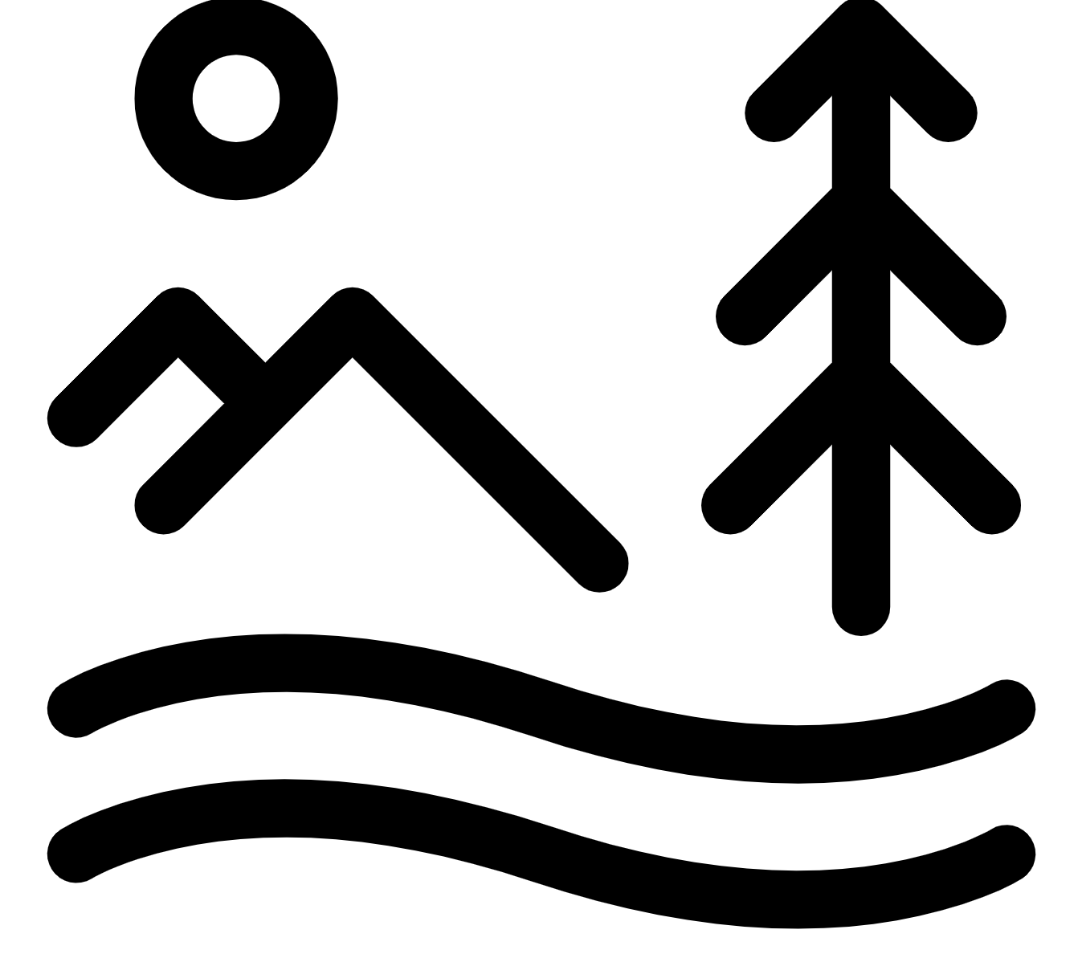

## Function diagram

### Definition

#### TBD

### Color

#### Color-1: [value]

#### Color-2: [value]

#### Color-3: [value]

### Grid content

#### Text, left (under construction)

#### Diagram, center

Function diagram

#### Text, right (under construction)

## Outlink

### Image: ontomatica-symbol-w33-h36-color-202125-bgnd-white.svg

### SVG full page

### SVG uses zoom

# Taxonomic Relationship

## Page control

### Page background: light

### Background image: fractal

### Page text color: dark

## Grid format

### text, left; diagram, center; text right

## Relationship symbol

### Definition

#### Relationships linking concepts which are related in the scientifical sense in a biological taxonomy (e.g. species, families, etc.). To relate concepts taxonomically.

### Color

#### Color-1: [value]

#### Color-2: [value]

#### Color-3: [value]

### Symbol

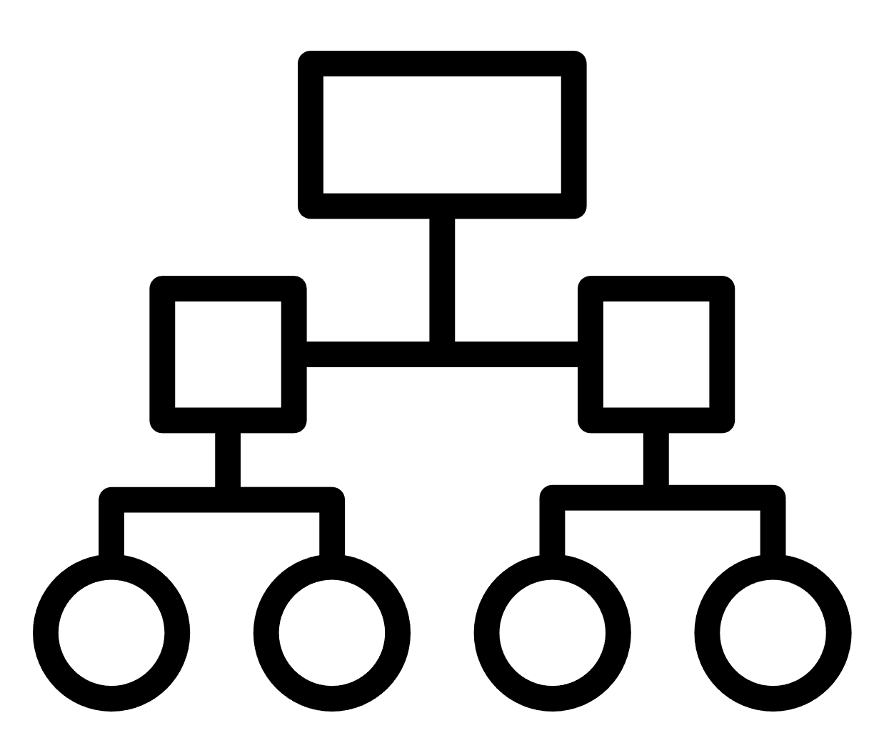

## Function diagram

### Definition

#### TBD

### Color

#### Color-1: [value]

#### Color-2: [value]

#### Color-3: [value]

### Grid content

#### Text, left (under construction)

#### Diagram, center

Function diagram

#### Text, right (under construction)

## Outlink

### Image: ontomatica-symbol-w33-h36-color-202125-bgnd-white.svg

### SVG full page

### SVG uses zoom

# Temporal Relationship

## Page control (decide)

### Page background: light

### Background image: fractal

### Page text color: dark

## Grid format

### text, left; diagram, center; text right

## Relationship symbol

### Definition

#### TBD

### Color

#### Color-1: [value]

#### Color-2: [value]

#### Color-3: [value]

### Symbol



## Function diagram

### Definition

#### TBD

### Color

#### Color-1: [value]

#### Color-2: [value]

#### Color-3: [value]

### Grid content

#### Text, left (under construction)

#### Diagram, center

Function diagram

#### Text, right (under construction)

## Outlink

### Image: ontomatica-symbol-w33-h36-color-202125-bgnd-white.svg

### SVG full page

### SVG uses zoom

# Transition slide

## Page title

### TBD

## Page control

### Page background: dark

### Background image: background-130F30-constellation

### Page text color: light

## Set up:

### Participants in the Knowledge Graph

# Biologist

## Page control

### Page background: dark

### Background image: background-130F30-constellation

### Page text color: light

## Grid format

### text, left; diagram, center; text right

## Persona

### Definition

#### Biologists study humans, plants, animals, and the environments in which they live. Biologists work in laboratories, offices, industrial settings, and outdoors.

### Reference

#### <https://www.onetonline.org/link/summary/19-1029.04>

### Gender

#### Female

### Attire

#### female-dress-t-shirt

### Hair

#### female-head-hair-hair-short

### Hat

#### none

### Accessories

#### female-neck-accessories-necklace

### Symbol

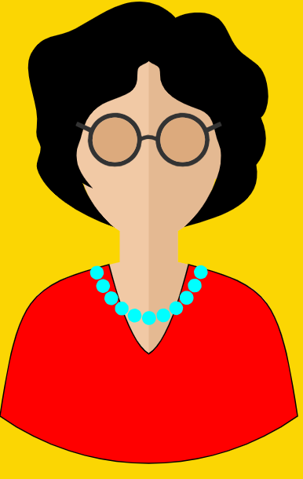

## Function diagram

### Definition

#### Reuse DNA diagram to represent Biologist focus on rice genetics

### Grid content

#### Text, left (under construction)

#### Diagram, center

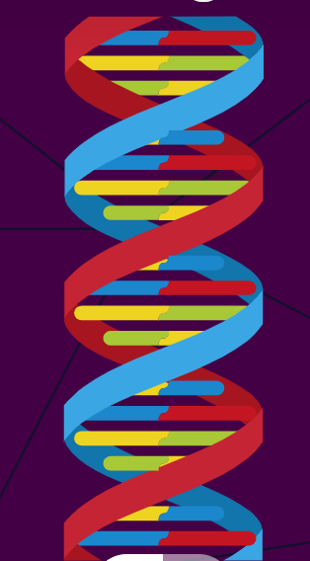

#### Text, right (under construction)

## Attachment

### Properties

#### Image:ontomatica-symbol-w33-h36-color-202125-bgnd-white.svg

#### Theme: null (white background)

#### Text color: dark

### Content

#### Under construction

# Breeder

## Page control

### Page background: dark

### Background image: background-130F30-constellation

### Page text color: light

## Grid format

### text, left; diagram, center; text right

## Persona

### Definition

#### Apply information about plant genome, hormones, proteins and their effects to modulate plant height, branching, tiller size and canopy features. So that a resultant modulated wheat plants with higher yield can be produced.

### Reference

#### https://www.onetonline.org/link/summary/19-1013.00

### Gender

##### Male

### Attire

##### male-dress-t-shirt

### Hair

##### male-head-hair, male-head-hair-facial-mustache-full

### Hat

##### none

### Accessories

##### male-head-accessory-sun-glasses

### Image

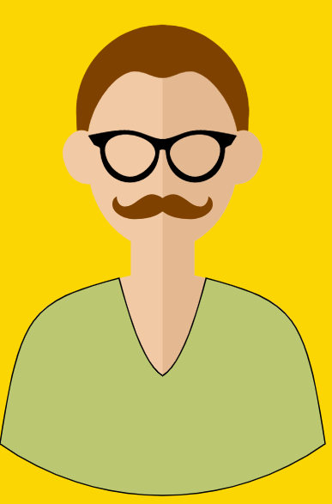

## Function diagram

### Definition

#### Wheat phenotypes (generalize; use text-left and text right to identify phenotype properties)

### Grid content

#### Heading: Wheat plant with two parts

#### Text, left: Above ground properties such as shoot phenotypes

#### Diagram, center

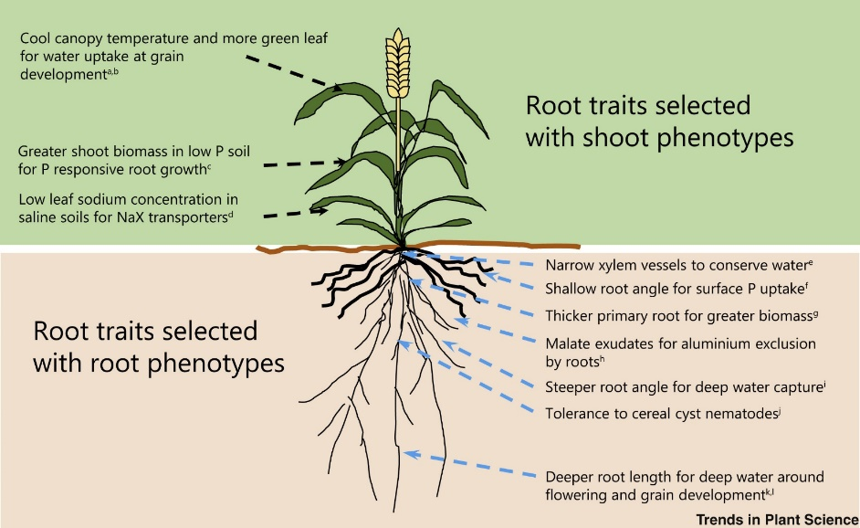

##### Text, right: Below ground properties such as root phenotypes

## Attachment

### Properties

#### Image: ontomatica-symbol-w33-h36-color-202125-bgnd-white.svg

#### Attachment theme: null (white background)

#### Attachment text color: dark

### Content

#### Under construction

# Grower (Farmer)

## Page control

### Page background: dark

### Background image: background-130F30-constellation

### Page text color: light

## Grid format

### text, left; diagram, center; text right

## Persona

### Definition

#### Raise crops, such as corn, wheat, tobacco, cotton, vegetables, fruits.

### Reference

#### https://www.bls.gov/ooh/management/farmers-ranchers-and-other-agricultural-managers.htm

### Gender

##### Male

### Attire

##### male-dress-unbuttoned-shirt, pocket

### Hair

##### male-head-hair, male-head-hair-facial-mustache-trim

### Hat

##### male-head-hat-sun-protecting-hat

### Accessories

##### none

### Image



## Function diagram

### Definition

#### Generalize. add elevation (perspective); remove mountains

#### A drome monitoring a wheat field to detect threats and apply specific solutions

### Grid content

#### Text, left (under construction)

#### Diagram, center

Function diagram

|  |  |  |
| --- | --- | --- |
| Drones Revolutionize Farmer's Lives | Drone as monitor (data collector and controllable actions)  Drone as agricultural equipment (performing specific actions) | drone Icon 5303193 |

#### Text, right (under construction)

## Attachment

### Properties

#### Image: ontomatica-symbol-w33-h36-color-202125-bgnd-white.svg

#### Attachment theme: null (white background)

#### Attachment text color: dark

### Content

#### Under construction