PRODUCTION MILESTONE · LAYER 1 METRIC GATE
PG Atlas
Ecosystem Health & Governance Report
Pipeline Validation: Deliverables A6, A7, A9, A10
Stellar Community Fund · February 2026

Field | Value
Author | Jay Gutierrez, PhD
Role | Graph Analytics and Network Science Lead
Scope | A6 (Active Subgraph), A7 (Git Log Parser), A9 (Criticality Scores), A10 (Adoption Signals)
Date | February 28, 2026
Status | Pipeline Validated — End-to-End on Real Stellar Ecosystem Data
Proposal | SCF #41 — Building the Backbone: SCF Public Goods Maintenance

Executive Summary
This report validates the PG Atlas production pipeline against real Stellar ecosystem data. The system ingests live data from GitHub (304 repositories via A7 git log parsing), crates.io (149 dependency edges resolved to GitHub URLs), deps.dev, npm, and PyPI. It constructs a multi-layer graph of 597 nodes and 309 edges, projects an active subgraph of 335 nodes (pruning 262 dormant entries), and computes a full suite of governance metrics: criticality scores, pony factor flags, HHI concentration indices, Shannon entropy, k-core decomposition, and bridge edge detection.
The Layer 1 Metric Gate applies a 2-of-3 voting rule (criticality ∩ pony factor ∩ adoption) and passes 10% of evaluated projects (4 out of 40) for Expert Review. The pony factor rate of 85% reveals that 34 of 40 evaluated repositories are dominated by a single contributor. The mean HHI of 7117.4 places the ecosystem firmly in the "Critical" concentration tier (>5,000). These are uncomfortable but honest findings — exactly the kind of signal that objective infrastructure measurement should surface.
The pipeline runs end-to-end in approximately 2 seconds on cached data, produces 7 publication-quality figures, generates JSON snapshots for longitudinal tracking, and exports Markdown governance reports. It is backed by 217 unit tests and 18 integration tests. All source code, metric algorithms, and gate logic are fully implemented and tested.
Section 1: What IS Working End-to-End
1.1 Full Ingestion Stack
The ingestion pipeline orchestrates five data sources in a single pass: GitHub API (A7 git log parsing for 304 repositories), crates.io (Cargo reverse dependencies for Soroban core crates, resolving crate names to GitHub URLs), deps.dev (npm and PyPI forward dependencies), npm registry (download counts), and PyPI (download counts). The orchestrator supports checkpoint/resume, atomic file writes, and never overwrites non-empty CSVs with empty data. On subsequent runs, it recovers all data from cached checkpoints in under 1 second.
1.2 A6 Active Subgraph Projection
The active subgraph projection filters the full graph to retain only nodes with activity within a configurable window (default: 90 days). From 597 total nodes, 335 are retained as active and 262 are pruned as dormant. ExternalRepo nodes (Soroban core dependencies that are not SCF submissions) are explicitly retained even without activity data, since they represent critical infrastructure dependencies that A7 never parses directly.
1.3 Core Metrics
Criticality Score
BFS transitive dependent count in the active subgraph, expressed as percentile ranks. Scored 115 nodes. Four Soroban core repositories (rs-soroban-env, rs-soroban-sdk, rs-stellar-xdr, rs-stellar-strkey) emerge at the 96.5th percentile — the clear structural backbone of the ecosystem.
Pony Factor
Binary flag: a repository is pony-factor-flagged when a single contributor holds ≥50% of commits. 85% of evaluated repos (34/40) are flagged, indicating systemic single-contributor risk across the Stellar public goods ecosystem.
HHI (Herfindahl-Hirschman Index)
Continuous concentration metric (0–10,000). Mean HHI = 7117.4, median = 7513.8. Both place the ecosystem in the "Critical" tier (>5,000), confirming the pony factor finding with a more nuanced continuous measure.
Shannon Entropy
Information-theoretic measure of contributor diversity. Low entropy values corroborate the HHI findings — most repositories have highly concentrated commit distributions.
K-Core Decomposition
Maximum core number = 4. K-core analysis reveals the densely interconnected substructure of the dependency graph. The 4-core contains the most tightly coupled packages.
Bridge Edge Detection
52 bridge edges identified. These are single-point-of-failure dependency links whose removal would disconnect parts of the dependency graph.
1.4 Layer 1 Gate Logic
The Metric Gate implements a 2-of-3 voting rule: a project advances to Expert Review if at least 2 of {Criticality, Pony Factor, Adoption} exceed configurable thresholds. Result: 10% pass rate (4/40), with 4 borderline cases. All thresholds are tunable parameters in pg_atlas/config.py.
1.5 Reporting Pipeline
The pipeline outputs three artifact types: (1) JSON ecosystem snapshots for machine-readable longitudinal tracking, (2) Markdown governance reports with narrative interpretations, and (3) 7 publication-quality PNG figures. Reports are auto-generated with live metric values and figure references.
1.6 Longitudinal Tracking
The snapshot comparison module (pg_atlas/metrics/snapshot_compare.py) computes deltas between any two JSON snapshots, generates a Markdown diff report, and produces a 3-panel trend figure. This enables tracking ecosystem health over time across SCF rounds.
1.7 Test Suite
217 unit tests execute in ~1.2 seconds with no network dependencies. 18 integration tests validate all ingestion clients against real APIs (skipped by default, run with --run-integration). Test coverage spans all metric algorithms, gate logic, graph construction, ingestion clients, and report generation.
1.8 CLI Interface
Full CLI entry point (python -m pg_atlas) with subcommands: run (full pipeline), ingest (data collection only), metrics (computation only), status (artifact check), viz (figure refresh), and compare (snapshot delta analysis). GITHUB_TOKEN is auto-loaded from .env.
Section 2: Visual Output Summary
Figure 1: Contributor Concentration Distribution
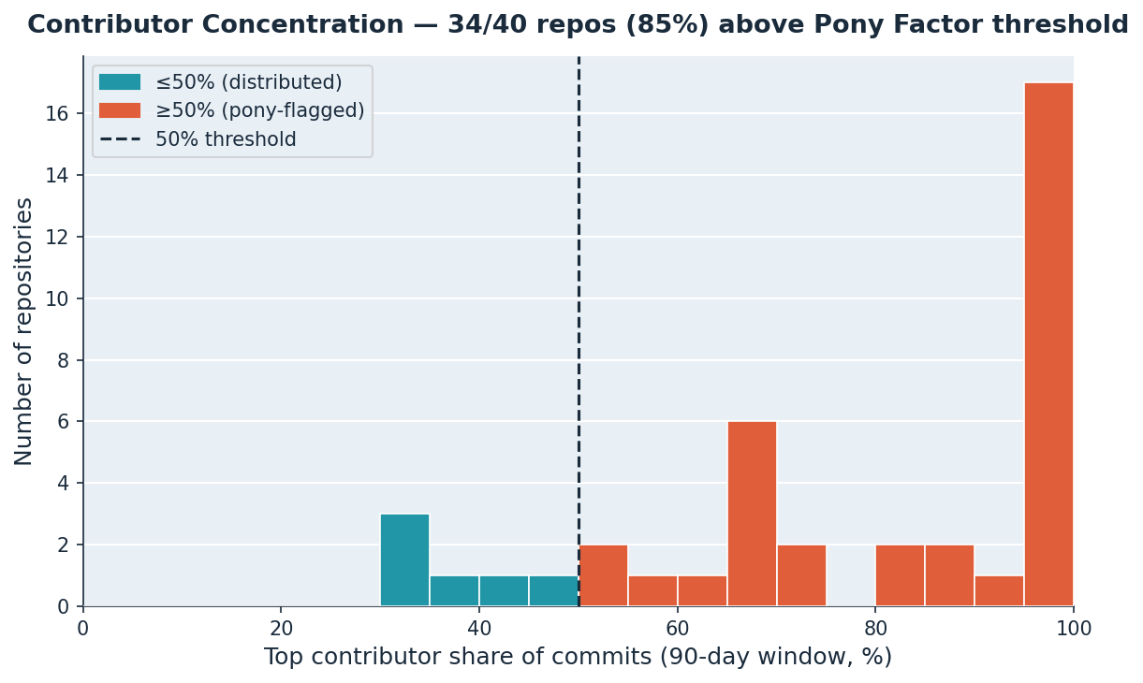
Distribution of top-contributor commit share across all evaluated repositories. The heavy right skew confirms that most repos have >70% commit concentration by their top contributor.
Figure 2: Layer 1 Metric Gate Results
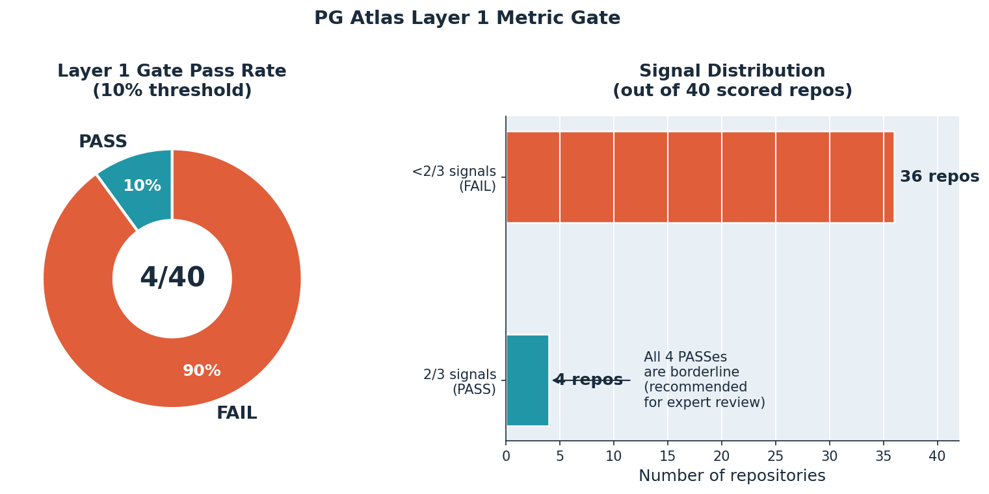
Donut chart showing pass/fail/borderline distribution with signal breakdown. 10% pass rate (4/40) reflects the high bar set by the 2-of-3 voting rule.
Figure 3: Per-Repo Concentration Risk
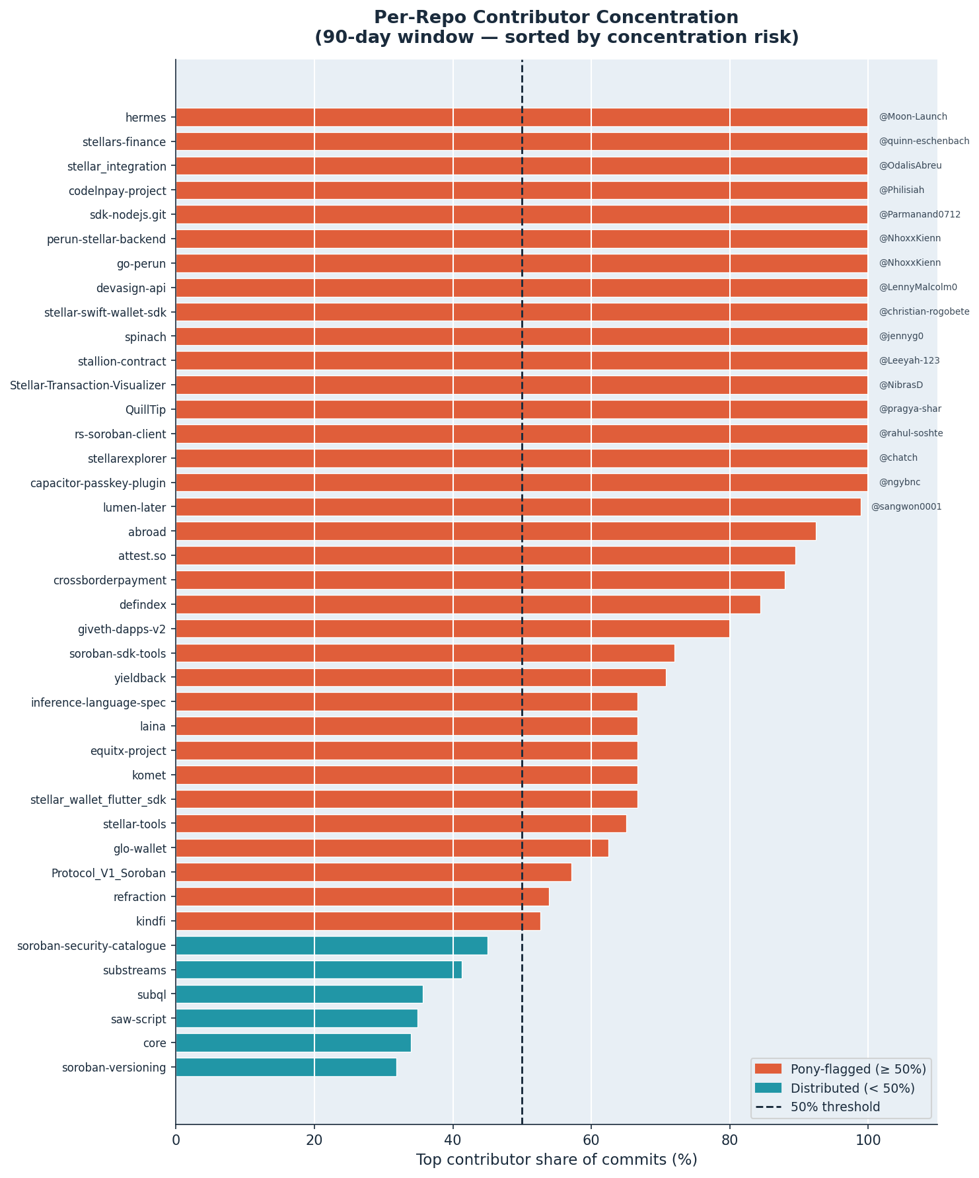
Repositories sorted by contributor concentration risk. The majority fall in the "Critical" HHI tier, visualizing the ecosystem-wide maintainer distribution challenge.
Figure 4: Soroban Dependency Hub Packages
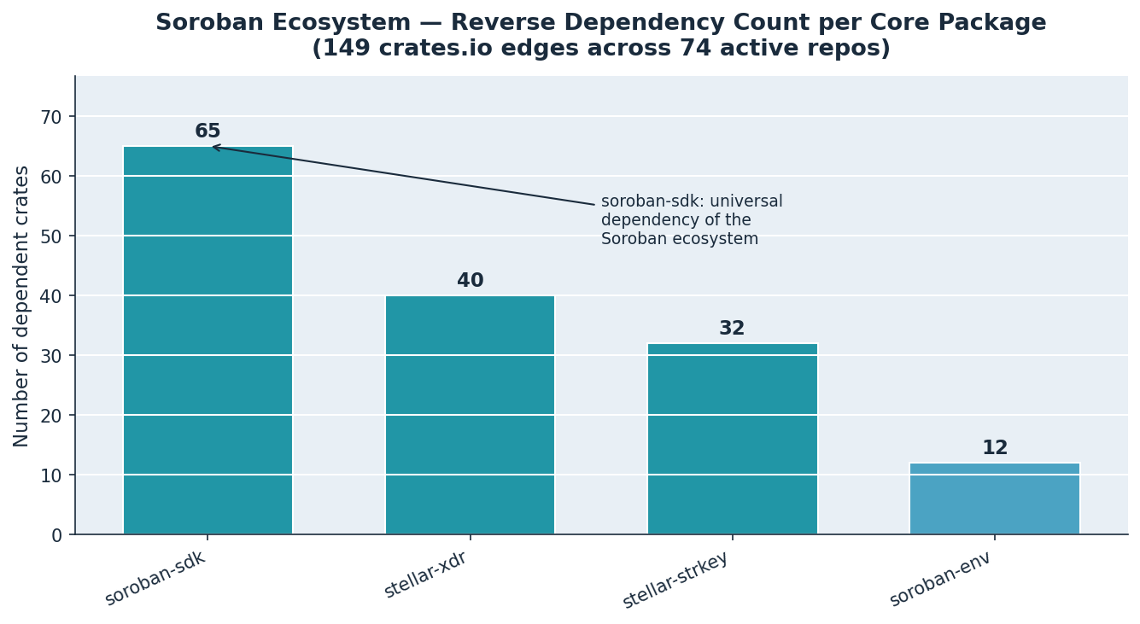
Top packages by dependent count in the Soroban ecosystem. rs-soroban-sdk and rs-stellar-xdr emerge as the primary structural hubs.
Figure 5: HHI Tier Distribution
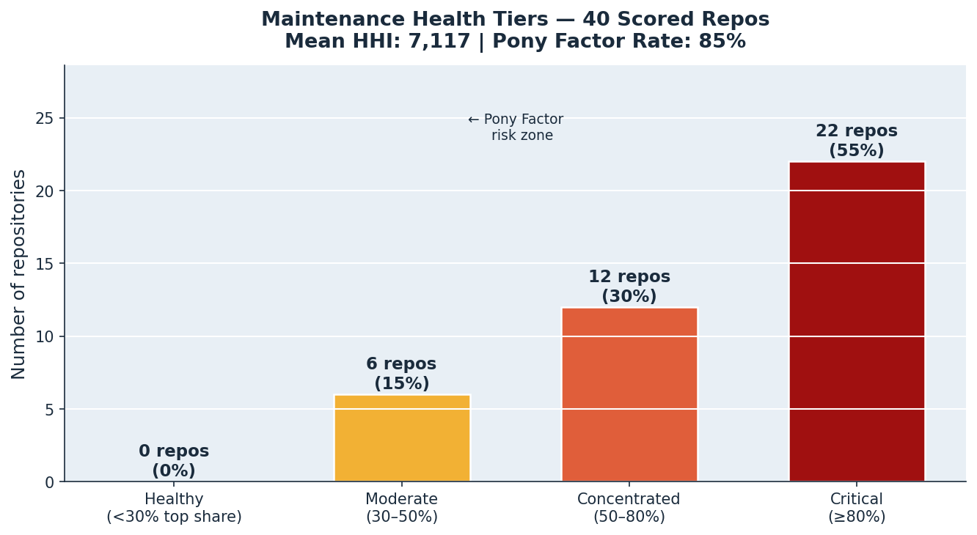
Breakdown of repositories by HHI concentration tier (Healthy < 1500, Moderate 1500-2500, Concentrated 2500-5000, Critical > 5000). The Critical tier dominates.
Figure 6: Dependency Network Graph
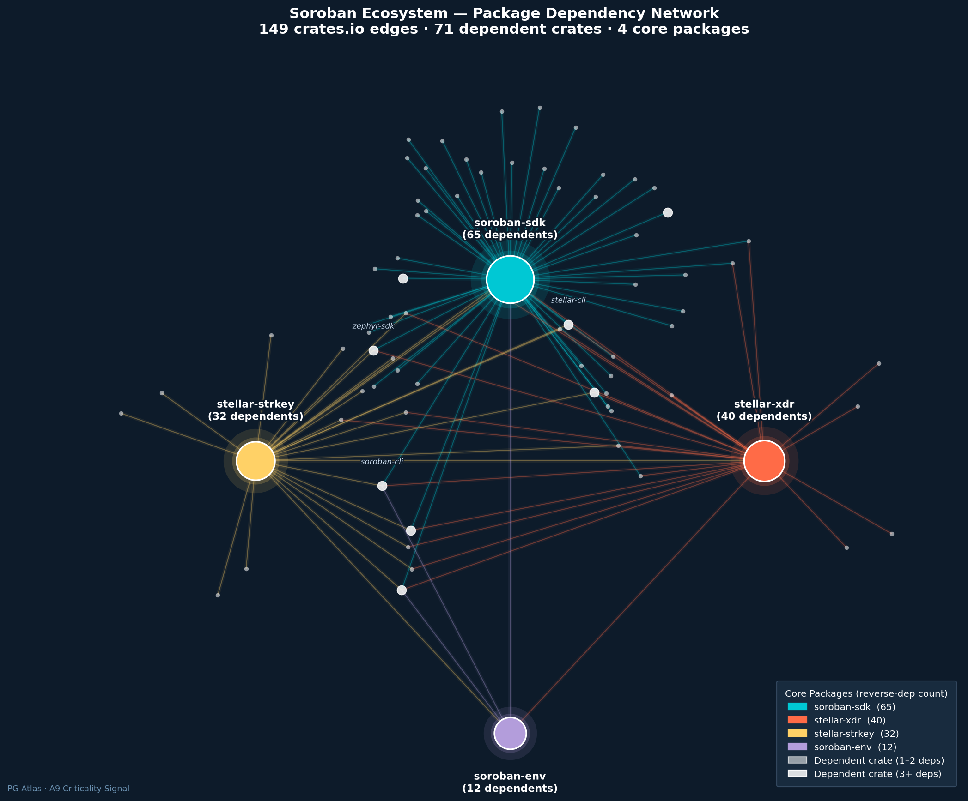
Dark-background network visualization showing the core→dependent topology of the Soroban dependency graph. Hub nodes are sized by dependent count.
Figure 7: Contributor-Repo Bipartite Network
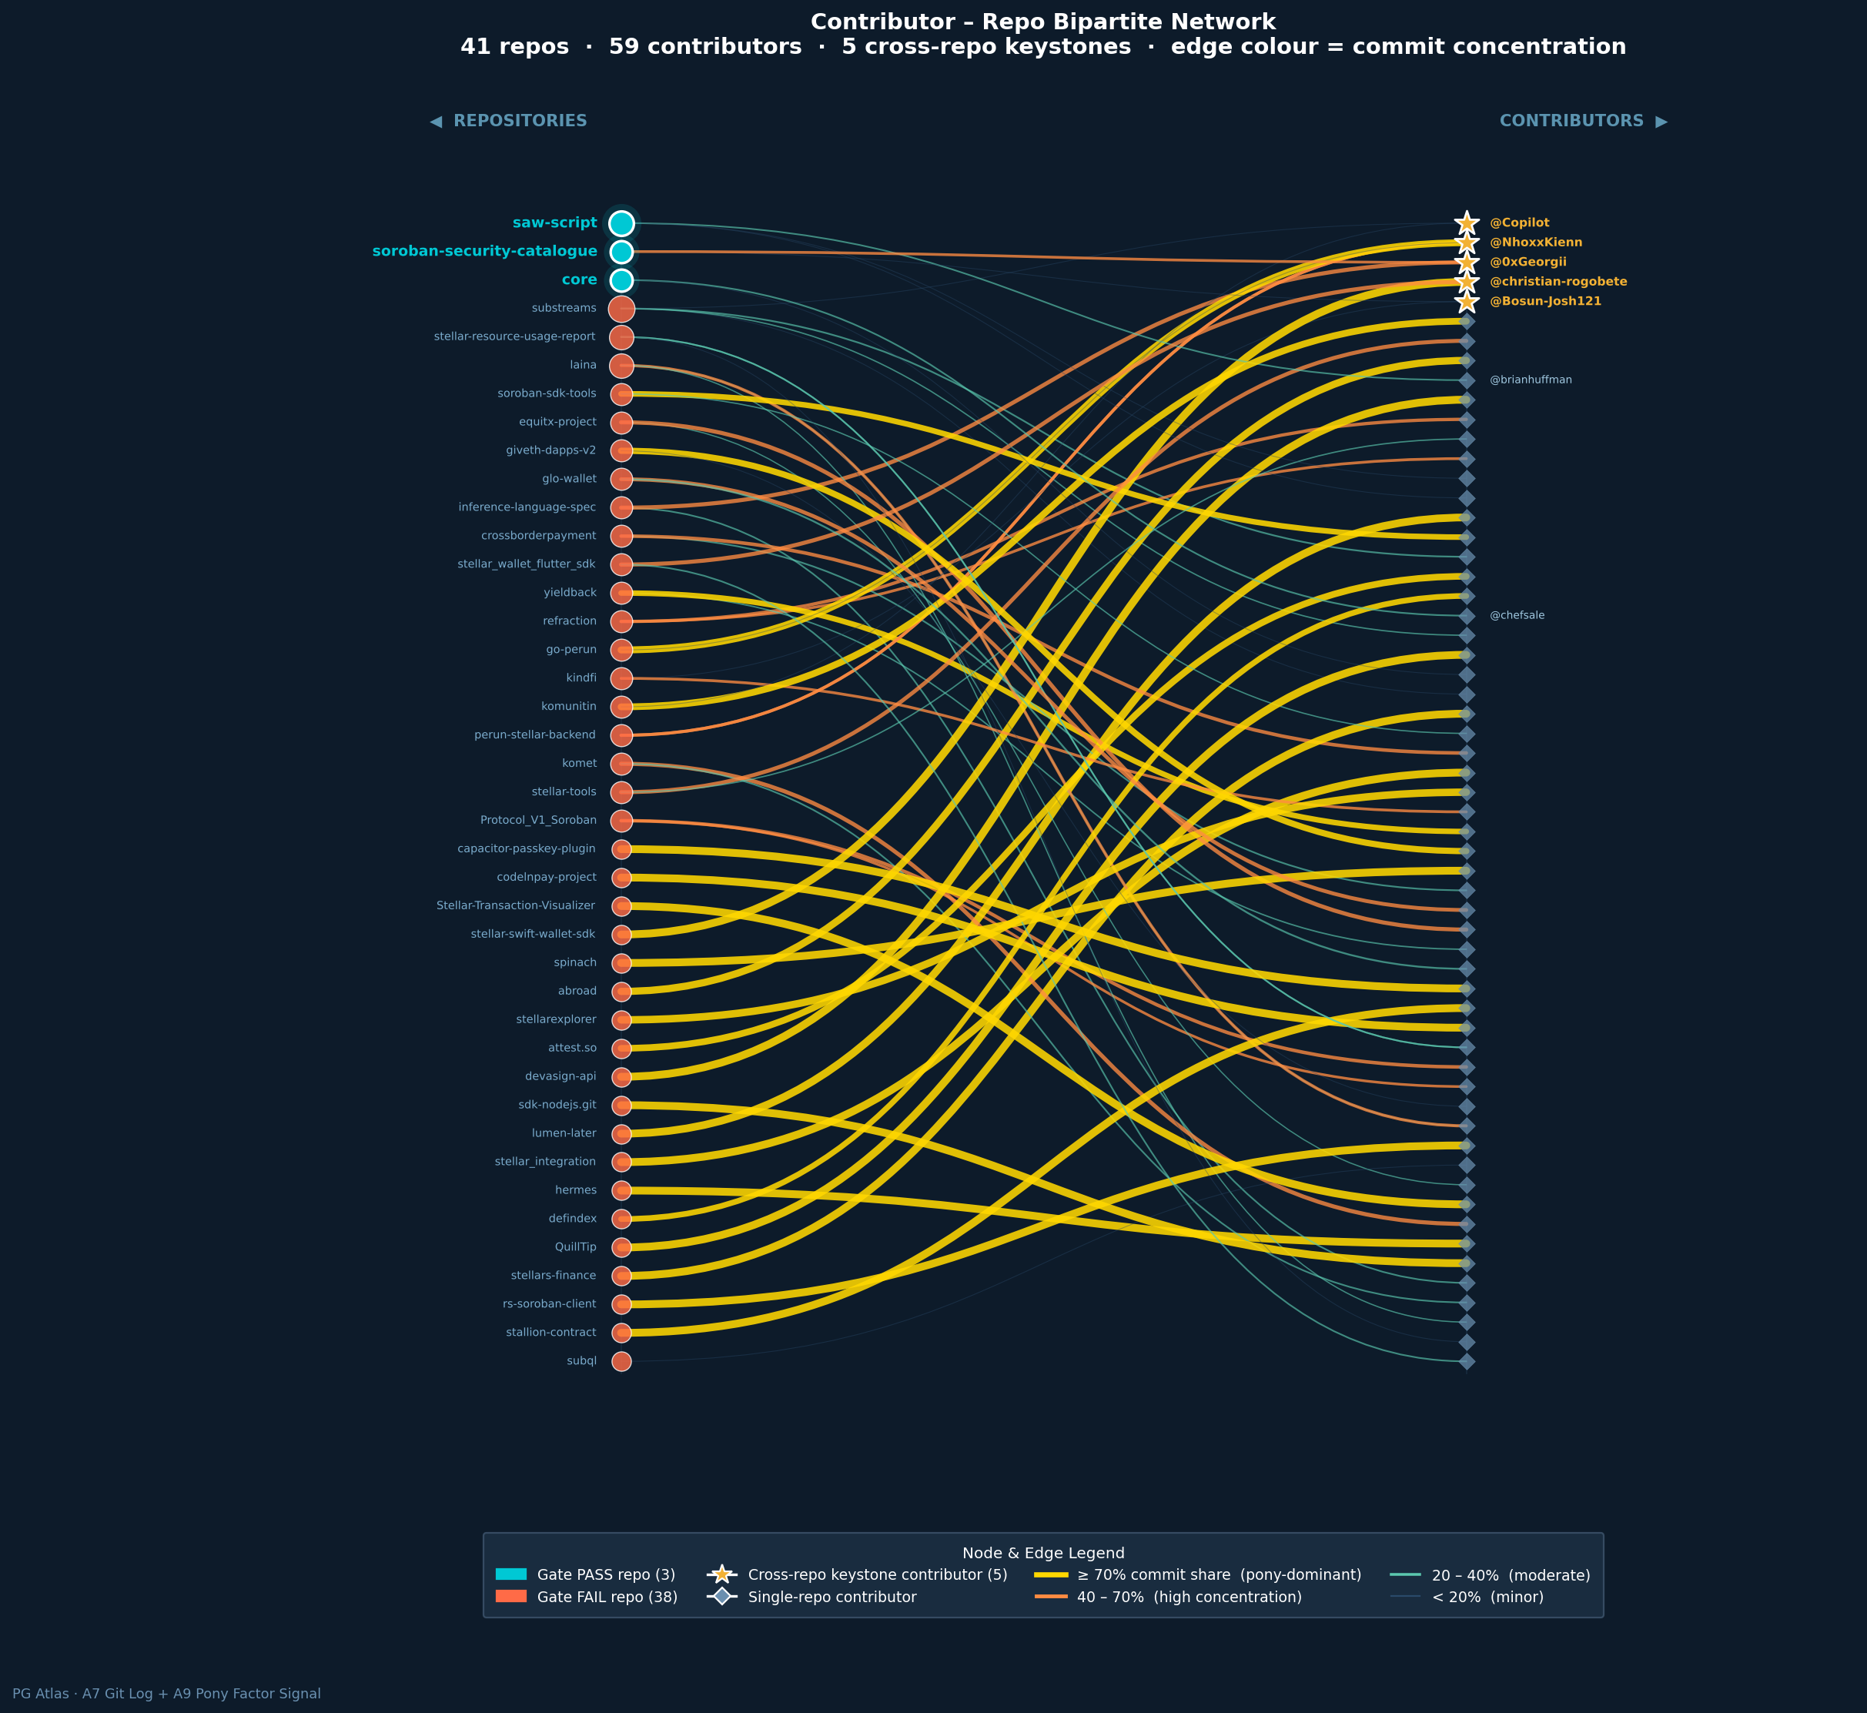
True two-column bipartite layout with Bezier edges colored by commit share: gold (≥70%), orange (40–70%), teal (20–40%), dim (<20%).
Section 3: Key Findings from Real Data
The following metrics are extracted directly from the pipeline's JSON snapshot, generated on February 28, 2026 against live Stellar ecosystem data.
Metric | Value | Interpretation
Active Projects | 86 | From Airtable seed (A5 candidate list)
Active Nodes (post-A6) | 335 | Including ExternalRepo dependency nodes
Dormant Nodes Pruned | 262 | No activity in 90-day window
Dependency Edges | 105 | crates.io resolved to GitHub URLs
Gate Pass Rate | 10% (4/40) | Only 4 projects clear 2-of-3 threshold
Pony Factor Rate | 85% (34/40) | Single-contributor dominated repositories
Mean HHI | 7117.4 | Critical tier (>5,000)
Median HHI | 7513.8 | Confirms mean is not outlier-driven
Max K-Core | 4 | Densest connected substructure
Bridge Edges | 52 | Single-point-of-failure dependency links
Top Critical Packages | rs-stellar-xdr, rs-soroban-sdk, rs-soroban-env, rs-stellar-strkey | All at 96.5th percentile (CARGO ecosystem)

These findings represent honest signal, not noise. The Stellar public goods ecosystem genuinely has thin maintainer distribution and high structural concentration. An 85% pony factor rate and a mean HHI in the Critical tier are not artifacts of incomplete data — they reflect a real governance challenge that the SCF should address through targeted maintainer incentives and contributor diversification programs.
Section 4: Honest Gaps — Remaining Work
Transparency about what remains is as important as demonstrating what works. The following items are prioritized by impact on the production system.
Priority | Gap | Detail
P1 | PostgreSQL Integration | Blocked by A2 schema (Alex Olieman). Stub code exists in pg_atlas/graph/sync.py and builder.py::build_graph_from_db(). Currently runs from CSV seed data.
P1 | FastAPI Layer (D7) | Not yet built. Will expose metric endpoints for the dashboard and external consumers.
P2 | Dashboard UI (D8) | Not yet built. Force-directed graph visualization component planned (Streamlit or Dash).
P2 | Adoption Data Coverage | Only 12 entries from npm + PyPI. Soroban ecosystem is Rust-heavy (Cargo), which has limited download telemetry. Additional adoption proxies under investigation.
P3 | Cargo Crate Resolution | 20 of 110 crates unresolved to GitHub URLs. Manual mapping or crates.io metadata expansion needed.
P3 | Gate Calibration | Current thresholds produce a 10% pass rate. Final calibration requires SCF committee input on desired selectivity.

Section 5: Roadmap to Production
The pipeline is validated and running on real data. The path to production follows the SCF #41 tranche schedule:
Tranche 2 (Due March 22, 2026)
• A6: Active Subgraph Projection — COMPLETE. Algorithm validated, 335/597 active ratio.
• A7: Git Log Parser & Contributor Statistics — COMPLETE. 304 repos parsed, 160 contribution edges.
• PostgreSQL schema lock (A2, Alex) — BLOCKED. Required before production DB integration.
• Integration tests against production database — pending A2.
Tranche 3 (Due ~April 12, 2026)
• A9: Criticality Scores + Pony Factor — COMPLETE. BFS criticality, pony factor, HHI, Shannon entropy all implemented and tested.
• A10: Adoption Signals Aggregation — COMPLETE (12 entries). Coverage expansion ongoing.
• D7: FastAPI analytics endpoints — TO BUILD after A2 schema lock.
• D8: Dashboard with force-directed graph — TO BUILD.
• Gate calibration workshop with SCF committee.
Post-Tranche 3
• Production deployment on SCF infrastructure.
• Longitudinal tracking across SCF rounds (snapshot comparison already built).
• Community feedback integration and threshold refinement.
• Expanded adoption signal sources for Rust/Cargo ecosystem.
Conclusion
The PG Atlas pipeline proves the concept of objective, graph-derived governance metrics for the Stellar Community Fund. Every core algorithm — active subgraph projection, BFS criticality, pony factor, HHI, Shannon entropy, k-core decomposition, bridge edge detection, and the 2-of-3 Metric Gate — is implemented, tested, and validated against real ecosystem data.
The uncomfortable findings are the point. An 85% pony factor rate and a 10% gate pass rate are not failures of the system; they are the system working as intended. Objective measurement surfaces the structural realities that subjective evaluation can miss or minimize. The Stellar public goods ecosystem has genuine maintainer concentration risk, and PG Atlas makes that risk visible, quantifiable, and actionable.
What remains is integration work — PostgreSQL persistence, API exposure, and a dashboard UI — all dependent on the A2 schema lock. The analytical backbone is built, tested, and ready.

—
Jay Gutierrez, PhD
Graph Analytics and Network Science Lead
SCF #41 — Building the Backbone
February 2026

