**資料表名稱　member_database**

**資料庫說明 會員相關資料檔**

**Table1. member_basic**

|  |  |  |  |  |
| --- | --- | --- | --- | --- |
| **代碼** | **名稱** | **數據類型** | **備註** | **補充說明** |
| **user_id** | **用戶ID** | **int** | **主鍵** |  |
| **user_name** | **用戶姓名** | **vachar(20)** | **not null unique** |  |
| **user_password** | **密碼** | **varchar(128)** | **not null** | **英文大小寫+數字共10碼** |
| **user_phone** | **手機** | **varchar(10)** | **not null unique** | **09XX-XXX-XXX** |
| **user_email** | **電子郵箱** | **varchar(120)** | **not null unique** |  |
| **user_nickname** | **綽號** | **varchar(20)** | **null** |  |
| **user_gender** | **性別** | **varchar(10)** | **null** | **可選 男.女.不願透漏** |
| **user_birth** | **生日** | **date** | **null** | **輸入完成後送優惠卷** |
| **user_address** | **地址** | **text** | **null** | **加入常用地址之選項** |
| **vip_status** | **會員等級** | **int** | **Default 0** | **會員等級為0.1.2三級別** |
| **user_avatar** | **頭貼** | **varchar(50)** | **null Default 'default.png' foreign key** | **member_photo(user_avatar)** |
| **privacy_id** | **隱私ID** | **int** | **null** |  |
| **created_at** | **建立時間** | **timestamp** | **default current_timestamp** |  |
| **updated_at** | **更新時間** | **timestamp** | **default current_timestamp on update current_timestamp** |  |

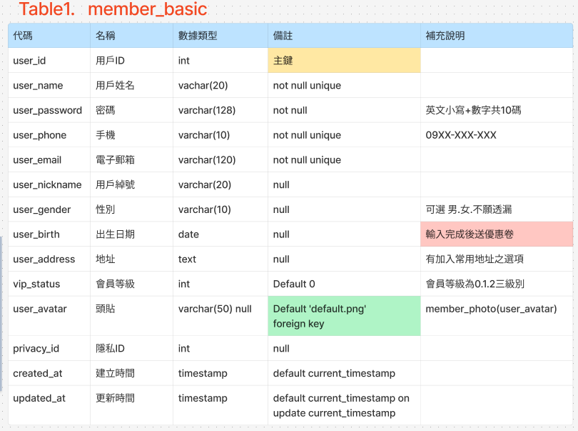

**Table2. member_login**

|  |  |  |  |  |
| --- | --- | --- | --- | --- |
| **代碼** | **名稱** | **數據類型** | **備註** | **補充說明** |
| **login_id** | **登入ID** | **int** | **主鍵** |  |
| **user_id** | **用戶ID** | **int** | **foreign key** | **member_basic(user_id)** |
| **provider** | **第三方服務提供者** | **varchar(50)** | **null** |  |
| **provider_id_google** | **第三方登入ID-Google** | **varchar(50)** | **null unique** |  |
| **provider_id_line** | **第三方登入ID-Line** | **varchar(50)** | **null unique** |  |
| **provider_id_fb** | **第三方登入ID-Fb** | **varchar(50)** | **null unique** |  |
| **access_token** | **第三方登入token** | **varchar(50)** | **null unique** |  |
| **created_at** | **建立時間** | **timestamp** | **default current_timestamp** |  |
| **updated_at** | **更新時間** | **timestamp** | **default current_timestamp on update current_timestamp** |  |

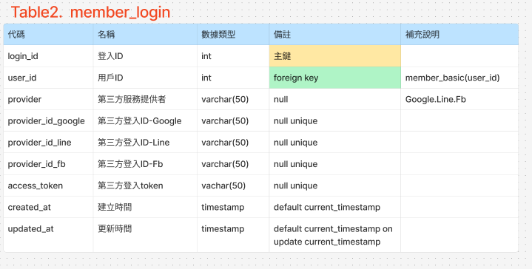

**Table3. member_privacy**

|  |  |  |  |  |
| --- | --- | --- | --- | --- |
| **代碼** | **名稱** | **數據類型** | **備註** | **補充說明** |
| **privacy_id** | **隱私ID** | **int** | **主鍵** |  |
| **user_id** | **用戶ID** | **int** | **foreign key** | **member_basic(user_id)** |
| **user_email** | **電子郵箱** | **varchar(120)** |  |  |
| **privacy_name** | **隱私名稱** | **varchar(50)** | **null** | **gender.birth.address...** |
| **privacy_value** | **隱私值** | **boolean** | **default 0** | **0.1** |
| **phone_change** | **手機修改** | **varchar(10)** | **Null unique** |  |
| **email_change** | **信箱修改** | **varchar(50)** | **Null unique** |  |
| **account_verify** | **帳戶驗證** | **boolean** | **default '0'** |  |
| **activity_checked** | **帳戶活動是否異常** | **boolean** | **default '0'** |  |
| **double_verify** | **雙重驗證** | **boolean** | **default '0'** |  |
| **created_at** | **建立時間** | **timestamp** | **default current_timestamp** |  |
| **updated_at** | **更新時間** | **timestamp** | **default current_timestamp on update current_timestamp** |  |

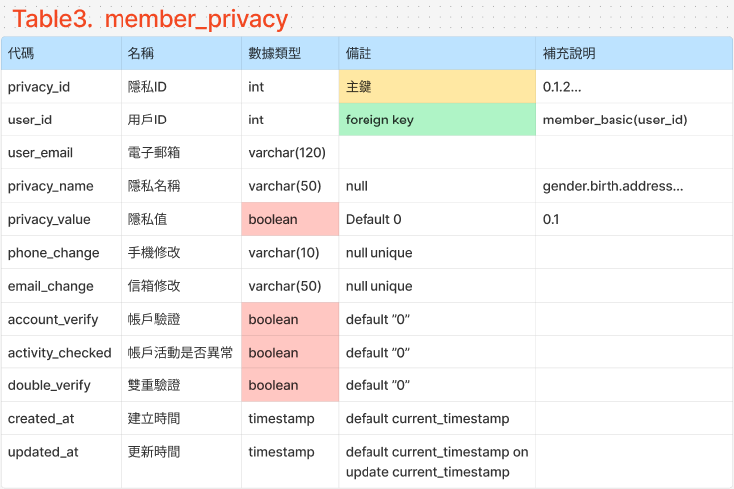

**Table4. member_favorite**

|  |  |  |  |  |
| --- | --- | --- | --- | --- |
| **代碼** | **名稱** | **數據類型** | **備註** | **補充說明** |
| **type_id** | **類型ID** | **int** | **主鍵** | **0.1.2...** |
| **user_id** | **用戶ID** | **int** | **foreign key** | **member_basic(user_id)** |
| **type_name** | **類型名稱** | **varchar(50)** | **null** | **movie.store.wated..** |
| **created_at** | **建立時間** | **timestamp** | **default current_timestamp** |  |
| **updated_at** | **更新時間** | **timestamp** | **default current_timestamp on update current_timestamp** |  |

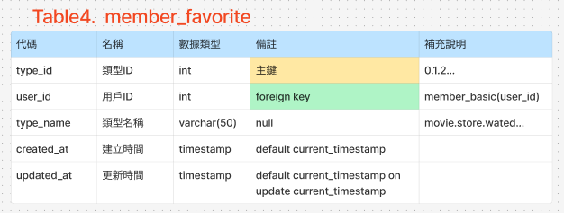

**Table5. member_photo**

|  |  |  |  |  |
| --- | --- | --- | --- | --- |
| **代碼** | **名稱** | **數據類型** | **備註** | **補充說明** |
| **user_avatar** | **頭貼** | **varchar(50)** | **主鍵** |  |
| **user_id** | **用戶ID** | **int** | **foreign key** | **member_basic(user_id)** |
| **image_url** | **圖片網址** | **varchar(128)** | **null** |  |
| **updated_at** | **更新日期** | **timestamp** | **default current_timestamp on update current_timestamp** |  |

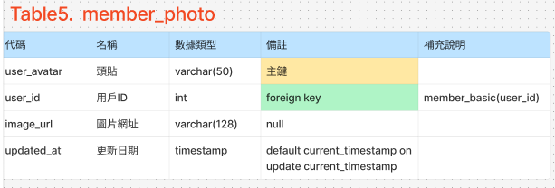

**Table6. member_orderdetails**

|  |  |  |  |  |
| --- | --- | --- | --- | --- |
| **代碼** | **名稱** | **數據類型** | **備註** | **補充說明** |
| **user_id** | **用戶ID** | **int** | **主鍵** | **member_basic(user_id)** |
| **orderNumber** | **訂單紀錄** | **int** | **foreign key** | **行銷(orderdetails)** |
| **created_at** | **建立時間** | **timestamp** | **default current_timestamp** |  |
| **updated_at** | **更新時間** | **timestamp** | **default current_timestamp on update current_timestamp** |  |

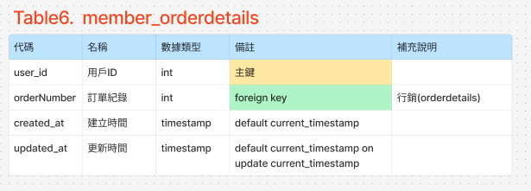

**Table7. member_coupon**

|  |  |  |  |  |
| --- | --- | --- | --- | --- |
| **代碼** | **名稱** | **數據類型** | **備註** | **補充說明** |
| **user_id** | **用戶ID** | **int** | **主鍵** | **member_basic(user_id)** |
| **coupon_id** | **優惠卷ID** | **int not null** | **foreign key** | **行銷(coupon_id)** |
| **created_at** | **建立時間** | **timestamp** | **default current_timestamp** |  |
| **updated_at** | **更新時間** | **timestamp** | **default current_timestamp on update current_timestamp** |  |

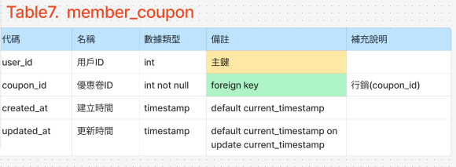

**Table8. member_verify**

|  |  |  |  |  |
| --- | --- | --- | --- | --- |
| **代碼** | **名稱** | **數據類型** | **備註** | **補充說明** |
| **verify_id** | **驗證ID** | **int** | **主鍵** |  |
| **user_id** | **用戶ID** | **int** | **foreign key** | **member_basic(user_email)** |
| **user_email** | **電子郵箱** | **varchar(120)** |  |  |
| **verification_code** | **驗證碼** | **varchar(6)** |  |  |
| **verification_token** | **驗證令牌** | **varchar(16)** |  |  |
| **code_used** | **是否使用過** | **boolean** | **default '0'** |  |
| **token_used** | **是否使用過** | **boolean** | **default '0'** |  |
| **created_at** | **建立時間** | **timestamp** | **default current_timestamp** |  |
| **expires_at** | **更新時間** | **timestamp** | **default current_timestamp** |  |
|  |  |  |  |  |

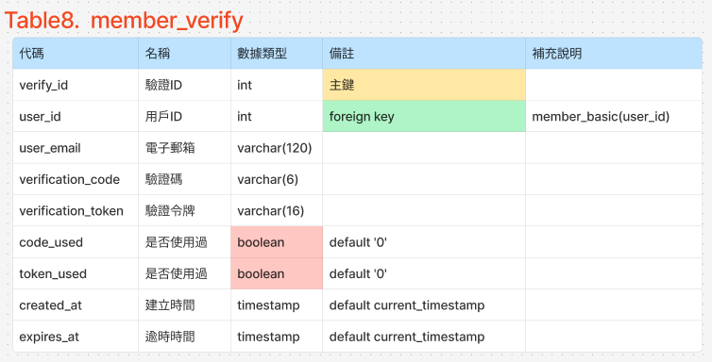

**Table9. auth_user**

|  |  |  |  |  |
| --- | --- | --- | --- | --- |
| **代碼** | **名稱** | **數據類型** | **備註** | **補充說明** |
| **superuser_id** | **管理者ID** | **Int auto_increment** | **主鍵** |  |
| **superuser_name** | **管理者姓名** | **varchar(50)** | **not null unique** |  |
| **superuser_email** | **管理者郵箱** | **varchar(120)** | **not null unique** |  |
| **superuser_password** | **管理者密碼** | **varchar(128)** | **not null** |  |
| **created_at** | **建立時間** | **timestamp** | **default current_timestamp** |  |
| **updated_at** | **更新時間** | **timestamp** | **default current_timestamp on update current_timestamp** |  |

