The starting code can be easily build on cs server: cs2.utdallas.edu

To connect to the cs server:

Windows user:

Install mobaXterm (<http://mobaxterm.mobatek.net/demo.html>)

MAC and Linux user:

copy files to server : scp -r src_dir your_netid@cs2.utdallas.edu:dst_dir

connect to server: ssh -Y [your_netid@cs2.utdallas.edu](mailto:your_netid@cs2.utdallas.edu)

To build the code:

g++ -std=c++11 -lGL -lGLU -lglut -lAntTweakBar -L. main.cpp -o lab1

To run the code:

LD_LIBRARY_PATH=. ./lab1

To create a eclipse project(c++) on CS server for the starting code

1. create a eclipse project

File→new→c++ project:

assign the project name

project type: Executable/Empty Project/

ToolChains: Linux GCC)

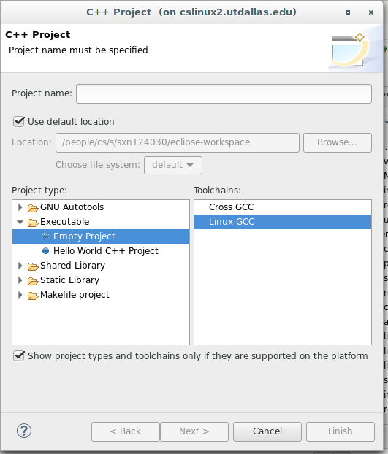

2. copy all the files to /eclipse-workspace/project_name

3. set the project properties

1. c/c++ Build→ Environment: add

Name: LD_LIBRARY_PATH

Value: /people/cs/s/**your_netid**/eclipse-workspace/**project_name**

Note :directory of the libAntTweakBar.so

2. c/c++ Build→Settings→GCC C++ Compiler→Dialect

Language standard: c++11

3. c/c++ Build→ Settings→GCC C++ Linker→Libraries

Libraries(-l): GL GLU glut AntTweakBar

Library search path (-L): "${workspace_loc:/${ProjName}}"

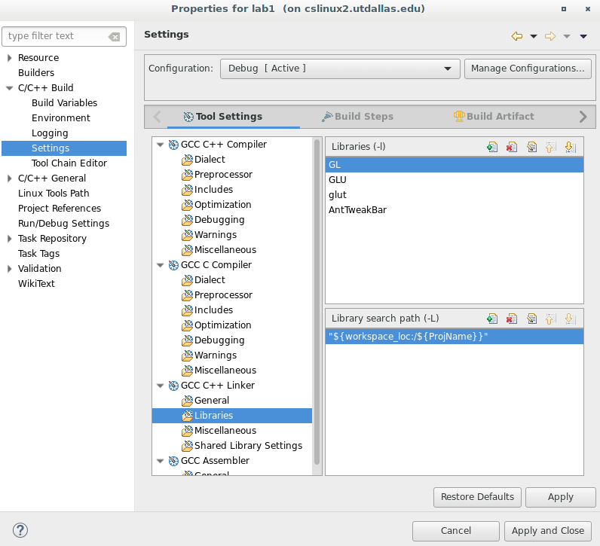

4. Then you can compile/build/Edit/Debug the project in eclipse