# Introduction

This document provides information on various components involved in the capstone project. The components that make up the system are

1. A Hyperledger Fabric network
2. Chaincode
3. A Web Server
4. A web front-end application

The sections below treat the components in more detail:

# The Fabric network

At the core a hyperledger fabric system is a network that is composed of peers from 2 or organizations, a database that stores world data, and an orderer that is responsible for the chronological ordering of data.

In our application, we call our network media-network and the files required to start the network are stored in the folder **capstone-project 🡪 media-network.**

The sh files are numbered 00_ through 09_.

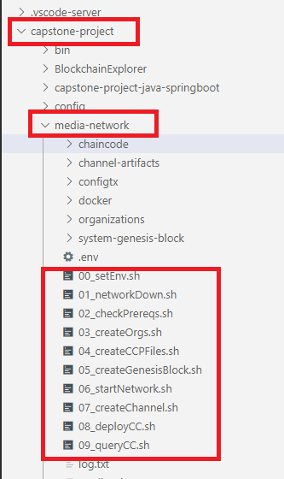

|  |  |
| --- | --- |
| 00_setEnv.sh | This file sets environmental variables for the network. Some of the variables are |
| 01_networkDown.sh | This script brings the network down and removes files generated during the network deployment phase. For example, some of the scripts redirects the output of command like ‘peer Chaincode install’ to a file called log.txt and output it for troubleshooting purposes. |
| 02_checkPrereqs.sh | This checks if the Fabric binaries are in the path. Outputs the results of the check. |
| 03_createOrgs.sh | This script generates the MSP structure for the ARTIST and the BUYER organizations that form the consortium in the capstone project. It uses FABRIC CA rather than the CRYPTOGEN tool.  It also creates the artifacts for the Orderer organization.  All the artifacts are stored in the **organizations** folder. |
| 04_createCCPFiles.sh | These common configuration profile files are generated for use by the web server. A web server uses these files for communicating with the peers in a fabric network.  The files generated are called connection-artist.json/yaml and connection-buyer.json/yaml. There are inside the organization/artist…com/ and organizations/buyer…com folders respectively. |
| 05_createGenesisBlock.sh | The commands in this file not only create the Geneis Block but also mark the leader peers for the individual organizations. |
| 07_createChannel.sh | This script creates the channel for communication between the 2 organizations. |
| 08_deployCC.sh | This script   1. packages the chain code into a zip file 2. installs, 3. approves for individual orgs 4. instantiates,   the Chaincode for the project. |
| 09_queryCC.sh | This script is a tester script. It executes a query against the installed Chaincode and outputs the returned value. It also creates two MediaContract records and queries the world database for all MediaContract records. |

# Chaincode

The

# Web Server

# Client Application

The client application is a Java Spring Boot application. It uses JSP technology for displaying data and interaction with a user.

It creates an Admin record and a regular user for interacting with world database.