Nodejs
- What is Nodejs?
Node.js is a powerful, open-source, and cross-platform JavaScript runtime environment built on Chrome's V8 engine(Compiles JavaScript into machine code). It allows you to run JavaScript code outside the browser.
- JavaScript was mainly used for frontend development earlier. With Node.js (introduced in 2009), JavaScript became a backend language as well.
- Supports the creation of REST APIs, real-time applications, and microservices.
- Comes with a rich library of modules through npm (Node Package Manager).
Node.js is fast because it uses Single Thread + Event Loop + Non-Blocking I/O.
- What is Single Thread?
- Only one task/instruction can run at a time on one main execution line.
- JavaScript is single-threaded → it executes code on one thread only.
- Node.js is single-threaded for JavaScript but it internally uses multiple threads via libuv for heavy tasks like file I/O, crypto, DNS etc.

- What is libuv?(library Unix Virtual)
libuv is a C/C++ library used inside Node.js
It provides multi-threading, event loop, and asynchronous I/O support.
Importance:
Because JavaScript is single-threaded, but Node.js needs:
- File handling
- Network requests
- Database queries
- Timers
- Crypto operations
These things can block the thread…
So libuv handles them in the background using multiple threads.

- What is Event Loop?
Event Loop lets Node.js handle asynchronous tasks without waiting, so the main thread never blocks.
Node.js gives heavy/slow tasks (file, DB, network) to libuv in background.
While the work is happening, Event Loop keeps handling other requests.
When the result is ready → Event Loop takes the callback and executes it.
A callback is a function that runs after a task finishes. Like Student registered successfully .
- What is Non-Blocking I/O?
Non-Blocking I/O allows Node.js to handle many requests together.
Slow operations run in background, and Node.js doesn’t wait — it continues processing other requests.
Node.js achieves Non-Blocking I/O using the Event Loop and libuv.
Note:
REST API: Representational State Transfer API
API: Application Programming Interface
- What is REST API.
REST API is a specific type of API that follows REST constraints like statelessness and uses HTTP methods to perform operations on resources.
REST APIs work by sending requests and receiving responses, typically in JSON format, between the client and server.
REST Rules:
No. | Rule | Simple Meaning
1 | Client–Server | Frontend and backend are separate.
2 | Stateless | Server does not store client session; each request is independent.
3 | Uniform Interface | Standard way to access resources (like /users/1).
4 | Resource-Based | Everything is a resource, identified by URLs.
5 | Cacheable | Responses can be stored temporarily to improve speed.
6 | Layered System | System can have multiple layers (like cache, load balancer).

- What is API?
API (Application Programming Interface) is a communication link between two software components so they can send requests & receive responses.

- Difference between api and rest api
Feature | API | REST API (RESTful API)
Meaning | Any way to communicate between apps | A type of API that follows REST rules
Protocol | Can use HTTP, SOAP, Library, SDK etc. | Only uses HTTP
Data Format | Can be anything | Mostly JSON
State | Can be stateful | Always stateless
Every REST API is an API, but not every API is REST API.

- What are Microservices?
Microservices is an architecture where a big application is broken into small independent services.
Each service does one specific job, can be developed, deployed, and scaled separately. Change in one service does NOT affect others.
Feature | Monolithic | Microservices
Structure | One big application | Many small services
Deployment | Single deploy | Each service deploys separately
Failure | Whole app might crash | Others continue to run

- How Nodejs Work?
- Node.js works on a single-threaded, event-driven architecture.
- It uses Chrome’s V8 engine to execute JavaScript very fast.
- Node.js uses non-blocking asynchronous I/O, where heavy operations are handled by libuv’s thread pool in the background.
- This allows Node.js to handle many concurrent requests efficiently.

- What is Refresh Token?
A refresh token is used to generate a new access token when it expires, helping users stay logged in securely without re-login.

- What is Access Token?
Access Token is a short-lived token used to authorize user and access protected APIs after login. Expires quickly for security.
If expired → user gets new one using refresh token
Note:
Access token → short expiry → refresh it
Refresh token → long expiry → after that → login again
Token | Expiry Time | Why
Access Token | 15 min – 1 hour | If stolen, attacker has less time
Refresh Token | 7 – 30 days | User stays logged in longer

- What is a Stateless Function?
Stateless means the system or function does not store previous state.
Stateless function has no history — output depends only on current input.
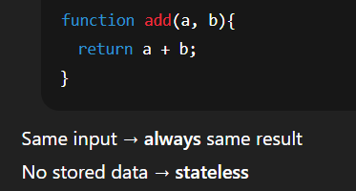
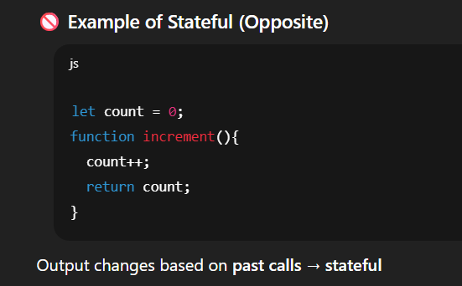

REST APIs are stateless — Server does not store user session.
Each request must send all required data again.

- How to improve the API call?
Technique | Why it improves speed
1. Caching (Redis, in-memory) | Avoids hitting DB again and again
2. Pagination | Sends only small data, not full table
3. Indexing in DB | Fast search → no full collection scan
4. Compression (Gzip/Brotli) | Smaller response = faster download
5. Reduce DB queries | Combine queries, avoid extra populates
6. Asynchronous & non-blocking code | Server doesn’t wait → handles more requests
7. CDN for static content | Faster asset delivery
8. Optimize JSON size | Remove unnecessary fields
9. Load Balancing | Divide load on multiple servers

- NPM vs Yarn vs NPX
Tool | What it is | What it does | When to use
npm | Package Manager | Install, update, remove packages | Everyday dependency management
yarn | Faster alternative to npm | Same as npm but faster, offline support | Large projects needing speed
npx | Package Runner | Run a package without installing globally | One-time commands (like CRA)

Command | Purpose
npm install express | install express
yarn add express | same install using yarn
npx create-react-app myapp | run CRA without installing

yarn is a faster alternative of npm and npx is used to execute packages without installing them globally.

- Difference between package.json and package-lock.json
File | Content | Can install alone? | Purpose
package.json | Names of dependencies project metadata(name, version, description, author, license), script etc. | ✔ Yes  If we have alone this file only we can install package. | What to install
package-lock.json | Exact versions for each dependency | ❌ No  If we have only this file we cannot install package. | Install exact same versions  (only if both package file present)

- what is nodemon?
Nodemon is a development tool for Node.js that automatically restarts the server whenever you make changes in your code.
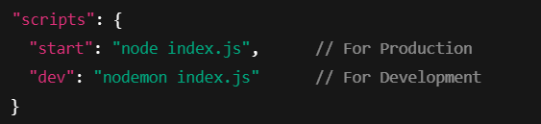
Then run npm run dev

If we have only
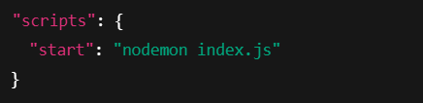
Then use run “npm start”
- What is PM2?
“PM2(Process Manager 2) is used in production to manage and monitor Node.js apps so they never go down or crash.”

- Synchronous vs Asynchronous in Node.js
Type | Meaning | What happens? | Result
Synchronous | Tasks run one by one | Next task waits until current finishes | Blocking
Asynchronous | Tasks run without waiting | Long tasks go to background | Non-blocking

- Why is NodeJS preferred over other backend technologies like Java and PHP?
Node.js is faster, more scalable, and uses the same language (JavaScript) on both frontend and backend, which improves productivity and reduces learning effort.
1️ High Performance → Non-blocking, event-driven model
2️ Scalability → Handles thousands of concurrent users efficiently
3️ Same Language → JavaScript everywhere (full-stack)
4️ Fast Development → Huge NPM ecosystem & lightweight apps

- What are Modules in Node.js?
Modules are reusable blocks of code in Node.js that can be imported and used in other files using require() or import.

- What is V8 engine in Node.js?
The V8 engine in Node.js is an open-source JavaScript engine developed by Google, written in C++.
- Compiles JavaScript to native machine code instead of interpreting it, making execution very fast.
- Manages memory and garbage collection.
- V8 uses JIT (Just-In-Time) compilation for high speed.
- JIT is a technique where code is compiled into machine code at runtime (just before execution), instead of interpreting line-by-line.
This makes execution much faster.
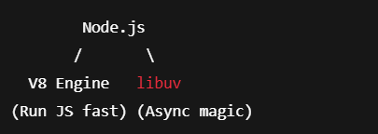

- What are the main disadvantages of NodeJS?
1️ Single-Threaded for CPU tasks
Good for I/O, but not suitable for heavy CPU operations like video processing → can block the event loop.
2️ Callback Hell (Complex async code)
Too many nested callbacks can make code hard to maintain (though promises/async-await reduce this).
3️ Immature libraries sometimes
Some npm packages may be poorly maintained or less stable compared to Java/enterprise ecosystems.

- What is REPL in NodeJS?
REPL stands for Read – Evaluate – Print – Loop.
It is a command-line tool in Node.js used to run JavaScript code interactively.
You type JS code → Node reads it → executes it → prints result → waits for next input.
REPL helps developers test and debug code quickly without creating a complete Node.js project.
“We open REPL by typing node in the terminal and pressing Enter.”

- How to create the simple HTTP server in NodeJS?
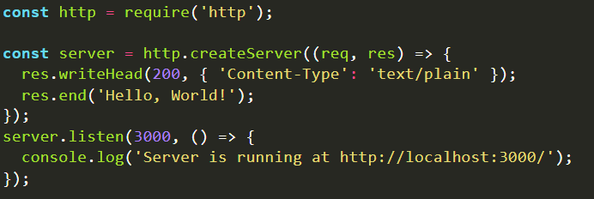

- What is Express and mongoose?
Express is a lightweight web framework for Node.js, used to create APIs and handle routing easily on the backend.
Mongoose is an ODM library for MongoDB that lets us define schemas and models, making database operations easier and more structured in Node.js.

- What are Promises in Node.js?
A promise is a JavaScript object that is used to handle all the asynchronous data operations. While developing an application, you may encounter that you are using a lot of nested callback functions, which causes a problem of callback hell. Promises solve this problem of callback hell.
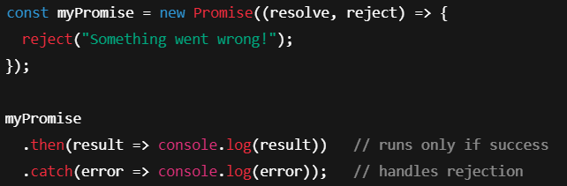
the result of an asynchronous operation that will complete in the future — either successfully (fulfilled) or with an error (rejected)
- What is event-driven programming in NodeJS?
Event-driven programming means Node.js responds to events (like a request, click, file read, DB response) and executes callbacks when those events occur.
Instead of waiting, Node reacts to events and triggers the appropriate callback.
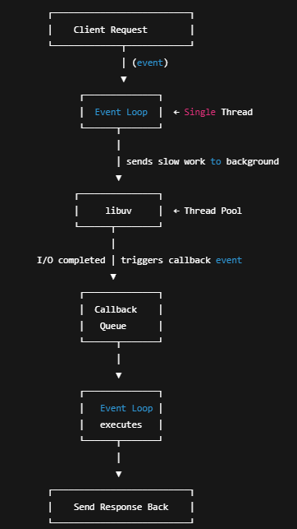
- What is a buffer in NodeJS?
Buffer is a temporary memory area in Node.js used to handle binary data directly, such as files, streams(audio, video, file read/write), or network packets.
It helps when data comes chunk-by-chunk (not all at once) and store all together.
Buffer vs Stream in Node.js
Feature | Buffer | Stream
Data Handling | Stores complete data in memory | Processes data chunk-by-chunk
Memory Usage | High (not good for large data) | Very low (best for large data)
Speed | Slower for big files | Faster & efficient
When Used | Small files or binary operations | Large files, video/audio, real-time data

Term | What it does with chunks
Stream | Processes chunks immediately one-by-one
Buffer | Collects chunks until data is complete (or until a fixed-size buffer is full)

Types of streams
Stream Type | Direction | Example Use
Readable | Data comes into Node.js | Reading a file, receiving a request
Writable | Data goes out from Node.js | Writing a file, sending a response
Duplex | Both read & write | TCP sockets
Transform | Read → Modify → Write | Compression (zip), encryption

- Explain the crypto module in NodeJS
The crypto module is used for encrypting, decrypting, or hashing any type of data.
The main use case of the crypto module is to convert the plain readable text to an encrypted format .
“Hashing is one-way — used for passwords — cannot be decrypted.
Encryption is two-way — used for sensitive data — can be decrypted with a key.
Node’s crypto module supports both.”

- What is bcrypt in nodejs?
bcrypt is a password-hashing library used to securely store user passwords.
It uses salt + slow hashing to protect against brute-force attacks.
📌 bcrypt is only for hashing, not for encryption
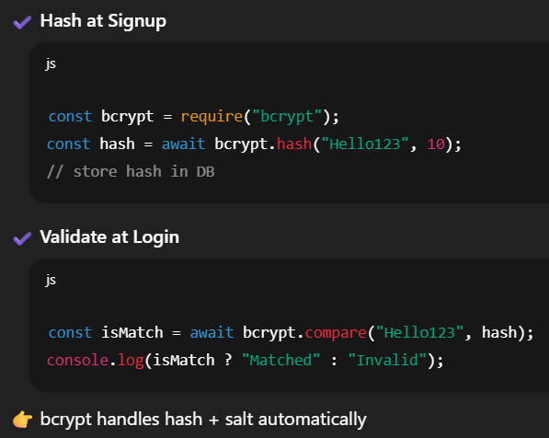

- What is callback hell?
Callback Hell occurs when multiple asynchronous callbacks are nested inside each other, making the code messy, hard to read, and hard to maintain.
It looks like a pyramid of doom ⬇️
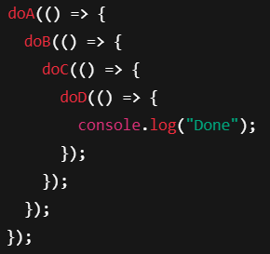
How to avoid Callback Hell?
Use:
✔ Promises
✔ async/await
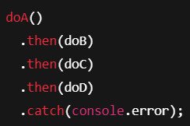
- What are timers module in NodeJS.
Function | When does it run? | Use Case | Priority
setTimeout() | After a delay | Run a task once later | Normal
setInterval() | After every delay (repeat) | Repeated tasks (like clock) | Normal
setImmediate() | Immediately after current event loop phase | Run after current code finishes | Higher
process.nextTick() | Before event loop continues | High-priority microtasks | Highest priority ⚡
