- What is React js?
React.js is a JavaScript library developed by Facebook for building fast and dynamic user interfaces, especially single-page applications (SPAs).
Advantge:
- Component-Based: UI is built using reusable components.
- Virtual DOM: Improves performance by updating only changed parts of the UI.
- Reusable Components – reduces duplication.
- One-Way Data Binding - Data flows in one direction — from parent component → child component.
- Strong Community Support
- SEO Friendly : helps search engines easily read and index your page.
Result → Your React website can rank better on Google

❌ Disadvantages of React
- High Learning Curve – Requires learning JSX, hooks, and state management concepts.
- Poor Documentation (sometimes) – Due to fast changes, docs may lag behind.

- What is library?
- A library is a collection of prewritten code that you can call and use in your program.
- You control the flow — you decide when and where to use the library functions.
- Example: ReactJS, NumPy, jQuery
- Mnemonic: You call the library. (You are the boss 😎)

- What is Framework?
- A framework gives you a structure and rules to build your application.
- It controls the flow — the framework calls your code at specific points.
- Example: Angular, Django, Spring Boot
- Mnemonic: Framework calls you. (Framework is the boss 🧠)

🔁 Quick Comparison (Interview Table)
Point | Library | Framework
Control | You control the flow | Framework controls the flow
Usage | You call functions | Framework calls your code
Flexibility | More flexible | More structured
Example | React, jQuery | Angular, Django

- What is State?
State in React is a built-in mutable object that stores dynamic data within a component and re-renders the UI whenever that data changes.
- Mutable Data: The state can be changed within the component using useState() (in functional components).
- Component-Specific: Each component has its own state, which helps React track changes and re-render only when needed.
- Triggers Re-render: Whenever state updates, React automatically re-renders that part of the UI.

- What is JSX and how does it work?
- JSX (JavaScript XML) is a syntax extension for JavaScript used in React.
- It allows you to write HTML-like code inside JavaScript.
- JSX makes code more readable and expressive, and is converted to JavaScript using tools like Babel.

⚙️ Example:
const element = <h1>Hello, Jay!</h1>;
// Transpiled to:
const element = React.createElement('h1', null, 'Hello, Jay!');

- 🔁 Difference Between JSX and HTML
Point | JSX | HTML
Language | JavaScript syntax extension | Markup language
Attributes | Uses camelCase (className, onClick) | Uses lowercase (class, onclick)
Embedding JS | Can include JS expressions using {} | Cannot include JS directly
Validation | Must return one parent element | No such restriction
Browser support | Needs to be transpiled by Babel | Directly understood by browsers

🧠 In short:
JSX = JavaScript + HTML-like syntax used in React (needs to be transpiled).

- Why "Transpiled" and not "Compiled"?
- Transpiling means converting code from one version of JavaScript (JSX/ES6) to another version that browsers understand (plain JS/ES5).
- Tools like Babel handle this process.
- Compiling usually means converting from a high-level language to machine code, which is not the case here.

- What is virtual DOM?
- The Virtual DOM is a lightweight copy of the Real DOM kept in memory by React.
- It allows React to update only the changed parts of the UI instead of re-rendering the whole page.
- It helps in making UI updates faster and more efficient.

- How Virtual DOM Works
- React keeps a virtual representation (JS object) of the real DOM.
- When a state or prop changes, React creates a new virtual DOM tree.
- It then compares the new virtual DOM with the previous one (Diffing process).
- Only the parts that changed are updated in the real DOM (Reconciliation process).

- Advantage and Disadvantage of Virtual Dom
✅ Benefits
- Better performance – avoids full-page re-rendering.
- Efficient updates – only changed elements are updated.
- Smooth UI – reduces direct DOM manipulation.
- Developer friendly – simpler coding with automatic updates.

❌ Downsides
- Extra memory is used for maintaining the virtual DOM.
- Not always faster for very small apps.
- Learning curve for beginners to understand how it works internally.

- What is the difference Between React Node, React Element, and React Component?

- What is Props ?
- Props (short for “properties”) are read-only inputs passed from a parent component to a child component.
- They allow data and functions to be shared between components.
- Props are immutable — a child component cannot modify the props it receives.
- Used to make components dynamic and reusable.

- Difference b/w Props and State
Feature | Props | State
Defined by | Parent component | Inside the component
Mutable? | ❌ No (read-only) | ✅ Yes (mutable via setState/useState)
Purpose | Pass data to child | Store and manage component data
Trigger Re-render? | When new props are received | When state changes

- What is SPA?
- It loads only one HTML page, and React updates the content dynamically without reloading the whole page.
- React Router is used for navigation between components or views.
- This gives a fast, smooth, app-like experience to users.

- Difference Between Real DOM and Virtual DOM
Basis | Real DOM | Virtual DOM
Definition | It is the actual structure of the webpage in the browser. | It is a lightweight copy of the Real DOM kept in memory by React.
Updating | Updates the whole DOM even for small changes. | Updates only the changed part of the DOM.
Speed | Slower because it re-renders the entire UI. | Faster because it uses diffing and updates only necessary parts.
Manipulation | Directly manipulated by the browser. | Managed by React internally.
Memory Usage | Uses more memory and time. | Uses less memory and improves performance.

- What are React Fragments used for?
- React Fragments are used to group multiple elements without adding extra nodes (like <div>) to the DOM.
- They let you return multiple elements from a component without wrapping them in an extra tag.
- This helps keep the DOM clean and efficient.
<></> is a short syntax for <React.Fragment>.

- Difference between functional and class components?
Functional Component | Class Component
Uses functions to build UI | Uses classes to build UI
Uses hooks for state & lifecycle | Uses this.state & lifecycle methods
Cleaner, faster, easy to read | More complex & lengthy syntax
Recommended in modern React | Old approach (less used now)
“Functional components are simple JavaScript functions using hooks, lightweight and preferred in modern React. Class components use classes with this.state and lifecycle methods and are now rarely needed.” ✅
- Difference between stateless and stateful components?
Stateless Component | Stateful Component
Cannot hold state (no data memory) | Can hold and manage state
Only uses props | Uses state + props
Pure UI, predictable & fast | Dynamic, interactive & complex
Easy to test | More logic, harder to test
Memory Trick:
➡️ Stateless = No memory
➡️ Stateful = Has memory
Stateless
function Greeting({ name }) {
return <p>Hello {name}</p>;
}
Stateful
function Counter() {
const [count, setCount] = useState(0);
return <button onClick={() => setCount(count+1)}>Count: {count}</button>;
}

- What are controlled vs uncontrolled components?

Controlled Components
- Form data is controlled by React state.
- The component’s value changes only when the state updates.
- You use value and onChange together.

- Example:
function Form() {
const [name, setName] = useState("");
return <input value={name} onChange={e => setName(e.target.value)} />;
}
- ✅ Easy to validate and manage data.

Uncontrolled Components
- Form data is handled by the DOM itself, not React.
- You access values using refs instead of state.
Example:
function Form() {
const nameRef = useRef();
return <input ref={nameRef} />;
}
- ⚙️ Easier for quick forms, but harder to control/validate.

- What is the purpose of the key attribute in React lists?
Ans: Purpose of the key attribute in React lists 👇
- The key helps React identify which items have changed, added, or removed.
- It gives each list element a unique identity.
- It helps in efficient re-rendering and improves performance.
- Without unique keys, React may update or reorder items incorrectly.
✅ Example:
{items.map(item => <li key={item.id}>{item.name}</li>)}

- What are Components lifecycle methods?
The component lifecycle refers to the stages a React component goes through from creation to removal in the DOM.
🔹 3 Main Phases:
- Mounting:
  - Component is created and inserted into the DOM.
  - Methods: constructor(), componentDidMount()
- Updating:
  - Happens when props or state change.
  - Method: componentDidUpdate()
- Unmounting:
  - Component is removed from the DOM.
  - Method: componentWillUnmount()
💡 In functional components, these phases are handled using useEffect() hook.

- What is props drilling in React?
Props drilling means passing data from a parent component to a deeply nested child component through multiple intermediate components — even if those middle components don’t need the data.
🔹 Problem:
- Makes code hard to maintain and less reusable.
- Unnecessary passing of props through components that don’t use them.
🔹 Solution:
- Use Context API or state management tools like Redux to avoid props drilling.

- What is the Context API in React?
The Context API is a feature in React that allows you to share data between components without props drilling (i.e., without passing props through every level).
🔹 How it works:
- createContext() → creates a context to store data.
- Provider → gives (provides) data to all children.
- useContext() → allows any child to read that data directly.
Example:
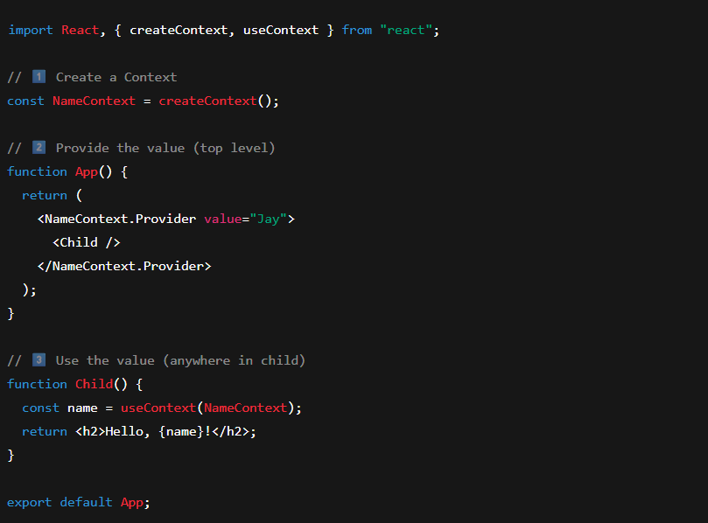
- What are higher-order components? Give an example.
A Higher-Order Component (HOC) is a function that takes a component as input and returns a new enhanced component.
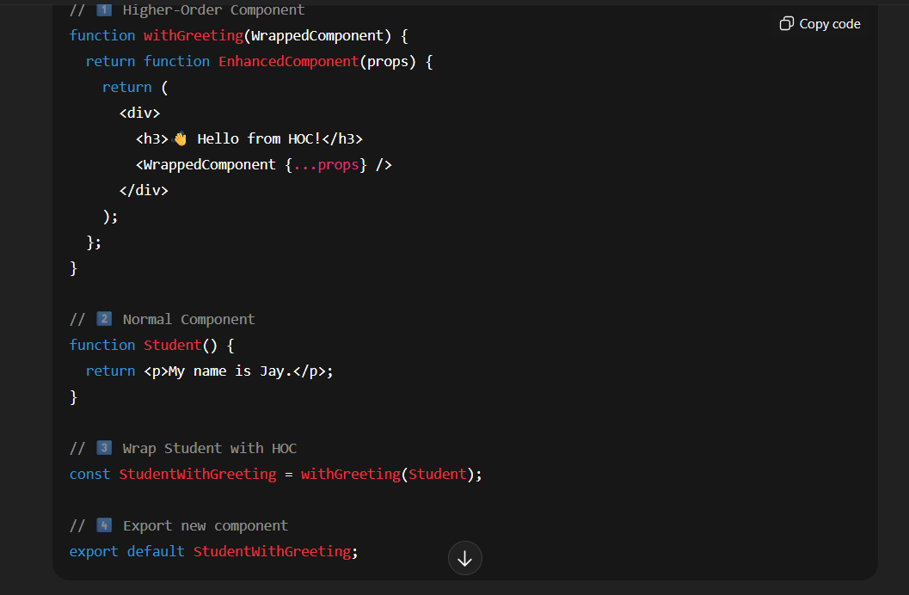

- What is Reconciliation in React.
🔹 Definition:
Reconciliation is the process React uses to compare the Virtual DOM with the previous one and update only the changed parts in the real DOM.
🔹 How it works (Simple Steps):
- React creates a Virtual DOM (a copy of the real DOM).
- When state or props change, React creates a new Virtual DOM.
- React compares the new and old Virtual DOMs using a diffing algorithm.
- Only the elements that have changed are updated in the real DOM — not the whole page.

- What is React Portals?
React Portals are used to render a component outside its parent element — usually for things like modals, popups, or tooltips that need to appear on top of everything.
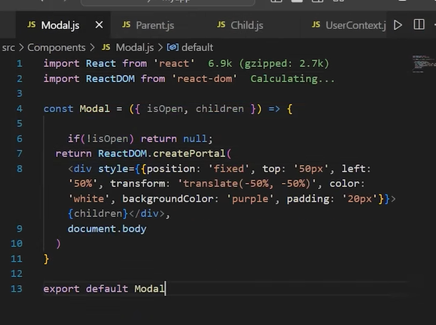
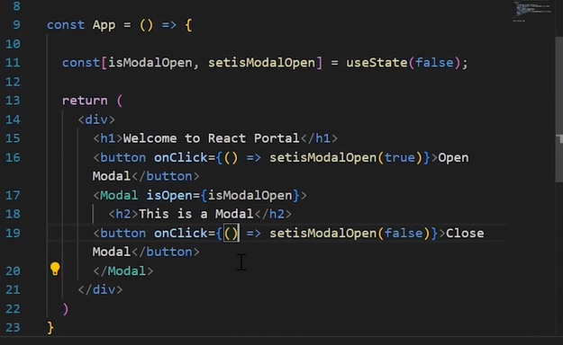

- How does React Router handle navigation in a single-page app?
React Router handles navigation by changing components, not pages,
making the app faster and smoother without full-page reloads.
🔹 Key Points:
- It uses the Browser History API to update the URL.
- Only the relevant component re-renders — not the full page.
- This gives a fast, smooth user experience like a native app.
- Components like <BrowserRouter>, <Routes>, and <Route> define the paths and components to show.

✅ Example:
<Route path="/about" element={<About />} />

- Explain React strict mode.
React Strict Mode is a development-only feature that helps developers find potential issues in their code early.
It doesn’t affect production — it’s only for warning and debugging.
🔹 Key Points (Interview Friendly):
- It highlights unsafe lifecycle methods.
- Warns about deprecated APIs and bad coding practices.
- Detects side effects in components (by running them twice in dev mode).
- Helps you write clean, future-proof React code.

