John Joseph T. Porras FUNDAMENTALS

BSIT-MWA

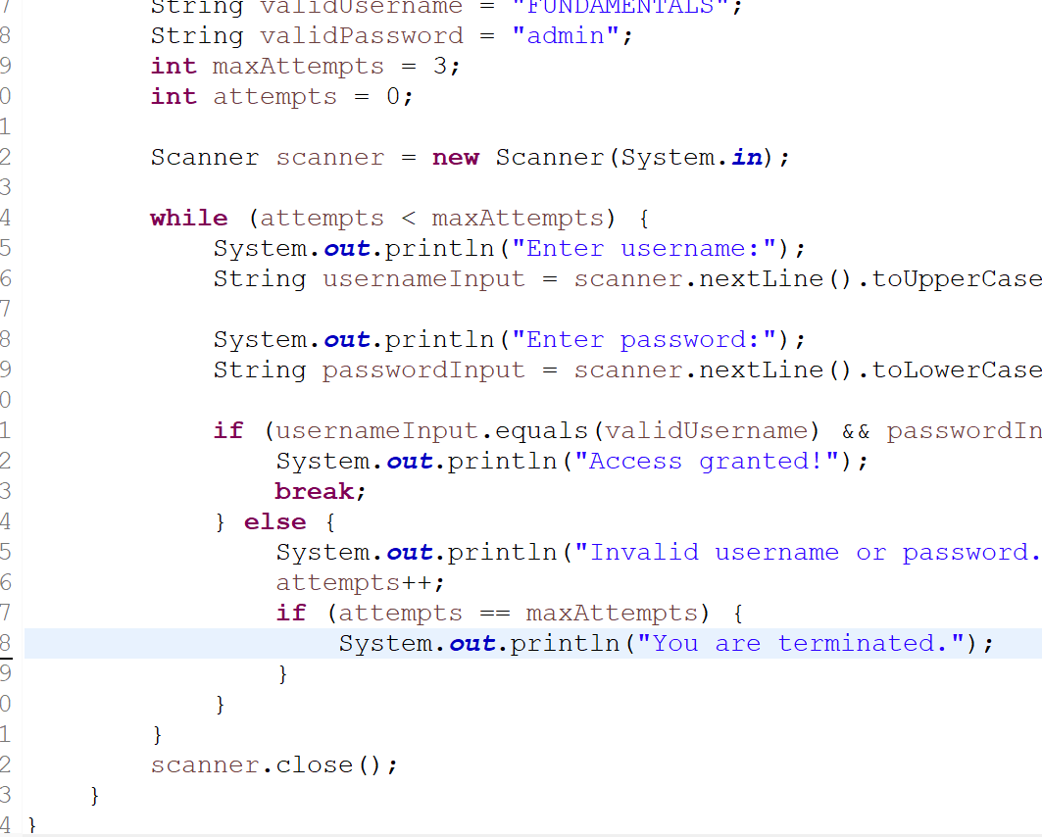

PSEUDOCODE:

Initialize a scanner object 'reader' to read input from the system.

OUTPUT "Enter a number: "

Read an integer input from the user using 'reader' and store it in the variable 'num'.

IF 'num' is divisible by 2 without a remainder:

THEN

OUTPUT (num + "is even").

ELSE

OUTPUT (num + "is odd").