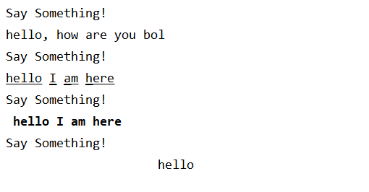

1. **Normal, Underline, Bold, Center(Above)**

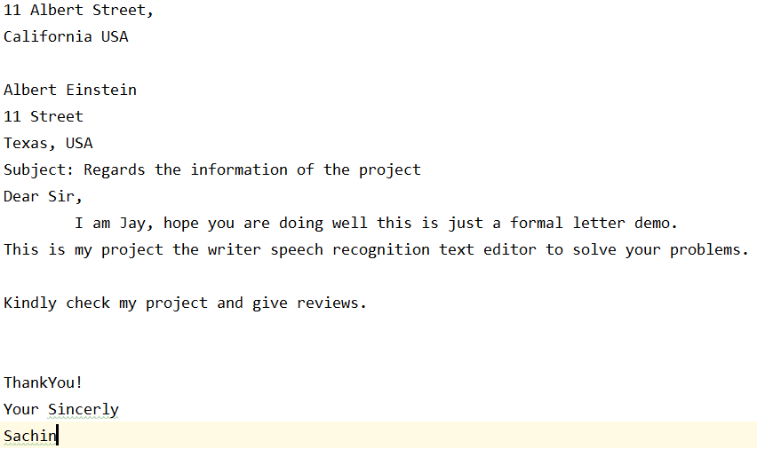

1. **Formal Letter Format(Above)**

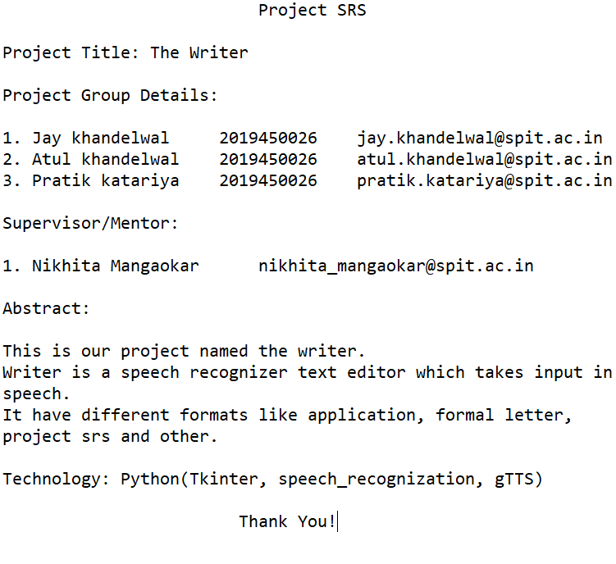

1. **Project SRS Demo Format(Above)**
2. **Home Page of the Writer(Below)**

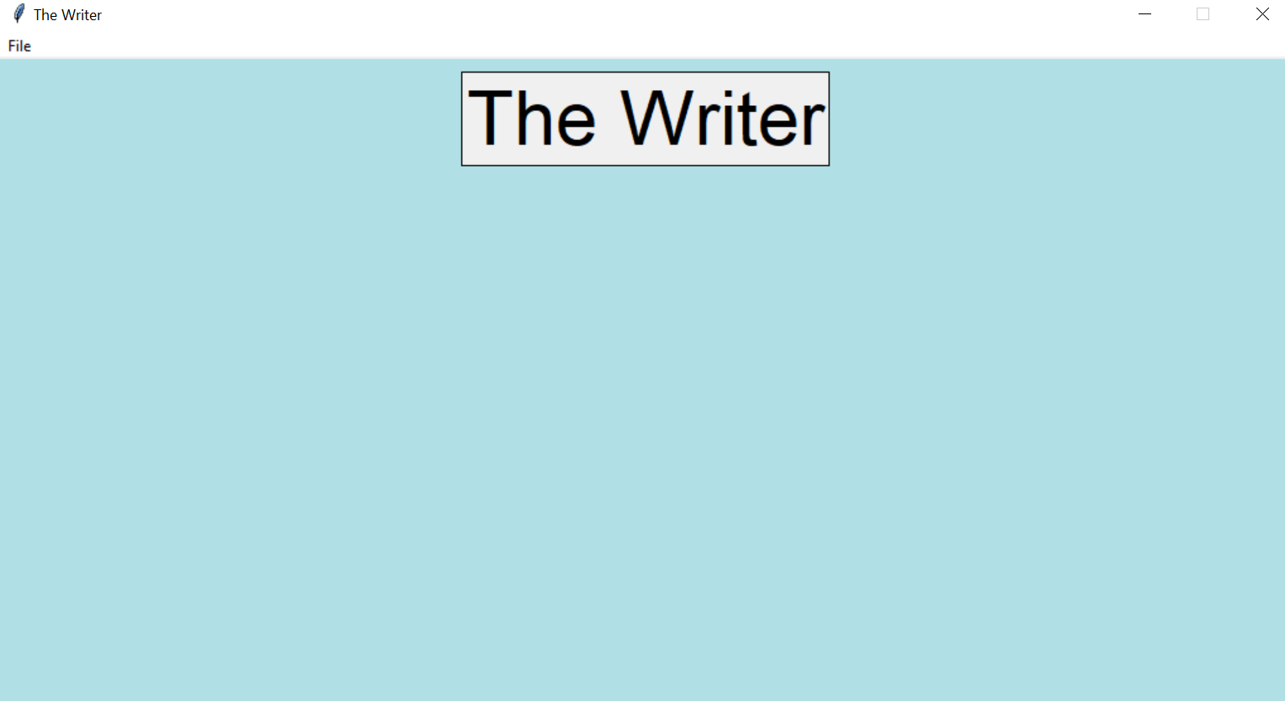

1. **Login Page of the Writer(Below)**

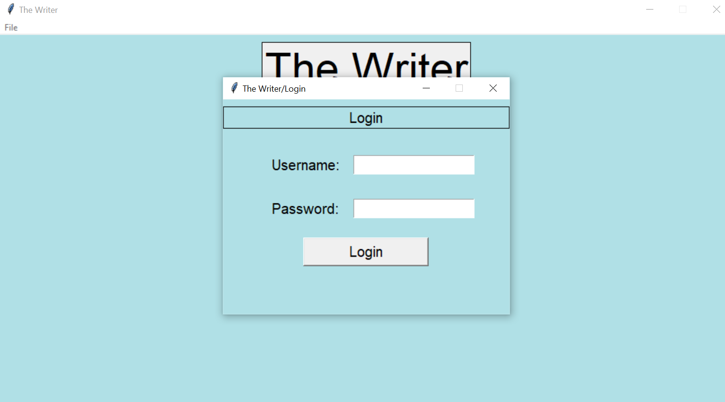

1. **It show the login validation(Below)**

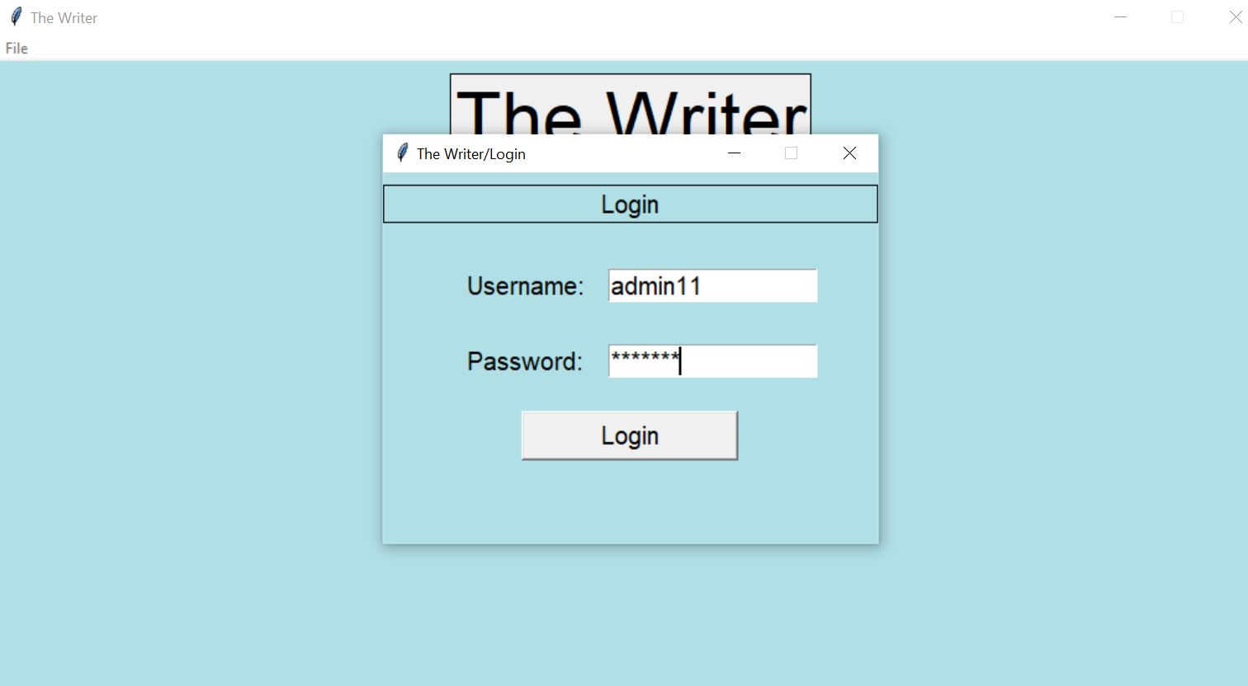

1. **It show the login validation(Below)**

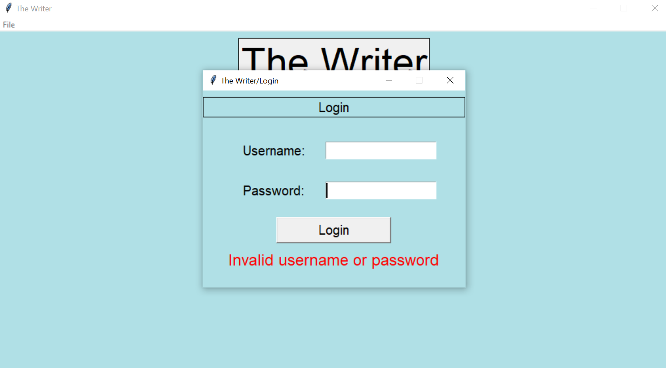

1. **It show the login validation(Below)**

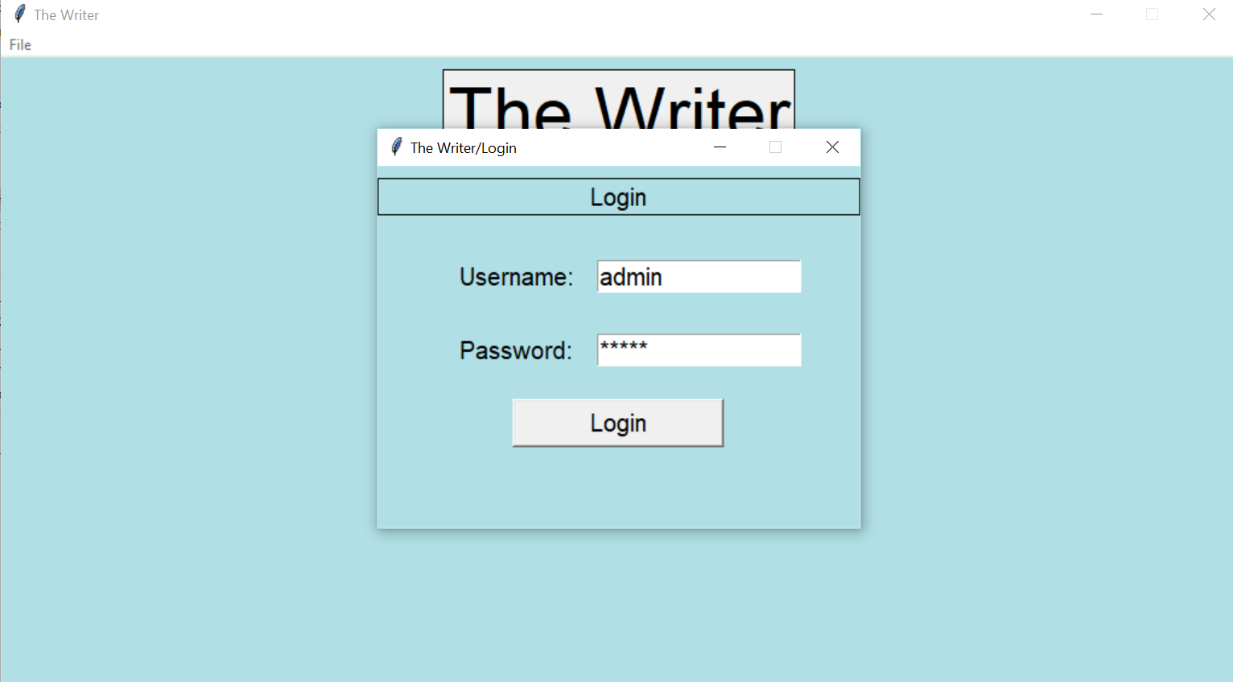

1. **Home page after Login Successful**

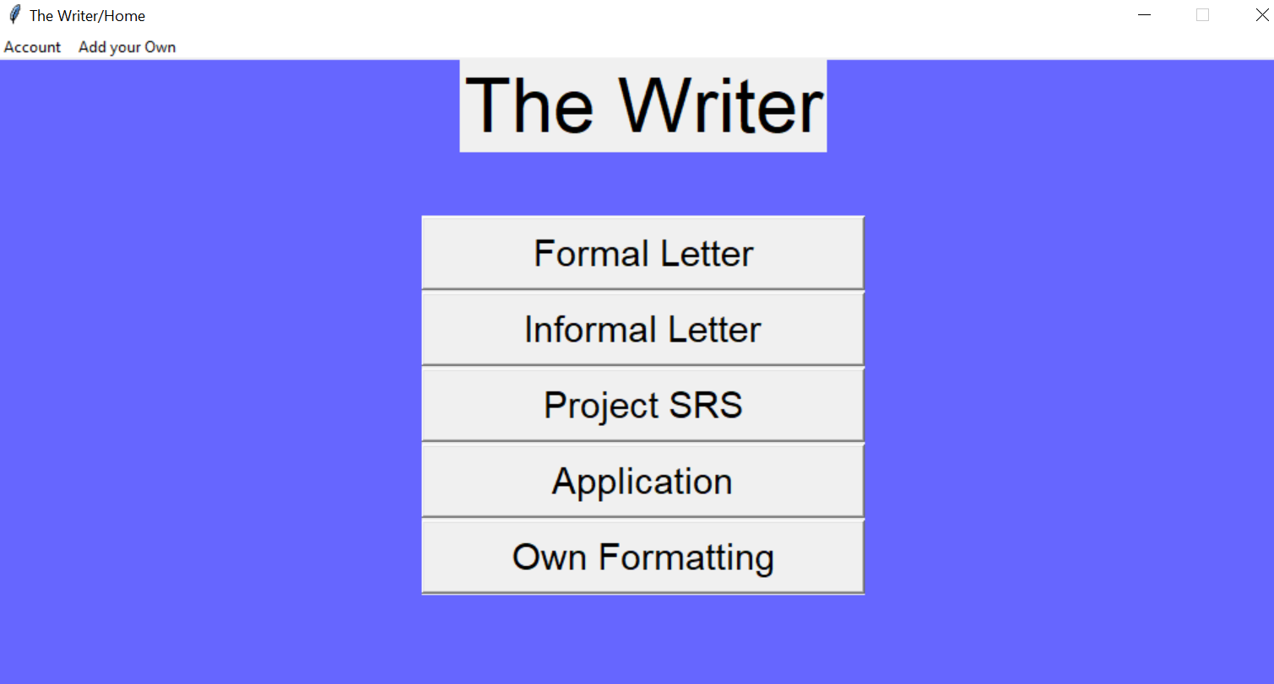

1. **Custom Text Editor**

