HANDS-ON DATA LAB
IMPLEMENTATION
A Practical Report on Building a Data Analysis Environment with Python and Jupyter

Submitted by: - jaykant kumar
Course / Internship: - Data Analyst Internship
Institute / Organization: - yuvaIntern
Submission date: - 14/10/2026

Abstract
This report explains the implementation of a beginner-friendly data analysis laboratory using Python, Jupyter Notebook, and commonly used data science libraries. The lab is designed to support practical work in data loading, inspection, cleaning, transformation, descriptive analysis, and visualization. It describes the software environment, a repeatable workflow, sample Python exercises, quality checks, expected outputs, and the lessons learned from the implementation. The examples are educational and use a small illustrative dataset; they are not presented as results from a real company or a completed external dataset. The overall goal is to create a reproducible environment in which a learner can move from raw data to clear, evidence-based findings.

1. Introduction
Data analysis is the process of examining data to answer questions, identify patterns, summarize performance, and support decisions. Data may be stored in CSV files, spreadsheets, databases, or other formats. Raw data often contains inconsistent labels, missing values, duplicate rows, and incorrect data types. A structured laboratory helps learners understand how to identify and handle these issues before interpreting results.
Python is widely used for data analysis because its syntax is readable and its ecosystem includes libraries for data manipulation, numerical operations, visualization, and scientific computing. Jupyter Notebook provides an interactive workspace where code, output, charts, and explanations can be kept together. This makes it suitable for learning, experimentation, and documenting practical exercises.

2. Objectives
- Set up a working Python data-analysis environment with Jupyter Notebook.
- Install and import the required libraries.
- Load a dataset and inspect its structure, columns, data types, and summary statistics.
- Identify missing values, duplicate rows, and inconsistent values.
- Perform basic filtering, grouping, aggregation, and calculated-column operations.
- Create appropriate visualizations and explain what they communicate.
- Document the workflow so that another learner can reproduce the steps.

3. Tools and Technologies
Tool / Library | Purpose | Typical use in this lab
Python | Programming language | Writing analysis and data-processing code
Jupyter Notebook | Interactive environment | Running code in cells and recording results
pandas | Tabular data processing | Reading CSV files, cleaning, filtering, grouping
NumPy | Numerical computing | Numeric calculations and array operations
Matplotlib | Plotting library | Creating charts and customizing axes/titles
Seaborn (optional) | Statistical visualization | Creating compact statistical plots
CSV file | Simple tabular data format | Input data for practical exercises

4. System Requirements and Environment Setup
A computer with a supported Python installation, internet access for initial installation, and enough storage for datasets is sufficient for the basic lab. The exact installation method may differ by operating system.

4.1 Installation steps
- Install Python from the official Python website, or install a Python distribution that includes Jupyter.
- Open Command Prompt or a terminal and check the installation with: python --version
- Install the required packages with: python -m pip install jupyter pandas numpy matplotlib seaborn
- Start the notebook interface with: jupyter notebook
- Create a new Python notebook and run a simple test such as print('Data Lab is ready').
- Import the libraries and confirm that no import errors appear.
If the command 'python' is not recognized, check the installation and PATH settings. On some Windows systems, 'py --version' and 'py -m pip install ...' may work instead. If pip reports a permissions issue, use a virtual environment rather than changing system-wide settings.

4.2 Recommended project folder
- data/ — input CSV files
- notebooks/ — Jupyter notebooks
- outputs/ — exported charts and cleaned data
- report/ — final report and notes
Keeping raw files separate from generated outputs reduces the risk of accidentally overwriting the original data and makes the project easier to maintain.

Figure 1. Typical Data Analysis Workflow
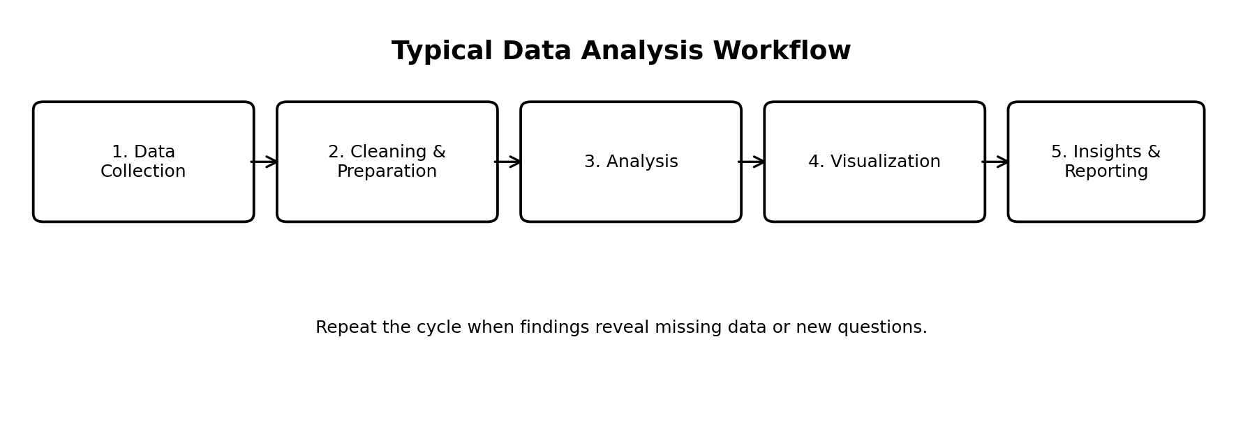
The workflow begins with data collection, then proceeds through cleaning, analysis, visualization, and reporting. It is iterative: unexpected results may require returning to an earlier step.

5. Practical Exercise 1: Import Libraries and Create a Sample Dataset
The first exercise checks that the environment works and demonstrates the basic structure of a tabular dataset. A small sample of fictional monthly sales is used so that the steps can run without an external file.
import pandas as pd
import numpy as np
import matplotlib.pyplot as plt
data = {
"Month": ["Jan", "Feb", "Mar", "Apr", "May", "Jun"],
"Region": ["North", "South", "North", "East", "South", "East"],
"Orders": [120, 135, 128, 150, 142, 160],
"Revenue": [24000, 27000, 25600, 30000, 28400, 32000]
}
df = pd.DataFrame(data)
df.head()
Expected interpretation: the output shows six records and four columns. Month and Region are categorical labels, while Orders and Revenue are numeric measures. The dataset is fictional and is included only to demonstrate the workflow.

6. Practical Exercise 2: Inspect the Dataset
print(df.shape) # number of rows and columns
print(df.columns) # column names
df.info() # data types and non-null counts
df.describe() # summary statistics for numeric columns
df.isna().sum() # missing values per column
These commands help answer basic quality questions: how large is the dataset, what fields are available, which columns are numeric, and are any values missing? Summary statistics such as mean, minimum, maximum, and quartiles can reveal unusual values that need further investigation.

7. Practical Exercise 3: Data Cleaning and Preparation
Cleaning should be based on the meaning of the data, not performed automatically. A missing value may mean that information was not recorded; a duplicate may be a genuine repeated transaction or an accidental copy. Each issue should be reviewed before it is changed.

7.1 Check missing and duplicate values
df.isna().sum()
df.duplicated().sum()

7.2 Example handling approach
# Example only: remove exact duplicate rows after confirming they are errors
df_clean = df.drop_duplicates().copy()
# For a numeric column, filling missing values with the median may be appropriate
# only when the context supports that choice:
# df_clean["Orders"] = df_clean["Orders"].fillna(df_clean["Orders"].median())
# Normalize text labels when inconsistent capitalization is present
df_clean["Region"] = df_clean["Region"].str.strip().str.title()
Deleting rows with missing values can reduce the sample size and may introduce bias. Filling missing values can also distort analysis if the chosen value is not appropriate. Therefore, record the original issue, the selected treatment, and the reason for the decision.
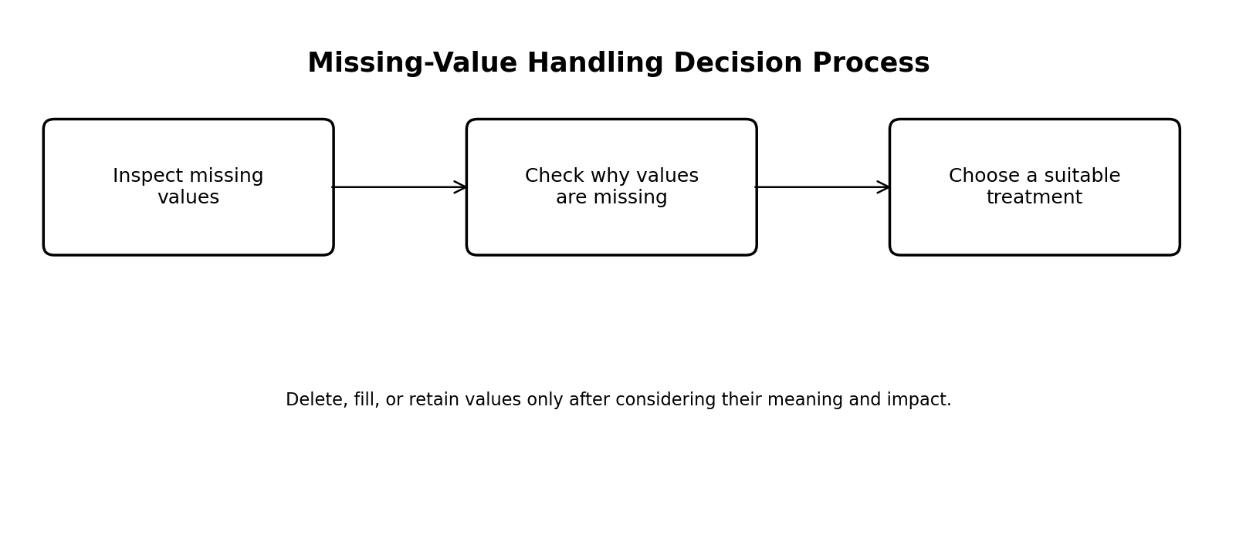
Figure 2. Missing-value handling decision process.

8. Practical Exercise 4: Data Transformation and Analysis
Once data quality has been checked, analysis can answer simple questions. The following examples calculate average revenue, total orders, and regional performance.
# Add a derived metric
df["Average_Revenue_Per_Order"] = df["Revenue"] / df["Orders"]
# Overall summaries
total_orders = df["Orders"].sum()
total_revenue = df["Revenue"].sum()
average_revenue = df["Revenue"].mean()
# Compare regions
region_summary = (
df.groupby("Region", as_index=False)
.agg(Total_Orders=("Orders", "sum"),
Total_Revenue=("Revenue", "sum"))
.sort_values("Total_Revenue", ascending=False)
)
print("Total orders:", total_orders)
print("Total revenue:", total_revenue)
print("Average revenue per period:", round(average_revenue, 2))
region_summary
Aggregation converts row-level information into a compact summary. Grouping by region makes it possible to compare performance across categories. The result should always be checked against the source data, especially when totals or filters are used.

9. Practical Exercise 5: Data Visualization
Charts make patterns easier to communicate, but the chart type must match the question. A bar chart is useful for comparing categories; a line chart is often useful for a time trend; a histogram describes the distribution of one numeric variable; and a scatter plot can help investigate the relationship between two numeric measures.
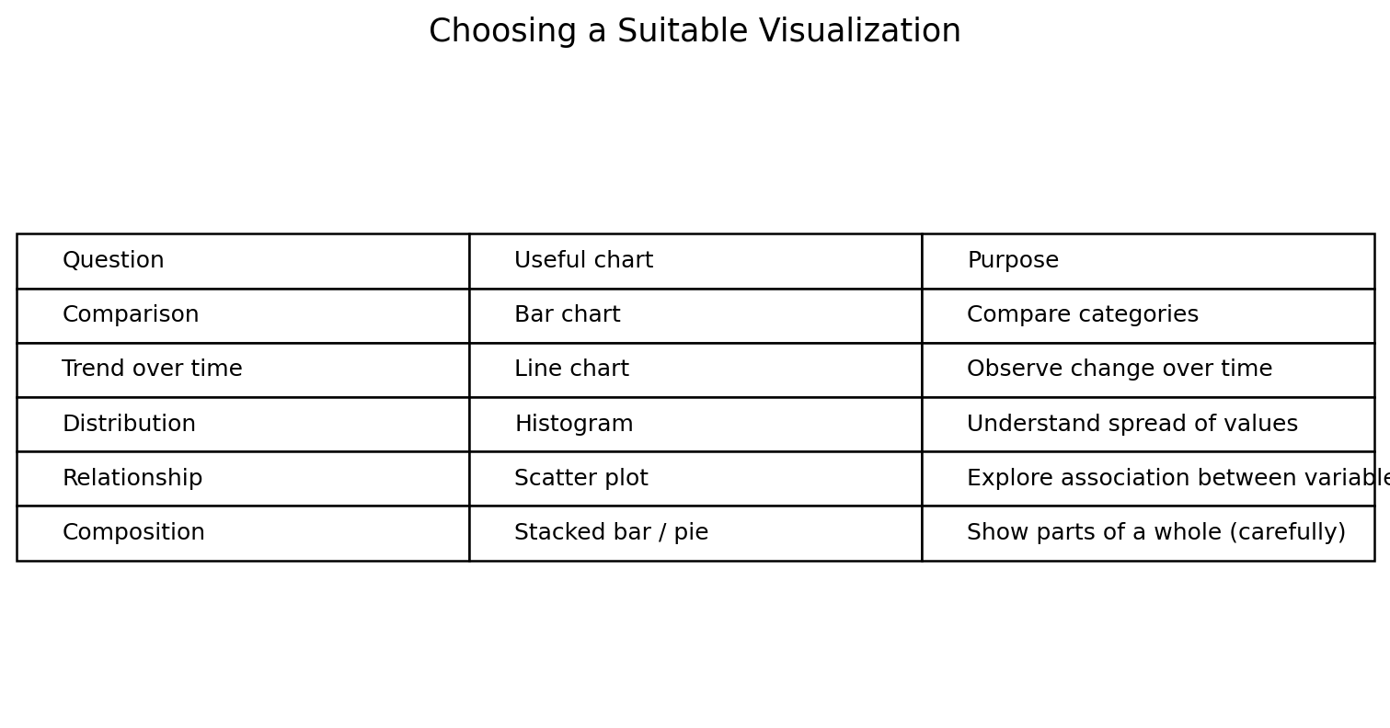
Figure 3. Choosing a suitable visualization.

9.1 Create a bar chart
plt.figure(figsize=(8, 4))
plt.bar(df["Month"], df["Revenue"])
plt.title("Illustrative Monthly Revenue")
plt.xlabel("Month")
plt.ylabel("Revenue")
plt.tight_layout()
plt.show()
The bar chart compares revenue across the six fictional months. In this example, June has the largest value and January has the smallest. This statement applies only to the illustrative values in the sample dataset, not to a real business.

9.2 Create a line chart
plt.figure(figsize=(8, 4))
plt.plot(df["Month"], df["Orders"], marker="o")
plt.title("Illustrative Orders by Month")
plt.xlabel("Month")
plt.ylabel("Number of Orders")
plt.tight_layout()
plt.show()
A line chart highlights the change in orders from one month to the next. When real dates are available, they should be parsed as date/time values and sorted chronologically before plotting.

Figure 4. Example Dataset Composition
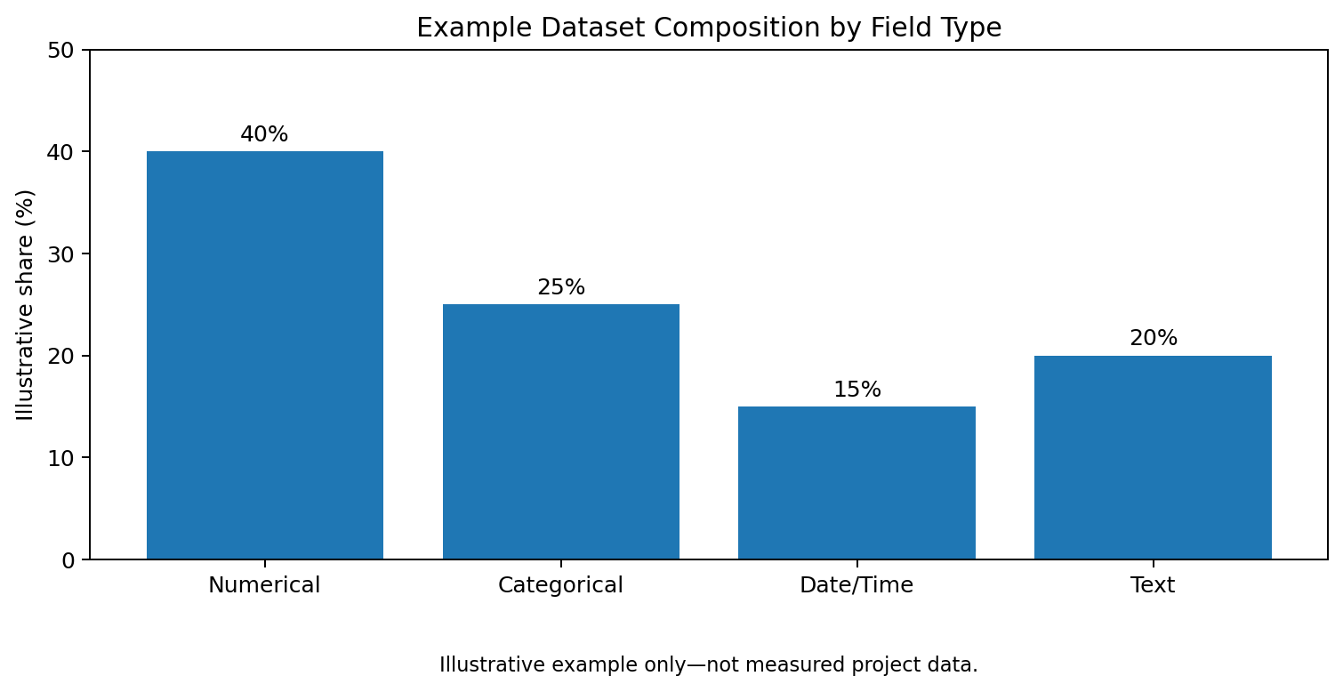
This chart is an illustrative teaching figure that shows possible field-type categories. It is not a statistic calculated from the six-row sample dataset.

10. Practical Exercise 6: Filtering and Conditional Analysis
# Rows where revenue exceeds 28,000
high_revenue = df[df["Revenue"] > 28000]
# Select only the columns needed for a report
report_view = df[["Month", "Orders", "Revenue"]]
# Sort from highest to lowest revenue
sorted_df = df.sort_values("Revenue", ascending=False)
Filtering narrows a dataset to records that meet a condition. Sorting makes it easier to identify high and low values. These techniques are useful for business questions such as which periods exceeded a target or which categories need attention.

11. Data Quality and Validation
- Confirm that the file loaded successfully and that the row count is plausible.
- Check column names, data types, missing values, and duplicate records.
- Validate numeric ranges; for example, revenue should not be negative unless the domain includes refunds or adjustments.
- Check whether totals calculated in Python agree with a manual sample or a spreadsheet calculation.
- Use clear chart titles, axis labels, units, and readable scales.
- Keep a copy of the raw data and record all cleaning decisions.
- Do not infer causation from a simple association or from a small illustrative dataset.
Quality assurance is important because a chart can look convincing even when the input data is incorrect. Validation should therefore happen before and after transformation, and key assumptions should be written down.

12. Results and Discussion
The practical workflow demonstrates how to set up an interactive analysis environment and move through common stages of a data project. The sample dataset supports inspection, simple calculations, grouping, filtering, and visualization. Because the dataset is small and fictional, its role is to validate the process rather than to provide meaningful business conclusions.
The main practical outcomes are: (1) a repeatable environment setup; (2) familiarity with core pandas operations; (3) a structured method for evaluating missing values and duplicates; (4) an understanding of how aggregation answers questions; and (5) improved ability to select charts based on the analytical objective. The workflow can be extended to larger datasets, real CSV files, and additional statistical methods once the fundamentals are reliable.

13. Challenges and Solutions
Potential challenge | Practical response
Python or pip command not found | Check Python installation and PATH; try the py launcher on Windows.
Library import error | Install the missing package in the same environment used by Jupyter.
CSV file not found | Confirm the file path and current working directory.
Unexpected data types | Inspect values and explicitly convert types when safe.
Too many missing values | Investigate why they are missing before deleting or filling.
Chart is difficult to read | Use a suitable chart, descriptive labels, and a readable figure size.

14. Applications of the Data Lab
The skills practiced in this lab are useful in many fields. A retail team can summarize orders and revenue; a hospital can examine waiting times and patient-flow measures; an education team can review attendance and assessment results; and a service organization can study customer feedback. Each application requires appropriate privacy protections, correct definitions, and domain knowledge.

15. Limitations
- The example dataset is fictional, very small, and designed for demonstration.
- No claims are made about real-world performance or statistical significance.
- The exercises focus on introductory analysis rather than advanced modeling, forecasting, or database integration.
- Data-cleaning decisions depend on context and should be documented for each real dataset.

16. Future Scope
- Practice with a larger, real-world CSV dataset and document its source.
- Add Excel or SQL to compare data-processing approaches.
- Build an interactive dashboard using a suitable business-intelligence tool.
- Explore correlation, hypothesis testing, and time-series analysis when the data supports them.
- Use version control to track notebook and report changes.
- Automate repeatable cleaning steps and export a cleaned dataset with a clear data dictionary.

17. Conclusion
This hands-on data lab provides a foundation for practical data analysis with Python and Jupyter Notebook. It combines environment setup with data inspection, cleaning, transformation, aggregation, visualization, and validation. The report emphasizes that trustworthy analysis depends not only on writing code but also on understanding the data, selecting suitable methods, checking results, and communicating limitations. By applying the same workflow to larger and more realistic datasets, a learner can gradually develop the skills needed for academic projects, internships, and entry-level data-related work.

Appendix A: Complete Example Script
import pandas as pd
import numpy as np
import matplotlib.pyplot as plt
data = {
"Month": ["Jan", "Feb", "Mar", "Apr", "May", "Jun"],
"Region": ["North", "South", "North", "East", "South", "East"],
"Orders": [120, 135, 128, 150, 142, 160],
"Revenue": [24000, 27000, 25600, 30000, 28400, 32000]
}
df = pd.DataFrame(data)
print("Shape:", df.shape)
print(df.info())
print("Missing values:\n", df.isna().sum())
print("Duplicate rows:", df.duplicated().sum())
print("Summary:\n", df.describe())
df["Average_Revenue_Per_Order"] = df["Revenue"] / df["Orders"]
region_summary = df.groupby("Region", as_index=False).agg(
Total_Orders=("Orders", "sum"),
Total_Revenue=("Revenue", "sum")
).sort_values("Total_Revenue", ascending=False)
print(region_summary)
plt.figure(figsize=(8, 4))
plt.bar(df["Month"], df["Revenue"])
plt.title("Illustrative Monthly Revenue")
plt.xlabel("Month")
plt.ylabel("Revenue")
plt.tight_layout()
plt.show()
plt.figure(figsize=(8, 4))
plt.plot(df["Month"], df["Orders"], marker="o")
plt.title("Illustrative Orders by Month")
plt.xlabel("Month")
plt.ylabel("Orders")
plt.tight_layout()
plt.show()

Appendix B: Submission Checklist
- Confirm that the report reflects the exercises you actually completed.
- Run the code in your own Python/Jupyter environment and capture genuine output screenshots if required.
- Replace the cover-page blanks with your name, course, institute, and date.
- Attach the report as a .docx file, as requested by the submission page.
- If the task requires a technical project URL, provide a real repository URL containing your notebook/code; do not enter a made-up URL.
- Review the report for accuracy and ensure all claims match the work completed.

