“Large Scale Volume Visualization on GPU”

MINI PROJECT REPORT
FOR THE DEGREE OF

BACHELOR OF TECHNOLOGY
IN

INFORMATION TECHNOLOGY


BY

Juhi Kumari (IIT2013153)

Sneha Jha (IIT2013174)

Tanushree Anand (IIT2013192)

Nikita Agarwal (ISM2013016)

KM Ishu (ISM2013019)

UNDER THE SUPERVISION OF

Dr. Anupam Agrawal

Professor
IIIT-ALLAHABAD

INDIAN INSTITUTE OF INFORMATION TECHNOLOGY,

ALLAHABAD

(A UNIVERSITY ESTABLISHED UNDER SEC.3 OF UGC ACT, 1956 VIDE NOTIFICATION NO. F.9-4/99-U.3 DATED 04.08.2000

OF THE GOVT. OF INDIA)
A CENTRE OF EXCELLENCE IN INFORMATION TECHNOLOGY ESTABLISHED BY GOVT. OF INDIA

6th May, 2016

CANDIDATES’ DELARATION

We hereby declare that the work presented in this project report entitled “Large Scale Volume Visualization on GPU”, submitted towards fulfillment of 6th Semester report of B.Tech. (IT) at Indian Institute of Information Technology, Allahabad, is an authenticated record of our original work carried out from Jan 2016 to May 2016 under the guidance of Prof. Anupam Agrawal. Due acknowledgements has been made in the text to all other material used. The project was done in full compliance with the requirements and constraints of the prescribed curriculum.

Place: Allahabad | Juhi Kumari | (IIT2013153)
Date: | Sneha Jha | (IIT2013174)
 | Tanushree Anand (IIT2013192)
 | Nikita Agarwal | (ISM2013016)
 | KM Ishu | (ISM2013019)

CERTIFICATE

This is to certify that the above statement made by the candidate is correct to the best of my knowledge.

Date: Dr.AnupamAgrawal

Place: Allahabad Professor

IIIT Allahabad

i
ACKNOWLEDGEMENT

We would like to acknowledge and extend our heartfelt gratitude to Dr. Anupam Agarwal, Indian Institute of Information Technology Allahabad, who guided us through this project. His keen vital encouragement, superb guidance, and constant support are the motive force behind this project work. We would like to show our war thanks to all our friends for their continuous motivation and encouragement during this project. We are very thankful to all the technical and non-technical staffs of the college for their assistance and co-operation.

Juhi Kumari | Sneha Jha | Tanushree Anand
IIT2013153 | IIT2013174 | IIT2013192

Nikita Agarwal | KM Ishu
ISM2013016 | ISM2013019

ii

ABSTRACT

A novel approach for GPU-based high-quality volume rendering of large out-of-core volume data has been implemented. By focusing on the storage of large volume data in an hierarchical data structure (i.e. octree) which stores the data in form of bricks , in addition every brick is further divided into macro-cells for easier traversal of data during run-time.

The approach performs branch-intensive accelerating structure traversal out of GPU raycasting loop and introduce an efficient empty-space culling method by rasterizing the proxy geometry of a view-dependent cut of the octree nodes . Octree traversal is now performed on CPU while rasterization and visualization processes are performed on the GPU. Rasterization pass can capture all of the bricks that the ray penetrates in a per-pixel list. Since the per-pixel list is captured in a front-to-back order, our ray-casting pass needs only to cast rays inside the tighter ray segments. During the process of evaluation and testing , this technique achieved 2 to 4 times faster rendering speed than a current state-of-the-art algorithm (which performs traversal of data structure on GPU) across a variety of data sets. As branch-intensive operations are operated in CPU at a better rate than on a GPU while floating point computations are better performed on GPU.

iii

Table of Contents

- Introduction………………………………………….………………………………1

- Problem definition and Objectives…………………………………………………..1

- Literature Survey…………………………………………………………………..2-10

- Methodology……..……………………………………………………………….11-15

- Hardware and Software Requirements ……………………………………………...16

- Activity Time Chart ………………………………………………………………...17

- Experimental Setup and Results…….……………………………………...…….17-18

- Performance Comparison…………………………………………………………….19

- Conclusion and Future Scope...……………………………………………………...20

- References……………………………………………………………………………21

iv

1. Introduction

Our project focuses on volume or 3D visualization of human data which is large-scale and has to be interactive, hence we are motivated to use GPU techniques.

1.1 Motivation

With the improving technology, medical diagnosis and increasing population the size of medical data (MRI, CT Scan etc.) is increasing day by day. Thus, the problem of visualization of large data arises which is very prominent in this era. However, in order to deal with the ever-increasing resolution and size of today’s volume data, it is crucial to use highly scalable visualization algorithms, data structures, and architectures in order to circumvent the restrictions imposed by the limited amount of on-board GPU memory. Volume visualization deals with methods to explore, analyze and visualize volumetric data acquired in medicine, computational physics and various other scientific disciplines. In other words, it is a method of extracting meaningful information from volumetric data using interactive graphics and imaging and it is considered with data representation, modeling, manipulation and rendering. Interactivity is making both the computational and the visualization effort proportional to the amount and resolution of data that is actually visible on screen (output-sensitive algorithms and system designs).

GPU-based large-scale volume visualization techniques based on the notions of actual output-resolution visibility and the current working set of volume bricks the current subset of data that is minimally required to produce an output image of the desired display resolution.

2. Problem definition

To visualize large volume medical human data on GPU efficiently. It can be used to view human body in different resolutions and perspectives based on the requirements of the user, hence interactive. This requires effective handling of large data in a structured way, keeping in mind the memory constraints.

2.1 Objective

To build a robust system which could be used to visualize data independent of its size on any inexpensive hardware having minimum specifications.

Modelling the data using multi resolution model like octree.

Selective rendering of data as required by the user, hence output-specific and Interactive.
3. Literature Survey

Table 1. Literature Survey Table

S. | Title | Year | Journal/ | Objective | Method | Dataset Used | Advantage | Disadvant | Challenge( | Future
No. |  |  | Conferenc |  |  | & |  | age | s) Dealt | Scope
 |  |  | e |  |  | Dataset Size
1 | A single-pass | 2008 | Journal | To present | Volume | Multi-gigavoxel | Octree is used | The | To handle | To exploit
 | GPU ray |  |  | an adaptive | tric | CT | for | rendering | vast data | the
 | casting |  | Visual | out-of-core | dataset | dataset | data | working set | efficiently | capability
 | framework for |  | Comput | technique | is |  | representation | will |  | of our
 | interactive out- |  | 2008 | for rendering | decomp |  | maintained out of | not |  | system to
 | of-core |  |  | massive | osed |  | Core. At runtime | efficiently |  | perform a
 | rendering of |  |  | scalar | into |  | an adaptive | Update as |  | full-
 | massive |  |  | volumes | small |  | loader, executing | the |  | volume ray
 | volumetric |  |  | employing | cubical |  | on the CPU, | integration |  | tracing to
 | datasets |  |  | single-pass | bricks, |  | updates a view | of level-of- |  | produce
 | [3] |  |  | GPU ray | which |  | and transfer | detail |  | higher
 |  |  |  | casting | are then |  | function- | and |  | quality
 |  |  |  |  | organize |  | dependent | visibility |  | images that
 |  |  |  |  | d into |  | working set of | culling |  | incorporate
 |  |  |  |  | an |  | bricks | techniques |  | more
 |  |  |  |  | octree |  | maintained on | are not |  | advanced
 |  |  |  |  | structur |  | GPU memory | used which |  | shading
 |  |  |  |  | e |  | by | is required. |  | effects
 |  |  |  |  | maintai |  | asynchronously
 |  |  |  |  | ned out- |  | fetching data
 |  |  |  |  | of-core |  | from the out-of-
 |  |  |  |  | and |  | core octree
 |  |  |  |  | during |  | representation.
 |  |  |  |  | run time |  | Out-of-core data
 |  |  |  |  | loading |  | management is
 |  |  |  |  | the |  | used for filtering
 |  |  |  |  | working |  | out as efficiently
 |  |  |  |  | set on |  | as possible
 |  |  |  |  | GPU |  | the data that is
 |  |  |  |  |  |  | not contributing
 |  |  |  |  |  |  | to a particular
 |  |  |  |  |  |  | image.
2 | A Survey of | 2014 | Conference | To give an |  | Large | Octree is used as | For large-
 | GPU-Based |  |  | overview of |  | Volumetric Data | data structure in | scale
 | Large-Scale |  | Eurographi | the current |  |  | volume | rendering,
 | Volume |  | cs | state of the |  |  | rendering | all the
 | Visualization |  | Conference | art in GPU |  |  | Which enable | stages in
 | [2] |  | on | techniques |  |  | adaptive level | this
 |  |  | Visualizatio | for |  |  | of detail, in | pipeline
 |  |  | n (EuroVis) | interactive |  |  | addition to | have to be
 |  |  | (2014) | large-scale |  |  | enabling empty | scalable
 |  |  |  | volume |  |  | space | (i.e., in our
 |  |  |  | visualization |  |  | skipping. | context:
 |  |  |  |  |  |  | Used Output | output-
 |  |  |  |  |  |  | Sesitive | sensitive),
 |  |  |  |  |  |  | Algorithm | or
 |  |  |  |  |  |  | Was making | they will
 |  |  |  |  |  |  | their running | become the
 |  |  |  |  |  |  | time | bottleneck

 |  |  |  |  |  |  | dependent on the | for the
 |  |  |  |  |  |  | size of the output | entire
 |  |  |  |  |  |  | instead of the | application
 |  |  |  |  |  |  | size of | otherwise
 |  |  |  |  |  |  | the input. | the
 |  |  |  |  |  |  | Focus on Ray- | visualizatio
 |  |  |  |  |  |  | guided and | n will not
 |  |  |  |  |  |  | visualization- | be done
 |  |  |  |  |  |  | driven | perfectly
 |  |  |  |  |  |  | architectures. | and
 |  |  |  |  |  |  |  | accurately.
3 | Octree | 2013 | Journal | Our target is | Store | Large out-of- | It focus to make | The | Maintainin | This
 | Rasterization: |  |  | to make | volume | core volume | high-quality | efficiency | g octree on | methodolo
 | Accelerating |  | IEEE | high-quality | in an | data. | visualization | of the | GPU limits | gy can be
 | High-Quality |  | TRANSAC | visualization | octree |  | more | hierarchical | the data | used in
 | Out-of-Core |  | TIONS ON | more | (of |  | practical by the | bricking | size. | other
 | GPU Volume |  | VISUALIZ | practical in | bricks) |  | use of a | scheme | Raycasting | visualizatio
 | Rendering |  | ATION | the clinic by | each |  | consumer-level | often | by passing | n systems,
 | [1] |  | AND | the use of a | having |  | GPU. | suffers | each brick, | such as in
 |  |  | COMPUTE | consumer- | further |  | It introduce an | from per- | hence | multiple
 |  |  | R | level GPU | split |  | new out-of-core | pixel | increasing | user
 |  |  | GRAPHIC |  | into |  | GPU volume | traversal of | the | activities,
 |  |  | S |  | regular |  | rendering | the | overhead | comparativ
 |  |  |  |  | macroce |  | framework, | hierarchical |  | e settings
 |  |  |  |  | lls. |  | which combines | acceleratio |  | and
 |  |  |  |  | Using |  | object-order and | n structure, |  | multiple
 |  |  |  |  | branch- |  | image-order | which is a |  | volume
 |  |  |  |  | intensiv |  | advantages and | branch- |  | studies, or
 |  |  |  |  | e |  | acts as a general | intensive |  | time-
 |  |  |  |  | accelera |  | acceleration | operation |  | varying
 |  |  |  |  | ting |  | technique, which | and |  | data
 |  |  |  |  | structur |  | makes more | may not |  | visualizatio
 |  |  |  |  | e |  | complex | perform |  | n in future
 |  |  |  |  | traversal |  | visualizations | well on |  | work
 |  |  |  |  | out of |  | possible, while | modern
 |  |  |  |  | the GPU |  | maintaining | GPU
 |  |  |  |  | raycasti |  | interactivity at | architecture
 |  |  |  |  | ng loop |  | the same time. | s, which
 |  |  |  |  | and by |  | The algorithm | have a
 |  |  |  |  | rasterizi |  | proposed can | heavy
 |  |  |  |  | ng the |  | achieve 2-4 times | performanc
 |  |  |  |  | proxy |  | faster rendering | e penalty
 |  |  |  |  | geometr |  | speed than a | for
 |  |  |  |  | y of a |  | current state-of- | divergent
 |  |  |  |  | view- |  | the-art algorithm | branching.
 |  |  |  |  | depende |  | for large out-of-
 |  |  |  |  | nt cut of |  | core data sets,
 |  |  |  |  | the |  | while also
 |  |  |  |  | octree |  | producing high-
 |  |  |  |  | nodes. |  | quality rendering
 |  |  |  |  | This |  | using tricubic
 |  |  |  |  | rasteriza |  | interpolation.
 |  |  |  |  | tion
 |  |  |  |  | pass
 |  |  |  |  | captures
 |  |  |  |  | all of
 |  |  |  |  | the

 |  |  |  |  | bricks
 |  |  |  |  | that the
 |  |  |  |  | ray
 |  |  |  |  | penetrat
 |  |  |  |  | es in a
 |  |  |  |  | per-
 |  |  |  |  | pixel
 |  |  |  |  | list.
4 | GPU-based | 2005 | Conference | To facilitate |  | CT | The work that it | It does not | the | moving
 | Volume |  |  | the usage of |  | scan of the | involved is to | used any | algorithm | classificati
 | Rendering for |  | Engineerin | well- |  | Stanford terra- | store | data | employed a | on
 | Medical Image |  | g in | developed |  | cotta bunny | volume data in | pipeline to | pre- | operation
 | Visualization |  | Medicine | hardware |  | (512*512*360) | texture, resample | implement | classificati | into GPU
 | [4] |  | and | resource, a |  |  | and interpolate | ray-casting | on method | to get even
 |  |  | Biology | graphics |  | real clinical | them using | operation | to classify | quicker
 |  |  | 27th | processing |  | human abdomen | hardware instead | completely | voxels | interactive
 |  |  | Annual | unit (GPU)- |  | CT | of software | in GPU so | before | speed
 |  |  | Conference | based |  | data, | This paper | because of | interpolatio
 |  |  |  | volume ray- |  | (400*400*344) | presented a novel | this the big | n, since
 |  |  |  | casting |  |  | volume- | data cannot | this must
 |  |  |  | algorithm is |  | MRI head scans | rendering | be | be done in
 |  |  |  | proposed |  | (190*217*190) | algorithm for | visualize | CPU, it
 |  |  |  |  |  |  | medical image | using this | costs much
 |  |  |  |  |  | MRI head scans | visualization | algorithm. | time
 |  |  |  |  |  | (256*256*109) | using NV40
 |  |  |  |  |  |  | GPU. Based on
 |  |  |  |  |  |  | the flexible
 |  |  |  |  |  |  | programming
 |  |  |  |  |  |  | model of FV40
 |  |  |  |  |  |  | pixel shader.
5 | A Framework | 2004 | Conference | To present a | The | Large | We present a | The | The | Studying
 | for Rendering |  |  | new | design | scale time- | new framework | primary | formidable | different
 | Large Time- |  | VG'05 | framework | goal of | varying data | for managing and | goals of | challenge | approaches
 | Varying Data |  | Proceeding | for | the |  | rendering large | our work is | for | to combine
 | Using |  | s of the | managing | WTSP |  | scale time- | to | interactive | the WTSP
 | Wavelet-Based |  | Fourth | and | tree is to |  | varying data | decorrelate | volume | tree data
 | Time-Space |  | Euro | rendering | support |  | using the | the time- | rendering | structure
 | Partitioning |  | graphics / | large scale | interacti |  | wavelet-based | varying | is the huge | with other
 | (WTSP) Tree |  | IEEE | time-varying | ve |  | time-space parti- | data into a | amount of | data
 | [5] |  | VGTC | data using | browsin |  | tioning (WTSP) | range of | data | compressio
 |  |  | conference | the wavelet- | g of |  | tree. We utilize | spatial and |  | n schemes.
 |  |  | on Volume | based time- | data at |  | the hierarchical | tem- |  | For
 |  |  | Graphics | space | arbitrary |  | TSP tree data | poral levels |  | instance, to
 |  |  |  | partitioning( | spatio- |  | structure to | of detail, |  | incorporate
 |  |  |  | WTSP) tree | tempora |  | capture both | and to |  | the
 |  |  |  |  | l |  | spatial and | develop |  | Laplacian
 |  |  |  |  | scales.U |  | temporal locality | efficient |  | pyramid
 |  |  |  |  | sing |  | and coher- | data |  | structure
 |  |  |  |  | Haar |  | ence of the | manageme |  | into the
 |  |  |  |  | wavelet |  | underlying time- | nt |  | WTSP tree
 |  |  |  |  | s, we |  | varying data and | Scheme to |  | and trade
 |  |  |  |  | can |  | exploit the | enable |  | space for
 |  |  |  |  | build a |  | wavelet | rapid run- |  | reconstruct
 |  |  |  |  | binary |  | transform to | time data |  | ion and
 |  |  |  |  | time |  | convert the data | retrieval |  | rendering
 |  |  |  |  | tree |  | into a | and |  | time
 |  |  |  |  | associat |  | multiresolution | reconstructi

 |  |  |  |  | ed with |  | spatio-temporal | on. So
 |  |  |  |  | each of |  | representation. | basically it
 |  |  |  |  | the |  | During | focused on
 |  |  |  |  | spatial |  | rendering, the | the space
 |  |  |  |  | nodes |  | wavelet- | and time
 |  |  |  |  | with a |  | compressed data | manageme
 |  |  |  |  | method |  | stream is | nt of
 |  |  |  |  | similar |  | decompressed | rendering
 |  |  |  |  | to the |  | on-the-fly and | and
 |  |  |  |  | error |  | rendered using | visualizatio
 |  |  |  |  | tree |  | 3D hardware | n rather
 |  |  |  |  | algorith |  | texture | than the
 |  |  |  |  | m |  | mapping. WTSP | image
 |  |  |  |  |  |  | tree allows | quality and
 |  |  |  |  |  |  | random access of | the results
 |  |  |  |  |  |  | data at arbitrary | accuracy.
 |  |  |  |  |  |  | spa-
 |  |  |  |  |  |  | tial and temporal
 |  |  |  |  |  |  | resolutions at run
 |  |  |  |  |  |  | time.
6 | Interactive Iso- | 2006 | Conference | To present a | Implem | UNC DATA | It present a | Adaptive | Interactive | Exploiting
 | surface Ray |  |  | technique | entation |  | technique for ray | isosurface | rendering | the multi
 | Tracing of |  | Interactive | for ray | is based | Blunt Fin | tracing | extraction | of large | resolution
 | Large Octree |  | Ray | tracing iso | on the | (40x32x32) | isosurfaces of | techniques | volumes is | nature of
 | Volumes |  | Tracing | surfaces of | followin |  | large compressed | are fast, but | a difficult | the octree
 | [6] |  | 2006, IEEE | large | g | Protein | structured | depend on | problem in | to provide
 |  |  | Symposium | compressed | theoreti | (64x64x64) | volumes. | effective | visualizatio | a dynamic,
 |  |  | on | structured | cal |  | By embedding | processing | n. With | view-
 |  |  |  | volumes of | concept | Enzyme | the acceleration | and | direct | adaptive
 |  |  |  | data | s: octree | (97x97x116 | tree and scalar | streaming | volume | level of
 |  |  |  |  | data | ) | data | of large | rendering, | detail
 |  |  |  |  | format, | Dolphin | in a single | data to the | GPU | scheme.
 |  |  |  |  | point | (320x320x40) | structure and | CPU. | memory | Such a
 |  |  |  |  | location |  | employing | They | imposes an | system
 |  |  |  |  | and | NMR Brain | optimized octree | render a | absolute | would
 |  |  |  |  | neighbo | (256x256x109) | hash schemes, | piecewise | limit on the | reduce the
 |  |  |  |  | r- |  | we achieve | linear mesh | volume | complexity
 |  |  |  |  | finding, | CT Head | competitive | that may be | size, and | and
 |  |  |  |  | and the | (256x256x113) | frame rates on | topological | the video | variance of
 |  |  |  |  | octree |  | common | ly different | bus | the overall
 |  |  |  |  | traversal |  | multicore | from the | restricts | scene
 |  |  |  |  |  |  | architectures, and | true | real time
 |  |  |  |  |  |  | render large | isosurface | rendering
 |  |  |  |  |  |  | time-variant data | as defined | of time-
 |  |  |  |  |  |  | that could not | by the | variant data
 |  |  |  |  |  |  | otherwise be | source
 |  |  |  |  |  |  | accomodated. | data.
 |  |  |  |  |  |  | It involves
 |  |  |  |  |  |  | compressing
 |  |  |  |  |  |  | volumes into
 |  |  |  |  |  |  | an octree
 |  |  |  |  |  |  | structure, and
 |  |  |  |  |  |  | employing that
 |  |  |  |  |  |  | for ray traversal.
7 | Interactive | 2009 | Conference | This method | The | Skull CT scan | To facilitate the | Due to the | The
 | GPU-based |  |  | makes use of | propose | data set | usage of well- | large | interactive
 | Volume |  | Conference | tri-linear | d | (256x256x256) | developed | number of | visualizatio

 | Rendering for |  | on | interpolation | algorith |  | hardware | trilinear | n of such
 | Medical Image |  | Biomedical | to | m | Human head | resource, a | interpolatio | data is a
 | [7] |  | Engineerin | Accelerate | implem | MRI data set | graphics | ns that | challenge,
 |  |  | g and | rendering | ent ray | (256x256x256) | processing unit | must be | since the
 |  |  | Informatics | speed. | casting |  | (GPU)-based | processed | frame rate
 |  |  |  | Besides for | operatio | Pet data set for | volume ray- | in order to | is heavily
 |  |  |  | volume ray- | n | chest | casting algorithm | produce | depending
 |  |  |  | casting | complet | (512x512x256) | is proposed | image | on the
 |  |  |  | back-to- | ely in |  | which implement | results of | amount of
 |  |  |  | frond order | GPU. It | Head CT scan | ray casting | high | data to be
 |  |  |  | is used when | re- | data | operation | quality, the | visualized
 |  |  |  | the voxel’s | samples | (256x256x84) | completely | availability
 |  |  |  | opacity is | volume |  | in GPU. The | of direct
 |  |  |  | Accumulate | data, |  | algorithm re- | volume
 |  |  |  | d to a | represen |  | samples volume | rendering
 |  |  |  | threshold the | ted as a |  | data, represented | has yet
 |  |  |  | after | stack of |  | as a stack of 3D | been
 |  |  |  | calculation | 3D |  | texture, onto a | restricted
 |  |  |  | will be | texture, |  | sampling surface. | to high-end
 |  |  |  | discard. | onto a |  | It can perform an | workstation
 |  |  |  |  | samplin |  | interactive rate | s and
 |  |  |  |  | g |  | even for direct | special
 |  |  |  |  | surface. |  | volume | purpose
 |  |  |  |  | The ray- |  | rendering while | graphics
 |  |  |  |  | casting |  | keeping the high | hardware.
 |  |  |  |  | algorith |  | image quality.
 |  |  |  |  | m
 |  |  |  |  | perform
 |  |  |  |  | s in
 |  |  |  |  | fragmen
 |  |  |  |  | t
 |  |  |  |  | shaders
8 | Mapping High- | 2009 | Journal | To learn and | It uses | Three sets of | This paper | The | The
 | Fidelity |  |  | analyze new | thread- | human CT data | describe a | advantage | challenge
 | Volume |  | IEEE | volumetric | and | (16-bit) | thread- and data- | is the | is to
 | Rendering for |  | Transaction | rendering | data- |  | parallel | challenge | provide
 | Medical |  | s on | algorithms | parallel | Large medical | implementation | to provide | improved
 | Imaging to |  | Visualizatio | that are | implem | human dataset | of ray-casting | improved | health care
 | CPU, GPU and |  | n and | suited to | entation | (750x750x1000) | that makes it | health care | efficiently,
 | Many-Core |  | Computer | modern | of ray- |  | amenable to key | efficiently, | which is
 | Architectures |  | Graphics | parallel | casting |  | architectural | which is | complicate
 | [8] |  |  | processing | that |  | trends | complicate | d by the
 |  |  |  | architectures | makes it |  | of three modern | d by the | magnitude
 |  |  |  |  | amenabl |  | commodity | magnitude | of the data.
 |  |  |  |  | e to key |  | parallel | of the data. | Despite the
 |  |  |  |  | architect |  | architectures: | Despite the | availability
 |  |  |  |  | ural |  | multi-core, GPU, | availability | of several
 |  |  |  |  | trends |  | and an upcoming | of several | general
 |  |  |  |  | of three |  | many-core Intel | general | purpose
 |  |  |  |  | modern |  | R architecture | purpose | and
 |  |  |  |  | commo |  | code-named | and | specialized
 |  |  |  |  | dity |  | Larrabee. | specialized | rendering
 |  |  |  |  | parallel |  | Overall parallel | rendering | engines,
 |  |  |  |  | architect |  | implementation | engines, | volume
 |  |  |  |  | ures: |  | of ray-casting | volume | visualizatio
 |  |  |  |  | multi- |  | delivers close to | visualizatio | n has not
 |  |  |  |  | core, |  | 5.8x speed-up on | n has not | been

 |  |  |  |  | GPU, |  | quad-core | been | widely
 |  |  |  |  | and an |  | Nehalem over an | widely | adopted by
 |  |  |  |  | upcomi |  | optimized scalar | adopted by | the medical
 |  |  |  |  | ng |  | baseline version | the medical | community
 |  |  |  |  | many- |  | running on a | community | except in
 |  |  |  |  | core |  | single | except in | certain
 |  |  |  |  | IntelR |  | core Harpertown. | certain | specific
 |  |  |  |  | architect |  |  | specific | cases
 |  |  |  |  | ure |  |  | cases. In
 |  |  |  |  | code- |  |  | ray-casting,
 |  |  |  |  | named |  |  | as the ray’s
 |  |  |  |  | Larrabe |  |  | traverses
 |  |  |  |  | e |  |  | through the
 |  |  |  |  |  |  |  | volume,
 |  |  |  |  |  |  |  | they access
 |  |  |  |  |  |  |  | voxels with
 |  |  |  |  |  |  |  | a non-
 |  |  |  |  |  |  |  | constant
 |  |  |  |  |  |  |  | stride.
9 | Large Scale | 2015 | Journal | To reduce | Present | Stag beetle | This paper | The basic | The JIT | just-in-time
 | Volume |  |  | the memory | a new | dataset | presents JiTTree, | principle of | approach | compilatio
 | visualization |  | IEEE | bandwidth | sparse | (brick size- | a novel sparse | the data | transforms | n of the
 | on GPU A |  | Transaction | (bottleneck | volume | 32*32*32) | hybrid volume | structure is | memory- | root level
 | Just-in-Time |  | s on | in GPU) for | hybrid |  | data structure | to adapt to | bound | to improve
 | Compiled |  | Visualizatio | sparse | data |  | that uses just-in- | the local | programs | performanc
 | Sparse GPU |  | n and | volume data | represen | Kingsnake | time compilation | sparsity of | into | e ;to add
 | Volume Data |  | Computer | structures | tation | dataset | to | a specific | instruction- | dynamic
 | Structure |  | Graphics | that pose a | (JiTTree | (brick size- | overcome the | data set. | bound | write
 | [9] |  |  | tradeoff | ) that | 128*128*128) | representation | Other | programs. | capabilities
 |  |  |  | between | makes it |  | problems. In this | volume | Although | in addition
 |  |  |  | memory | possible |  | paper we present | representati | data | to the read-
 |  |  |  | efficiency | to |  | JiTTree, a new | ons often | structure is | only
 |  |  |  | and access | combine |  | type of sparse | make the | not | access;
 |  |  |  | performance | multiple |  | volume data | distinction | designed | improve
 |  |  |  |  | element |  | representation | between | for dense | the JIT
 |  |  |  |  | al data |  | that enables | dense and | data, it | compilatio
 |  |  |  |  | structur |  | memory-efficient | empty (or | outperform | n approach
 |  |  |  |  | es |  | storage and | homogenou | s other | for other
 |  |  |  |  | resultin |  | highperformance | s) regions | representati | memory
 |  |  |  |  | g in |  | data access. The | and treat | ons, such | access
 |  |  |  |  | lower |  | JiTTree is the | these | as a dense | patterns
 |  |  |  |  | memory |  | just-in-time | regions | bricking, | like ray
 |  |  |  |  | require |  | compilation | differently. | for most | traversal
 |  |  |  |  | ments |  | stage that |  | cases.
 |  |  |  |  | while |  | transforms data |  | However,
 |  |  |  |  | enabling |  | into efficient |  | for a better
 |  |  |  |  | high |  | access functions. |  | analysis of
 |  |  |  |  | runtime |  | Thereby it |  | the data
 |  |  |  |  | perform |  | enables the use |  | structure
 |  |  |  |  | ance. |  | of multiple kinds |  | we used
 |  |  |  |  | No |  | of data structures |  | data sets
 |  |  |  |  | memory |  | to represent one |  | with
 |  |  |  |  | fetches |  | volume, without |  | varying
 |  |  |  |  | are |  | introducing a |  | scarcity.
 |  |  |  |  | required |  | significant
 |  |  |  |  | for the |  | traversal
 |  |  |  |  | kd-tree |  | overhead. By

 |  |  |  |  | traversal |  | combining
 |  |  |  |  | . The |  | multiple sparse
 |  |  |  |  | splitting |  | data structures
 |  |  |  |  | axis |  | and reducing
 |  |  |  |  | order is |  | traversal
 |  |  |  |  | directly |  | overhead we
 |  |  |  |  | encoded |  | leverage their
 |  |  |  |  | in the |  | individual
 |  |  |  |  | Conditi |  | advantages.
 |  |  |  |  | onals. |  | JiTTree reduces
 |  |  |  |  | Splitting |  | the traversal
 |  |  |  |  | plane |  | overhead of the
 |  |  |  |  | position |  | resulting optimal
 |  |  |  |  | s are |  | data
 |  |  |  |  | inserted |  | structure
 |  |  |  |  | as
 |  |  |  |  | literals.
10 | A Survey of | 2006 |  | survey and |  | Large | This paper | It only |  | Future
 | Octree Volume |  |  | comparison |  | Volume Data | surveys and | examine |  | application
 | Rendering |  |  | of existing |  |  | compares | octree |  | s of octree
 | Methods |  |  | works |  |  | existing works | structures |  | volume
 | [10] |  |  | employing |  |  | employing | that are of |  | rendering
 |  |  |  | octrees for |  |  | octrees for | interest in |  | could
 |  |  |  | volume |  |  | volume | volume |  | attempt to
 |  |  |  | rendering |  |  | rendering. It | Rendering |  | combine
 |  |  |  |  |  |  | focuses | not for the |  | the pure
 |  |  |  |  |  |  | specifically on | other |  | octree
 |  |  |  |  |  |  | extraction, direct | purpose so |  | volume
 |  |  |  |  |  |  | volume | we cannot |  | with GPU
 |  |  |  |  |  |  | rendering, and | compare its |  | rendering
 |  |  |  |  |  |  | iso surface ray | usefulness |  | approaches
 |  |  |  |  |  |  | tracing. | towards the |  | , using out-
 |  |  |  |  |  |  | It survey several | particular |  | of-core
 |  |  |  |  |  |  | varieties of | purpose. |  | methods
 |  |  |  |  |  |  | octree and
 |  |  |  |  |  |  | efficient hashing
 |  |  |  |  |  |  | schemes for their
 |  |  |  |  |  |  | traversal.
11 | Cell Octrees: | 2001 | Conference | An |  | Large Volume | It propose a new | When the | An | property
 | A New Data |  | , | improvemen |  | Data | indexing method | number of | improveme | values may
 | Structure for |  | Proceeding | t of bono |  |  | that uses an | cells of any | nt of bono, | be stored in
 | Volume |  | s of the | approach |  |  | incomplete | dimension | noted as | the tree, so
 | Modeling and |  | Vision | which uses |  |  | octree and which | of | cells | it is not
 | Visualization |  | Modeling | an |  |  | requires less | the volume | octree, has | necessary
 | [11] |  | and | incomplete |  |  | memory to be | is not a | been done | to store the
 |  |  | Visualizatio | octree with a |  |  | stored. | power of |  | grid and
 |  |  | n | smaller |  |  | It present an | two, or is |  | there may
 |  |  |  | memory |  |  | improvement of | not equal |  | be further
 |  |  |  |  |  |  | BONO (Branch | to the |  | reductions
 |  |  |  |  |  |  | On Need Octree) | number of |  | in the
 |  |  |  |  |  |  | approach which | cells of |  | storage
 |  |  |  |  |  |  | uses an | another |  | requiremen
 |  |  |  |  |  |  | incomplete | dimension |  | ts
 |  |  |  |  |  |  | octree with a | of it,
 |  |  |  |  |  |  | smaller memory. | nodes will
 |  |  |  |  |  |  | The method | not have all
 |  |  |  |  |  |  | indexes a set of | eight sons.

 |  |  |  |  |  |  | cells as a block | In such
 |  |  |  |  |  |  | when their | cases,
 |  |  |  |  |  |  | property value is | nodes will
 |  |  |  |  |  |  | nearly uniform. | have a
 |  |  |  |  |  |  | In this approach | larger
 |  |  |  |  |  |  | the prune | ramificatio
 |  |  |  |  |  |  | condition is | n in the
 |  |  |  |  |  |  | independent on | levels
 |  |  |  |  |  |  | threshold and | which are
 |  |  |  |  |  |  | point of view. | close to the
 |  |  |  |  |  |  | The branches of | leaf nodes,
 |  |  |  |  |  |  | the tree that do | and a
 |  |  |  |  |  |  | not index cells | smaller
 |  |  |  |  |  |  | containing the | ramificatio
 |  |  |  |  |  |  | isosurface are not | n in the
 |  |  |  |  |  |  | processed, so the | levels close
 |  |  |  |  |  |  | isosurface | to the root
 |  |  |  |  |  |  | building time is | node.
 |  |  |  |  |  |  | reduced. | Consequent
 |  |  |  |  |  |  |  | ly, the
 |  |  |  |  |  |  |  | storage
 |  |  |  |  |  |  |  | requiremen
 |  |  |  |  |  |  |  | t is smaller.
12 | Multi- | 2001 | Journal | Reducing | Texture- | MRI brain | The purpose of | The |  | "Future
 | Resolution |  |  | the amount | based | (32 MB) | this paper is to | algorithm |  | work” is
 | volume |  | The Visual | of texture | octree |  | speed up the | proposed in |  | Addressed
 | visualization |  | Computer | memory |  | MRI Brain | texture based | the paper |  | to analyze
 | with a texture - |  | 2001 | needed to |  | (4 MB) | rendering of | does not |  | Different
 | based octree |  |  | render a |  |  | large datasets. | consider |  | Heuristics
 | [12] |  |  | volume |  | CT jaw | The paper | view- |  | to select
 |  |  |  | dataset, and |  | (32 MB) | propose a new | dependent |  | the interest
 |  |  |  | thus |  |  | texture | criteria |  | Function
 |  |  |  | reducing the |  | CT Jaw | memory | (which are |  | that better
 |  |  |  | texture |  | (11 MB) | representation | generally |  | Satisfies
 |  |  |  | loading |  |  | and a | based on |  | user-
 |  |  |  | overhead |  | CT Vertebra | management | the |  | Defined
 |  |  |  |  |  | (64 MB) | policy | perspective |  | Restrictions
 |  |  |  |  |  |  | that substitute the | distortion |  | . Problem
 |  |  |  |  |  | CT Vertebra | classical one- | and |  | of the
 |  |  |  |  |  | (42 MB) | texel per voxel | shrinking |  | Combining
 |  |  |  |  |  |  | approach for a | of farthest |  | surface and
 |  |  |  |  |  |  | hierarchical | data |  | Volume
 |  |  |  |  |  |  |  |  |  | Informatio
 |  |  |  |  |  |  | approach. The | sections) |  | n
 |  |  |  |  |  |  | hierarchical | because, |  | n
 |  |  |  |  |  |  | approach | in volume
 |  |  |  |  |  |  | benefits nearly | rendering,
 |  |  |  |  |  |  | homogeneous | the
 |  |  |  |  |  |  | regions and | differences
 |  |  |  |  |  |  | regions of lower | in the
 |  |  |  |  |  |  | interest. The | projecting
 |  |  |  |  |  |  | proposed | ratio are
 |  |  |  |  |  |  | algorithm is | very
 |  |  |  |  |  |  | based on a | limited.
 |  |  |  |  |  |  | simple traversal | This paper
 |  |  |  |  |  |  | of the octree | is basically
 |  |  |  |  |  |  | representation of | focused on
 |  |  |  |  |  |  | the volume data. | the

 |  |  |  |  |  |  | Driven by a user- | speedup of
 |  |  |  |  |  |  | defined image | the 3D
 |  |  |  |  |  |  | quality, defined | volume
 |  |  |  |  |  |  | as a combination | visualizatio
 |  |  |  |  |  |  | of data | n so the
 |  |  |  |  |  |  | homogeneity and | other
 |  |  |  |  |  |  | importance, a set | attributes
 |  |  |  |  |  |  | of octree nodes | (i.e. image
 |  |  |  |  |  |  | (the cut) is | quality)are
 |  |  |  |  |  |  | selected | considered
 |  |  |  |  |  |  | to be rendered. | as a
 |  |  |  |  |  |  | The degree of | secondary
 |  |  |  |  |  |  | accuracy applied | choice
 |  |  |  |  |  |  | for the
 |  |  |  |  |  |  | representation of
 |  |  |  |  |  |  | each one of the
 |  |  |  |  |  |  | nodes
 |  |  |  |  |  |  | of the cut in the
 |  |  |  |  |  |  | texture memory
 |  |  |  |  |  |  | is set
 |  |  |  |  |  |  | independently
 |  |  |  |  |  |  | according to the
 |  |  |  |  |  |  | user-defined
 |  |  |  |  |  |  | parameters.

4. Methodology

The visual Human male dataset is used for experimentation. It is of 3.15 GB RAW file. The data is made up of a stack of images of resolution 1760 X 1024. The stack consists of 1878 slices. Each slice represents the body cut horizontally. The paper [1] is our base research paper as it introduces a novel method to process the large volume data efficiently.
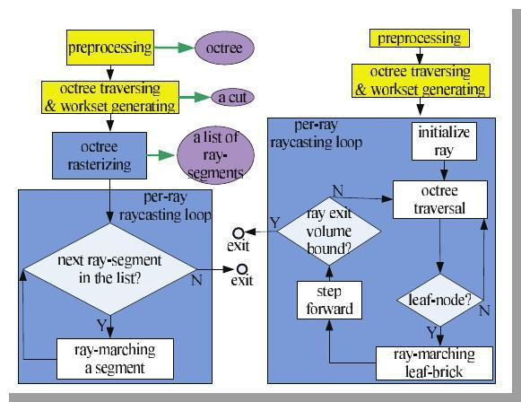

Figure 1: Flowcharts of our algorithm (left) and previous out-of-core GPU volume Rendering algorithms (right). Yellow boxes are executed on the CPU, all other boxes on the GPU. Black arrows indicate control flow; green arrows indicate output
of intermediate data.

The flow of method in Figure 1 is explained as follows [1] :

4.1. Pre-processing

A large volume dataset is first pre-processed using blocking techniques (division of large dataset in blocks of data) and storing it in Octree (a 3-D data structure is represented in the form of recursively sub-dividing into eight octants). An octree of bricks is constructed where the actual resolution data is stored in leaf nodes. At each
3
level or node a brick of same dimension Bres is made. The length of the tree is kept

shallow which results in courser bricks. Inner bricks are built using down sampling of the lower level nodes like averaging filter.in this way the whole data is represented as multi-resolution hierarchy which is maintained on CPU (out of core). Each node of the octree points to the brick with a constant resolution that approximates the part of the

volume corresponding to the octree’s node.
Bricks store extra overlapping voxels, which helps in accessing the neighboring voxels at runtime using the tri-cubic interpolation and gradient computations. Since the octree don’t use any transfer function for empty space culling it uses macro-cells to store the min-max

scalar values for the corresponding brick, for efficient brick culling. The dimension for
3. macro-cell is Mres

- Octree Creation and Visualization of View-Dependent Working Set :

1878 slices were first constructed into a single 3D-Volume. Dimensions of each image slice is 1760 * 1024. Brick size of evry node in octree is taken as 220*128*235.Single large Volume is splitted into 512 bricks of resolution 220*128*235. These bricks are then averaged by a factor of 8 to construct 64 bricks of same resolution which are further averaged by a factor of 8 to construct 8 bricks which are then combined to form a single root. These bricks are then saved as nodes of an octree where root acts as parent having 8 children which are individually divided into 8 more children. Struct of the octree node is as follows –

struct node{ ifstream fp;

struct node *child[NO_CHILDREN]; struct node *parent;

int level; int a[3];

int no_children; int is_leaf; string name;
};

Table 2: Structure of octree

4.2. Generating a View-Dependent Working Set

For viewing different frames a cut is decided out of the octree according to the required frame. The cut includes different resolution nodes as per needed dependent on the viewing angle. This cut is used to update the GPU brick pool for rendering. If we zoom the image the children of the current node has to be loaded and if we zoom out then multiple nodes has to be fused together. For deciding the cut breadth first order octree traversal is used starting from the root node and is continued till the required node is found.
Work-set Generation Algorithm

Initialize queue with root tag = 2

while(stack_not_empty) { cur = queue.front() queue.pop()

split cur in 8 octants if possible

for (i = 0; i < 8; i++) { if ROI lies in octant[i]

if ROI lies completely in octant[i] tag = 1

push in brick_pool else

tag = 2

push in queue

else

tag = 0

}

}

copy brickpool to cudaMemory

Table 3: Workset Generation Algorithm

4.2.1. View-Dependent Sorting of the Bricks

The nodes in the cut are rasterized before. Hence we sort the nodes and store them in front to back fashion using a pointer list which is stored for further use. Pointers to the traversed cut-nodes are stored in a STL list. A traversed node is always replaced by in front its children to back order during depth-first search, this is done till a node labeled as node cut is found. It is implemented using an 8 X 8 lookup table. Each row of the look up table encodes a possible order of the 8 octants according to the viewpoint in the octree space.

4.2.2. Memory Management of the Working Set

The cut represents the brick data and macro-cell data of the nodes. Tis data is then transferred to GPU asynchronously. The working set is loaded into 2 memory pools:
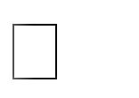Brick Pool

It is organized ad a 3D texture of specific size and dimension. Each of the cell of this pool corresponds to a particular brick, and the cell stores the corresponding brick Id BID.
Macro-cell Pool

The 3D macro-cell pool is packed with the corresponding brick’s macro-cell at particular brick id BID.

4.3. Proxy-Geometry Rasterization

The comparison between 2 pass and normal rasterization is shown in Fig 3. The explained process of two pass rasterization could be seen in Fig 4. Proxy geometries of the whole working set of bricks is rasterized in the first pass and capture all bricks that a ray penetrates into a per-pixel list. In second pass, we rasterize all non-empty macrocell (of all bricks) and refine per-pixel list in which each element will contain a ray-segment corresponding to the brick that the ray penetrates. This results in skipping

of empty spaces of macrocell. Fig 4. Gives detailed process for the 2nd pass i.e. traversing the macrocells.
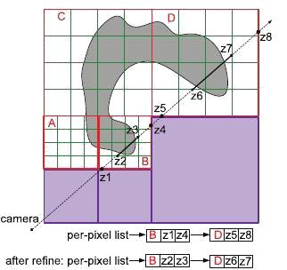

Figure 2: Algorithm philosophy. The octree-cut is composed of all of the active bricks (red—A, B, C, and D) at different LoDs depending on the current view. Each active brick is subdivided into macrocells (green). Empty bricks (purple) are never added to the octree-cut. We first rasterize active blocks so that the fragment shader can capture all of the active blocks that the ray penetrates (B and D) into a list in front-to-back order. Then we rasterize nonempty macrocells and refine the z-values in the list in order to get a tighter ray segment (shown as the solid black line) for each brick at the accuracy of the macrocell level.
4.4. Raycasting

A ray is generated for each desired image pixel. Using a simple camera model, the ray starts at the centre of projection of the camera (usually the eye point) and passes through the image pixel on the imaginary image plane floating in between the camera and the volume to be rendered. In the raycasting pass, depth interval is defined by the two end points of a ray-segment that performs the GPU raycasting for the corresponding brick.
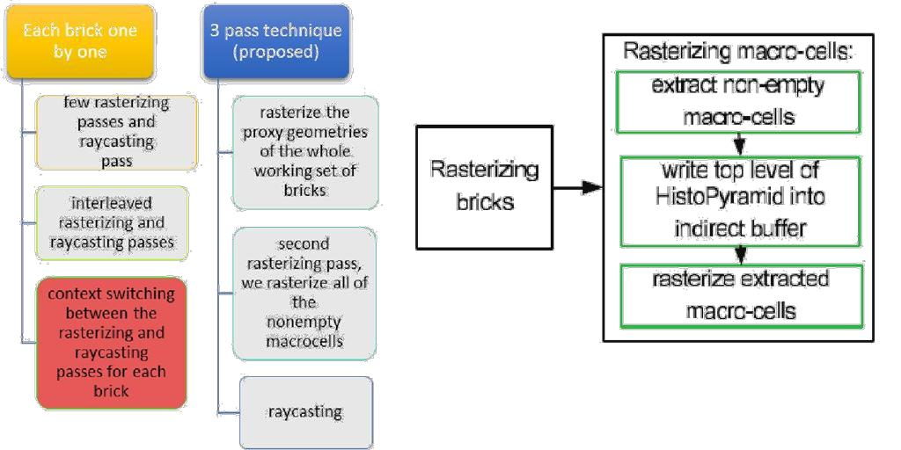

Figure 4: Flowchart of rasterization

Figure 3: Comparison between 2 pass rasterization
Process and normal method

- Hardware and Software requirements

  - Software Requirements

    - CUDA enabled system

    - OpenGL

    - Visualization Toolkit (VTK)

    - Visual Studio (8+)

    - National Library of Medicine Visible Human Body (Male) 3.15 GB Dataset

  - Hardware Requirements
SPECIFICATIONS

 | GPU processor |  | Tesla C1060
 | CUDA Cores |  | 240
 | Shader clock |  | 1296 MHz
 | Memory interface |  | 512-bit
 | Memory |  | 5888 MB
 | Total available graphics |  | 4096 MB
 | memory
 | Bus |  | PCI Express x16

6. Activity Time Chart

 |  | Work done till Mid-Sem |  |  |  |  |  |  |  |  |  |  |  |  |  | End-Semester
 | Phase 1: |  |  | Phase 2: |  |  | Phase 3: |  |  | Phase 4: |  |  | Phase V: |  |  | Phase VI: |  |  | Phase VII: |  |  | Phase VIII:
 | 10th Jan - |  |  | 25th Jan – |  |  | 5th Feb – |  |  | 12th Feb – |  |  | 25th Feb – |  |  | 22nd Mar – |  |  | 10th Apr – |  |  | 20th Apr –
 | 25th Jan |  |  | 5th Feb |  |  | 12th Feb |  |  | 25th Feb |  |  | 10th Mar |  |  | 10th Apr |  |  | 20th Apr |  |  | 4th May
 | Literature |  | Data |  |  |  | Environment |  |  | Learning |  |  | Visualization |  |  | Implementation |  |  | Rendering |  |  | Visualization
 | Survey |  | Collection |  |  |  | Setup: |  |  | OpenGL |  |  | of small |  |  | of octree data |  |  | small |  |  | Pipelining
 |  |  | and |  |  |  | OpenGL, |  |  | and CUDA |  |  | dataset |  |  | structure to |  |  | portion of |  |  | and Multi –
 |  |  | analyzing |  |  |  | CUDA |  |  |  |  |  |  |  |  | manage the |  |  | octree |  |  | Resolution
 |  |  | the format |  |  |  |  |  |  |  |  |  |  |  |  | large volume |  |  |  |  |  | Model
 |  |  | of the data |  |  |  |  |  |  |  |  |  |  |  |  | data
7. Experimental Setup and Results

Experimental Setup requires following:

- Visual Studio

- Setting OpenGL

- CUDA

Following are the screenshots of the code for visualization of small dataset that we have done so far:-

(a) (b)
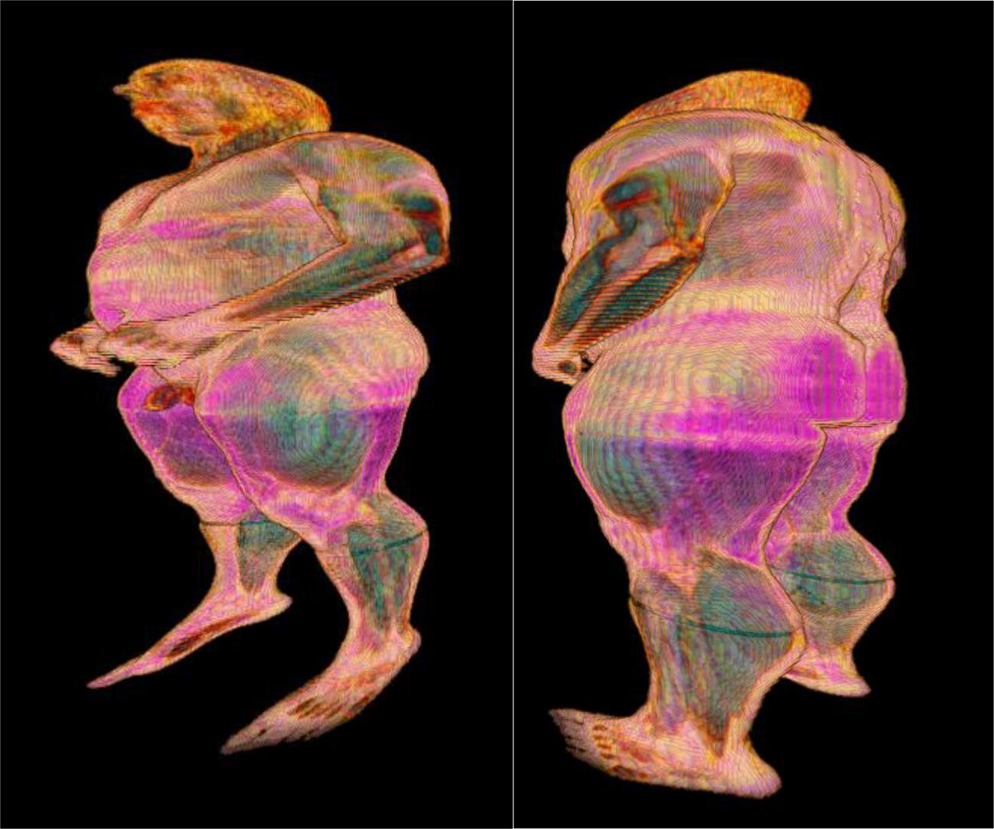

Figure 5: (a) and (b) are 2 different orientation of root node

(a) (b)
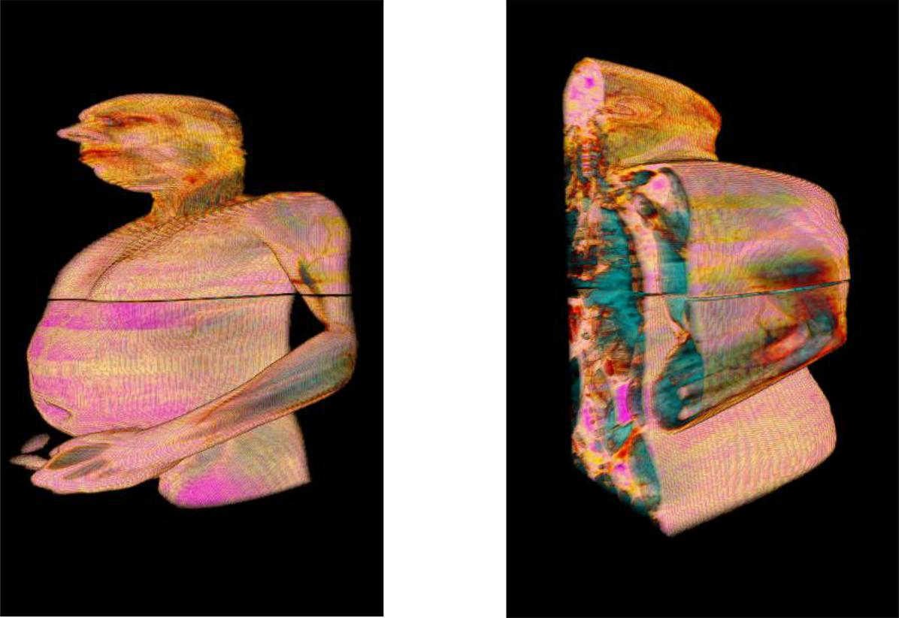

Figure 6: (a) 0th child and (b) 2nd child of root node

(a) (b)
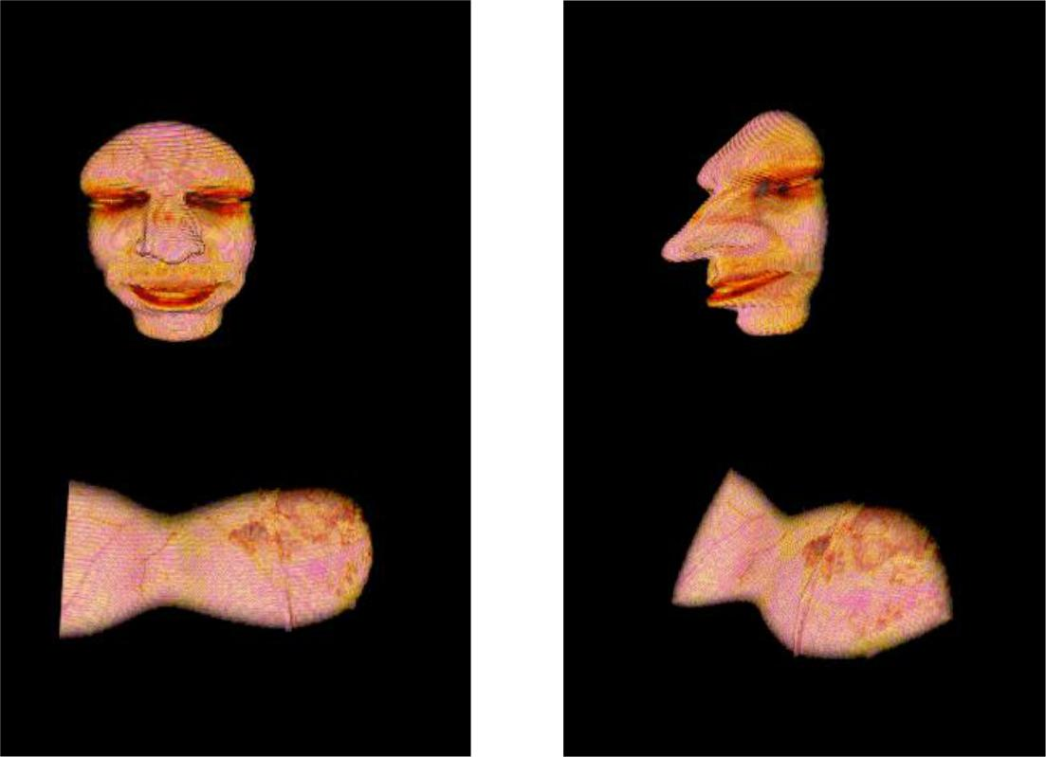

Figure 7: (a) shows 011 (b) 012

8. Performance Comparison

Performance comparison on the basis of rendering quality, when we performed visualization using the source codes of different algorithms which are available as open source and on our technique, the results obtained have smoother image quality from the technique using GPU octree rasterization methods (i.e. the proposed methodology).

Performance comparison on the basis of Rendering Speed with a GPU Octree Traversing Algorithm Octree creation method takes 5-10 minutes on any type of datasets. After which octree traversal, rasterization , per-pixel list generation and rendering are done in matter of minutes as they are performed on GPU using maximum number of cores which can be utilized. As octree creation for a dataset is only performed once and stored in hard disk , the rendering speed is 2-4 times greater than what was performed by previous algorithms which performed octree traversal on GPU.

Table 4: Comparison between CPU and GPU time
 |  | Time Require from | Time Require from
S. No. | Processor | 8 to 1 brick | 64 to 1 Brick
 |  | construction | construction
1. | Quad Core | ~20 mins | ~2 hrs
2. | Intel i3 | ~12 mins | ~45 mins
3. | Intel i5 | ~5 mins | ~25 mins
4. | GPU | ~micro secs | ~secs

9. Future Scope and Conclusion

In our method which we have implemented is a fast, GPU based out-of-core volume ray-casting, which moves the branching intensive octree traversal out of the GPU ray-casting loop and after the traversing execute it on the GPU. By introducing the tighter depth range for GPU ray-casting it exercised the greater control over the rendering process by using the hardware rasterization unit performance. The method is also offers more sophisticated empty space skipping, and which makes possible the interactive use of advanced features like cubic interpolation for the large out-of-core data sets. Since the method that is presented provides a general accelerating scheme (by rasterizing an octree to generate tight ray segments), and the method can also be used to improve the performance of the other visualization systems, such as in multiple user activities, comparative settings and multiple volume studies, or as a future work apart from these we can also use it for time-varying data visualization. Improvements like a more generalized method to deal with the size of brick irrespective of the size of data and optimum number of levels will help to enhance the performance.

- References

  - B. Liu, G. J. Clapworthy, F. Dong and E. C. Prakash "Octree Rasterization: Accelerating High-Quality Out-of-Core GPU Volume Rendering" IEEE TRANSACTIONS ON VISUALIZATION AND COMPUTER GRAPHICS, VOL. 19, NO. 10, pp. 1731-1745, OCTOBER 2013

  - J. Beyer, M. Hadwiger and H. Pfister, "A Survey of GPU-Based Large-Scale Volume Visualization", Eurographics Conference on Visualization (EuroVis), 2014

. obbetti . arton and . . uiti an, "A single -pass GPU ray casting framework for interactive out-of-core rendering of massive volumetric datasets", Springer-Verlag 2008 pp: 797–806, 2008

- Y. Heng and L. Gu, "GPU-based Volume Rendering for Medical Image Visualization", Engineering in Medicine and Biology 27th Annual Conference, Shanghai, China, pp. 5145-5148, September 1-4, 2005

- C. Wang and H. Shen, "A Framework for Rendering Large Time-Varying Data Using Wavelet-Based Time-Space Partitioning (WTSP) Tree", Department of Computer and Information Science, The Ohio State University, 2004

- A. Knoll, I. Wald, S. Parker and C. Hansen, "Interactive Iso-surface Ray Tracing of Large Octree Volumes", Scientific Computing and Imaging Institute, University of Utah, Technical Report No UUSCI-2006-026, 2006

- S. Chen and C. Hao, "Interactive GPU-based Volume Rendering for Medical Image", Biomedical Engineering and Informatics, BMEI '09. 2nd International Conference on 17-19 Oct, 2009

- M. Smelyanskiy, D. Holmes, J. Chhugani, A. Larson, D. M. Carmean, D. Hanson, P. Dubey, K. Augustine, D. Kim, A. Kyker, V. W. Lee, A. D. Nguyen, L. Seiler and R. Robb, "Mapping High-Fidelity Volume Rendering for Medical Imaging to CPU, GPU and Many-Core Architectures", IEEE TRANSACTIONS ON VISUALIZATION AND COMPUTER GRAPHICS, VOL. 15, NO. 6, Nov/Dec, 2009

- M. Labschutz, S. Bruckner, M. E. Groller, M. Hadwiger and P. Rautek, "JiTTree: A Just-in-Time Compiled Sparse GPU Volume Data Structure", Visualization and Computer Graphics, IEEE Transactions, Vol. 22, Issue. 1, pp. 1025-1034, 2015

- A. Knoll, "A Survey of Octree Volume Rendering Methods", Scientific Computing and Imaging Institute University of Utah, 2006

- F. Velasco and J. C. Torres, "Cell Octrees: A New Data Structure for Volume Modeling and Visualization", VMV '01 Proceedings of the Vision Modeling and Visualization Conference, pp. 151-158, 2001

- I. Boada, I. Navazo and R. Scopigno, "Multi- Resolution volume visualization with a texture-based octree", Springer-Verlag, pp. 185-197, 2001

- A. Agrawal, J. Kohout, G. J. Clapworthy, N. J.B. McFarlane, F. D. M. Viceconti, F. Taddei and D. Testi, "Enabling the interactive display of large medical volume datasets by multiresolution bricking", Springer, pp. 3-19, 2009

