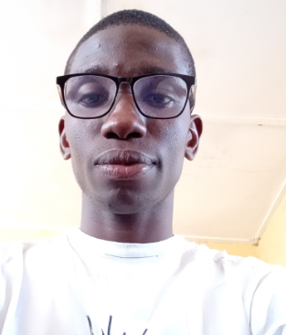

**Contact**

Alimosho, Lagos.

Nigeria

Tel: +234 814 434 9382

jaykelly997@gmail.com

GitHub.com/jaykelly997

x.com/Jaykelly997

linkedin.com/in/johnson-caleb-30400b291

**Technical skill**

HTML

CSS

JavaScript, jquery

PHP

MySQL

Visual Studio Code

Github

AdobeXD

Typescript

React (Beginner)

Microtik router

Winbox

**Hobbies**

Reading

Cooking

Travelling

Sport

**Certification**

B.Sc

Web developer (Fullstack)

Network management (certified MTCNA)

Johnson, Caleb Onyekachi

Web Developer (Fullstack)



**Summary**

Result-oriented technical in product creation, UI/UX design and fullstack web development. Seeking to work in an organization where I can contribute to it development and growth as well as add values to life and improving myself.

Very passionate with aesthetics and UI design.

**Experience**

**Proxy coding school 2025**

Full stack website development facilitator.

**Okportech Digitals 2022**

Team up with Okportech crew in 2022 to build a dynamic website for an organization.

**Emmaco Motors & Metals 2020-2024**

Designed an engaging user interface, built the frontend and programmed the backend of the website.

**Karadin Pharmacy 2017**

Computer Operator, cashier.

**Education**

**University of Nigeria, Nsukka. 2022**

B.Sc Plant Sciences, Biotechnology and Environmental Biology

**Projects**

* Dynamic Product creation and design- UI/ UX of emmako website (Advance).
* Frontend and Backend development of DLCF-UNN website
* Top-notch, responsive and dynamic Frontend design of vegefood website.
* Responsive , top-notch Fullstack development of jaykelly website.
* Project Presentation.

**Reference**

Available on requestl