**Behaviorics Documentation  
  
Web Pages**

The software’s Web App architecture allows the user to navigate the software through web pages. This document denotes the possible requests that can be called within the software and how they interact with it. Webpages use Spring Thymeleaf to call java functions from within the html.

**Login Page** *login.html* **(/login)**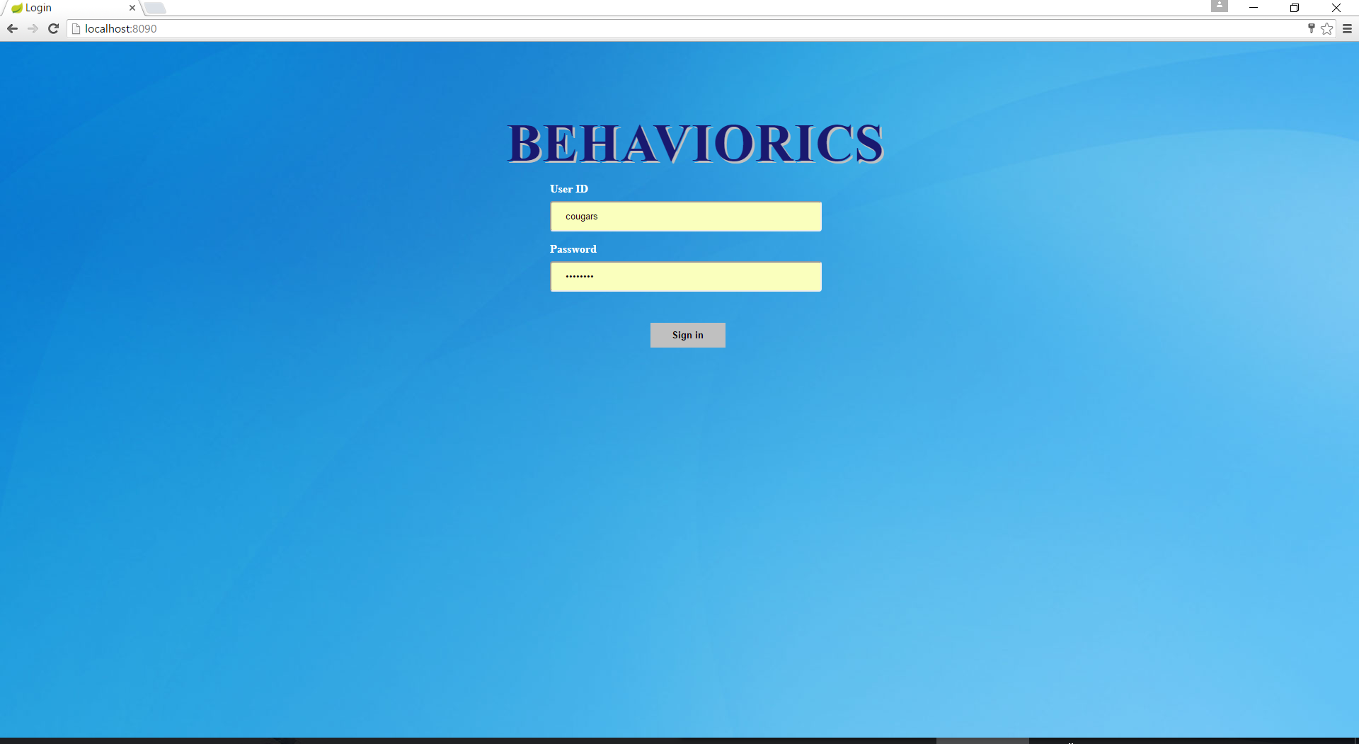The login page is simply used to log the user in by checking their entered credentials with the database to verify that they are a valid user.

**Home/Reports Page** reportsPage.html (/*reports*)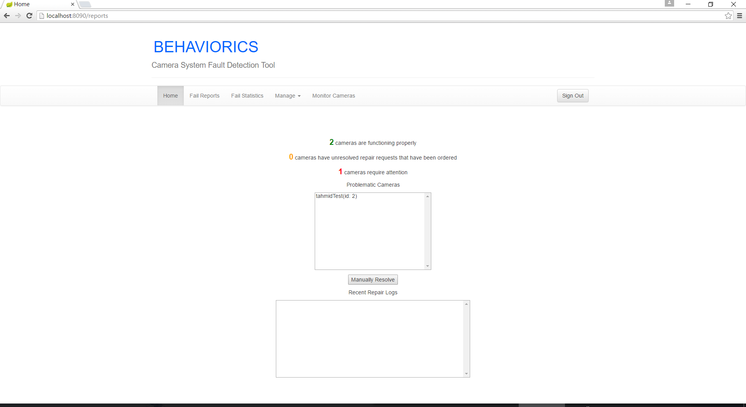The Home page or Reports pagedisplays the current conditions of existing cameras.  
 **Camera Management Page** *managementPage.html**(/manage)*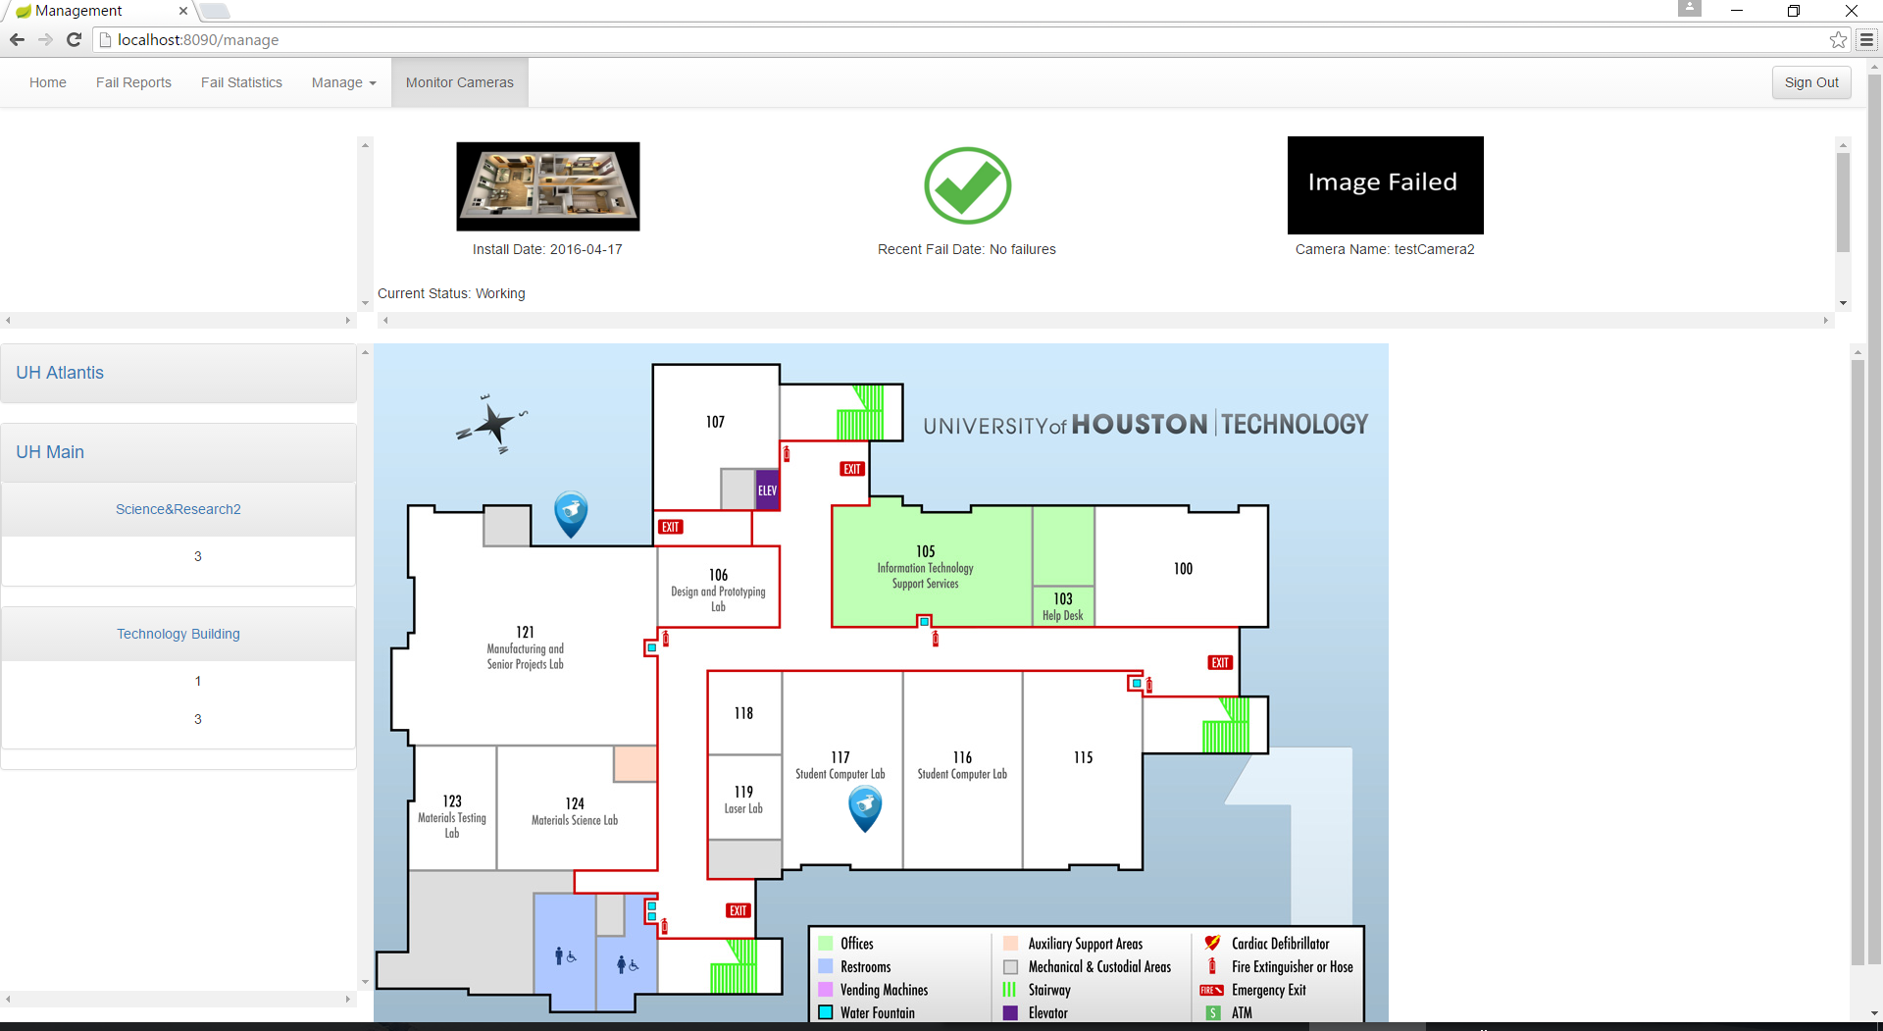

The Camera Management page allows the user to view the locations of existing cameras in Buildings, Floors and Entities as well as viewing their conditions in the status view at the top right.

**Manage Buildings/Floors/Entities/Cameras/Users** addbuilding.html (*/admin/addbuilding*)  
 addfloor.html (*/admin/addfloor*)  
 addentity.html (*/admin/addentity*)  
 addcamera.html (*/admin/addcamera*)  
 addUser.html (*/admin/addUser*)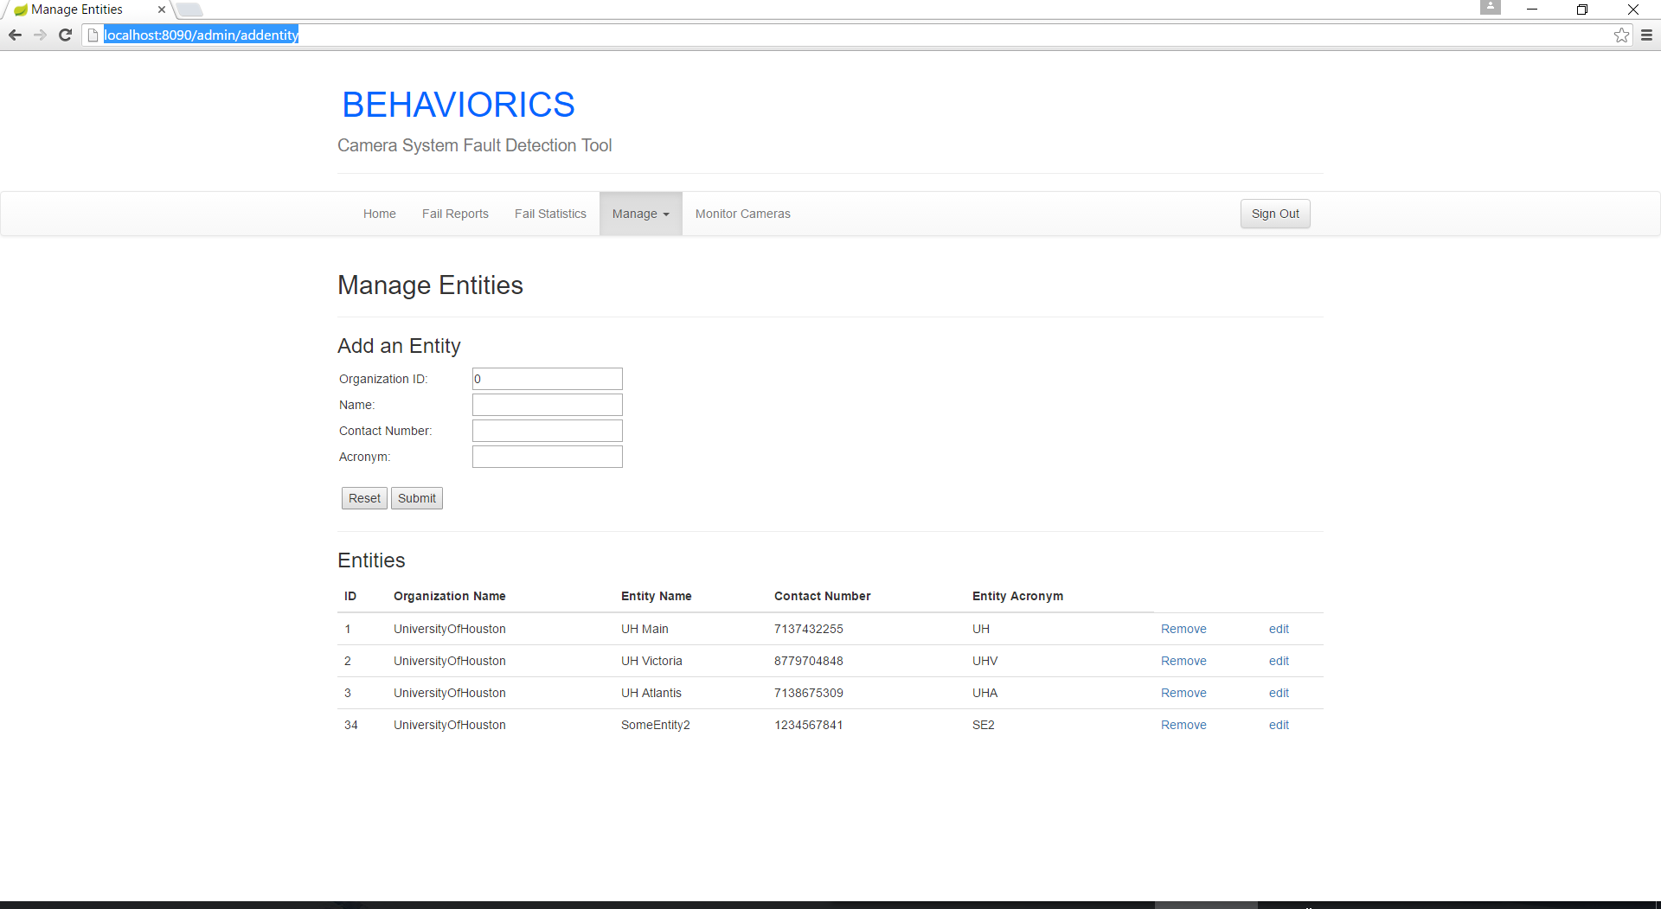The Management page allows the user to manually Add, Remove and Edit entries in the database.

**Fail Reports Page** *failReports.html* (*/failreports*)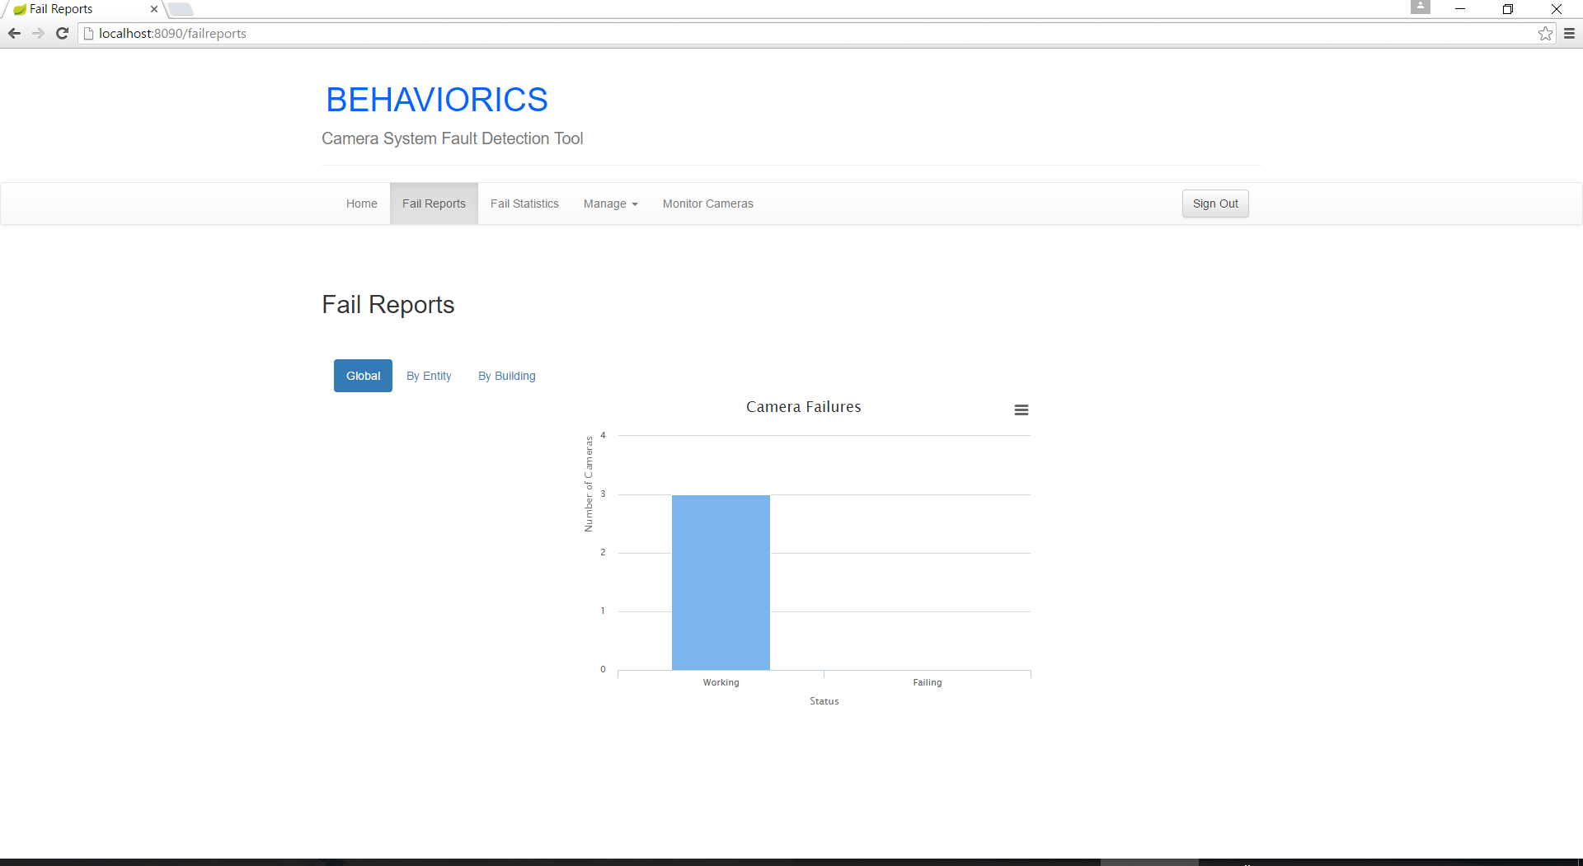  
The Fail Reports page provides a visual statistical representation of the current camera failure conditions  
 **failStatistics.html (*/failstatistics*)**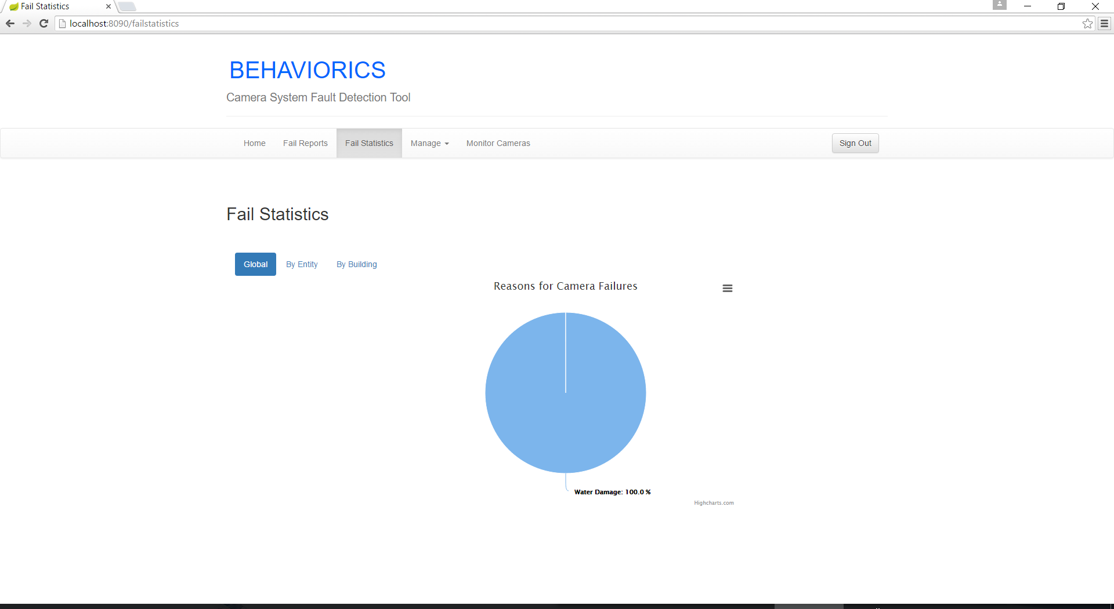

**Other Important usage notes…  
config.properties** has all the information for the database (database URL, driver, password, username)

**DefaultSnapshotURL.json** has a list of default snapshot URLs for cameras that do **not** respond to **getSnapshotUri()** request of ONVIF standard (the list is made in a JSON format)

**application.properties** has variable for the port number that the Web Server uses

**Rest Server Request Mappings  
BuildingController.java**

|  |  |
| --- | --- |
| **URL** | */building/id/{id}* |
| **Mapping Arguments** | int id |
| **Method** | getBuildingById(int id) |
| **Outcomes** | **-OK -INTERNAL_SERVER_ERROR** |
| **Description** | Returns an existing Building with id |
| **Database Behavior** | Query from Buildings |

|  |  |
| --- | --- |
| **URL** | */building/{buildingName}* |
| **Mapping Arguments** | String name |
| **Method** | getBuildingByBuildingName(String name) |
| **Outcomes** | **-OK -UNAUTHORIZED** |
| **Description** | Returns an existing Building with the name provided |
| **Database Behavior** | Query from Buildings |

|  |  |
| --- | --- |
| **URL** | */building/entityID/{entityID}* |
| **Mapping Arguments** | int id |
| **Method** | getAllBuildingsByEntityID(int id) |
| **Outcomes** | **-OK -UNAUTHORIZED** |
| **Description** | Returns a list of Buildings that belong to the Entity with id |
| **Database Behavior** | Query from Buildings |

|  |  |
| --- | --- |
| **URL** | */building/organizationID/{organizationID}* |
| **Mapping Arguments** | int organizationID |
| **Method** | getAllBuildingsByOrganizationID(int organizationID) |
| **Outcomes** | **-OK -UNAUTHORIZED** |
| **Description** | Returns a list of Buildings that belong to the Organization with organizationID |
| **Database Behavior** | Query from Buildings |

|  |  |
| --- | --- |
| **URL** | *[POST]/building* |
| **Mapping Arguments** | RequestBody buildingBO |
| **Method** | createBuilding(RequestBody buildingBO) |
| **Outcomes** | **-CREATED -UNAUTHORIZED** |
| **Description** | Creates a Building with the properties specified in the body |
| **Database Behavior** | Inserts into Buildings |

|  |  |
| --- | --- |
| **URL** | *[PUT]/building/{id}* |
| **Mapping Arguments** | int id RequestBody buildingBO |
| **Method** | updateBuilding(int id, RequestBody buildingBO) |
| **Outcomes** | **-OK -UNAUTHORIZED** |
| **Description** | Updates an existing Building with the given id with the data in the body |
| **Database Behavior** | Updates one entry in Buildings |

|  |  |
| --- | --- |
| **URL** | *[DELETE]/building/{id}* |
| **Mapping Arguments** | int id |
| **Method** | deleteBuilding(int id) |
| **Outcomes** | **-OK -UNAUTHORIZED** |
| **Description** | Deletes an existing Building with the given id |
| **Database Behavior** | Deletes one entry in Buildings |

**CamerasController.java**

|  |  |
| --- | --- |
| **URL** | */cameras/{cameraName}* |
| **Mapping Arguments** | String "cameraName" name |
| **Method** | getCameraByCameraName(String name) |
| **Outcomes** | **-OK -UNAUTHORIZED** |
| **Description** | Returns a Camera with the given name |
| **Database Behavior** | Queries one entry from Cameras |

|  |  |
| --- | --- |
| **URL** | */cameras/all* |
| **Mapping Arguments** | none |
| **Method** | getAllCameras() |
| **Outcomes** | **-OK -UNAUTHORIZED** |
| **Description** | Returns a list of all existing cameras |
| **Database Behavior** | Queries list from Cameras |

|  |  |
| --- | --- |
| **URL** | */cameras/orgID/{orgID}* |
| **Mapping Arguments** | int "orgID" orgId |
| **Method** | getAllCamerasByOrgId(int orgId) |
| **Outcomes** | **-OK -UNAUTHORIZED** |
| **Description** | Returns a list of existing Cameras that belong to the Organization with orgId |
| **Database Behavior** | Queries list from Cameras |

|  |  |
| --- | --- |
| **URL** | */cameras/floorID/{floorID}* |
| **Mapping Arguments** | int "floorID" id |
| **Method** | getAllCamerasByFloorID(int id) |
| **Outcomes** | **-OK -UNAUTHORIZED** |
| **Description** | Returns a list of existing Cameras that are on the Floor with the given id |
| **Database Behavior** | Queries list from Cameras |

|  |  |
| --- | --- |
| **URL** | *[POST]/cameras* |
| **Mapping Arguments** | RequestBody camerasBO |
| **Method** | createCamera(RequestBody camerasBO) |
| **Outcomes** | **-CREATED -UNAUTHORIZED** |
| **Description** | Creates a Camera with the data in the body |
| **Database Behavior** | Inserts entry into Cameras |

|  |  |
| --- | --- |
| **URL** | *[PUT]/cameras/{id}* |
| **Mapping Arguments** | int “id” id RequestBody camerasBO |
| **Method** | updateCamera(int id, RequestBody camerasBO) |
| **Outcomes** | **-OK -UNAUTHORIZED** |
| **Description** | Updates an existing Camera with the given id with the data in the body |
| **Database Behavior** | Updates one entry in Cameras |

|  |  |
| --- | --- |
| **URL** | *[DELETE]/cameras/{id}* |
| **Mapping Arguments** | int "id" id |
| **Method** | deleteCamera(int id) |
| **Outcomes** | **-OK -UNAUTHORIZED** |
| **Description** | Deletes the an existing Camera with the given id |
| **Database Behavior** | Deletes one entry from Cameras |

|  |  |
| --- | --- |
| **URL** | *[GET]/camera/{id}* |
| **Mapping Arguments** | int "id" id |
| **Method** | getCameraById(int id) |
| **Outcomes** | **-OK -INTERNAL_SERVER_ERROR** |
| **Description** | Returns an existing Camera with the given id |
| **Database Behavior** | Queries one entry from Cameras |

**EntityController.java**

|  |  |
| --- | --- |
| **URL** | */entity/id/{id}* |
| **Mapping Arguments** | int "id" id |
| **Method** | getEntityById(int id) |
| **Outcomes** | **-OK -INTERNAL_SERVER_ERROR** |
| **Description** | Returns an existing Entity with the given id |
| **Database Behavior** | Queries an entry in Entities |

|  |  |
| --- | --- |
| **URL** | */entity/{entityName}* |
| **Mapping Arguments** | String "entityName" name |
| **Method** | getEntityByEntityName(String name) |
| **Outcomes** | **-OK -UNAUTHORIZED** |
| **Description** | Returns an existing Entity with the given name |
| **Database Behavior** | Queries an entry in Entities |

|  |  |
| --- | --- |
| **URL** | */entity/organizationID/{organizationID}* |
| **Mapping Arguments** | int "organizationID" id |
| **Method** | getAllEntitiesByOrganizationID(int id) |
| **Outcomes** | **-OK -UNAUTHORIZED** |
| **Description** | Returns a list of the existing Entities within the Organization with the given id. |
| **Database Behavior** | Queries a list from Entities |

|  |  |
| --- | --- |
| **URL** | *[POST]/entity* |
| **Mapping Arguments** | RequestBody entityBO |
| **Method** | createEntity(RequestBody entityBO) |
| **Outcomes** | **-CREATED -INTERNAL_SERVER_ERROR** |
| **Description** | Creates a new Entity with the data in the body |
| **Database Behavior** | Inserts one entry into Entities |

|  |  |
| --- | --- |
| **URL** | *[PUT]/entity/{id}* |
| **Mapping Arguments** | int "id" id  RequestBody entityBO |
| **Method** | updateEntity(int id, RequestBody entityBO) |
| **Outcomes** | **-OK -UNAUTHORIZED** |
| **Description** | Updates the data of the existing Entity with the given id. |
| **Database Behavior** | Updates one entry in Entities |

|  |  |
| --- | --- |
| **URL** | *[DELETE]/entity/{id}* |
| **Mapping Arguments** | int "id" id |
| **Method** | deleteEntity(int id) |
| **Outcomes** | **-OK -UNAUTHORIZED** |
| **Description** | Deletes an existing Entity with the given id |
| **Database Behavior** | Deletes one entry from Entities |

**FailImagesController.java**

|  |  |
| --- | --- |
| **URL** | */failImages/{failImagesID}* |
| **Mapping Arguments** | int "failImagesID" id |
| **Method** | getFailImagesByID(int id) |
| **Outcomes** | **-OK -UNAUTHORIZED** |
| **Description** | Returns an existing FailImage with the given id |
| **Database Behavior** | Queries one entry from FailImages |

|  |  |
| --- | --- |
| **URL** | */failImages/repairID/{repairID}* |
| **Mapping Arguments** | int "repairID" id |
| **Method** | getFailImagesIDByRepairID(int id) |
| **Outcomes** | **-OK -UNAUTHORIZED** |
| **Description** | Returns an existing FailImage with the given Repairid |
| **Database Behavior** | Queries one entry from FailImages |

|  |  |
| --- | --- |
| **URL** | *[POST]/failImages* |
| **Mapping Arguments** | RequestBody failImagesBO |
| **Method** | createFailImages(RequestBody failImagesBO) |
| **Outcomes** | **-CREATED -UNAUTHORIZED** |
| **Description** | Creates a new FailImage with the data in the body |
| **Database Behavior** | Inserts one entry into FailImages |

|  |  |
| --- | --- |
| **URL** | *[PUT]/failImages/{id}* |
| **Mapping Arguments** | int "id" id RequestBody failImagesBO |
| **Method** | updateFailImages(int id, RequestBody failImagesBO) |
| **Outcomes** | **-OK -UNAUTHORIZED** |
| **Description** | Updates the FailImage of the given id with the data in the body |
| **Database Behavior** | Updates one entry in FailImages |

|  |  |
| --- | --- |
| **URL** | *[DELETE]/failImages/{id}* |
| **Mapping Arguments** | int "id" id |
| **Method** | deleteFailImagesBO(int id) |
| **Outcomes** | **-OK -UNAUTHORIZED** |
| **Description** | Removes an existing FailImage with the given id |
| **Database Behavior** | Deletes one entry from FailImages |

**FloorPlanController.java**

|  |  |
| --- | --- |
| **URL** | */floorPlan/{floorPlanID}* |
| **Mapping Arguments** | int "floorPlanID" id |
| **Method** | getFloorPlanByID(int id) |
| **Outcomes** | **-OK -UNAUTHORIZED** |
| **Description** | Returns the FloorPlan with the given id |
| **Database Behavior** | Queries one entry from FloorPlans |

|  |  |
| --- | --- |
| **URL** | */floorPlan/floor/{floorID}* |
| **Mapping Arguments** | int "floorID" id |
| **Method** | getFloorPlanByFloorID(int id) |
| **Outcomes** | **-OK -UNAUTHORIZED** |
| **Description** | Returns the FloorPlan with the given id |
| **Database Behavior** | Queries one entry from FloorPlans |

|  |  |
| --- | --- |
| **URL** | *[POST]/floorplan* |
| **Mapping Arguments** | RequestBody floorPlanBO |
| **Method** | createFloorPlan(RequestBody floorPlanBO) |
| **Outcomes** | **-CREATED -UNAUTHORIZED** |
| **Description** | Creates a FloorPlans with the data in the body |
| **Database Behavior** | Inserts one entry into FloorPlans |

|  |  |
| --- | --- |
| **URL** | *[PUT]/floorPlan/{id}* |
| **Mapping Arguments** | int " id " id RequestBody floorPlanBO |
| **Method** | updateFloorPlan(int id, RequestBody floorPlanBO) |
| **Outcomes** | **-OK -UNAUTHORIZED** |
| **Description** | Updates the FloorPlan with the given id with the data in the body |
| **Database Behavior** | Updates one entry in FloorPlans |

|  |  |
| --- | --- |
| **URL** | *[DELETE]/floorPlan/{id}* |
| **Mapping Arguments** | int "id" id |
| **Method** | deleteFloorPlan(int id) |
| **Outcomes** | **-OK -UNAUTHORIZED** |
| **Description** | Deletes an existing FloorPlan with the given id |
| **Database Behavior** | Deletes one entry from FloorPlans |

**FloorController.java**

|  |  |
| --- | --- |
| **URL** | */floor/{buildingID}/{floorNumber}* |
| **Mapping Arguments** | int "buildingID" buildingID int “floorNumber” floorNumber |
| **Method** | getFloor(int buildingID, int floorNumber) |
| **Outcomes** | **-OK -UNAUTHORIZED** |
| **Description** | Returns a Floor in a given Building with the provided FloorNumber |
| **Database Behavior** | Queries one entry from Floors |

|  |  |
| --- | --- |
| **URL** | */floors/id/{id}* |
| **Mapping Arguments** | int "id" id |
| **Method** | getFloorById(int id) |
| **Outcomes** | **-OK -INTERNAL_SERVER_ERROR** |
| **Description** | Returns an existing Floor with the given id |
| **Database Behavior** | Queries one entry from Floors |

|  |  |
| --- | --- |
| **URL** | */floors/{buildingID}* |
| **Mapping Arguments** | int “buildingID” buildingID |
| **Method** | getFloors(int buildingID) |
| **Outcomes** | **-OK -UNAUTHORIZED** |
| **Description** | Returns a list of Floors within the given buildingID |
| **Database Behavior** | Queries a list from Floors |

|  |  |
| --- | --- |
| **URL** | */floors/organizationID/{organizationID}* |
| **Mapping Arguments** | int "organizationID" organizationID |
| **Method** | getAllFloorsForAnOrganization(int organizationID) |
| **Outcomes** | **-OK -UNAUTHORIZED** |
| **Description** | Returns a list of Floors that belong to the Organization with the given organizationID |
| **Database Behavior** | Queries a list from Floors |

|  |  |
| --- | --- |
| **URL** | *[POST]/floor* |
| **Mapping Arguments** | RequestBody floorBO |
| **Method** | createFloor(RequestBody floorBO) |
| **Outcomes** | **-CREATED -UNAUTHORIZED** |
| **Description** | Creates a Floor with the data in the body |
| **Database Behavior** | Inserts one entry into Floors |

|  |  |
| --- | --- |
| **URL** | *[PUT]/floor/{id}* |
| **Mapping Arguments** | int “id” id RequestBody floorBO |
| **Method** | updateFloor(int id, RequestBody floorBO) |
| **Outcomes** | **-OK -UNAUTHORIZED** |
| **Description** | Updates an existing Floor with the data in the body |
| **Database Behavior** | Updates one entry in Floors |

|  |  |
| --- | --- |
| **URL** | *[DELETE]/floor/{id}* |
| **Mapping Arguments** | int “id” id |
| **Method** | deleteFloor(int id) |
| **Outcomes** | **-OK -UNAUTHORIZED** |
| **Description** | Deletes an existing Floor with the given id |
| **Database Behavior** | Deletes one entry in Floors |

**OrganizationController.java**

|  |  |
| --- | --- |
| **URL** | */organization/id/{id}* |
| **Mapping Arguments** | int “id” id |
| **Method** | getOrganizationById(int id) |
| **Outcomes** | **-OK -INTERNAL_SERVER_ERROR** |
| **Description** | Returns an existing Organization with the given id |
| **Database Behavior** | Queries one entry from Organizations |

|  |  |
| --- | --- |
| **URL** | */organization/{organizationName}* |
| **Mapping Arguments** | String "organizationName" name |
| **Method** | getOrganizationByName(String name) |
| **Outcomes** | **-OK -UNAUTHORIZED** |
| **Description** | Returns an existing Organization with the given name |
| **Database Behavior** | Queries one entry from Organizations |

|  |  |
| --- | --- |
| **URL** | */organization* |
| **Mapping Arguments** | none |
| **Method** | getAllOrganizations() |
| **Outcomes** | **-OK -UNAUTHORIZED** |
| **Description** | Returns all existing Organizations |
| **Database Behavior** | Queries all entries from Organizations |

|  |  |
| --- | --- |
| **URL** | *[POST]/organization* |
| **Mapping Arguments** | RequestBody organizationBO |
| **Method** | createOrganization(RequestBody organizationBO) |
| **Outcomes** | **-OK -UNAUTHORIZED** |
| **Description** | Creates an Organization with the data in the body |
| **Database Behavior** | Inserts one entry into Organizations |

|  |  |
| --- | --- |
| **URL** | *[PUT]/organization/{id}* |
| **Mapping Arguments** | int "id" id RequestBody organizationBO |
| **Method** | updateOrganization(int id, RequestBody organizationBO) |
| **Outcomes** | **-OK -UNAUTHORIZED** |
| **Description** | Updates an existing Organization with the data in the body |
| **Database Behavior** | Updates one entry into Organizations |

|  |  |
| --- | --- |
| **URL** | *[DELETE]/organization/{id}* |
| **Mapping Arguments** | int "id" id |
| **Method** | deleteOrganization(int id) |
| **Outcomes** | **-OK -UNAUTHORIZED** |
| **Description** | Deletes an existing Organization with the given id |
| **Database Behavior** | Deletes one entry from Organizations |

**RepairLogsController.java**

|  |  |
| --- | --- |
| **URL** | */repairLogs/{id}* |
| **Mapping Arguments** | int "id" id |
| **Method** | getRepairLogByID(int id) |
| **Outcomes** | **-OK -UNAUTHORIZED** |
| **Description** |  |
| **Database Behavior** |  |

|  |  |
| --- | --- |
| **URL** | */repairLogs/cameraID/{cameraID}* |
| **Mapping Arguments** | int " cameraID " id |
| **Method** | getAllRepairLogsByCameraID(int id) |
| **Outcomes** | **-OK -UNAUTHORIZED** |
| **Description** | Returns all RepairLogs associated with a given Cameraid |
| **Database Behavior** | Queries a list of entries from RepairLogs |

|  |  |
| --- | --- |
| **URL** | */repairLogs/activeRepairs* |
| **Mapping Arguments** | none |
| **Method** | getActiveRepairs() |
| **Outcomes** | **-OK -INTERNAL_SERVER_ERROR** |
| **Description** | Returns the RepairLogs with active repairs |
| **Database Behavior** | Queries a list of entries from RepairLogs |

|  |  |
| --- | --- |
| **URL** | *[POST]/repairLogs* |
| **Mapping Arguments** | RequestBody repairLogsBO |
| **Method** | createRepairLog(RequestBody repairLogsBO) |
| **Outcomes** | **-CREATED -UNAUTHORIZED** |
| **Description** | Creates a RepairLog with the data in the given body |
| **Database Behavior** | Inserts one entry in RepairLogs |

|  |  |
| --- | --- |
| **URL** | *[PUT]/repairLogs/{id}* |
| **Mapping Arguments** | int "id" id RequestBody repairLogsBO |
| **Method** | updateRepairLogById(int id, RequestBody repairLogsBO) |
| **Outcomes** | **-OK -UNAUTHORIZED** |
| **Description** | Updates an existing RepairLog with the data in the given body |
| **Database Behavior** | Updates one entry in RepairLogs |

|  |  |
| --- | --- |
| **URL** | *[DELETE]/repairLogs/{id}* |
| **Mapping Arguments** | int "id" id |
| **Method** | deleteRepairLog(int id) |
| **Outcomes** | **-OK -UNAUTHORIZED** |
| **Description** | Deletes a RepairLog with the given id |
| **Database Behavior** | Deletes one entry from RepairLogs |

**SpecialCaseQueriesController.java**

|  |  |
| --- | --- |
| **URL** | *[GET]/OrganizationToFloorsList* |
| **Mapping Arguments** | none |
| **Method** | getEntityById() |
| **Outcomes** | **-OK -INTERNAL_SERVER_ERROR** |
| **Description** | Returns a sorted list of entries with specified data for Organizations, Entities, Buildings and Floors |
| **Database Behavior** | Queries a joined list between Organizations, Buildings, Entities and Floors |

|  |  |
| --- | --- |
| **URL** | *[GET]/allCameras/organizationID/{organizationID}* |
| **Mapping Arguments** | int "organizationID" organizationID |
| **Method** | getAllCamerasByOrganizationId(int organizationID) |
| **Outcomes** | **-OK -INTERNAL_SERVER_ERROR** |
| **Description** | Returns a sorted list of Cameras with specified data for Entities, Buildings and Floors |
| **Database Behavior** | Queries a joined list between Buildings, Entities and Floors |

|  |  |
| --- | --- |
| **URL** | *[PUT]/camerasEdit/{id}* |
| **Mapping Arguments** | int "id" id RequestBody editCameraBO |
| **Method** | updateCamera(int id, RequestBody editCameraBO) |
| **Outcomes** | **-OK -UNAUTHORIZED** |
| **Description** | Updates an existing Camera with the given id with the body provided |
| **Database Behavior** | Updates one entry from Cameras |

**StatesController.java**

|  |  |
| --- | --- |
| **URL** | */states/{stateName}* |
| **Mapping Arguments** | String stateName name |
| **Method** | getStateByStateName(String name) |
| **Outcomes** | **-OK -UNAUTHORIZED** |
| **Description** | Returns a State with the given name |
| **Database Behavior** | Queries one entry from States |

|  |  |
| --- | --- |
| **URL** | */states/acr/{stateAbbr}* |
| **Mapping Arguments** | String "stateAbbr" acro |
| **Method** | getStateByStateAcronym(String acro) |
| **Outcomes** | **-OK -UNAUTHORIZED** |
| **Description** | Returns a State with the given acronym |
| **Database Behavior** | Queries one entry from States |

|  |  |
| --- | --- |
| **URL** | *[GET]/states* |
| **Mapping Arguments** | none |
| **Method** | getAllStates() |
| **Outcomes** | **-OK -UNAUTHORIZED** |
| **Description** | Returns all States |
| **Database Behavior** | Queries all entries from States |

**UserController.java**

|  |  |
| --- | --- |
| **URL** | */users/{userName}* |
| **Mapping Arguments** | String "userName" name |
| **Method** | getUserByUserName(String name) |
| **Outcomes** | **-OK -UNAUTHORIZED** |
| **Description** | Returns a User with the given name |
| **Database Behavior** | Queries one entry from Users |

|  |  |
| --- | --- |
| **URL** | */users/organizationID/{organizationID}* |
| **Mapping Arguments** | int "organizationID" organizationID |
| **Method** | getAllUsersByOrganizationID(int organizationID) |
| **Outcomes** | **-OK -UNAUTHORIZED** |
| **Description** | Returns all existing users associated with the given Organization |
| **Database Behavior** | Queries a list of entries from Users |

|  |  |
| --- | --- |
| **URL** | *[POST]/users* |
| **Mapping Arguments** | RequestBody userBO |
| **Method** | createUser(RequestBody userBO) |
| **Outcomes** | **-CREATED -UNAUTHORIZED** |
| **Description** | Creates a User with the data in the body |
| **Database Behavior** | Inserts an entry into Users |

|  |  |
| --- | --- |
| **URL** | *[PUT]/users/{id}* |
| **Mapping Arguments** | int "id" id RequestBody userBO |
| **Method** | updateUser(int id, RequestBody userBO) |
| **Outcomes** | **-OK -UNAUTHORIZED** |
| **Description** | Updates the User with the given id with data provided in the body |
| **Database Behavior** | Updates one entry in Users |

|  |  |
| --- | --- |
| **URL** | *[DELETE]/users/{id}* |
| **Mapping Arguments** | int "id" id |
| **Method** | deleteUser(int id) |
| **Outcomes** | **-OK -UNAUTHORIZED** |
| **Description** | Deletes an existing User with the given id |
| **Database Behavior** | Deletes one entry from Users |

**WorkingStateImagesController.java**

|  |  |
| --- | --- |
| **URL** | */workingStateImages/{imagesID}* |
| **Mapping Arguments** | int "imagesID" id |
| **Method** | getWorkingStateImagesByID(int id) |
| **Outcomes** | **-OK -UNAUTHORIZED** |
| **Description** | Returns a WorkingStateImages with the given id |
| **Database Behavior** | Queries one entry from WorkingStateImages |

|  |  |
| --- | --- |
| **URL** | */workingStateImages/cameraID/{cameraID}* |
| **Mapping Arguments** | int "cameraID" id |
| **Method** | getWorkingStateImagesByCameraID(int id) |
| **Outcomes** | **-OK -UNAUTHORIZED** |
| **Description** | Returns a list of WorkingStateImages associated with the given Camera |
| **Database Behavior** | Queries a list of entries from WorkingStateImages |

|  |  |
| --- | --- |
| **URL** | *[POST]/workingStateImages* |
| **Mapping Arguments** | RequestBody workingStateImagesBO |
| **Method** | createWorkingStateImages(RequestBody workingStateImagesBO) |
| **Outcomes** | **-CREATED -UNAUTHORIZED** |
| **Description** | Creates a WorkingStateImage with the data in the body |
| **Database Behavior** | Inserts entry into WorkingStateImages |

|  |  |
| --- | --- |
| **URL** | *[PUT]/workingStateImages/{id}* |
| **Mapping Arguments** | int "id" id RequestBody workingStateImagesBO |
| **Method** | updateWorkingStateImages(int id, RequestBody workingStateImagesBO) |
| **Outcomes** | **-OK -UNAUTHORIZED** |
| **Description** | Updates an existing WorkingStateImage with the data in the body |
| **Database Behavior** | Updates an entry in WorkingStateImages |

|  |  |
| --- | --- |
| **URL** | *[DELETE]/workingStateImages/{id}* |
| **Mapping Arguments** | int "id" id |
| **Method** | deleteWorkingStateImages(int id) |
| **Outcomes** | **-OK -UNAUTHORIZED** |
| **Description** | Deletes an existing WorkingStateImage with the given id |
| **Database Behavior** | Deletes an entry from WorkingStateImages |

**Web App Request Mappings**  
**AdminController.java**

|  |  |
| --- | --- |
| **URL** | *[GET]/admin/addentity* |
| **Mapping Arguments** | none |
| **Method** | addEntity(Model) |
| **Outcomes** | **Page: "addentity"**  **Page: "errorpage"** |
| **Description** | Loads the AdminService class for the Add Entity page. |
| **Database Behavior** | Queries list from Entities |

|  |  |
| --- | --- |
| **URL** | *[POST]/admin/addentity* |
| **Mapping Arguments** | ModelAttribute Entity entity |
| **Method** | formSubmit(Entity entity, Model, RedirectAttributes) |
| **Outcomes** | **RedirectView("/admin/addentity")** |
| **Description** | Submits the form to create an Entity |
| **Database Behavior** | Inserts an entry into Entities |

|  |  |
| --- | --- |
| **URL** | *[GET]/admin/deleteEntity* |
| **Mapping Arguments** | RequestParam int id |
| **Method** | removeEntity(int id, RedirectAttributes) |
| **Outcomes** | **RedirectView("/admin/addentity")** |
| **Description** | Submits the form to delete an Entity |
| **Database Behavior** | Deletes an entry from Entities |

|  |  |
| --- | --- |
| **URL** | *[POST]/admin/editEntity* |
| **Mapping Arguments** | ModelAttribute Entity entity |
| **Method** | formSubmit(Entity, RedirectAttributes) |
| **Outcomes** | **redirect:addentity.html** |
| **Description** | Submits the form to update an Entity |
| **Database Behavior** | Updates an entry in Entities |

|  |  |
| --- | --- |
| **URL** | *[GET]/admin/addbuilding* |
| **Mapping Arguments** | none |
| **Method** | addBuilding(Model) |
| **Outcomes** | **Page: "addbuilding"**  **Page: "errorpage"** |
| **Description** | Initiates the addBuilding page |
| **Database Behavior** | none |

|  |  |
| --- | --- |
| **URL** | *[POST]/admin/addbuilding* |
| **Mapping Arguments** | ModelAttribute Building building |
| **Method** | formSubmit(Building, Model, RedirectAttributes) |
| **Outcomes** | **RedirectView("/admin/addbuilding")** |
| **Description** | Submits the form to create a Building |
| **Database Behavior** | Inserts an entry into Buildings |

|  |  |
| --- | --- |
| **URL** | *[GET]/admin/deleteBuilding* |
| **Mapping Arguments** | ModelAttribute int id |
| **Method** | removeBuilding(int id, RedirectAttributes) |
| **Outcomes** | **RedirectView("/admin/addbuilding")** |
| **Description** | Submits the form to delete a Building |
| **Database Behavior** | Deletes an entry from Buildings |

|  |  |
| --- | --- |
| **URL** | *[POST]/admin/editBuilding* |
| **Mapping Arguments** | ModelAttribute Building building |
| **Method** | formSubmit(Building building, RedirectAttributes) |
| **Outcomes** | **redirect:addbuilding.html** |
| **Description** | Submits the form to update a Building |
| **Database Behavior** | Updates an entry in Buildings |

|  |  |
| --- | --- |
| **URL** | *[GET]/admin/addfloor* |
| **Mapping Arguments** | none |
| **Method** | addFloor(Model) |
| **Outcomes** | **Page: "addfloor"**  **Page: "errorpage"** |
| **Description** | Initiates the addFloor page |
| **Database Behavior** | none |

|  |  |
| --- | --- |
| **URL** | *[POST]/admin/addfloor* |
| **Mapping Arguments** | ModelAttribute Floor floor RequestParam MultipartFile file |
| **Method** | formSubmit(Floor floor, Model,  MultipartFile file, RedirectAttributes) |
| **Outcomes** | **RedirectView("/admin/addfloor")** |
| **Description** | Submits the form to create a Floor |
| **Database Behavior** | Inserts an entry into Floors |

|  |  |
| --- | --- |
| **URL** | *[GET]/admin/deleteFloor* |
| **Mapping Arguments** | RequestParam int id |
| **Method** | removeFloor(int id, RedirectAttributes) |
| **Outcomes** | **RedirectView("/admin/addfloor")** |
| **Description** | Submits the form to delete a Floor |
| **Database Behavior** | Deletes an entry from Floors |

|  |  |
| --- | --- |
| **URL** | *[POST]/admin/editFloor* |
| **Mapping Arguments** | ModelAttribute Floor floor RequestParam MultipartFile file |
| **Method** | formSubmit(Floor floor, MultipartFile file, RedirectAttributes redirectAttributes) |
| **Outcomes** | **RedirectView("/admin/addfloor")** |
| **Description** | Submits the form to update a Floor |
| **Database Behavior** | Updates an entry in Floors |

|  |  |
| --- | --- |
| **URL** | *[GET]/admin/addUser* |
| **Mapping Arguments** | none |
| **Method** | addUser(Model) |
| **Outcomes** | **Page: "addUser"**  **Page: "errorpage"** |
| **Description** | Initiates the addUser page |
| **Database Behavior** | none |

|  |  |
| --- | --- |
| **URL** | *[POST]/admin/addUser* |
| **Mapping Arguments** | ModelAttribute User user |
| **Method** | formSubmit(User user, Model, RedirectAttributes) |
| **Outcomes** | **RedirectView("/admin/addUser")** |
| **Description** | Submits the form to create a User |
| **Database Behavior** | Inserts an entry into Users |

|  |  |
| --- | --- |
| **URL** | *[GET]/admin/deleteUser* |
| **Mapping Arguments** | RequestParam int id |
| **Method** | removeUser(int id, RedirectAttributes) |
| **Outcomes** | **RedirectView("/admin/addUser")** |
| **Description** | Submits the form to delete a User |
| **Database Behavior** | Deletes an entry from Users |

|  |  |
| --- | --- |
| **URL** | *[POST]/admin/editUser* |
| **Mapping Arguments** | ModelAttribute User user |
| **Method** | formSubmit(User user, RedirectAttributes) |
| **Outcomes** | **"redirect:addUser.html"** |
| **Description** | Submits the form to update a User |
| **Database Behavior** | Updates an entry in Users |

|  |  |
| --- | --- |
| **URL** | *[GET]/admin/addcamera* |
| **Mapping Arguments** | none |
| **Method** | addCamera(Model) |
| **Outcomes** | **Page: "addcamera"**  **Page: "errorpage"** |
| **Description** | Initiates the addCamera page |
| **Database Behavior** | none |

|  |  |
| --- | --- |
| **URL** | *[POST]/admin/addcamera* |
| **Mapping Arguments** | @ModelAttribute Camera camera |
| **Method** | formSubmit(Camera camera, Model, RedirectAttributes) |
| **Outcomes** | **RedirectView("/admin/addcamera")** |
| **Description** | Submits the form to create a Camera |
| **Database Behavior** | Inserts an entry into Cameras |

|  |  |
| --- | --- |
| **URL** | *[GET]/admin/deleteCamera* |
| **Mapping Arguments** | ModelAttribute Camera camera RequestParam int id |
| **Method** | removeCamera(int id, RedirectAttributes) |
| **Outcomes** | **"redirect:addcamera.html"** |
| **Description** | Submits the form to delete a Camera |
| **Database Behavior** | Deletes an entry from Cameras |

|  |  |
| --- | --- |
| **URL** | *[POST]/admin/editCamera* |
| **Mapping Arguments** | @ModelAttribute EditCamera editCamera |
| **Method** | formSubmit(EditCamera editCamera, RedirectAttributes) |
| **Outcomes** | **"redirect:addcamera.html"** |
| **Description** | Submits the form to update a Camera |
| **Database Behavior** | Updates an entry in Cameras |

**CameraFailController.java**

|  |  |
| --- | --- |
| **URL** | *[GET]/PresentationCameraFail* |
| **Mapping Arguments** | none |
| **Method** | failPage(Model) |
| **Outcomes** | **Page:"presentationCameraFailPage"**  **Page: "errorpage"** |
| **Description** | Initiates the CameraFail page |
| **Database Behavior** | none |

|  |  |
| --- | --- |
| **URL** | *[POST]/PresentationCameraFail* |
| **Mapping Arguments** | ModelAttribute RepairRequest repairRequest  MultipartFile "file" file |
| **Method** | formSubmit(RepairRequest repairRequest, RedirectAttributes, MultipartFile file) |
| **Outcomes** | **RedirectView("/PresentationCameraFail")** |
| **Description** | Submits the form to set a Camera to ‘Down’ and creates a repair log |
| **Database Behavior** | Updates an entry in Cameras and Inserts an entry into RepairLogs |

**CameraInformationController.java**

|  |  |
| --- | --- |
| **URL** | *[GET]/cameraInformation* |
| **Mapping Arguments** | none |
| **Method** | reports(Model) |
| **Outcomes** | **Page:"cameraInformation"**  **Page: "errorpage"** |
| **Description** | Initiates the CameraInformation page |
| **Database Behavior** | none |

**ErrorPageController.java**

|  |  |
| --- | --- |
| **URL** | */error* |
| **Mapping Arguments** | none |
| **Method** | error () |
| **Outcomes** | **Page: "errorpage"** |
| **Description** | Displays the error page |
| **Database Behavior** | none |

|  |  |
| --- | --- |
| **URL** | *[GET]/accessdenied* |
| **Mapping Arguments** | none |
| **Method** | accessDenied() |
| **Outcomes** | **Page:"accessdeniedPage"** |
| **Description** | Displays the access denied page |
| **Database Behavior** | none |

**FailReportsController.java**

|  |  |
| --- | --- |
| **URL** | *[GET]/failreports* |
| **Mapping Arguments** | none |
| **Method** | reports(Model) |
| **Outcomes** | **Page: "failReports"**  **Page: "errorpage"** |
| **Description** | Initiates the FailReports page |
| **Database Behavior** | none |

|  |  |
| --- | --- |
| **URL** | *[GET]/totalWorkingCameras* |
| **Mapping Arguments** | none |
| **Method** | getTotalWorkingCameras(Model) |
| **Outcomes** | **“working\#”** |
| **Description** | Returns the number of working Cameras |
| **Database Behavior** | Queries a list from Cameras |

|  |  |
| --- | --- |
| **URL** | *[GET]/totalFailingCameras* |
| **Mapping Arguments** | none |
| **Method** | getTotalFailingCameras(Model) |
| **Outcomes** | **“failing\#”** |
| **Description** | Returns the number of failing Cameras |
| **Database Behavior** | Queries a list from Cameras |

|  |  |
| --- | --- |
| **URL** | *[GET]/entities/names/{organizationalId}* |
| **Mapping Arguments** | int "organizationalId" organizationalId |
| **Method** | getEntityNames(int organizationalId) |
| **Outcomes** | **List<String>** |
| **Description** | Returns a list of names for the existing Entities |
| **Database Behavior** | Queries a list from Entities |

|  |  |
| --- | --- |
| **URL** | *[GET]/buildings/names/{organizationalId}* |
| **Mapping Arguments** | int "organizationalId" organizationalId |
| **Method** | getBuildingNames(int organizationalId) |
| **Outcomes** | **List<String>** |
| **Description** | Returns a list of names for the existing Buildings |
| **Database Behavior** | Queries a list from Buildings |

|  |  |
| --- | --- |
| **URL** | *[GET]/cameras/entity/cameraStatuses/{entityName}* |
| **Mapping Arguments** | String "entityName" entityName |
| **Method** | getWorkingAndFailingCameraCountForEntity(String entityName, Model) |
| **Outcomes** | **List<Integer>** |
| **Description** | Returns the number of working and failing Cameras for the Entity with the given name |
| **Database Behavior** | Queries a list from Cameras |

|  |  |
| --- | --- |
| **URL** | *[GET]/cameras/building/cameraStatuses/{buildingName}* |
| **Mapping Arguments** | String "buildingName" buildingName |
| **Method** | getWorkingAndFailingCameraCountForBuilding(String buildingName, Model) |
| **Outcomes** | **List<Integer>** |
| **Description** | Returns the number of working and failing Cameras for the Building with the given name |
| **Database Behavior** | Queries a list from Cameras |

|  |  |
| --- | --- |
| **URL** | *[GET]/cameras/failReasonCounts/{orgID}* |
| **Mapping Arguments** | String “buildingName” buildingName int “orgID” orgId |
| **Method** | getCameraStatusCategoryCountsForOrgId(int orgId, Model) |
| **Outcomes** | **HashMap<String, Integer>** |
| **Description** | Returns a String-Integer mapping for Cameras of a given Organization |
| **Database Behavior** | Queries a list from Cameras |

|  |  |
| --- | --- |
| **URL** | *[GET]/cameras/entities/cameraStatuses* |
| **Mapping Arguments** | RequestParam String[] “entities” entities |
| **Method** | getCameraStatusesForEntities(String[] entities) |
| **Outcomes** | **“{“response”:$}”** |
| **Description** | Returns a list of statuses for the Cameras belonging to Entities with the given names |
| **Database Behavior** | Queries a list from Cameras |

|  |  |
| --- | --- |
| **URL** | *[GET]/cameras/buildings/cameraStatuses* |
| **Mapping Arguments** | String[] "buildings" buildings |
| **Method** | getCameraStatusesForBuildings(String[] buildings) |
| **Outcomes** | **“{“response”:$}”** |
| **Description** | Returns a list of statuses for the Cameras belonging to Buildings with the given names |
| **Database Behavior** | Queries a list from Cameras |

**FailStatisticsController.java**

|  |  |
| --- | --- |
| **URL** | *[GET]/failstatistics* |
| **Mapping Arguments** | none |
| **Method** | reports(Model) |
| **Outcomes** | **Page: "failStatistics"**  **Page: "errorpage"** |
| **Description** | Initiates the FailStatistics page |
| **Database Behavior** | none |

**ManagementController.java**

|  |  |
| --- | --- |
| **URL** | *[GET]/manage* |
| **Mapping Arguments** | none |
| **Method** | managementPage(Model) |
| **Outcomes** | **Page: "managementPage"**  **Page: "errorpage"** |
| **Description** | Initiates the Management page |
| **Database Behavior** | none |

|  |  |
| --- | --- |
| **URL** | *[GET]/floorPlan/{floorID}* |
| **Mapping Arguments** | final int floorID |
| **Method** | getImage(final int floorID) |
| **Outcomes** | **-OK -NOT_FOUND** |
| **Description** | Returns the image data for a FloorPlan |
| **Database Behavior** | Queries an entry in FloorPlans |

|  |  |
| --- | --- |
| **URL** | *[GET]/cameras/{floorID}* |
| **Mapping Arguments** | final int floorID |
| **Method** | getCameras(Model, final int floorID) |
| **Outcomes** | **-OK -NOT_FOUND** |
| **Description** | Returns a list of Cameras belonging to a given floor |
| **Database Behavior** | Queries a list from Cameras |

|  |  |
| --- | --- |
| **URL** | *[GET]/workingStateImage/{cameraName}* |
| **Mapping Arguments** | final String cameraName |
| **Method** | getImage(final String cameraName) |
| **Outcomes** | **-OK -NOT_FOUND** |
| **Description** | Returns the working state image data for a Camera with the given name |
| **Database Behavior** | Queries an entry from WorkingStateImages |

|  |  |
| --- | --- |
| **URL** | *[GET]*/*failImage/{repairID}* |
| **Mapping Arguments** | final int repairID |
| **Method** | getfailImage(final int repairID) |
| **Outcomes** | **-OK -NOT_FOUND** |
| **Description** | Returns the failure state image data for a Camera with the given name |
| **Database Behavior** | Queries an entry from FailImages |

|  |  |
| --- | --- |
| **URL** | *[GET]/getStream/{cameraName}* |
| **Mapping Arguments** | final String cameraName |
| **Method** | getStream(Model, final String cameraName) |
| **Outcomes** | **-OK -BAD_REQUEST** |
| **Description** | Returns the Stream url for a given Camera |
| **Database Behavior** | Queries an entry from Cameras |

|  |  |
| --- | --- |
| **URL** | *[GET]/getSnapshot/{cameraName}* |
| **Mapping Arguments** | final String cameraName |
| **Method** | getSnapshot(Model model, final String cameraName) |
| **Outcomes** | **-OK -BAD_REQUEST** |
| **Description** | Returns the image data of the screenshot for a camera with the given name |
| **Database Behavior** | Queries an entry from Cameras |

|  |  |
| --- | --- |
| **URL** | *[GET]/getDefaultSnapshot/{cameraName}* |
| **Mapping Arguments** | final String cameraName |
| **Method** | getDefaultSnapshot(Model, final String cameraName) |
| **Outcomes** | **-OK -BAD_REQUEST** |
| **Description** | Returns the image data of the default screenshot for a camera with the given name |
| **Database Behavior** | Queries an entry from Cameras |

|  |  |
| --- | --- |
| **URL** | *[GET]/repair/{alertid}* |
| **Mapping Arguments** | int "id" alertid |
| **Method** | handleRepairLog(int id, int alertid) |
| **Outcomes** | **-OK -NOT_FOUND** |
| **Description** | Takes action to Resolve a RepairLog with the given id |
| **Database Behavior** | Updates an entry in Cameras |

|  |  |
| --- | --- |
| **URL** | *[GET]/mostRecentFailDate/{cameraID}* |
| **Mapping Arguments** | int "cameraID" cameraID |
| **Method** | mostRecentFailDate(Model, int cameraID) |
| **Outcomes** | **-OK -NOT_FOUND** |
| **Description** | Returns the most recent failure date of the Camera with the given id |
| **Database Behavior** | Queries an entry from Cameras |

|  |  |
| --- | --- |
| **URL** | *[GET]/updateStatus/{cameraID}/{newStatus}* |
| **Mapping Arguments** | int "cameraID" cameraID String "newStatus" newStatus |
| **Method** | updateStatus(Model, int cameraID, String newStatus) |
| **Outcomes** | **-OK -NOT_FOUND** |
| **Description** | Updates the status of a Camera to the new status provided |
| **Database Behavior** | Updates an entry in Cameras |

|  |  |
| --- | --- |
| **URL** | *[GET]/getFloorIDfromCameraID/{cameraID}* |
| **Mapping Arguments** | int "cameraID" cameraID |
| **Method** | updateStatus(Model, int cameraID) |
| **Outcomes** | **-OK -NOT_FOUND** |
| **Description** | Updates the status of a Camera with the given id |
| **Database Behavior** | Updates an entry in Cameras |

**ReportsController.java**

|  |  |
| --- | --- |
| **URL** | *[GET]/reports* |
| **Mapping Arguments** | none |
| **Method** | reports(Model) |
| **Outcomes** | **Page: "reportsPage"**  **Page: "errorpage"** |
| **Description** | Initiates the Reports page |
| **Database Behavior** | none |