Network Programming

Assignment 2 – JAVA chatting

Jin Tae Kim - 1485971

2017

1. **How to setup test environment**
   1. Database configuration
      1. Database installation

* Download and install Oracle Express Edition 11g Release 2 from blow url.

<http://www.oracle.com/technetwork/database/database-technologies/express-edition/downloads/index.html>

* Download JDBC driver(ojdbc6.jar) from blow url.

<http://www.oracle.com/technetwork/apps-tech/jdbc-112010-090769.html>

* + 1. Create DB Table
* Start Oracle Database and login to the DB
* Use default user name and password

*SQL>sqlplue scott/tiger*

* npchat is table name which has four different fields; id, pwd, name and nick.

*SQL> create table npchat (*

*id varchar2(16) primary key,*

*pwd varchar2(16) not null,*

*name varchar2(30) not null,*

*nick varchar2(30) not null unique,*

*);*

* Confirm the table

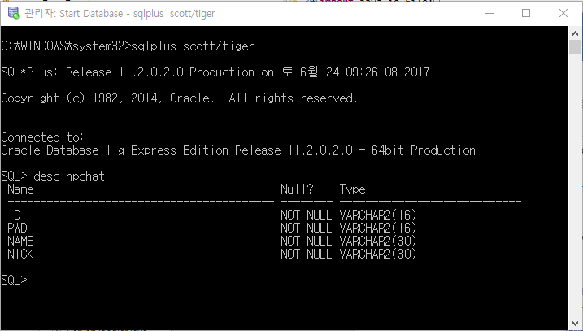

* 1. Import JDBC driver to Eclipse

In order to access to Oracle database from Eclipse, the project that needs to have an access to DB should import JDBC driver to the project.

In package explorer, click right button on the package name and follow “*Build path -> Add External Archives*”, then select *ojdbc6.jar.*

* 1. Source code structure

Source code consist of three different field, client, server and database.

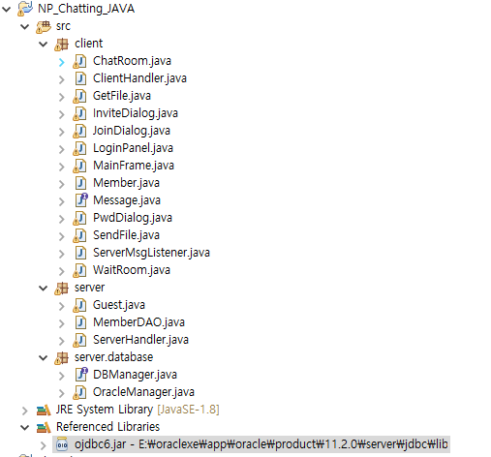

1. **Software structure**
   1. Overall structure

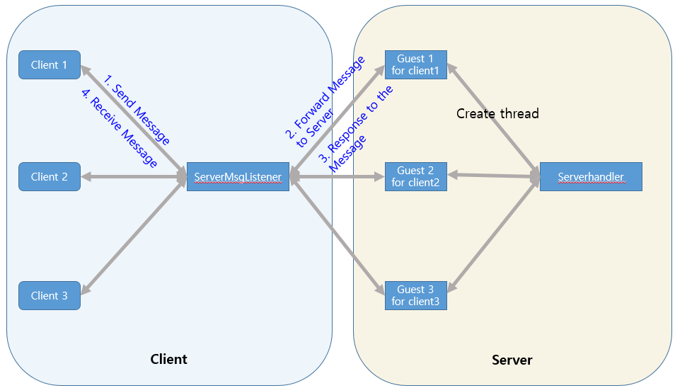

* 1. Server classes

ServerHandler : Main class of server. This class create Guest thread to serve individual client.

Guest : Communicate to client via ServerMsgListener. Handles all of messages from client.

* 1. Client class

ClientHandler : Main class of client. Work between gui class and ServerMsgListner.

ServerMsgListener : Send and Receive messages from/to Guest in server.

WaitRoom : In charge of Waiting room GUI. User wait for chatting.

ChatRoom : In charge of Chatting room GUI.

SendFile/GetFile : File transfer handler

LoginPanel : Firstly launched class to login server

JoinDialog : sign up

InviteDialog : Handle invitation in Chatting Room

PwdDialog : query password when user update its information after login

1. **Software Control flow**
   1. Chatting message

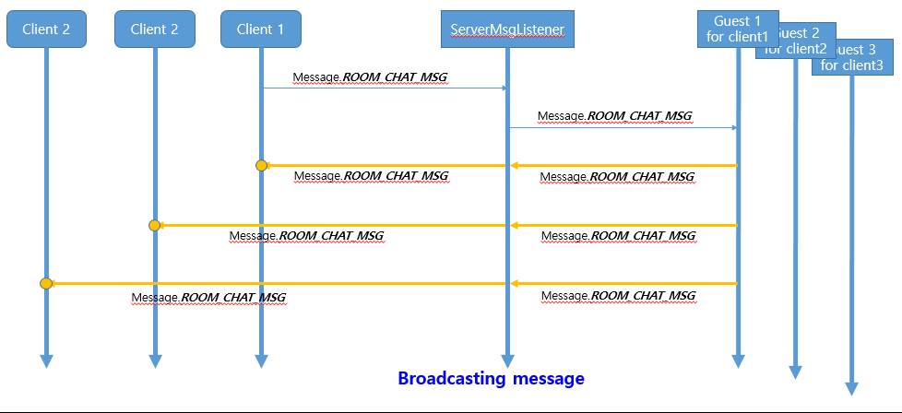

* 1. Private message

