Three things I like about pexiscore –

1. The pexiscore concept
2. The assessment, scoring and report
3. Shortlisting candidates

# The concept

Pexiscore is an assessment enabled hiring platform. It helps in shortlisting candidates based on pexiscore, People Excellence Indicator Score.

**The normal processing of Candidates profiles -**

Currently the HR/consultant goes through the detailed profile of candidates. She uses one of her fast reading technique’s (scanning/skimming) to go through piles of profiles and shortlist candidates for further processing. It’s a daunting task and the deadlines add complexity to it. This also brings in the personal bias in the shortlisting process. You are not always sure if a potential better candidate has been overlooked or a not so better candidate has got through this manual process.

**Pexiscore helps you move the decision making process from Unstructured information towards structured and quantified information.**

Pexiscore brings in fairness, reliability and openness in the shortlisting process so that you don’t miss out on hiring any right talent for the job.

# The assessment and the report

Pexiscore assesses candidates on these segments -

1. Psychometric analysis (workplace behaviour)
2. Aptitude analysis
3. Job Skills analysis
4. Profile to Job Description match analysis

Based on measure on these four segments, the platform gives a score to the candidate - pexiscore.

**Psychometric assessment**

We have a fixed set of question bank for psychometric assessment.

**Aptitude assessment**

These are fixed set of questions. This accesses the aptitude of the candidate.

While creating the JD the HR/business person will have the ability to select set of questions from the question bank based on the Job Description (JD) requirements.

**Skills based Assessment**

Skills based questions for the job – This is set of questions which are job specific. While creating the Job Description (JD) the HR or business can upload the questions (Text or picture based MCQ ) from a fixed format or can enter them one by one.

**Profile to JD match**

“Pexsiscore” matches the JD with the candidates profile and the overall score also takes this measure into account.

Pexiscore also has the ability to ask “HR” related questions to the candidate.There is a question bank for HR questions which is segregated into four sections.While creating the Job description the HR/Consultant can select questions from different sections and add to the job description.The questions are all subjective and you get to see the questions and answers in the detailed report.

**Report**

Once the assessment is done, the “pexiscore” and a detailed report is generated which can be downloaded for reference and further processing for interview process.

A sample of the detailed output report –

Personality Match

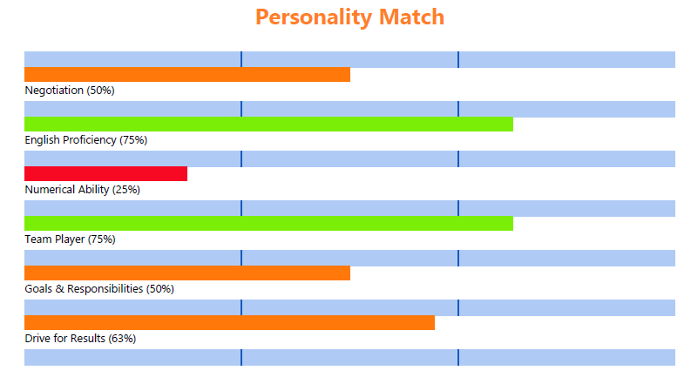

7AS Framework –

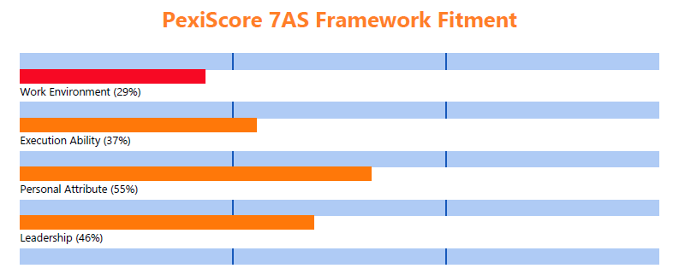

And the detailed assessment –

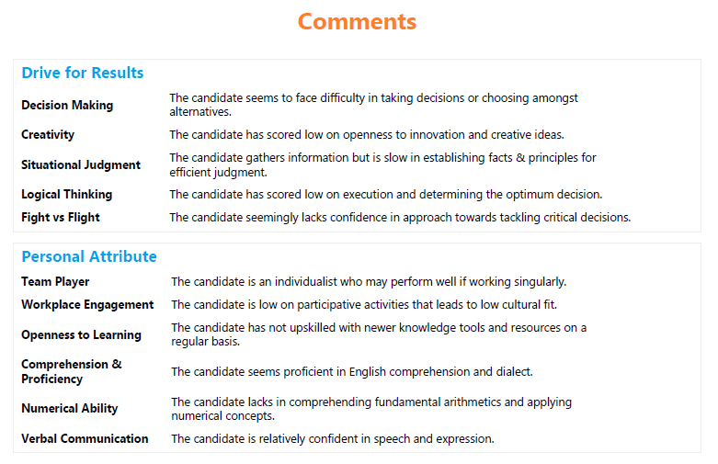

The report details the candidate’s assessment from different segments. For the HR questions and the skills based questions, the platform also gives the answers given by the candidate. This can be used for further discussions during the interview process.

You can check out on a sample report here –

<https://pexiscore.com/includes/sample_report.pdf>

# Shortlisting of Candidates

Once the assessment is done, the HR will then go on to shortlist the candidates based on multiple parameters along with “pexiscore”.

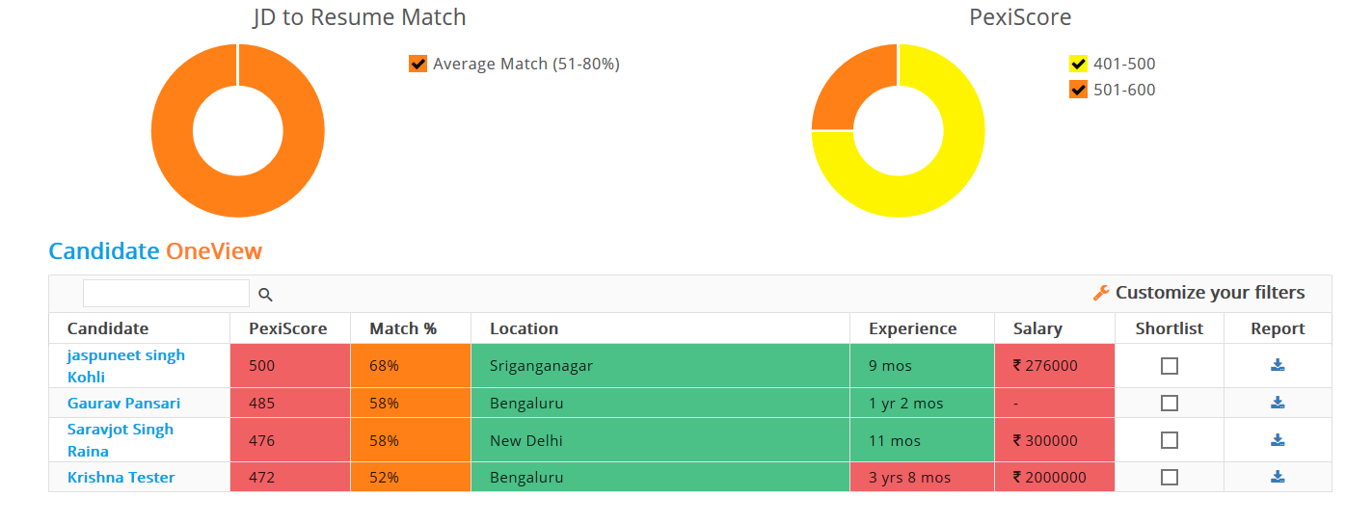

To aid the shortlisting process, the platform allows you to filter candidates based on parameters like industry, experience, key skills and many more. You shortlist candidates based on the defined parameters for the job and process only a few shortlisted candidates instead of a long list of potential candidates with generic profile match.

# Current Trend is using data for hiring

There is a moving trend towards using data, machines and algorithm in the hiring process. You feed data to the machine and algorithm to identify potential candidates for your job.

A recent article in “peoplematters” titled “How Accenture transformed its recruitment using contextual analytics” detailed out how Accenture used technology and machines to shortlist candidates for hiring.

# Contact Us

Please check how it works @ <https://pexiscore.com/how-it-works-recruiters>

You can also write to us @ [support@pexiscore.com](mailto:support@pexiscore.com)