Pexiscore is an assessment enabled hiring platform. It helps in shortlisting candidates based on pexiscore, People Excellence Indicator Score.

Currently the HR/consultant goes through the detailed profile of candidates. She uses one of her fast reading technique’s (scanning/skimming) to go through piles of profiles and shortlist candidates for further processing. It’s a daunting task and the deadlines add complexity to it. This also brings in the personal bias of the person shortlisting.

Pexiscore brings in fairness, reliability and openness in the shortlisting process so that you dint miss out on any talent for the job.

Pexiscore assesses candidates on these segments -

1. Psychometric analysis
2. Aptitude analysis
3. Job Skills
4. Profile to Job Description analysis

Based on measure on these four segments, the platform gives a score to the candidate - pexiscore.

**Psychometric assessment**

We have a fixed set of question bank for psychometric assessment. (write about 7 AS framework )

**Aptitude assessment**

These are fixed set of questions. This accesses the aptitude of the candidate.

While creating the JD the HR/business person will have the ability to select set of questions from the question bank based on the Job Description (JD) requirements.

**Skills based Assessment**

Skills based questions for the job – This is set of questions which are job specific. While creating the Job Description (JD) the HR or business can upload the questions (Text or picture based MCQ ) from a fixed format or can enter them one by one.

We provide a detailed report on different assessment, you can check out on a sample report here –

<https://pexiscore.com/includes/sample_report.pdf>

Once the assessment is done, the HR has the ability to shortlist candidates based on multiple parameters along with “pexiscore”.

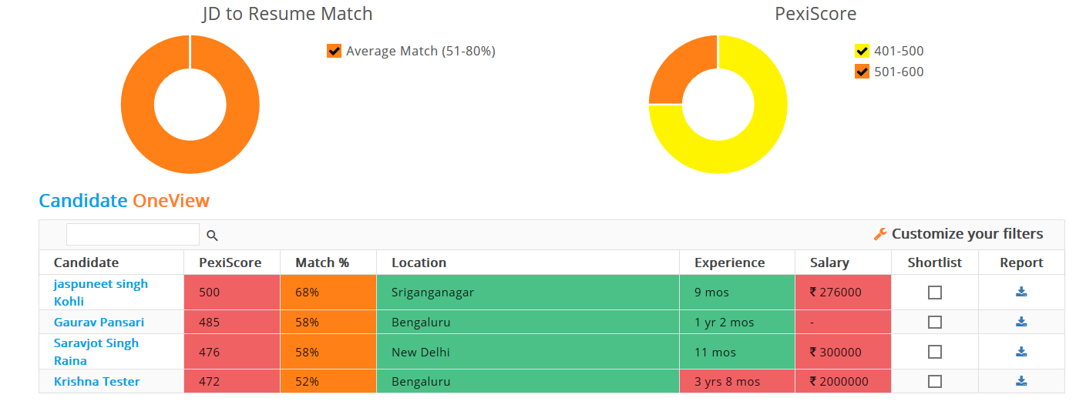

To aid the shortlisting process, the platform allows you to filter candidates based on parameters like industry, experience, key skills and many more. You shortlist based on the defined parameters for the job and process only a few shortlisted candidates instead of wasting time on candidates with generic profile match.

**Pexiscore helps you move the decision making process from Unstructured information towards structured and quantified information.**