# Worxogo Project

Recently we finished a project on creating a data model and analysing the data for a company doing gamification of sales. The data was for varied customers including –

1. a manufacturing and sales company and
2. financial services company.

# Design

The data was from different tables and the diagram below details the process –

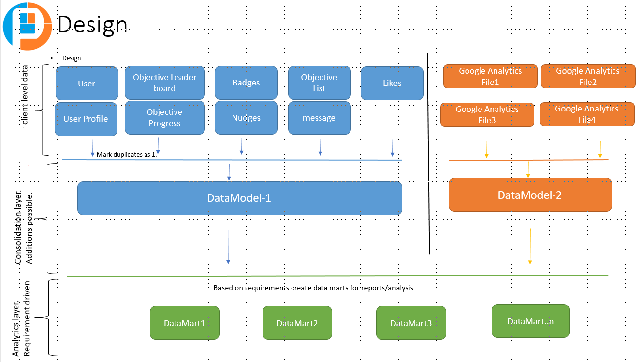

The data was from different tables –

1. User table
2. User Personality
3. Leader Board
4. Badges
5. Nudges
6. KPI’s (daily, weekly and monthly)
7. Google Analytics files

# Data Model

We process data from all tables, mark duplicates and merge them all to create the data model. Based on requirements/analysis we then create as many data marts required for reporting and analysis.

We initially started with one day data and merged all data from different sources into a single data model. Then we did the same for one month data and then we included all data we were provided with. We did this stage wise process to validate the design process.

Since the KPI’s were defined on daily, weekly and monthly basis, we had to create the mart on a daily basis and we rolled up the KPI’s achieved on a weekly and monthly basis apart from other information from google analytics.

Once the data mart was there, it was exported to excel format for creating reports using pivot tables.

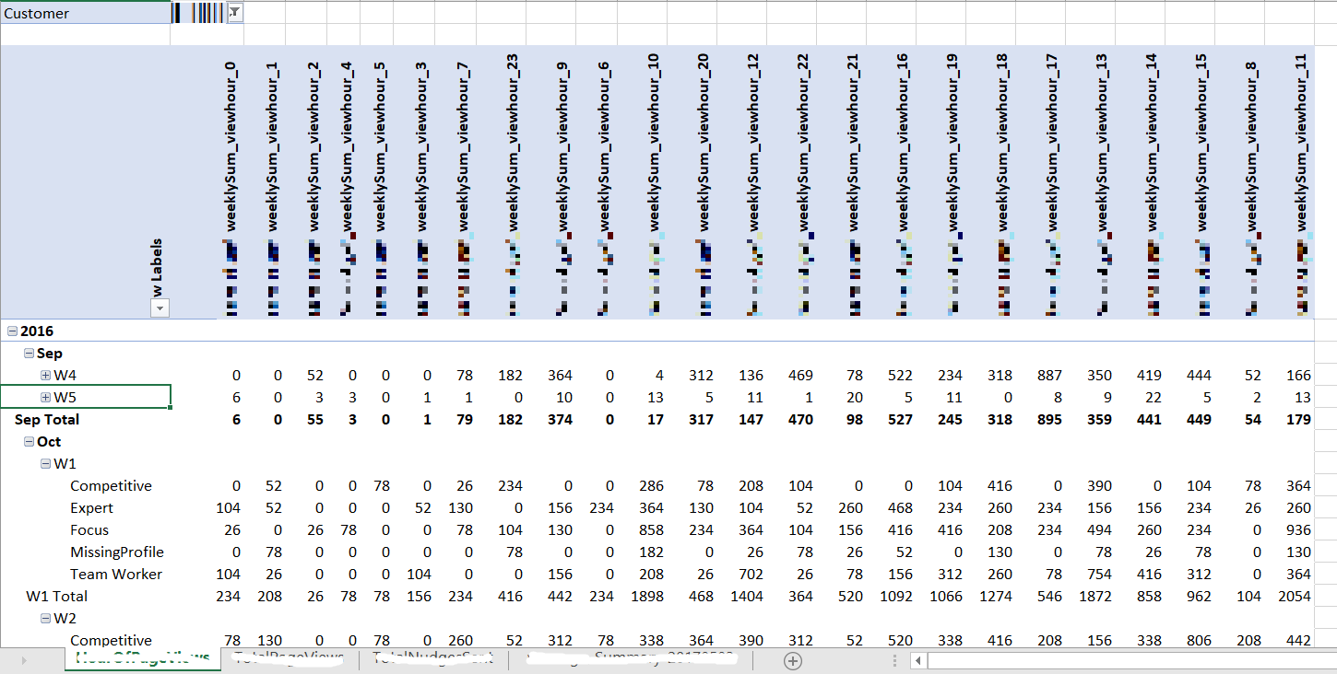

# Data Marts

We also analysed the different gaming aspects with respect to the KPI’s achieved.

With the analysis using visualization, we got some valuable insights and something for the business to think about and take action on.

Some of the analysis and insights we came across -

The viewing habits of the employees on different days of the week -

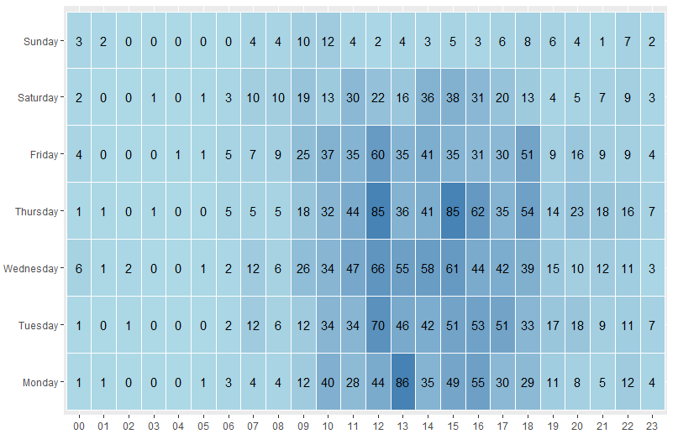

Viewing habits of the employees by personality –

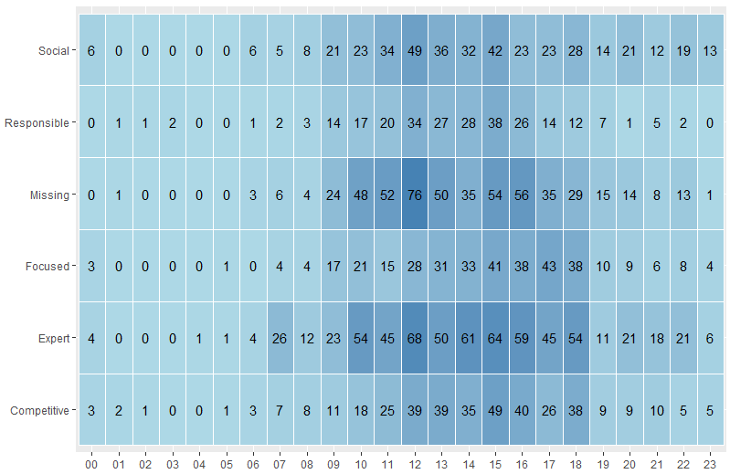

The above two would help in interacting with the employees accordingly.

Correlation between the KPI’s achieved –

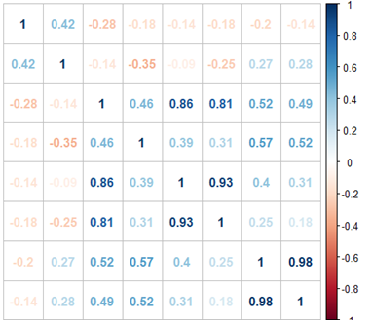

This gives an insight into the KPI’s achievement relationships. Once correlation is found, the next step would be to find the causation.

We plotted two metrics besides each other to get more insights -

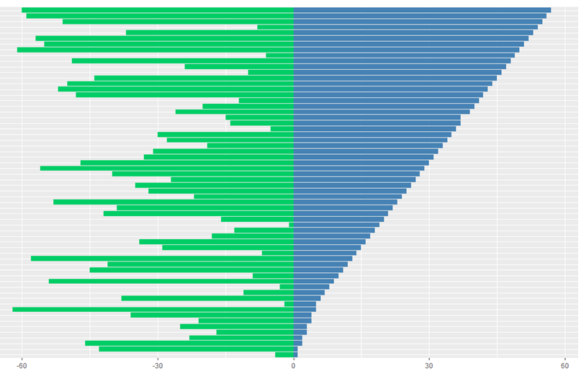

These gives an insight into the relationship between the two metrics.

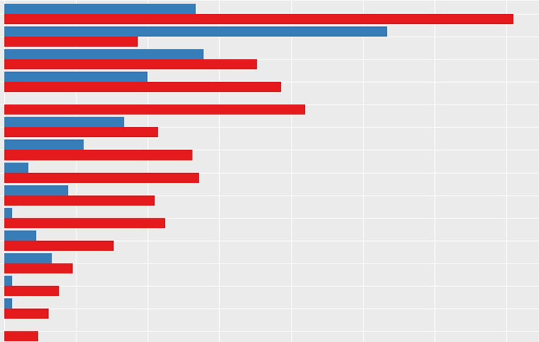

Here we captured the metrics before and after an event so as to give more insight into the event management.

# KPI’s

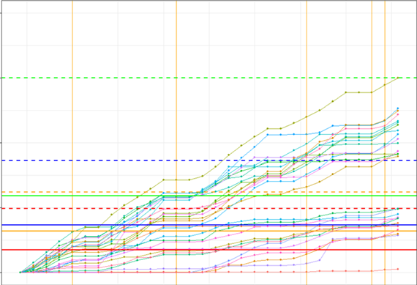

Here we plotted the vintage chart of the KPI’s and clustering them into different groups. This shows the pattern in the KPI achievement process for a month.