Road Safety Efficiency Across Indian States:
A Data Envelopment Analysis (DEA) Approach
Jaykumar Rajkumar Bagaria
Széchenyi István University
SSRN Working Paper | March 2026

Abstract
Road safety remains a pressing public policy challenge in India, with substantial variation in accident outcomes across states. This paper applies an input-oriented Data Envelopment Analysis (DEA) model to evaluate the relative efficiency of 34 Indian states and union territories in managing road safety, using 2011 Government of India data. Two risk-exposure inputs — accidents per lakh population and accidents per 10,000 registered vehicles — are modeled against a transformed safety output (inverse of total accidents). Results reveal a strongly right-skewed efficiency distribution: only Nagaland achieves frontier efficiency (score = 1.0), while large, economically developed states such as Tamil Nadu, Maharashtra, and Karnataka record scores below 0.0001. Smaller states and union territories consistently dominate efficiency rankings, suggesting a pronounced scale effect whereby higher motorization and urban traffic complexity impose efficiency penalties not fully offset by infrastructure advantages. The findings point to the need for context-sensitive road safety policies and provide a benchmarking framework applicable to future panel-data extensions.
Keywords: Road Safety, Data Envelopment Analysis, India, Efficiency, Transportation Policy, Scale Effects
JEL Classification: R41, C61, H75

1. Introduction
India accounts for approximately 11% of global road traffic fatalities despite having only 1% of the world's vehicles, making road safety one of the most urgent public policy challenges facing the country. The distribution of road accidents is, however, far from uniform: states differ sharply in their accident rates, traffic density, infrastructure quality, and enforcement capacity. Understanding which states manage these risks effectively — and which do not — is essential for targeted policy design.
Conventional analyses of road safety performance rely on absolute accident counts or simple normalized indicators such as accidents per unit of population or per registered vehicle. While informative, these single-ratio approaches fail to capture relative efficiency when multiple exposure dimensions interact simultaneously. A state may report a low accidents-per-vehicle figure yet still perform poorly relative to its population exposure, or vice versa.
This paper addresses this gap by applying Data Envelopment Analysis (DEA) — a non-parametric linear programming technique widely used in operations research and applied economics — to evaluate road safety efficiency across Indian states. DEA constructs an empirical efficiency frontier from the observed data, scoring each state relative to the best-performing peers. States on the frontier receive a score of 1.0; all others receive scores between 0 and 1 that quantify the proportional reduction in risk inputs achievable while maintaining current safety output.
The analysis uses publicly available 2011 data from the Government of India's Open Data Platform. The choice of 2011 reflects data completeness and the stability of the pre-expressway-expansion period. Results surface a strong scale effect: smaller states and union territories dominate the efficiency frontier, while large, highly motorized states cluster at the bottom of the distribution. These findings have direct implications for benchmarking and policy design.

2. Literature Background
Road safety research has a rich tradition of statistical modeling, including negative binomial regression, structural equation models, and spatial econometrics applied to identify determinants of accident frequency and severity. These methods are well-suited to causal inference but are inherently single-output and require strong distributional assumptions. They do not readily accommodate simultaneous evaluation across multiple inputs and outputs.
DEA, introduced by Charnes, Cooper, and Rhodes (1978), offers a complementary approach. By solving a sequence of linear programs, DEA identifies an empirical production frontier from observed decision-making units (DMUs) without requiring functional form specification or predefined weights. The technique has since been applied extensively in healthcare, banking, education, and transportation efficiency studies.
In the transportation domain, DEA has been used to benchmark airport performance, public transit systems, and logistics networks. Its application to road safety, however, is comparatively sparse. Studies in European and East Asian contexts have explored DEA-based road safety benchmarking, but analogous work using Indian state-level data remains limited — leaving a gap this paper begins to address.

3. Data
The dataset is drawn from publicly available records published by the Government of India, specifically the Ministry of Road Transport and Highways (MoRTH) accident statistics for 2011. Three variables are extracted for each state and union territory:
- Total number of road accidents (used to construct the output variable)
- Accidents per lakh population (Input 1: population-normalized exposure)
- Accidents per 10,000 registered vehicles (Input 2: motorization-normalized exposure)

A safety output variable is constructed as the inverse of total accidents (safety_output = 1 / accidents), transforming the undesirable accident count into a positive output aligned with DEA's production framework: higher values represent better safety performance. States with zero accidents (mathematically undefined under this transformation) are excluded. After cleaning for missing and inconsistent entries, the final dataset comprises 34 states and union territories.
The 2011 cross-section was selected for its data completeness across all states. Future work will extend the analysis to panel data covering subsequent years to account for temporal dynamics.

4. Methodology

4.1 DEA Model Specification
An input-oriented constant-returns-to-scale (CRS) DEA model is employed. In this framework, each state j is treated as a DMU characterized by two inputs (x₁, x₂) and one output (y). The input-orientation asks: by what proportion θ could inputs be reduced while holding output constant, if the DMU operated on the efficiency frontier?
For each DMU i, the efficiency score θ* is obtained by solving the following linear program:
Minimize θ
Subject to:
∑ⱼ λⱼ xⱼₖ ≤ θ xᵢₖ ∀ inputs k
∑ⱼ λⱼ yⱼᵣ ≥ yᵢᵣ ∀ outputs r
λⱼ ≥ 0 ∀ j, 0 ≤ θ ≤ 1
where λⱼ are intensity variables defining the efficiency frontier as a convex combination of observed DMUs, and θ* is the efficiency score for DMU i. The model is implemented in Python using the PuLP linear programming library, with the CBC solver, solving one LP per state.

4.2 Variable Definitions
The two inputs capture distinct dimensions of road risk exposure: population-based exposure (accidents per lakh population) reflects the probability of an individual being involved in an accident, while vehicle-based exposure (accidents per 10,000 vehicles) captures the risk conditional on being a road user with a registered vehicle. Together, they provide a richer picture of risk than either indicator alone. The single output (safety measure = 1/accidents) anchors performance to actual accident reduction, ensuring that efficiency gains are tied to real-world safety improvements.

5. Results

5.1 Efficiency Score Distribution
The DEA model produces a highly skewed distribution of efficiency scores across the 34 DMUs. Table 1 presents selected results spanning the full range of performance. Only Nagaland achieves frontier efficiency (θ* = 1.0). At the other extreme, large states including Tamil Nadu, Maharashtra, Karnataka, Andhra Pradesh, and Madhya Pradesh record scores below 0.0001 — implying that their risk inputs would need to be reduced by more than 99.99% to reach the frontier while maintaining current accident levels.

Table 1: Selected DEA Efficiency Scores — Indian States (2011)
State / UT | Accidents per Lakh Pop. | Accidents per 10,000 Veh. | Efficiency Score
Nagaland | Low | ~1 | 1.000 (Frontier)
Daman and Diu | Low | ~5 | ~0.150
Mizoram | Moderate | ~5 | ~0.090
Tamil Nadu | High | ~44 | ~0.00003
Maharashtra | High | ~41 | ~0.00003
Karnataka | High | ~44 | ~0.00003
Andhra Pradesh | High | ~43 | ~0.00004
Madhya Pradesh | High | ~70 | ~0.00003
Table 1: calculations based on MoRTH data (2011). Note: Accident exposure columns show qualitative ranges for brevity.

5.2 Efficiency vs. Risk Exposure
Figure 1 plots efficiency scores (log scale) against accidents per 10,000 vehicles for all states. The visualization reveals three structural features of the distribution:
- A steep frontier: Nagaland sits at the top-left — very low vehicle-based exposure, maximum efficiency — with no other state coming close.
- A cluster of moderate performers: Daman and Diu and Mizoram occupy intermediate efficiency levels, reflecting lower absolute accident volumes relative to their exposure.
- A dense bottom cluster: The vast majority of states are compressed into a narrow band of extremely low efficiency scores despite spanning a wide range of vehicle exposure.

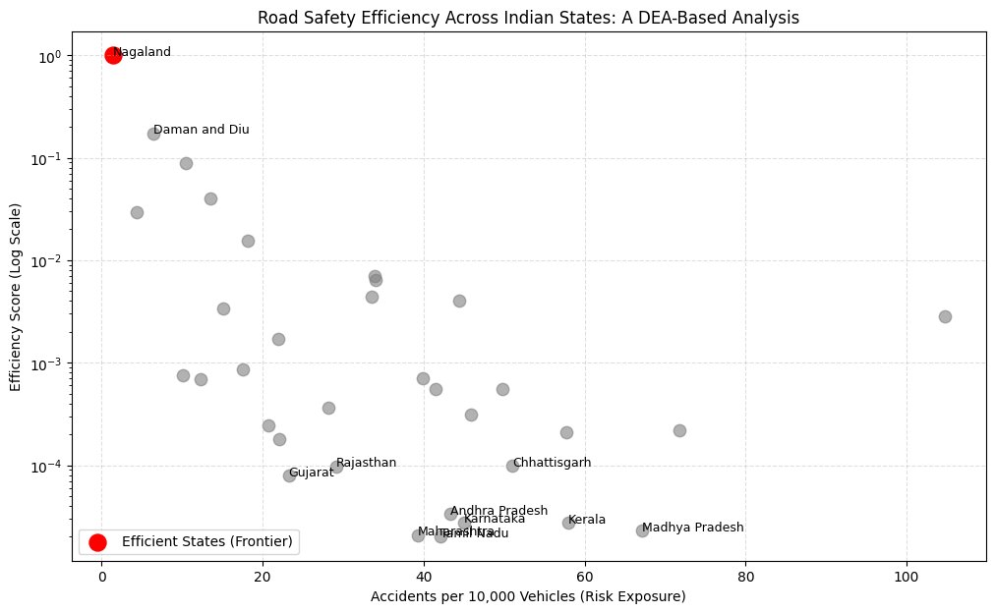
Figure 1: DEA Efficiency Score vs. Accidents per 10,000 Vehicles (log scale). Red dot = frontier state (Nagaland).

6. Discussion

6.1 The Scale Effect
The dominant pattern in the results is a strong inverse relationship between state size (as proxied by total accident volume and motorization density) and DEA efficiency. This is consistent with a scale effect: smaller states benefit from lower traffic complexity, fewer high-density interaction zones, and reduced behavioral heterogeneity among road users. These structural advantages translate into better relative safety outcomes for a given level of exposure.
Conversely, large, economically dynamic states face compounding challenges — urban congestion, mixed traffic (motorized and non-motorized), long-distance freight corridors, and wide variation in driver behavior — that elevate accident risk even after controlling for population and vehicle exposure. The DEA model captures these structural disadvantages in the form of very low efficiency scores.

6.2 The Efficiency-Development Paradox
A counterintuitive finding deserves emphasis: states with more developed transport infrastructure and stronger institutional capacity — Tamil Nadu, Karnataka, Maharashtra — record the lowest efficiency scores. This apparent paradox is explained by the composition of the DEA model. Efficiency here is measured relative to accident exposure, not in absolute terms. Highly developed states have substantially higher motorization and urbanization, which increases the denominator of the efficiency calculation. Put differently, these states generate more accidents than a frontier state with comparable inputs would be expected to, suggesting that infrastructure improvements have not kept pace with the safety challenges introduced by rapid motorization.
This finding aligns with the broader literature on the "safety in numbers" paradox and the non-linear relationship between economic development and road safety outcomes, often modeled through the Kuznets-type curve framework in transportation research.

6.3 Policy Implications
The DEA efficiency scores provide a benchmarking framework that can directly inform policy prioritization. Four actionable recommendations emerge:
- Frontier benchmarking: Policymakers in low-efficiency states should study the traffic management conditions that enable Nagaland's frontier performance, while accounting for scale differences.
- Differentiated policy design: A single national road safety standard is unlikely to be effective. High-motorization states require context-specific interventions targeting congestion, enforcement, and behavioral change at scale.
- Input efficiency audits: States with low scores should conduct systematic audits to identify which input dimension — population exposure or vehicle exposure — drives inefficiency, enabling targeted resource allocation.
- Panel extension: Extending this analysis to 2012–2022 data would enable dynamic efficiency tracking, capturing the effect of major interventions such as the Motor Vehicles (Amendment) Act 2019.

7. Limitations
Several limitations circumscribe the interpretation of these results. First, the analysis relies on a single cross-section (2011), precluding causal or temporal inference. Second, the CRS assumption may be inappropriate if significant returns to scale exist; future work should test variable-returns-to-scale (VRS) specifications and scale efficiency decomposition. Third, the safety output is a simplified transformation of total accident counts and does not distinguish between fatal, grievous, and minor accidents. Incorporating severity-weighted outcomes would enrich the model. Fourth, DEA scores are sensitive to outliers; the strong dominance of Nagaland should be interpreted in light of its small population and limited road network rather than as evidence of superior policy performance per se. Finally, important omitted variables — road length, speed limits, enforcement intensity, and weather conditions — could be incorporated in future multi-input extensions.

8. Conclusion
This paper applies Data Envelopment Analysis to evaluate road safety efficiency across 34 Indian states and union territories using 2011 government data. The results reveal a strongly right-skewed efficiency distribution: only Nagaland sits on the efficiency frontier, while the large majority of states — including some of India's most economically advanced — record extremely low efficiency scores. A pronounced scale effect is evident, whereby smaller states and union territories achieve better relative performance in managing road risk exposure.
The findings challenge a simple infrastructure-centered view of road safety improvement. Economically developed states with better roads and stronger institutional capacity still register poor efficiency when evaluated relative to their motorization and population exposure levels. This suggests that the rate of motorization has outpaced the rate of safety improvement in India's largest states — a structural challenge demanding adaptive, context-sensitive policy responses rather than uniform national standards.
This study contributes a replicable DEA-based benchmarking framework that can be extended to panel data, alternative output definitions, and cross-country comparisons. The data, code, and methodology are documented in a publicly available Jupyter notebook and can be reproduced using open-source tools.

References
Charnes, A., Cooper, W. W., & Rhodes, E. (1978). Measuring the efficiency of decision making units. European Journal of Operations Research, 2(6), 429–444.
Government of India, Ministry of Road Transport and Highways (MoRTH). (2012). Road Accidents in India — 2011. Transport Research Wing, New Delhi.
Haddon, W. (1968). The changing approach to the epidemiology, prevention, and amelioration of trauma. American Journal of Public Health, 58(8), 1431–1438.
Kumar, S., & Dhaliwal, S. (2010). Road safety in India: A study of past trends and future expectations. Journal of the Indian Roads Congress, 71(1), 45–62.
Shen, Y., Hermans, E., Brijs, T., & Wets, G. (2012). Data envelopment analysis for composite indicators: A multiple layer model. Social Indicators Research, 114(2), 739–756.
Wanvik, P. O. (2009). Effects of road lighting: An analysis based on Dutch accident statistics 1987–2006. Accident Analysis & Prevention, 41(1), 123–128.

—

