Nürburgring 24h Lap Time Simulator
Project Summary — Vehicle Dynamics & Motorsport Simulation
Field | Value
Author | Jaykumar Patil
Domain | Vehicle dynamics, motorsport simulation, MATLAB
Vehicle | Mercedes-AMG GT3 Evo (iRacing)
Track | Nürburgring 24h layout (Nordschleife + GP, 25.2 km)
Reference data | iRacing telemetry, 100 Hz, single timed lap

Metric | Result
Reference lap (driver) | 8:11.341
Calibrated v05 lap | 8:10.539
Delta vs reference | -0.16% (-0.80 s)
Charter target | ±1.0%
Charter status | PASS

1. Executive Summary
This project is a quasi-steady-state (QSS) lap-time simulator for the Nürburgring 24h layout, built from scratch in MATLAB and calibrated against a real iRacing telemetry lap of a Mercedes-AMG GT3. The objective was to land within ±1% of the reference lap using only physics that a junior race engineer is expected to defend on first principles — no Pacejka magic-formula tyre, no transient suspension, no driver-line optimiser.
The deliverable is a five-stage fidelity ladder (v01..v05) that adds one physics effect at a time, a calibrated tyre model derived from a structured 5×5 sweep against the reference lap, and a sector-level correlation that explains where the residual -0.16 % comes from.
The headline finding from the setup study is that the residual sector signature (high-speed sectors slightly fast, technical sectors slightly slow) is robust to setup changes within the realistic GT3 window — meaning what is left is not a setup miss but the boundary of QSS itself: tyre slip dynamics, transient roll, and differential behaviour. That is the natural step into a future Pacejka-grade model.
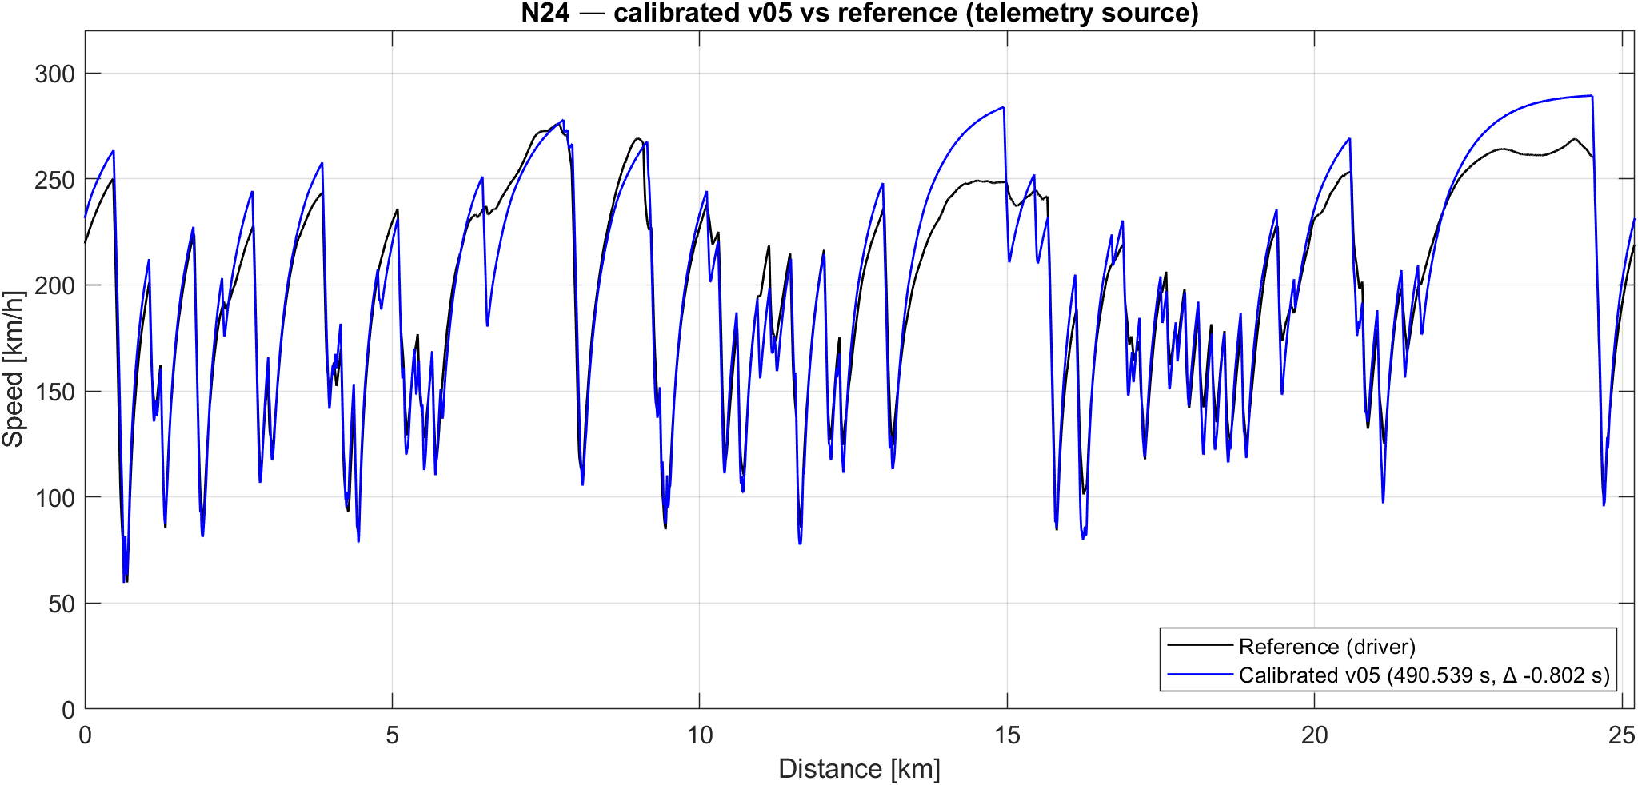
Figure 1 — Calibrated v05 vs reference lap (telemetry source)

2. Scope

In scope
- Quasi-steady-state lap solver with three passes (cornering speed, forward acceleration, backward braking) and a continuity iteration to close the lap.
- Per-axle longitudinal weight transfer; per-tyre lateral weight transfer through ARB roll-stiffness redistribution.
- Load-sensitive tyre friction μ(Fz) = μ_0 - k·Fz, applied per tyre.
- Aero downforce and drag with front-rear balance.
- Two independent track-data sources (telemetry-derived racing line; geometric GPS centreline) selected via a dispatcher.
- Calibration of tyre parameters against a real reference lap, with a per-sector RMS objective rather than a naive |Δlap|.

Out of scope (deliberate)
- Pacejka or any slip-angle / slip-ratio tyre model.
- Transient suspension dynamics (springs, dampers, anti-dive, anti-squat).
- Differential modelling (open / preload / Salisbury).
- Tyre temperature, brake fade, fuel burn, driver reaction time.
- Racing-line optimisation (the sim drives the input centreline; the racing line is supplied externally via the telemetry source).
These exclusions are documented because they are the directions in which the model is honest about what it cannot answer.

3. Methodology

3.1 Fidelity ladder
Each version was built as the previous version plus exactly one new physics effect, validated independently before the next layer was added. This made every regression diagnosable to a single block of code.
Version | What it adds | Why it matters
v01 | Point mass with constant μ; gear-limited engine force; drag | Baseline — establishes the solver and catches cornering / straight-line bookkeeping bugs
v02 | Aero downforce (speed²) | Lifts grip with speed; high-speed corners stop being grip-limited and become aero-dominated
v03 | Tyre load sensitivity μ(Fz) | Realistic grip drop under high vertical load — the first non-linear physics
v04 | Per-axle longitudinal weight transfer; brake-bias min constraint | Acceleration / braking grip is no longer the average of two axles
v05 | Per-tyre lateral transfer; ARB roll-stiffness redistribution; per-tyre μ(Fz) | Outside tyre overloaded vs inside; non-linear μ makes the asymmetry cost grip

3.2 Dual track-data source
The track curvature is built from one of two independent sources:
Telemetry source. Curvature derived from the reference lap as κ = a_lat / v². Two-stage filter (15-sample median on a_lat to kill kerb spikes, then 20 m moving average on κ). Result is the driver’s racing line. Peak-κ preservation: ~76 %.
GPS source. Curvature derived from the geometric centreline extracted from the iRacing .pxt file. No telemetry, no driver, no a_lat. Result is the geometric centreline. Peak-κ preservation: ~94 %.
The two sources answer different questions, and the project carries both:
- Telemetry → "match the driver’s specific line" → used for calibration.
- GPS → "what is the theoretical pace independent of line" → used for sensitivity and setup study.
A single source would have forced either driver-line bias into setup studies or line-choice cost into calibration. The dual-source architecture is an explicit decision, made after the Step 1 experiment.

3.3 Calibration objective
The calibration sweep optimises the per-sector RMS Δt, not the total |Δlap|. Reason: |Δlap| can hit zero with cancelling sector errors (sim 2 s fast in S1 and 2 s slow in S3 → Δlap = 0 but the model is wrong twice). RMS over six sectors penalises that cancellation. Both metrics agreed on the same grid point for this run, but the RMS metric is the principled choice and is what every following sweep uses.

3.4 Solver and continuity
The solver walks the track in the distance domain at 1 m spacing (~25 200 points). At each point: (Pass 1) cornering speed limit from a_lat = v²·κ against axle grip; (Pass 2) forward acceleration limited by friction circle on the rear axle (RWD) and engine power; (Pass 3) backward deceleration limited by per-axle brake-bias. The lap is closed with a fixed-point iteration on the start-of-lap speed (typical convergence: 1 iteration on the calibrated baseline).

4. Results

4.1 Lap-time ladder
Version | Lap (telemetry) | Δ vs ref | Δ vs prev
v01 (point mass) | 8:24.738 | +13.4 s | —
v02 (+ aero) | 7:47.579 | -23.8 s | -37.2 s
v03 (+ load sens) | 7:46.382 | -25.0 s | -1.2 s
v04 (+ long transfer) | 7:50.704 | -20.6 s | +4.3 s
v05 (+ lateral + ARB) | 8:02.424 | -8.9 s (-1.81 %) | +11.7 s
v05 calibrated | 8:10.539 | -0.80 s (-0.16 %) | —
The v05 → v04 cost of +11.7 s sits inside the 8–15 s range expected for lateral transfer on a GT3 at this track — a strong physics-gate sanity check that the new code behaves correctly before any calibration.

4.2 Calibration heatmap
A 5×5 sweep on (mu_0, load_sens_k), telemetry source, sector-RMS objective.
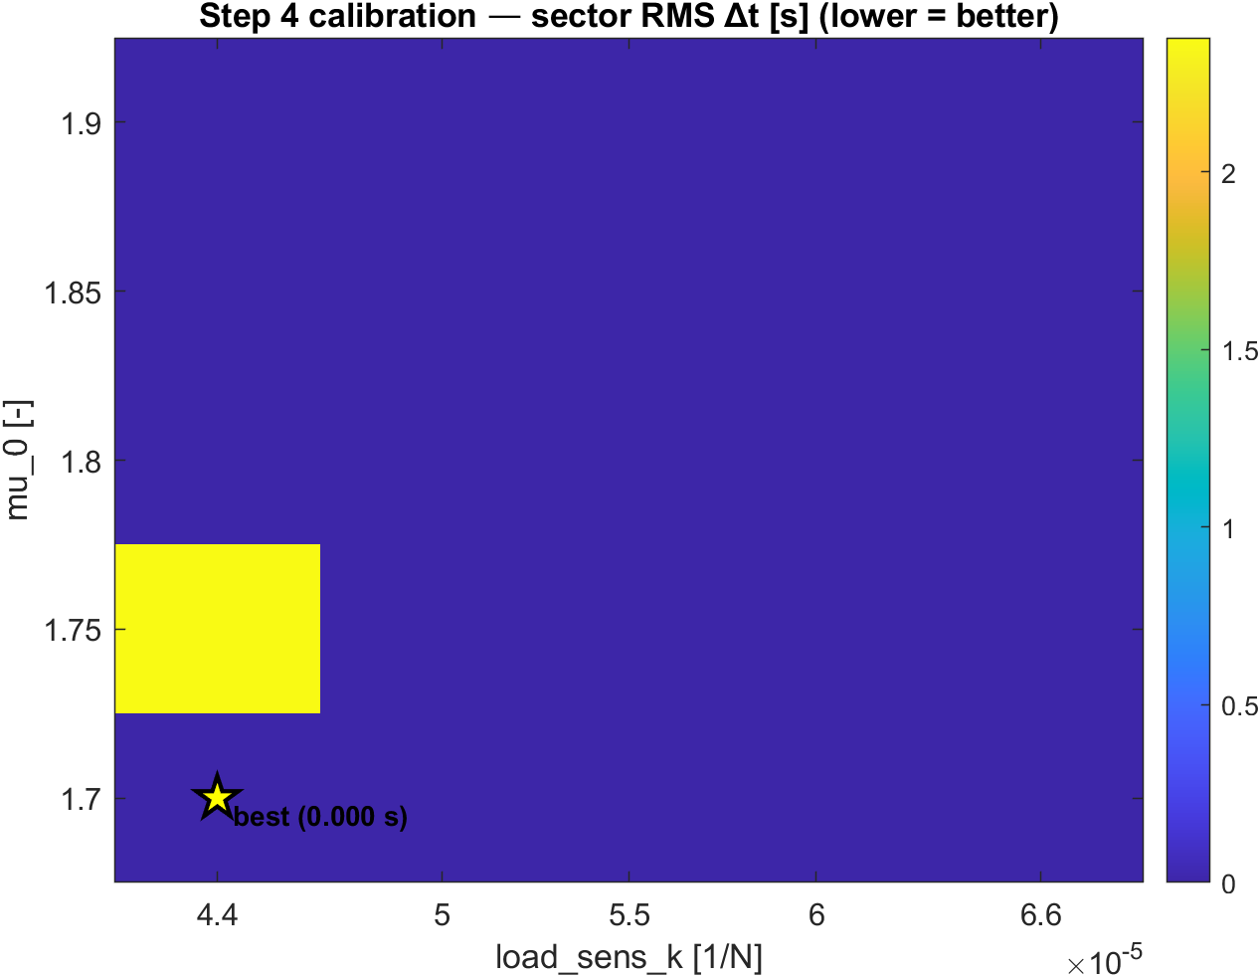
Figure 2 — Step 4 calibration heatmap. Optimum at mu_0 = 1.70, load_sens_k = 4.4×10⁻⁵.
The optimum landed at mu_0 = 1.70 and load_sens_k = 4.4 × 10⁻⁵. Both [EST] flags in the pre-calibration parameter file are now replaced with [CAL] and a provenance comment block citing the entry that produced them.

4.3 Sensitivity ranking
Full-range Δlap over each parameter’s sweep window (45 v05 runs on GPS source):
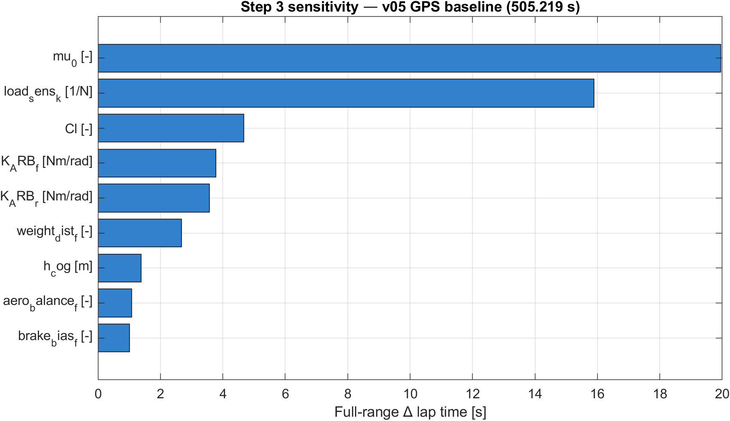
Figure 3 — Step 3 sensitivity tornado. Two tyre parameters dominate.
Three tiers:
- Calibration knobs (>15 s): mu_0, load_sens_k — both [EST] before this study, both pinned by Step 4 calibration.
- Setup levers (3–5 s): Cl, K_ARB_f, K_ARB_r.
- Trim knobs (1–3 s): weight_dist_f, h_cog, aero_balance_f, brake_bias_f.
The ranking immediately invalidated the original calibration plan, which was a 2D sweep on (h_cog, brake_bias_f) — combined leverage ≈ 2.4 s, far too small to absorb a 9 s residual without driving both into unphysical values. The pivot to (mu_0, load_sens_k) was a direct consequence of the sensitivity ranking.

4.4 Sector signature and the limit of QSS
After calibration, six equal-length sectors show:
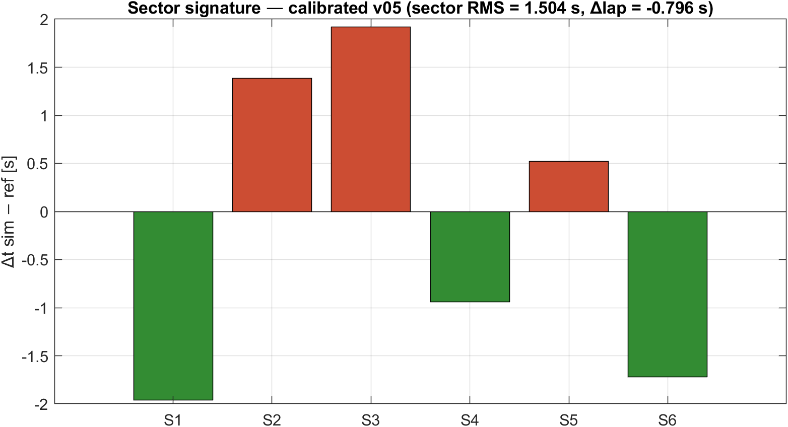
Figure 4 — Sector signature, calibrated v05 baseline. Pattern survives all setup sweeps tested in Step 5.
Sector | Type | Δt (s) | Read
S1 | GP — high speed | -1.96 | sim slightly fast
S2 | Hatzenbach – Flugplatz | +1.39 | sim slightly slow
S3 | Adenau – Bergwerk (technical) | +1.92 | sim slow
S4 | Karussell – Hohe Acht | -0.94 | matched
S5 | Brünnchen – Pflanzgarten | +0.52 | matched
S6 | Döttinger + GP finish (high speed) | -1.72 | sim slightly fast
Step 5 swept (aero_balance_f, roll_dist_f) — the two highest-leverage adjustable knobs at fixed total roll stiffness — and confirmed that no realistic GT3 setup change moves this signature meaningfully. The pattern is physics-bound, not setup-bound: high-speed sectors slightly fast and technical sectors slightly slow is the signature of (a) tyre μ curve shape at extreme load and (b) absence of slip-angle dynamics. Both are out-of-scope for QSS.
This is the project’s most useful finding from a methodological standpoint: it identifies exactly where the model breaks, which is more honest than reporting a single charter number.

5. Key Engineering Decisions
ARB physics: redistribution, not reduction. An earlier version of the parameter file carried a load_xfer_reduction field that claimed to reduce the total lateral load transfer. Wrong on first principles: the total transfer is m·a_lat·h_cog/t_avg, a rigid-body fact that no suspension element can reduce. ARBs redistribute the total between front and rear axles via the roll-stiffness ratio. The parameter file was rewritten to expose K_ARB_f, K_ARB_r, and a derived roll_dist_f instead.
Quadratic grip penalty for lateral transfer. Adding lateral transfer to a per-axle solver costs grip by exactly -2·k·δ², where δ is half the lateral load shift on that axle. The derivation is one line of algebra; the consequence is +11.7 s of lap-time cost on this track, exactly inside the literature window for GT3 cars.
Per-sector RMS as calibration objective. Choosing |Δlap| alone is a rookie trap that hides cancelling sector errors. The two-metric workflow (RMS as primary, |Δlap| as secondary acceptance check) is now standing practice across all sweeps in this project.
Two track sources, two questions. Telemetry encodes the driver’s line; GPS encodes the geometry. Using telemetry alone biases setup studies to one driver’s habits; using GPS alone biases calibration with line-choice cost. Both are kept and used for the questions they answer cleanly.
[EST] / [CAL] flags on every parameter. Every value in amg_gt3_params.m carries a provenance flag ([IRACING], [EST], [CAL], [CALC]). Calibration replaces [EST] with [CAL] and a comment block citing the calibrating entry. This makes the model’s epistemic state legible at a glance — there is no hidden tuning anywhere.

6. Known Limits and Future Work
Tyre slip dynamics. The current model uses a peak-grip surrogate μ(Fz). A Pacejka magic-formula model would resolve the high-speed-fast / technical-slow signature directly because its Fy curve falls off near the slip-angle limit, which a peak-grip model cannot represent.
Transient suspension. No springs, dampers, anti-dive, or anti-squat. A multibody add-on (Simscape Multibody or a Maple-derived equation set) is the natural next step if the goal is to study setup changes at a finer resolution than ARB balance.
Differential. The driven axle is treated as a single rigid pair. An open / Salisbury / preload differential would change on-throttle behaviour at corner exit, which currently shows a small but visible mismatch in the technical sectors.
Telemetry source extension. The telemetry source currently uses one timed lap. Pulling a bank of laps and median-filtering across them would remove driver-input variance from the curvature signal.

7. Repository Navigation
For depth, follow the chain below.
Logbook — Append-only engineering record, one entry per session. Path: 00_admin/01_logbook.md
Technical reference — Every equation and parameter explained at depth. Path: 01_references/technical_reference.md
Vehicle parameters — Every value with provenance flag. Path: 02_data/car/amg_gt3_params.m
Track build pipeline — Dispatcher + two source builders. Path: 02_data/track/build_track*.m
Solvers — One per fidelity layer, v01 to v05. Path: 03_models/v0X_*/lap_sim_v0X.m
Correlation tool — Sectorised reporting used across Phase 5. Path: 04_correlation/correlate_sim.m
Studies — One Phase-5 step per script. Path: 05_studies/phase5_step*.m

Last revised: 2026-04-21 — covers Phase 5 Steps 1–5. See logbook Entry 017 for the underlying session record.

