**Digital Technologies assignment 2: Report**

The purpose of this web application project is to create a suitable concept art portfolio for the accomplished environmental concept artist Luke Berliner. This portfolio will strive to put his artwork at the forefront, along with his other qualifications, to help increase employability. The use of images and visually striking elements is a very important design consideration, as this is will best show off Luke’s achievements. The site will allow potential employers to see Luke’s works, give them a means to contact him directly, and witness his vast skillset, which includes advertising, game design, and teaching, should they choose to employ him in an alternative role to concept artist. This site will endeavor to remove unnecessary text and clutter, keep a consistent design, be easily navigable, and provide good room for future development.

Luke’s work at Santa Monica Studios is that of the highest standard, consequently this web application will attempt to match this quality. Therefore, effective use of CSS and JavaScript will be pivotal in the styling of the portfolio, and the scripting of the dynamic elements that will improve the navigability and aesthetics of the portfolio.

# Program Design

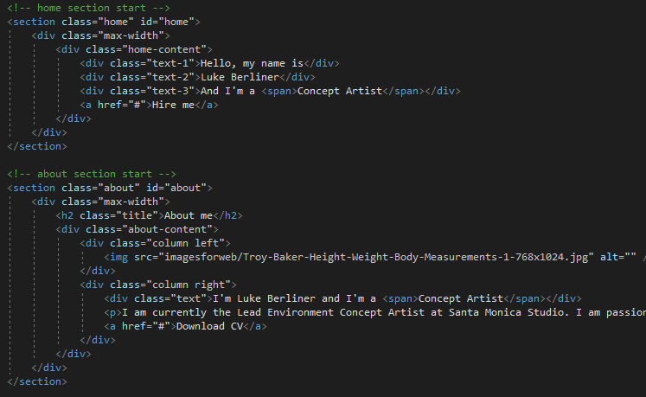**Home page:** The landing page (entitled HTML_Jacob.html) will have all pages on it one after the other to provide a more easily navigable site. This is achieved by having each page as a <section>, as well as having their own .html file.

The landing page itself will have one of Luke’s concept arts as the main background so potential clients are immediately drawn to the quality of the work. In front of this, there will be text in bold, heading font ‘Ubuntu’, stating Luke’s name and his job as a concept artist. The words ‘concept artist’ will be in crimson, whereas the remainder of text will be white.

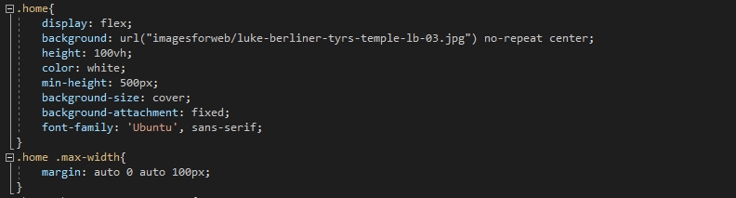A ‘Hire Me’ button will be underneath this text, which is in the middle left of the page. It will be a crimson text box with a ‘transition: all 0.3s ease;’ script so when the mouse is hovered over it, it will switch to ‘background: none’ and text ‘color: crimson’ from white. The background image is fixed, so upon scroll, the next pages scroll on top. 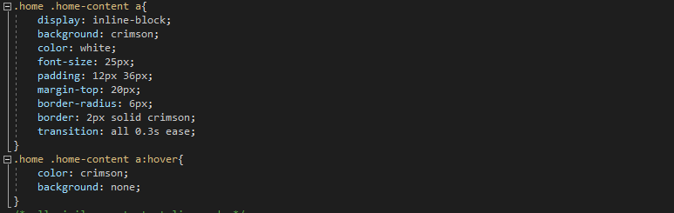

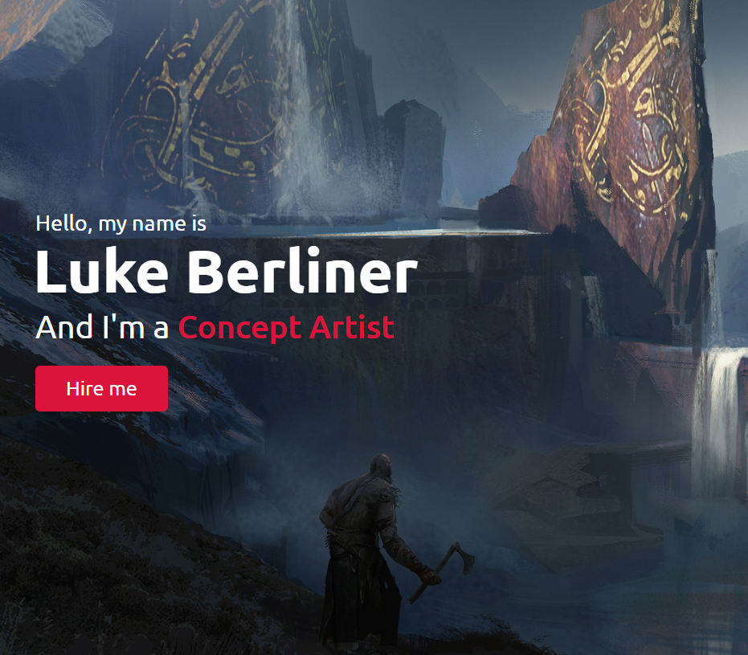The site dynamically changes according to the device size, so as the screen size decreases, the font size does the same.

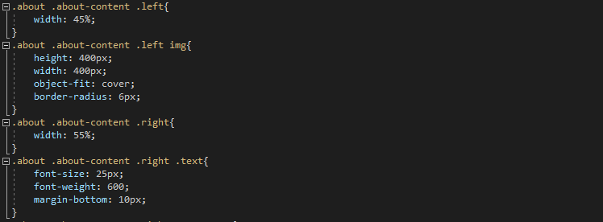**About me:** The about me page will be directly underneath the home page and be accessable via the navbar as a separate .html. The background colour scheme will be black, to contrast the white and crimson text and navigation bar. The image of Luke is on the left, with a set height and width at 400px, border raduis of 6px. The text on the right is at 55% width and is central to the image. The ‘Download CV’ button is simialr to the ‘Hire Me’ button. For mobile device users, the image and text become central, with the former being above the text.

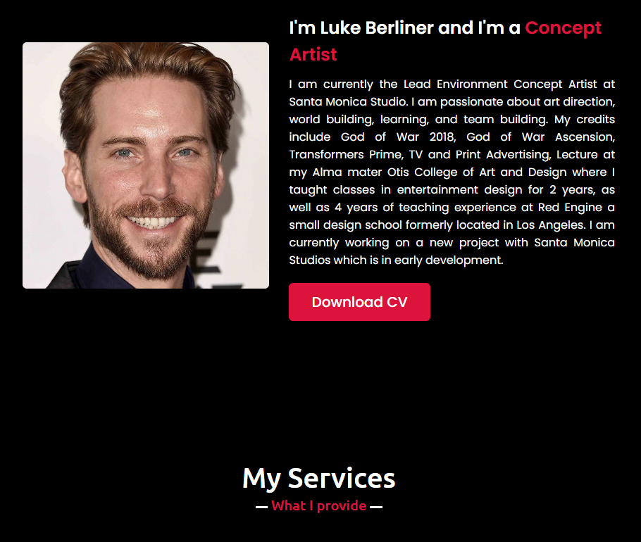On the page itself, the ‘About me’ and ‘services’ are merged to provide more content on one page. The text explains who Luke is, where he works, and his qualifications.

**My Services:** This relatively small section includes three text boxes describing Luke’s work in ‘Concept Art, Advertising, and Game Design’. The boxes are light grey, with the titles in bold ‘Ubuntu’ text. Above the titles are icons which transistion from crimson to white upon mouse hover. The boxes and text icons also scale up by 5% when the mouse is hovered over them. This is so its 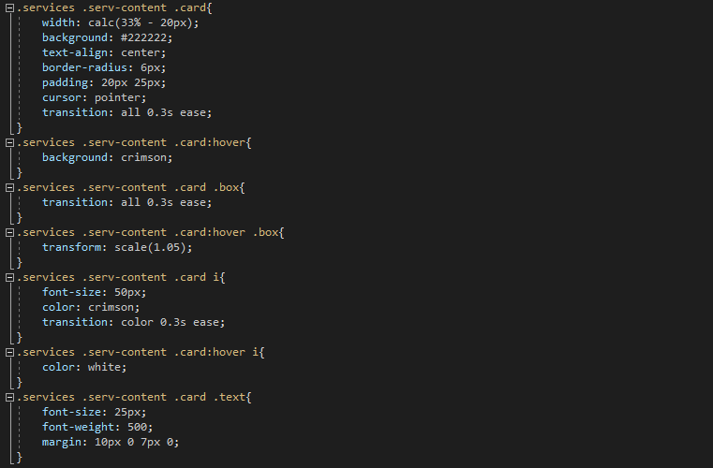easier to see the text. 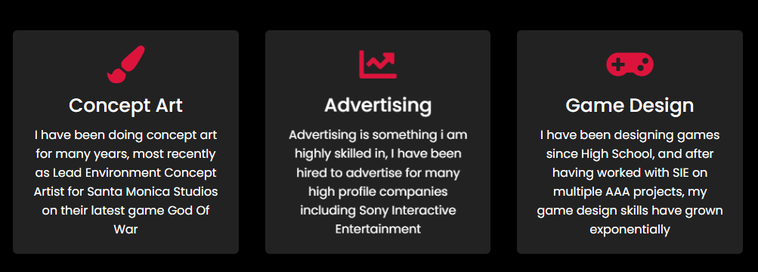

**My Work:** The my work section is all about showcasing Luke’s best work. The images are always ‘width: 100%’, so they’re always filling the page regardless of device size.

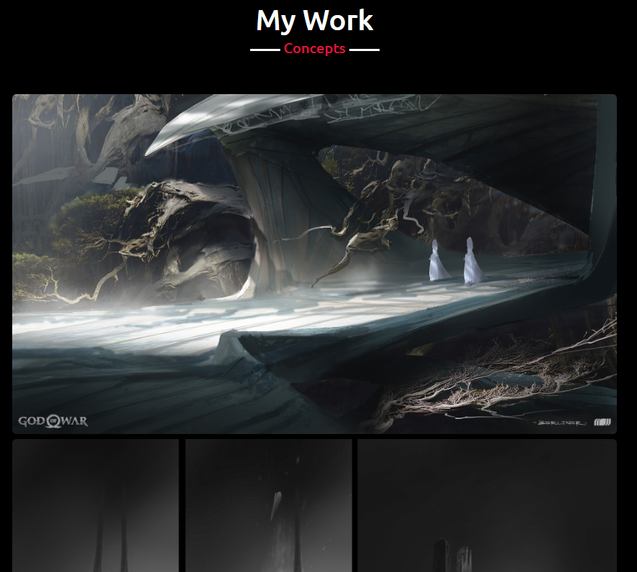The ‘View more’ button again is similar to the ‘Hire me’ button from the home page. There will be 4 images on this page, one after the other.

**Contact me:** This section has text on the left side and input boxes on the right, where the user can input ‘name’, ‘email’, ‘subject’, before ‘describing project’, with a ‘send message’ button at the bottom. The button will not work if the fields aren’t filled properly. 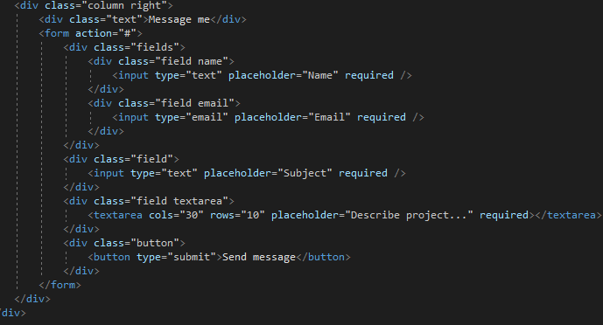

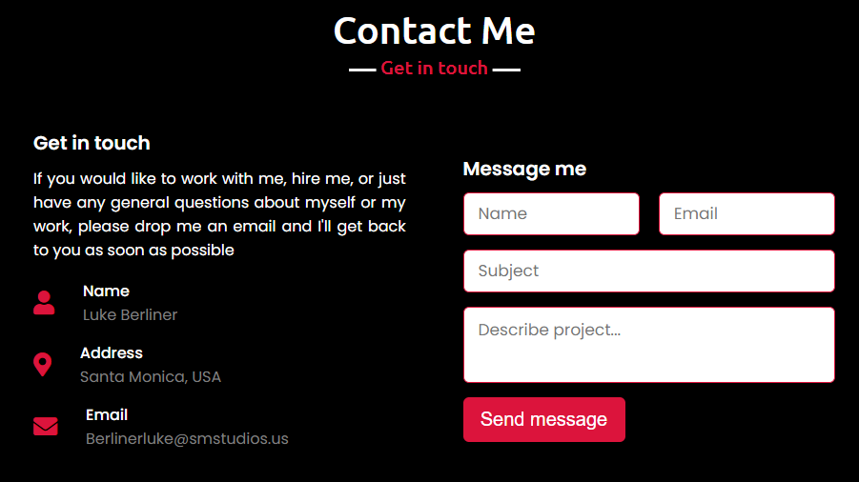Luke’s contact details are on the right hand side, alongside three icons. The text goes above the input boxes if the device width is too small.

**Navbar:** The navbar position is fixed and it has a z-index: 999 to ensure it is above all other elements. This is so users find it easy to navigate the website and prevent confusion. As the bar is scrolled down, the nemubar transistions from transparent to crimson, so it can easily be seen. 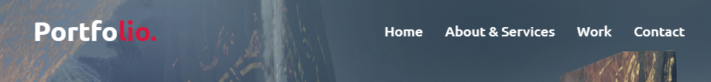

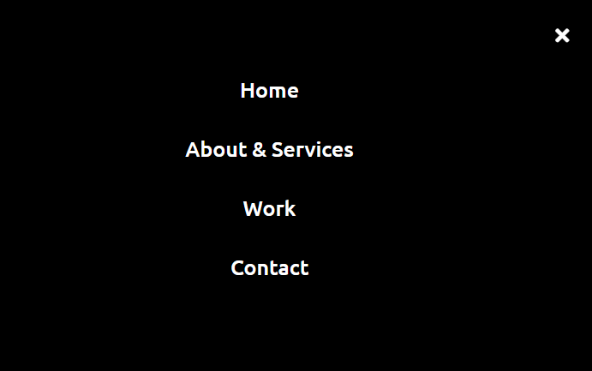Each navigation option takes the client to a different page. If the device width is too low, the navbar buttons are condensed into a single menu button which enables a black screen with the original options to appear vertically stacked instead of horizontally. 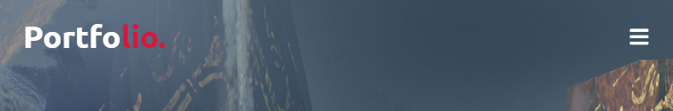

# Conclusion

This project has been a success, but there are many areas that can be improved upon. The layout of the site allows Luke’s work to be at the forefront. The consistent colour scheme and header and footer cause the portfolio to acquire a more professional look. Building upon this, the navbar helps users navigate the site easily. The site maintains its ease of navigation without sacrifices to quality for different devices. Limitations, however, do occur. The limited number of pages does not give users much information about Luke. Fixing this could include adding a bigger about section, with a possible expansion to include information about his time at Santa Monica Studios. The movement between web pages could be made smoother, this could be fixed by having a fade to/ from black transition. Overall, however, this project has passed most the specification points very well. For future editing, the CSS, HTML and JavaScript scripts are laid out very clearly, with sections clearly defined. Future additions could include game demos, more concept art, dynamic picture slideshows and other content like this.