
WEEK_03_REPORT
CYBERSECURITY IT PROJECT WEEK 3

22ND September 22, 2026
AZI JADA
COMPUTER SCIENCE, UNIVERSITY OF JOS.

Contents
TASK1: Workstation And Network Interface 2
TASK2: DNS Information 2
TASK 3: Connectivity Testing…………………………………………………..2
TASK 4: DNS Lookup… 3
TASK 5: Route Investigation…………………………………………………….4
TASK 6: Wireshark ICMP Capture 5
TASK 7: Wireshark DNS Capture 5
TASK 8: Network Diagram 6
SECURITY OBSERVATIONS AND REFLECTION 8
CONCLUSION 9

TASK1: WORKSTATION AND NETWORK INTERFACE
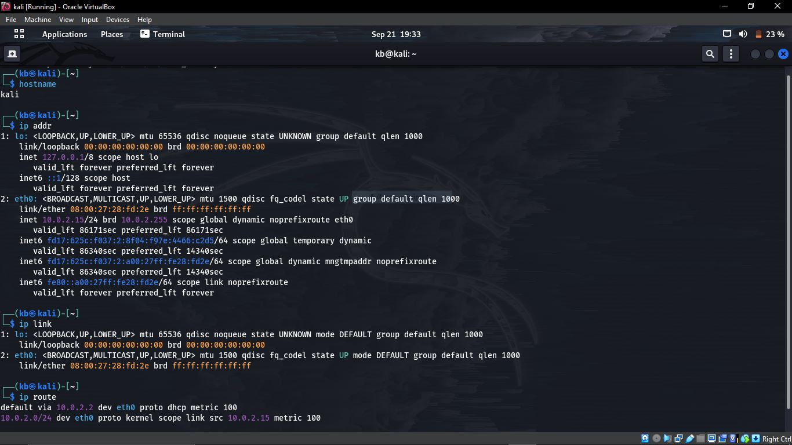
INFORMATION | WHERE TO FIND IT
Hostname | kali
Active network interface | 10.0.2.15 / 08:00:27:28:fd:2e
IPv4 address | 10.0.2.15
MAC address | 08:00:27:28:fd:2e
Default gateway | 10.0.2.2

TASK 2: DNS INFORMATION
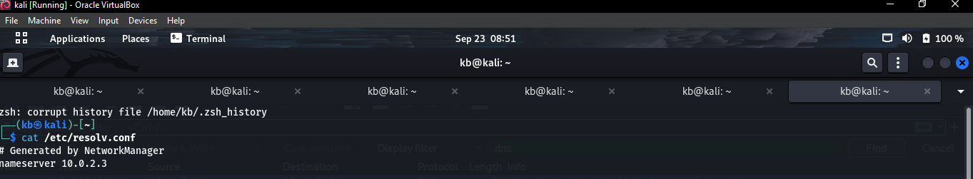
DNS server – nameserver 10.0.2.3

TASK 3: Connectivity Testing
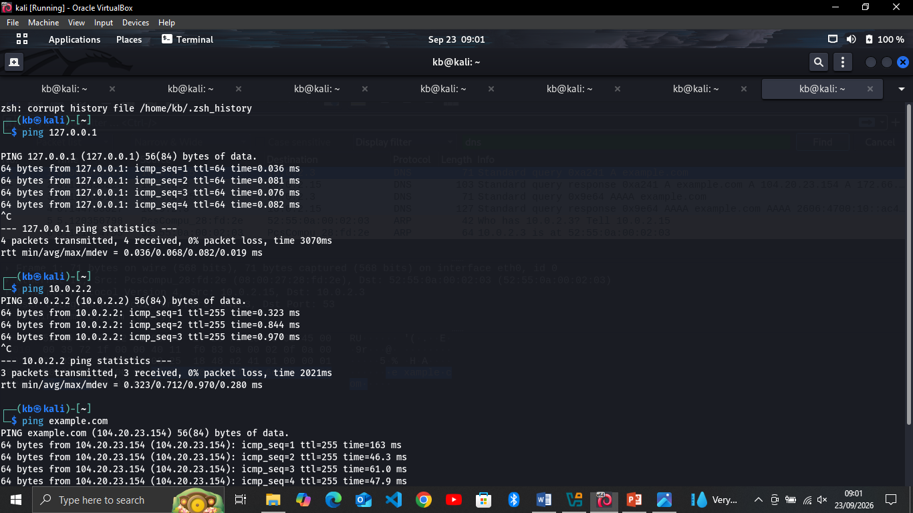
Destination | Replies | Meaning
127.0.0.1 | Yes | The work station can communicate with itself through LAN (Local Access Network).
10.0.2.2 | Yes | The work station can communicate with the local gateway
example.com | yes | It is placeholder web address, it can show a domain name without pointers to a real website.

TASK 4: DNS Lookup
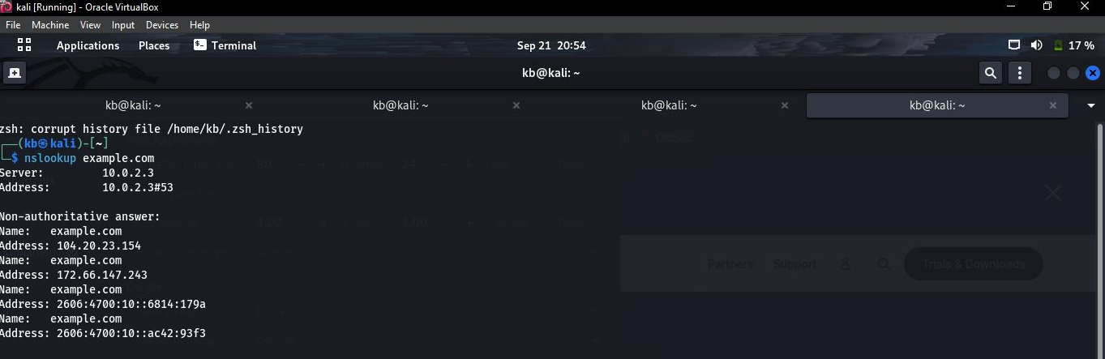
- Domain queried; example.com
- DNS server used, if visible; 10.0.2.3
- At least one IP address returned; 104.20.23.154

TASK 5: ROUTE INVESTIGATION
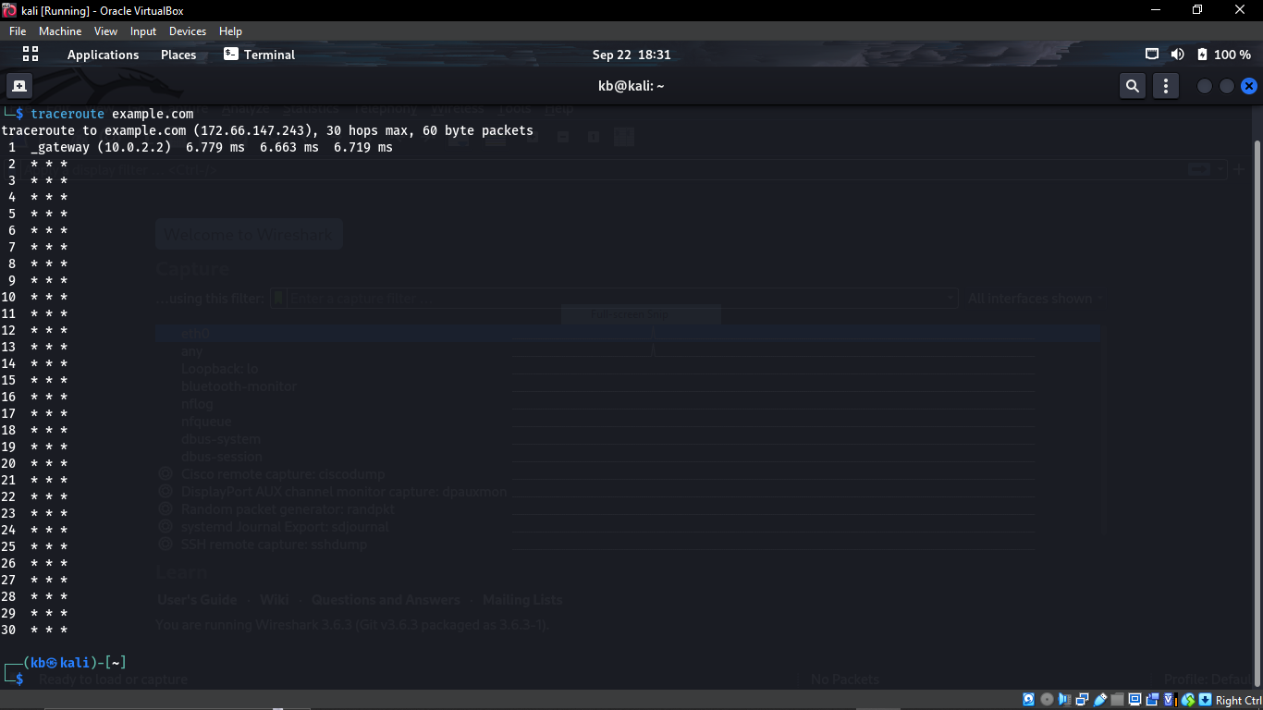
- Number of visible hops => 30
- What a hop represents – a hop represents a point / router along the network path between your computer and the destination. The project also notes that some hops may show timeouts and this is not automatically an error.

TASK 6: WIRESHARK ICMP CAPTURE
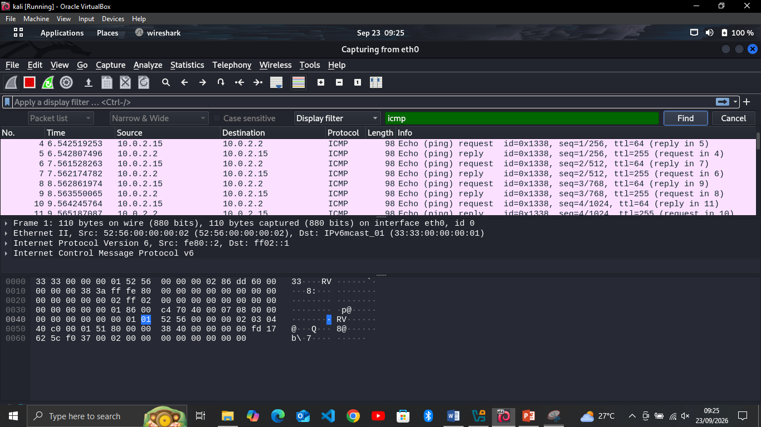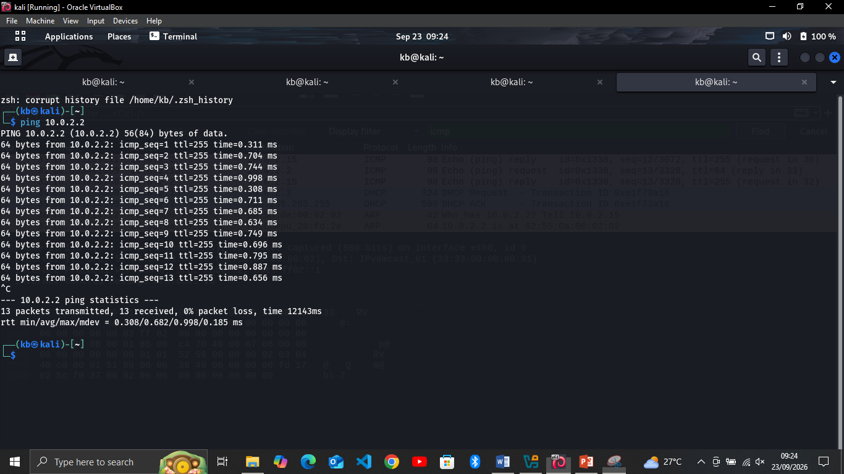
INFORMATION | ECHO REQUEST | ECHO REPLY
Packet number | 4 | 5
Source IP | 10.0.2.15 | 10.0.2.2
Destination IP | 10.0.2.2 | 10.0.2.15
Protocol | ICMP | ICMP
Type | Echo request | Echo reply

TASK 7: WIRESHARK DNS CAPTURE
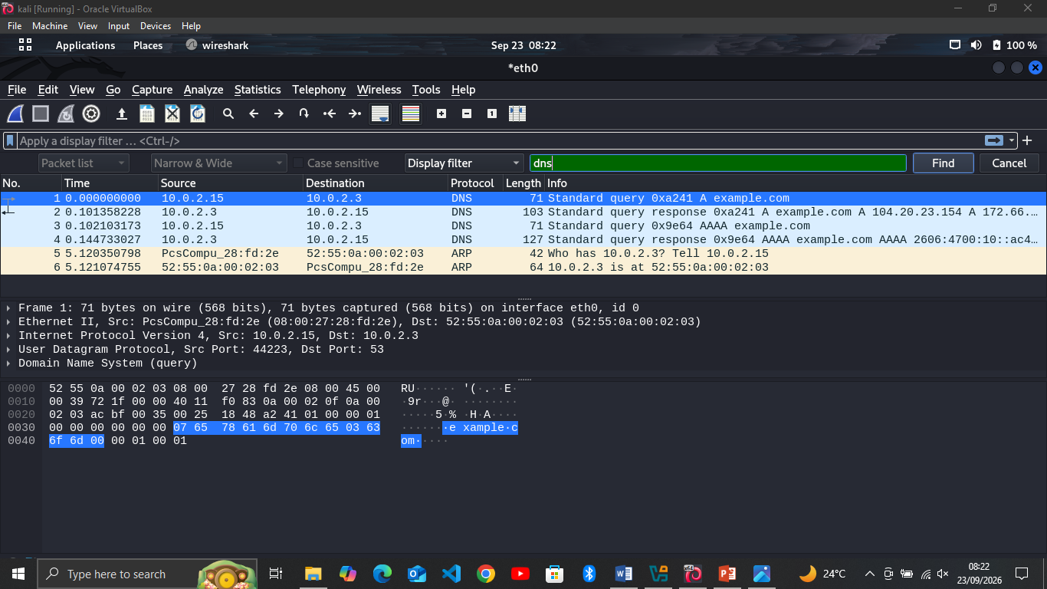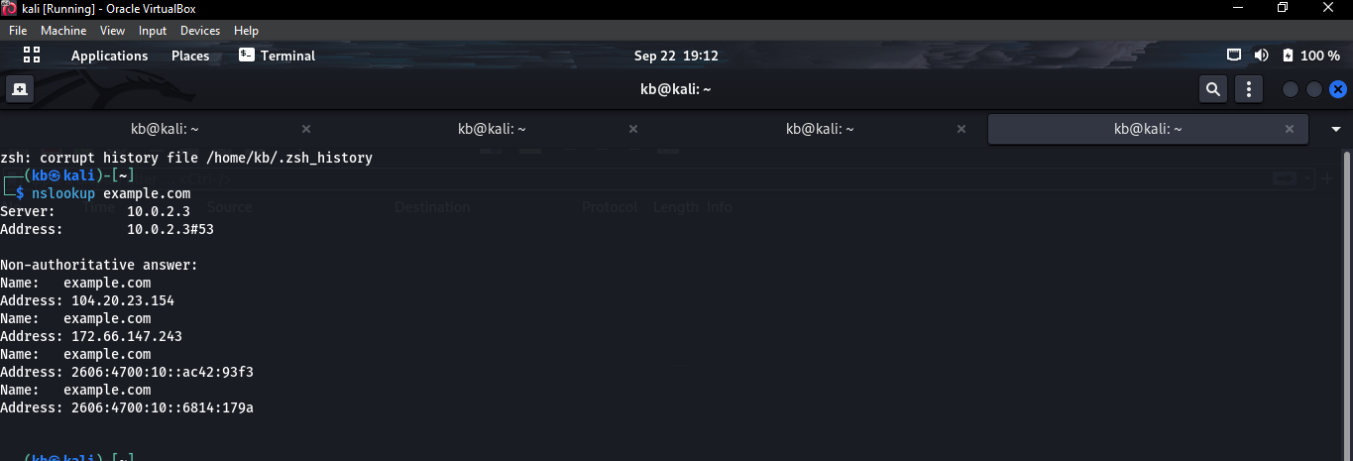
INFORMATION | RESULT
Source IP | 10.0.2.15
Destination IP | 10.0.2.3
Requested domain | example.com
Returned IP address | 104.20.23.154

Packets | Source IP | Destination IP | Protocol | Type
Packet X | 10.0.2.15 | 10.0.2.2 | ICMP | Echo (ping) request
Packet Y | 10.0.2.2 | 10.0.2.15 | ICMP | Echo (ping) reply
TASK 8: NETWORK DIAGRAM
My Workstation
10.0.2.15

Wi-Fi / Access Point / Switch

Router / Gateway
10.0.2.2

Internet
Remote Server

SECURITY OBSERVATIONS AND REFLECTION.
- PURPOSE OF IP ADDRESS =>The purpose of an IP address is for devices to locate and communicate with each other and helps network traffic reach the correct destination.
- DIFFERENCE BETWEEN AN IP ADDRESS AND MAC ADDRESS =>
IP ADDRESS | MAC ADDRESS
A logical network address used to identify a device on a network. | It is a physical / hardware address associated with network interface.
- PURPOSE OF DEFAULT GATEWAY => The default gateway is the device, usually a router, that forward traffic from a local network to other networks.
- FUNCTION OF DNS => DNS meaning Domain Name System. It translates human readable domain name into IP addresses, DNS helps the computer find IP address associated with that domain so it can communicate with the destination.
- REASON A FAILED PING CAN BE MISLEADING=> A failed ping does not always mean that the destination is offline, the destination or a firewall along the network path may block ICMP echo request or replies.
- INFORMATION DISPLAYED BY WIRESHARK DURING ICMP CAPTURE => During my ICMP capture, Wireshark showed ICMP echo request and echo reply packets generated by workstation. My actual capture response:
- Echo request packet number; 4
- Request source IP; 10.0.2.15
- Request destination IP; 10.0.2.2
- Echo reply packet number; 4
- Reply source IP; 10.0.2.2
- Reply destination IP;10.0.2.15
- OBSERVATION IN DNS QUERY AND DNS RESPONSE => During my DNS capture, I observed a DNS query from my workstation asking for the IP address of the domain I looked up. My actual capture details;
- Requested domain: example.com
- Query source IP: 10.0.2.15
- Query destination IP: 10.0.2.3
- Returned IP: 104.20.23.154
- REASON CYBERSECURITY ANALYSTS INSPECT NETWORK TRAFFIC => Cybersecurity analysts inspect network traffic to understand how devices communicate and to identify unusual or potentially suspicious activity. Network traffic analysis can help analysts detect security incidents, investigate attacks and understand how information moves across a network.
- REASON PACKET CAPTURE CAN BE PERFORMED ONLY ON AUTHORISED SYSTEM AND NETWORK => Packet capture should only be performed on authorized systems and network because network traffic may contain private or sensitive information. In this project, packet capture is limited to my own workstation.
10.MOST USEFUL NETWORKING CONCEPT=> The most useful networking concept I learned this week was how IP addresses, DNS and the default gateway work together. Understanding how these components work together makes it easier to understand how computers communicate over networks.

CONCLUSION.
In conclusion, operating my workstation / interface to check my IP addresses, MAC addresses, and also checking my default gate way and running Wireshark to check for ICMP packets and DNS query packets.
THANK YOU!!

