Network Reconnaissance Report.

Nmap scanning of a Metasploitable 2 target from Kali Linux
CYBERSECURITY IT REPORT WEEK 4

Item | Detail
Attacker / scanner | Kali Linux 2025.1c (VirtualBox, amd64), hostname kali
Target | Metasploitable 2, 192.168.56.102 (hostname metasploitable.localdomain)
Tool | Nmap 7.95
Environment | Isolated VirtualBox host-only lab network (192.168.56.0/24)

1. Purpose and Scope
This report documents the network reconnaissance steps performed from a Kali Linux virtual machine against a deliberately vulnerable Metasploitable 2 virtual machine. The goal was to practice host discovery, port scanning, service and version detection, and operating-system fingerprinting with Nmap, and to interpret what each scan reveals about the target’s attack surface. All activity took place inside a private, self-contained VirtualBox lab.

2. Summary of Commands Executed
The table below lists every command visible in the screenshots, in chronological order, with its purpose and outcome.
# | Command | Purpose | Outcome
1 | nmap 192.168.58.102 | Default TCP scan of the top 1,000 ports | Mistyped IP (.58 instead of .56). All 1,000 ports filtered; nothing useful returned (5.07 s).
2 | nmap -sV 192.168.56.102 | Service and version detection | 23 open ports with product and version strings (14.29 s).
3 | nmap -T4 192.168.56.102 | Fast scan using timing template 4 | Same 23 open ports, service names only (0.81 s).
4 | nmap -A 192.168.56.102 | Aggressive scan: OS detection, versions, default scripts, traceroute | Detailed service data, script output and OS guess (27.68 s).
5 | nmap -sn 192.168.56.102 | Ping scan (host discovery only, no port scan) | Host is up; MAC address identified (0.22 s).
6 | nmap -0 192.168.56.102 | Attempted OS detection | Failed: unrecognized option “-0” (zero instead of letter O).
7 | nmap -o 192.168.56.102 | Attempted OS detection | Failed: lowercase -o is the output-file flag, so the IP was consumed as a filename and no target was scanned.
8 | (hosts-style listing), then “ss” typed | Checking local name/address entries; starting another command | IPv6 loopback and host entries displayed; “ss” was still being typed when the screenshot was taken.

3. Detailed Walkthrough

3.1 Initial scan and a targeting mistake
nmap 192.168.58.102
The first scan used the default settings: a TCP SYN scan of the 1,000 most common ports. The address entered was 192.168.58.102. The target lives at 192.168.56.102. Nmap reported that all 1,000 ports were in an ignored state (filtered, no response), so no services were identified.
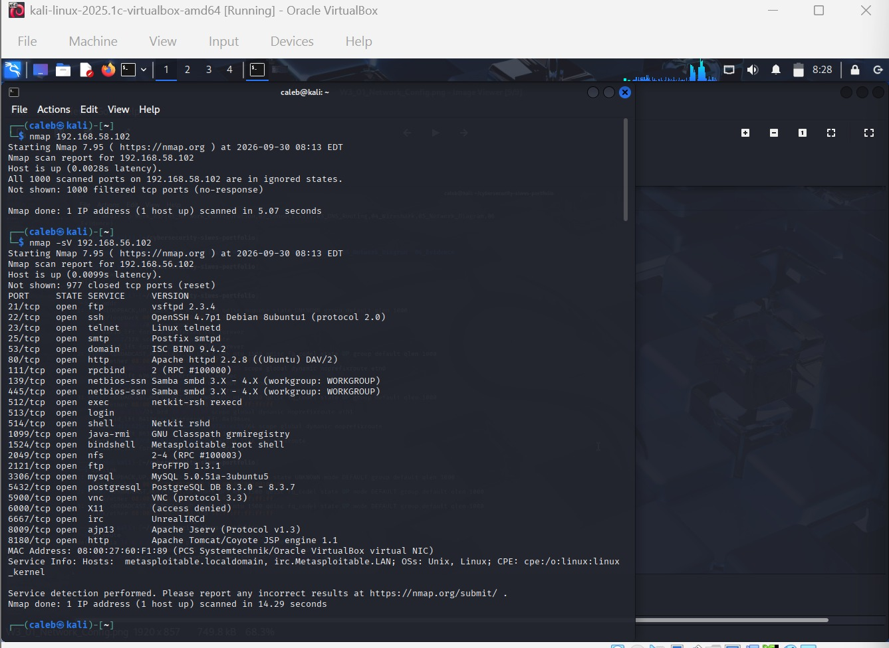
Figure 1: Initial scan of the IP (192.168.58.102) followed by the -sV scan of the target.

3.2 Service and version detection (-sV)
nmap -sV 192.168.56.102
After correcting the address, the scan was repeated with -sV, which probes each open port to determine the software and version listening on it. The host responded within about 10 ms, 977 ports were closed (reset), and 23 ports were open. The output identified products such as vsftpd 2.3.4, OpenSSH 4.7p1, Postfix, ISC BIND 9.4.2, Apache 2.2.8, Samba, MySQL 5.0.51a, PostgreSQL 8.3.x, UnrealIRCd and Apache Tomcat 5.5. It also reported a service named “bindshell” on port 1524, described as a Metasploitable root shell.
Nmap’s “Service Info” line confirmed the host names metasploitable.localdomain and irc.Metasploitable.LAN, and the operating-system family as Linux. The MAC address 08:00:27:60:F1:89 belongs to an Oracle VirtualBox virtual NIC, confirming the target is a VirtualBox guest.

3.3 Fast scan (-T4)
nmap -T4 192.168.56.102
The -T4 option selects the “aggressive” timing template, which shortens timeouts and retries. Because it performs no version probing, it finished in 0.81 seconds and listed the same 23 open ports using only the default service names from Nmap’s port table. This illustrates the trade-off between speed and detail: names derived from port numbers are guesses (for example, 2121 appears as “ccproxy-ftp” and 8180 as “unknown”), whereas -sV verified the real software.
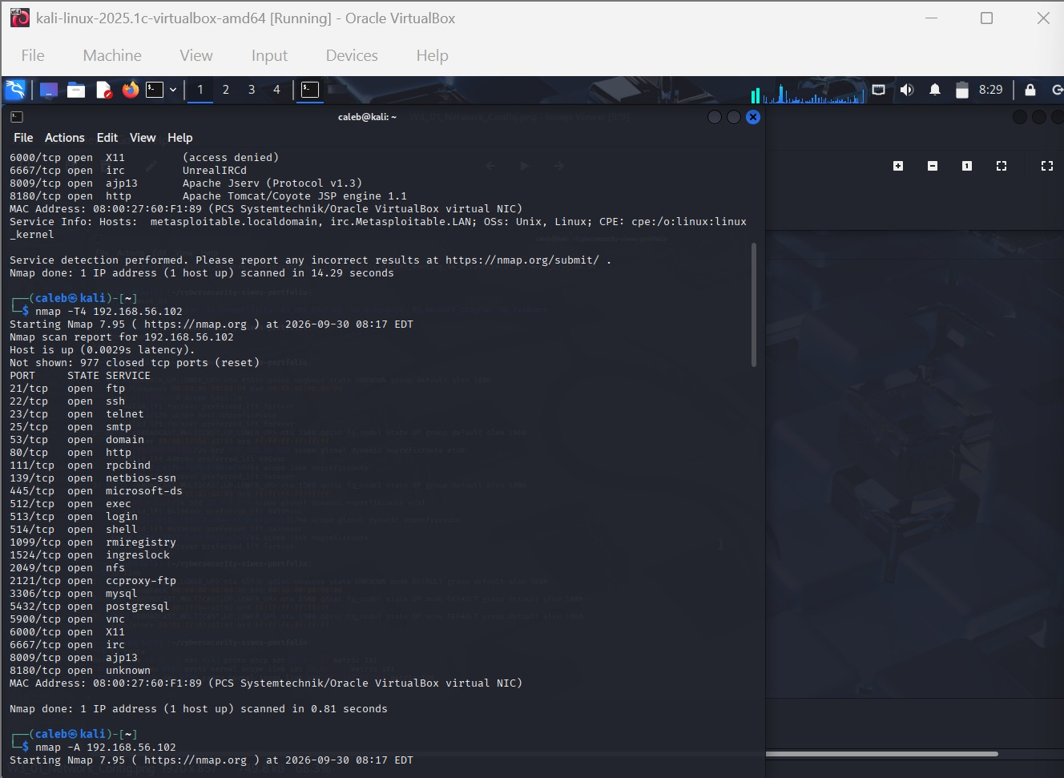
Figure 2: End of the -sV output, the -T4 fast scan results, and the start of the -A scan.

3.4 Aggressive scan (-A)
nmap -A 192.168.56.102
The -A option enables OS detection, version detection, default NSE scripts and traceroute in a single pass. It took 27.68 seconds and produced the richest data in the session. Key observations, by service:
- FTP (21): the ftp-anon script showed that anonymous login is permitted (code 230). The status output also showed the session originating from 192.168.56.101, which is the Kali machine, and that control and data connections are plain text.
- SSH (22): host keys were listed: a 1024-bit DSA key and a 2048-bit RSA key.
- SMTP (25): the server advertised VRFY (which can be used to enumerate users), STARTTLS and other extensions. Its certificate was issued for ubuntu804-base.localdomain and expired in April 2010. SSLv2 was supported along with weak ciphers such as RC4 and single-DES export-grade suites.
- DNS (53): BIND 9.4.2 disclosed its version through bind.version.
- HTTP (80): Apache 2.2.8 (Ubuntu) with DAV/2; the page title was “Metasploitable2 - Linux”.
- RPC (111): the rpcinfo script listed registered programs, including nfs (2049), mountd, nlockmgr and status, each with its port.
- SMB (139/445): Samba 3.0.20-Debian. Host scripts showed the guest account in use, challenge-response supported, and message signing disabled (“dangerous, but default”). NetBIOS name METASPLOITABLE and FQDN metasploitable.localdomain were recovered.
- Legacy r-services (512–514): rexecd, rlogin and rshd are all exposed.
- Java RMI (1099) and bind shell (1524): both reachable; port 1524 is labelled a root shell.
- MySQL (3306): version 5.0.51a-3ubuntu5, protocol 10, autocommit status, and the authentication salt were returned.
- PostgreSQL (5432): versions 8.3.0 to 8.3.7; the SSL certificate expired in 2010.
- VNC (5900): protocol 3.3 with VNC authentication (security type 2).
- X11 (6000): open but returned “access denied”.
- IRC (6667), AJP (8009), Tomcat (8180): UnrealIRCd, Apache Jserv 1.3 (the AJP method check failed to get a valid response), and Apache Tomcat/Coyote 1.1 with the title “Apache Tomcat/5.5”.
The OS fingerprint returned a general-purpose Linux 2.6.x kernel (2.6.9 to 2.6.33), one network hop away, with a round-trip time of roughly 2.6 ms. The host scripts also reported a clock skew of about one hour (mean 1h00m00s), with the system time recorded as 2026-09-30T08:18:05-04:00.
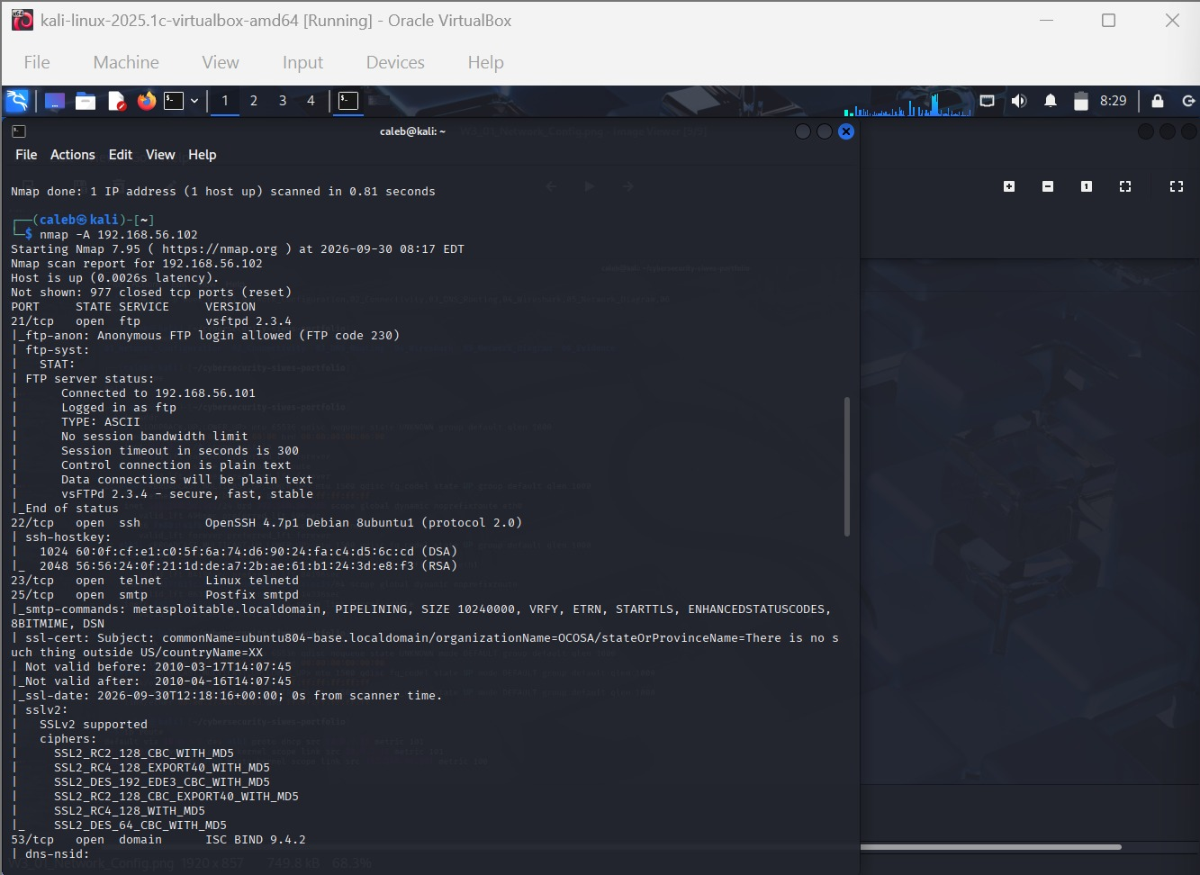
Figure 3: -A scan: anonymous FTP, SSH host keys, SMTP and SSLv2 details.
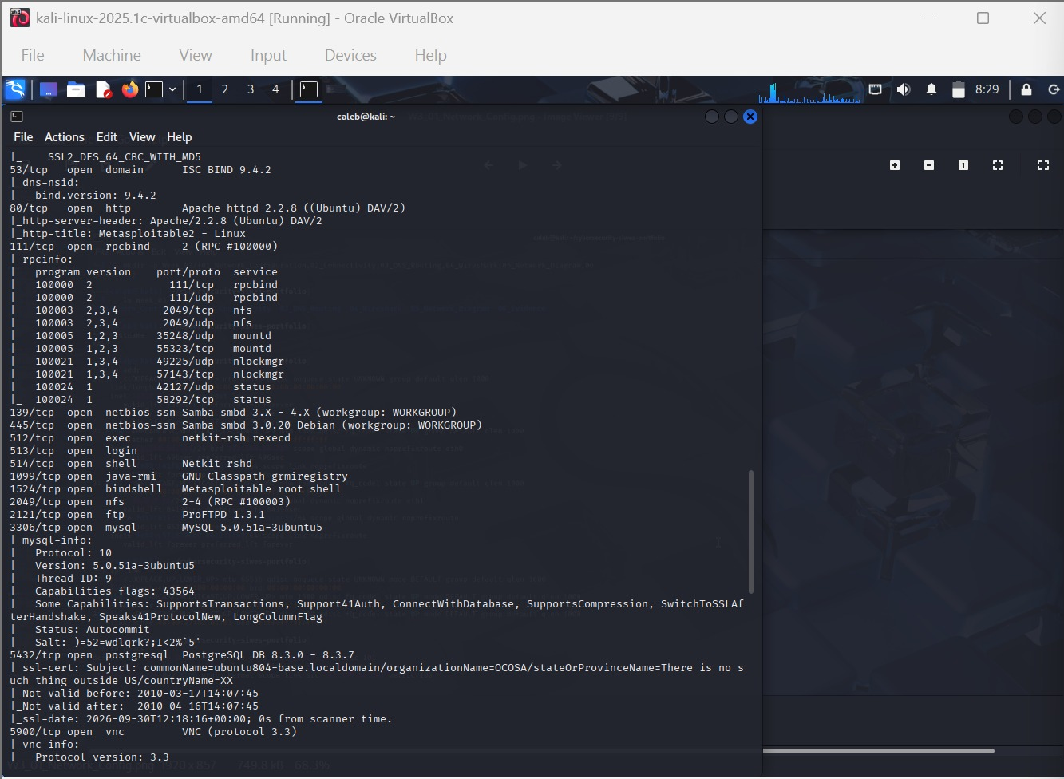
Figure 4: -A scan continued: DNS, HTTP, RPC, Samba, r-services, MySQL, PostgreSQL and VNC.
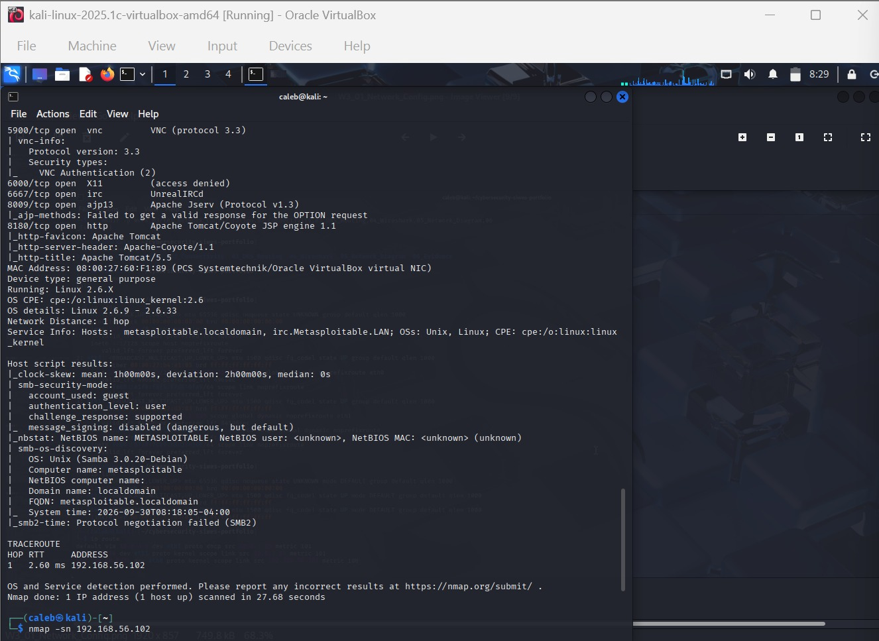
Figure 5: -A scan conclusion: VNC, X11, IRC, AJP, Tomcat, OS detection, SMB host scripts and traceroute.

3.5 Host discovery only (-sn)
nmap -sn 192.168.56.102
The -sn option (formerly “ping scan”) checks whether a host is alive without scanning any ports. It confirmed the host was up with 0.0078 s latency and displayed the MAC address, completing in 0.22 seconds. This is the quickest, least intrusive way to map which addresses on a network are occupied.

3.6Writing output to a file(-o)
nmap -o 192.168.56.102
Nmap accepted the flag but it has a different meaning: -o is a legacy shorthand for writing output to a file and requires a filename argument. Nmap consumed 192.168.56.102 as that filename, so no targets remained and it warned “No targets were specified, so 0 hosts scanned”. A file named after the IP address may therefore have been created in the working directory. The correct command is nmap -O 192.168.56.102 (capital O), or nmap -oN scan.txt 192.168.56.102 to save normal-format output.

3.7 Final steps
The last screenshot shows IPv6-related host entries ( ::1, ff02::1, ff02::2) alongside the local hostname “kali”, consistent with listing the local hosts file. The prompt then shows “ss” being typed, most likely the beginning of a socket-statistics command to inspect local network connections. No output from it is captured.
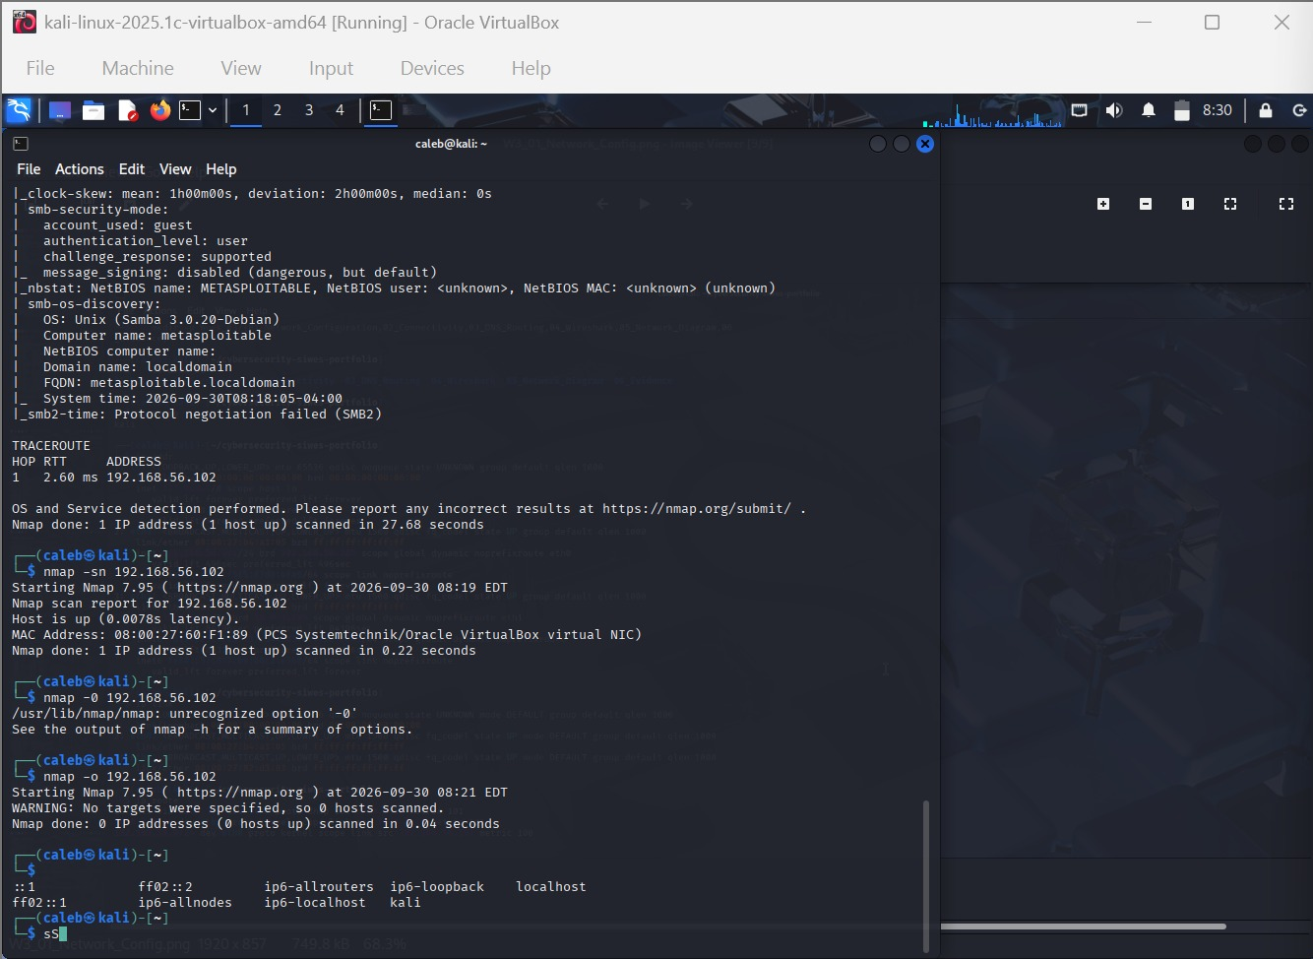
Figure 6: Ping scan, the two mistyped OS-detection commands, a local hosts listing, and a partly typed command.

4. Consolidated Open Ports
The following table merges the results of the -sV, -T4 and -A scans. All 23 ports were in the open state; the remaining 977 of the top 1,000 were closed.
Port | Service | Version | Notable detail
21/tcp | ftp | vsftpd 2.3.4 | Anonymous login allowed; plain-text control and data connections
22/tcp | Ssh | OpenSSH 4.7p1 Debian 8ubuntu1 (protocol 2.0) | DSA (1024) and RSA (2048) host keys reported
23/tcp | telnet | Linux telnetd | Unencrypted remote login
25/tcp | Smtp | Postfix smtpd | VRFY enabled; SSLv2 and weak export ciphers offered; certificate expired 2010
53/tcp | domain | ISC BIND 9.4.2 | bind.version disclosed
80/tcp | http | Apache httpd 2.2.8 (Ubuntu) DAV/2 | Page title "Metasploitable2 - Linux"
111/tcp | rpcbind | 2 (RPC #100000) | Exposes NFS, mountd, nlockmgr and status services
139/tcp | netbios-ssn | Samba smbd 3.X - 4.X | Workgroup: WORKGROUP
445/tcp | netbios-ssn | Samba smbd 3.0.20-Debian | Guest account; message signing disabled
512/tcp | Exec | netkit-rsh rexecd | Legacy r-service
513/tcp | Login | (not identified) | Legacy r-service
514/tcp | Shell | Netkit rshd | Legacy r-service
1099/tcp | java-rmi | GNU Classpath grmiregistry | Java RMI registry exposed
1524/tcp | bindshell | Metasploitable root shell | Bind shell listening on the network
2049/tcp | Nfs | 2-4 (RPC #100003) | Network file system
2121/tcp | ftp | ProFTPD 1.3.1 | Second FTP service (shown as ccproxy-ftp in -T4 scan)
3306/tcp | Mysql | MySQL 5.0.51a-3ubuntu5 | Handshake details and salt disclosed
5432/tcp | postgresql | PostgreSQL DB 8.3.0 - 8.3.7 | SSL certificate expired 2010
5900/tcp | Vnc | VNC (protocol 3.3) | VNC authentication (type 2)
6000/tcp | X11 | (access denied) | X server reachable but refusing access
6667/tcp | Irc | UnrealIRCd | IRC daemon
8009/tcp | ajp13 | Apache Jserv (Protocol v1.3) | AJP connector
8180/tcp | http | Apache Tomcat/Coyote JSP engine 1.1 | Tomcat 5.5

5. Key Findings
- Very large attack surface. 23 open ports, many running legacy or unencrypted protocols (telnet, rexec/rlogin/rsh, plain FTP, VNC).
- Outdated software. Versions such as vsftpd 2.3.4, OpenSSH 4.7, Apache 2.2.8, BIND 9.4.2, MySQL 5.0.51a, PostgreSQL 8.3, Samba 3.0.20 and Tomcat 5.5 are many years old and have numerous publicly documented vulnerabilities. vsftpd 2.3.4 and certain UnrealIRCd releases in particular are well known for having shipped with backdoors.
- Weak or missing authentication. Anonymous FTP is enabled, SMB uses a guest account with signing disabled, and port 1524 exposes a root shell without credentials.
- Weak cryptography. SSLv2 and export-grade ciphers are offered on SMTP, and TLS certificates on SMTP and PostgreSQL expired in 2010.
- Information disclosure. Banners, BIND version, SMTP VRFY, RPC service listings, NetBIOS names, and the MySQL salt all give an attacker useful detail.

6. Lessons Learned
- Always double-check the target IP before scanning; a single mistyped octet produced a misleading “all filtered” result.
- Flag case matters in Nmap: -O (OS detection) is not -o (output file) and neither is -0.
- Choose the scan to fit the goal: -sn to find hosts, -T4 for a quick port overview, -sV for accurate service identification, and -A when a full profile is needed.
- Save output with -oN, -oX or -oA so results can be referenced and compared later.

7. Recommendations (If This Were a Production System)
- Disable or remove unneeded services (telnet, r-services, bind shell, unused databases and RPC/NFS) and firewall everything that must remain.
- Patch or replace all outdated software and upgrade to supported operating-system releases.
- Disable anonymous FTP and guest SMB access, enable SMB signing, and require strong authentication everywhere.
- Replace SSLv2 and weak ciphers with TLS 1.2 or higher and renew expired certificates.
- Reduce banner and version disclosure, disable SMTP VRFY, and restrict database and VNC access to trusted hosts.
- Run regular authenticated vulnerability scans and monitor for unexpected open ports.

8. Conclusion
Across roughly seventeen minutes, the Kali VM was used to discover, enumerate and fingerprint the Metasploitable 2 target using a progression of Nmap scans. The work shows how increasing scan depth trades speed for detail, and it exposes a wide array of misconfigured and outdated services that are typical of an intentionally vulnerable training machine. The mistyped IP and mistyped flags were minor setbacks that reinforced good scanning habits. The next logical steps in a lab exercise would be to research the identified versions for known vulnerabilities and to practise safe exploitation and remediation within the same isolated environment.

