
WEEK_02_REPORT
CYBERSECURITY IT PROJECT WEEK 2.

17th September, 2026
Azi Jada
COMPUTER SCIENCE, UNIVERSITY OF JOS

Contents
TASK1: System Information 2
TASK2: File and directory management 3
TASK 3: User, groups and permissions 4
TASK 4: Process investigation 4
TASK 5: Service investigation 5
TASK 6: Environment variables 6
TASK 7: Filesystem and logs 7
TASK 8: Search and Text inspection 7
SECURITY OBSERVATIONS AND REFLECTION 8
CONCLUSION 9

TASK1: System Information
- Username - kb
- Computer name - kali
- Current directory - /home/kb
- Linux version – 2022.2
- Home directory - /home/kb
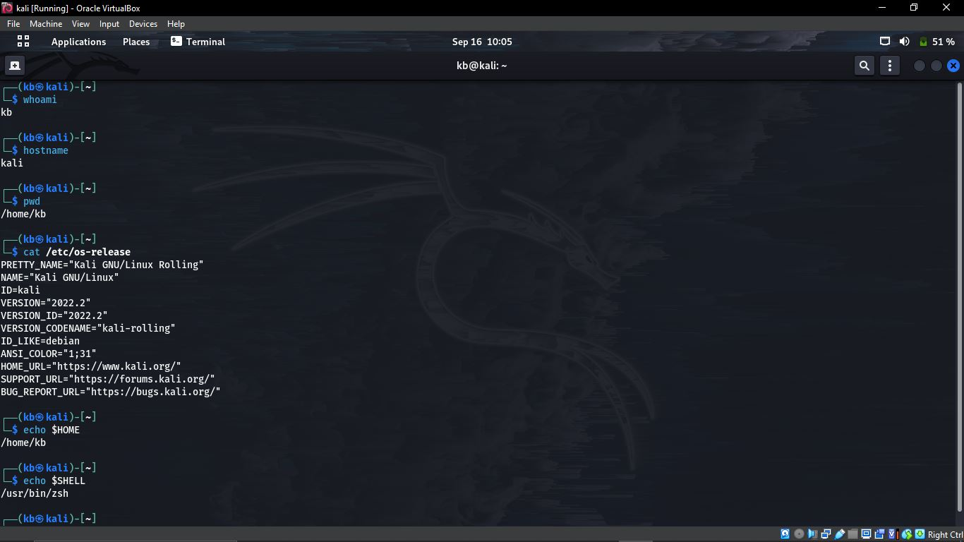

TASK2: File and directory management 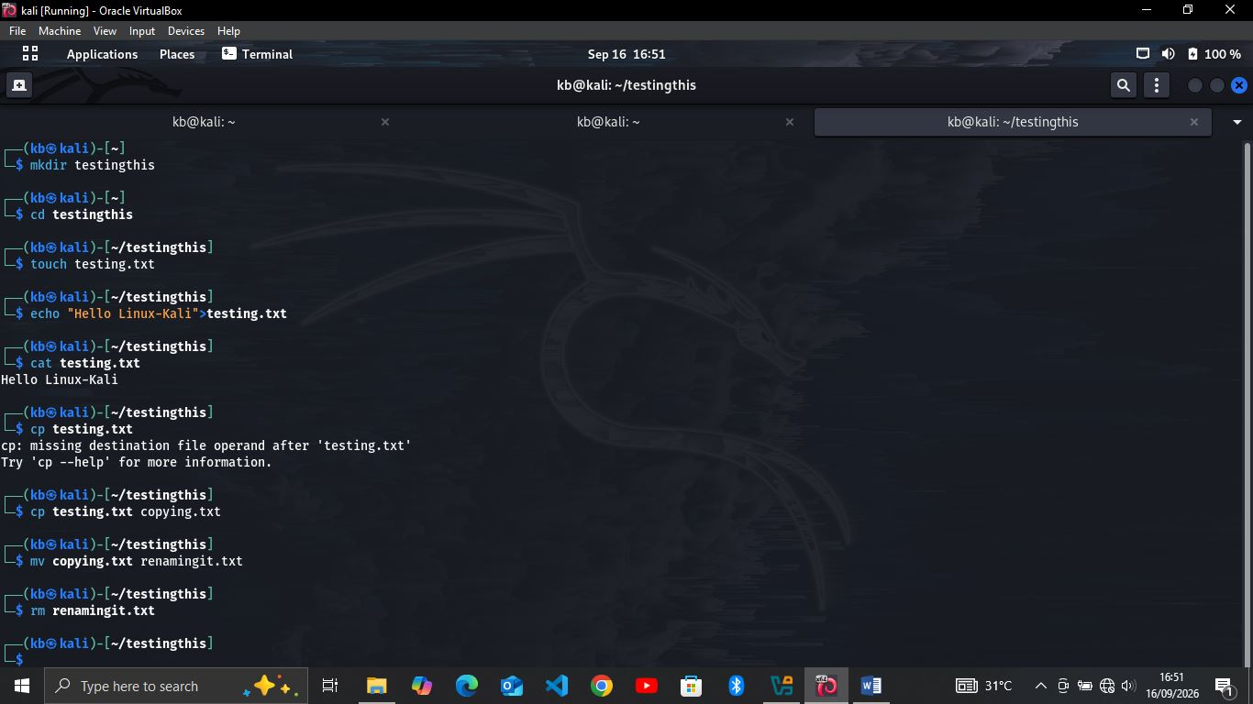
The above demonstrates how I created and managed a file and directories from the terminal. The image below shows an extensive use the commands given in the project;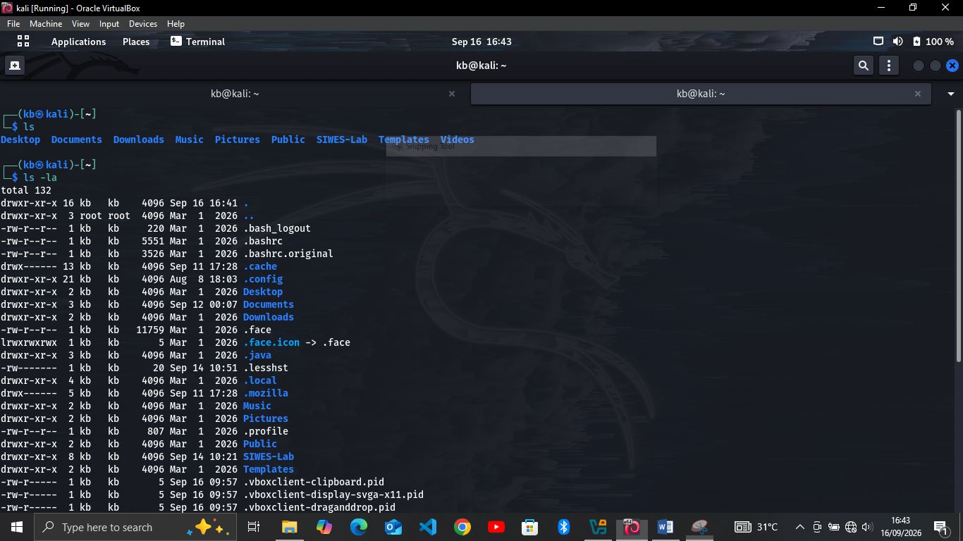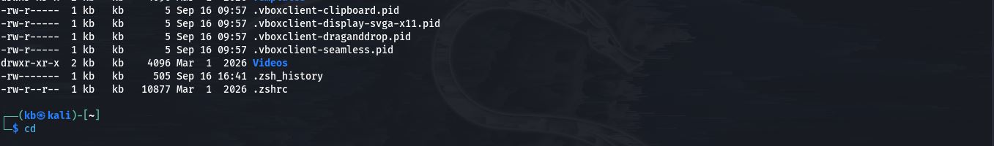

TASK 3: User, groups and permissions
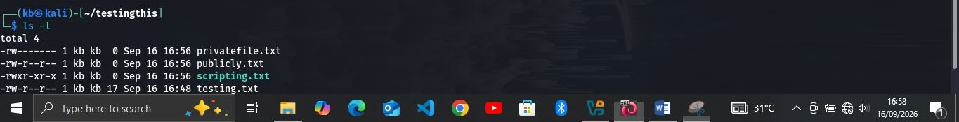
- What does 644 mean? => It simply means the owner can read (r) and write (w), while everyone else will only read. (so publicly.txt is restricting everyone from writing but they are allowed to read).
- What does 600 mean? => It simply means the owner can read (r) and write (w), while everyone else sees or does nothing. (so privatefile.txt is more restricted).
- What does 755 mean? => It simply allows the owner to read, write and execute while everyone else reads and execute.

TASK 4: Process investigation
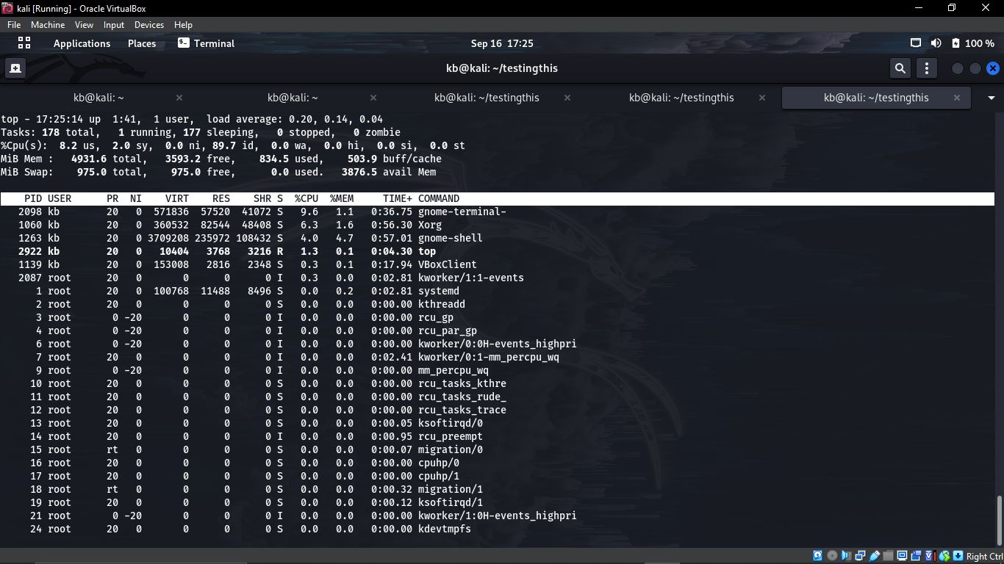
Owner | PID (Process ID) | Process Name
Kb | 2922 | Top
Kb | 2098 | gnome-terminal-
Root | 1 | System
Kb | 1139 | VBoxClient
Kb | 1263 | gnome-shell

Explaining

TASK 5: Service investigation
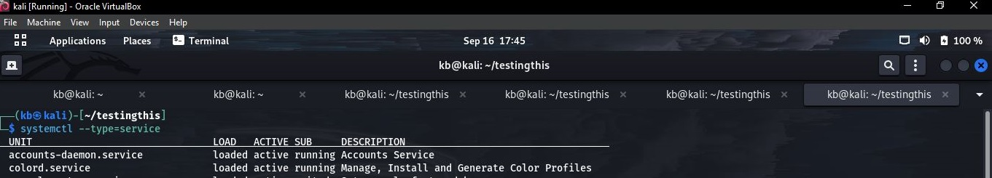
Service Name | What It Does | Whether You Think It Communicates Over The Network
account-daemon.service | Account service | It does
colord.service | Manage, install and generate color profile | It does not
cron.service | Regular background program processing daemon | It does not

TASK 6: Environment variables
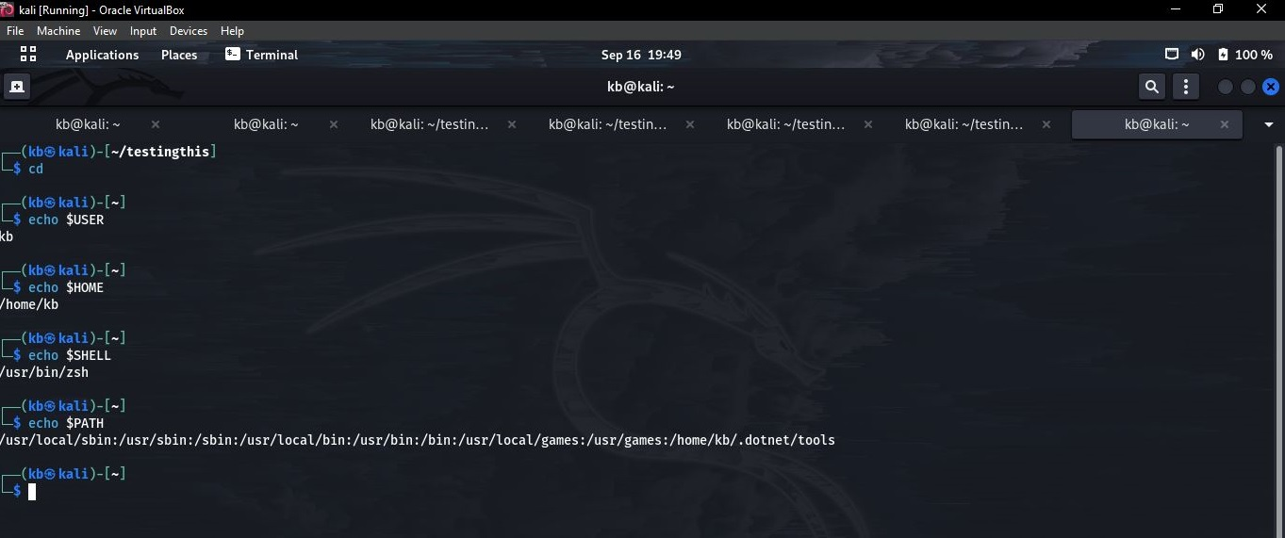
- USER => It is the user name.
- HOME =>It is your home directory.
- SHELL => Your shell.
- PATH => the locations Linux searches when you type commands.

TASK 7: Filesystem and logs

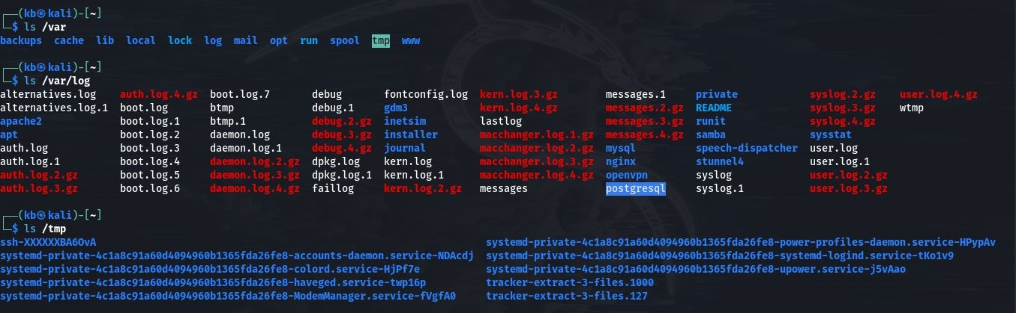
- /home – This is the location of the user’s personal folders.
- /etc – This is the system configuration files.
- /var – this is for the variable or changing system data
- /var/log – This helps you check or go through the system or application logs
- /tmp – This shows the temporary files
- /usr – Many user programs and system resources
- /proc – Information about running processes and the system.

TASK 8: Search and Text inspection
Below is the demonstration of the search and inspect a text in Linux:

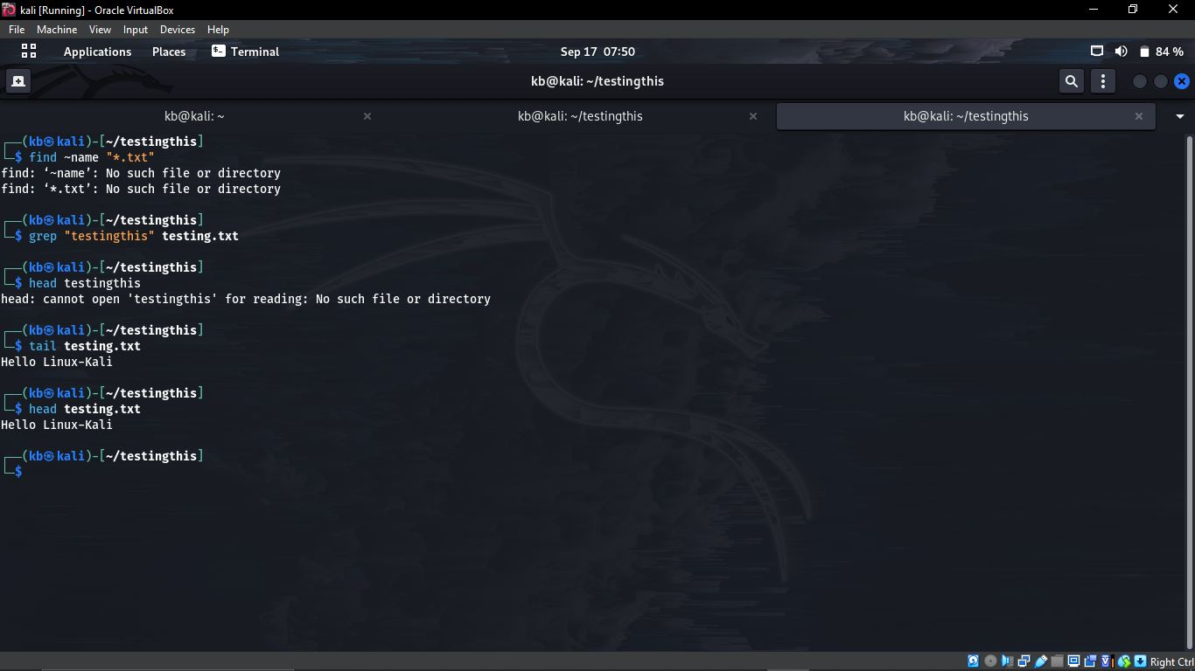

SECURITY OBSERVATIONS AND REFLECTION
- WHY IS LEAST PRIVILEGE IMPORTANT? => it is important because users should only have permissions to what they need, for example, a janitor, a receptionist and an administrator all use a certain system, the janitor has no business with the registry of guest and scheduling of appointment hence does not need to have access to the receptionist, likewise the receptionist to the administrator, the receptionist has no business with anything the admin does.

- WHY IS USING ROOT/ADMINISTRATOR FOR ORDINARY WORK RISKY? =>The root or administrator is risky to use for ordinary work because it has very high privileges, it can grant access to any program. A mistake or malware that is granted into the system can cause severe damage to the system.

- WHY ARE FILE PERMISSIONS IMPORTANT? => File permissions are important because they can control who can read, modify or execute files and help protect information. Basically, they make sure that the file is not tampered with and reaches user to user without being altered.

- WHY INSPECT RUNNING PROCESSES? => We inspect running processes so that we know and understand what is currently running (system programs) and potentially identifying unusual or suspicious activity(malware) so it be removed, deleted or ended.

- HOW CAN UNNECESSARY SERVICES INCREASE ATTACK SURFACE? => Unnecessary services increase the attack surface because every unnecessary service can provide another possible entry point for an attacker. Services that are not necessary for the system to function can be another way for an attacker to send malware or invade the system.

- WHY ARE LOGS USEFUL? => Log are useful because they keep system records and application activities, which can help security analysts monitor events and investigate incidents. Any ethical hacker who does not want their activity to be seen will have to delete or remove the logs.

WHICH LINUX COMMAND DID YOU FIND USEFUL AND WHY? => I found the chmod command to be the most helpful, That is chmod 644 showing that a file can be read and write for the owner (in this case me) while everyone else reads only that is it is seen by the public, chomd 600 showing that the owner can read and write while everyone else sees nothing because it converts your file to a private meaning everyone else will see nothing, and chmod 755 showing that the owner can read, edit or write and execute, while everyone else can read that is, see it and also execute it as well.

CONCLUSION
This week’s project has helped me understand and practice what I have learnt so far. I have learnt who I am in my Linux operating system, my hostname and my version. I also learnt how to access my files, how to make a new one, how to delete them, how to make them executable, readable and private on my Linux terminal.
I have learnt how to investigate processes to each for unusual programs running, I learnt to investigate my services as well. I got familiar with the environment variables and how to navigate through Linux directories
I learnt how to find and search for texts using the files that we made ourselves.

THANK YOU!

