
NETWORK RECONNAISSANCE REPORT.
Nmap scanning of a Metasploitable 2 target from kali linux.

2nd October 7, 2026
cybersecurity it report.
WEEK 4.

Items used. | Details.
Attacker/scanner | Kali Linux (VirtualBox, amd64)
Target | Metasploitable 2;192.168.56.102 (hostname metasploitable local domain
Tool | Nmap
Environment | Isolated VirtualBox host-only lab network (192.168.56.0/24

TABLE OF CONTENT

- PURPOSE AND SCOPE.
The report documents the network reconnaissance steps performed from a kali linux virtual machine against a deliberately vulnerable metasploitable 2 virtual machine. The goal was to practice host discovery, port scanning, service and version detection, and operating-system fingerprinting with Nmap, and to interpret what each scan reveals about the target’s attack surface. All activity took place inside a private, self-contained VirtualBox lab.
- COMMANDS EXECUTED.
s/n | COMMAND | PURPOSE | OUTCOME
1 | nmap 192.168.58.102 | The host was up. | To check if the host was active, which it was.
2 | nmap -sV 192.168.56.102 | Service and version detection. | 23 open ports with product and version strings (14.29s  ).
3 | nmap -T4 192.168.56.102 | Fast scan using timing template 4 | Same 23 open ports, service names only (0.81s).
4 | nmap -A 192.168.56.102 | Aggressive scan: OS detection, versions, default scripts, traceroute. | Detailed service data, script output and OS guess(27.68s).
5 | nmap -sn 192.168.56.102 | Ping scan (host discovery only, no port scan  ). | Host is up; MAC address identified(0.22s).
6 | nmap -o 192.168. | Attempted OS detection | Writing output to a file and requires a filename argument.
7 | Hosts-style listing, then “ss” typed | Checking local name/address entries; starting another command | IPV6 loopback and host entries displayed; “ss” was still being typed when the screenshot was taken.

- DETAILED WALKTHROUGH.

- Initial scan and a targeting mistake.
Nmap 192.168.58.102
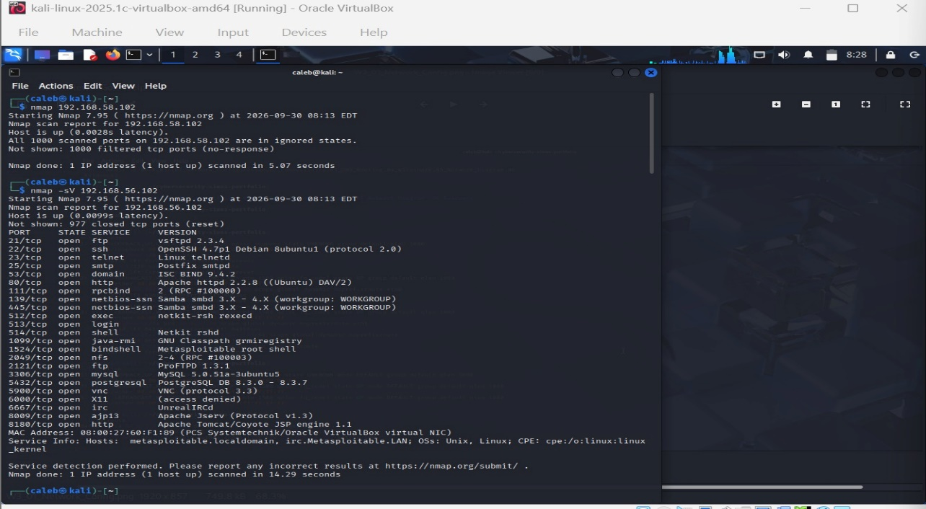
The first scan used was the default settings, a TCP SYN scan pf the 1000 most common ports. The address entered was 192.168.58.102, checking if the host was active, which it was. nmap reported that all 1,000 ports were in an ignored state (filtered, no response).

Figure 1: initial scan of the IP (192.168.58.102) checking if the host is up, followed by the -sV scan of the target.
- Service and version detection(-sV).
nmap -sV 192.168.56.102
As the image above illustrates, the scan with the address (192.168.56.102) is done using the nmap command -sV which probes each open port to determine the software and version listening on it. The host responded, 977 ports were closed (reset), and 23 ports s were open. The output identified products such as vsftpd 2.3.4, OpenSSH 4.7P1, Postfix, ISC BIND 9.4.2 and so on. It also reported a service named bindshell on port 1524, described as a metasploitable root shell.
Nmap’s “Service Info” line confirmed the host names metasploitable.localdomain and irc.Metasploitable.LAN, and the operating-system family as Linux.
The MAC address 08:00:27:60:F1:89 belongs to an Oracle VirtualBox virtual NIC, confirming the target is a VirtualBox guest.
- Fast scan (-T4)
nmap -T4 192.158.56.102
The -T4 option selects the “aggressive’ timing template, which shortens timeouts and retries. It performs no version probing, it finished in 0.81 seconds and listed the same 23 open ports using only the default service names from nmap’s port table.
It illustrates the trade-0pff between speed and detail: names derived from port numbers are guesses. The -sV verified the real software.
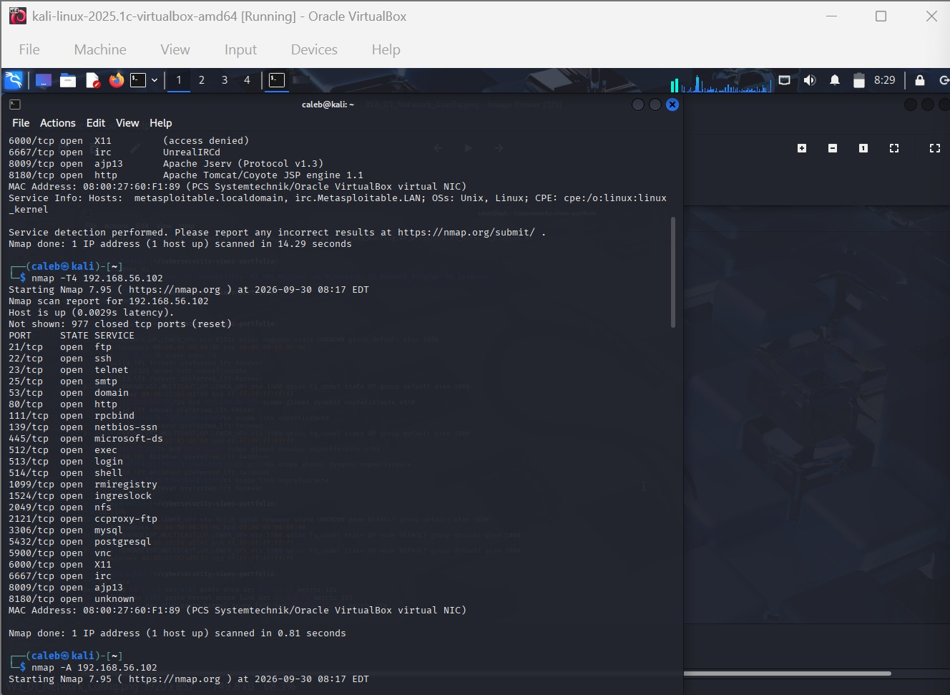
Figures 2: end of the -sV output, -T4 fast scan results, and the start of the -A scan.
- Aggressive scan (-A)
nmap -A 192.168.56.102
The -A option enables OS detection, version detection, default NSE scripts and traceroute in a single pass. It took 27.68 seconds.
The OS fingerprint returned a general-purpose Linux kernel, one network hop away, with a round-trip time of roughly 2.6ms. The host scripts also reported a clock skew of about one hour (mean 1h00m00s), with the system time recorded as 2026-09-30T08:18:05-04:00.
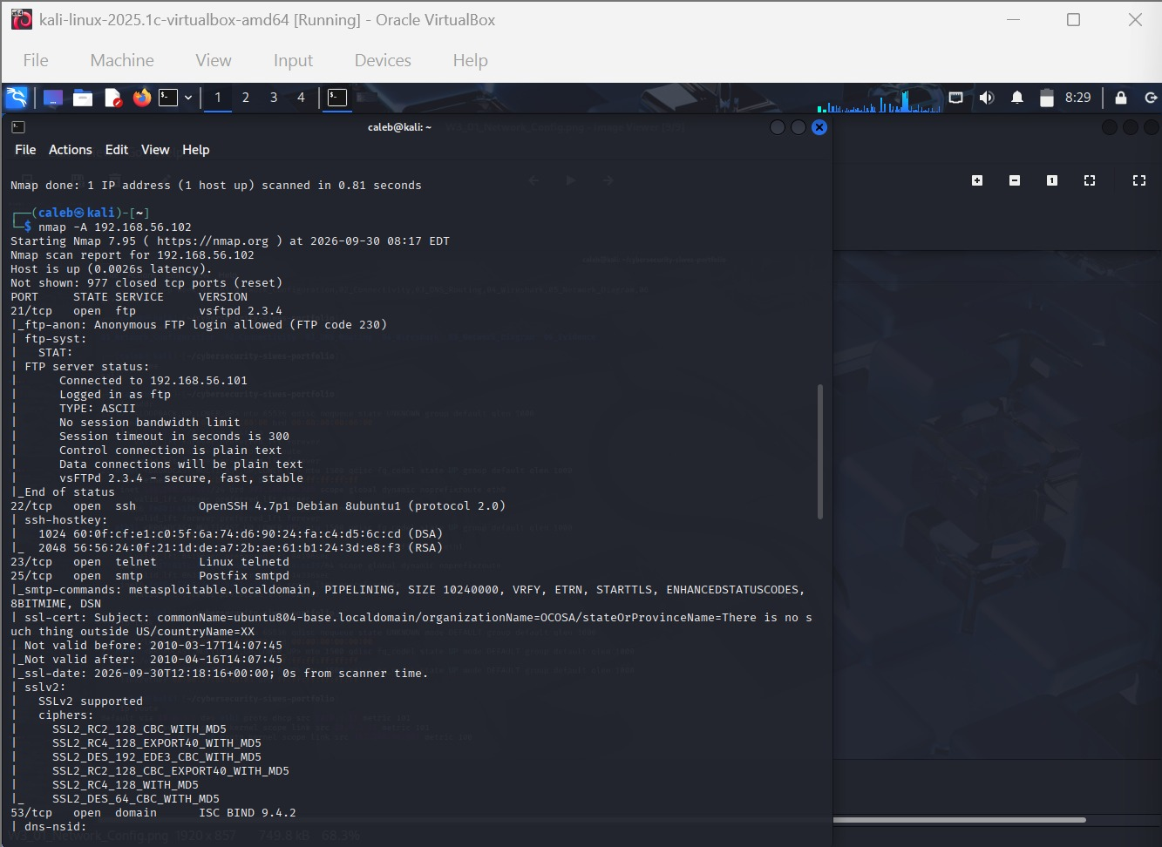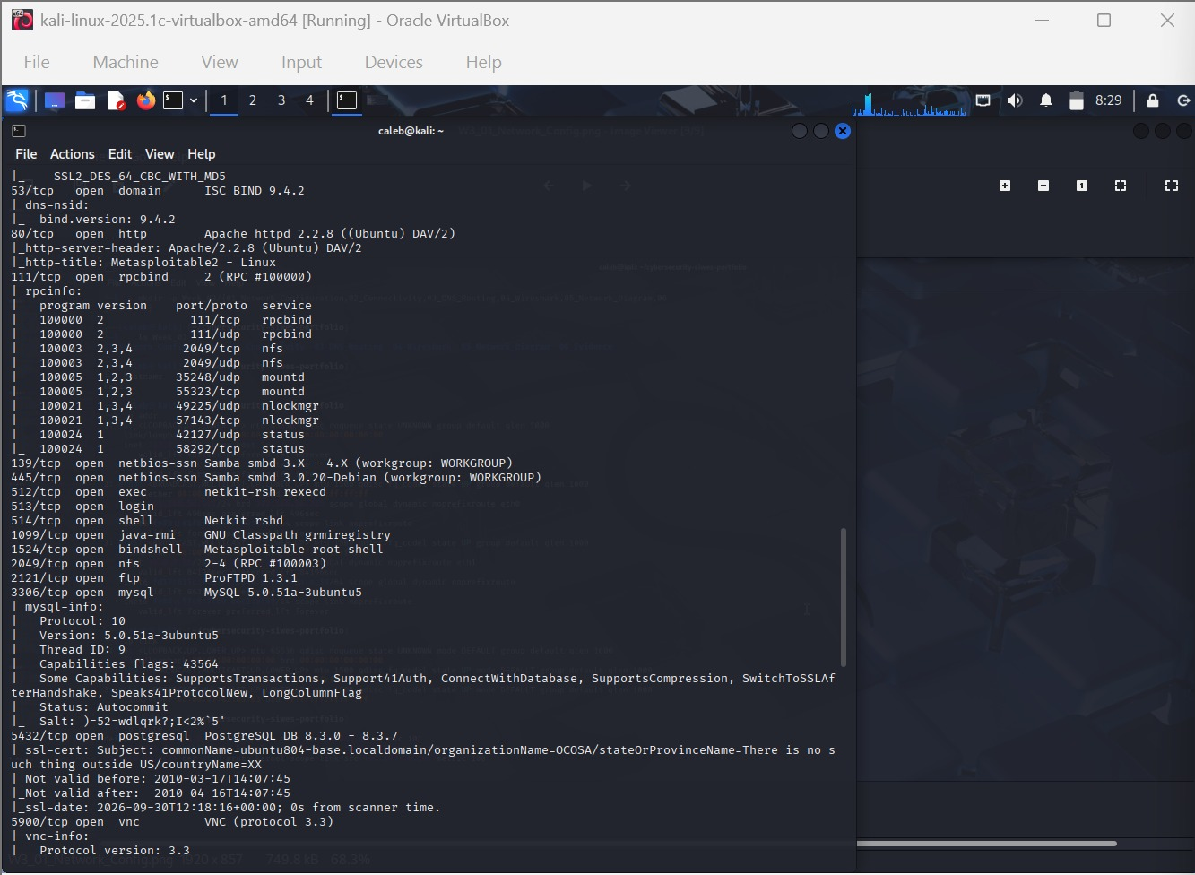
Figure 3: -A scan: anonymous FTP, SSH host keys, SMTP and SSLv2 details.
Figure 4: -A scan continued; DNS, HTTP, RPC, Samba, r-services, MySQL, PostgreSQL and VNC.

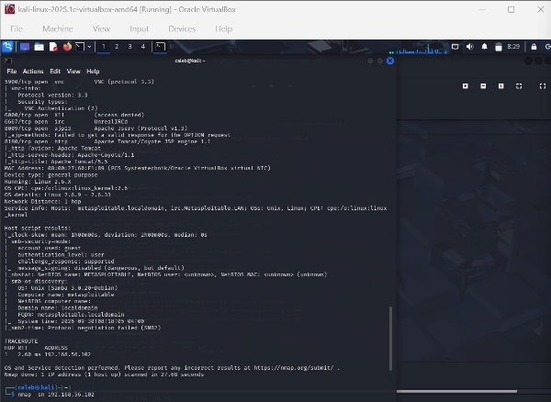
Figure 5: -A scan conclusion; VNC, X11, IRC, AJP, Tomcat, OS detection, SMB host scripts and traceroute.

- Host discovery only (-sn)
nmap -sn 192.168.56.102
The -sn option (formerly known as ping scan) checks whether a host is alive without scanning any ports. It confirmed the host was up with 0.0078 seconds latency and displayed the MAC address, completing in 0.22 seconds. This is the quickest, least intrusive way to map which addresses o a network are occupied.

- Writing output to a file (-O)
nmap -O 192.168.56.102
Nmap accepted the flag but it has a different meaning: -O is a legacy shorthand for writing output to a file and requires a filename argument. Nmap consumed 192.168.56.102 as that filename, so no targets remained.
A file named after the IP address may therefore have been created in the working directory.

- Final steps
The last screenshot shows IPv6 related host entries (::1, ff02::1, ff02::2) alongside the local hostname “kali”, consistent with listing the local hosts file. The prompt then shows “ss” being typed, mostly the beginning of a socket-statistics command to inspect local network connections, No output from in is captured.
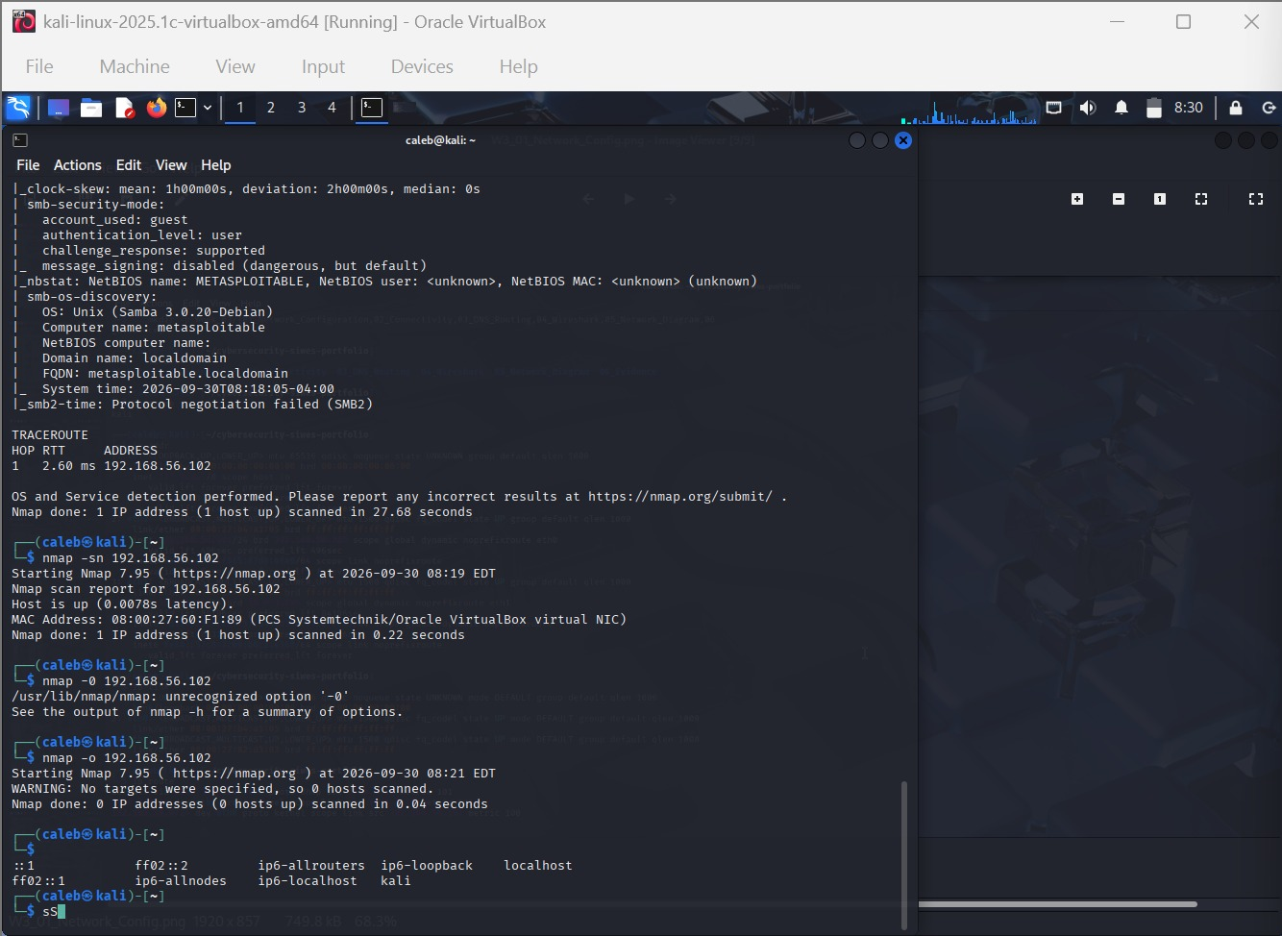
Figure 6: ping scan, the two mistyped OS- detection commands, a local hosts listing, and a partly typed command.
- Conclusion.
The Kali virtual machine was used to discover and enumerate the Metasploitable 2 target using a progression of nmap scans. The work shows how increasing scan depth trades speed for detail, and it exposes a wide array of misconfigured and outdated services that are typical of an intentionally vulnerable training machine. The next logical steps in a lab exercise would be to research the identified versions for known vulnerabilities and to practise safe exploitation and remediation within the same isolated environment.

