Data set description

1. Data set: redditSubmissions.csv

Data Format: #image_id,unixtime,rawtime,title,total_votes,reddit_id,number_of_upvotes,subreddit, number_of_downvotes,localtime,score,number_of_comments,username

1005,1335861624,2012-05-01T15:40:24.968266-07:00,I immediately regret this decision,27,t296r,20,pics,7,1335886824,13,0,ninjaroflmaster
1005,1336470481,2012-05-08T16:48:01.418140-07:00,"Pushing your friend into the water, Level: 99",18,tds4i,16,funny,2,1336495681,14,0,hme4
1005,1339566752,2012-06-13T12:52:32.371941-07:00,I told him. He Didn't Listen,6,v0cma,4, funny,2,1339591952,2,0,HeyPatWhatsUp
1005,1342200476,2012-07-14T00:27:56.857805-07:00,Don't end up as this guy.,16,wjivx,7, funny,9,1342225676,-2,2,catalyst24
1005,1342485280,2012-07-17T07:34:40.225147-07:00,last one in is a rot...oh shit,9987, wpar7,5633,pics,4354,1342510480,1279,153,phillythebeaut
1005,1342499862,2012-07-17T11:37:42-07:00,Dat t[o]ngue,139,wpq35,134,whalebait,5, 1342525062,129,10,clicksnd
1005,1342788847,2012-07-20T19:54:07.898464-07:00,When I try to break the ice with a smooth joke,6,wwocv,3,funny,3,1342814047,0,0,LHeeezy
1005,1343926973,2012-08-03T00:02:53-07:00,Whalebait (x-post from r/whalebait),53,xlyyr, 45,PerfectTiming,8,1343952173,37,5,thatseffedup

Where:
- image_id: id of the image, submissions with the same id are of the same image
- unixtime: time of the submission (unix time)
- rawtime: raw text of the time
- title: submission title
- total_votes: number of upvotes + number of downvotes
- reddit_id: id of the submission on reddit, e.g. reddit.com/14c3ls
- number_of_upvotes: number of upvotes
- subreddit: subreddit, e.g. reddit.com/r/pics/
- number_of_downvotes: number of downvotes
- localtime: local time of the submission (unix time)
- score: number of upvotes - number of downvotes
- number_of_comments: number of comments the submission received
- username: name of the user who submitted the image e.g. www.reddit.com/user/thatseffedup

For more info:
http://snap.stanford.edu/data/web-Reddit.html

2. Data set: redditComments.tar.gz

Data Format:
Compressed directory containing JSON files (reddit_id.json), which contain the comments inside reddit submissions, as well as other info.

For each JSON file:
{ id: {'children': […..],
'parent_id': ….,
'points': … ,
'text':…!',
'username': 'romeincorporated'},

id: {'children': […..],
'parent_id': ….,
'points': … ,
'text':…!',
'username': 'romeincorporated'},

id: {'children': […..],
'parent_id': ….,
'points': … ,
'text':…!',
'username': 'romeincorporated'},

…
}

Where:
- children: A list with the ids of the immediate comment-replies to the specific comment.
- id: Comment id as extracted from html data.
- parent_id : id of parent in comment tree. None, if the comment is a top level comment.
- points: number of points the comment collected from reddit users.
- text: The text in the comment.
- username: The name of the user who wrote the comment.

Example:
reddit_id: xlyyr
url : reddit.com/xlyyr

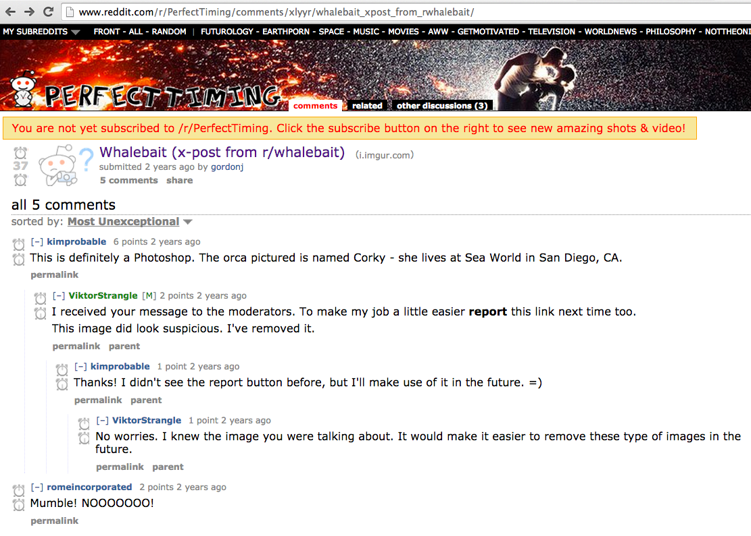

JSON file: xlyyr.json

{'c5nimce': {'children': [],
'parent_id': None,
'points': 2,
'text': 'Mumble! NOOOOOOO!',
'username': 'romeincorporated'},
'c5nsj33': {'children': ['c5o3fje'],
'parent_id': None,
'points': 6,
'text': 'This is definitely a Photoshop. The orca pictured is named Corky - she lives at Sea World in San Diego, CA.',
'username': 'kimprobable'},
'c5o3fje': {'children': ['c5o42jo'],
'parent_id': 'c5nsj33',
'points': 2,
'text': "I received your message to the moderators. To make my job a little easier report this link next time too.\n\nThis image did look suspicious. I've removed it.",
'username': 'ViktorStrangle'},
'c5o42jo': {'children': ['c5o97y4'],
'parent_id': 'c5o3fje',
'points': 1,
'text': "Thanks! I didn't see the report button before, but I'll make use of it in the future. =)",
'username': 'kimprobable'},
'c5o97y4': {'children': [],
'parent_id': 'c5o42jo',
'points': 1,
'text': 'No worries. I knew the image you were talking about. It would make it easier to remove these type of images in the future.',
'username': 'ViktorStrangle'}}

For more info:
All the JSON files have been extracted from the redditHtmlData.tar.gz that you can find in:
http://snap.stanford.edu/data/web-Reddit.html

