PHASEONE COMPLIANCE
The SF-1408
Survival Guide
How SBIR Phase I Teams Pass Their Pre-Award Accounting System Survey on the First Try
Version 1.0 • April 2026
PhaseOne Compliance, Inc. • phaseonecompliance.com

Who This Guide Is For
This guide is written for the principal investigator, program manager, or technical founder at a company that has won a Phase I SBIR or STTR award and is now looking toward Phase II. If that description fits you, this document was written for you. Read it once, and you will know more about surviving the SF-1408 than most CPA firms that advertise the service.
If you are 30 days into your Phase I award and Phase II feels like a distant problem, this guide will convince you it is not. If you are 90 days into your award and the contracting officer has started asking questions about your accounting system, this guide will show you how to respond. If you are actively writing a Phase II proposal right now, skip to Part 4.
Every piece of information in this guide is freely available in federal regulations, DCAA audit manuals, and government publications. What is not freely available is the synthesis — the sequence in which SBIR teams actually encounter these requirements, the shortcuts that fail, and the specific traps that have ended promising companies' Phase II pursuits. That synthesis is what this guide provides.
WHAT YOU GET
A complete walk-through of every SF-1408 criterion, a 90-day preparation plan, twelve common failure patterns and how to avoid them, a glossary of every acronym you will encounter, and a pre-survey self-assessment checklist. Roughly 40 pages. Read time: one focused evening.

Contents
Part 1 Why Phase II Is Different from Phase I
Part 2 The SF-1408 Explained, Criterion by Criterion
Part 3 The 90-Day Preparation Timeline
Part 4 Writing Your Proposal Appendix
Part 5 Twelve Failure Patterns and How to Avoid Them
Part 6 The Self-Assessment Checklist
Part 7 Glossary of Every Acronym You Will Encounter
Part 8 Resources and Where to Get Help

Part 1 — Why Phase II Is Different from Phase I

The Shift Nobody Warns You About
Phase I awards are firm-fixed-price contracts. You agreed to deliver a specified scope for a specified amount — typically up to $314,363 — and the government agreed to pay you that amount regardless of what it actually cost you to deliver. Under a firm-fixed-price structure, the government does not particularly care how you tracked labor, how you allocated overhead, or whether your accountant uses QuickBooks Online or an Excel workbook. The deliverable is what matters.
Phase II is structurally different. Phase II awards — up to $2,095,748 under current statutory caps — are typically cost-reimbursable contracts. A cost-reimbursable contract reimburses your company for actual incurred costs, plus a fixed fee. That single structural change transforms what the government needs to see from your accounting system. When the government is reimbursing actual costs, it needs confidence that the costs you report are real, allocable to the contract, allowable under federal cost principles, and recorded in a system that can be audited. (Note: Phase I and Phase II dollar caps shown throughout this guide reflect statutory limits as of April 2026. These caps have changed multiple times in program history and may change again — verify against the current SBA guidance at sbir.gov before relying on them for proposal budgeting.)
The mechanism the government uses to gain that confidence — before it obligates Phase II funds — is called a pre-award accounting system survey. The survey is conducted by the Defense Contract Audit Agency (DCAA) or the contracting officer's cognizant audit office. The survey instrument is Standard Form 1408.
THE CORE INSIGHT
The SF-1408 is not a test of your accounting software. It is a test of whether your accounting SYSTEM — software plus procedures plus documented practices — can reliably produce auditable cost data. Many teams lose Phase II awards not because their accountant was incompetent but because their engineers never documented their labor in a way the system could verify.

What DCAA Actually Evaluates
The SF-1408 has 13 criteria spread across three main areas: segregation of costs, accumulation of costs, and operational readiness of the accounting system. For each criterion, DCAA evaluates not just whether you have software that can produce the required output, but whether the procedures and practices supporting that software are actually being followed consistently.
This is where Phase I teams most often fail. A team will purchase a DCAA-compliant timekeeping product, configure it, train their engineers on it, and then watch as those engineers stop using it within two weeks. At Phase II application time, the team looks at its timesheet system and finds it contains approximately nothing — no consistent daily entries, no labor distribution by CLIN, no audit trail. The software was compliant. The practice was not.
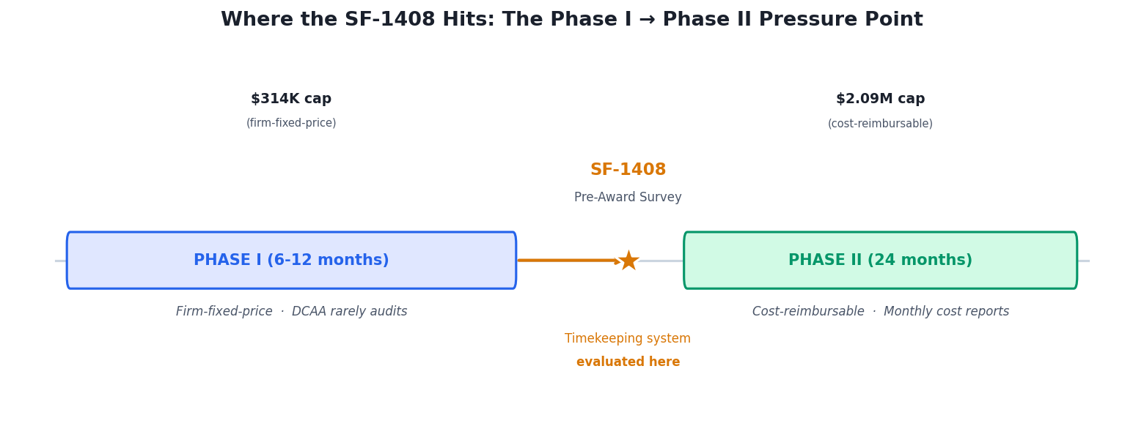
Figure 1: Phase II introduces the SF-1408 pre-award survey — evaluated before funds are obligated.

The Timeline Problem
The other reason Phase II is different is the timeline. Under Phase I, you had a 6-to-12-month performance period and the contracting officer was evaluating deliverables. Under Phase II, the pre-award survey happens before the contract is awarded. If the survey identifies deficiencies, one of three things happens:
- If deficiencies are minor, you may be required to correct them before award, delaying the contract start date by 30 to 90 days.
- If deficiencies are substantial but correctable, the contracting officer may choose to award the contract but hold back a portion of funds or require progress reports on remediation.
- If deficiencies are severe, the contracting officer may determine that your accounting system is inadequate and decline to award the contract at all. The award may be redirected to a competitor, or your proposal may be shelved indefinitely.
The worst outcome is not losing the award outright — it is the delay. Every month between your expected award date and your actual award date is a month you are burning runway without revenue, with engineers sitting idle or working on speculation. Teams that prepare for the SF-1408 during Phase I avoid this entire category of risk. Teams that discover the requirement at proposal time pay for that discovery in cash and calendar.

Part 2 — The SF-1408 Explained, Criterion by Criterion
The SF-1408 is organized into three sections: Section 1 identifies the contractor and the auditor, Section 2 evaluates the accounting system's compliance with Generally Accepted Accounting Principles (GAAP) and federal cost principles (13 criteria), and Section 3 evaluates operational readiness (3 criteria). Section 1 is administrative. Section 2 and Section 3 are where companies pass or fail. The criteria are walked through below in the order DCAA evaluates them.
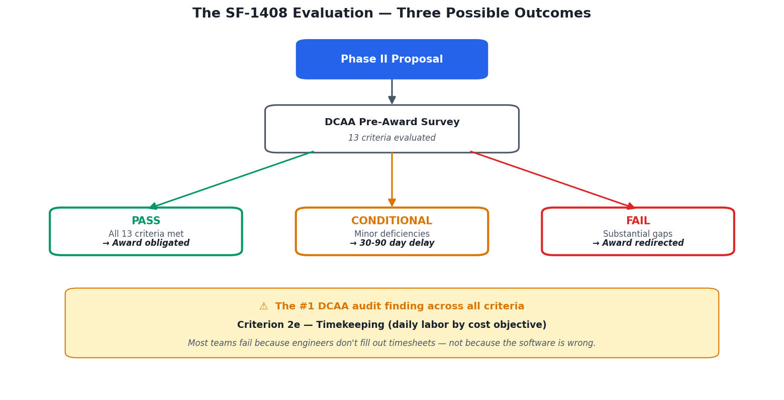
Figure 2: Three possible outcomes of the SF-1408 pre-award survey. Most failures trace back to Criterion 2e (Timekeeping).

Section 2 — Accounting System Criteria

Criterion 2a — Proper Segregation of Direct Costs from Indirect Costs
Direct costs are costs that can be specifically identified with a particular contract — for example, a software engineer's hours spent writing code for the Phase II deliverable. Indirect costs are costs that benefit multiple contracts or general business operations — for example, the office rent or the HR manager's salary. Your accounting system must keep these two categories clearly separated, never commingling them in the same account.
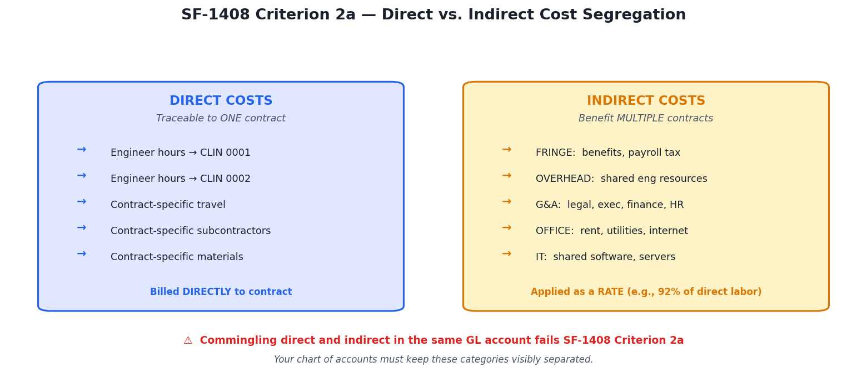
Figure 3: Criterion 2a: direct and indirect costs must live in separate GL accounts, never commingled.
What auditors look for: A chart of accounts that distinguishes direct accounts from indirect accounts. Individual transactions recorded in the correct category. A written policy documenting which types of costs are treated as direct and which as indirect, with that policy consistently applied across the books.
Common failure: Using a single "Labor Expense" account for both engineer hours charged to a contract and administrative hours. The fix is a chart of accounts with separate direct-labor and indirect-labor accounts, and a documented policy that specifies which employees and activities fall in each.

Criterion 2b — Identification and Accumulation of Direct Costs by Contract
Every direct cost must be traceable to the specific contract it was incurred for. If your company has three active contracts — a Phase I SBIR, a commercial consulting engagement, and an internally-funded R&D project — your system must be able to show every direct cost allocated to the Phase I SBIR and nothing else. This is the foundation of cost-reimbursable billing.
What auditors look for: A job-cost or project-cost structure in the accounting system. Timesheets that capture the contract (or CLIN) for each labor hour. Materials, travel, and subcontractor costs invoiced or allocated against the specific contract they support.

Criterion 2c — Logical and Consistent Method for Allocation of Indirect Costs
Indirect costs do not belong to any single contract, but they still need to be allocated across contracts so that each contract bears its fair share. The government wants to see that you use a logical, consistent method to do this — typically by establishing indirect cost pools (fringe benefits, overhead, general and administrative) and allocating each pool to contracts using an appropriate base (usually direct labor dollars).
What auditors look for: A documented indirect cost rate structure. At minimum, a fringe benefit rate and a general and administrative (G&A) rate. More mature systems have separate overhead rates. The method should be consistent period-over-period — you should not be changing allocation bases every quarter.
PROVISIONAL RATES
For your first cost-reimbursable contract, you will establish provisional indirect rates — your best estimate of what your actual rates will be for the year. At year-end, you calculate your actual rates. If the actual rates are lower than provisional, you owe the government the difference. If higher, the government owes you. This is the Incurred Cost Submission (ICS) process. Establishing defensible provisional rates is a task for your CPA partner, not your technical team.

Criterion 2d — Accumulation of Costs Under General Ledger Control
Every cost reported to the government must be traceable back to an entry in your general ledger. If DCAA asks where a specific dollar of labor came from, you must be able to produce the general ledger entry that supports it, with dates, amounts, and account codes that match your cost reports. This is sometimes called "book-to-invoice" traceability.
What auditors look for: A monthly reconciliation procedure that ties labor distribution from your timekeeping system to your general ledger, with written sign-off. Timely journal entries. No unexplained discrepancies between the timekeeping system totals and the payroll run totals.

Criterion 2e — Timekeeping System That Identifies Employees' Labor by Cost Objective
This is the criterion on which most Phase I teams fail, and it is the single most common DCAA audit finding in any year. The requirement is specific: you must have a system in which every employee records their labor daily, identifying the contract or cost objective each hour was spent on, with the labor charged to the correct category.
"Daily" means daily. Weekly timesheets filled out at the end of the week from memory do not meet the requirement. "Identifies by cost objective" means the employee is selecting from a defined list of contracts or CLINs — not writing freeform descriptions and hoping an accountant can reconstruct what happened later. "Every employee" means everyone on payroll: engineers, the CEO, the office manager. No exemptions.
What auditors look for: A timekeeping system with daily entries. Records that show the contract or CLIN for each hour. An audit trail showing when entries were made (not just for what date). Evidence that entries are reviewed and approved by a supervisor. No gaps in the record for working days.
WHY THIS CRITERION MATTERS SO MUCH
If you fail criterion 2e, the remaining criteria become nearly impossible to pass — because every other cost-related criterion depends on labor data. A broken timekeeping system pollutes everything downstream. This is also why timekeeping is the #1 DCAA audit finding across all contractor types. Engineers do not voluntarily fill out timesheets. Systems that depend on voluntary engineer discipline do not survive contact with reality.

Criterion 2f — Labor Distribution System Charging Direct and Indirect Labor
Beyond collecting timekeeping data, your system must distribute that data to the correct cost categories — direct labor to specific contracts, indirect labor to the appropriate indirect cost pools. The distribution must match what your employees actually recorded, with no silent reclassification.
What auditors look for: A traceable chain from an individual employee's daily entry → to a labor distribution report → to the payroll general ledger entries. Consistency between the timekeeping data and the payroll run. Documentation of any adjustments, with reason codes.

Criterion 2g — Interim Determination of Costs Charged to a Contract (Monthly)
You must be able to tell the government how much a contract has cost you so far, at any point, with the most recent data no more than one month old. This is the foundation of progress billing and cost reporting on cost-reimbursable contracts. In practice, this means closing your books monthly — labor allocated, indirect rates applied, contract-specific cost reports produced.

Criterion 2h — Exclusion of Unallowable Costs
FAR Part 31.205 defines dozens of specific cost categories that are "expressly unallowable" — meaning you cannot bill them to the government under any circumstances, even indirectly through your overhead rate. Your system must catch these costs and segregate them into unallowable accounts so they never flow into amounts billed to the government.
The list of expressly unallowable costs includes: alcohol, entertainment, first-class airfare, lobbying expenses, bad debts, fines and penalties, gifts, lobbying, contributions to political candidates, losses on other contracts, and several dozen other categories. A cost does not need to be intentionally charged to be a problem — if your accountant routinely books team lunches to "Direct Labor — Client Engagement" and that account flows into your billable hours, you have a compliance failure, even if no one intended to bill the government for pizza.
THE UNALLOWABLE COST TRAP
The most expensive audit findings in SBIR history have come from unallowable costs improperly buried in indirect cost pools. A company thinks it is billing $800,000 of legitimate overhead and discovers at audit that $40,000 of that was entertainment, holiday parties, and executive travel in classes of service that are not allowable. The penalty is usually disallowance of the specific costs, but severe cases can trigger cost accounting standards violations with much broader consequences.

Criterion 2i — Identification of Costs by Contract Line Item and Units
For contracts with multiple CLINs (Contract Line Item Numbers), your system must track costs not just to the contract but to the specific CLIN within the contract. This matters because Phase II deliverables are usually broken into CLINs that are funded separately — often including a base effort, options, and a funding ceiling per CLIN. The government needs to see that you are not billing labor to CLIN 0001 when the work was actually performed for CLIN 0002.

Criterion 2j — Segregation of Preproduction Costs (If Applicable)
This criterion applies only to contracts that include both development and production phases. For most SBIR Phase II awards, this criterion will be marked "Not Applicable" on the survey. If your Phase II does include a production component, a separate set of accounting controls applies, and you should work with a government contracting CPA to structure them.

Section 3 — Operational Readiness Criteria

Criterion 3a — Accounting System Is in Full Operation
The auditor needs to see that the accounting system you have described is actually running — not something you plan to implement once the Phase II contract is awarded. This means your monthly close process must have been run at least once, your labor distribution reports must have been produced from real data, and your indirect cost pools must be actively accumulating costs.
PHASE II BOOTSTRAP PROBLEM
If you are reading this guide at the start of your Phase I award, you have time to run your accounting system through several monthly close cycles before Phase II submission. Use that time. The auditor wants to see operational evidence — actual closed months, actual reconciled reports — not a configuration that has never been tested under load.

Criterion 3b — Adequate for Managing Progress Payments (If Applicable)
If your Phase II contract will include progress payments rather than cost-reimbursement, additional controls apply. Most SBIR Phase II contracts use cost-reimbursement, so this criterion is often marked Not Applicable. If your contract does involve progress payments, your CPA partner will help you navigate the specific requirements.

Criterion 3c — Adequate for Managing Cost-Reimbursable Contracts
This is the capstone criterion. DCAA is asking: can your system actually operate a cost-reimbursable contract from day one? That means generating monthly cost vouchers, applying provisional indirect rates, producing supporting documentation, and responding to government questions about cost reasonableness.
What auditors look for: Evidence that at least one cost voucher has been successfully generated (even against internal overhead as a test). A documented voucher preparation procedure. Clear ownership — someone in your organization who knows how to produce a voucher without external help.

Part 3 — The 90-Day Preparation Timeline
If you are 90 days or more from Phase II submission, the timeline below will get you there with a strong SF-1408 posture. If you are closer to submission, skip forward to the relevant week and execute from there. If you are past submission and the pre-award survey has already been scheduled, your priority is damage control — jump to Part 5.

Weeks 1–4: Foundation
- Engage a government contracting CPA partner. Not a general small business CPA — a firm with active GovCon clients. They will be your co-pilot through the indirect rate structure, the ICS submission, and the voucher preparation. Plan on 4–8 hours of working sessions per month during preparation.
- Deploy daily timekeeping for every employee. The system must capture daily labor by contract or CLIN, timestamp each entry, and retain an immutable audit trail. Any gap longer than two weeks in any employee's record is a red flag — not just a minor issue.
- Review your chart of accounts. Confirm direct and indirect labor accounts are separated. Confirm unallowable cost accounts exist and are being used. If your chart of accounts was set up by a general accountant, it almost certainly needs adjustment for cost-reimbursable readiness.
- Document your indirect cost pool structure. At minimum: a fringe benefits pool, a G&A pool, and a policy document that defines what goes in each.

Weeks 5–8: Rate Development
- Calculate provisional indirect rates. Your CPA will help — the general process is annualized indirect pool dollars divided by annualized direct labor dollars. For a Phase II proposal, you typically need a fringe rate, an overhead rate, and a G&A rate.
- Establish the written rate memorandum. This is a 2-to-4 page document describing your indirect cost structure, the pools, the allocation bases, and the calculated provisional rates. The memo becomes an appendix to your Phase II proposal.
- Run your first full monthly close using the new structure. You will find issues. Fix them. Run the second monthly close. The goal by the end of Week 8 is to have two consecutive months that close cleanly.
- Generate a test cost voucher. This is a dry run: pick an internal project or the overhead pool, produce a voucher that shows direct labor + fringe + overhead + G&A as they would appear on a real invoice. File the voucher in a working folder. You have now operationally demonstrated cost-reimbursable capability — criterion 3c.

Weeks 9–12: Readiness Validation
- Execute a monthly labor-to-GL reconciliation. This is the procedure that ties your timekeeping system totals to your payroll general ledger entries, with written sign-off. Formalize it as a documented procedure — call it "SOP-FIN-001" or similar — so that when DCAA asks to see it, you can produce a named document.
- Run your self-assessment against the SF-1408 (see Part 6 of this guide).
- Identify any criterion scoring below 85 on your self-assessment. For each, document the remediation plan and target completion date.
- Prepare your SF-1408 readiness package. This is a 10-to-20 page document you will submit as an appendix to your Phase II proposal. It includes: chart of accounts, indirect rate memorandum, timekeeping policy, unallowable cost policy, sample labor distribution report, sample cost voucher, and self-assessment results. Submitting this proactively — before DCAA asks — signals maturity and shortens the pre-award survey.
WHY PROACTIVE SUBMISSION MATTERS
A contracting officer who receives a Phase II proposal with a complete SF-1408 readiness package attached will often escalate the proposal for faster review. A contracting officer who receives a bare proposal and has to request an SF-1408 survey will typically see the award timeline slip by 60 to 90 days. The readiness package is free, and it compresses your timeline.

Part 4 — Writing Your Proposal Appendix
The SF-1408 readiness package is an unofficial appendix — the government does not require it, but experienced SBIR teams include it because it demonstrates operational maturity and compresses the review timeline. The package below represents the minimum viable version. Add to it if you have more evidence available.

Required Sections

1. Cover Memo (1 page)
A single page addressed to the contracting officer identifying your company, the proposal you are submitting, and the fact that this appendix is being provided to facilitate pre-award survey preparation. State explicitly that you believe your accounting system is adequate for cost-reimbursable contract administration. Reference the specific SF-1408 criteria the appendix addresses.

2. Chart of Accounts Summary (1–2 pages)
A summary of your general ledger account structure showing: (a) direct labor accounts by contract or project, (b) indirect cost pool accounts (fringe, overhead if applicable, G&A), (c) unallowable cost segregation accounts, (d) revenue accounts. Do not include every line item — a structural summary is sufficient. Addresses criteria 2a, 2b.

3. Indirect Rate Memorandum (2–4 pages)
Prepared by your CPA. Describes your indirect cost pool structure, allocation bases, and calculated provisional rates. Shows the math behind each rate. States the period the rates apply to. Addresses criterion 2c.

4. Timekeeping Policy (1–2 pages)
A written policy stating: (a) what timekeeping system is used, (b) that all employees record labor daily, (c) how labor is identified by contract or CLIN, (d) who reviews and approves entries, (e) what happens when an entry is late or missing, (f) how corrections are tracked. Addresses criteria 2e, 2f.

5. Unallowable Cost Policy (1 page)
A written policy identifying the categories of costs your company treats as unallowable per FAR Part 31.205, the specific general ledger accounts used to segregate them, and the review process that ensures these costs do not migrate to billable accounts. Addresses criterion 2h.

6. Sample Labor Distribution Report (1–3 pages)
A redacted example of a monthly labor distribution report showing: total hours by employee, hours allocated to each contract and CLIN, hours allocated to indirect pools, and reconciliation to total payroll hours. Use the most recent complete month. Addresses criterion 2f, 2g.

7. Sample Cost Voucher (1–2 pages)
A sample cost voucher showing direct labor + fringe + overhead (if applicable) + G&A, formatted as it would appear on a real invoice to the government. If you have not yet executed a cost-reimbursable contract, use a test voucher from an internal project. Addresses criterion 3c.

8. SF-1408 Self-Assessment Summary (1 page)
A one-page summary showing your self-assessment score against each SF-1408 criterion, with a brief note on any criterion scoring below 85 and the remediation plan for it. This signals to the contracting officer that you have already done your own review and are comfortable with what an external auditor would find.

Part 5 — Twelve Failure Patterns and How to Avoid Them
The patterns below are drawn from DCAA public audit findings, SBIR program office debriefs, and the lived experience of SBIR teams that have either failed an SF-1408 or narrowly survived one. They appear in rough order of how common they are.

Pattern 1 — No Daily Timekeeping Discipline
The most common failure. The team purchased a timekeeping product, configured it, trained engineers on it, and stopped enforcing use after two weeks. At Phase II application time, the system contains sporadic entries with multi-week gaps. There is no path to repair this retroactively in a way that will pass audit scrutiny — labor records dated months after the fact do not have the audit trail characteristics of contemporaneous records.
How to avoid: Use a system that captures labor at the point of work, not at the end of the week. Enforce gap detection with automated reminders. Escalate missing entries to the program manager within 48 hours. If you are using PhaseOne, this is built in.

Pattern 2 — Commingled Direct and Indirect Labor
A company uses a single "Salaries" general ledger account for all employee compensation, direct and indirect. When the auditor asks to see how much direct labor has been charged to the Phase I contract, the company cannot produce the number without manually reconstructing it from timesheets.
How to avoid: Restructure the chart of accounts so direct labor and indirect labor are in separate GL accounts. Require this restructure be completed before month-end close, not at proposal time.

Pattern 3 — Unallowable Costs Hidden in Overhead
The company has an "Overhead" account that includes team meals, holiday parties, first-class flights for executives, and periodic alcohol purchases. None of these are segregated to unallowable accounts, so they all flow into the company's overhead rate — which is then applied to every cost-reimbursable invoice. The auditor catches the problem and disallows the costs, often retroactively.
How to avoid: Review the last 12 months of overhead account transactions. Reclassify any entries that match FAR Part 31.205 unallowable categories. Establish a monthly review process going forward. Ensure your books have a dedicated "Unallowable — Meals/Entertainment", "Unallowable — Travel", and "Unallowable — Other" account set.

Pattern 4 — No Written Procedures
The company has adequate systems and adequate practices, but nothing is written down. The auditor asks "show me your timekeeping policy" and the company has to improvise. The auditor asks "show me your labor distribution procedure" and there is no document to produce.
How to avoid: Write everything down. Each policy can be a single page. Name each document with a stable identifier (SOP-FIN-001 for the monthly close procedure, SOP-FIN-002 for labor distribution, etc.). Update them on a defined review cycle.

Pattern 5 — Indirect Rates with No Supporting Math
The company proposes a 92% overhead rate in its Phase II proposal but cannot produce the calculation. The rate was pulled from a similar company's public filing or estimated based on what "sounded reasonable".
How to avoid: Calculate provisional rates from your actual expected costs. Document the calculation in a memorandum. Have your CPA sign off. The specific number matters less than the ability to show how you got to it.

Pattern 6 — Employee Labor Misclassification
An employee whose role is documented as "Senior Software Engineer" is routinely logging hours against CLINs reserved for research or documentation work, with no justification. The auditor flags this as inconsistent labor category coding.
How to avoid: Establish an employee-to-CLIN matrix in your labor categorization policy. Allow cross-coding, but require a written justification (one line is enough) from the program manager. This gets captured in your audit trail.

Pattern 7 — Backdated Timekeeping Entries
The company realized mid-Phase II proposal that its timekeeping records were sparse. Engineers were asked to reconstruct their last 90 days of work from memory and enter it into the system. The entries all have the same timestamp — the day they were entered — and no audit trail of the actual work dates.
How to avoid: Do not backdate. If you have gaps in your historical record, disclose them honestly in your proposal. A company that says "our timekeeping discipline improved in Month 5 of the award, and we have complete records from that point forward" is in a far better position than one that presents fabricated records an auditor can identify.

Pattern 8 — No Monthly Close
The company's accountant closes the books quarterly or annually, not monthly. Auditor asks for a cost report through the most recent month-end — company cannot produce one because its books are not closed.
How to avoid: Monthly close must be the baseline. At minimum: labor distributed, indirect pools accumulated, cost reports available, all by the 10th business day of the following month. Your CPA can run monthly close for a small firm in under a day.

Pattern 9 — Single Point of Failure in Financial Operations
The accountant who set up the system leaves the company. No one internally understands the indirect rate structure or how to produce a voucher. When DCAA calls with a question, no one can answer.
How to avoid: Cross-train. At a minimum, the CFO or controller (even a fractional one) should be able to walk through every part of the system. Written procedures (Pattern 4) make this survivable.

Pattern 10 — Poor CLIN Discipline in Multi-CLIN Contracts
A Phase II contract with four CLINs — base effort, two option tasks, and technical reporting — is billed without rigor. Labor that should be charged to CLIN 0002 gets charged to CLIN 0001 because the engineer doesn't remember which CLIN they were working on. At contract closeout, the government identifies ceiling violations on CLIN 0001 and issues a finding.
How to avoid: Require CLIN selection at the time of labor entry, not at the time of invoice. Give engineers a short list of active CLINs with plain-language descriptions. Review CLIN-level burn monthly.

Pattern 11 — No Reconciliation Between Systems
The timekeeping system shows 412 direct labor hours for March. The payroll system shows 420 hours paid. The general ledger shows $28,400 of direct labor booked. None of these numbers tie back to each other and no one has reconciled them.
How to avoid: Monthly labor-to-GL reconciliation, signed off in writing. The numbers do not have to match to the penny, but any variance over 1% needs a documented explanation.

Pattern 12 — Assuming the Accountant Is Handling Everything
The technical founder assumes compliance is handled by the accountant. The accountant assumes the technical team is handling timekeeping. No one is looking at the SF-1408 criteria holistically. At audit time, gaps appear.
How to avoid: One person — typically the program manager or CFO — owns SF-1408 readiness end-to-end. They maintain a running self-assessment, they run the monthly review, they own the readiness package. This is not a 20-hour-per-week job. It is a 2-hour-per-month job. But someone has to own it.

Part 6 — The Self-Assessment Checklist
Score yourself on each criterion below. Use the scoring rubric shown: 90–100 if the criterion is solidly met with documented evidence, 70–89 if minor gaps exist, 50–69 if substantial remediation is needed, and below 50 if the criterion is structurally broken. Any score below 85 should have a corresponding remediation plan before Phase II submission.

Crit | Requirement | 90+ | 70-89 | 50-69 | <50
2a | Direct and indirect labor in separate GL accounts | ☐ | ☐ | ☐ | ☐
2a | Written policy defining direct vs. indirect cost categories | ☐ | ☐ | ☐ | ☐
2b | Each active contract has a dedicated job-cost or project code | ☐ | ☐ | ☐ | ☐
2b | All direct materials, travel, and subcontractor costs are project-coded | ☐ | ☐ | ☐ | ☐
2c | Indirect cost pools are defined (fringe, overhead, G&A as applicable) | ☐ | ☐ | ☐ | ☐
2c | Written indirect rate memorandum exists and is current | ☐ | ☐ | ☐ | ☐
2d | Monthly reconciliation of labor distribution to GL is documented | ☐ | ☐ | ☐ | ☐
2d | Reconciliation has written sign-off by a named owner | ☐ | ☐ | ☐ | ☐
2e | All employees record labor daily, not weekly | ☐ | ☐ | ☐ | ☐
2e | Each labor entry identifies the contract or CLIN | ☐ | ☐ | ☐ | ☐
2e | Timekeeping system retains immutable audit trail with timestamps | ☐ | ☐ | ☐ | ☐
2e | No employee has a gap longer than 5 business days in the last 90 | ☐ | ☐ | ☐ | ☐
2f | Labor distribution reports match payroll run totals within 1% | ☐ | ☐ | ☐ | ☐
2f | Any adjustments are documented with reason codes | ☐ | ☐ | ☐ | ☐
2g | Books close monthly, within 10 business days of month-end | ☐ | ☐ | ☐ | ☐
2g | Monthly cost reports by contract are generated | ☐ | ☐ | ☐ | ☐
2h | Unallowable cost accounts exist in chart of accounts | ☐ | ☐ | ☐ | ☐
2h | Written unallowable cost policy exists and is current | ☐ | ☐ | ☐ | ☐
2h | Last 12 months of overhead transactions reviewed for unallowable items | ☐ | ☐ | ☐ | ☐
2i | Labor entries capture CLIN, not just contract number (for multi-CLIN contracts) | ☐ | ☐ | ☐ | ☐
3a | All described procedures have been run at least twice with real data | ☐ | ☐ | ☐ | ☐
3b | Progress payment capability documented (if applicable, else N/A) | ☐ | ☐ | ☐ | ☐
3c | At least one test cost voucher has been generated | ☐ | ☐ | ☐ | ☐
3c | Written voucher preparation procedure exists | ☐ | ☐ | ☐ | ☐

Part 7 — Glossary of Every Acronym You Will Encounter
Government contracting is acronym-dense. The list below covers every term you will encounter in SF-1408 preparation, Phase II proposal writing, and cost-reimbursable contract administration. Bookmark this section.
Term | Definition
CLIN | Contract Line Item Number. The specific numbered line in a contract that defines a distinct scope of work with its own funding ceiling. A Phase II contract typically has 3–6 CLINs.
CPA | Certified Public Accountant. For SBIR purposes, you want a CPA with government contracting experience specifically — a "GovCon CPA." Your local small business CPA is usually not sufficient.
DCAA | Defense Contract Audit Agency. The primary federal audit agency for defense contracts. Conducts most SF-1408 pre-award surveys. Part of the Department of Defense, reports to the Under Secretary of Defense (Comptroller).
DCMA | Defense Contract Management Agency. Administers DoD contracts after award. Different from DCAA — DCMA manages contracts, DCAA audits them. Both agencies coordinate on issues.
Direct Cost | A cost that can be specifically identified with a single final cost objective, typically a contract. Engineer hours writing code for the Phase II deliverable are direct costs.
FAR | Federal Acquisition Regulation. The primary rulebook for federal government contracting. FAR Part 31 contains cost principles — which costs are allowable, which are not, and under what conditions. Your target reading: FAR 31.201 (general cost principles) and FAR 31.205 (selected costs).
Fringe Rate | The indirect rate applied to direct labor to cover employee benefits. Typical Phase II fringe rates range from 25% to 45%. Calculated as total fringe costs divided by total labor dollars.
G&A Rate | General and Administrative rate. The indirect rate covering general company operations (legal, finance, executive, etc.). Typical Phase II G&A rates range from 15% to 30%. Applied to total direct cost plus other indirect costs.
GAAP | Generally Accepted Accounting Principles. The standardized accounting rules used in the United States. DCAA expects your books to conform to GAAP.
GL | General Ledger. The master record of every financial transaction in your accounting system.
Indirect Cost | A cost that benefits multiple contracts or general business operations and cannot be specifically identified with a single contract. Office rent, HR, legal fees are indirect costs.
ICS | Incurred Cost Submission. An annual filing required for every cost-reimbursable contract, showing actual incurred costs versus provisional billings. Reconciles provisional indirect rates to actual rates and determines owed amounts in either direction.
NDA | Non-Disclosure Agreement. Relevant when engaging CPA firms or compliance advisors who will review your financial structure.
Overhead Rate | An indirect rate applied to direct labor (or sometimes total direct cost) to cover operational costs that benefit multiple contracts but are not G&A. Many smaller firms combine overhead into G&A for simplicity. Typical range when used: 40%–90%.
Phase I SBIR/STTR | The initial small business federal R&D award. Firm-fixed-price, typically 6–12 months, up to $314,363 (current cap as of October 2024).
Phase II SBIR/STTR | The follow-on award after successful Phase I completion. Typically 24 months, up to $2,095,748 (current cap). Usually cost-reimbursable — triggers the SF-1408 requirement.
Phase III SBIR/STTR | Commercialization follow-on, outside SBIR funding. Various contract types. Not triggered by the SF-1408 pre-award survey process.
PI | Principal Investigator. The technical lead on an SBIR award. Often but not always the CEO at small firms.
PM | Program Manager. On the government side, the person administering the contract. On the contractor side, the person responsible for delivery and compliance. Both exist for every contract.
Pre-Award Survey | The accounting system evaluation performed by DCAA before obligating cost-reimbursable contract funds. Documented on Standard Form 1408.
Provisional Rate | An indirect rate used during the contract performance period, pending year-end true-up. You bill at provisional rates, reconcile at actual rates via the ICS.
RFP | Request for Proposal. The government's solicitation document for a specific contract opportunity. SBIR topics come via RFP-like solicitations.
SBA | Small Business Administration. The federal agency overseeing the SBIR/STTR programs at a government-wide level. Individual agencies (DoD, NSF, NASA, etc.) run their own SBIR programs within SBA guidelines.
SBIR | Small Business Innovation Research. The primary federal R&D set-aside program for small businesses. Administered by 11 federal agencies including DoD, NSF, NASA, NIH, DOE, DHHS, and others.
SF-1408 | Standard Form 1408. The pre-award accounting system survey form used by DCAA and other federal audit agencies. 13 criteria across three sections. Failure to pass the survey blocks cost-reimbursable contract awards.
SOW | Statement of Work. The section of a contract defining what the contractor is obligated to deliver. Your labor entries should be traceable back to SOW tasks.
STTR | Small Business Technology Transfer. A parallel program to SBIR requiring research partnership between a small business and a university or federal R&D center. Similar SF-1408 requirements at Phase II.
TPOC | Technical Point of Contact. The government's technical representative on an SBIR award — typically a research scientist at the awarding agency, distinct from the contracting officer.
Unallowable Cost | A cost that cannot be charged to the government under any circumstance, even indirectly through overhead allocation. Defined by FAR Part 31.205.

Part 8 — Resources and Where to Get Help

Official Government Resources
- DCAA website: dcaa.mil — audit manuals and public guidance
- DCAA Contract Audit Manual (DCAM): searchable and free online at dcaa.mil/guidance
- FAR text: acquisition.gov/far
- SBIR.gov: central portal for all 11 agencies' SBIR programs
- SF-1408 form text (search "SF-1408" on gsa.gov for the current version)

Finding a GovCon CPA
The Association of Government Accountants (agacgfm.org) maintains a member directory. For small SBIR firms, seek CPA firms that advertise SBIR experience specifically — several specialize in this niche. Three general heuristics for identifying a qualified GovCon CPA: (1) they have at least 10 current active SBIR clients, (2) they have handled an ICS filing in the last 12 months, (3) they have sat across the table from DCAA auditors in the last 24 months. If all three boxes check, they are qualified. If any are missing, keep looking.

Software and Systems
Your accounting system (QuickBooks, NetSuite, etc.) handles the GL side. For timekeeping — the highest-failure-rate criterion — you have three structural choices:
- Enterprise ERP (Deltek Costpoint, Unanet) — complete coverage, $50K+ implementation, built for 500+ person contractors.
- DCAA-compliant timekeeping tools (Hour Timesheet, WeWorked, BigTime) — affordable per-user pricing, but requires engineers to fill out timesheets manually, which is where most systems fail operationally.
- Slack-native capture (PhaseOne Compliance) — engineers type a short Slack update, AI translates to DCAA-compliant format, auto-flags unallowable costs, maintains audit trail. Designed specifically for the Phase I → Phase II transition path.

About PhaseOne Compliance
PhaseOne built this guide because we encounter the same questions and misconceptions from every SBIR team we work with. The information in this guide is freely available in federal regulations — but the synthesis is not. Every team deserves to know what the SF-1408 actually requires before they discover it at proposal time.
If the system gaps described in this guide sound familiar in your own operation, book a 15-minute Phase II Readiness Check at calendly.com/jaylun-phaseonecompliance/15-min-compliance-audit. We'll review your current posture against the SF-1408 criteria and identify the highest-priority remediations. No pitch, no pressure. If PhaseOne is the right tool for your situation we'll tell you. If another path is better we'll tell you that too.

ONE LAST THOUGHT
The teams that pass their SF-1408 on the first try are not the teams with the most sophisticated accounting systems. They are the teams that started compliance as a habit in month two of Phase I, rather than as a fire drill in month two of Phase II preparation. Everything in this guide is achievable by a disciplined 4-person team with a good CPA partner. None of it requires Deltek. What it does require is that you start now.

— END OF GUIDE —

