# This is a test

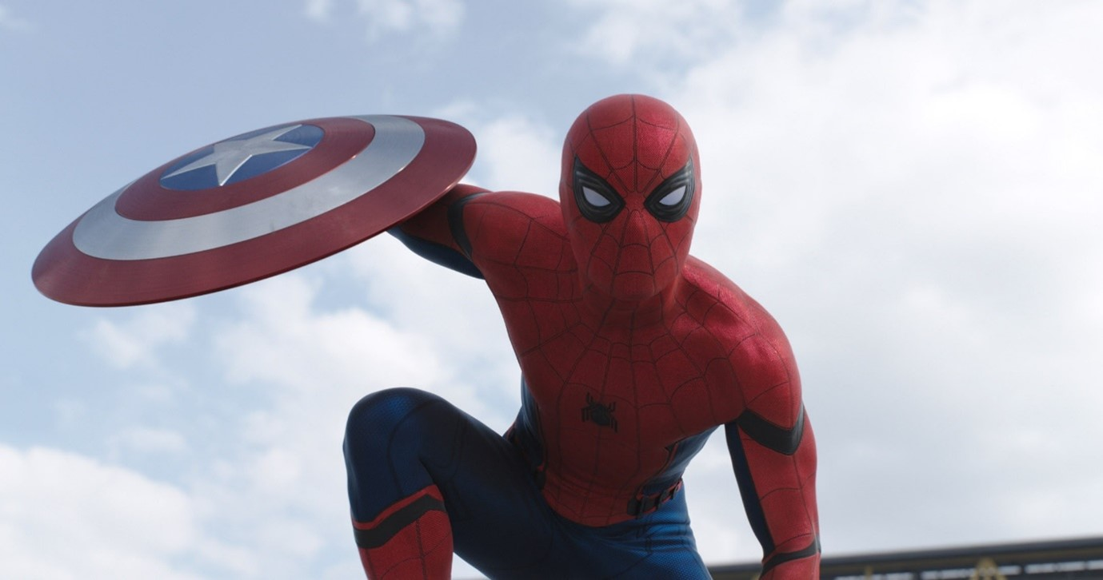

This is a picture of spiderman it should work!