Spring Security Notes
Topic 1: What is Security in Web Apps?
Phase 1 — Foundations

1. Authentication vs Authorization
These are the two most fundamental security concepts. They are often confused, but serve completely different purposes.
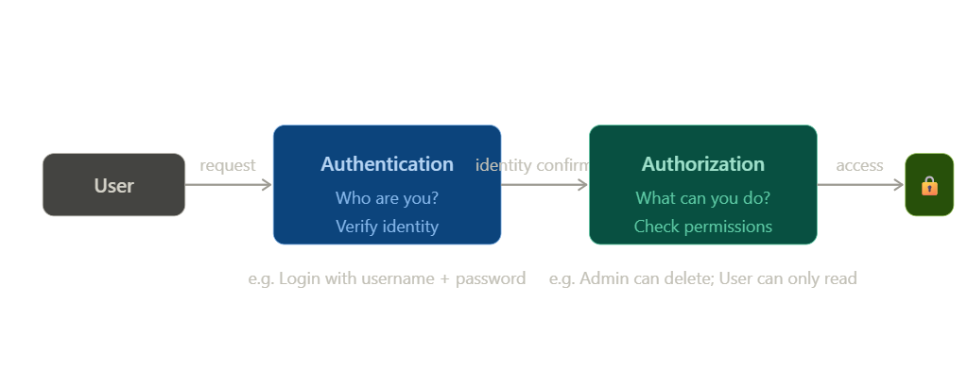

Authentication (AuthN) — "Who are you?"
Authentication is the process of verifying the identity of a user. It answers the question: "Are you really who you claim to be?"
- User provides credentials (username + password, OTP, biometrics)
- System validates the credentials against stored data
- If valid → user is considered "authenticated"
- In Spring Security: handled by UserDetailsService + PasswordEncoder

Authorization (AuthZ) — "What can you do?"
Authorization is the process of determining what an authenticated user is allowed to do. It answers: "Do you have permission to access this resource?"
- Happens AFTER authentication
- Checks roles and permissions (e.g. ROLE_ADMIN, ROLE_USER)
- Controls access to URLs, methods, and data
- In Spring Security: handled by hasRole(), hasAuthority(), @PreAuthorize

Authentication (AuthN) | Authorization (AuthZ)
WHO are you? | WHAT can you do?
Verifies identity | Checks permissions
Happens FIRST | Happens AFTER AuthN
Username + Password, JWT, OAuth2 | Roles: ROLE_ADMIN, ROLE_USER
401 Unauthorized if fails | 403 Forbidden if fails
UserDetailsService in Spring | hasRole(), @PreAuthorize in Spring

Real-world analogy:
A hotel: Authentication = front desk checks your ID and gives a keycard. Authorization = that keycard only opens certain floors/rooms.

2. Stateless vs Stateful
This describes how the server "remembers" who you are between HTTP requests. HTTP is naturally stateless — every request is independent — so we need a mechanism to maintain user sessions.

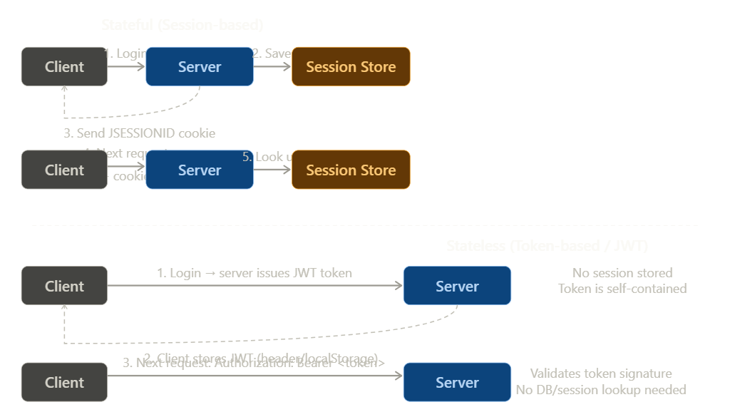

Stateful (Session-based)
The server stores session data in memory (or a session store like Redis). The client just holds a session ID in a cookie.
- 1. User logs in → server creates a session and stores user data
- 2. Server sends back a session ID in a cookie (JSESSIONID)
- 3. Browser auto-sends the cookie with every subsequent request
- 4. Server looks up the session by ID to identify the user

Stateful flow:
Client → POST /login → Server creates session → Sends JSESSIONID cookie → Client stores cookie → Next request auto-sends cookie → Server looks up session → User identified

Pros of Stateful:
- Easy to invalidate sessions (logout = delete session)
- User data stored server-side (not exposed to client)
- Built-in Spring Security default behavior
Cons of Stateful:
- Doesn't scale well — every server must share session store
- Requires sticky sessions or centralized session store (Redis)
- More server memory usage

Stateless (Token-based / JWT)
The server stores NO session data. All user info is packed into a signed token which the client stores and sends with every request.
- 1. User logs in → server validates credentials and issues a JWT token
- 2. Server sends JWT back to the client
- 3. Client stores the token (localStorage or memory)
- 4. Client sends JWT in every request: Authorization: Bearer <token>
- 5. Server validates the token's signature — no DB lookup needed

Stateless flow:
Client → POST /login → Server validates → Issues JWT → Client stores token → Next request: Authorization: Bearer eyJ... → Server validates signature → User identified

Stateful (Session) | Stateless (JWT)
Server stores session data | Server stores nothing
Session ID in cookie | JWT token in header
JSESSIONID cookie | Authorization: Bearer <token>
Easy invalidation (delete session) | Hard to invalidate (token lives until expiry)
Doesn't scale horizontally | Scales easily (no shared state)
Default in Spring Security | Used for REST APIs
Best for web apps | Best for microservices / SPAs

3. Session, Cookies & Tokens
Session
A server-side data store that maps a session ID to user information. The session lives on the server. Only the ID is given to the client.
// Conceptual session store (server-side)
sessions = {
"abc123": { userId: 42, username: "john", role: "ADMIN", expiry: ... },
"xyz789": { userId: 7, username: "jane", role: "USER", expiry: ... }
}

Cookie
A small piece of text stored by the browser. The browser automatically sends cookies with every request to the same domain. Spring Security stores the session ID in a cookie called JSESSIONID.
// Browser automatically sends this header with every request:
Cookie: JSESSIONID=abc123def456...

// Spring Security sets this cookie after successful login:
Set-Cookie: JSESSIONID=abc123; Path=/; HttpOnly; Secure

- HttpOnly flag → JavaScript cannot read the cookie (prevents XSS theft)
- Secure flag → Cookie only sent over HTTPS
- SameSite attribute → Controls cross-site cookie sending (CSRF protection)

Token (JWT — JSON Web Token)
A self-contained, signed string that carries user information directly. No server-side storage needed. The server only needs to verify the signature.

JWT structure: three Base64-encoded parts separated by dots:
eyJhbGciOiJIUzI1NiJ9 . eyJzdWIiOiJ1c2VyMSIsInJvbGUiOiJBRE1JTiJ9 . SflKxwRJSMeKKF2QT4fwpMeJf36POk6yJV
HEADER PAYLOAD SIGNATURE

// Header (decoded):
{
"alg": "HS256", // Signing algorithm
"typ": "JWT"
}

// Payload (decoded) - called "claims":
{
"sub": "user1", // Subject (username)
"role": "ADMIN", // Custom claim
"iat": 1700000000, // Issued at (timestamp)
"exp": 1700003600 // Expiry (1 hour later)
}

// Signature: HMAC-SHA256(base64(header) + "." + base64(payload), secretKey)
// If ANY part of header/payload is tampered, signature verification fails

Important:
JWT payload is Base64 encoded, NOT encrypted. Anyone can decode and read it. Never put sensitive data (passwords, credit cards) in a JWT payload. The signature only guarantees the data hasn't been tampered with.

Access Token vs Refresh Token
Access Token | Refresh Token
Short-lived (e.g. 15 minutes) | Long-lived (e.g. 7 days)
Sent with every API request | Only sent to get a new access token
Stored in memory or header | Stored securely (HttpOnly cookie)
If stolen → short exposure window | If stolen → can get new access tokens
Authorization: Bearer <token> | POST /refresh-token

4. CSRF & CORS (Conceptual)
These two are commonly confused. CSRF is a security attack. CORS is a browser security policy. They are completely different problems.

CSRF — Cross-Site Request Forgery
What is CSRF?
A CSRF attack tricks a logged-in user's browser into sending a malicious request to a trusted website — without the user's knowledge. The attack exploits the fact that browsers automatically send cookies (including session cookies) with every request.
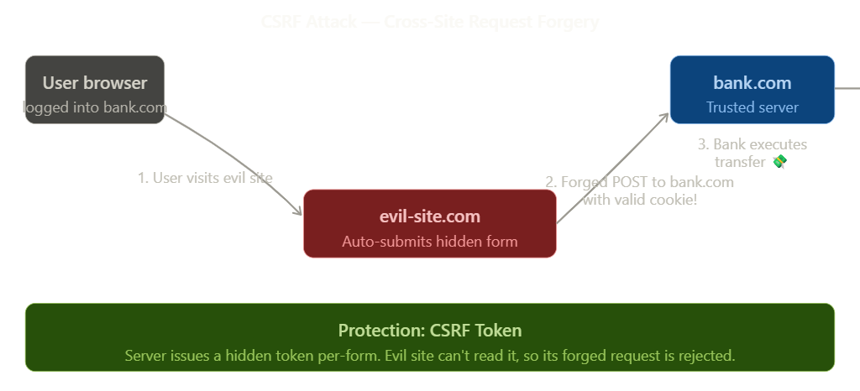
How a CSRF Attack Works (Step by Step):
- User logs into bank.com and gets a valid session cookie (JSESSIONID)
- User (still logged in) visits evil-site.com in another tab
- evil-site.com has a hidden form: <form action="https://bank.com/transfer" method="POST">
- The form auto-submits via JavaScript — browser sends the POST WITH the valid bank.com cookie!
- Bank sees a valid session → executes the transfer 💸

Key insight:
The browser automatically attaches the cookie. The attacker never needs to SEE the cookie. They just exploit the browser's behavior.

CSRF Protection — How it works:
The server generates a unique, random CSRF token per session and embeds it in the HTML form. The attacker's evil site cannot read this token (same-origin policy). So when the forged request arrives without the token, the server rejects it.
// Spring Security CSRF token in a form (Thymeleaf):
<form method="POST" action="/transfer">
<input type="hidden" th:name="${_csrf.parameterName}" th:value="${_csrf.token}"/>
<!-- form fields -->
</form>

When to disable CSRF in Spring Security:
CSRF protection should be DISABLED for stateless REST APIs that use JWT (no cookies = no CSRF risk). Keep it ENABLED for traditional web apps that use session cookies.
// Spring Security — disable CSRF for REST API:
http.csrf(csrf -> csrf.disable());

// Spring Security — keep CSRF enabled (default for web apps):
// Don't call csrf.disable() — it's on by default

CORS — Cross-Origin Resource Sharing
What is CORS?
CORS is a browser security mechanism, NOT an attack. The browser blocks JavaScript from making requests to a different origin (domain/port/protocol) than the current page — unless the server explicitly allows it.
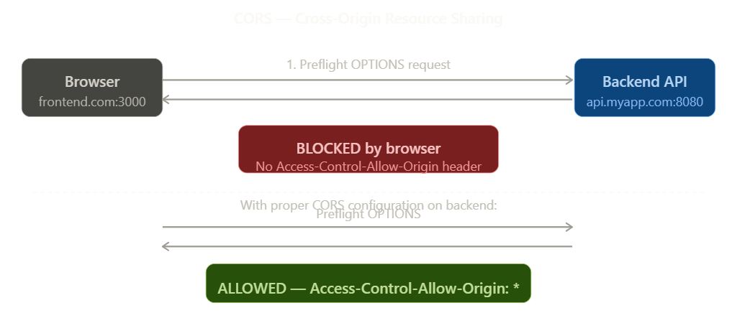

An "origin" is the combination of: protocol + domain + port
https://frontend.com:3000 ← this is one origin
https://api.myapp.com:8080 ← this is a different origin

// Same origin: no restriction
https://myapp.com → https://myapp.com/api/users ✅ allowed

// Cross origin: CORS policy applies
https://frontend.com:3000 → https://api.myapp.com:8080 ❌ blocked by browser

How CORS Works:
- Browser sends a "preflight" OPTIONS request to the API server
- If server responds with Access-Control-Allow-Origin header → browser allows the actual request
- If server does NOT send the header → browser blocks the response (server received it, but JS can't read it)

Common misconception:
CORS is enforced by the BROWSER, not the server. The server still receives and processes the request. CORS only prevents the browser's JavaScript from reading the response.

CORS Configuration in Spring Security:
@Configuration
public class SecurityConfig {

@Bean
public SecurityFilterChain filterChain(HttpSecurity http) throws Exception {
http
.cors(cors -> cors.configurationSource(corsConfigurationSource()))
.csrf(csrf -> csrf.disable()); // For REST APIs
return http.build();
}

@Bean
public CorsConfigurationSource corsConfigurationSource() {
CorsConfiguration config = new CorsConfiguration();
config.setAllowedOrigins(List.of("https://frontend.com"));
config.setAllowedMethods(List.of("GET", "POST", "PUT", "DELETE"));
config.setAllowedHeaders(List.of("Authorization", "Content-Type"));
config.setAllowCredentials(true);

UrlBasedCorsConfigurationSource source = new UrlBasedCorsConfigurationSource();
source.registerCorsConfiguration("/**", config);
return source;
}
}

CSRF vs CORS — Key Differences:
CSRF | CORS
An ATTACK exploiting cookies | A BROWSER POLICY blocking cross-origin requests
Attacker uses victim's cookies | Prevents JS from reading cross-origin responses
Requires the user to be logged in | Applies to all cross-origin JS requests
Fix: CSRF token in each request | Fix: Server sends Allow-Origin headers
Server-side protection | Server tells browser what is allowed
Disable for JWT APIs (no cookies) | Configure for every cross-origin frontend

Key Points to Remember
Authentication vs Authorization
- AuthN = identity verification (401 if fails)
- AuthZ = permission check (403 if fails)
- AuthN always comes BEFORE AuthZ

Stateless vs Stateful
- Stateful = server stores session → scales poorly, great for web apps
- Stateless = JWT token carries everything → scales well, used in REST APIs
- Spring Security default = stateful (JSESSIONID cookie)
- For REST APIs → use STATELESS session policy + JWT

Session / Cookie / Token
- Session = server-side data store
- Cookie = browser sends it automatically (used for session ID)
- JWT = signed token, client sends manually in Authorization header
- JWT payload is readable (Base64), NOT encrypted
- Always set HttpOnly + Secure on cookies

CSRF
- Forged request from evil site using victim's session cookie
- Spring Security enables CSRF protection by default
- DISABLE CSRF only for stateless REST APIs (JWT APIs don't use cookies)
- Enable CSRF for any app that uses session cookies

CORS
- Browser blocks cross-origin JS requests by default
- Fix: backend sends Access-Control-Allow-Origin header
- CORS is a browser policy, NOT a server restriction
- Use cors() configuration in Spring Security's SecurityFilterChain

Spring Security Notes — Topic 1 Complete | Phase 1: Foundations

