Spring Security Notes
Topic 2: How Spring Security Works Internally
Phase 1 — Foundations

Overview — The Big Picture
When an HTTP request arrives, it does NOT go directly to your Spring controller. It first passes through a pipeline of security filters. Understanding this pipeline is the foundation of everything in Spring Security.
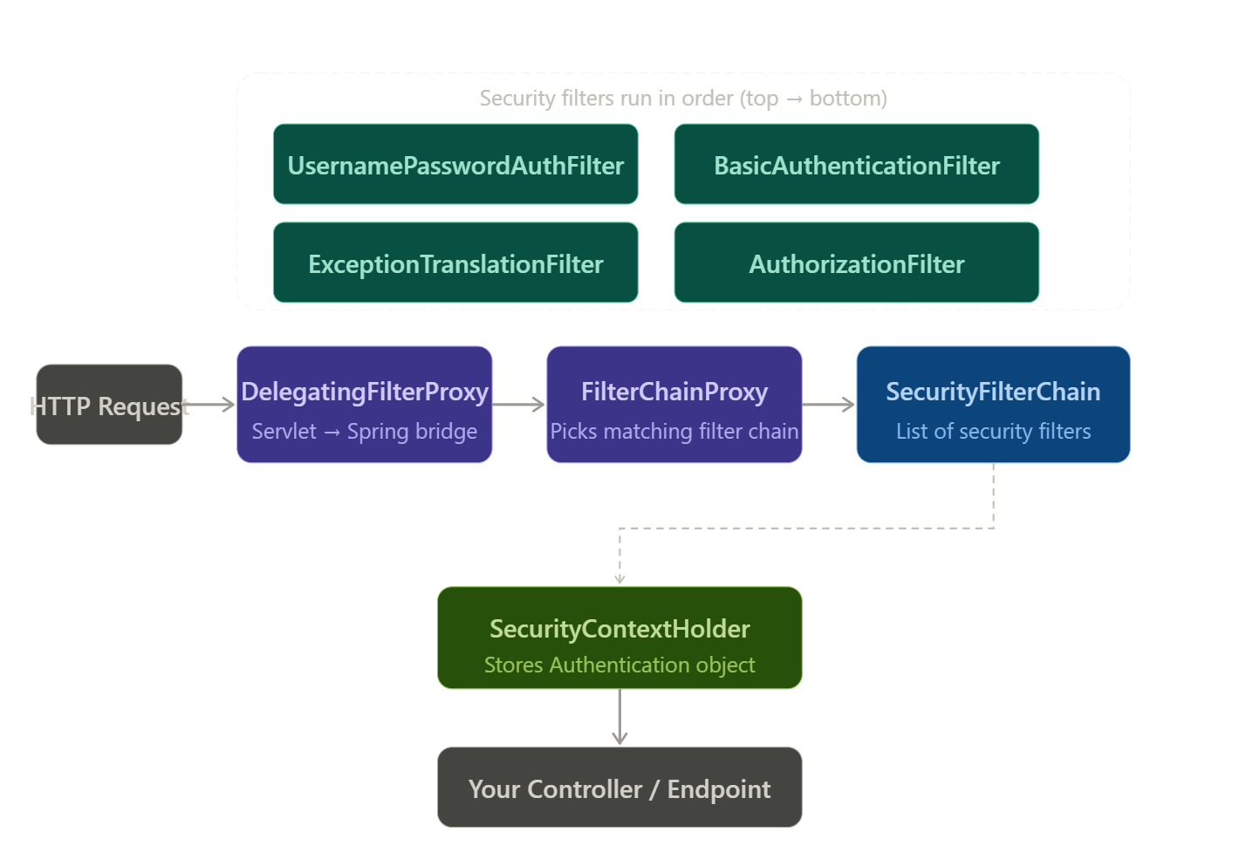

Request Journey (simplified):
HTTP Request
→ DelegatingFilterProxy (Servlet container bridge)
→ FilterChainProxy (Spring bean, picks the right chain)
→ SecurityFilterChain (ordered list of security filters)
→ SecurityContextHolder (authentication stored here)
→ Your Controller (request reaches here only if all filters pass)

1. Security Filter Chain
The SecurityFilterChain is an ordered list of javax.servlet.Filter implementations. Every HTTP request matching the chain's URL pattern is processed by each filter in sequence.

How it works:
- Each filter does its job and then calls chain.doFilter() to pass to the next filter
- If a filter decides the request is invalid (e.g. not authenticated), it short-circuits — returns an error response without calling the next filter
- You define your SecurityFilterChain as a Spring @Bean
- You can have multiple SecurityFilterChain beans — each matched to different URL patterns

Basic Configuration:
@Configuration
@EnableWebSecurity
public class SecurityConfig {

@Bean
public SecurityFilterChain filterChain(HttpSecurity http) throws Exception {
http
.authorizeHttpRequests(auth -> auth
.requestMatchers("/public/**").permitAll()
.requestMatchers("/admin/**").hasRole("ADMIN")
.anyRequest().authenticated()
)
.formLogin(Customizer.withDefaults()) // enables form login
.csrf(Customizer.withDefaults()); // CSRF on by default
return http.build();
}
}

Key point:
The order of filters is fixed and managed by Spring Security. You do NOT define which filters run by listing them — you configure BEHAVIOR (formLogin, csrf, etc.) and Spring inserts the correct filters automatically.

2. Filters Overview
Spring Security has 30+ built-in filters. You need to know the most important ones and their order. Filters run top to bottom.
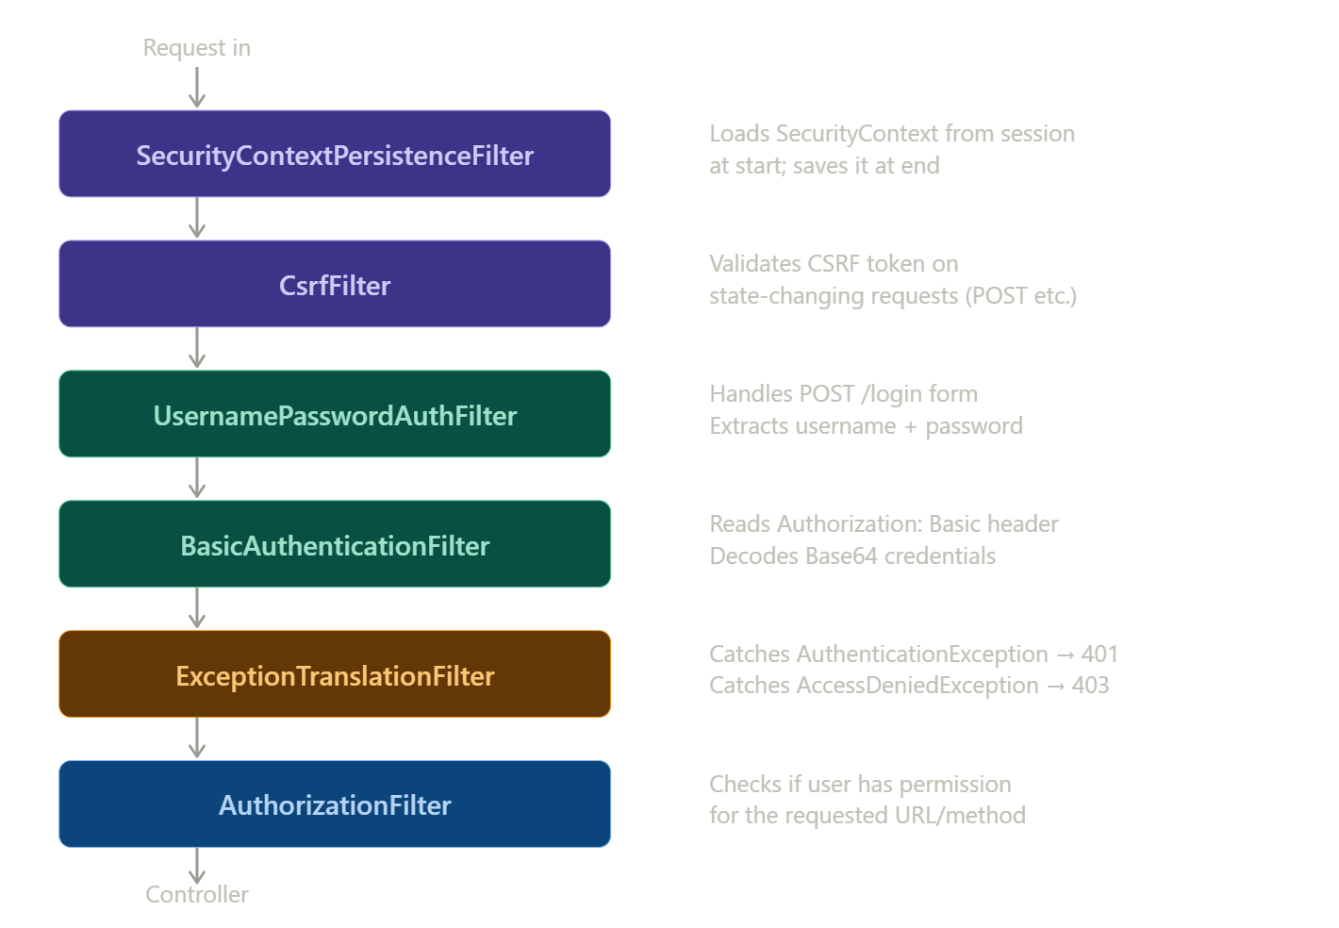

Filter | Purpose | Triggered by
SecurityContextPersistenceFilter | Loads SecurityContext from session at request start; saves it back at end | Every request
CsrfFilter | Validates CSRF token on POST/PUT/DELETE requests | State-changing requests
UsernamePasswordAuthenticationFilter | Handles form login (POST /login). Extracts username + password, triggers authentication | POST /login only
BasicAuthenticationFilter | Reads Authorization: Basic header, decodes Base64 credentials | Requests with Basic auth header
BearerTokenAuthenticationFilter | Reads Authorization: Bearer header, validates JWT token | Requests with Bearer token
RememberMeAuthenticationFilter | Checks remember-me cookie, auto-authenticates if valid | Requests with remember-me cookie
AnonymousAuthenticationFilter | Sets anonymous Authentication if no auth found yet | Unauthenticated requests
ExceptionTranslationFilter | Converts AuthenticationException → 401, AccessDeniedException → 403 | When exceptions thrown downstream
AuthorizationFilter | Checks if authenticated user has permission for the URL | Every request (last security filter)

The Two Most Important Filters in Detail:

UsernamePasswordAuthenticationFilter
- Intercepts only POST /login — no other URL
- Extracts username and password from the request body
- Creates an unauthenticated UsernamePasswordAuthenticationToken
- Passes it to AuthenticationManager for validation
- On success: stores Authentication in SecurityContextHolder, redirects to success URL
- On failure: redirects to login page with error

ExceptionTranslationFilter
- Wraps the AuthorizationFilter — catches any security exceptions thrown downstream
- AuthenticationException → sends 401 Unauthorized → triggers AuthenticationEntryPoint
- AccessDeniedException → sends 403 Forbidden → triggers AccessDeniedHandler
- This is why you never need try/catch for security exceptions in your own code

Interview tip:
When asked 'what happens when a user tries to access a protected URL without logging in?'
Answer: AuthorizationFilter throws AccessDeniedException → ExceptionTranslationFilter catches it → checks if user is anonymous → if yes, redirects to login page (triggers AuthenticationEntryPoint).

3. DelegatingFilterProxy
This is the glue between the Servlet container (Tomcat) and the Spring ApplicationContext. It solves a fundamental lifecycle problem.
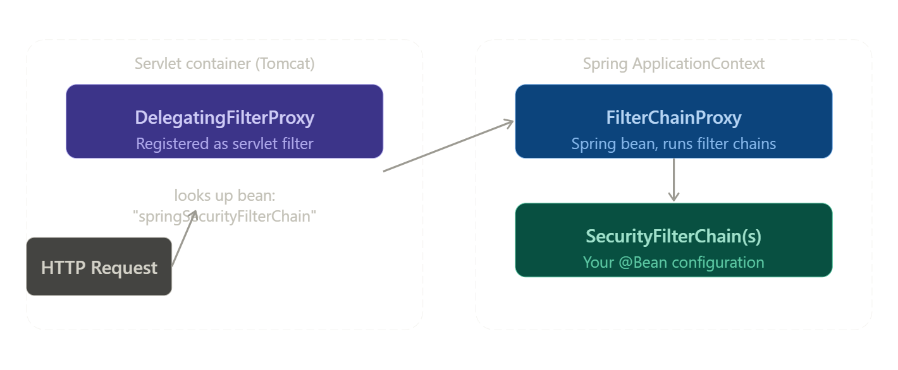

The Problem it Solves:
- Tomcat starts and registers servlet filters BEFORE Spring's ApplicationContext is ready
- So Tomcat cannot directly use Spring beans as servlet filters
- DelegatingFilterProxy is a plain servlet filter (Tomcat can use it) that internally holds a reference to a Spring bean

How it works:
// DelegatingFilterProxy is auto-registered by Spring Boot.
// It holds the bean name: "springSecurityFilterChain"
// On first request, it looks up that bean from ApplicationContext
// Then delegates ALL filter work to it.

// You never write this code yourself — Spring Boot does it automatically.
// This is what happens behind the scenes:

public class DelegatingFilterProxy implements Filter {
private Filter delegate; // = FilterChainProxy bean

public void doFilter(request, response, chain) {
// lazily looks up 'springSecurityFilterChain' bean
this.delegate = applicationContext.getBean("springSecurityFilterChain");
delegate.doFilter(request, response, chain);
}
}

DelegatingFilterProxy | FilterChainProxy
Lives in Servlet container | Lives in Spring ApplicationContext
Registered with Tomcat | A normal Spring @Bean
Just a thin wrapper / proxy | Does the actual security work
Auto-configured by Spring Boot | You configure via SecurityFilterChain @Bean
Named 'springSecurityFilterChain' | Holds all SecurityFilterChain instances

4. SecurityContext & SecurityContextHolder

SecurityContextHolder
The central store for the currently authenticated user's information during a request. It uses ThreadLocal storage — meaning each thread (each HTTP request) has its own independent copy.
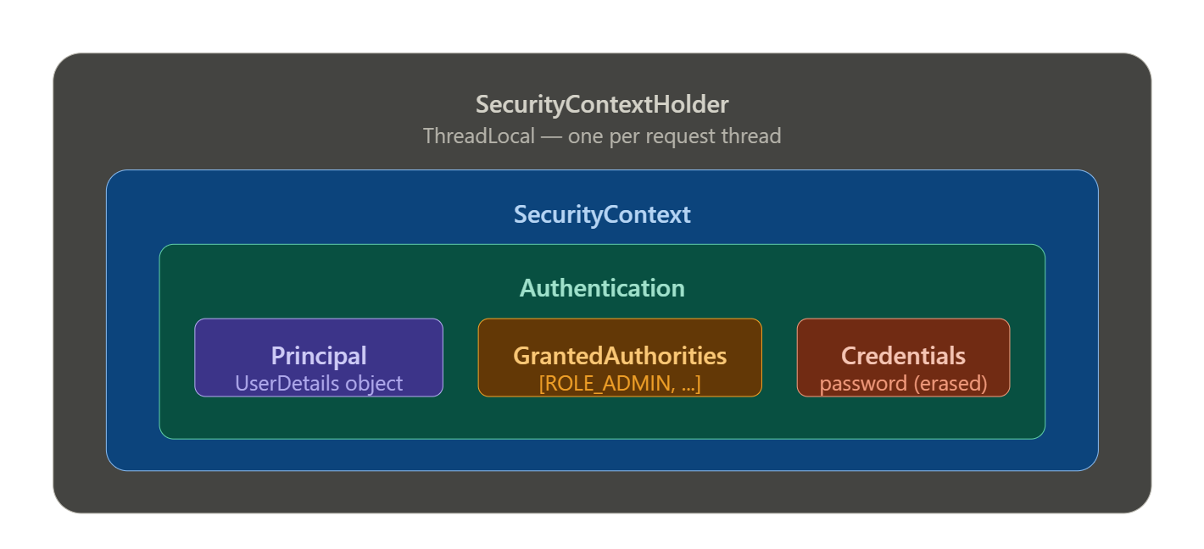

// Reading the current user from anywhere in your code:
Authentication auth = SecurityContextHolder.getContext().getAuthentication();

String username = auth.getName(); // "john"
Object principal = auth.getPrincipal(); // UserDetails object
boolean isAuthed = auth.isAuthenticated(); // true
Collection<? extends GrantedAuthority> roles = auth.getAuthorities();
// → [ROLE_ADMIN, ROLE_USER]

Reading in a Controller (cleaner way):
@GetMapping("/profile")
public ResponseEntity<String> getProfile(@AuthenticationPrincipal UserDetails user) {
return ResponseEntity.ok("Hello " + user.getUsername());
}

// Or using Authentication directly:
@GetMapping("/me")
public ResponseEntity<String> me(Authentication auth) {
return ResponseEntity.ok("Logged in as: " + auth.getName());
}

Setting Authentication Manually (used in JWT filters):
// After validating a JWT token, you manually set the Authentication:
UserDetails userDetails = userDetailsService.loadUserByUsername(username);

UsernamePasswordAuthenticationToken authToken =
new UsernamePasswordAuthenticationToken(
userDetails, // principal
null, // credentials (null after auth)
userDetails.getAuthorities() // roles
);

SecurityContextHolder.getContext().setAuthentication(authToken);
// Now Spring Security knows who the user is for this request

Clearing the Context:
// Always clear context on logout or after async processing:
SecurityContextHolder.clearContext();

ThreadLocal warning:
SecurityContextHolder uses ThreadLocal by default. This means the security context is tied to the current thread.
In async code (@Async, CompletableFuture, reactive), the security context is NOT automatically propagated to new threads.
Fix: use SecurityContextHolder.setStrategyName(SecurityContextHolder.MODE_INHERITABLETHREADLOCAL)
Or manually pass the context to child threads.

SecurityContext Lifecycle per Request:
- Request arrives → SecurityContextPersistenceFilter loads context from session (or creates empty)
- Filters run → authentication filter populates the context with Authentication object
- Controller runs → you read the context to get the current user
- Response sent → SecurityContextPersistenceFilter saves context back to session (stateful) or discards it (stateless)

5. Authentication vs Principal vs GrantedAuthority
These three objects live inside the SecurityContext and represent different layers of identity information.
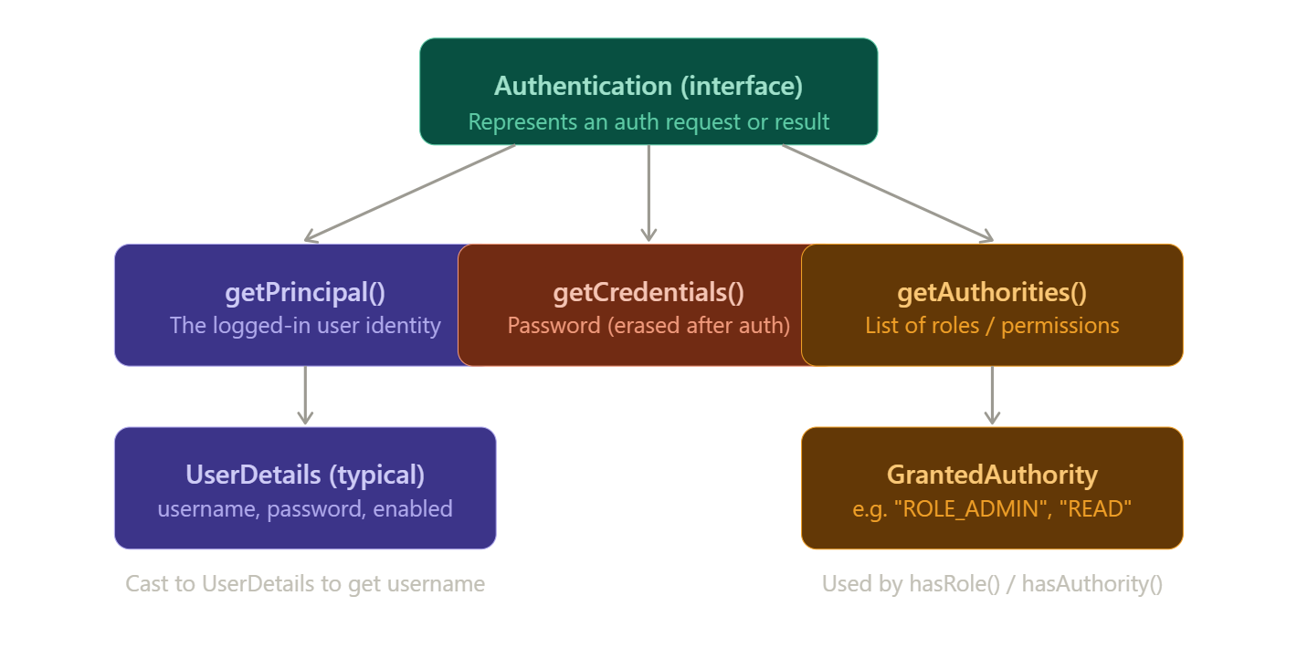

Authentication (interface)
The top-level object. It represents either an authentication request (before login) or an authenticated result (after login). It has three key methods:

public interface Authentication extends Principal, Serializable {
Object getPrincipal(); // WHO the user is
Object getCredentials(); // HOW they proved identity
Collection<? extends GrantedAuthority> getAuthorities(); // WHAT they can do
boolean isAuthenticated(); // is this a valid auth?
void setAuthenticated(boolean isAuthenticated);
}

Principal — getPrincipal()
- Represents the identity of the logged-in user
- Usually returns a UserDetails object (cast it to access username, roles etc.)
- Can also be just a String (username) if you use simple in-memory auth
- Use @AuthenticationPrincipal in controllers to inject it directly

// Getting principal as UserDetails:
UserDetails user = (UserDetails) auth.getPrincipal();
String username = user.getUsername();
boolean enabled = user.isEnabled();

// Shortcut in controller:
@GetMapping("/hello")
public String hello(@AuthenticationPrincipal UserDetails user) {
return "Hi " + user.getUsername();
}

Credentials — getCredentials()
- The password or token used to prove identity
- Spring Security ERASES this immediately after successful authentication
- Always null after login — this is intentional for security
- You should never need to read credentials in your own code

GrantedAuthority — getAuthorities()
- A list of permissions/roles assigned to the user
- Each GrantedAuthority is just a String — e.g. "ROLE_ADMIN", "ROLE_USER", "READ_ORDERS"
- hasRole("ADMIN") → Spring internally checks for "ROLE_ADMIN" (adds ROLE_ prefix)
- hasAuthority("ROLE_ADMIN") → checks for exact string (no prefix added)
- hasAuthority("READ_ORDERS") → fine-grained permission, no prefix

// Implementing UserDetails — getAuthorities() example:
@Override
public Collection<? extends GrantedAuthority> getAuthorities() {
return roles.stream()
.map(role -> new SimpleGrantedAuthority("ROLE_" + role.getName()))
.collect(Collectors.toList());
}

// Using in SecurityFilterChain config:
.requestMatchers("/admin/**").hasRole("ADMIN") // checks ROLE_ADMIN
.requestMatchers("/api/**").hasAuthority("ROLE_USER") // exact match
.requestMatchers("/orders").hasAuthority("READ_ORDERS") // fine-grained

hasRole("ADMIN") | hasAuthority("ROLE_ADMIN")
Adds ROLE_ prefix automatically | Checks exact string as-is
Checks for "ROLE_ADMIN" | Checks for "ROLE_ADMIN"
Simpler syntax for roles | Required for non-ROLE_ permissions
Use for standard roles | Use for fine-grained authorities like READ, WRITE

6. Full Authentication Flow (Bonus — Internal Deep Dive)
This is what actually happens step by step when a user submits the login form. Understanding this flow is critical for interviews and for implementing custom authentication.
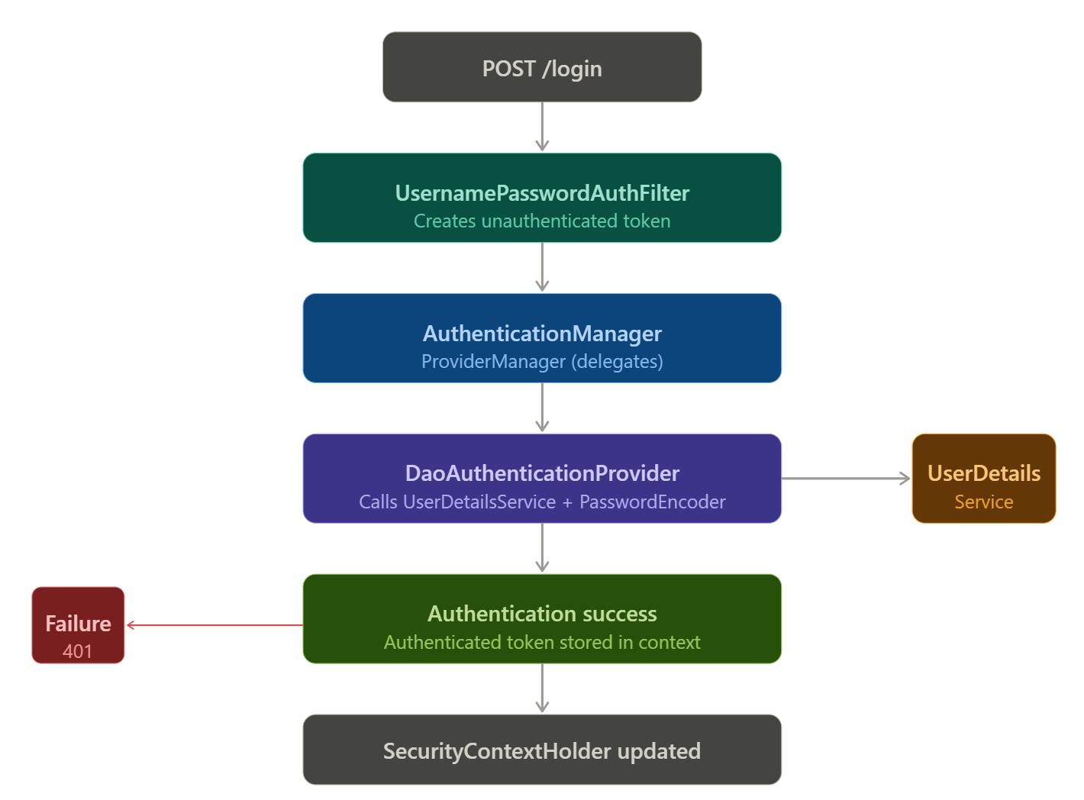

- Browser sends POST /login with username and password in request body
- UsernamePasswordAuthenticationFilter intercepts the request (only POST /login matches)
- Filter creates an unauthenticated token: new UsernamePasswordAuthenticationToken(username, password)
- Filter calls AuthenticationManager.authenticate(token)
- AuthenticationManager is actually ProviderManager — it loops through registered AuthenticationProviders
- DaoAuthenticationProvider handles the token — it calls UserDetailsService.loadUserByUsername(username)
- UserDetailsService loads the user from DB and returns a UserDetails object
- DaoAuthenticationProvider calls PasswordEncoder.matches(rawPassword, storedHash)
- If password matches: creates a fully authenticated token with authorities
- Authenticated token stored in SecurityContextHolder.getContext().setAuthentication(token)
- On success: redirect to the originally requested URL (or default success URL)
- On failure: AuthenticationFailureHandler is called → redirect to /login?error

// The classes involved in the flow:

UsernamePasswordAuthenticationFilter
→ AuthenticationManager (interface)
→ ProviderManager (implementation — loops through providers)
→ DaoAuthenticationProvider (handles username/password)
→ UserDetailsService.loadUserByUsername()
→ PasswordEncoder.matches()
→ (other providers: JwtAuthProvider, OAuth2Provider, etc.)
→ SecurityContextHolder.getContext().setAuthentication()

Why ProviderManager?
ProviderManager supports multiple authentication mechanisms simultaneously.
e.g. one provider handles form login, another handles JWT, another handles OAuth2.
Each provider declares what token type it supports via the supports() method.
ProviderManager loops through providers and uses the first one that supports the token type.

Key Points to Remember
Security Filter Chain
- Ordered list of filters — every request passes through them top to bottom
- Each filter calls chain.doFilter() to continue, or short-circuits to block
- You configure behavior (formLogin, csrf, etc.) — Spring inserts the correct filters

DelegatingFilterProxy
- Bridge between Tomcat (Servlet container) and Spring ApplicationContext
- Solves the bootstrap problem: Tomcat starts before Spring
- Delegates work to FilterChainProxy (a Spring bean named 'springSecurityFilterChain')
- Auto-registered by Spring Boot — you never configure it manually

Key Filters to Know (in order)
- SecurityContextPersistenceFilter → loads/saves SecurityContext from session
- CsrfFilter → validates CSRF token
- UsernamePasswordAuthenticationFilter → handles POST /login
- BasicAuthenticationFilter → handles Authorization: Basic header
- ExceptionTranslationFilter → converts exceptions to 401/403
- AuthorizationFilter → checks URL access permissions (last)

SecurityContextHolder
- ThreadLocal storage — one context per request thread
- Cleared at end of every request
- In async code — context is NOT auto-propagated to new threads
- Use SecurityContextHolder.getContext().getAuthentication() to read current user

Authentication Object — 3 key parts
- getPrincipal() → the user identity (usually UserDetails)
- getCredentials() → password (erased after authentication — always null)
- getAuthorities() → list of GrantedAuthority (roles and permissions)

hasRole vs hasAuthority
- hasRole("ADMIN") → checks for "ROLE_ADMIN" (ROLE_ prefix added automatically)
- hasAuthority("ROLE_ADMIN") → exact string match, no prefix added
- hasAuthority("READ") → for fine-grained permissions without ROLE_ prefix

Authentication Flow
- Filter → AuthenticationManager (ProviderManager) → DaoAuthenticationProvider
- → UserDetailsService.loadUserByUsername() → PasswordEncoder.matches()
- → Success: set in SecurityContextHolder | Failure: 401

Spring Security Notes — Topic 2 Complete | Phase 1: Foundations

