TO-DO-List(TO-DO-ListID, Kategorie)

Task(TaskID, Location, Priority, Description, Title, Date)

User(E-Mail, Passwort, UserID, To-DO-ListID, *TaskID*)

zugewiesen(*E-Mail*, *TaskID*)

freigegeben_für(*TO-DO-ListID, E-Mail,* RWX)

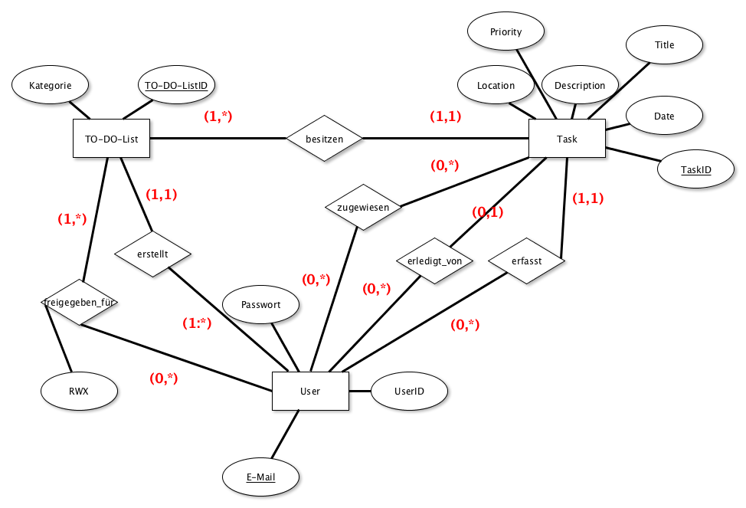

CREATE TABLE TO-DO-List(

(TO-DO-ListID INTEGER NOT NULL CONSTRAINT TO-DO-LIST_PK PRIMARY KEY,

KATEGORIE VARCHAR(255) NOT NULL,

)

CREATE TABLE freigeben_für(

RWX VARCHAR(255),

CONSTRAINT freigeben_PK PRIMARY KEY (TO-DO-ListID, E-Mail),

CONSTRAINT freigeben_TO-DO_FK FOREIGN KEY(TO-DO-ListID) REFERENCES TO-DO-List,

CONSTRAINT freigeben_User_FK FOREIGN KEY(E-Mail) REFERENCES User

)

CREATE TABLE User(

TaskID INTEGER NOT NULL CONSTRAINT Task_PK PRIMARY KEY,

Password INTEGER,

UserID VARCHAR(255)

)

CREATE TABLE Task(

TaskID INTEGER NOT NULL CONSTRAINT Task_PK PRIMARY KEY,

Location VARCHAR(255) NOT NULL,

Priority VARCHAR(255) NOT NULL,

Title VARCHAR(255) NOT NULL,

Date DATETIME NOT NULL,

)

Es fehlen noch einige Entitäten