# Press Wiz

## Helping System for Mega Café (Pvt) Ltd

SENG 21553-Software Modelling

SENG 21593 Interactive Application Design & Development

SENG 21553 Requirement Engineering & Management

**Student Group 11**

**Student No Name**

SE/2013/059 W. J. A. J. K. Wijesinghe

SE/2013/057 C. K. Kumar

SE/2013/042 M. K. P. I. Sewwandi

SE/2013/057 D. P. D. K. D. Premarathne

**Bachelor of Science Software Engineering**

**Department of Industrial Management**

**Faculty of Science**

**University of Kelaniya**

**Declaration by the Group Leader**

I hereby certify that no part of this assignment has been copied from any other student work or from any other source except where due acknowledgement is made in the assignment. No part of this assignment has been written/ produced for me by any other person except where such collaboration has been authorized by the subject lecturer/tutor concerned. I hold a copy of this assignment that I can produce if the original is lost or damaged.

**Student Number Signature**

SE/2013/059 ……………………………………..

**Note: An examiner or lecturer/tutor has the right not to mark this assignment if the above declaration has not been signed.**

Total marks out of 100:

Weighting considered for the continuation:

Assessment Lecturer’s/Tutor’s initials:

**Acknowledgements**

We take this opportunity to express our heartfelt gratitude and profound feeling to many people who lent us their helping hand in order to make our project success.

Table of Contents

**Type chapter title (level 1)1**

Type chapter title (level 2)2

Type chapter title (level 3)3

**Type chapter title (level 1)4**

Type chapter title (level 2)5

Type chapter title (level 3)6

**List of Tables**

1. Document Flow Diagram
2. BSO vs. Functional requirements
3. BSO vs. Non Functional requirements

**List of figures**

1. BAM
2. Context Diagram
3. Level 1 DFD
4. Level 2 DFD

1.0 Introduction

**Introduction**

Mega café printers are one of the famous printing shop in Dalugama area. They are looking for opportunities to improve their day today works efficiencies and enhance their services. Using new opportunities they can reduce cost without affecting customers and compete with their competitors.

The purpose of this system is fulfill the requirements of mega café printers. In this document mentioned requirement that we have identified. Mega café printers do their job using manual way and they don’t have any system. They hope to introduce new system for their business, because manually they cannot generate daily and monthly reports and analysis their business progress. And also approaching automated system they can reduce paper wastage.

**1.1 Project Background**

1. Mega Café (Pvt) Ltd.

Mega Café is a press + printers + Internet café type sole proprietor business in Dalugama, kelaniya. It mainly focuses on:

1. Wide format printouts (color/black and white)
2. Normal printouts (color/black and white)
3. Laser printouts (color/black and white)
4. Laminating
5. Photocopies
6. Graphic designing
7. Digital printing
8. Internet

These business was started in 2008 by Mr. Gumunu who is an Industrial Management graduate from , University of Kelaniya. (1999-2000 batch).

Most of the university students come to the mega café for their various printing purposes.

Mega café is run by the owner/ proprietor Mr. Gamunu and several staff members (3-8)

Customers hand over the files to be printed using pen drives, emails or in another appropriate manner, and they ask the staff to do the needful according to their particular purposes.

**1.2 Business Processes**

Presently the process goes on manually

As the customer hands over the file to be printed, the staff goes through it and ask for the requirements of the customer. Then they would do the needful using MS office word they set printout properties

In the case of color printouts they check the page to be printed then they calculate the price per page ,in this case they consider the white space ,black and the other colors separately .Basically they do this price calculation without using an appropriate method which requires some kind of experience

All the computers and printers that they have in the mega cafe, are interconnected to each other (network) through a switch. So that any file can be sent from any machine to any printer easily, this makes the process an efficient one

Files that are needed to be printed in color will be sent to color printing machine, others to black and white printer normally the Duplo machine, cartridges and toners will be replaced when needed, and also sheets are added if they are over. This process doesn’t create any problem because as they have cartridges toners and papers stocked.

**1.3 Problem Definition**

Several problems occurred in the current system are:

* Cost evaluation of a color print out is not efficient. If there are several pages with different colors .staff member has to go through each and every paper to calculate the price, this process cannot expected to be accurate most of the time.
* There is no proper way to record the prints they have done all through the day.
* No proper billing system.
* No way to know the inventory status.
* They have no proper way of getting daily/Monthly reports. Such as Number of pages printed, the number wasted (color B/W).
* No Basic Inventory status. Machines, Cartridges, toners, Papers
* They have no proper way to keep up customer records.
* They might need an appropriate method to calculate the actual number pages which have been sent to a printer or to another computer from each computer, as well as the number of pages that have been printed by each printer within the period of interest.
* Same customer in the morning and the afternoon.

**1.4 Aims and Objectives of the Proposed System**

The objectives to develop System are:

* To help the managing the ordering schedule. It's includes the functions to record about keeping, and add information that will be recorded within time to time.
* To help creating a paper - less environment by storing the data in the computer- based system. Therefore, the paper usage can be reduced.
* Customers can get efficient service
* Generate reports is very easy
* Minimize human errors

**1.5 Scope with Clear Boundaries**

This system will not cover full process of the printing, but it will help to improving overall business. And also if we get success in our app it will be a huge market for the Mega Café.

This system handles aspects of inventory control functions and staff can easily handle their recodes and analysis their business progress. This system also cover the part of the job of staff member’s and it helps to reduce time wastage.

**1.6 Organization of the Report**

There are three major parts which are described in this report here onwards. They are,

* System Analysis
* System Design
* GUI

System Analysis contains all the facts gathering techniques and the products of SSADM for the existing system and the proposed system. The Business Activity Model (BAM) for the proposed system is shown first. Then Context Diagram, Document Flow Diagram, Lower Level DFDs. After that several Business System Options (BSOs) are introduced

System Design contains the use case diagram, activity diagrams, class diagram and the sequences diagram.

GUI includes the pictures of the interfaces we have developed in the implemented Visual Basic.Net using C# language.

2.0 System Analysis

**2.1 Fact Gathering Techniques used and Findings**

When we were searching for a proper organization to design the system as we came up with Mega café pvt ltd which is located in Dalugama, Kelaniya. We visited the place and discussed the issues which are occurring in current manual system.

**2.1 Business Activity Model**

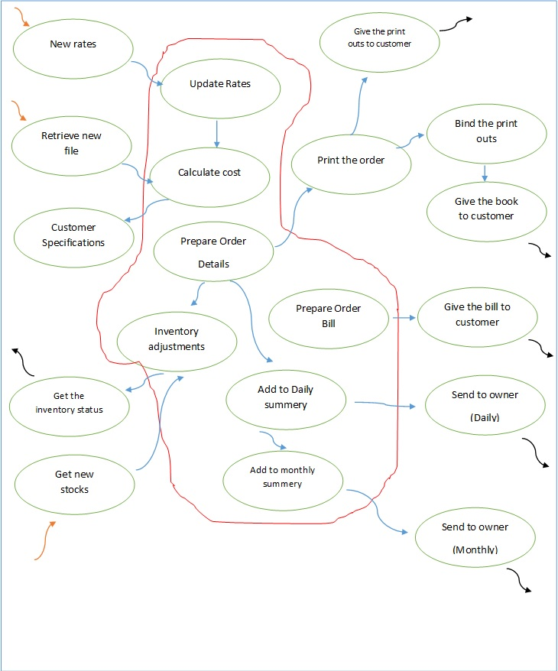

**2.2 Context Diagram**

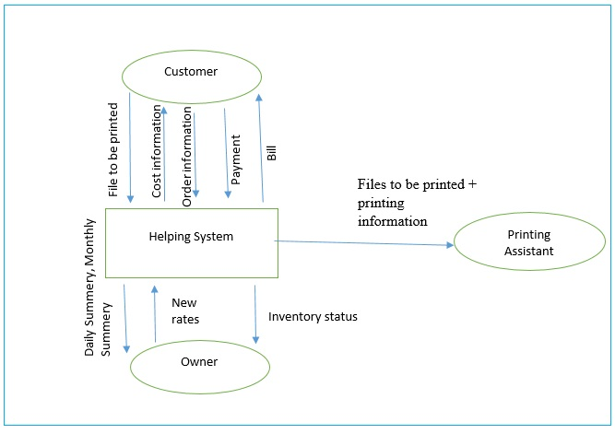

**2.3 Document Flow Diagram**

|  |  |  |
| --- | --- | --- |
| **Sources** | **Document** | **Recipient** |
| Customer | Provide pen drive | Employee |
| Employee | Get printouts | Customer |
| Employee | Provide payment details | Customer |
| Customer | Make payments | Employee |
| Employee | Provide bill | Customer |
| Employee | Create monthly report | Owner |
| Suppliers | Make orders | Owner |
| Owner | Make payment | Suppliers |
| Employee | Audits inventory status | Owner |
| Supplier | Provide order | Owner |

**Level 1 DFD**

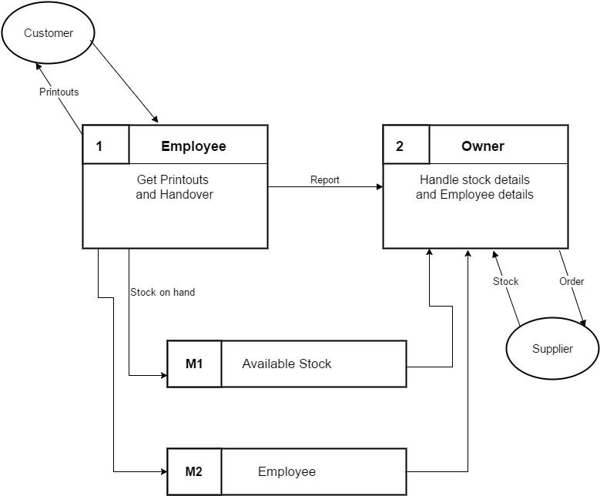

**Level 2 DFD**

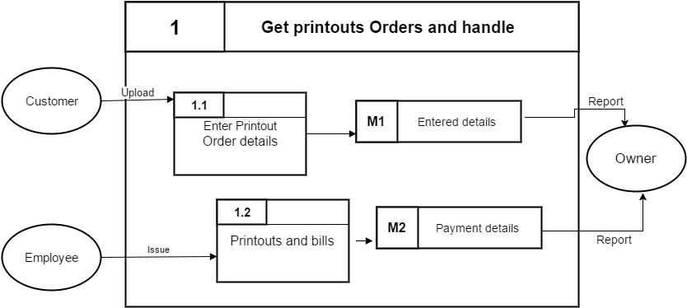

3.0 **Software Requirement Specifications**

**3.1 Functional requirements**

* Shall be able to upload documents
* Shall be able to keep payment recodes
* Shall be able to calculate total amounts
* Shall be able to generate daily, weekly and monthly reports
* Shall be able to keep supplier details
* Shall be able to keep purchase details
* Shall be able to keep order details
* Shall be able to keep stock details
* Should be able to keep staff member details
* Should be able to keep regular customer details
* Should facilitate find regular supplier details
* Should facilitate find regular purchasing
* Should facilitate find efficient staff members
* Should be able to keep job numbers with staff member number
* Should facilitate online services

**3.2 Nonfunctional requirements**

**Performance Requirements**

* Shall be able to provide a user friendly GUI
* Shall be able to run on existing operating system
* Should provide mobile app
* Should provide web interface

**Security Requirements**

* Shall be able to provide login system according to the user
* Should provide security for online transaction

**Safety Requirements**

* Shall be able to get backup using database

**3.3 Business System Options (BSO)**

|  |  |  |  |
| --- | --- | --- | --- |
| Requirement | BSO 1 | BSO 2 | BSO 3 |
| * Shall be able to upload documents | x | x | x |
| * Shall be able to keep payment recodes | x | x | x |
| * Shall be able to calculate total amounts | x | x | x |
| * Shall be able to generate daily, weekly and monthly reports | x | x |  |
| * Shall be able to keep supplier details | x |  |  |
| * Shall be able to keep purchase details | x | x |  |
| * Shall be able to keep order details | x | x |  |
| * Shall be able to keep stock details | x | x | x |
| * Should be able to keep staff member details | x | x | x |
| * Should be able to keep regular customer details | x |  |  |
| * Should facilitate find regular purchasing | x | x | x |
| * Should facilitate find efficient staff members | x | x | x |
| * Should be able to keep job numbers with staff member number |  |  |  |
| * Should facilitate online services |  |  |  |
| * Should facilitate find regular supplier details |  |  |  |

4.0 System Design

* 1. **Use case diagram**

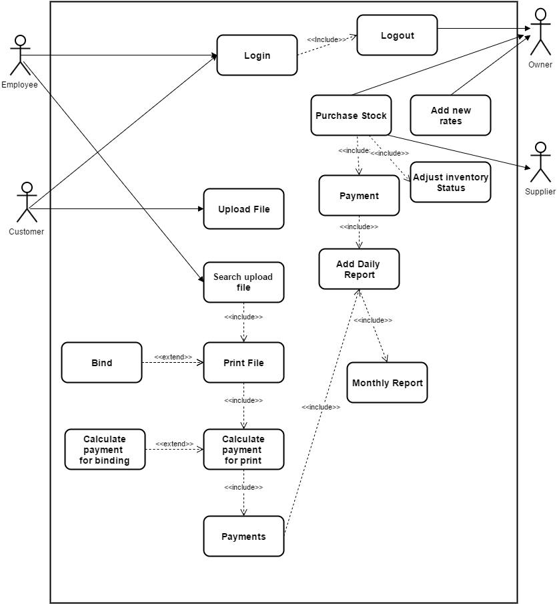

* 1. **Activity Diagrams**
     1. **Login to the main**

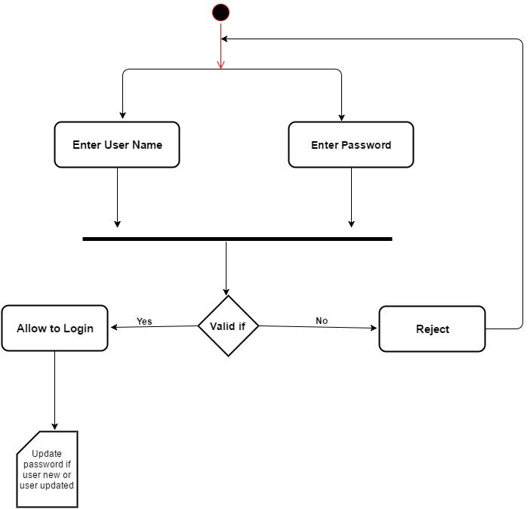

* + 1. 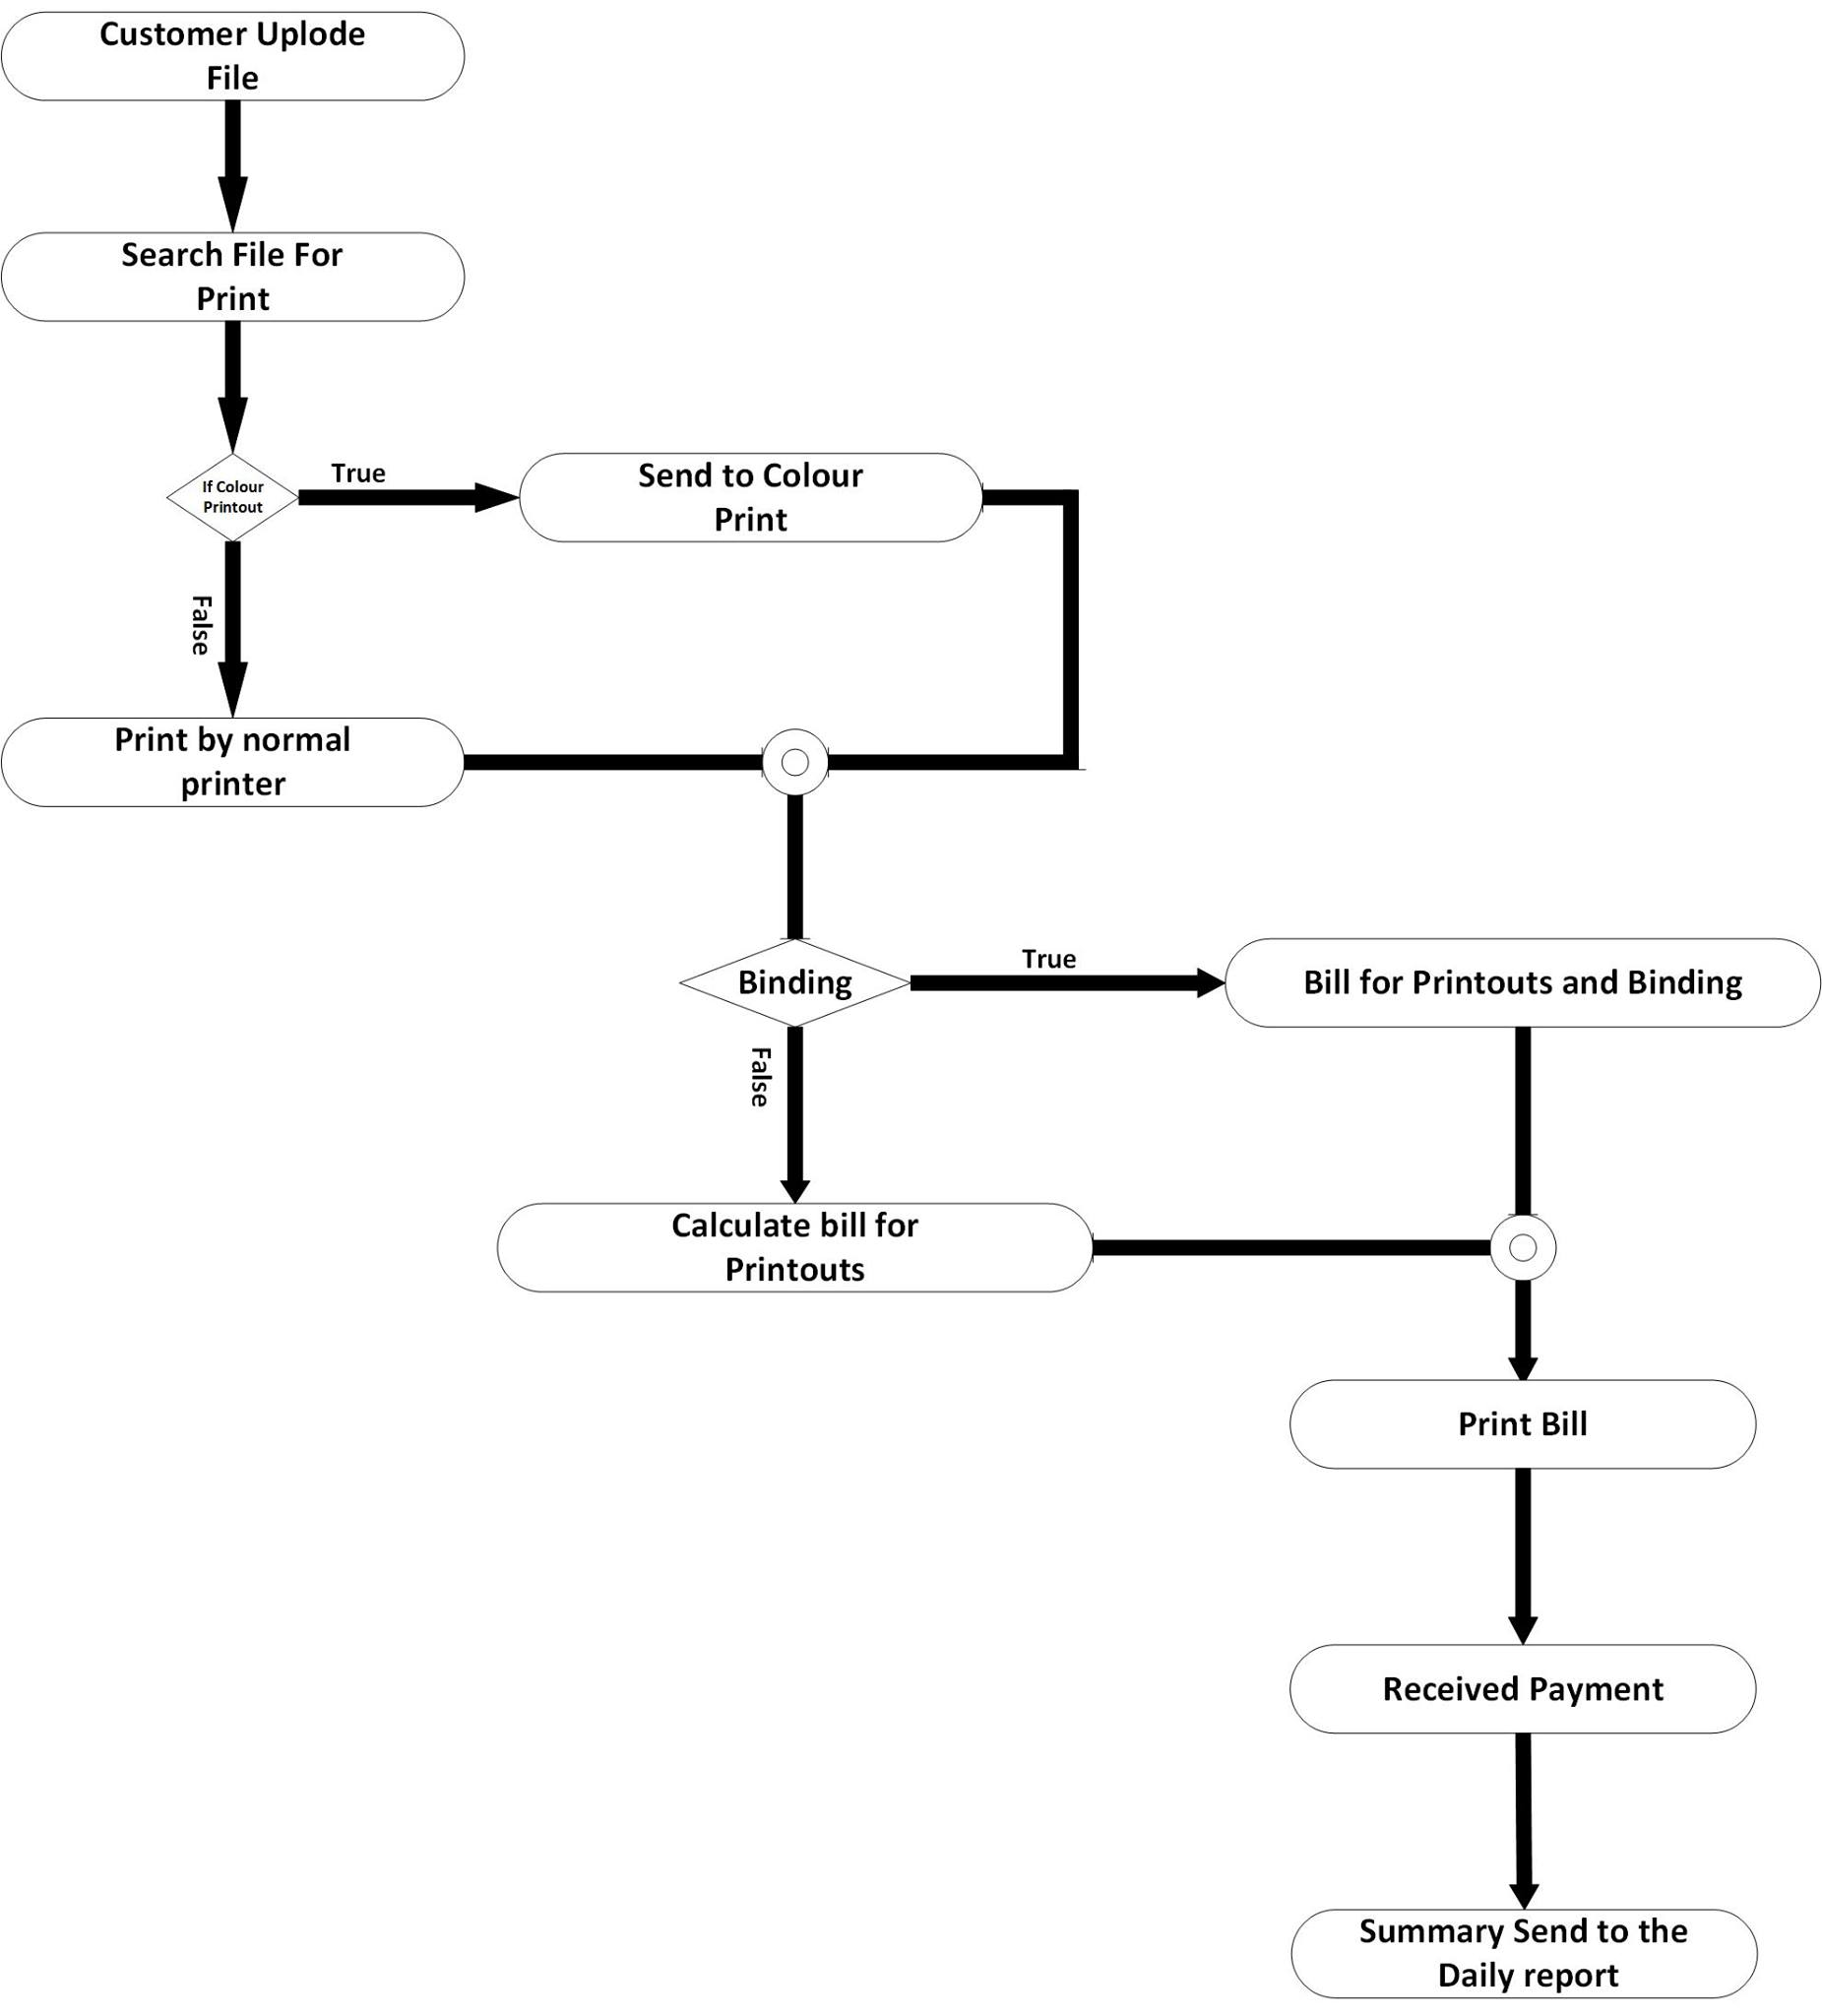**Upload files ,get printouts**
  1. 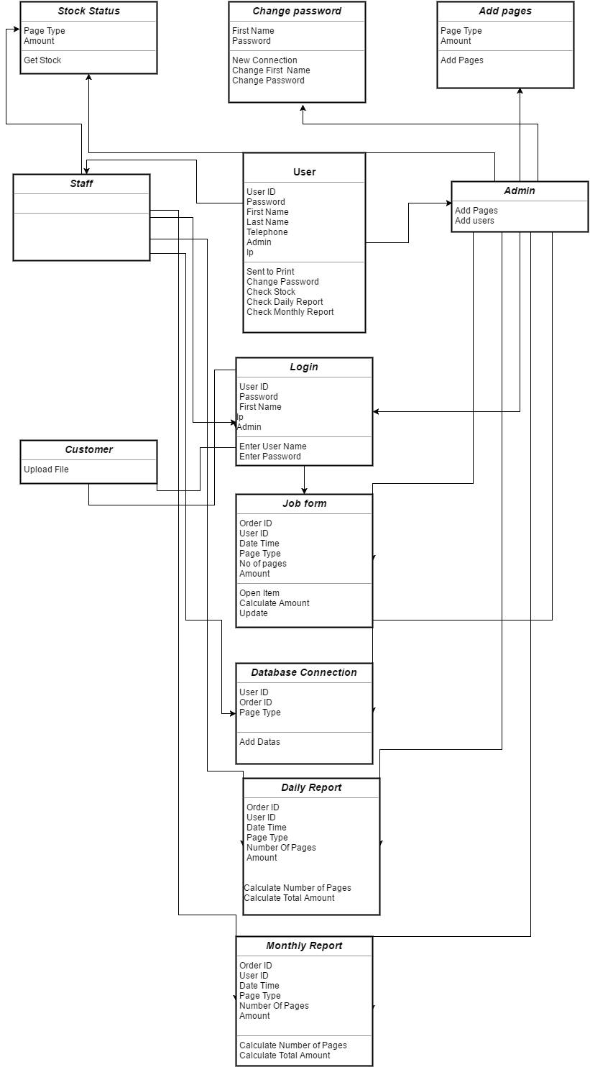**Class Diagram**
  2. **Sequence Diagram**

**4.4.1 Login to main**

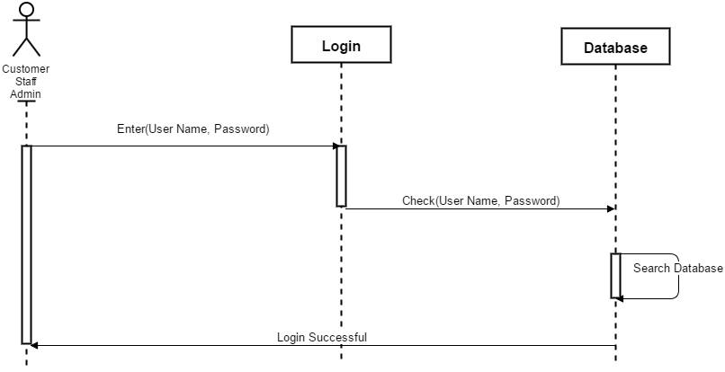

* + 1. **Upload file and get printouts**

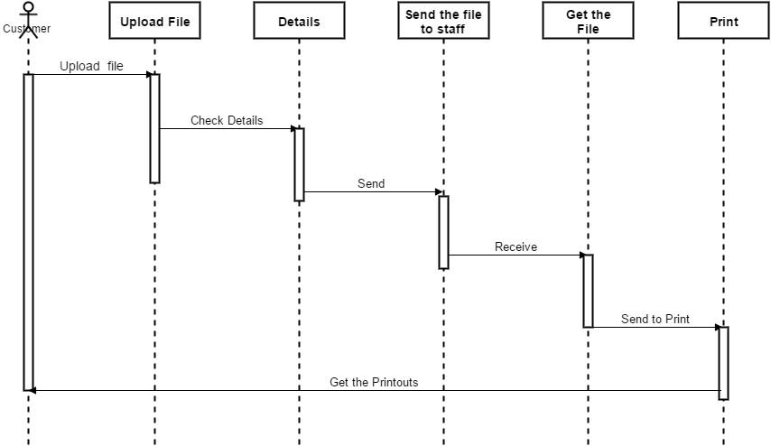

**5.0 GUI**

**Login Form**

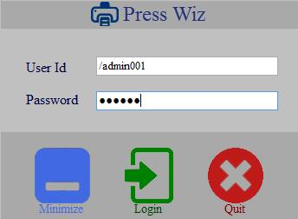

**Main Form**

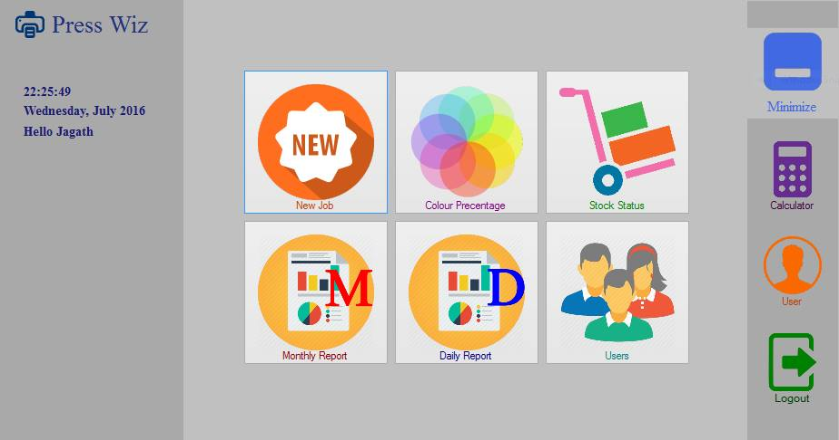

**Monthly report generate form**

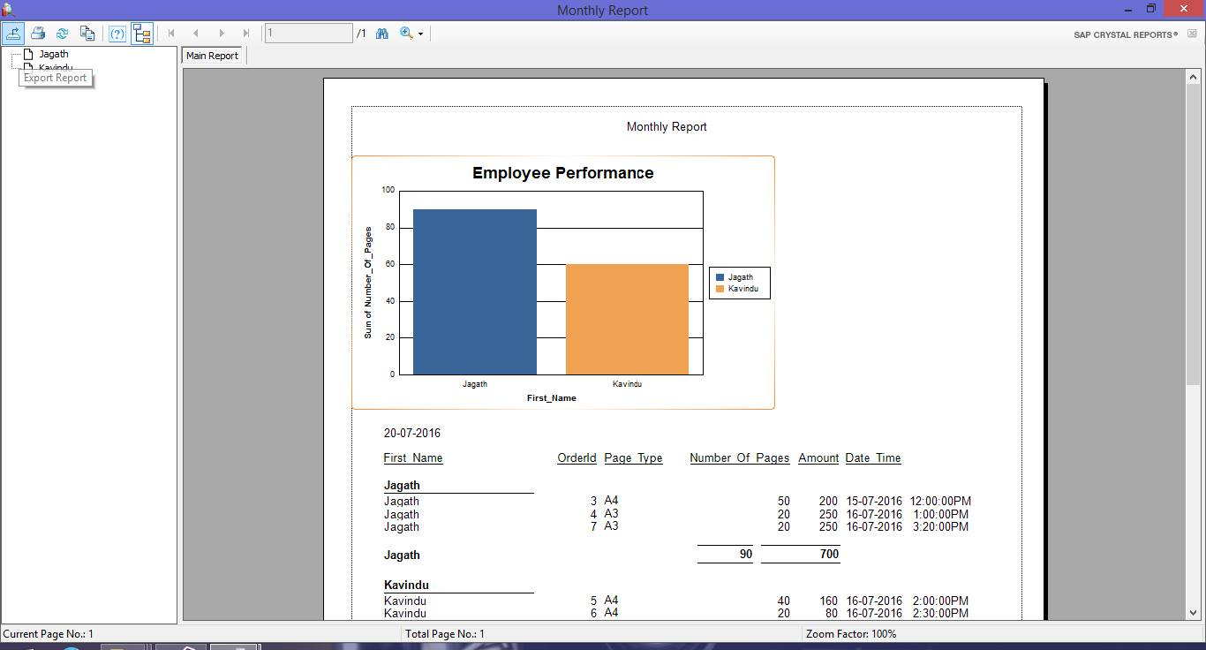

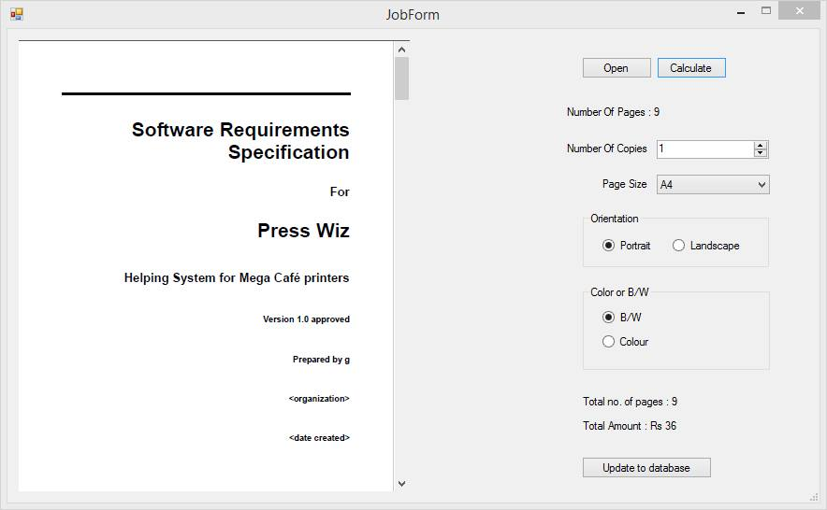**Job Form**

**Stock status**

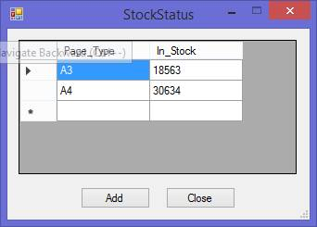

**Upload file form**

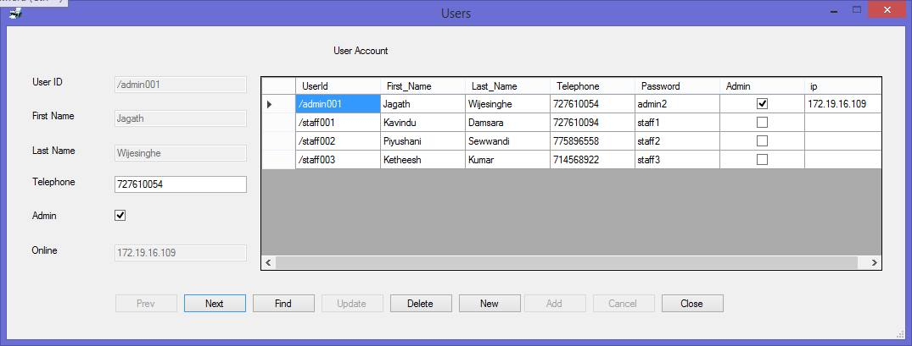

**Check color Range form**

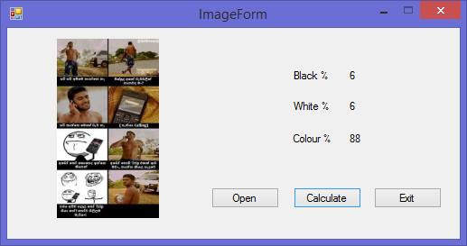

THANK YOU…!