Residential Delivery in Limerick
National context and county analysis, 2018–2026
Draft for discussion with Limerick City and County Council
Part A. Limerick in national context
Part B. Residential delivery in County Limerick, from planning application to completion

PART A
Limerick in national context
Where Limerick sits against Ireland and the other local authorities, 2018 to mid-2026

A1. Key findings
In brief
Of every 100 homes granted permission in Limerick since 2018, 71 have been started and 59 are finished. Ireland as a whole is at 83% started and 71% finished.
Limerick is 27th of 29 local authorities on starts and 26th on completions. Once a scheme starts, Limerick finishes 84% of its units against 86% nationally, so the gap opens before work begins.

Limerick grants below the national rate per head. 9,963 units were granted from Q1 2018 to Q2 2026, which ranks 12th of 29 in total. Per 1,000 residents the rate is 48 against 61 for Ireland, 14th of 29. Ten authorities are above the national rate: Dún Laoghaire-Rathdown, Fingal, Dublin City, Wicklow, Louth, Meath, Cork, Westmeath, Kildare and Laois.
The shortfall is in starts. 7,042 units, 71% of those granted, have a commencement notice. The national figure is 83%. Limerick is 27th of 29, ahead of only Westmeath and Dublin City.
Once started, Limerick builds at close to the national rate. 5,901 units have been completed, 84% of those commenced against 86% for Ireland (24th of 29).
Recent permissions do not explain the gap. Some of the 2025 and 2026 grants have not had time to start. Allowing for that, starts up to the end of 2025 are 83% of units granted up to the end of 2024 in Limerick, against 95% nationally (25th of 29). The completion gap narrows on the same test (87% against 91%, 21st).
Limerick is in the same band as Cork and Waterford, and behind Galway. Completed units as a share of those granted are 58% in Cork, 62% in Waterford and 59% in Limerick, against 76% in Galway.
Part B reaches the same conclusion from scheme-level data. It finds that permission takes about 7 months, but only 48% of permitted schemes start within two years and 72% within five.
Table A1. Limerick against Ireland
Measure | Limerick | Ireland | Limerick rank (of 29)
Population, Census 2022 | 209,536 | 5,149,139 | –
Units granted | 9,963 | 315,543 | 12th
Units granted per 1,000 residents | 47.5 | 61.3 | 14th
Units commenced | 7,042 | 262,542 | –
Commenced as % of granted | 71% | 83% | 27th
Units completed | 5,901 | 224,805 | –
Completed as % of commenced | 84% | 86% | 24th
Completed as % of granted | 59% | 71% | 26th
Commenced to end-2025 as % of granted to end-2024 | 83% | 95% | 25th
Completed to end-2025 as % of granted to end-2023 | 87% | 91% | 21st
Q1 2018 to Q2 2026 unless stated. Rank 1 is the highest value. Cork and Galway city and county are combined, as Limerick City and County is one authority.

A2. Scope and sources
Part A uses published national statistics for all 29 local authority areas, so that Limerick can be compared with every other area on the same basis. Part B follows individual schemes in Limerick. The two are complementary, and their totals will not match.
- Units granted: CSO table BHQ17, Planning Permissions Granted for New Houses and Apartments. Units for one-off houses, multi-development houses and apartments (updated 17 September 2026).
- Units commenced: CSO table HSM13, Commencement Notices, Department of Housing, Local Government and Heritage statistics hosted by the CSO. Number of residential units, including one-off units (updated 18 September 2026).
- Units completed: CSO table NDQ05, New Dwelling Completions, downloaded 9 October 2026.
- Population: CSO table FY003A, Census 2022 population by local authority.
All series run from Q1 2018 to Q2 2026. The three counts are measured separately and are not linked scheme by scheme, so a unit completed in 2024 may have been granted before 2018. That is why some authorities show more than 100%. Cork and Galway are combined because Limerick City and County is a single council. The four Dublin councils are shown separately.
Part B tracks 10,811 permitted units in 252 schemes up to September 2026 and excludes one-off houses. The CSO count for Limerick up to June 2026 is 9,963 units, of which 2,103 are one-off houses. Section 2.5 of Part B compares the two sources in more detail.

A3. How much is Limerick granting?
Limerick ranks 12th of 29 for units granted and 14th once population is taken into account. The big totals belong to Dublin City, Cork, Fingal and Dún Laoghaire-Rathdown. Wexford, Waterford and South Dublin are just ahead of Limerick, and Kilkenny and Galway just behind. Limerick is below the national rate of 61 units per 1,000 residents.
Figure A1. Units granted per 1,000 residents, Q1 2018 to Q2 2026
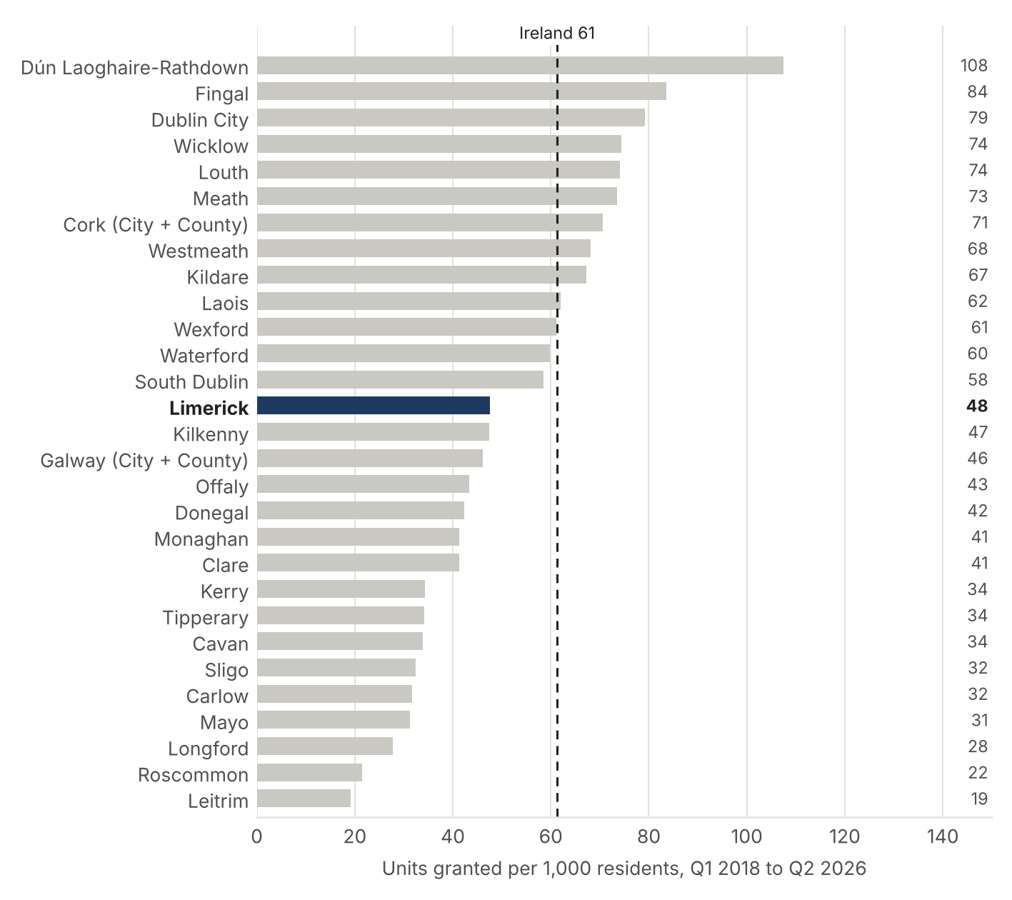
Units granted from BHQ17 divided by Census 2022 population from FY003A. Cork and Galway city and county combined.

A3.1 What kind of housing
Apartments make up 37% of units granted in Limerick against 49% nationally, and one-off houses 21% against 15%. Nationally the apartment share is pulled up by the Dublin councils and Cork. Per head, Limerick is ahead of the national rate for one-off houses and behind it for multi-development houses and apartments.
Table A2. Units granted by type of dwelling
Type | Limerick units | Limerick share | Limerick per 1,000 | Ireland per 1,000 | Limerick rank per 1,000
One-off houses | 2,103 | 21% | 10.0 | 9.4 | 18th
Multi-development houses | 4,154 | 42% | 19.8 | 22.1 | 14th
Apartments | 3,706 | 37% | 17.7 | 29.8 | 11th
All units | 9,963 | 100% | 47.5 | 61.3 | 14th
Q1 2018 to Q2 2026. Rank is among 29 authorities on units per 1,000 residents.

A4. How much of it gets built?
This is where Limerick separates from the national picture. Of 9,963 units granted, 2,921 have no commencement notice and a further 1,141 have started without being completed. Nationally 83% of granted units have started. Limerick is at 71%.
Figure A2. Commenced units as a share of units granted, Q1 2018 to Q2 2026
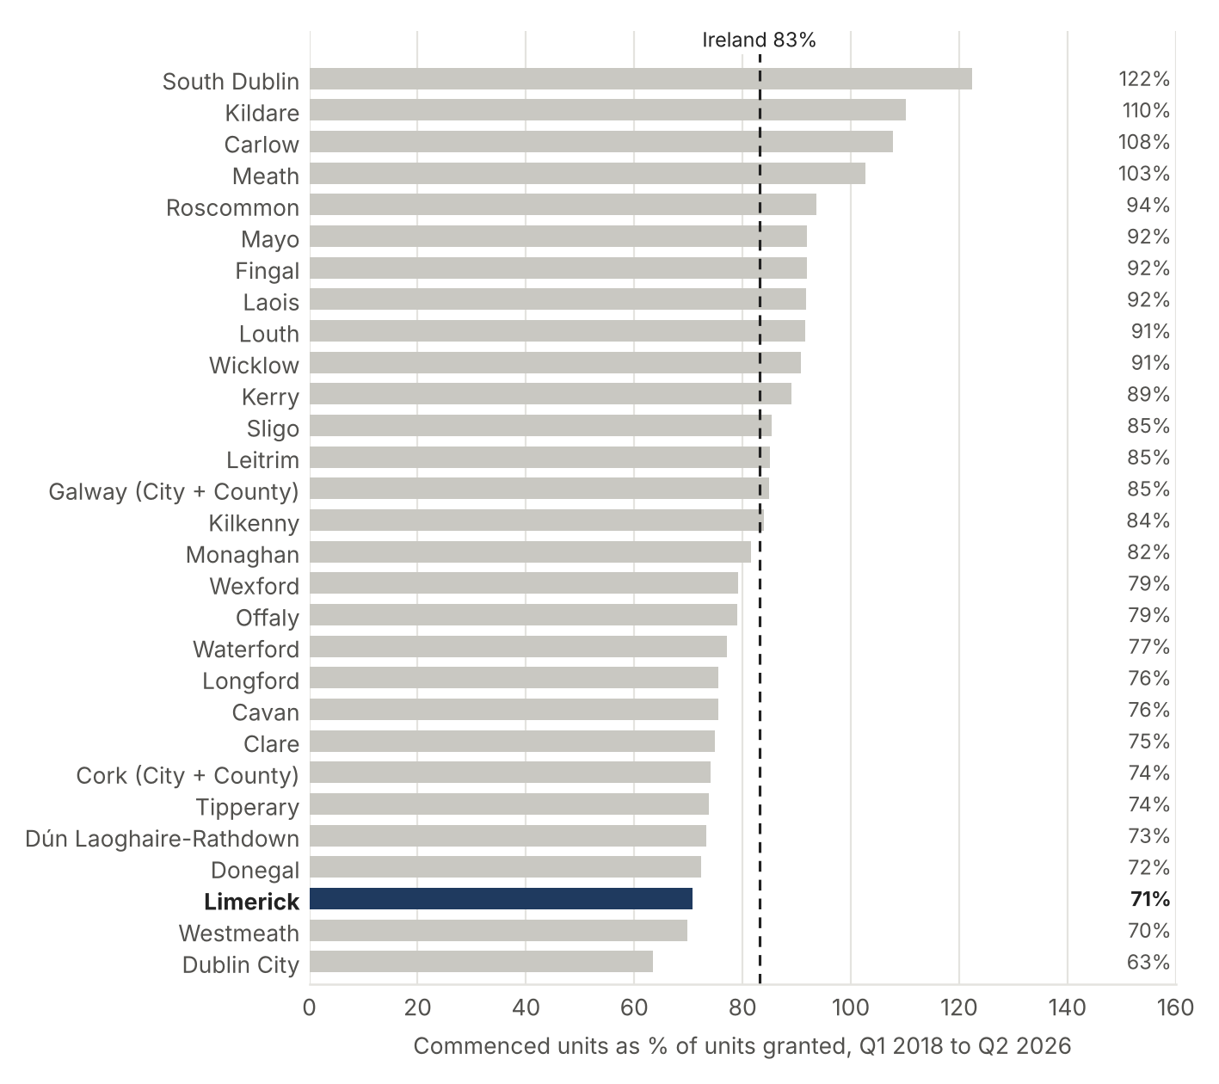
Commenced units from HSM13 divided by units granted from BHQ17. Values above 100% reflect starts on permissions granted before 2018.

A4.1 Is it just recent permissions?
Part of any gap is timing, because a permission granted in 2026 has not had long to start. Limerick granted 1,117 units in the first half of 2026, 3rd among the 29 authorities. To allow for this, the table below compares starts up to the end of 2025 with permissions up to the end of 2024, and completions up to the end of 2025 with permissions up to the end of 2023. The gap in starts remains: Limerick is 25th of 29. The gap in completions is smaller, at 21st of 29.
Table A3. The same comparison with a time lag
Measure | Limerick | Ireland | Limerick rank (of 29)
Starts up to end-2025, as % of units granted up to end-2024 | 83% | 95% | 25th
Completions up to end-2025, as % of units granted up to end-2023 | 87% | 91% | 21st
Lagged measures are a check on timing, not a cohort tracking of individual permissions.

A4.2 Delivery over time
Starts in Limerick were highest in 2024, at 1,532 units, which was close to the 1,504 units granted that year. Completions rose from 503 in 2018 to 1,001 in 2024 and 866 in 2025. 2022 was the largest year for permissions at 1,808 units (5th of 29), with 848 starts recorded in the same year.
Figure A3. Units granted, commenced and completed in Limerick, by year
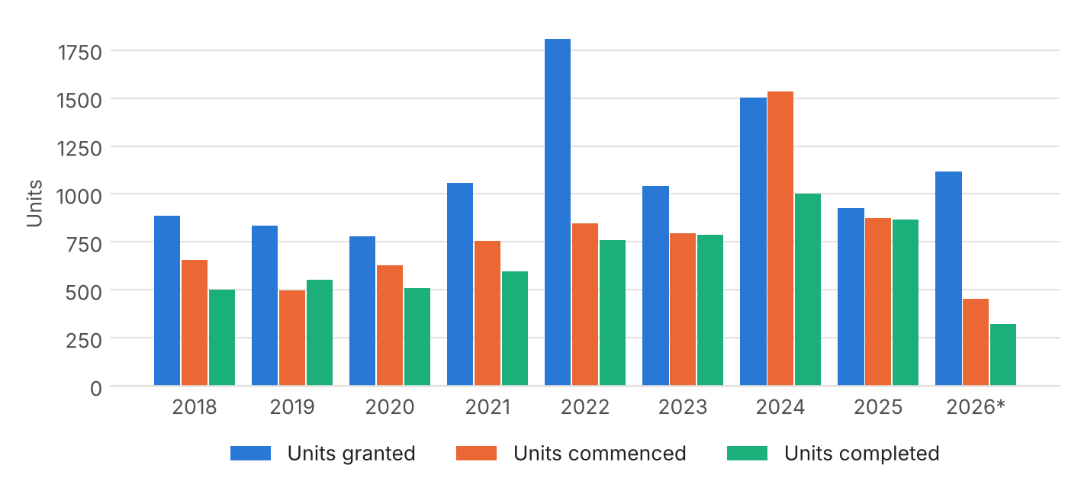
2026* is January to June. These are CSO counts for Limerick City and County including one-off houses, so they differ from the scheme sample in Part B Figure 5. Source: CSO BHQ17, HSM13 and NDQ05.
Year | Granted | Commenced | Completed | Granted, rank (of 29)
2018 | 888 | 657 | 503 | 10th
2019 | 836 | 499 | 552 | 13th
2020 | 781 | 629 | 508 | 14th
2021 | 1,059 | 755 | 597 | 12th
2022 | 1,808 | 848 | 761 | 5th
2023 | 1,042 | 795 | 788 | 11th
2024 | 1,504 | 1,532 | 1,001 | 7th
2025 | 928 | 874 | 866 | 14th
2026* | 1,117 | 453 | 325 | 3rd
2026* is January to June.

A5. Limerick and its peers
Galway, Waterford and Cork are the other regional city and county authorities outside Dublin. Their ratios put Limerick in context.
Figure A4. Commenced and completed units as a share of units granted
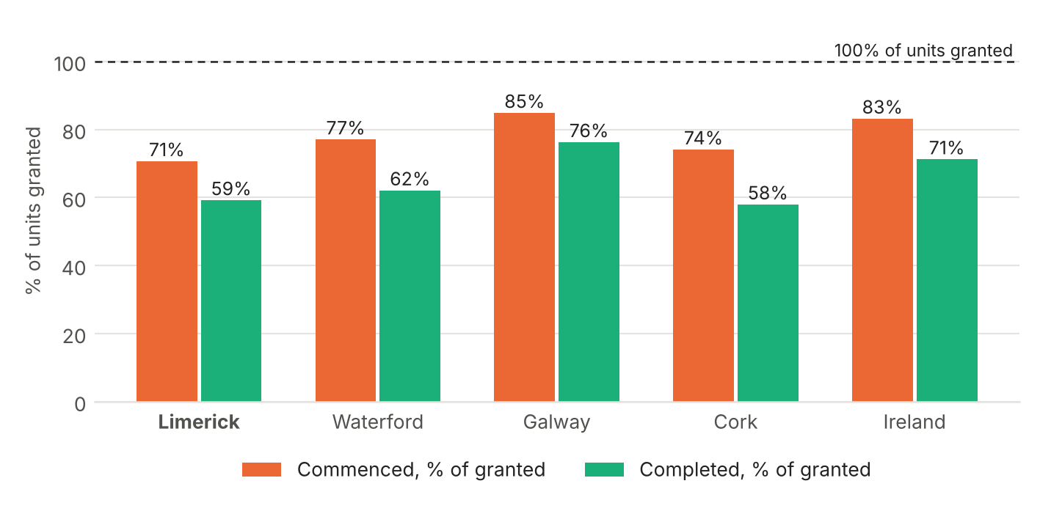
Q1 2018 to Q2 2026. Source: CSO BHQ17, HSM13 and NDQ05.
Table A4. Limerick and its regional peers
Authority | Population | Units granted | Per 1,000 | Commenced % of granted | Completed % of commenced | Completed % of granted
Limerick | 209,536 | 9,963 | 48 | 71% | 84% | 59%
Waterford | 127,363 | 7,617 | 60 | 77% | 81% | 62%
Galway (City + County) | 277,737 | 12,813 | 46 | 85% | 90% | 76%
Cork (City + County) | 584,156 | 41,202 | 71 | 74% | 78% | 58%
Ireland | 5,149,139 | 315,543 | 61 | 83% | 86% | 71%
Q1 2018 to Q2 2026. Cork and Galway city and county combined.
Galway is the strong performer: 85% of its granted units have started and 76% are complete, with a grant rate per head close to Limerick (46 against 48). Waterford grants more per head (60) and starts more (77%), but completes 62%, close to Limerick. Cork is the closest match on completions (58%) with a higher grant rate (71). The comparison does not show that Limerick is an outlier among its peers. It shows that Galway is converting permissions into homes better than the rest.
Dublin City is the lowest on starts (63%) and Westmeath second lowest (70%). Both are weaker than Limerick on that measure, so Limerick is not the national low point.

A6. Conclusions
The points below are our reading of the national figures in Part A together with the scheme-level findings in Part B. They are professional opinion, not statements from the data.
- The gap is at commencement. Limerick grants below the national rate per head and completes at close to the national rate once building starts. The loss comes between permission and a start on site: 71% of granted units started against 83% for Ireland.
- Planning speed is not the main constraint. Part B finds a median of about 7 months from application to permission, and a median of 1.3 years from permission to start for schemes that have started. The national figures point the same way. The data cannot say why schemes do not start, and Part B notes that reasons are rarely recorded.
- The Council's levers sit after planning. The actions in Section 9 of Part B, such as working through the near-expiry list, checking 2025 and 2026 permissions at 12 months, speeding up tender and funding for public schemes, and looking at the City Centre separately, target the stage where the comparison shows the gap.
- The 2025 and 2026 permissions are the test. Limerick granted 928 units in 2025 and 1,117 in the first half of 2026, 3rd among the 29 authorities for that period. The main thing to watch is whether they start at the national rate or at the lower rate seen in earlier years.
- Galway is the useful comparator. It grants at a similar rate per head and completes a much higher share. Looking at how permissions in Galway move to site would be a sensible next step.
- Repeat each year. All four sources are published by the CSO and can be refreshed. The four measures to track are units granted per 1,000 residents, commenced as a share of granted, completed as a share of commenced, and the lagged versions of the first two.

Limits of the comparison
- Separate counts. Grants, commencements and completions are counted separately. Values above 100% show that starts and completions include permissions granted before 2018.
- Different scope to Part B. Part A includes one-off houses and runs to June 2026. Part B excludes one-off houses and runs to September 2026.
- Population. Rates per head use the 2022 census. Authorities that have grown faster since then will be overstated on a per-head basis.
PART B
Residential delivery in County Limerick
From planning application to completion, 2018–2026
Part B is the scheme-level study. It tracks each permitted scheme in County Limerick from application to completion and sets out the findings and implications for the Council.

Summary
This study tracks 252 permitted residential schemes in County Limerick, totalling 10,811 units, from planning application to completion. It joins the national planning applications register, building control commencement notices and CIS project records at scheme level, and classifies each scheme as public (local authority, approved housing body or Land Development Agency) or private. The aim is to show how quickly permitted housing gets built, where it stalls, and which permissions are close to expiry.
Getting permission is not the main delay. The median time from application to permission is about 7 months. It is about 12 weeks where no further information is requested and there is no appeal, 0.7 years with a further information request, and 1.3 years on appeal. Further information was requested on 80% of private and LRD applications.
Starting on site takes longer. 48% of permitted schemes had started within two years of permission and 72% within five years. For schemes that have started, the median gap between permission and start is 1.3 years.
Completed schemes took a median of 3.9 years from application to completion (interquartile range 2.6 to 5.1 years, 47 schemes). Median build-out rates run from 4 dwellings per annum on schemes of 1–9 units to 50 on schemes of 100+ units, though the larger bands rest on very few completed schemes.
Public schemes are quicker through planning but slower to start. Public schemes (78 schemes, 1,768 units, 16% of units) have a median approval period of 0.3 years against 0.7 for private schemes. After permission, 43% of public schemes had started within two years against 50% of private schemes. Over the longer run the gap narrows: on permissions at least two years old, 81% of public units and 75% of private units have started.
5,472 permitted units have not started. Most sit on recent permissions: 3,826 units have more than three years left to run. The near-term risk is 890 units: 311 already past expiry and 579 expiring within two years.
Limerick city holds 81% of permitted units. Within the nine city neighbourhoods, Castletroy/Annacotty (2,959 units), Dooradoyle (1,920) and Caherdavin (1,310) carry the most permitted housing. The City Centre stands out: only 45% of units on older permissions have started, against 89% in Castletroy/Annacotty.
Official completions data is incomplete. Completion certificates exist for 44 of the 47 completed schemes, but they account for only 340 of their 1,275 units.

1. Purpose and scope
The Council asked how quickly residential permissions in Limerick are turning into homes, what holds them back, and where. The study measures three stages for every scheme: the time from lodging an application to receiving permission, the time from permission to starting on site, and the time from starting to completion, together with the annual rate at which completed schemes delivered homes.
Most schemes in Limerick are small, so results are reported in five size bands: 1–9, 10–24, 25–49, 50–99 and 100+ units. Results are also split by public and private delivery, by Local Electoral Area and, for the city, by the nine neighbourhoods the Council uses for planning.
The sample is the set of residential schemes tracked by CIS in County Limerick with permissions from 2018 onward, newer applications from the latest CIS export, and Part 8 council schemes from the planning register that CIS does not hold. Where several applications relate to one site, each distinct scheme is counted once. Extensions of duration, superseded applications and minor amendments are not counted as separate schemes. Refused and withdrawn applications are excluded from the scheme count but reported as indicators of delay.
The study does not cover one-off rural houses, schemes neither CIS nor the Part 8 register records, or pre-application and zoning stages.

2. Data and method

2.1 Sources
Stage | Source | Coverage in this study
Application, further information, appeal, decision, grant, expiry | National Planning Applications dataset (Department of Housing, Local Government and Heritage), Limerick records from 2017; An Coimisiún Pleanála case records for SHD | CIS applications matched by planning reference; Part 8 schemes matched by file number or location
Start on site | Building control commencement notices (National Building Control Office open data, 2014 onward) | 136 schemes with a measured start
Completion | CIS project updates (dated), CIS finish dates; Department of Housing social housing construction status report for matched public schemes | 47 completed schemes
Public / private | Grantee named in CIS records, CIS promoter, building control flags for local authority and approved housing body projects, Part 8 file numbers, Department of Housing social housing construction status report (Q1 2026) | All schemes
Location | Scheme coordinates; Local Electoral Areas 2019 (Tailte Éireann); city neighbourhoods defined by the Council from 42 Electoral Divisions | All schemes

2.2 Definitions
- Approval period: application received to final grant. Where a decision was appealed, the appeal decision date is used. For Part 8 schemes, the register decision date.
- Permission to start: final grant to the earliest commencement date on a building control commencement notice for that permission, including notices citing its extension of duration or appeal reference.
- Build period: start on site to the date CIS first records the scheme as complete. Build-out rate is units divided by build period (floored at six months).
- Status: Complete; Under construction (commencement notice, or CIS records the scheme on site); Not started with permission live; Not started and past expiry. Expiry is the register expiry date, updated where a granted extension of duration applies. Part 8 approvals have no register expiry.
- Public: schemes promoted by Limerick City and County Council (including Part 8), approved housing bodies or the Land Development Agency. Turnkey schemes bought by a public body are classed as public where the Department of Housing’s social housing construction status report (Q1 2026) could be matched to the scheme with confidence; other turnkeys remain classed as private.

2.3 Part 8 coverage
Limerick files Part 8 schemes in the planning register as “yy/8nnn”. CIS records many Part 8s under its own project numbers rather than the council file number, so these were matched to the register by location, date and unit count. The study includes 57 Part 8 schemes. 10 residential Part 8s in the register (104 units) were not held by CIS and have been added. Their start dates come from building control; their completion is not tracked, so those that have started are counted as under construction. Two further 2017 Part 8s have no recorded decision or commencement and are excluded: 178003 (27 units) and 178016 (20 units). Part 8 schemes before 2017 are not in the register.

2.4 Social housing construction report
The Department of Housing’s quarterly status report lists social housing construction and turnkey projects by name, units, funding programme and stage, without planning references or coordinates. It was matched to the study schemes on name, address and unit count. 31 schemes (460 units) matched with confidence and consistent dates; these supply public ownership (including 5 turnkey purchases), and completion dates for 3 schemes that CIS had not recorded as complete. Buy and Renew, remedial works and rows that could not be matched with confidence were not used.

2.5 Reconciliation with the KPMG audit and student accommodation data
The scheme list was checked against the KPMG audit of the Limerick city and suburbs pipeline. 11 live Limerick schemes (377 units) in that audit were missing from our CIS extracts and have been added, after confirming each one in the planning register. Schemes the audit lists that the register shows as refused, withdrawn or invalid were not added, and two audit schemes in County Clare fall outside this study. The check also found 6 Part 8 schemes (112 units) held twice in CIS, once under a CIS project number and once under the council file number; each is now counted once. Bedspace counts for permitted student accommodation schemes are taken from the purpose-built student accommodation (PBSA) schedule supplied for this study; existing student accommodation is not part of the pipeline.
Granted residential applications in the planning register were also compared with Central Statistics Office figures on units granted permission in Limerick (BHQ17). Register grants of 10 or more units since 2021 that CIS does not hold were checked one by one against the register and An Coimisiún Pleanála case records: 2 live private schemes (24 units) were added, and the rest had been refused on appeal or were not new supply. One-off houses and schemes of under 10 units outside CIS are not covered by this study.

2.6 Limitations
- Sample sizes in the 50–99 and 100+ bands are small, particularly for completed schemes. Treat those medians as indicative.
- Durations from permission to start are measured only for schemes that have started. The cumulative start shares in Section 3 cover all permissions and are the fairer measure of how many permissions get built.
- CIS records reasons for delay only occasionally, so barriers are mostly inferred from the planning and building control record rather than stated by developers.
- Completion certificates under-record units (see Appendix A), so completions rely on CIS.

3. How long does it take to get started?
Figure 1. Median time from application to completion, by scheme size
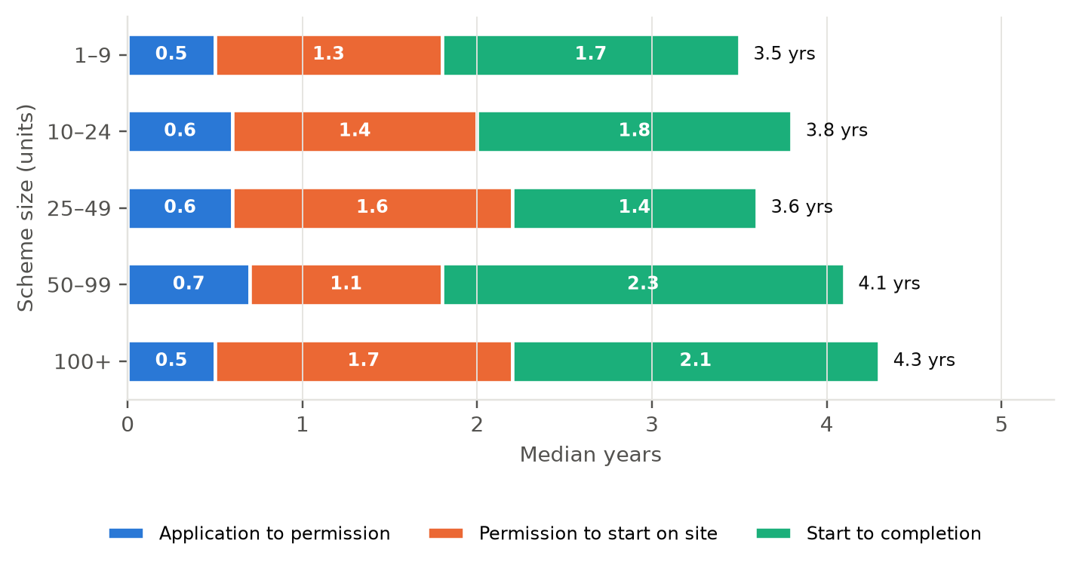
Medians of each stage calculated separately; the total is indicative, not the median of end-to-end times. Source: national planning register, NBCO commencement notices, CIS.
Across all sizes, permission takes a median of about 7 months from lodgement, and it barely varies with scheme size. The bigger variation is in what happens after permission.
Size band (units) | Application to permission | Permission to start | Start to completion | Build rate (dpa)
1–9 | 0.5 (n=65) | 1.3 (n=45) | 1.7 (n=18) | 4.1
10–24 | 0.6 (n=66) | 1.4 (n=34) | 1.8 (n=15) | 8.3
25–49 | 0.6 (n=47) | 1.6 (n=23) | 1.4 (n=6) | 21.5
50–99 | 0.7 (n=36) | 1.1 (n=23) | 2.3 (n=4) | 34
100+ | 0.5 (n=23) | 1.7 (n=10) | 2.1 (n=3) | 50.3
All | 0.6 (n=241) | 1.3 (n=136) | 1.8 (n=47) | 8
Median years, with number of schemes measured in brackets. Build rate is the median of completed schemes.

3.1 The planning path
Further information requests and appeals account for most of the variation in approval times. Where the Council asked for further information, the median rose from 0.2 to 0.7 years. Appealed decisions took a median of 1.3 years. Further information was requested on 80% of the applications in this group.
Planning path | Schemes | Median (yrs) | Lower quartile | Upper quartile
No further information, no appeal | 31 | 0.2 | 0.2 | 0.2
Further information requested | 126 | 0.7 | 0.5 | 0.8
Appealed | 48 | 1.3 | 0.9 | 1.7
Standard and LRD applications in the council planning register. SHD and Part 8 excluded.

3.2 From permission to start on site
Figure 2. Share of permitted schemes started, by time since permission
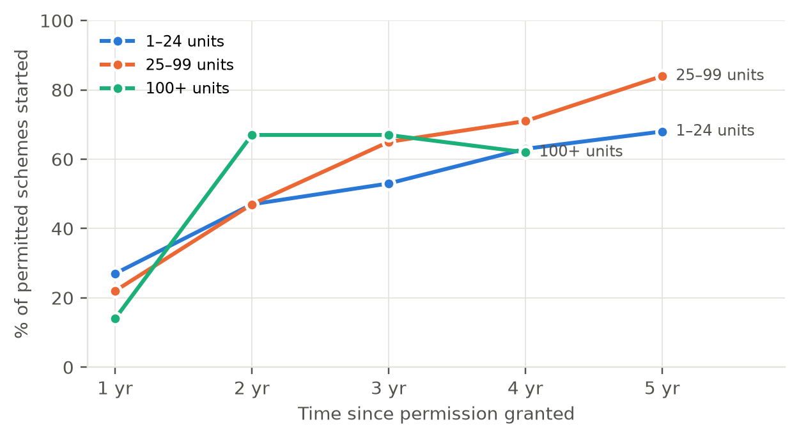
Each point covers only permissions old enough to have reached that time.
About a quarter of schemes start within a year of permission and 48% within two years. By five years, 72% have started. Schemes of 25–99 units have the highest start rate by five years (84%); schemes of 1–24 units reach 68%. The 100+ band has too few older permissions to measure beyond four years.
Scheme size | Within 1 yr | Within 2 yr | Within 3 yr | Within 4 yr | Within 5 yr
1–24 units | 27% (120) | 47% (107) | 53% (83) | 63% (71) | 68% (50)
25–99 units | 22% (72) | 47% (60) | 65% (48) | 71% (38) | 84% (31)
100+ units | 14% (14) | 67% (12) | 67% (9) | 62% (8) | – (4)
All | 24% (209) | 48% (182) | 57% (143) | 65% (120) | 72% (88)
% of schemes started (number of permissions old enough to be measured).

4. Public and private delivery
Public schemes account for 78 of the 267 schemes and 1,768 units (16%). Most are local authority schemes (61 schemes, 1,144 units), followed by approved housing bodies (16 schemes, 339 units). The Land Development Agency has one scheme in the sample: the former Limerick Gasworks site on Dock Road (25/60780, 285 units), granted in February 2026 and at tender stage.
Sector | Schemes | Units | Application to permission | Permission to start | Start to completion | Build rate (dpa)
Public | 78 | 1,768 | 0.3 | 1.7 (n=36) | 1.5 (n=18) | 7.6
Private | 189 | 9,306 | 0.7 | 1 (n=100) | 1.8 (n=29) | 10.6
Median years (number of schemes measured).

Public schemes get through planning faster, mainly because Part 8 approvals are not subject to further information requests or appeal. They are slower to start: 43% had started within two years of approval, against 50% of private schemes. In our experience, public schemes usually go to tender and seek funding approval after planning, which adds time before a contractor is on site.
Figure 3. Share of permitted schemes started, public and private
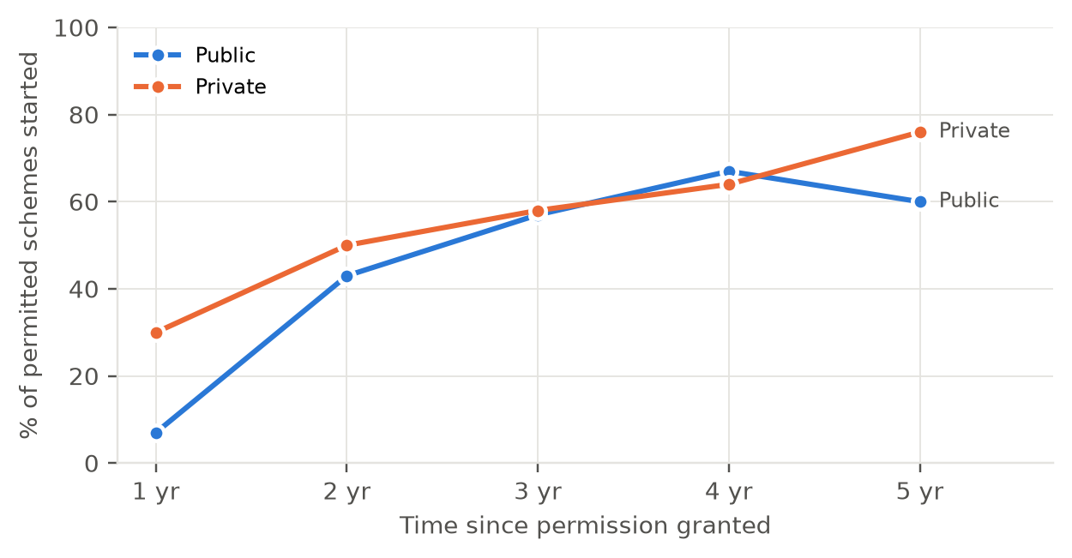
Each point covers only permissions old enough to have reached that time.
Sector | Within 1 yr | Within 2 yr | Within 3 yr | Within 4 yr | Within 5 yr
Public | 7% (54) | 43% (51) | 57% (44) | 67% (36) | 60% (25)
Private | 30% (155) | 50% (131) | 58% (99) | 64% (84) | 76% (63)
% of schemes started (number of permissions old enough to be measured).

Measured by units rather than schemes, public delivery holds up: on permissions at least two years old, 81% of public units have started against 75% of private units. The difference reflects a larger number of small public schemes that have not started alongside larger public schemes that have.
Owner | Schemes | Units permitted | Units started | % units started | Median permission to start (yrs)
Public – local authority | 37 | 856 | 686 | 80% | 1.7
Public – approved housing body | 14 | 319 | 265 | 83% | 2
Private | 131 | 5,428 | 4,073 | 75% | 1.2
Permissions at least two years old.

5. How quickly do schemes build out?
47 schemes in the sample have been completed. The median build period was 1.8 years. Build-out rates rise with scheme size: larger schemes run more units in parallel.
Figure 4. Median build-out rate of completed schemes, by size
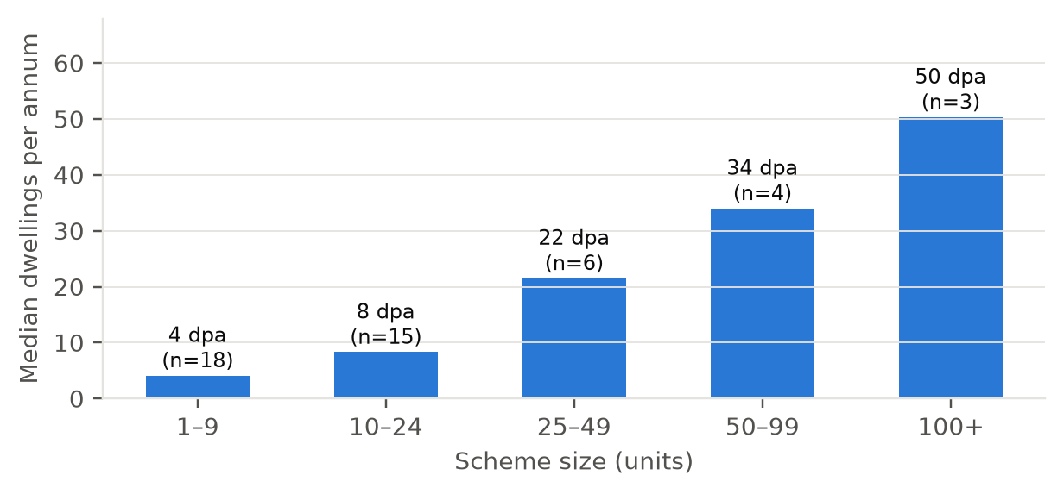
Dwellings per annum = units ÷ build period. Source: NBCO commencement notices, CIS completion updates.
Group | Completed schemes | Median build period (yrs) | Median build rate (dpa) | Interquartile range (dpa)
All completed | 47 | 1.8 | 8 | 4.2–17.8
1–9 | 18 | 1.7 | 4.1 | 2.3–5.8
10–24 | 15 | 1.8 | 8.3 | 6–11.2
25–49 | 6 | 1.4 | 21.5 | 17.7–26.6
50–99 | 4 | 2.3 | 34 | 24–44.2
100+ | 3 | 2.1 | 50.3 | 38.4–73.7
Houses | 22 | 1.7 | 4.2 | 2.6–12.1
Apartments | 10 | 1.8 | 9.3 | 5.8–11.4
Mixed | 7 | 1.9 | 26.5 | 16.7–46.2

Few large schemes have completed in Limerick since 2018, which limits what can be said about build-out on the 100+ unit permissions now in the pipeline.

5.1 Delivery over time
Figure 5. Units granted, started and completed per year (study sample)
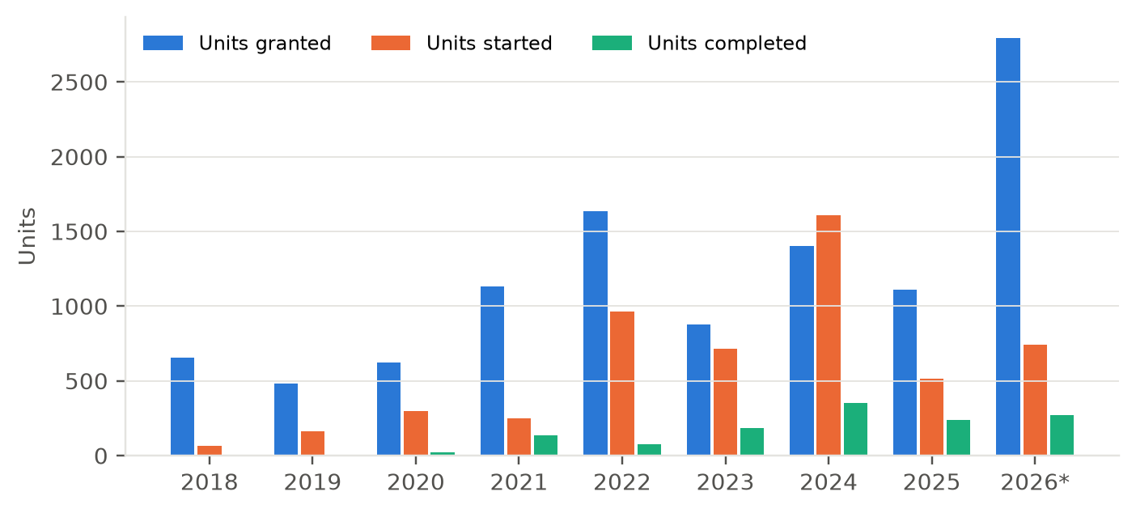
2026 runs to September. Completions count schemes CIS records as fully complete; completed phases on sites still under construction are not included. Source: planning register, NBCO, CIS.
Permissions have run ahead of starts in most years. In the first nine months of 2026, 2,795 units were granted, including several large LRD schemes in Castletroy, Mungret, Singland and Dock Road. Starts peaked in 2024 at 1,607 units. Completions are low relative to starts because most recently started schemes are still under construction.

6. Barriers to delivery
CIS rarely records why a scheme has not progressed. 9 schemes carry notes such as “on hold” or “no movement”, one was quashed following a legal challenge, and two sites were reported for sale. The planning and building control record gives a fuller picture of where delivery slows.
Indicator | Schemes / applications | Units
Permitted schemes not started, permission live | 95 | 5,161
Permitted schemes not started, past expiry | 14 | 311
Schemes recorded by CIS as stalled or suspended | 4 | 156
Schemes with CIS note: on hold / no movement | 9 | 666
Schemes with CIS note: legal challenge / quashed | 0 | 0
Schemes with CIS note: site for sale / sold | 2 | 98
Schemes where further information was requested | 163 | 6,478
Schemes that went to appeal | 48 | 2,703
Applications refused or withdrawn (not counted) | 14 | 518
Applications superseded by a later application | 3 | 90
Extensions of duration sought | 14 | –
Counts overlap: a scheme can appear under several indicators.

6.1 Which permissions are least likely to start?
The tables below cover permissions granted at least two years before September 2026 (182 schemes, 6,603 units), so every scheme has had time to start. 76% of those units have started.
Route | Schemes | Units permitted | Units started | % units started | Median permission to start (yrs)
Standard planning application | 138 | 4,178 | 3,071 | 74% | 1.3
LRD | 3 | 315 | 315 | 100% | 1
SHD (An Bord Pleanála) | 5 | 1,257 | 955 | 76% | 1.8
Part 8 / council | 36 | 853 | 683 | 80% | 1.8
Permissions at least two years old.

Standard planning applications and Part 8 schemes start at similar rates by units (74% and 80%). Three of the 5 live SHD permissions have started, accounting for 76% of their 1,257 units. Not yet started: Clonmacken Gardens (165 units) and Annacotty (137 units, now past expiry). A sixth SHD, Punches Cross student accommodation, was quashed by the High Court in December 2023 and is excluded.
Type | Schemes | Units permitted | Units started | % units started | Median permission to start (yrs)
Houses | 75 | 1,381 | 954 | 69% | 1.3
Mixed | 25 | 2,875 | 2,388 | 83% | 1.6
Apartments | 55 | 1,837 | 1,363 | 74% | 1.7
Student | 4 | 82 | 26 | 32% | 1.6
Unknown | 23 | 428 | 293 | 68% | 1.8
Permissions at least two years old. Type from bedroom mix or development description.

Houses and apartments start at similar rates by units. Student accommodation stands out: one of five older student permissions has started. The largest student permissions in the sample, including Punches Cross and the 196-unit Castletroy scheme granted in 2025, have not started.

7. Expiring permissions
Figure 6. Units not started, by time to expiry
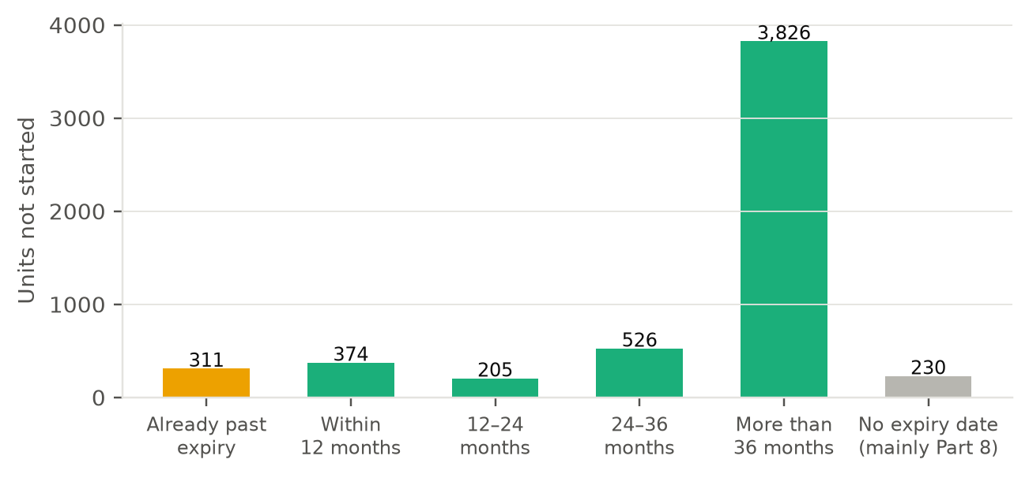
Expiry from the planning register, updated for granted extensions of duration. Part 8 schemes have no register expiry. Source: planning register, NBCO, CIS.
Of the 5,472 permitted units not started, 3,826 have more than three years left on their permission. The near-term pipeline at risk is smaller: 311 units are already past expiry, 374 expire within 12 months and 205 within 12 to 24 months.
Expiry window | Schemes | Adare-Rathkeale | Cappamore-Kilmallock | Limerick City East | Limerick City North | Limerick City West | Newcastle West | Total units
Already past expiry | 14 | 3 | 22 | 149 | 16 | 121 | 0 | 311
Within 12 months | 8 | 65 | 0 | 0 | 190 | 51 | 68 | 374
12–24 months | 6 | 32 | 0 | 0 | 90 | 83 | 0 | 205
24–36 months | 20 | 17 | 113 | 0 | 196 | 116 | 84 | 526
More than 36 months | 43 | 190 | 35 | 2,072 | 262 | 1,257 | 10 | 3,826
No expiry date (mainly Part 8) | 18 | 31 | 3 | 17 | 55 | 52 | 72 | 230
Units not started, by LEA and expiry window.

7.1 Watchlist: schemes of 10+ units past or near expiry
These schemes have not started according to building control and CIS records and are past expiry or within two years of it. Each should be checked against the planning file and building control before the Council acts on it, since a start may have been notified under a different reference.
Scheme (CIS heading) | Planning ref | Area | Owner | Units | Expiry
Residential Development, Patrickswell | 18346 | Limerick City West | Private | 49 | 22/10/2023
Apartments | 19302 | Caherdavin | Public | 12 | 18/06/2024
Change of Use to Care Residential Units | 19149 | Cappamore-Kilmallock | Public | 21 | 10/09/2024
Housing Development | – | Limerick City West | Private | 17 | 27/09/2024
Housing Development | 197025 | Castletroy/Annacotty | Private | 12 | 01/12/2024
Change of Use to Apartment Development | 20622 | City Centre | Private | 15 | 06/10/2025
Mixed Use Development, 34-41 Catherine Street | 20222 | City Centre | Private | 24 | 05/01/2026
Residential Development, Annacotty | ABP-309999 | Castletroy/Annacotty | Private | 137 | 04/08/2026
Register: the construction of 14 dwelling houses, including 2 no semi-detached 2 | 20525 | Adare-Rathkeale | Private | 14 | 01/12/2026
Housing Development | 21147 | Caherdavin | Private | 11 | 06/02/2027
Apartment Development, Limerick | 21835 | Singland/Garryowen | Private | 14 | 16/02/2027
Residential Development, Croom | 21630 | Adare-Rathkeale | Private | 51 | 11/05/2027
Apartment/Retail Development, Limerick | 211598 | City Centre | Private | 37 | 24/05/2027
Clonmacken Gardens Housing Development, Limerick | ABP-312683 | Caherdavin | Private | 165 | 25/05/2027
Residential Development | 21594 | Newcastle West | Private | 68 | 05/09/2027
Apartment Development | 211454 | City Centre | Private | 14 | 20/09/2027
Nursing Home Development, Croom | 22410 | Adare-Rathkeale | Private | 32 | 19/02/2028
Apartment/Retail Development, Dooradoyle | 221107 | Dooradoyle | Private | 30 | 13/06/2028
Residential Development, Limerick | 22817 | Caherdavin | Private | 86 | 03/07/2028
Apartment Development, Limerick | 221003 | City Centre | Private | 29 | 11/07/2028
Residential Development, Limerick | 221367 | City Centre | Private | 24 | 12/09/2028
Scheme names are CIS project headings. Area is the city neighbourhood where applicable, otherwise the LEA.

8. Location

8.1 County
Figure 7. Status of permitted units by Local Electoral Area
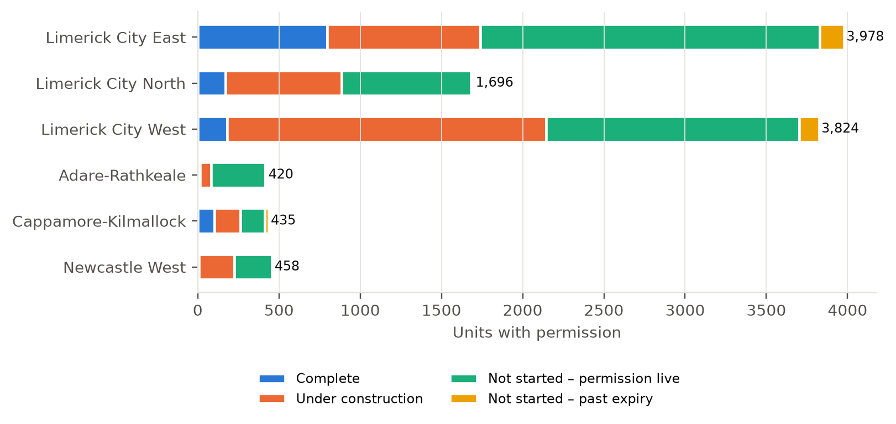
All permitted schemes in the sample. Source: planning register, NBCO, CIS; LEA boundaries Tailte Éireann (2019).
Among older permissions, Limerick City East has the highest start rate (91% of units), followed by City West (84%) and City North (62%). The county LEAs have smaller volumes and lower start rates: 31 of 179 units in Adare-Rathkeale and 206 of 418 in Newcastle West. Of the unstarted units in City East, 93% are on permissions granted since January 2025.
LEA | Schemes | Units permitted | Units started | % units started | Median permission to start (yrs)
Limerick City East | 39 | 1,834 | 1,673 | 91% | 1.2
Limerick City North | 34 | 1,362 | 838 | 62% | 1.4
Limerick City West | 58 | 2,487 | 2,084 | 84% | 1.4
Adare-Rathkeale | 11 | 179 | 31 | 17% | 2.1
Cappamore-Kilmallock | 23 | 323 | 192 | 59% | 1.8
Newcastle West | 17 | 418 | 206 | 49% | 1.3
Permissions at least two years old.
Figure 8. Permitted schemes by status, County Limerick
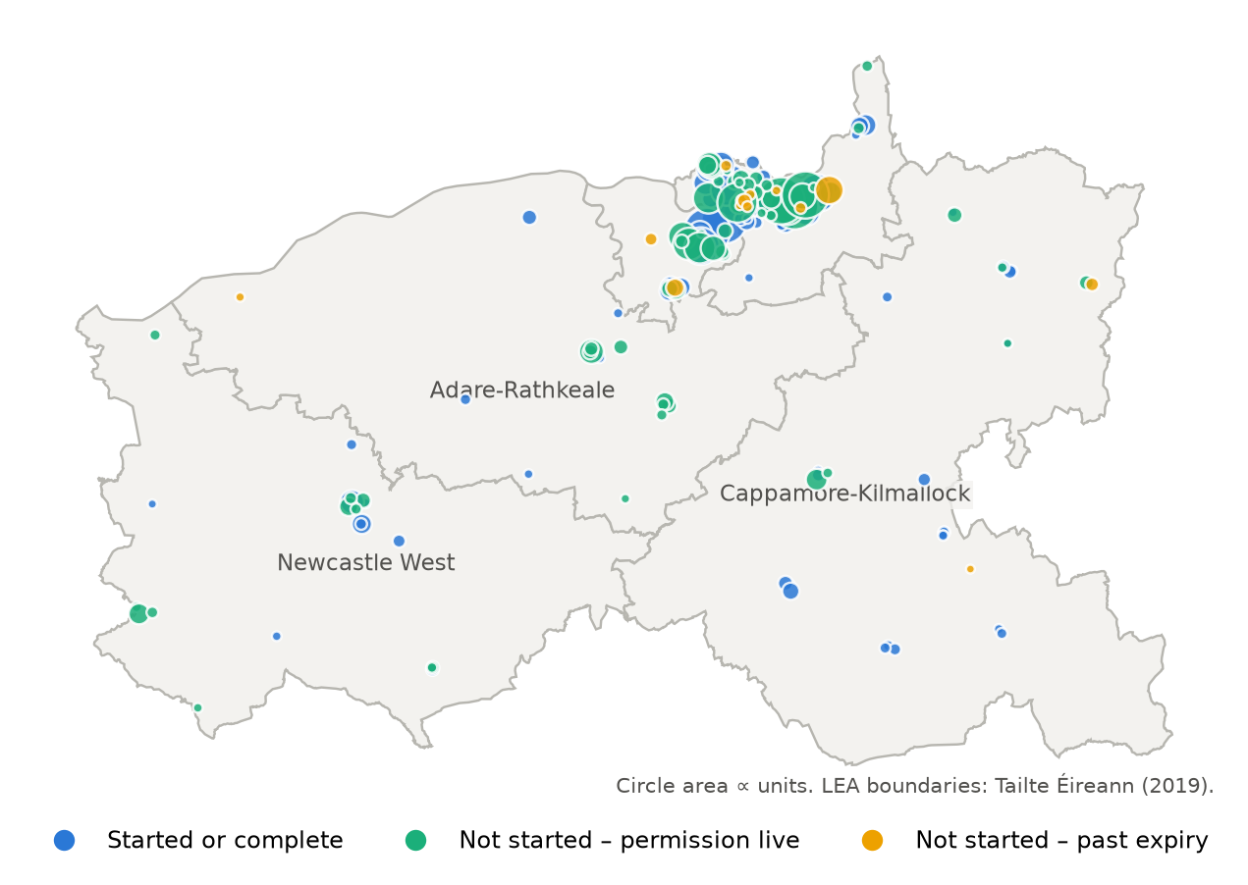

8.2 Limerick city neighbourhoods
The nine city neighbourhoods hold 8,751 permitted units across 156 schemes, 81% of the county total. The boundaries follow the Council’s grouping of 42 Electoral Divisions; King’s Island (coded 1a) is shown separately from the rest of the City Centre. Mungret, Patrickswell and the county towns fall outside the nine neighbourhoods and are reported as outside.
Figure 9. Status of permitted units by city neighbourhood
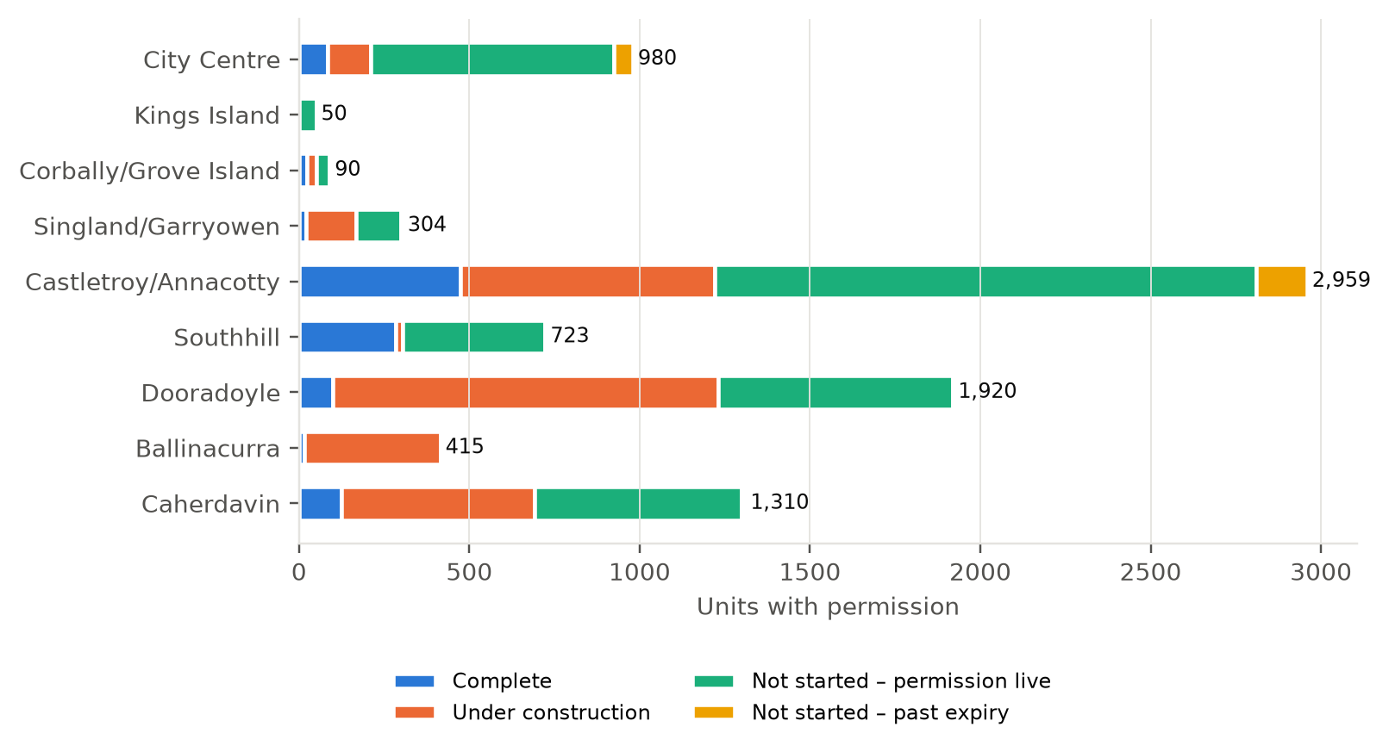
All permitted schemes. Neighbourhood boundaries: Limerick City and County Council (42 Electoral Divisions).
Neighbourhood | Schemes | Complete | Under construction | Not started (live) | Past expiry | Total units | Public share
City Centre | 40 | 83 | 127 | 715 | 55 | 980 | 40%
Kings Island | 2 | 0 | 0 | 50 | 0 | 50 | 100%
Corbally/Grove Island | 4 | 24 | 26 | 40 | 0 | 90 | 0%
Singland/Garryowen | 16 | 22 | 146 | 132 | 4 | 304 | 19%
Castletroy/Annacotty | 32 | 474 | 746 | 1,590 | 149 | 2,959 | 0%
Southhill | 12 | 284 | 21 | 418 | 0 | 723 | 14%
Dooradoyle | 22 | 98 | 1,133 | 689 | 0 | 1,920 | 14%
Ballinacurra | 4 | 17 | 398 | 0 | 0 | 415 | 9%
Caherdavin | 24 | 125 | 566 | 607 | 12 | 1,310 | 19%
Outside city neighbourhoods | 94 | 148 | 901 | 920 | 91 | 2,060 | 20%
Units with permission by status. Public share = units on local authority, AHB and LDA schemes.

Castletroy/Annacotty carries the largest volume, mostly large private permissions: 1,590 of its units have not yet started, almost all on permissions granted in 2025 and 2026. Dooradoyle is similar: 689 units not started, most on 2025–26 permissions. In Caherdavin, by contrast, the unstarted units are on older permissions.
The City Centre is different. Apart from King’s Island (one older scheme, not started), it has the lowest start rate in the city on older permissions: 45% of 409 units. 770 of its 980 permitted units have not started. Its public share (40%) is driven by the LDA’s 285-unit Dock Road scheme. The other unstarted schemes are mostly small private apartment and mixed-use schemes, a median of 13 units, several of them conversions of existing buildings.
Neighbourhood | Schemes | Units permitted | Units started | % units started | Median permission to start (yrs)
City Centre | 28 | 409 | 184 | 45% | 1.6
Kings Island | 1 | 27 | 0 | 0% | –
Corbally/Grove Island | 2 | 50 | 50 | 100% | 0.6
Singland/Garryowen | 9 | 149 | 123 | 83% | 1.7
Castletroy/Annacotty | 24 | 1,363 | 1,214 | 89% | 1.5
Southhill | 7 | 288 | 288 | 100% | 1.6
Dooradoyle | 16 | 1,282 | 1,231 | 96% | 0.8
Ballinacurra | 4 | 415 | 415 | 100% | 1.2
Caherdavin | 20 | 1,130 | 663 | 59% | 1.1
Outside city neighbourhoods | 71 | 1,490 | 856 | 57% | 1.8
Permissions at least two years old. Small counts in some neighbourhoods make percentages volatile.
Figure 10. Permitted schemes by status, Limerick city neighbourhoods
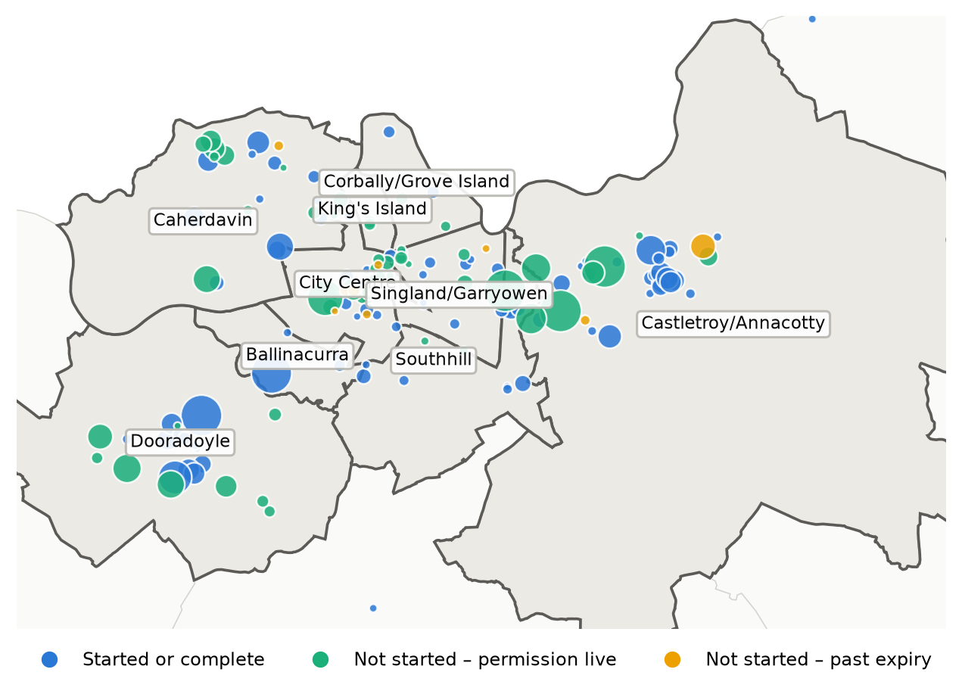
Circle area proportional to units.

9. Implications for the Council
The points below are our professional view, drawing on the findings above.
- Focus engagement on the near-expiry list. About 890 units are past expiry or will expire within two years without starting. Contacting the owners of the larger schemes on the watchlist would establish which are likely to proceed, which need an extension, and which are unlikely to be built.
- Track the 2025–26 permissions early. About 3,858 unstarted units sit on permissions less than two years old, mostly large schemes in Castletroy/Annacotty, Dooradoyle, the City Centre and Mungret. Roughly half of permissions start within two years, so a 12-month check on each is worthwhile.
- Shorten the post-approval stage for public schemes. Public schemes clear planning quickly but take longer to reach site. Running tender preparation and funding approval alongside the Part 8 process, where possible, would narrow the gap.
- Look at the City Centre separately. Its start rate is among the lowest in the city, and most of its unstarted schemes are small apartment schemes and conversions. The barriers there, such as construction cost on constrained or older buildings, are likely to differ from the suburban pipeline.
- Reduce further information requests where possible. They roughly triple the median approval time for private schemes. Better pre-application engagement on the issues that trigger them is likely to shorten the planning stage more than any other change within the Council’s control.
- Fix the completions record. Completion certificates under-record units by a wide margin in this sample. Checking unit counts on certificates, or recording completions at site level each quarter, would give the Council reliable delivery figures.
- Ask why schemes stall. A short survey of permission holders with unstarted schemes of 10+ units would turn the inferred barriers in Section 6 into stated ones: viability, finance, infrastructure or sale.
- Repeat annually. The method uses public data and can be refreshed each year.

Appendix A. Data coverage
Item | Value
Schemes in study (counted applications) | 267
Schemes with permission | 252
Start date from building control commencement notice | 132
Start date from CIS only | 10
Completed schemes (CIS and Department social housing report) | 47
Completed schemes with a completion certificate | 44
Units on completed schemes | 1,275
Units on completion certificates for those schemes | 340
Part 8 schemes in study | 57
Part 8 schemes added from the register (not in CIS) | 10
Units on Part 8 schemes added from the register | 104
Public schemes (local authority, AHB, LDA) | 78
Units on public schemes | 1,768

Completion certificates are the only official site-level record of completions. For the 47 completed schemes, certificates exist for 44 but record 340 units against 1,275. This could reflect how units are entered on certificates, phased certificates not yet lodged, or schemes certified under a different reference.

Appendix B. Start rate by scheme size
Size band | Schemes | Units permitted | Units started | % units started | Median permission to start (yrs)
1–9 | 55 | 297 | 216 | 73% | 1.4
10–24 | 52 | 854 | 530 | 62% | 1.5
25–49 | 32 | 1,093 | 652 | 60% | 1.8
50–99 | 28 | 2,109 | 1,678 | 80% | 1.2
100+ | 12 | 2,250 | 1,948 | 87% | 1.7
Permissions at least two years old.

Appendix C. Companion data
The accompanying workbook (Limerick_Delivery_Study_Data.xlsx) contains the scheme-level dataset, every table in this report and the full expiry watchlist. Status tables in the workbook update from the scheme sheet.

Appendix D. National comparison data
All 29 local authority areas, Q1 2018 to Q2 2026, ranked by units granted per 1,000 residents. Cork and Galway city and county are combined.
Rank | Authority | Population | Granted | Per 1,000 | Commenced % of granted | Completed % of commenced | Completed % of granted
1 | Dún Laoghaire-Rathdown | 233,860 | 25,144 | 107.5 | 73% | 85% | 62%
2 | Fingal | 330,506 | 27,602 | 83.5 | 92% | 77% | 71%
3 | Dublin City | 592,713 | 46,930 | 79.2 | 63% | 85% | 54%
4 | Wicklow | 155,851 | 11,600 | 74.4 | 91% | 92% | 83%
5 | Louth | 139,703 | 10,352 | 74.1 | 91% | 85% | 78%
6 | Meath | 220,826 | 16,224 | 73.5 | 103% | 83% | 85%
7 | Cork (City + County) | 584,156 | 41,202 | 70.5 | 74% | 78% | 58%
8 | Westmeath | 96,221 | 6,556 | 68.1 | 70% | 72% | 50%
9 | Kildare | 247,774 | 16,678 | 67.3 | 110% | 92% | 101%
10 | Laois | 91,877 | 5,701 | 62.1 | 92% | 84% | 77%
11 | Wexford | 163,919 | 10,029 | 61.2 | 79% | 88% | 70%
12 | Waterford | 127,363 | 7,617 | 59.8 | 77% | 81% | 62%
13 | South Dublin | 301,075 | 17,596 | 58.4 | 122% | 87% | 107%
14 | Limerick | 209,536 | 9,963 | 47.5 | 71% | 84% | 59%
15 | Kilkenny | 104,160 | 4,947 | 47.5 | 84% | 85% | 72%
16 | Galway (City + County) | 277,737 | 12,813 | 46.1 | 85% | 90% | 76%
17 | Offaly | 83,150 | 3,610 | 43.4 | 79% | 93% | 73%
18 | Donegal | 167,084 | 7,076 | 42.3 | 72% | 96% | 70%
19 | Monaghan | 65,288 | 2,695 | 41.3 | 82% | 97% | 79%
20 | Clare | 127,938 | 5,281 | 41.3 | 75% | 98% | 73%
21 | Kerry | 156,458 | 5,379 | 34.4 | 89% | 97% | 87%
22 | Tipperary | 167,895 | 5,740 | 34.2 | 74% | 87% | 64%
23 | Cavan | 81,704 | 2,773 | 33.9 | 76% | 94% | 71%
24 | Sligo | 70,198 | 2,279 | 32.5 | 85% | 95% | 81%
25 | Carlow | 61,968 | 1,965 | 31.7 | 108% | 94% | 101%
26 | Mayo | 137,970 | 4,306 | 31.2 | 92% | 96% | 89%
27 | Longford | 46,751 | 1,297 | 27.7 | 76% | 101% | 76%
28 | Roscommon | 70,259 | 1,512 | 21.5 | 94% | 113% | 106%
29 | Leitrim | 35,199 | 676 | 19.2 | 85% | 121% | 103%
Source: CSO BHQ17, HSM13, NDQ05 and FY003A. Population is Census 2022. Percentages above 100% reflect starts or completions on permissions granted before 2018.

