Collabryx — Project Walkthrough
✅ Status: Running & Verified
Both servers start cleanly, TypeScript compiles with 0 errors, and all API endpoints return correct responses.
How to Run
bash
# Terminal 1 — Backend (Express + Socket.io + MongoDB)
cd server
npm install
npm run dev # → http://localhost:3001
# Terminal 2 — Frontend (Vite + React + TypeScript)
cd Collabryx # (root)
npm install
npm run dev # → http://localhost:5173
IMPORTANT
MongoDB must be running locally on port 27017, or update server/.env with your MongoDB Atlas URI.
Project Structure
Collabryx/
├── index.html # Entry HTML with Inter font, SEO meta
├── vite.config.ts # Vite + Tailwind v4 + proxy to backend
├── tsconfig.json # TS strict mode, path aliases
├── package.json # Frontend dependencies
│
├── public/
│ └── collabryx.svg # Favicon
│
├── src/
│ ├── main.tsx # React entry with BrowserRouter
│ ├── App.tsx # Routes + Toaster
│ ├── index.css # Design system (Tailwind v4 themes)
│ │
│ ├── types/index.ts # All TypeScript interfaces
│ ├── lib/utils.ts # cn(), ID/username/color generators
│ │
│ ├── stores/
│ │ ├── themeStore.ts # Light/Dark/System theme (Zustand)
│ │ └── boardStore.ts # Canvas state, elements, history
│ │
│ ├── services/
│ │ ├── api.ts # REST API client
│ │ └── socket.ts # Socket.io service class
│ │
│ ├── components/
│ │ ├── layout/Navbar.tsx # Glassmorphism navbar
│ │ ├── ui/ThemeToggle.tsx # Animated theme cycler
│ │ └── board/
│ │ ├── BoardNavbar.tsx # Board toolbar + user avatars
│ │ ├── ToolSidebar.tsx # Drawing tools + color palette
│ │ ├── CanvasArea.tsx # Konva.js canvas engine
│ │ └── RightSidebar.tsx # Activity, metrics, settings
│ │
│ └── pages/
│ ├── LandingPage.tsx # Hero, features, FAQ, footer
│ ├── DashboardPage.tsx # Create/join boards
│ ├── BoardPage.tsx # 3-column workspace
│ └── SessionExpiredPage.tsx
│
└── server/
├── package.json
├── .env
└── src/
├── index.js # Express + Socket.io + MongoDB
├── models/index.js # Board, Element, Session schemas
├── routes/board.js # REST API (CRUD + export)
├── socket/handler.js # Real-time event handling
└── jobs/cleanup.js # Stale board cleanup worker
Architecture
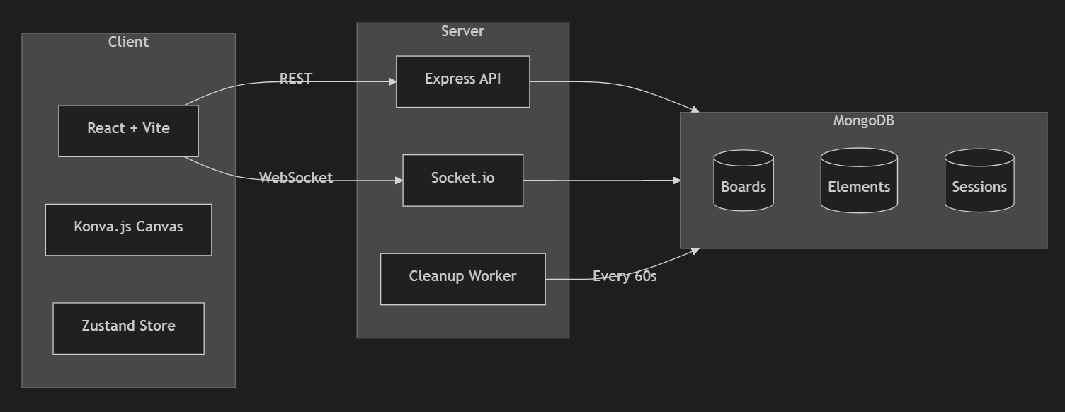
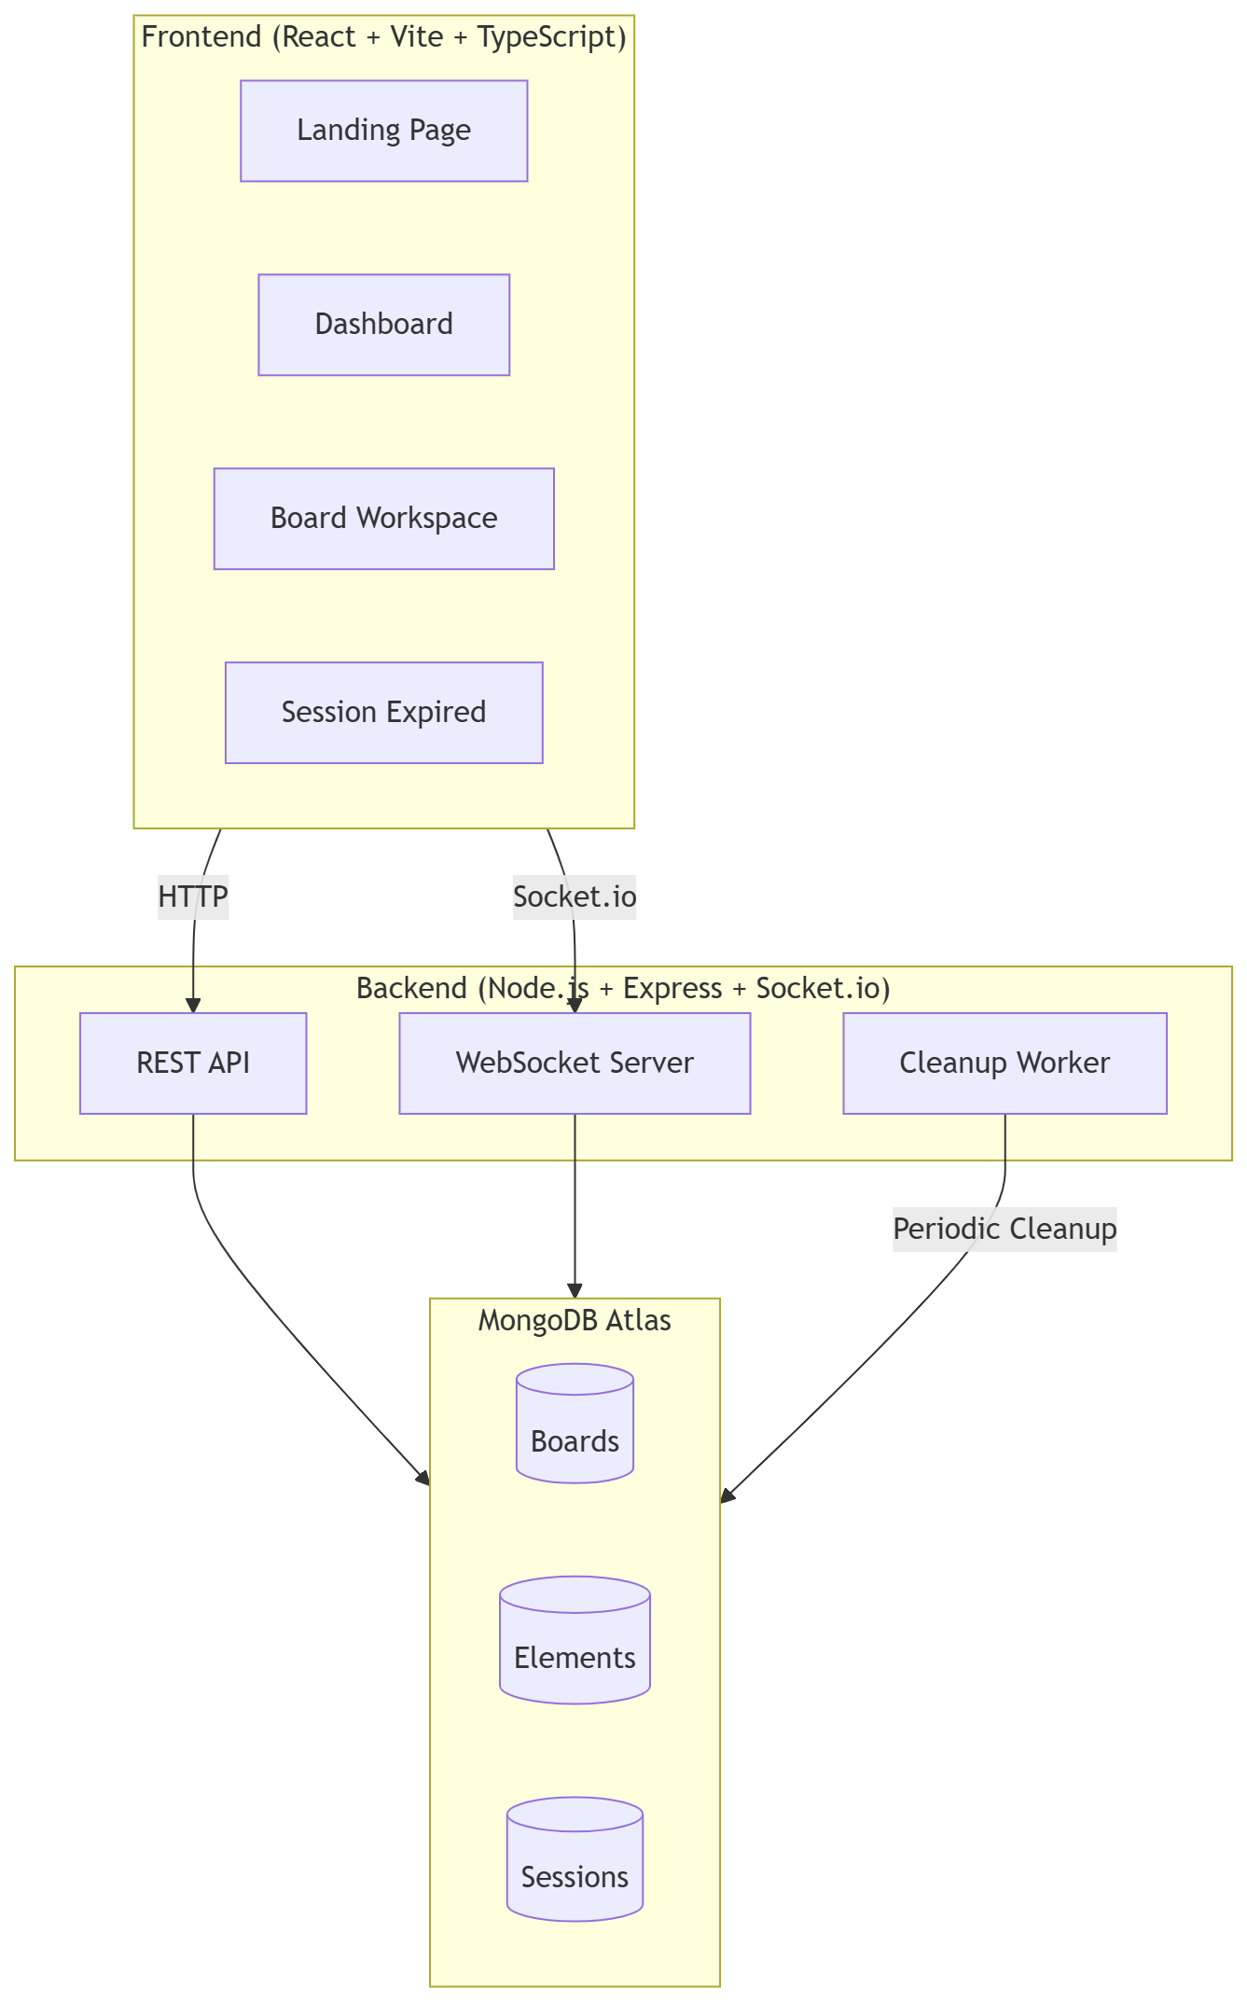Features Implemented
Frontend
Feature | Status
Landing page (hero, features, FAQ, footer) | ✅
Dashboard (create/join boards) | ✅
Board workspace (3-column layout) | ✅
Session expired page | ✅
Theme engine (light/dark/system + localStorage) | ✅
Konva.js canvas with all drawing tools | ✅
Tool sidebar with shortcuts & tooltips | ✅
Right sidebar (activity, metrics, users, settings) | ✅
Framer Motion animations throughout | ✅
Glassmorphism navbar | ✅
Shiny text effect | ✅
Border glow effect | ✅
Dot grid backgrounds | ✅
Skeleton/loading states | ✅
Keyboard shortcuts (Del, Ctrl+Z/Y/V/A, tool keys) | ✅
Zoom/pan canvas | ✅
Undo/redo history | ✅
Backend
Feature | Status
Board CRUD API | ✅
Socket.io room management | ✅
Real-time element sync | ✅
Cursor sync (volatile emit) | ✅
Presence tracking | ✅
Activity feed events | ✅
Heartbeat system (10s interval) | ✅
Auto-cleanup on last user leave | ✅
Stale board cleanup worker (2min threshold) | ✅
JSON export | ✅
Anonymous user generation | ✅
Design System
Element | Implementation
Colors | Indigo accent (#6366F1), dual theme tokens
Typography | Inter (sans), JetBrains Mono (mono)
Cards | Glassmorphism + shadow hierarchy
Buttons | Glow hover, lift transform
Transitions | 400ms spring easing
Scrollbar | Custom styled
Selection | Accent-colored
API Endpoints
Method | Path | Description
POST | /api/board/create | Create new board
GET | /api/board/:id | Fetch board + elements
DELETE | /api/board/:id | Delete board
GET | /api/board/:id/export/json | Export board JSON
POST | /api/board/save | Save board state
GET | /api/health | Health check
WebSocket Events
Event | Direction | Purpose
JOIN_BOARD | Client → Server | Join board room
LEAVE_BOARD | Client → Server | Leave board room
CURSOR_MOVE | Client → Server | Send cursor position
ADD_ELEMENT | Bidirectional | Add canvas element
UPDATE_ELEMENT | Bidirectional | Update element props
DELETE_ELEMENT | Bidirectional | Remove element
CLEAR_BOARD | Bidirectional | Clear all elements
HEARTBEAT | Client → Server | Keep session alive
BOARD_STATE | Server → Client | Initial board state
BOARD_DELETED | Server → Client | Board was deleted
PRESENCE_UPDATE | Server → Client | Active users list
CURSORS_UPDATE | Server → Client | All cursor positions
ACTIVITY_EVENT | Bidirectional | Activity feed events

Board Lifecycle
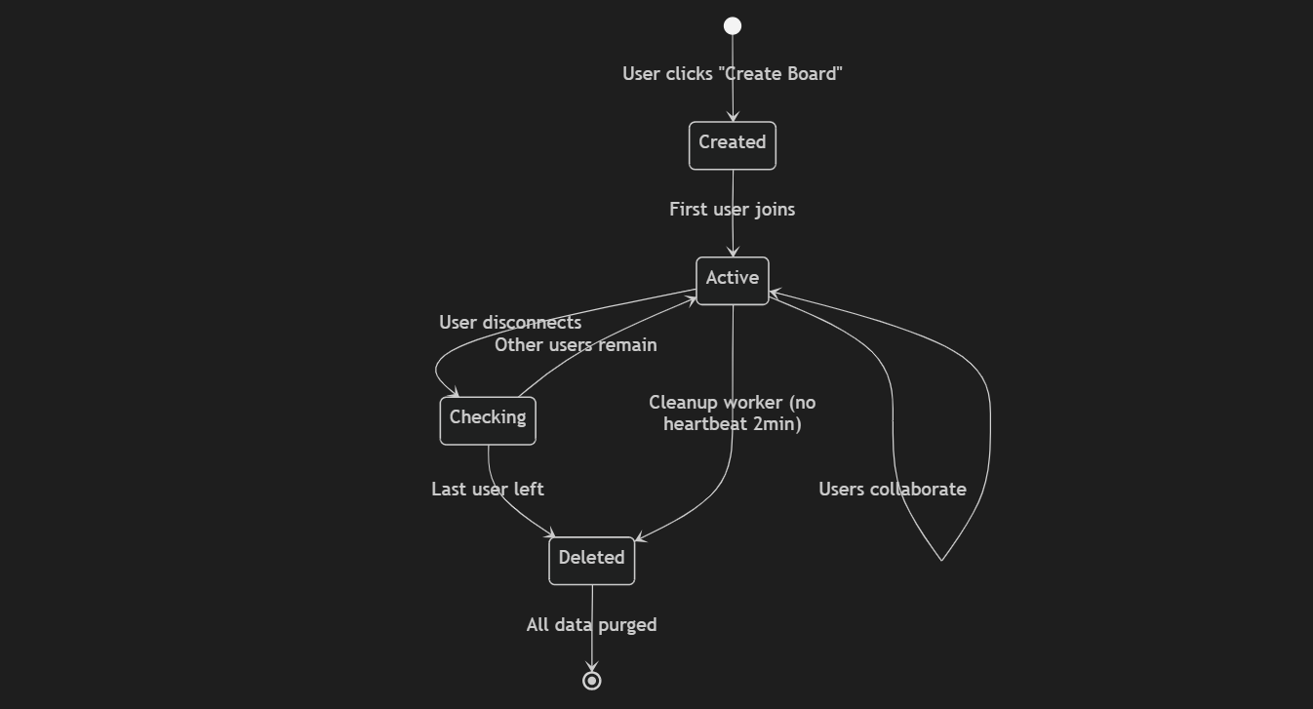
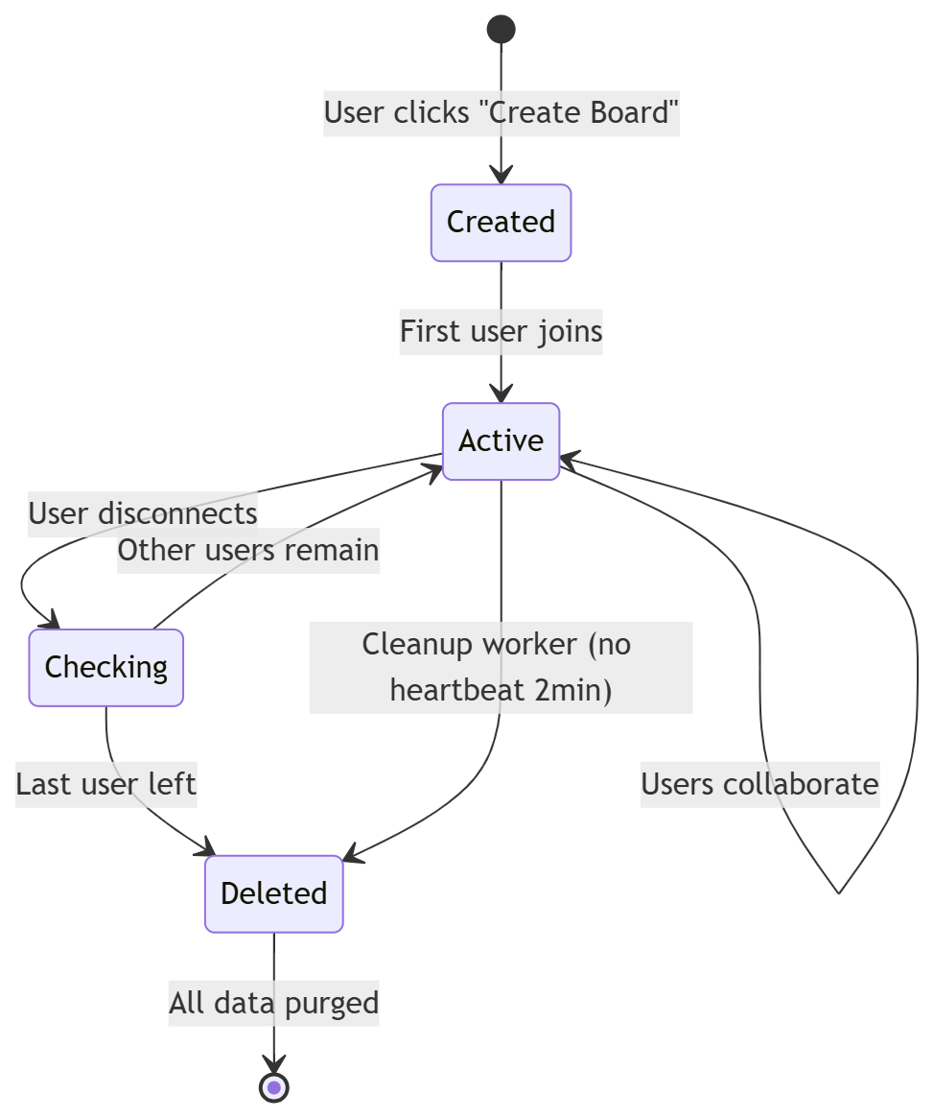

Collabryx — Implementation Plan
Overview
Anonymous real-time collaborative whiteboard + structured idea workspace. Combines Figma (canvas) + Notion (structure) + Miro (multiplayer).
Phases
Phase 1 — Foundation Setup ✅
- Initialize Vite + React + TypeScript frontend
- Initialize Express backend with MongoDB
- Configure TailwindCSS v4 with design system
- Setup theme engine (light/dark/system)
- Create routing (/, /dashboard, /board/:id, /session-expired)
- Create layout system with glassmorphism navbar
Phase 2 — UI System Build ✅
- Build glassmorphism navbar with gradient logo
- Build landing page (hero, features, how-it-works, FAQ, CTA, footer)
- Build dashboard (create/join boards, empty state)
- Build session expired page
- Shiny text, border glow, dot grid effects
- Loading spinners & states
Phase 3 — Canvas Engine ✅
- Install Konva.js + react-konva
- Create Stage with pan/zoom (scroll wheel)
- Add all drawing tools (pen, rectangle, circle, line, arrow)
- Add text blocks with inline editing (textarea overlay)
- Add sticky notes with inline editing
- Add drag, selection, eraser
- Tool sidebar with shortcuts + color palette
- Auto-switch to select tool after placing text/sticky
- Zoom controls (+/- buttons + percentage display)
Phase 4 — Real-Time Sync ✅
- Setup Socket.io client/server
- Create room-based architecture
- Sync elements (add/update/delete)
- Sync cursor movement (volatile emit for performance)
- Sync presence (user join/leave)
- Activity feed events
- SYNC_STATE event for undo/redo sync across all users
- Fixed latency by using direct setElements for remote deletes
Phase 5 — Temporary Session System ✅
- Track active users per board
- Track disconnects (socket.disconnect + beforeunload)
- Implement 10-second heartbeat
- Auto-delete board when last user leaves
- Cleanup worker (60s interval, 2min stale threshold)
- Invalidate links → redirect to /session-expired
Phase 6 — Export System ✅
- JSON export (via REST API)
- PNG export (client-side canvas.toDataURL)
- Export buttons in right sidebar settings panel
Phase 7 — Premium Polish ✅
- Framer Motion animations throughout
- Editable board name (click to rename in navbar)
- Editable username (click name badge to change)
- Keyboard shortcuts skip input/textarea focus
- Fixed text/sticky editing (no duplicate creation)
- Fixed undo/redo syncing to all connected users
- React key warning fixed (separated from spread props)
- Loading states with animated spinner
- Error handling + session expired flow
- Generated custom Collabryx logo/favicon
- Improved landing page with gradients, section labels, CTA section
- PATCH API for board rename
- Multiple board creation works correctly
All Bugs Fixed This Session
Bug | Root Cause | Fix
Text/sticky duplicating on click | Tool stayed active, creating new elements on every mousedown | Auto-switch to select after placing; only create on empty-space clicks
Text/sticky not editable | No inline editing mechanism | Added textarea overlay positioned over Konva element, activated on double-click
Same user can't create new board | Not actually a backend issue — UI was preventing re-navigation | Added loading state to prevent double-clicks, verified API creates unique boards every time
Undo/redo not syncing to other users | undo() only modified local store | Added SYNC_STATE socket event that broadcasts full element array after undo/redo
Latency on element delete sync | deleteElement in store was pushing history for remote events | Remote deletes now use setElements directly (no history push)
Board name not editable | Static text in navbar | Added click-to-edit input with PATCH API backend route
Username not editable | Hardcoded random username | Added click-to-edit name badge, updates socketService and re-joins board
React key warning | key spread via {...commonProps} | Separated key from commonProps, passed directly to JSX
Keyboard shortcuts firing while typing | No check for active input/textarea | Added target.tagName check to skip shortcuts

