HW1

1. Suppose you wanted to do a transaction from a remote client to a server as fast as possible. Would you use UDP or TCP? Why?
   1. TCP
   2. UDP
2. Consider an HTTP client that wants to retrieve a Web document at a given URL. The IP address of the HTTP server is initially unknown. What transport and application-layer protocols besides HTTP are needed in this scenario?
   1. TCP and SMTP
   2. TCP and DNS
   3. UDP and POP3
   4. TCP and FTP
3. Suppose we want to send 25 MB using a geosynchronous satellite 35,000km between the sender and receiver. The signal travels at 300,000km/s and the satellite has a bandwidth of 100Mbps. Both end-hosts have a protocol delay of 50ms. The total end-to-end delay is _____?
4. Suppose we have two hosts connected by two switches as a network H-S-S-H. Suppose each link has a loss probability for a packet of 10% (.1) and that the protocol can detect when packets are lost using time outs and re-transmits lost packets. Question: the probability (number between 0-1) that a packet will not arrive after 3 transmissions (the original + 2 re-transmissions) is: ___
5. Suppose users share a 3 Mbps link. Also suppose each user requires 150 Kbps when transmitting, but each user only transmits 10% of the time.
   1. Circuit switching can support up to ___ users
   2. For parts b-d assume packet switching. What is the probability a given user is transmitting? ___%
   3. Suppose there are 120 users, the probability of 5 users transmitting is ____. The probability of 10 users transmitting is _____. (use binomial distribution)
   4. The probability that >20 users are transmitting is ____
6. Parts a and B
   1. A certain physical layer has a maximum transmission unit (MTU) of 1500 bytes. Given the network stack below, the maximum application payload that can be sent at the physical layer is ____ bytes

|  |  |  |
| --- | --- | --- |
| Layer | Header Size (bytes) | Trailer Size (bytes) |
| Transport | 20 | 0 |
| Network | 20 | 0 |
| Datalink | 14 | 4 |

* 1. The maximum efficiency, in terms of network bandwidth, of the above layers running with the MTU of 1500 bytes is: ___%

1. A user requests a web page using HTTP 1.0 that consists of some text and three images. For this page, the client will send one request message and receive four response messages. True/False?
2. Two distinct Web pages (for example www.mit.edu/research.html and www.mit.edu/students.html) can be sent over the same persistent connection. True/False?
3. The Date: header in the HTTP response message indicates when the object in the response was last modified. True/False?
4. TCP provides secure, reliable data transfer. True/False?
5. A UDP socket allows the programmer to specify the data-rate that is needed to the UDP layer, which might be needed, for example, when sending HD video. True/False?

HW1 Answers

1. B - UDP is quicker because it is not as reliable as TCP. TCP guarantees reliable transport, flow control, congestion control, and has a connection-oriented setup which all take time.
2. TCP and DNS
3. 2.29|2.36
4. .27
5. (a) 20, (b) 10, (c) .01, .108, (d) .008
6. (a) 1442 (b) 96
7. False. For non-persistent connections (version 1.0), each object requires a separate request/response set of messages.
8. True
9. False. The Date: field in the header is when the message was sent, not when the content was modified.
10. False. TCP messages are sent as clear text so it does not provide security from eavesdroppers
11. False. UDP is a "best effort" protocol, which means the data rate is whatever the network can support at the time the messages are sent.

HW2

1. Using a Go-Back-N protocol, it is possible that the sender can receive a packet outside of the current window. True/False?
2. A Go-Back-N protocol as a window size of 6, and sent packets numbered 10, 11, 12, and 13. Packet 11 was dropped by a router because its queue was full, but the other packets arrived correctly and in-order, and packet 10's acknowledgement was received. A valid set of frames that could be re-transmitted by the sender are:
   1. 11, 12, 13, 14, 15, 16, 17
   2. 10, 11, 12
   3. 11
   4. 11, 12
   5. None of the Above
3. It is possible for protocol rdt2.1 to deadlock if a packet is lost. True/False?
4. Host A is sending host B a large file over a TCP connection. Assume host B has no data to send A. In this scenario, Host B's acknowledgments to host A will have to wait until host B has data to send, in order to piggyback the acknowledgments on the data. True/False?
5. You have received the following UDP packet:

Offset Bytes in the header and payload (in hexadecimal):

0x0000 4500 0025 ce16 4000 4011 f941 c0a8 020d

0x0010 4281 6e39 8e35 7ab7 0011 f3fd 5255 5261

0x0020 6852 6168 21

In dotted decimal notation, the source IP address is ____, the destination IP address is ____, the source port, in decimal, is ____, and the destination port, in decimal, is ____. The payload, as a string, is ____.

1. A TCP connection sends the first segment with a sequence number of 90; the second has sequence number 100. How much data is the first segment?
   1. 9 bytes
   2. 10 bytes
   3. 11 bytes
   4. 0 bytes – the segment numbers are out of order
2. In the diagram, above, a packet timeout occurs at transmission round ____. A fast recovery occurs at round ____. Slow start ends at transmission rounds____ and ____.
3. 4 users are downloading a huge file from a single web server. The users' "first-hop" connections are via different technologies. User 1 is connected using FIOS at 100 Mbps, users 2 and 3 are connected using cable modems at 20 Mbps, and user 4 is connected using DSL at 10Mbps. The server is connected using a cable modem at 40 Mbps, and this is the slowest of all the shared links between the users and the server. TCP's congestion control algorithm will try to converge to give what bandwidth per user? (in order 1-4):
   1. 100 Mbps, 40 Mbps, 40 Mbps, 10 Mbps
   2. 21 Mbps, 8.4 Mbps, 8.4 Mbps, 2.2 Mbps
   3. 10 Mbps, 10 Mbps, 10 Mbps, 10 Mbps
   4. 53 Mbps, 21 Mbps, 21 Mbps, 5 Mbps

HW2 Answers

1. True
2. E
3. True
4. False
5. 192.168.2.13, 66.129.110.57, 36405, 31415, RURahRah!
6. B
7. 8|9, 9, 4, 12
8. C

HW 3

1. What is the 32-bit binary equivalent of the IP address 192.168.1.55?
2. What are the two most important network-layer functions in a datagram network? [What third function is additionally important in a virtual circuit network?]
   1. Forwarding, Routing, [Connection Setup]
   2. Forwarding, Error Connection, [Session Management]
   3. Routing, Retransmission, [Reliability]
   4. Retransmission, Error Correction, [Connection Setup]
3. Given the routing table below, which link the packet will be routed on for the '192.168.0.78' IP address.

|  |  |  |
| --- | --- | --- |
| Subnet | Subnet Mask | Outgoing Link |
| 192.168.0.0 | 255.255.255.128 | eth0 |
| 192.168.0.128 | 255.255.255.192 | eth1 |
| 192.168.1.128 | 255.255.255.128 | wlan0 |
| 128.6.4.0 | 255.255.255.224 | wlan1 |
| default |  | ppp0 |

* 1. eth0
  2. eth1
  3. wlan0
  4. wlan1
  5. ppp0

1. Given the routing table below, which link the packet will be routed on for the '192.168.0.245' IP address.

|  |  |  |
| --- | --- | --- |
| Subnet | Subnet Mask | Outgoing Link |
| 192.168.0.0 | 255.255.255.128 | L1 |
| 192.168.0.128 | 255.255.255.192 | L2 |
| 192.168.1.128 | 255.255.255.128 | L3 |
| 128.6.4.0 | 255.255.255.224 | L4 |
| default |  | L5 |

* 1. L1
  2. L2
  3. L3
  4. L4
  5. L5

1. Using the table from question 4, which link the packet will be routed on for the '192.168.1.31' IP address.
   1. L1
   2. L2
   3. L3
   4. L4
   5. L5
2. Using the table from question 4, which link the packet will be routed on for the '128.6.4.6' IP address.
   1. L1
   2. L2
   3. L3
   4. L4
   5. L5
3. Using the table from question 4, which link the packet will be routed on for the '128.6.4.27' IP address.
   1. L1
   2. L2
   3. L3
   4. L4
   5. L5
4. PurpleTurtles.com has been given a class C address, 73.223.89.0/24, and wants to form 3 subnets to support three departments. Which of the subnet network arrangement is correct (any within the correct range): Dept. A: 55 hosts, Dept. B: 24 hosts, Dept. C: 100 hosts
   1. Dept. A: 55 hosts

73.223.89.0/25

Dept. B: 24 hosts

73.223.89.192/27

Dept. C: 100 hosts

73.223.89.128/26

* 1. Dept. A: 55 hosts

73.223.89.128/26

Dept. B: 24 hosts

73.223.89.0/25

Dept. C: 100 hosts

73.223.89.192/27

* 1. Dept. A: 55 hosts

73.223.89.128/26

Dept. B: 24 hosts

73.223.89.192/27

Dept. C: 100 hosts

73.223.89.0/25

* 1. Dept. A: 55 hosts

73.223.89.128/26

Dept. B: 24 hosts

73.223.89.192/27

Dept. C: 100 hosts

73.223.89.0/24

1. Given representation of a network below as graph, and that you are running the shortest-path algorithm: Suppose you are computing the shortest path from router A to E. The length of the shortest path is ____.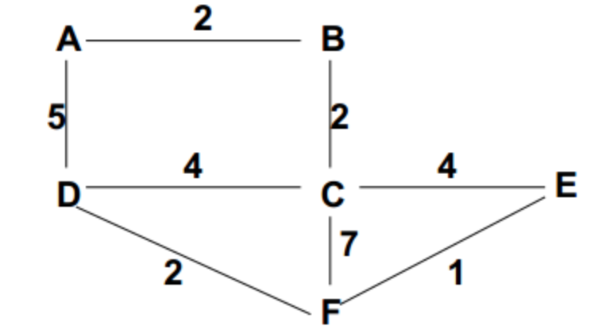

1. Using the network topology below, answer the following questions.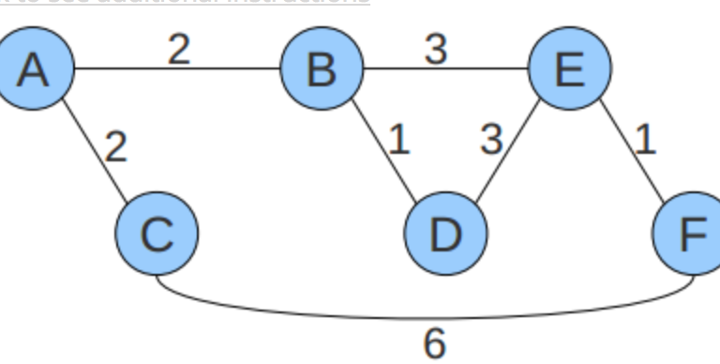
   1. Compute the distance vector table at node A after all nodes have exchanged their final distance vector tables.

|  |  |  |  |  |  |
| --- | --- | --- | --- | --- | --- |
| From A | B | C | D | E | F |
| (Distance, next-hop) | (___, B) | (___, C) | (___, B) | (___, B) | (___, B) |

* 1. Show the final distance vector table at node D after link DE fails.

|  |  |  |  |  |  |
| --- | --- | --- | --- | --- | --- |
| From D | A | B | C | E | F |
| (Distance, next-hop) | (___, B) | (___, B) | (___, B) | (___, B) | (___, B) |

1. 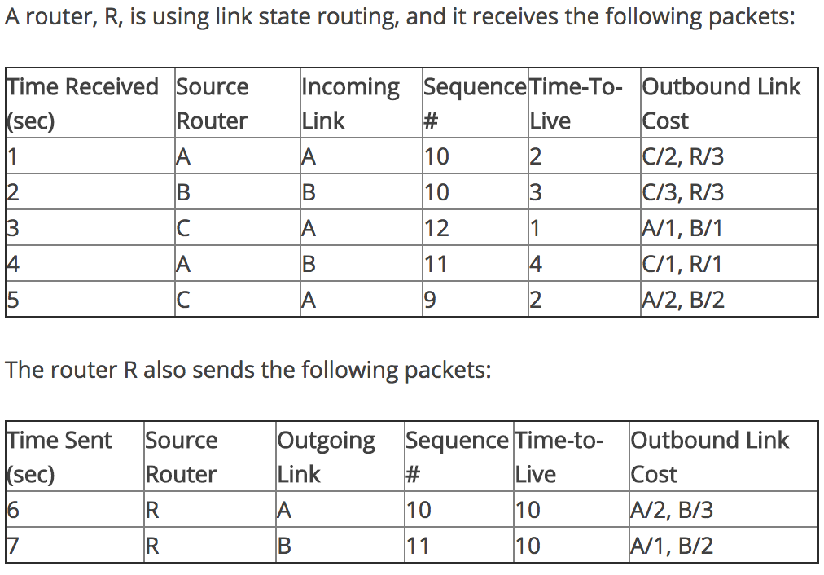Router R is using a shortest path algorithm run on a directed graph. At time 8 sec, what distance does router R think it is to the other routers?
   1. A: ____
   2. B: ____
   3. C: ____

HW 3 Answers

1. 1100 0000 1010 1000 0000 0001 0011 0111
2. Forwarding, Routing, [Connection Setup]
3. eth0
4. L5
5. L5
6. L4
7. L4
8. Dept. A: 55 hosts

73.223.89.128/26

Dept. B: 24 hosts

73.223.89.192/27

Dept. C: 100 hosts

73.223.89.0/25

1. 8
2. 1. 2, 2, 3, 5, 6
   2. 3, 1, 5, 4, 5
3. A: 1, B: 2, C: 2

HW4

* + - 1. 3 parts
         1. Hosts A and B both have 1 frame to send on an Ethernet channel that uses binary exponential backoff. Both hosts sense the channel at the same instant in time. The probability of a collision in this first (0th) contention period is: ____.
         2. A and B still have 1 frame as above, and just collided. The probability of a collision in the next (1st) contention period is: ____.
         3. A and B collide again. The probability of a collision in the next (2nd) contention period is: ___.
      2. Given the 2 dimensional data sent with even parity below:

1 0 1 1 | c

0 1 1 0 | c

1 0 0 1 | c

1 1 1 0 | c

r r r r x

The value, in binary, of the 'r' parity bit vector (labeled with 'r's) would be (do not include the x digit): _____

The value, in binary, of the 'c' bit vector (labeled with 'c's) work be (do not include the x digit): _____

* + - 1. Suppose an Ethernet network is using a 500m coaxial cable, running at 100 Mb/s, and the propagation speed is 5 ns/m. In addition, the receiver for the collision detection needs to receive a minimum of 8 bytes which have collided to declare a collision occurred (to compare what it's transmitting to what it's receiving). The minimum frame size needed to detect a collision is _____ bits.
      2. Suppose you have a 4 nodes A,B,C and D, contending for a channel using slotted ALOHA. Each node transmits with probability 40% and has an infinite number of packets to transmit. The slots are numbered starting at 1. All Answers should have 2 digits of precision.
         1. The probability node A's first successful transmission occurs in slot 1 is (probability is a number between 0 and 1): ____
         2. The probability that both node A is successful in slot 1 and B is successful in slot 2 is: ___
         3. The probability of no packet going through in slot 2, either because of no transmission or a collision is: ____
         4. The long run efficiency (as the number of packets goes to infinity) of the channel is: (a number between 0 and 100): ___

HW 4 answers

1. (a) 50, (b) 25, (c) 12
2. 0101, 0110
3. 200
4. (a) .33, (b) .87, (c) .13 (d) 76