Dissertation Submitted for the partial fulfillment of the **M.Sc. (Integrated) Data Science** degree to the Department of AI&ML and Data Science

**Internship Dissertation**

**Data Science Intern @Petpooja**

submitted to

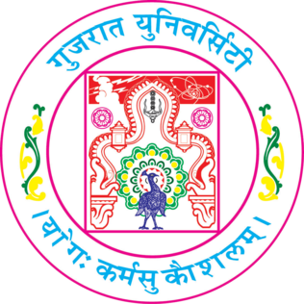

By

**Jay Soni**

Under the guidance of

**Meet Yogi  
(Lead Data Scientist @Petpooja )**

**M.Sc. (Integrated) Data Science**

Department of AIML & Data Science

School of Emerging Science and Technology

Gujarat University

**April, 2024**

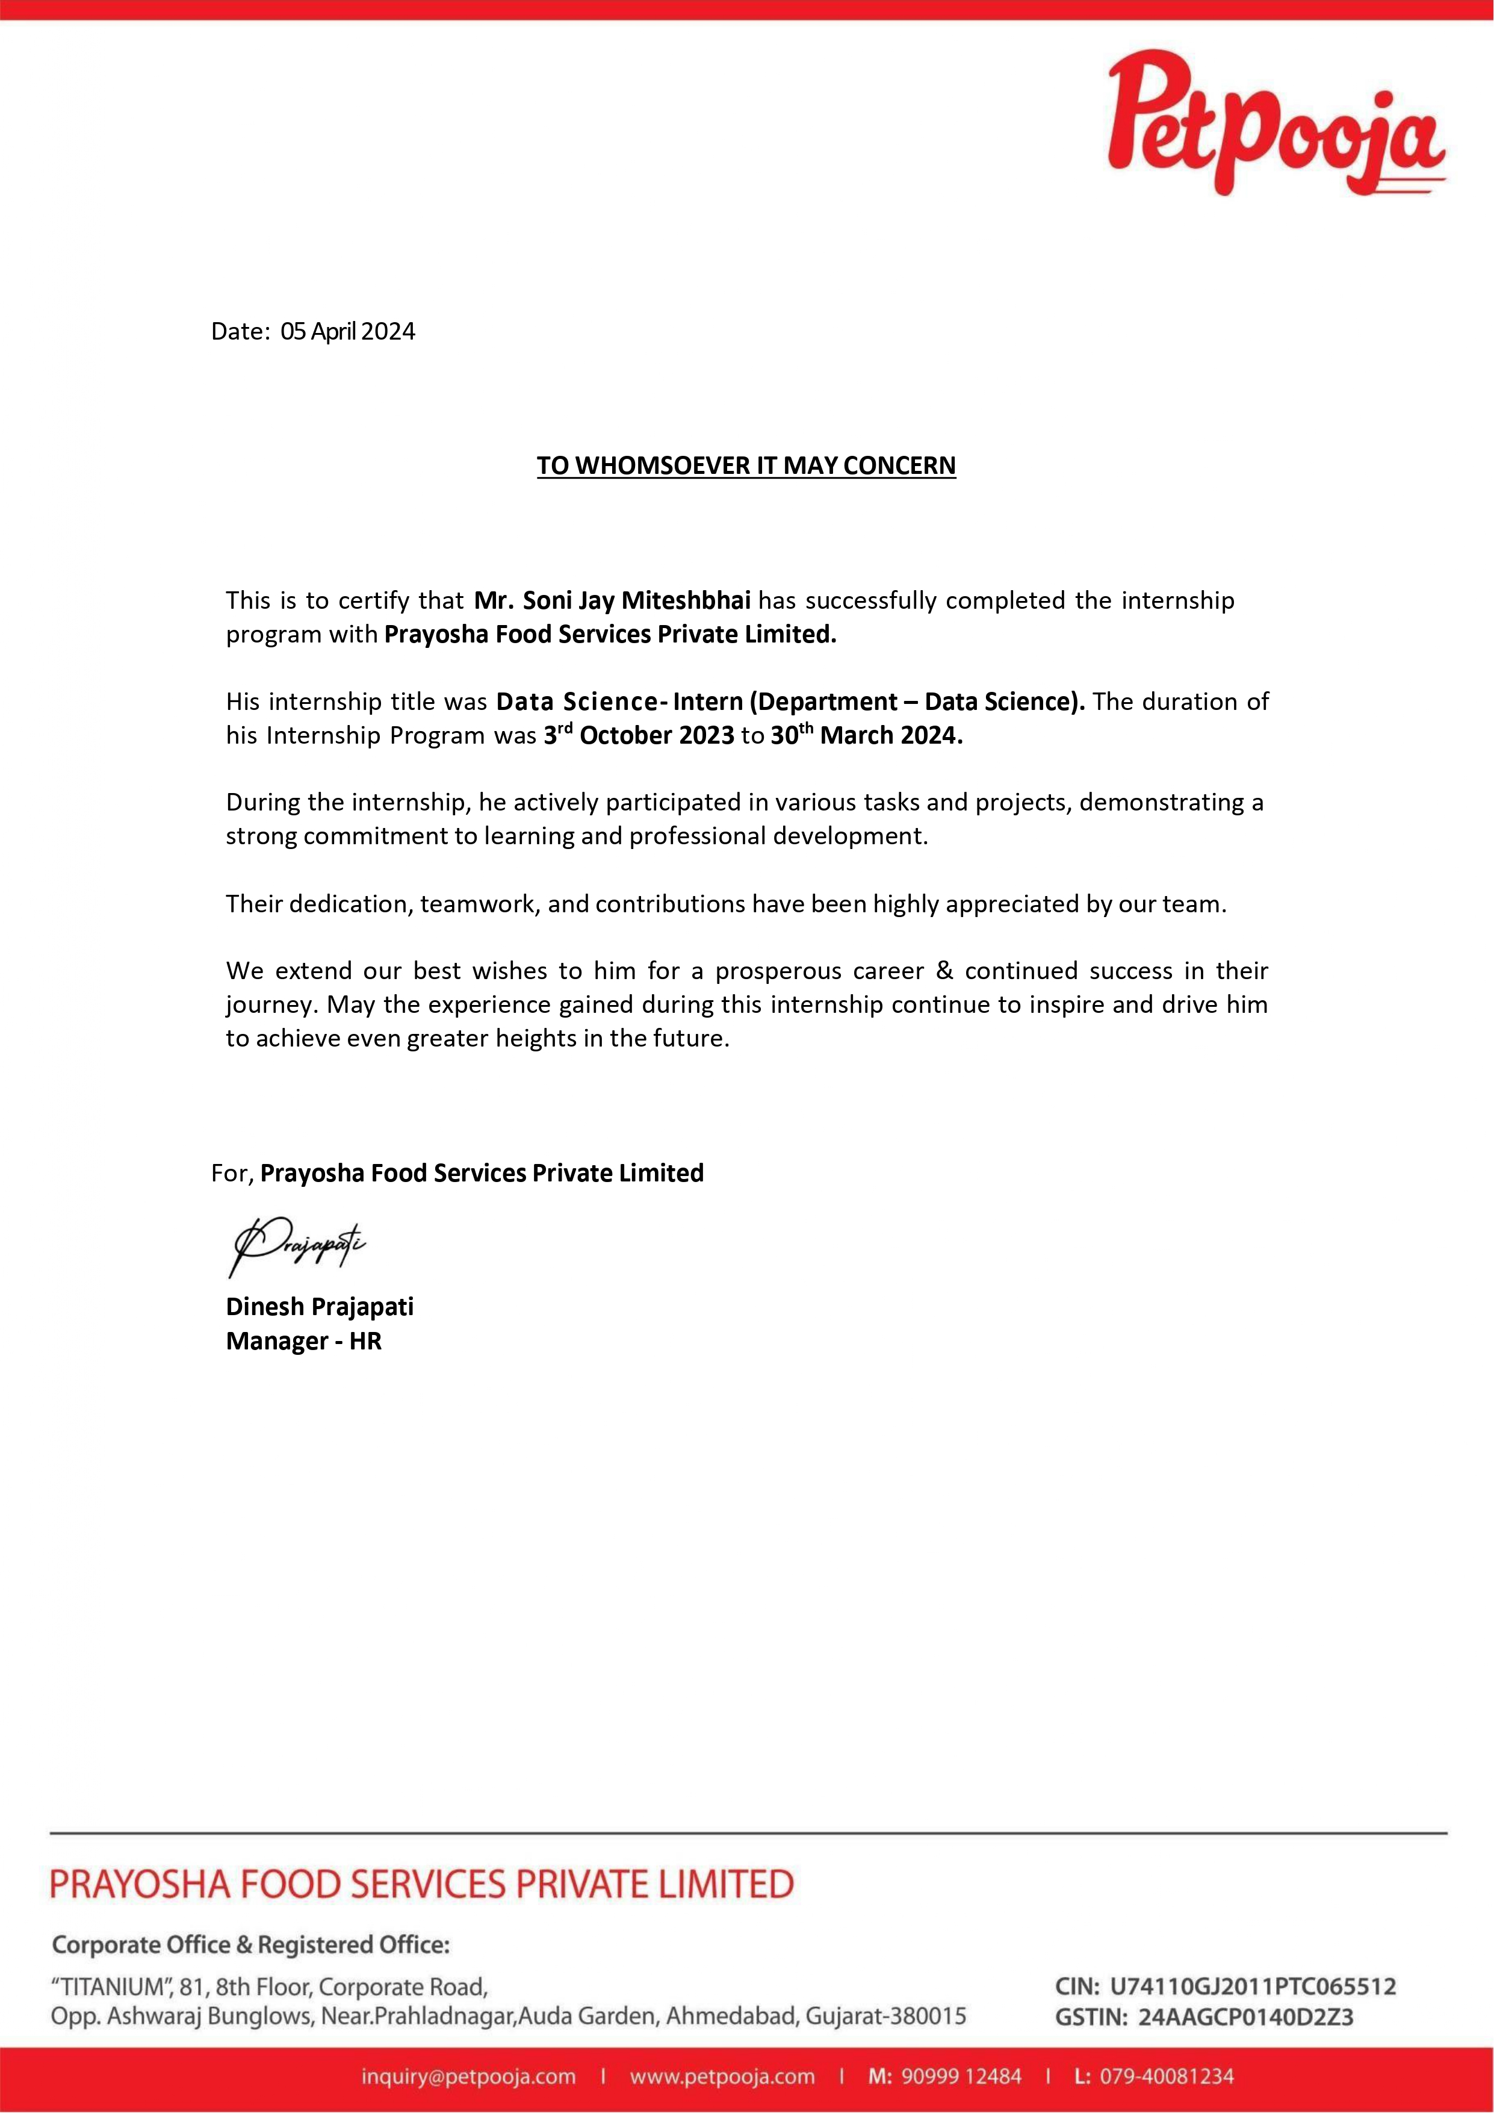

During my internship, I focused on text-to-image generation, researching and experimenting with different model architectures. I carefully collected image datasets from various online sources and shared them on platforms like Kaggle and Hugging Face, aiming to expand resources for others while demonstrating my dedication to collaboration.

I also sharpened my skills in prompt engineering, which involves crafting specific instructions for training AI models. This was crucial for getting the results we wanted from complex systems. Additionally, I played a significant role in cleaning and preprocessing data, which improved the accuracy of our models.

Throughout the internship, I became adept at spotting patterns and understanding how models behaved. This helped us continuously refine our approaches and make our solutions better over time. I also learned firsthand about the practical challenges of deploying machine learning in real-world settings, such as managing time and resources effectively.

Also, I have worked on project for text-to-image image generation, Where i explored stable diffusions models. Curated a custom data for this project through webscraping. Created a different fine-tuned model using stable diffusion model as a base model, and uploaded to HuggingFace.

Overall, my internship was incredibly valuable, providing me with hands-on experience, industry insights, and a deeper understanding of machine learning and deep learning concepts.