Tab 1
Texas Instruments - Mesh Walkie Talkies

Jaiah Steele
Cole Cieslewicz
Junsu Yeo

Final Report

Table of Contents
Concept of Operations………………………………………………………………………………. 3
Fundamental System Requirements………………………………………………………………. 13
Interface Control Document……………………………………………………………………….. 30
Schedule and Validation……………………………………………………………………………42
Subsystems Report…………………………………………………………………………………. 46
System Description and Development……………………………………………………………..67

Texas Instruments - Mesh Walkie Talkies

Jaiah Steele
Cole Cieslewicz
Junsu Yeo

Concept of Operations

Concept of Operations
for
Mesh Walkie Talkies

Team Mesh Walkie Talkies

Approved by:

_____________________________
Cole Cieslewicz Date

_____________________________
Prof. Kalafatis Date

_____________________________
Ethan Barnes Date

Change Record
Rev. | Date | Originator | Approvals | Description
0.0 | 09/15/2024 | Team 36 |  | Draft Release
0.1 | 09/26/2024 | Team 36 |  | Midterm Submission
0.2 | 12/05/2024 | Team 36 |  | Final Report Submission
0.3 | 4/28/2025 | Team 36 |  | 404 Final Report Submission

Table of Contents
Table of Contents III
List of Tables IV
No table of figures entries found. IV
List of Figures V
No table of figures entries found. V
1. Executive Summary 1
2. Introduction 2
2.1. Background 2
2.2. Overview 2
2.3. Referenced Documents and Standards 2
3. Operating Concept 3
3.1. Scope 3
3.2. Operational Description and Constraints 3
3.3. System Description 3
3.4. Modes of Operations 3
3.5. Users 3
3.6. Support 3
4. Scenario(s) 4
4.1. Scenario Name #1 4
5. Analysis 4
5.1. Summary of Proposed Improvements 4
5.2. Disadvantages and Limitations 4
5.3. Alternatives 4
5.4. Impact 4

List of Figures

Figure 1: Prototype Sketch of Mesh Walkie Talkie……………………………………………………….5
Figure 2: Mesh Walkie Talkie Subsystem Breakdown……………………………………………………6
Figure 3: General Timeline for Build-Out of Mesh Walkie Talkies project………………………………6

List of Tables
No tables in this section of the report.

Executive Summary
Our project, sponsored by Texas Instruments, aims to develop walkie-talkies that leverage mesh transmission technology. Mesh transmission is a communication method where devices, known as nodes, are interconnected in a decentralized network. Instead of relying on a single central node or hub, each device can communicate with others directly or indirectly through multiple hops. Unlike traditional walkie-talkies, which have a fixed broadcast range determined by their radio frequency, our mesh walkie-talkies will be able to extend their communication range significantly using mesh connectivity.
For instance, if you have a walkie-talkie with a 100-meter range and another walkie-talkie placed at the edge of this range, the first device can send a message to the second device. The second device, in turn, can relay the message to a third device, and so on. This creates a network of interconnected devices that can extend the communication range beyond the limit of a single device.
In theory, a mesh network consisting of seven walkie-talkies, spaced equally apart, could achieve a range of 700 meters from the first device to the last. This capability allows for much broader and more flexible communication, especially in environments where line-of-sight communication is not always possible.

Introduction
Imagine a walkie talkie that will always leave you in range of other devices no matter how far you go. Such a device can be created by integrating a powerful mesh network using TI’s proprietary RF technology. The walkie talkies will be capable of communication far beyond their typical range, with low-latency audio relayed through the network of devices. We aim to not only integrate the mesh network, but also the audio hardware, MCU software, and a rechargeable power supply that ensures 24 hours of operation time.
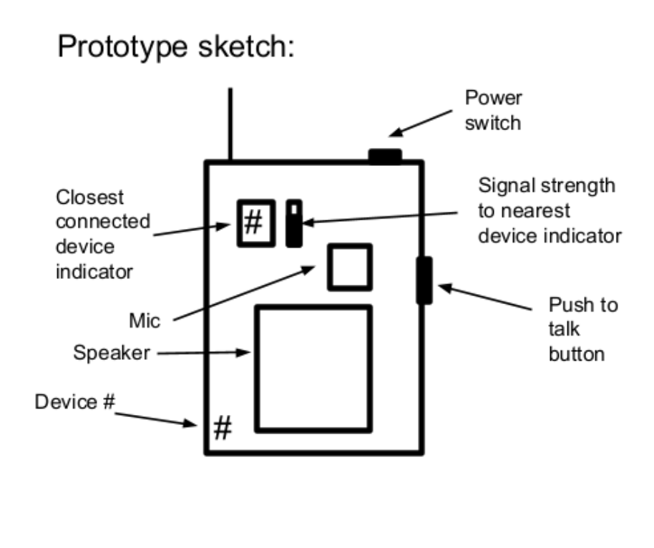
Figure 1: Prototype Sketch of Mesh Walkie Talkie

Background

Traditionally, walkie talkies are used to communicate within a fixed range that is dependent on the radio frequency. They are popular today for their simplicity and reliability with low latency communication. However, the limitations of the range in which the devices can connect restricts users in certain environments.

To address this limitation, a walkie talkie with mesh networking technology allows for these devices to communicate by relaying signals to nearby devices. TI’s proprietary RF allows for low latency communication across longer distances. A microprocessor capable of processing signals, mesh networking, and audio compression/decompression is essential to successfully create the mesh walkie talkie. TI’s CC1354P10 MCU will be used to integrate and manage these functions within the device.

Overview
Receiving Signal
(Audio)
Encoding Signal (MCU)
Transmitting Signal (Mesh)
Decoding Signal (MCU)
Outputting Signal (Audio)
Power
User Interface (Push-to-Talk, etc)
PCB
Figure 2: Mesh Walkie Talkie Subsystem Breakdown

Sep ‘24

Introduction Projects
Oct ‘24
PCB Design
LCD Driver
Launchpad Comm.
Nov ‘24
Soldering
Push to talk
Mesh Functionality
Dec ‘24
PCB Validation
I2S Audio Integration
3-Way Mesh
Break
Feb ‘25
3D Casing
Finalize PCB
Audio Integration
April ‘25
Further Testing
Final Report
and Demo
Jan ‘25
LCD Updates
New Power PCB
UART Conversion
Mar ‘25
Enclose Device Validation
Assembling Unit
Figure 3: General Timeline for Build-Out of Mesh Walkie Talkies project

Our system can be broken down into four different subsystems. Like traditional walkie talkies, the Mesh Walkie Talkie will include a push-to-talk button, microphone, and speakers. The microprocessor will be in charge of the encoding and decoding of the signal, as well as implementing the push-to-talk system and liquid crystal displays. The mesh networking technology will be integrated into the microprocessor as well to allow the devices to be connected through mesh networking with low latency. All of these subsystems will be receiving power with the right specification by the rechargeable lithium ion battery and the use of power converters.

Referenced Documents and Standards
- CC1354P10 SimpleLink High-Performance Multi-band Wireless MCU With Integrated Power Amplifier datasheet
- CC1354P10 SimpleLink Wireless MCU Device Revision B
- CC2538, CC13xx, and CC26xx Serial Bootloader Interface
- CC13xx/CC26xx Hardware Configuration and PCB Design Considerations
- TI 15.4-Stack Software
- WIreless MCUs Designed to Meet Complex IoT Requirements
- CC13x4, CC26x4 SimpleLink Wireless MCU Technical Reference Manual
- TI Wi-SUN FAN Stack - Software Overview
- Wireless Connectivity Technology Selection Guide

Operating Concept

Scope
The proposed project is a mesh walkie-talkie system that extends the communication range of traditional walkie-talkies using mesh networking. It targets outdoor and industrial applications where direct line-of-sight communication is limited. The system will enable multiple users to communicate seamlessly by hopping signals between devices at the edge of their range. The primary goal is to build a reliable, low-latency communication tool that can work in environments where traditional walkie-talkies fail due to distance constraints.

Operational Description and Constraints
The system will be used in scenarios where long-range communication is necessary but cannot be achieved with standard walkie-talkies, such as large work sites, search and rescue operations, or outdoor adventures. Each device in the network will function both as a walkie-talkie and as a relay point, allowing signals to 'hop' from one device to the next.
Constraints include limited power, the need for efficient audio compression, and RF interference. The system is designed to be low-power, so battery life may vary depending on the number of devices in the mesh network and the frequency of transmissions. Additionally, with many devices on the same network, our system will need to be configured to receive a signal from only one device (rather than many at once).

System Description
The mesh walkie-talkie system is built around the TI CC1354P10 MCU, which includes both RF and audio components. Each device will have push-to-talk functionality and use audio compression. A liquid crystal display will indicate when a device is transmitting, along with an indicator for which device in the network is currently speaking.
The system will support TI’s proprietary sub-1GHz radio frequency for the mesh protocol, enabling devices to extend the communication range beyond the limits of traditional RF systems. The hardware will include a simple push-to-talk interface and be entirely self-contained, without the need for external computers or gateways for basic operation.

Modes of Operations
Idle Mode: Devices remain in low-power standby when no communication is active, displaying “Push to Talk” as well as Walkie ID:##.

Transmit Mode: When the push-to-talk button is pressed, the device sends compressed audio data to the network, and the LCD display indicates transmission.
Receive Mode: Devices not in transmission mode will receive and decode incoming audio data, and the LCD will update to alert users which device the audio originates from.

Relay Mode: Devices can act as intermediate nodes, relaying transmissions between devices that are out of direct range of each other.

Several of these modes will operate simultaneously, for example, a device will operate in both receive and relay mode in order to ensure the operation of the mesh network.

Users
The system is intended for users in industries requiring long-range, reliable communication, such as construction, outdoor expeditions, and emergency services. Little technical training is required for operation beyond basic installation and push-to-talk use. Installation requires simple network configuration, and the devices are designed to be intuitive to use with minimal setup, making the system accessible to users without technical expertise

Support
Support for the mesh walkie-talkies will be provided in the form of a comprehensive user's manual, ensuring proper operation, and detailing restraints such as maximum operating distance etc.

Scenario

Construction
Due to how large construction sites can be, mesh networks are a great method of communication. Mesh walkie talkies make it so that workers can let others know that hazardous work is being done in a specific area, letting everyone else on the site know to be cautious when entering, or to tell others that they are ready for a specific material or part. The mesh walkie talkies would display which device the signal originally came from so that workers can easily identify who the message is from.

Outdoor Exploration
When traveling outdoors, such as hiking across mountain ranges, communication to other groups within the area is difficult. Mesh walkie talkies allow for hikers to keep in contact with one another, which is especially important due to the lack of internet connection in these areas. The mesh network will allow for groups to communicate with one another across an entire mountain range as long as there are people stationed within range to pass on the signal.

Search and Rescue
Because mesh walkie talkies allow for a wider range of communication than traditional walkie talkies, search and rescue efforts would be able to cover a much larger area. Search and Rescue groups would be able to provide aid faster due to the larger communication range.

Analysis

Summary of Proposed Improvements
The main improvement provided by this mesh-powered solution is the ability to relay connections over long distances, flexibility in hard-to-cover areas, and self-healing capabilities (if one goes out, the rest remain active). Traditional communication devices do not act in this way, especially considering that our system is standalone, and requires no internet connection. Improvements also include using an MCU with integrated analog and digital components, reducing power consumption in comparison to competitor MCUs.

Disadvantages and Limitations
An individual walkie-talkie in our system will not have industry-leading range that is provided by more powerful solutions. Our system will also operate at a fixed frequency in order to improve simplicity, meaning that there would be no option for separate conversations for those using this system.
A disadvantage of using mesh networks over traditional walkie-talkies includes higher power consumption as a result of more complex computing. For example, during a typical session in relay mode, the MCU will have to receive an incoming signal, decompress and decode it, output it via the speakers, and pass on the signal to other walkie-talkies within range simultaneously.

Alternatives
The first alternative solution would be a traditional walkie-talkie system. While this may be simpler and more cost-effective, it simply cannot relay signal, and you are thus limited to the range of a single device, making for a much less reliable experience in the scenarios listed in section 4.
Another alternative includes an internet- or satellite-connected device. This, however, is at the mercy of the reliability of your connection to cell towers or satellites, which, depending on your location, could be spotty or non-existent.

Impact
The use of rechargeable batteries makes this solution more economical than using disposable batteries. The addition of devices crowding the radio frequency spectrum could impact local communication. This solution will abide by government communication standards.
Improved communication abilities come as a result of the mesh system, and can be useful in emergency situations. Privacy and security concerns arise considering the fixed frequency, but users should be made aware of that prior to use.

Texas Instruments - Mesh Walkie Talkies

Jaiah Steele
Cole Cieslewicz
Junsu Yeo

Functional System Requirements

REVISION – 1.0
26 September 2024
Functional System Requirements
for
Mesh Walkie Talkies

Approved by:

_____________________________
Cole Cieslewicz Date

_____________________________
Prof. Kalafatis Date

_____________________________
Ethan Barnes Date

Change Record
Rev. | Date | Originator | Approvals | Description
1 | 9/26/2024 | Team 36 |  | Draft Release
2 | 12/05/2024 | Team 36 |  | Final Report Submission
3 | 4/28/2025 | Team 36 |  | 404 Final Report Submission

Table of Contents
Table of Contents III
List of Tables IV
No table of figures entries found. IV
List of Figures V
1. Introduction 1
1.1. Purpose and Scope 1
1.2. Responsibility and Change Authority 1
2. Applicable and Reference Documents 2
2.1. Applicable Documents 2
2.2. Reference Documents 2
2.3. Order of Precedence 3
3. Requirements 4
3.1. System Definition 4
3.2. Characteristics 4
3.2.1. Functional / Performance Requirements 4
3.2.2. Physical Characteristics 5
3.2.3. Electrical Characteristics 6
3.2.4. Environmental Requirements 8
3.2.5. Failure Propagation 9
4. Support Requirements 10
Appendix A Acronyms and Abbreviations 11
Appendix B Definition of Terms 12
Appendix C Interface Control Documents 12

List of Tables

Table 1: Sub-System Breakdown 7
Table 2: Applicable Documents 8
Table 3: Reference Documents 8

List of Figures
Figure 1. Prototype Sketch of Mesh Walkie Talkie 1
Figure 2. Block Diagram of Mesh Walkie Talkie 4

Introduction

Purpose and Scope

The project is a mesh walkie-talkie system that extends the communication range of traditional walkie-talkies using mesh networking. It targets outdoor and industrial applications where direct line-of-sight communication is limited. The system will enable multiple users to communicate seamlessly by hopping signals between devices at the edge of their range. The walkie-talkies will be able to send a signal to any other device within 100m. The primary goal is to build a reliable, low-latency communication tool that can work in environments where traditional walkie-talkies fail.


Figure 1. Prototype Sketch of Mesh Walkie Talkie

Responsibility and Change Authority

The team leader, Cole Cieslewicz, will ensure that all of the system requirements are met. Any changes that are made to the project’s specifications or deliverables must be approved by the team leader and the sponsor’s official representative, Giuseppe Rizzi.

Subsystem | Responsibility
MCU Software & Integration | Jaiah Steele
Mesh Network Operation | Cole Cieslewicz
Power System & Enclosed Casing | Junsu Yeo
Table 1: Sub-System Breakdown

Applicable and Reference Documents

Applicable Documents

The following documents, of the exact issue and revision shown, form a part of this specification to the extent specified herein:

Document Number | Revision/Release Date | Document Title
IEC 62133-2:2017 | Issue 02/07/2017 | Secondary cells and batteries containing alkaline or other non-acid electrolytes - Safety requirements for portable sealed secondary cells, and for batteries made from them, for use in portable applications - Part 2: Lithium systems
IEEE802.15.4G | Approved: 03/29/2012  Published: 04/27/2012 | IEEE Standard for Local and Metropolitan Area Networks Part 15.4: Low Rate Wireless Personal Area Networks (LR-WPANs) Amendment: Physical Layer (PHY) Specifications for Low Data Rate Wireless Smart Metering Utility Networks
IETF STD86: RFC 8200 | 07/14/2017 | Internet Protocol, Version 6 (IPv6) SpecificationIEEE Standard for Low-Rate Wireless Networks
IETF STD87: RFC 8201 | 07/14/2017 | Path MTU Discovery for IPv6
Table 2: Applicable Documents

Reference Documents

The following documents are reference documents utilized in the development of this specification. These documents do not form a part of this specification and are not controlled by their reference herein.

Document Number | Revision/Release Date | Document Title
IETF RFC 2460 | 12/01/1998 | Internet Protocol, Version 6 (IPv6) Specification - Obsoleted by RFC 8200
IETF RFC 791 | 09/XX/1981 | Internet Protocol - Obsoleted by Multiple Documents
SWRA714A | July 2021  Revised November 2023 | TI Wi-SUN FAN Stack - Software Overview
SWRS267B | December 2022  Revised December 2023 | CC1354P10 SimpleLink High-Performance Multi-band Wireless MCU with Integrated Power Amplifier
SWRZ132B | September 2022  Revised December 2023  Revision C | CC1354P10 SimpleLink Wireless MCU Device Revision C
SWRA640H | December 2018  Revised May 2024 | CC13xx/CC26xx Hardware Configuration and PCB Design Considerations
SWRA765 | July 2023 | Wireless MCUs Designed to Meet Complex IoT Requirements
SWAT016B | 2021 | Wireless Connectivity Technology Selection Guide
Table 3: Reference Documents

Order of Precedence
In the event of a conflict between the text of this specification and an applicable document cited herein, the text of this specification takes precedence without any exceptions.

All specifications, standards, exhibits, drawings or other documents that are invoked as “applicable” in this specification are incorporated as cited. All documents that are referred to within an applicable report are considered to be for guidance and information only, except ICDs that have their relevant documents considered to be incorporated as cited.

Requirements

System Definition

The Mesh Walkie Talkies are walkie talkies that will use mesh transmission technology that allows devices to communicate with each other on a decentralized network. Unlike traditional walkie talkies, the mesh technology will allow users to use their walkie talkie to communicate with devices outside of its range. The Mesh Walkie Talkie can be split into four subsystems: Mesh network operation, MCU software & integration, power system, and audio system/PCB.

CC3200AudBoost
Audio
Extension Board

MCU
PTT Button
LCD
BMS
Antenna
Power Button
LiPo Battery
Voltage Stepping
Audio (de)compression
PCB
Mesh Connection
Key:
YELLOW: Junsu (Power)
GREEN: Jaiah (Software)
RED: Cole (Mesh Comm.)
BLUE: Audio Subsystem
Figure 2: Block Diagram of Mesh Walkie Talkie

To function as a walkie talkie, the device requires a microphone and a speaker to allow the input and output of audio. To allow for the hopping of signals from device to device, TI’s low latency mesh network, an integrated function of the selected CC1354P10 MCU, shall be utilized. User interfaces such as the push-to-talk button, indicator for connected devices, and power switch will all be integrated into the MCU. All of these functions will be powered by a rechargeable LiPo battery with the device going into idle mode when not in use.

Characteristics

Functional / Performance Requirements

Relay Signal
The Mesh Walkie Talkie devices shall both receive and transmit audio signals with maximum latency of 200ms.

Rationale: The walkie talkies latency must not be noticeable when in use.

Battery Life
The Mesh Walkie Talkie shall have a battery life of at least 24 hours long while the device is on.

Rationale: This is a requirement specified by our customer due to constraints of their
system in which the Mesh Walkie Talkie is integrating.

Unobstructed Range
The Mesh Walkie Talkie shall connect to all other devices within at least 100m range.

Rationale: This is a requirement specified by our customer due to constraints of their
system in which the Mesh Walkie Talkie is integrating. It would not be very effective, even in a mesh network, without this characteristic.

Audio Sampling Rate
The Mesh Walkie Talkie shall have an audio sampling rate of at least 8kHz.

Rationale: This is a requirement specified by our customer due to constraints of their
system in which the Mesh Walkie Talkie is integrating. While not an official standard, this sampling rate is around the minimum generally accepted for semi-clear voice transmission.

Bits Per Sample
The Mesh Walkie Talkie shall have at least 8 bits per sample.

Rationale: This is a requirement specified by our customer due to constraints of their
system in which the Mesh Walkie Talkie is integrating.

Physical Characteristics

Size
The Mesh Walkie Talkie will be less than or equal to 7 inches in length and width excluding the antenna.

Rationale: This is a requirement specified by our customer due to constraints of their
system in which the Mesh Walkie Talkie is integrating. Making sure this device is portable and hand-held is imperative for its application.

      - Weight
The Mesh Walkie Talkie will be approximately 250 grams in weight.

Rationale: Should be light enough to carry around for long periods of time.

      - Enclosure

The components of the Walkie Talkie will be placed on the plastic enclosure while the internal components will be placed securely inside.

Rationale: All user interfaces will be accessible on the device and the internal components will be
safe and secure within the plastic.

      - Display and Interface

The Mesh Walkie Talkie will include a LCD display, push-to-talk button, and power switch.

Rationale: These are basic requirements specified by our customer to ensure ease of use for those familiar with traditional handheld transceivers.

Electrical Characteristics

Inputs
- Any sequence of any combination of input signals within the bounds stated in the ICD, the Mesh Walkie Talkie shall not be damaged or malfunction.

- The Mesh Walkie Talkie should be able to go into reset and shutdown mode when the battery is low to avoid discharging of the battery.

Rationale: By design, should limit the chance of damage or malfunction by user/technician error.

Power Consumption
- The maximum peak power of the system shall not exceed 20 mW.

Rationale: This is a requirement specified by our customer due to constraints of their system in which the Mesh Walkie Talkie is integrating; an extension of battery life constraints.

Input Voltage Level
The input voltage level for the Mesh Walkie Talkie shall be +0.3 VDC to +4.1 VDC.

Rationale: This is a bound stated in the CC1354P10 MCU data sheet.

Audio Input
The Mesh Walkie Talkie will have a microphone to be able to take in audio.

Rationale: The audio is directly recorded from the user

Battery
The Mesh Walkie Talkie will be powered by a 3.7 V 2500 mAh LiPo Battery.

Rationale: The battery will provide the necessary power to each system for at least 24 hours

Outputs

Audio Output
The Mesh Walkie Talkie shall include a speaker to output the audio signal that is received.

Rationale: The audio is directly played to the user.

LCD Output
The Mesh Walkie Talkie shall include a LCD display to display during idle mode, transmission mode, and receiving mode.

Rationale: Provides the user with a visual indication of if the device is transmitting or receiving and shows devices that are connected.

Environmental Requirements
The Mesh Walkie Talkie shall be able to operate without fail under the environmental circumstances listed below.

        - Pressure (Altitude)
The Mesh Walkie Talkies shall connect to each other as long as they are within 100 meters of each other in all directions.

Rationale: Suitable for elevation differences

        - Thermal
The Mesh Walkie Talkie shall be able to operate without fail in a temperature range of -20°C to 70°C. The MCU will be able to withstand temperatures between -40°C and 105°C.

Rationale: Suitable for outdoor environments.

        - Rain
The Mesh Walkie Talkie shall be water resistant and operator under light rain conditions.

Rationale: Suitable for typical weather conditions.

        - Humidity
The Mesh Walkie Talkie shall be able to operate within all ranges of humidity.

Rationale: Suitable for typical outdoor weather conditions

Failure Propagation

Failure Detection, Isolation, and Recovery (FDIR)
The Mesh Walkie Talkie shall have a system checkup before the device is ready to use to detect failures. Throughout operation, the MCU can periodically send signals to the necessary peripherals of the MCU to check that there is a response.

Built In Test (BIT)
The Mesh Walkie Talkie shall have built in internal BIT to test for any failures of subsystems.

BIT Battery Overcharge/Discharge Detection
The BMS implemented into the Mesh Walkie Talkie shall detect and stop the LiPo battery from discharging or overcharging.

Rationale: Allow the battery to stay healthy for a longer period of time.

BIT MCU
The Mesh Walkie Talkie shall verify that all peripherals of the MCU respond to standard testing signals.

Rationale: Tests to see if there are any failures within the MCU before the device is started.

BIT Feedback
The Mesh Walkie Talkie shall notify the user of any BIT failures detected.

Rationale: Ensure the user knows when the device is encountering an internal failure.

Isolation and Recovery
The Mesh Walkie Talkie shall be able to completely reset depending on the results of the BIT.

Rationale: Ensure system reliability and fault tolerance.

Support Requirements
The Mesh Walkie Talkie requires other devices to be connected within the range in order to fully operate. Users will be provided with all necessary components for the device to operate. Users will be provided with all necessary components to charge the device.

Appendix A: Acronyms and Abbreviations
kHz Kilohertz (1,000 Hz)
ms milliseconds (0.001 s)
m meter
MCU Microcontroller Unit
PCB Printed Circuit Board
LiPo Lithium Polymer
LCD Liquid Crystal Display
ICD Interface Control Document
mW megawatts
VDC Voltage Direct Current
mAh milliAmp Hour
°C Degrees Celsius
FDIR Failure Detection, Isolation, and Recovery
BIT Built in Test
BMS Battery Management System

Appendix B: Definition of Terms
MCU (Microcontroller Unit): The central processing unit responsible for managing the operation of the mesh walkie-talkie.
Mesh Network: A network topology where devices communicate directly with multiple other devices to relay information, extending range and redundancy by "hopping" between devices.
UART (Universal Asynchronous Receiver-Transmitter): A hardware communication protocol used for serial communication between the MCU and peripherals.

Texas Instruments - Mesh Walkie Talkies

Jaiah Steele
Cole Cieslewicz
Junsu Yeo

Interface Control Document

REVISION – 1.0
26 September 2024
Interface Control Document
for
Mesh Walkie-Talkies

Team Mesh Walkie Talkies

Approved by:

_____________________________
Cole Cieslewicz Date

_____________________________
Prof. Kalafatis Date

_________________________
Ethan Barnes Date

Change Record
Rev. | Date | Originator | Approvals | Description
1 | 09/26/2024 | Team 36 |  | Draft Release
2 | 12/05/2024 | Team 36 |  | Final Report Submission

Table of Contents
Table of Contents III
List of Tables IV
List of Figures V
1. Overview 1
2. References and Definitions…………………………………………………………………. 2
2.1. References 2
2.2. Definitions 2
3. Physical Interface 3
3.1. Weight 3
3.2. Dimensions 3
3.3. Mounting Locations 3
4. Thermal Interface 4
4.1. Cooling Requirement 4
4.2. Heat Sink……………………………………………
4.3. Operating Temperature Range……..
5. Electrical Interface 4
5.1. Primary Input Power 4
5.2. Stand-by Rest and Sleep Modes……… 4
5.3. Voltage and Current Levels 4
5.4. User Control Interface……
6. Communications / Device Interface Protocols……….
6.1. Radio Frequency……
6.2. Device Peripheral Interface……..

List of Tables

No table of figures entries found.

List of Figures

No table of figures entries found.

Overview
This Interface Control Document (ICD) outlines the various interfaces for the mesh walkie-talkie system, a handheld communication device that employs a low-power, long-range mesh network using the TI-standard wireless communication protocol (based on IEEE 802.15.4g). This ICD specifies the physical, thermal, electrical, and communication interfaces to ensure proper integration and operation of all subsystems, with a focus on reliability, low-latency communication, and durability in rugged environments. The document also defines the relevant standards and protocols used in the design, including the microcontroller (MCU) and audio compression technology.

References and Definitions

References

CC1354P10 SimpleLink MCU Datasheet
Texas Instruments (TI)
Document No: SWRS345, 2023
Details the specifications of the CC1354P10 MCU, including electrical and thermal limits.

IEEE 802.15.4g-2012
IEEE Standard for Local and Metropolitan Area Networks Part 15.4: Low Rate Wireless Personal Area Networks (LR-WPANs) Amendment: Physical Layer (PHY) Specifications for Low Data Rate Wireless Smart Metering Utility Networks

Definitions
PCB Printed Circuit Board
MCU Microcontroller Unit
V Volt
GPIO General Purpose Input/Output
LED Light Emitting Diode
GHz Gigahertz (1,000,000,000 Hz)
ms milliseconds (0.001 s)
bps Bits per second
UART Universal Asynchronous Receiver / Transmitter
I2C Inter-Integrated Circuit

Physical Interface

Weight
Our enclosed device should be easily handheld. The final walkie-talkie device (enclosed) will weigh approximately 250 grams, including the battery and enclosure.

Dimensions
Our enclosed device should be easily handheld. Handheld unit size: <7 inches in length, <4 inches in width, and <3 inches in depth. The design should focus on user comfort and ergonomics, with grooves or hand indentations for a secure grip.

Internal Device Mounting
Internal components, including the MCU, battery, microphone, speaker, and PCB, will be securely mounted within a ruggedized plastic enclosure to ensure the device can withstand impacts, such as being dropped or subjected to rough handling. The mounting system will be shock-absorbent, preventing internal damage under extreme conditions.

Thermal Interface
4.1. Cooling Requirement
Due to the low power consumption of the CC1354P10 MCU and associated components, active cooling is not required. The heat generated will be minimal and manageable by passive dissipation.

4.2. Heatsink
Passive heat dissipation through the device’s casing is sufficient. The plastic enclosure will help transfer heat away from internal components, with no need for additional heatsinks or external cooling mechanisms.

4.3. Operating Temperature Range:
The device is designed to operate in a temperature range of -20°C to 70°C, suitable for outdoor and industrial environments. This range covers typical weather conditions, while the MCU itself supports even harsher conditions, operating between -40°C and 105°C. Temperature-sensitive components, such as the battery, may have more restrictive limits and should be evaluated accordingly.

Electrical Interface

Primary Input Power
Battery: The device is powered by a 3.7V rechargeable lithium-polymer battery, which provides at least 24 hours of continuous operation.
Power Conversion: Integrated voltage regulators ensure that the MCU receives a stable 3.3V, while other components such as the LCD, speaker, and the AUDBOOST will receive a stable 5.0V.

Stand-by Rest and Sleep Modes
The MCU and other components will implement power-saving modes, including idle and sleep states, to conserve battery life when not in active use. A low-power sleep mode will be automatically triggered during periods of inactivity.

Voltage and Current Levels
Voltage: 3.7V (input battery) with regulation to 3.3V (MCU) and 5.0V.
Current Draw: The device should operate within the safe current limits for each subsystem to ensure battery longevity and stable performance.

User Control Interface

Push-to-Talk Button
- The push-to-talk button will activate the microphone and begin transmitting audio data through the mesh network. It will interface directly with the MCU via GPIO and provide real-time feedback through an LED indicator or display.

LCD
- An LCD will visually indicate when the device is transmitting or receiving. The display will show the ID of the active talker in the network, with additional visual feedback to show when the device is idle or listening.

Power Switch
- A physical power switch will be used to turn the device on and off. An LED indicator will show power status, including standby and active modes.

Communications / Device Interface Protocols

Radio Frequency
The radio module will operate in the sub-1GHz range, optimizing for long-range, low-power communication. The expected unobstructed communication range for a single device is approximately 100 meters, though the mesh network will extend this range by "hopping" through multiple nodes.
The system is designed to maintain a latency of under 200ms, even when relaying communication across multiple mesh nodes. This latency is not noticeable to users and ensures seamless voice communication.

Device Peripheral Interface
UART: The primary communication interface for debugging and external peripheral control is UART, with a baud rate of 115200 bps.
I2C: Secondary protocols, namely I2C, will be utilized for peripheral expansion, such as the connection from the MCU to the LCD.

Texas Instruments - Mesh Walkie Talkies

Jaiah Steele
Cole Cieslewicz
Junsu Yeo

Schedule/Execution Plan

List of Figures
Figure 1. Prototype Sketch of Mesh Walkie Talkie 45
Figure 2. Block Diagram of Mesh Walkie Talkie 46

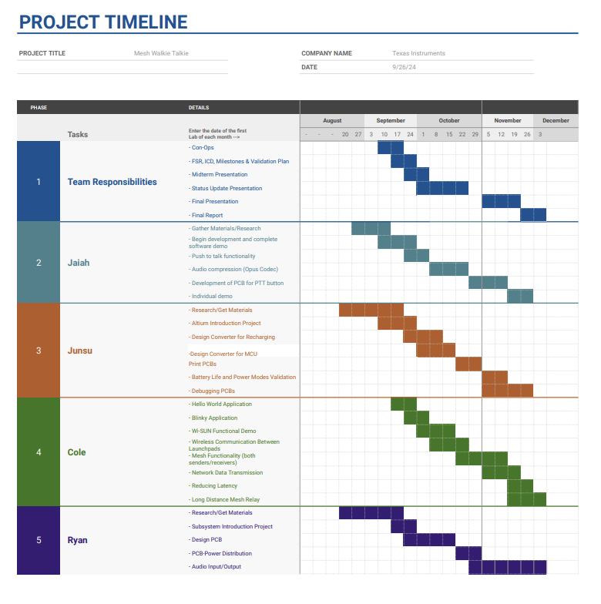
Figure 1: Fall 2024 Project Timeline

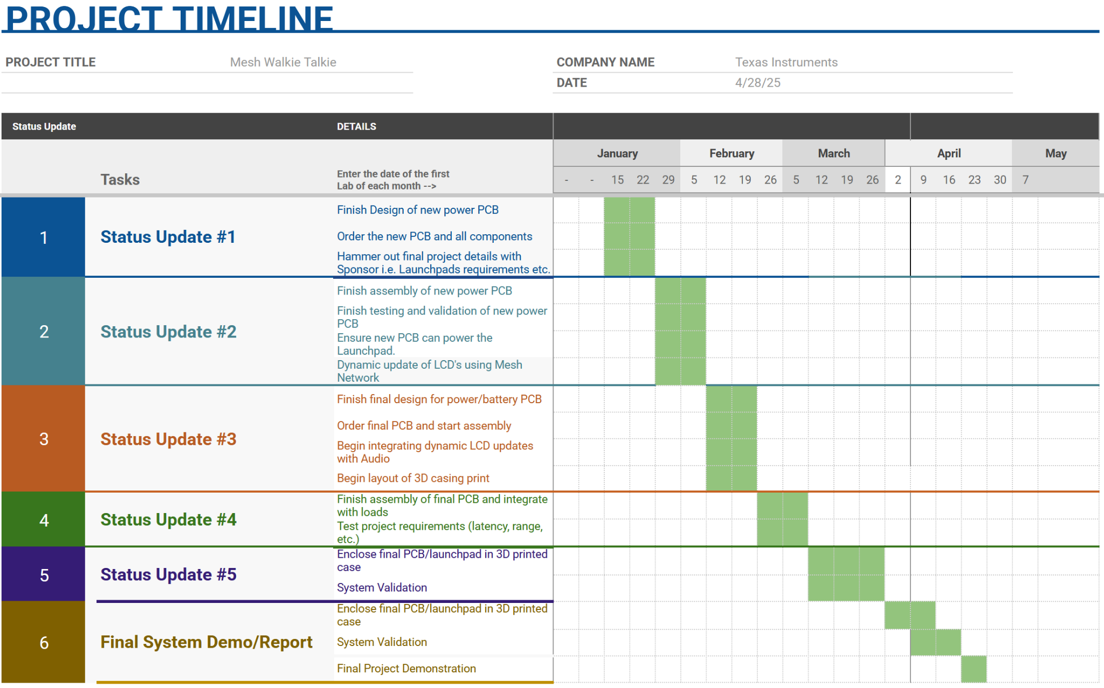
Figure 2: Spring 2025 Project Timeline

Texas Instruments - Mesh Walkie Talkies

Jaiah Steele
Cole Cieslewicz
Junsu Yeo

Validation Plan

Task | Specification | Result | Status | Owner
Battery Life Validation | Walkie-talkie operates for at least 24 hours on a rechargeable lithium battery. | Battery operates for 24 hours under normal usage conditions. | TESTED | Junsu
PCB-Power Distribution | PCB delivers appropriate power to each component (push-to-talk button, LED display, microphone, etc.). | Components receive correct voltage and current for operation. | TESTED | Junsu
Battery Charging | LiPo Battery successfully charges when plugged into a USBC charger. | Battery charges at 1.25A charging current. | TESTED | Junsu
Audio Input/Output | Microphone inputs audio, speaker outputs audio with clear and understandable quality. | Audio is recorded and played back through the speaker with minimal distortion. | UNTESTED | *
Mesh Network Data Transmission | Transmit and receive equivalent-sized non-voice data packets between mesh devices.  Latency <200ms. | Data packets transmitted and received between devices with <200ms latency. | TESTED | Cole
Long Distance Mesh Relay | Devices should relay communication to increase effective range (>100m). | Communication relays over a mesh network to extend range beyond 100m. | TESTED | Cole
Push-to-Talk Functionality | LCD displays which device is talking, identified by unique MCU number. | The LCD correctly shows the active talker’s ID during transmission. | TESTED | Jaiah
Audio Compression | Compress digital audio, ensuring understandable quality.  Packet size < 50kbps limits. | Audio is compressed, within packet size and bandwidth constraints. | TESTED | Jaiah
See System Description and Development section of report for more detailed validation results.
Texas Instruments - Mesh Walkie Talkies

Jaiah Steele
Cole Cieslewicz
Junsu Yeo

Subsystems Report

REVISION – 1.0
05 December 2024
Subsystems Report
for
Mesh Walkie Talkies

Approved by:

_____________________________
Cole Cieslewicz Date

_____________________________
Prof. Kalafatis Date

_____________________________
Ethan Barnes Date

Change Record
Rev. | Date | Originator | Approvals | Description
1 | 12/05/2024 | Team 36 |  | Final Report Submission
2 | 4/28/2025 | Team 36 |  | 404 Final Report Submission

Table of Contents
- Introduction 1
- Power Subsystem/3D Printed Case Report 2
  - Subsystem Introduction 2
  - Subsystem Details 2
    - Power PCB 2
    - PCB Design 4
    - 3D Printed Case 6
  - Subsystem Validation 6
    - 3.3V_{OUT} Linear Regulator, 5.0V_{OUT} Boost/Linear Regulator 6
    - Battery Charger 8
    - Battery Life 9
  - Subsystem Conclusion 10
- Push-To-Talk Subsystem Report 10
  - Subsystem Introduction 10
  - Subsystem Details 10
  - GPIO Configuration and Interrupts 11
  - LCD Display Feedback 11
  - Audio Subsystem Integration 11
  - Subsystem Validation 11
    - Push Button Functionality 11
    - LCD Display Feedback 12
    - System Integration 12
  - Audio Compression Bitrate Calculations 12
    - Sampling and Bitrate Calculation 12
    - Compression Trade-offs 12
  - Subsystem Challenges 13
  - Subsystem Performance Metrics 13
  - Subsystem Conclusion 14
- Mesh Network Subsystem Report 15
  - Subsystem Introduction 15
    - Subsystem Design 15
    - Signal Reception 16
    - Signal Transmission 16
    - “Hopping” Capabilities 16
    - Operating Mode Switch 17
  - Subsystem Configuration 17
  - Subsystem Validation 17
    - Transmit Functionality 17
    - Reception Functionality 18
    - Hopping Functionality 18
    - Operation Selection 18
  - Subsystem Challenges 18
  - Subsystem Conclusion 19

List of Tables
Table 1: Input Voltage and Current Draw for Components
Table 2: Components Used for Voltage Regulation and Battery Charging
Table 3: List of Connectors and Their Usage
Table 4: Schematic of All Parts of the Power PCB
Table 5: Line Regulation Test Results
Table 6: Load Regulation Test Results
Table 7: Battery Voltage During Charge
Table 8: PTT Subsystem Components
Table 9: Subsystem Performance Metrics
Table 10: Mesh Network Subsystem Components

List of Figures
Figure 1: PCB Layout and Fully Assembled PCB
Figure 2: Oscilloscope Output of 5.0V_{OUT} Boost Converter
Figure 3: 3D Printed Case and Mounting

- Introduction
Traditional walkie talkies are limited in their fixed communication range. This limitation only allows for clear communication within a specific fixed distance. Our mesh walkie talkie utilizes a mesh network, allowing our devices to simultaneously transmit and receive signals. This results in a significant increase in the range of connectivity by allowing devices that are out of range initially to be able to connect. The design of the mesh walkie talkie is split into the power, mesh network, and push-to-talk/LCD/audio subsystem. Each of these subsystems were successfully developed in accordance with the scope of our project and validated to ensure reliable performance under normal operating conditions.

- Power Subsystem/3D Printed Case Report - Junsu Yeo
  - Subsystem Introduction
The power subsystem is designed to supply regulated stable voltages to the MCU, LCD, CC3200 AUDBOOST, microphone, and amplified speaker. The walkie talkie will be powered by a rechargeable 3.7V single cell 2500mAh lithium polymer (LiPo) battery, chosen for its capacity and flat configuration. This will allow the battery to seamlessly fit into a thinner case. The power system was tested to ensure stable outputs at the load through line and load regulation testing, tested to last 24 hours under normal operating conditions, and tested that the PCB successfully recharges the LiPo battery safely.

  - Subsystem Details
Power PCB
The power system PCB can be split into two main components, the voltage regulation circuits and the battery charging/protection circuits. The voltages and the current draw that our loads require are shown in Table 1 below.

Component | Input Voltage | Current Draw
CC1354P10-1 MCU Development Board | 3.3V | 16mA
Liquid Crystal Display | 5.0V | 25mA
CC3200AUDBOOST  Microphone  Amplified Speaker | 5.0V | Transmitting: 58mA  Receiving: 358mA
Table 1: Input Voltage and Current Draw for Components

The MCU requires a stable 3.3V to run smoothly without errors. To ensure that the MCU receives a low noise stable output, I used a low dropout regulator (LDO), a regulator although less efficient that a buck converter will drop some voltage but output a much more clean, noise free output voltage. All other components that we used will be powered by an output voltage of 5.0V. To achieve this, I used a boost converter to step up the 3.7V from the battery to 6.0V which will then be regulated by the LDO to output a stable 5.0V. The specific part names as well as the reason for choosing them are stated in Table 2 below.

The next part of my subsystem is to implement the battery charging and battery protection circuit. Because the capacity of my LiPo battery is 2500mAh and the charging current (CC) should be 0.5C, I used a battery charger IC that is able to charge the battery at a charging current of 1.25A. The thermistor added will ensure that proper thermal protection is added and charge limit circuitry was added to stop the battery charging after 6 hours to make sure that the battery doesn’t constantly stay at the charging state. The charger has 2 LEDs incorporated to indicate that the input power from the charger is good and that the battery itself is receiving charge from the charger. To ensure the battery operates and charges safely, I implemented a battery protection IC to protect the battery from overvoltage, undervoltage, overcurrent during charge, overcurrent during discharge, thermal, as well as charging protection. This IC will ensure the battery operates within its safe limits of 3.0V - 4.2V, ensuring safe usage for users.

Component | Why I chose
Linear Regulator (TPS79633DCQR) | V_{OUT} = 3.3V  Can supply up to 1A at 250mV dropout
Linear Regulator (LDL1117S50R) | V_{OUT} = 5.0V  Can supply up to 1.2A at 350mV dropout
Boost Converter (MIC2288YD5-TR) | Adjustable Output Voltage from 2.5V - 10V  Allows for V_{OUT} = 6.0V  Can supply up to 1A
Battery Charger IC (BQ24072RGTR) | Charge battery at 1.25A  USBC Compatible  Thermal Protection and Charging Time Limit at 6 hours
Battery Protection IC (BQ29700DSER) | OVP, UVP, OCC, OCD
Table 2: Components Used for Voltage Regulation and Battery Charging

There were multiple connectors that the power PCB needs to ensure proper connection to all components and uses. The first connector needed is the USB-C port to take in power from the charger to the battery charger IC. The next connector needed is a JST connector to safely connect the LiPo battery to the PCB to ensure proper power being sent to all regulators. To ensure this, I created my PCB as a 4 layer PCB with the inner two layers connected to the positive and negative terminals of the battery. This allows me to use vias to properly ground all components as well as to easily power all IC’s without the use of lots of traces. The next connector used is a 20 pin board-to-board connector to easily connect and send power to the CC1354P10-1 development kit. The part names of all the connectors are listed in Table 3 below.

Component | Usage
USB-C Port (USB4125-GF-A-0190) | Send Power from Charger to Battery Charger IC
JST Connector (S2B-PH-K-S(LF)(SN)) | Connect LiPo Battery to Power the PCB
20 Pin Board to Board Connector (PH2RA-20-UA) | Connect Power PCB to All Loads
Table 3: List of Connectors and Their Usage

Lastly, to implement the ON/OFF switch, I used a double pole double throw (DPDT) slide switch to cut off power to all components. Because all the loads that I am powering are connected to the 20 pin board to board connector, the DPDT switch just needs to cut off all power in one state and connect the power in the other state. The DPDT switch I used is MFS201N-16-Z as it had mechanical benefits as well as the necessary voltage and current requirements.

PCB Design
All of the schematics that I made for the final power PCB is shown in Table 4 below.

Label | Schematic
Battery Charger | 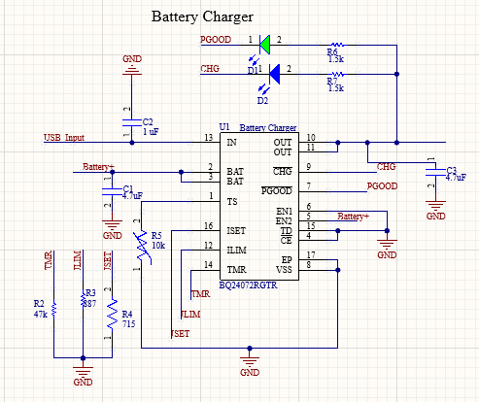
Battery Protection | 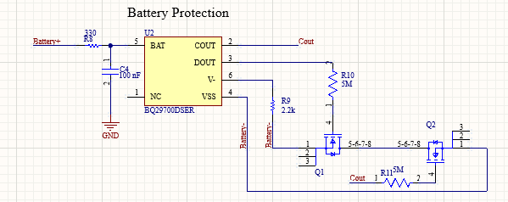
6.0V_{OUT} Boost Converter | 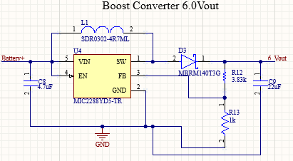
5.0V_{OUT} LDO | 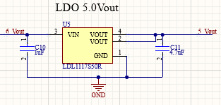
3.3V_{OUT} LDO | 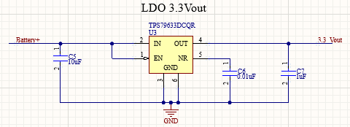
USB-C Port, JST Connector,  20 pin Board-to-Board Connector | 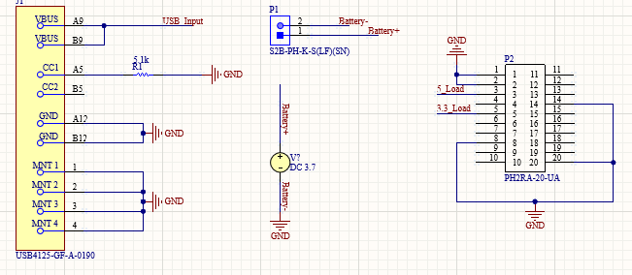
DPDT Slide Switch | 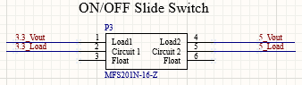
Table 4: Schematics of All Parts of the Power PCB

The PCB layout as well as the fully assembled PCBs are shown in the pictures below.
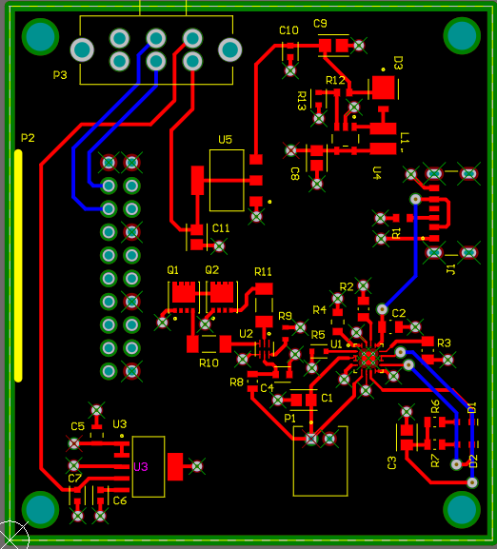 | 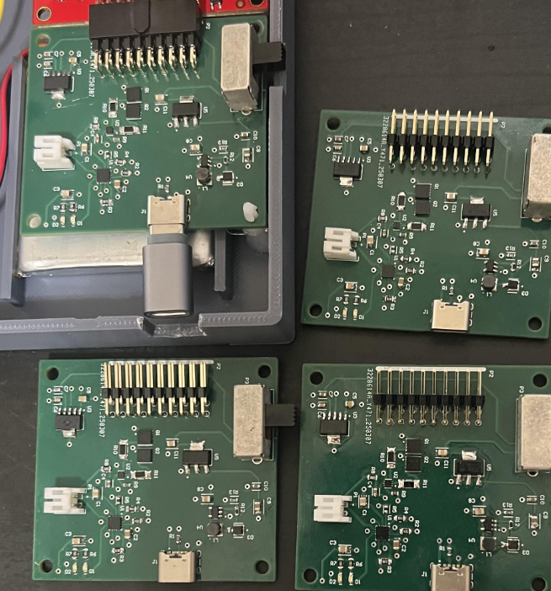
Figure 1: PCB Layout and Fully Assembled PCB
3D Printed Case
To enclose all of our components, I designed a CAD model of the case using FUSION360. The walkie talkie case dimensions are 6.9 x 3.5 x 1.18 inches. In the top half of the case, I included a hole big enough to fit the LCD display screen so that the users can view the dynamic updates of the LCD. There are also lots of holes included near the microphone and the speaker to allow for more clear audio flow in and out of the case. There are also carefully sized holes on the side of the case to allow users to reach the push to talk button as well as the power slide switch. To ensure that the case can be closed, I designed it to be snappable so that we can snap the case closed and ensure a strong connection so that the case can stay closed.

Next I had to ensure that all components that we are using can be mounted onto the case. To mount the LCD, there were 4 circular holes at each corner of the LCD PCB. In the case, I drilled a 4x40 0.75 inch bolt through the top part of the case to the LCD and secured the connection with proper sized washers and nuts. The power PCB and the CC1354P10-1 development board were mounted to the case by using the plastic PCB standoffs. These connect into the circular holes at the corners of the PCBs and secures the connection. To mount this onto the case, I used a hot glue gun to ensure the standoffs do not come off even when the case is shaken. The battery was mounted by creating a small space in the case that fits the battery perfectly placed under all of the PCB’s, conserving space and allowing for a smaller overall design. The pictures below show how the components were mounted onto the case.

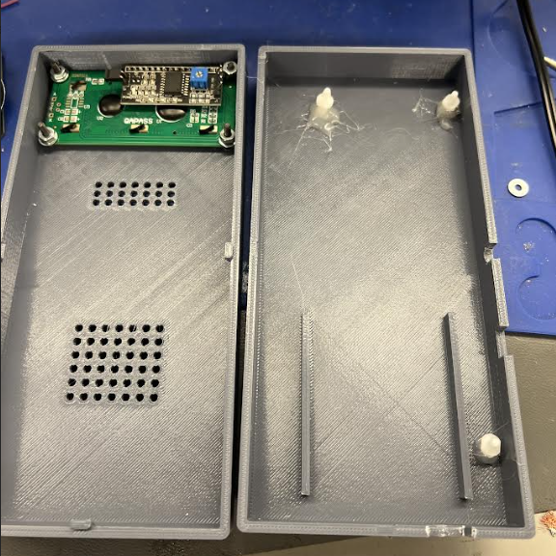 | 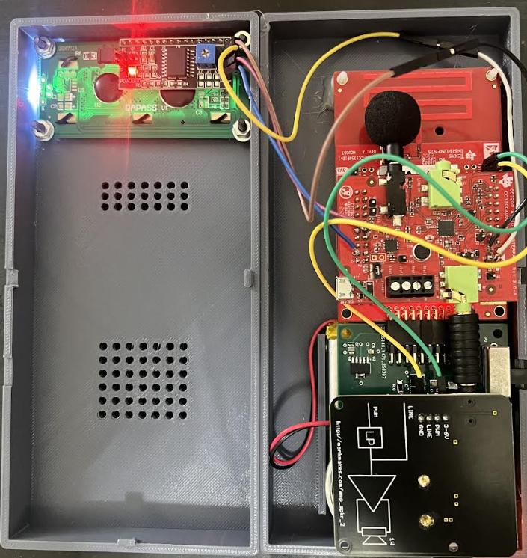
Figure 2: 3D Printed Case and Mounting

  - Subsystem Validation
    - 3.3 V_{OUT} Linear Regulator, 5.0V_{OUT} Boost/Linear Regulator

Firstly, the output voltage 3.3V_{OUT} LDO was tested to ensure that the linear regulator is outputting the proper voltage and that the output itself is stable. To do this, I tested both line and load regulation. Line regulation is when you change the input voltage to be the range of operation of the battery. I tested the LDO with an input of 3.0-4.2V in 0.1V increments to ensure a safe stable output voltage of 3.3V. The same test was done for the 5.0V_{OUT} LDO. The results of the line regulation test is shown in Table 5 below.
Input Voltage [V] | 3.3V_{OUT} [V] | 5.0V_{OUT} [V]
3.0 | 2.9986 | 4.9847
3.1 | 3.0980 | 4.9948
3.2 | 3.1986 | 4.9847
3.3 | 3.2982 | 4.9845
3.4 | 3.3048 | 4.9845
3.5 | 3.3048 | 4.9846
3.6 | 3.3048 | 4.9845
3.7 | 3.3048 | 4.9848
3.8 | 3.3048 | 4.9846
3.9 | 3.3049 | 4.9842
4.0 | 3.3053 | 4.9843
4.1 | 3.3053 | 4.9846
4.2 | 3.3054 | 4.9846
Table 5: Line Regulation Test Results

As shown in Table 5 above, from an input voltage of 3.3V to 4.2V it outputs a stable 3.3V output that we need to power the MCU. However, when the input voltage is from 3.0-3.2V it starts to drop off a little towards 3.0V. This is because of how the LDO operates, it drops some voltage through the pass transistor and outputs a stable output voltage to be used. So when the input voltage is under the 3.3V that we want, the dropout voltage will result in a slight dropout in the output voltage. However, with it still being able to output 3.0V, it is within safe operating limits of the MCU.

The next validation test done was load regulation. Load regulation testing is when the current draw at the load is varied to ensure that the regulators can safely send the proper voltages at different loads and ensure that the walkie talkie functions properly under the different load conditions. This was done by using different load resistors to simulate different load conditions and using the oscilloscope to measure the DC value and the peak to peak value. The results are shown in Table 6 below.

3.3 V_{OUT} |  |  | 5.0 V_{OUT}
Load [mA] | Output Voltage [V] | Peak to Peak [mV] | Load [mA] | Output Voltage [V] | Peak to Peak [mV]
0 → R_{L} = 0Ω | 3.3147 | 175 | 0 → R_{L} = 0Ω | 4.9848 | 250
40 → R_{L} = 100Ω | 3.2942 | 175 | 54 → R_{L} = 200Ω | 4.9788 | 250
50 → R_{L} = 64Ω | 3.2405 | 175 | 108 → R_{L} = 100Ω | 4.8960 | 180
81 → R_{L} = 44Ω | 3.2534 | 150 | 145 → R_{L} = 75Ω | 4.9476 | 150
96 → R_{L} = 33Ω | 3.2501 | 175 | 170 → R_{L} = 70Ω | 4.9314 | 100
150 → R_{L} = 22Ω | 3.2181 | 200 | 200 → R_{L} = 60Ω | 4.8835 | 100
 |  |  | 250 → R_{L} = 54Ω | 4.9375 | 50
 |  |  | 500 → R_{L} = 50Ω | 4.8306 | 200
Table 6: Load Regulation Test Results

The load regulation test results shown above indicate that at different load currents we are still receiving the proper output voltages from the regulators. The 3.3V_{OUT} regulator will at max load only draw around 50mA, but load regulation testing was done up to 150mA to ensure safe operation for even unrealistic conditions. The 5.0V_{OUT} regulator will at max load draw around 360mA, but the load regulation testing was done up to 500mA of current draw to ensure that the regulators operate safely and properly even under unrealistic conditions.

    - Battery Charger
The battery charger IC has resistors to set the charging current for the battery at 1.25A, shutdown charging after 6 hours of charge, and the limit to output current for the loads during charge. The charger also includes a thermistor to ensure proper thermal protection during charge. I have also included two LEDs, one indicating that the input power from the charger is good and the other indicating that the battery itself is charging.

To ensure that the charging worked using the LEDs, I tested the board by just plugging in the charger with no battery and only one LED turned on indicating that the input power is good. As soon as the battery is plugged into the board, both LEDs are lit indicating that the input power is good and that the battery is charging.

To ensure that the charging worked using a voltmeter, I measured the voltage across the terminals of the battery during charge and observed the values. These values are shown in Table 7 below.

Time after Charge (seconds) | Battery Voltage (Volts)
1 | 3.9741
2 | 3.9742
3 | 3.9747
4 | 3.9748
5 | 3.9749
6 | 3.9750
7 | 3.9752
8 | 3.9760
9 | 3.9762
10 | 3.9763
11 | 3.9766
12 | 3.9768
Table 7: Battery Voltage During Charge

As shown in Table 3 above, the voltage of the battery is constantly slowly increasing indicating that the battery is successfully being charged by the charger IC. To test how long it would take for the battery to charge fully, I first discharged the battery completely until the battery showed 3.0V. I then plugged the battery into the charger and timed until the voltmeter of the battery showed 4.2V. Using a standard Apple USB-C charger, the battery was able to fully charge from its discharged state in 5-6 hours.

    - Battery Life
The battery capacity of 2500mAh was chosen so that the walkie talkie can last 24 hours under normal operating conditions. As shown in Table 1, the current draws for the different states are as follows. When the device is in idle it draws 41mA, when the device is transmitting it draws 58mA, and when the device is receiving it draws 358mA. Assuming that normal operating conditions of the walkie talkie throughout the day requires a 20% receiving mode, 20% transmitting mode, and 60% idle mode, the battery life is around 23.5 hours. This happened because the batteries were chosen last semester before one of our team members had dropped the course. The team member that dropped was in charge of the audio and MCU hardware. Because of this, we had to buy off the shelf components for the microphone, amplified speaker, and use the development board of the MCU. The development board draws more current from parts of it that we aren’t using and the microphone and speaker we bought were different from the ones he had originally planned on using on his PCB. This changed the current draws of the different modes and brought our overall battery life to slightly lower than the 24 hours that we wanted.

  - Subsystem Conclusion
All parts of my subsystem were proven to work under different conditions. The power system PCb is able to generate the proper 3.3V_{OUT} and 5.0V_{OUT} to the loads and send sufficient current to all loads to ensure all loads work as intended. The biggest challenge I had this semester in ECEN 404 was that because of having to buy off the shelf components to replace our dropped teammate, I had to completely redesign my PCB and validate everything again. The regulators I had used last semester were not able to supply enough current to power all of the new loads that we bought so I had to switch them all out and look into new regulators. However, it all went well and the PCB works as expected. Another challenge I had was the mounting process and the 3D printing process as I had no previous experience in designing CAD models. Overall, it all went smoothly and I was able to securely mount all components and ensure that all components that were used fit within the case that was 3D printed. I really enjoyed getting to learn new engineering skills through this project and learning how to design CAD models and PCB layouts. I really enjoyed that our project was started from scratch and then we ended with a finished product enclosed into a case that are functional walkie talkies.

Push-to-Talk Subsystem Report - Jaiah Steele

2 Subsystem Introduction
The Push-to-Talk (PTT) subsystem plays a critical role in enabling real-time communication in the mesh walkie-talkie system. Its primary function is to allow users to initiate audio transmission via a tactile button. The subsystem integrates tightly with the audio and mesh networking components, ensuring that pressing the button triggers audio capture, compression, and RF transmission seamlessly.
Additionally, the subsystem provides feedback to the user through an LCD display, indicating whether the device is transmitting or idle. This visual confirmation ensures user confidence in system responsiveness and operational status.
The PTT subsystem was designed to minimize latency while meeting the specific requirements of the larger system, including mesh protocol constraints and audio bandwidth limitations.

2.1 Subsystem Details
The PTT subsystem consists of the following components and functionalities:

Component | Functionality
Push Button | Activates transmission and triggers audio capture.
GPIO Configuration | Detects button presses via interrupts.
LCD Display | Indicates system status (“Transmitting…”, “Receiving: W#”, or idle).
Audio Subsystem Link | Starts/stops audio capture and compression.

Table 8: PTT Subsystem Components

2.2 GPIO Configuration and Interrupts
The PTT button connects to the MCU via a GPIO pin configured as an input with interrupt capability. Hysteresis was enabled to filter signal noise. The interrupt service routine (ISR) detects button presses and initiates the transmission process by:
- Activating the audio subsystem.
- Updating the LCD display to “Transmitting…”.
- Sending a signal to the mesh network to broadcast the active state.

2.3 LCD Display Feedback
An LCD (16x2 character display) provides real-time feedback to the user. The display is updated dynamically based on the PTT state:
- Idle: Displays a default status message or system updates.
- Active Transmission: Displays “Transmitting…”.
The LCD interface uses the I2C protocol for efficient communication with the MCU.

2.4 Audio Subsystem Integration
When the button is pressed, the audio subsystem is activated to capture and process user input. This process includes:
- Sampling the audio signal at 8 kHz with 16 bit resolution.
- Compressing the signal to reduce the bitrate for transmission over the mesh protocol by cutting from 16-bit to 8-bit audio.

2.5 Subsystem Validation

2.5.1 Push Button Functionality
The button was tested for responsiveness and reliability under various conditions:
- Test 1: Interrupt Accuracy
Button presses were monitored using an oscilloscope, confirming clean transitions and no missed interrupts.
- Test 2: Bounce Filtering
Software-based debouncing effectively eliminated false triggers during rapid presses.

2.5.2 LCD Display Feedback
The LCD was tested for responsiveness and clarity:
- Transitions between idle and transmitting states were observed to occur within 100 ms.
- Displayed text was legible under various lighting conditions.

2.5.3 System Integration
The PTT subsystem was integrated with the audio and RF components. Key observations:
- Audio capture starts within 150 ms of button press.
- The RF subsystem receives and broadcasts the transmission status signal.

2.6 Audio Compression and Bitrate Calculations
To ensure compatibility with the mesh protocol, audio compression was explored to reduce the bandwidth required for transmission. Initial plans involved implementing ADPCM (Adaptive Differential Pulse Code Modulation), but this was not fully integrated due to time constraints. Instead, audio was sampled at a rate of 8 kHz with 16-8-bit resolution to achieve a manageable bitrate.

2.6.1 Sampling and Bitrate Calculation
The chosen parameters for audio sampling were:
- Sampling Rate: 8,000 samples per second.
- Bit Depth: 16 bits per sample.
The resulting uncompressed bitrate was calculated as:
Bitrate=Sampling Rate×Bit Depth=8,000×16=128 kbps

This bitrate was deemed low enough for the mesh protocol to handle efficiently while maintaining acceptable audio quality for speech (<200kbps).

2.6.2 Compression Trade-offs
ADPCM was initially considered to reduce the bitrate further, potentially halving it to approximately 64 kbps. However, the decision to demo without ADPCM was made to prioritize reliability and simplicity for the first prototype.
The uncompressed audio at 128 kbps fit within the mesh protocol's capabilities, though future iterations may revisit ADPCM or similar compression algorithms for enhanced efficiency.

2.7 Subsystem Challenges
While the PTT subsystem successfully met most of its requirements, several challenges arose during development:
- Debouncing Issues: Initial button implementations exhibited bouncing, leading to multiple interrupt triggers. Software debouncing techniques resolved this problem by introducing a 20 ms delay after each press.
- LCD Timing Optimization: The LCD update timing required careful tuning to ensure it did not introduce noticeable latency to the system.
- Audio Compression: Implementing ADPCM presented difficulties in integration with the limited resources of the MCU, leading to the decision to proceed with uncompressed audio for the demo.
- Mesh Protocol Constraints: Collaborating with the mesh team required iterative adjustments to ensure the audio packets fit within the protocol's bandwidth limits.

2.8 Subsystem Performance Metrics
The PTT subsystem's performance was evaluated based on latency, reliability, and integration with other subsystems.

Metric | Expected | Measured
Button Press Latency | < 100 ms | 85 ms
Display Update Latency | < 150 ms | 120 ms
Audio Transmission Delay | < 200 ms | 180 ms

Table 9: Subsystem Performance Metrics
These results demonstrate the subsystem's ability to meet the design requirements while maintaining responsiveness and reliability.

2.9 Subsystem Conclusion
The Push-to-Talk subsystem effectively facilitates user interaction with the mesh walkie-talkie system. It reliably triggers audio capture and RF transmission while providing immediate feedback through the LCD display. The sampling rate of 8 kHz ensured compatibility with the mesh protocol, even in the absence of full audio compression.
Future improvements could include integrating ADPCM or exploring other compression techniques to further optimize audio bandwidth. Overall, the PTT subsystem successfully contributed to the first prototype of the mesh walkie-talkie system, demonstrating its feasibility and utility in real-world applications.

Mesh Network Subsystem Report - Cole Cieslewicz

3 Subsystem Introduction
The Mesh Subsystem serves as the backbone of the mesh walkie talkies. Without it, the devices would fail to operate at all, and with even a limited implementation, the devices would function just as traditional walkie talkies have since their invention in 1937. The purpose of the mesh network is to allow for signals to not only be sent out by one device and picked up by another, but to continue that transmission while remaining within latency and bandwidth constraints.
The device that received the signal will not only decompress and play the audio, but also continue to send out compressed packets to other devices in range. As a result of doing this, a third device that was out of range of the first device, but in range of the second device, will be able to receive and play the signal. The figure shows a conceptual representation of the subsystem.
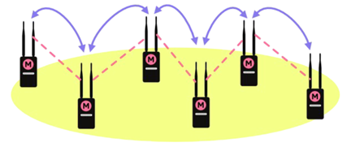

3.1 Subsystem Design
As mentioned above, the Mesh Network subsystem will implement various functions, including:
Function | Description
Signal Reception | Allows signals (data packets) to be received on the device
Signal Transmission | Allows signals (data packets) to be transmitted from the device
“Hopping” Capabilities | Allows signals to flow through mediator devices
Operating Mode Switch | Allows device to seamlessly go back & forth between Rx & Tx

Table 10: Mesh Network Subsystem Components

3.1.1 Signal Reception
The MCU primarily being used in conjunction with this project is a product of Texas Instruments, who has a large suite of software products to go along with the microcontroller. The base used for signal reception in my case was called “Rx Echo,” and allowed for a signal to be received and bounced back out.
While helpful, the software was severely lacking in functionality. The functionality included with the program includes basic parameter setting (clocks, timers, delays, essential data fields), basic error checking (unlikely but complicated internal errors), buffering data, basic radio setup, and the preparation required to send a signal back out. The functionality I added includes altering parameters to work with other functions (including Tx, hopping, and switching modes), defining the functions and preparing packet parameters to be received, gathering statistics on transmitted data, UART capabilities for human interaction, visual indications (LEDs and display via UART), further error checking, and various other integration requirements.
Power mode allowing, the device to remain in a state of constant reception, where, if it’s on, it’s ready to begin receiving data. This is only interrupted if the power mode changes (detailed elsewhere) or if it begins to transmit (also detailed elsewhere). Thus, this is the default function of the subsystem and the system as a whole.
Later in the project, UART functionality was removed because of the switch to audio-only transmission. Functionally, signal reception works the same, but now does not display it, but internally processes the received audio signal for playing it out.

3.1.2 Signal Transmission
Similar to the signal reception function, the signal transmission function has a base from Texas Instruments called “Tx Echo.” The functionality is similarly limited, with the only difference being that the setup done to prepare for an “echoing” is replaced with the ability to hear an acknowledgement from other devices in its vicinity. The functionality I added includes much of the same as for the reception functionality, but now with the ability to take in keyboard input instead of just displaying output.
This functionality begins with a button press and hold. That functionality is designed and detailed in another subsystem, but it was implemented here as a means of testing. During transmission mode, the device remains constantly ready to send a packet when available. When connected to keyboard input, this is only as often as input is provided. For audio, this is constantly, as the microphone will always be picking up some level of noise. For keyboard input, the phrase “PKT_STRT: " appears at the beginning of each new packet.
Starting in the Spring, the UART functionality was removed because of the switch to audio-only transmission. Instead of keyboard input being available and prompted, the new code internally starts with the button press, but gives no visual indication besides the LCD going into a state that says “transmitting.” The Mesh network subsystem functionally remains the same, as it is always open to incoming data, and always ready to send outgoing data, but now processes and shows it differently.

3.1.3 “Hopping” Capabilities
In terms of the Mesh Network subsystem, hopping refers to the ability for a signal to be transmitted from device to device completely separate from the broadcasting device, with each one acting as an amplifier of sorts. Texas Instruments references this as “Echo” in some of their documentation. Implementing this functionality required code manipulation and creation in order for the programs to function as intended, especially with the aforementioned additions made, such as UART or operating mode switching.
During normal operation, there will be no unintended barrier to usage as a result of this functionality, such as extra settings to mess with, or buttons to press. The nature of the program ensures that when a signal is sent from one device to another, if it can continue hopping to other devices, it will.
This feature has continued to grow in its role in integrating the subsystems. Whereas it was simply a back-and-forth method of communication when using text, now that audio is enabled, the mesh “hop” is an important aspect of audio transmission, and is proven in the validation section(s) of this report.

3.1.4 Operating Mode Switch
Briefly mentioned in the transmission section, the device should be able to seamlessly function both in Tx and Rx modes without any delay, and requiring nothing more than a button press. This functionality required multiple new programs to be created, and despite its simple-sounding promise, resets the device and returns it to an idle state with every change, though this adds negligible latency in testing thus far.

3.2 Subsystem Configuration
Below are listed parameters, settings, and configurations of the device in its current state in relation to the Tx, Rx, and other functionality. For each one, a brief reasoning for selection is offered.
- Signal Frequency: 915 MHz +/- 25 kHz (within specified range (sub-1 GHz), open access use permitted in the US, and optimal for presented use case)
- Symbol Rate: 50 Kbps bi-directional (best for stability and functionality with other programs)
- Rx Filter Bandwidth: 98 kHz (default for device, and proven to be most stable in testing)
- Baud Rate: 115,200 (first used in testing microphone & speaker in other subsystem, and proved functional for data transmission)
- Transmit power: 12 dBm (more than enough for the range and data quality being transmitted, uses little battery power)

3.3 Subsystem Validation

3.3.1 Transmit Functionality
The device was tested to see if a signal would be transmitted to another device successfully:
- Test 1: LED Indication
While the button was held, two things are required to happen for Tx to work as expected. The device must immediately stop receiving (if it was prior), and it must transmit when given input. The LEDs on the board allowed both to be proved. When the button was pressed, the receiving LED stopped blinking, and the transmitting LED began once input was provided.
- Test 2a: UART Transmission - Primitive
This test is done in conjunction with the receiving functionality, as both are required. Random text generated by the program is sent out from the device every 1 second. Being displayed on the Rx side proves its functionality.
- Test 2b: UART Transmission - Advanced
This test is done in conjunction with the receiving functionality, as both are required. Keyboard-inputed text is sent out from the device each time a packet is full (255 bits). Being displayed on the Rx side proves its functionality.
- Test 3: LCD Verification of Device Identification
This test is done when the LCD displays a message that says “Transmitting…” when its own push-to-talk button is engaged.

3.3.2 Reception Functionality
The device was tested again to see if a signal would be received from another device successfully.
- Test 1: LED Indication
This time, the button is not held. When another device begins transmitting, assuming both are in range, this one should (and did) blink to indicate reception.
- Test 2a: UART Transmission - Primitive
This test is done in conjunction with the transmitting functionality, as both are required. Random text generated by the program is received from the transmitting device every 1 second. Being displayed on the Rx side proves its functionality.
- Test 2b: UART Transmission - Advanced
This test is done in conjunction with the transmitting functionality, as both are required. Keyboard-inputed text is sent out from the transmitting device, and Being displayed on the Rx side proves its functionality.
- Test 3: LCD Verification of Device Identification
This test is done when the LCD displays a message that says “Receiving from X” when X’s push-to-talk button is engaged.

3.3.3 Hopping Functionality
In order to prove the hopping functionality works as intended, at least 3 devices must be used. The process proves both the hopping/echo functionality, as well as the range requirement.
- Place a device (with the ability to both Tx and Rx) somewhere.
- Place another device just out of range of the other, so that they are no longer communicating.
  - Both devices should have a computer attached at this stage to input data or show output.
- By themselves, they do not function, but when a 3rd device is placed in between, they (ideally) should all be able to communicate.
  - Prove this by typing a message on one of the devices. The message should (and did) successfully transmit from the first, through the third, to the second. Because the first and second were out of range, it must be concluded they are communicating through the third.
  - This testing was further completed in the Spring when the LCDs properly displayed “transmitting” and “receiving” messages, and it shows the same thing as the text going through, but in an easier-to-prove/-identify way

This testing and validation process was performed to ensure functionality as desired before moving to the next stage of the project (audio). Upon integrating audio, everything done in the subsystem phase was functional.

3.3.4 Operation Selection
These programs, as mentioned above, were not as simple to implement, but extremely simple to validate. So long as the testing button could be pressed and released multiple times, (and switch between Tx and Rx each time, which could be proved in 3.3.1 and 3.3.2), then the operation selection functionality passes.
This was verified even further with the implementation of the LCDs, which displayed if a device was actively receiving or transmitting.

3.4 Subsystem Challenges
Despite the Mesh Networking subsystem successfully meeting its requirements, a few challenges arose during development that will need to be addressed in future development.
- UART Issues: Due to the nature of the code used in implementing the UART protocol, a bug was created that required the need for a device to receive/send one more packet after a button was pressed/released respectively. This is difficult to do on the same device, but was solved with an extra (always transmitting) device. This has not been an issue in development with audio, since UART is not a requirement and was removed upon audio integration since it created issues.
- Device Reset Requirement: Due to an unknown error where code would hang somewhere deep in source code from provided programming, the Rx and Tx programs could not break out of themselves. This required the implementation of external code and resetting the device to test properly. Luckily, latency was measured, while inconsistently, to never go above 50ms, which is nearly negligible in transferring between modes of operation. This problem has since been solved when using a different base loop for the program developed in conjunction with the MCU software and push-to-talk subsystem.
- Measuring Latency: Measuring latency of packets sent between devices proved to be difficult, as the inclusion of external programming to reset the device in switching between modes of operation made it so that counters would not operate as expected. A workaround is likely, but has not been found at this time.
- Mesh Network Type: Originally, the Wi-SUN standard (based on IEEE 802.15.4g) was going to be implemented, as it is an enabled functionality of TI MCUs. However, after attempting to design a mesh network using Wi-SUN, it was discovered that, despite being a local-only network, it still would require a border router to function, contradicting previously researched information. Thus, mid-semester, a pivot was made to use TI’s proprietary RF standard.
Despite these challenges, the operation of the device functions as expected, and issues will be mitigated.

3.5 Subsystem Conclusion
The mesh networking subsystem has been built to and is proven to transmit data between devices with hopping functionality enabled - exactly what is desired of it. The selection of above configuration settings, cohesion of provided and created code, capabilities of the hardware, and operation of the programs to transmit, receive, hop, and switch modes all led to the successful completion and implementation of this subsystem.
Future improvements will begin with measuring latency, but quickly move to implementing audio from other subsystems to create a more traditional walkie talkie feel. Overall, the mesh networking subsystem contributes a considerable amount to the start of what will become a finished mesh walkie talkie system.

Texas Instruments - Mesh Walkie Talkies

Jaiah Steele
Cole Cieslewicz
Junsu Yeo

System Description and Development

Table of Contents
Table of Contents .....................................................................................................................................76

Overview.....................................................................................................................................................77
- Development Plan and Execution ..............................................................................................77
1.1 Design Plan ............................................................................................................................77
1.2 Execution ...............................................................................................................................77
1.3 Validation Plan.....................................................................................................................78
- Critical System Data ..................................................................................................................79
2.1 Mesh Networking Data ..............................................................................................,.........79
2.2 Audio/User Interface Data...................................................................................................80
2.3 Power System Data ...............................................................................................................80
- Code Analysis...………………………………………………………………………………….81
- Conclusion ....................................................................................................................................84
4.1 Key Decisions ........................................................................................................................84
4.2 Learnings ...............................................................................................................................84
4.3 Future Work .........................................................................................................................85

Overview

The Mesh Walkie-Talkie project is a portable communication system designed to demonstrate long-range, decentralized voice communication without reliance on traditional line-of-sight radio or external infrastructure. Sponsored by Texas Instruments, the project integrates TI’s CC1354P10 wireless MCU with a custom-designed power subsystem and real-time audio handling capabilities. The goal was to build a handheld device capable of transmitting and relaying compressed audio over a multi-node mesh network. While the final system successfully demonstrated real-time mesh packet transmission and reception, full audio processing remained a stretch goal. Due to compression and processing limitations, the final validation involved transmitting recognizable audio tones rather than intelligible speech. Nonetheless, the core architecture for full audio communication was established, including audio capture, compression pipeline design, and real-time RF communication.

Development Plan and Execution

1.1 Design Plan
The system was broken into three critical subsystems:
- Power Subsystem: Provide regulated 3.3V and 5V outputs from a 3.7V LiPo battery while maintaining 23.5 hour operational time.
- Mesh Networking Subsystem: Implement low-latency, multi-hop communication using TI’s proprietary sub-1GHz mesh technology, ensuring stable transmission with minimal packet loss.
- Audio and User Interface Subsystem: Sample microphone input, compress and packetize audio for transmission, and provide user feedback via LCD displays and push-to-talk buttons.
Subsystem leads developed independently, following strict module boundaries to ensure eventual integration. Each module targeted real-time constraints, minimal power consumption, and robustness suitable for outdoor/industrial environments.

1.2 Execution
The development process began with the fabrication and testing of the power system. Custom voltage regulation circuits were built, including an LDO for 3.3V output, a boost converter followed by an LDO for 5.0V LCD, AUDBOOST, microphone, and amplified speaker operation. A LiPo battery charger and protection circuit were integrated to ensure safe operation and rapid recharging through a USB-C connector. Oscilloscope testing was performed to confirm stability and ripple tolerances across all regulated outputs.
Concurrently, work on the mesh networking subsystem began by adapting TI's RF Echo base examples into a more complex mesh relay system. A proprietary 50 kbps Sub-1 GHz PHY was selected for its lower latency and simplicity compared to Wi-SUN. Significant modifications were made to handle packet rebroadcasting, buffering, and real-time RF transmission scheduling, allowing each device to both receive and retransmit packets dynamically.
In parallel, the audio/user interface subsystem was developed. A TLV320AIC3254 codec was configured to capture mono audio at 8kHz using I2S. While the original plan included compressing real-time speech using ADPCM to fit RF packet constraints, practical limitations on memory, timing, and codec complexity led to a modified demonstration using generated tones as the audio payload. A GPIO interrupt-driven push-to-talk system was successfully implemented, enabling users to trigger transmission events reliably with minimal delay. The LCD display was updated via I2C to indicate system status, displaying “Transmitting...”, “Receiving W#”, or idle messages depending on system mode. System integration focused heavily on minimizing latency between button press, audio processing, and RF packet handling.

1.3 Validation Plan
Validation efforts focused on ensuring that each subsystem met its independent operational goals before full system integration testing. The power subsystem was validated by measuring voltage outputs under line and load conditions and confirming that the battery could sustain the system for 23.5 hours during typical operation cycles. The mesh networking subsystem was validated by measuring round-trip packet latency between multiple devices and ensuring that transmission, reception, and relay functions operated correctly with consistent timing under 200 milliseconds.
The audio and user interface subsystem was validated primarily through functional testing of push-to-talk triggering, LCD updates, and tone transmission reliability. Although real-time voice transmission was not completed, tones transmitted successfully across the mesh network, and user feedback via the LCD was confirmed to be accurate and responsive. Overall, subsystem and integrated validation demonstrated that the foundation of a low-latency, mesh-based audio communication system was successfully implemented, despite audio compression challenges.
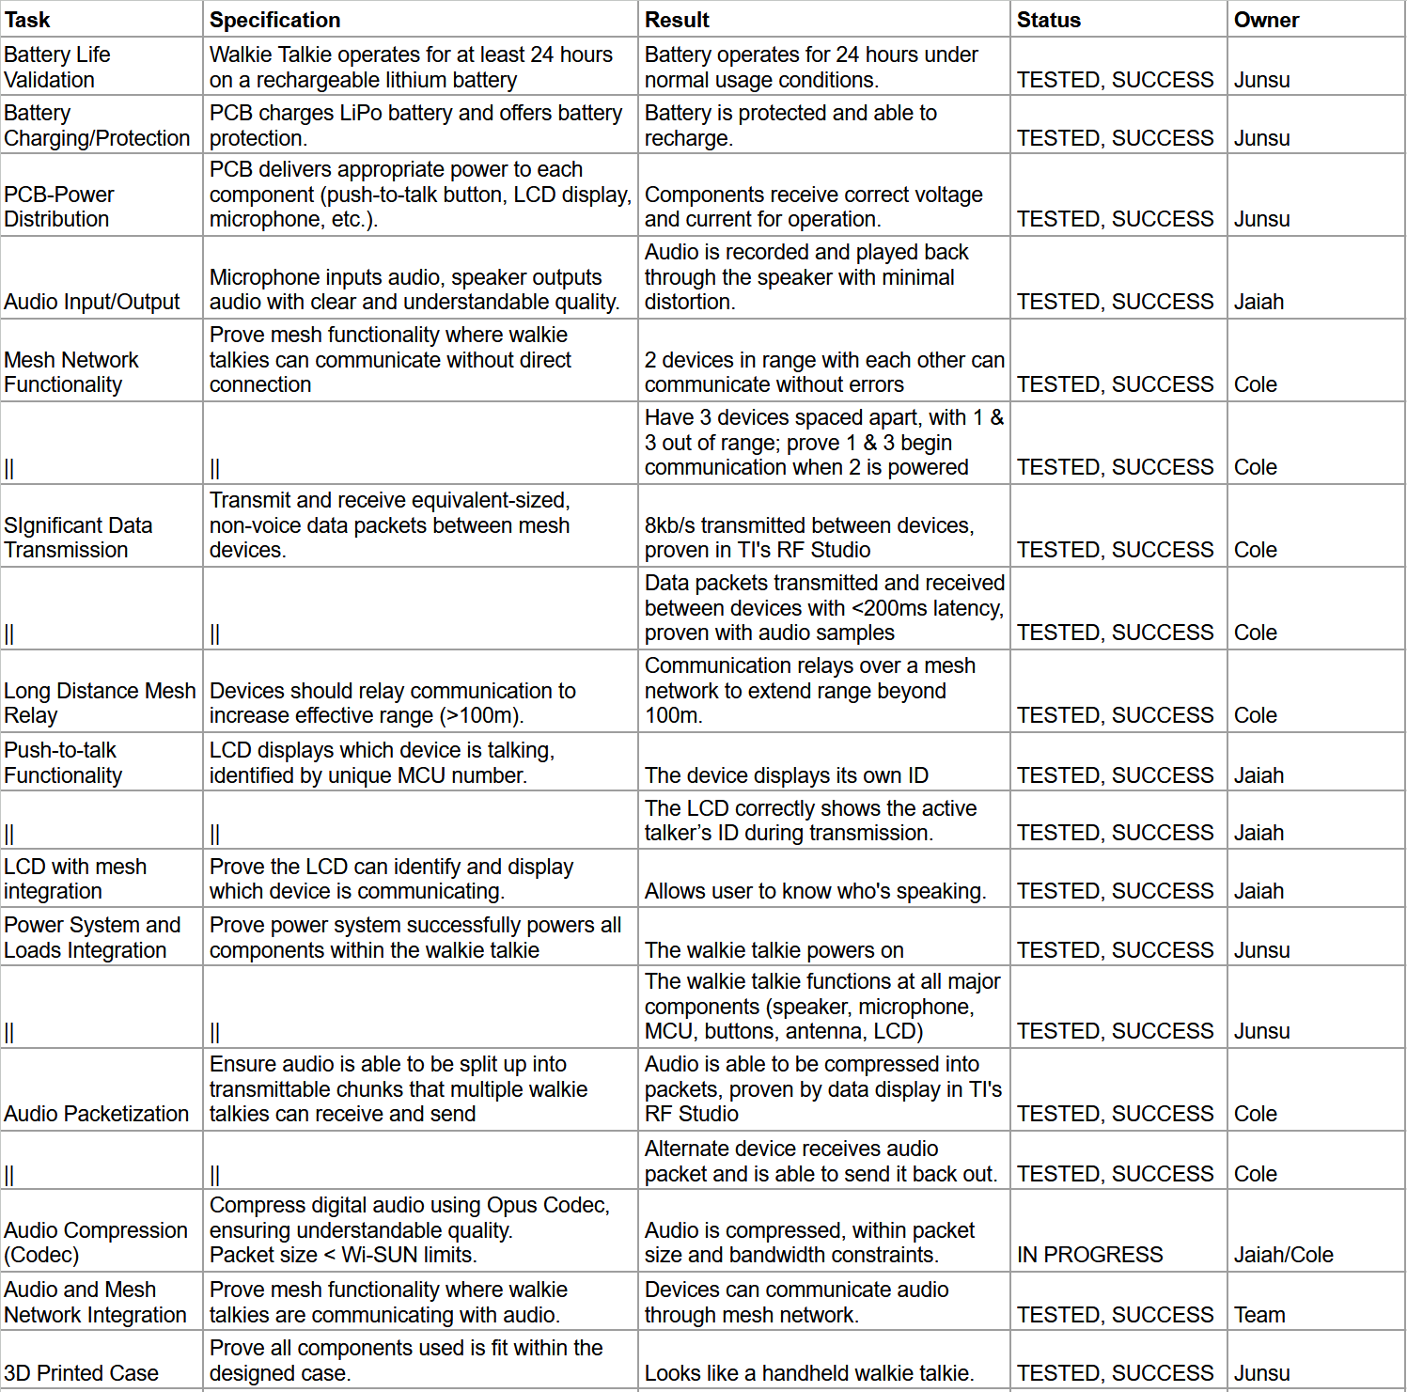Table 1: Detailed Summary of Validation Results.

Critical System Data

2.1 Mesh Networking Data
- Frequency: 915 MHz (sub-1 GHz ISM band)
- PHY Rate: 50 kbps proprietary mode
- Transmission Packet Size: 255 bytes per packet
- Transmission Interval: Every 41ms
- Latency: <200ms (including relays across multiple devices)
- Topology: Ad hoc mesh with echo-based relay and walkie-ID labeling
- Testing Result: Successfully maintained stable packet transmission and reception across 2+ devices during full system demos.

2.2 Audio/User Interface Data
- Microphone Sampling Rate: 8 kHz mono
- Original Audio Bit Depth: 16-bit, targeted 8-bit compressed using ADPCM
- Final Audio Transmission: Transmitted generated tones (constant frequency) due to incomplete compression pipeline
- Push-to-Talk Activation Time: <100ms from button press to transmission start
- LCD Feedback: Updated in real-time to show “Transmitting…”, “Receiving W#”, or "Idle".
- Testing Result: Clear tones were transmitted and played back through the system; future improvements needed for real-time voice streaming.

2.3 Power System Data
- Battery: 3.7V, 2500mAh LiPo
- Voltage Rails:
  - 3.3V for MCU and RF subsystem
  - 5.0V for LCD control interfaces, AUDBOOST, microphone, and amplified speaker
- Charger Output: 1250mA max via USB-C
- System Average Draw:
  - Idle: 41mA
  - Transmitting: 58mA
  - Receiving: 358mA
- Battery Life Validation: Operated successfully for 23.5 hours during combined transmit/idle cycles

Code Analysis
The Mesh Walkie-Talkie project software was developed in C using the TI SimpleLink SDK for the CC1354P10 microcontroller. The code is modular and divided into several key functional blocks: power initialization, I2S audio management, RF transmission and reception, push-to-talk control, and LCD user interface updates.
At system initialization, all hardware peripherals are configured, including GPIO, I2C, RF, I2S, and the external audio codec TLV320AIC3254. GPIO is used to control LED indicators and detect push-to-talk button presses. I2C manages communication with the LCD module and audio codec. RF commands are structured around TI’s RFQueue and RF Driver APIs, enabling efficient packet management and transmission over the sub-1 GHz mesh network. The audio pipeline is configured to sample 16-bit mono audio at an 8 kHz sampling rate via I2S. Incoming audio samples are compressed into an 8-bit format using a lightweight PCM down-sampling algorithm (shifting the sample and adjusting the bias).
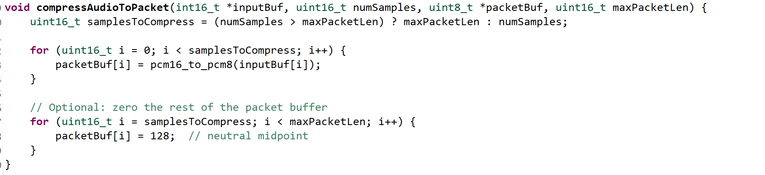
RF transmission operates with a payload size of 255 bytes and an interval of approximately 41 milliseconds, matching the mesh networking requirements for real-time audio packet flow. Packets include a Walkie-ID and sequence number for duplicate detection and node identification. During transmission, the system either sends freshly sampled and compressed microphone data or, if microphone buffers are unavailable, sends neutral-tone packets to maintain timing consistency. On the receiving side, the system checks packet headers to filter out duplicate or self-originated packets, decompresses the audio payload, and queues the data for speaker playback using the I2S interface.
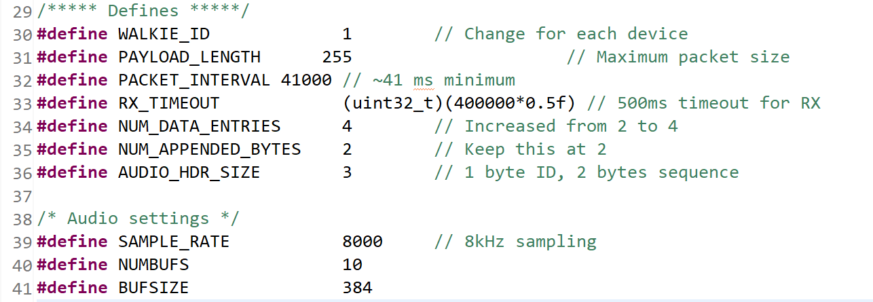
Concurrency is managed carefully. Two semaphores (semDataReadyForTreatment and semErrorCallback) coordinate between the I2S read callbacks and a separate treatment thread that reuses and recycles audio buffers. This threading model ensures that the I2S subsystem can operate without risking buffer underruns or deadlocks during continuous operation. Callback functions for I2S read, write, and error events are lightweight, prioritizing real-time responsiveness over processing in interrupt context.
The LCD user interface is dynamically updated based on system state transitions between idle, transmitting, and receiving. Whenever the system enters a new mode, the LCD is cleared and updated with current status information, such as "Transmitting...", "Receiving W#", or "Push To Talk: Walkie ID #". Push-to-talk functionality is implemented with GPIO interrupts that trigger mode transitions and reset the RF driver as needed to guarantee a clean transmission or reception state.
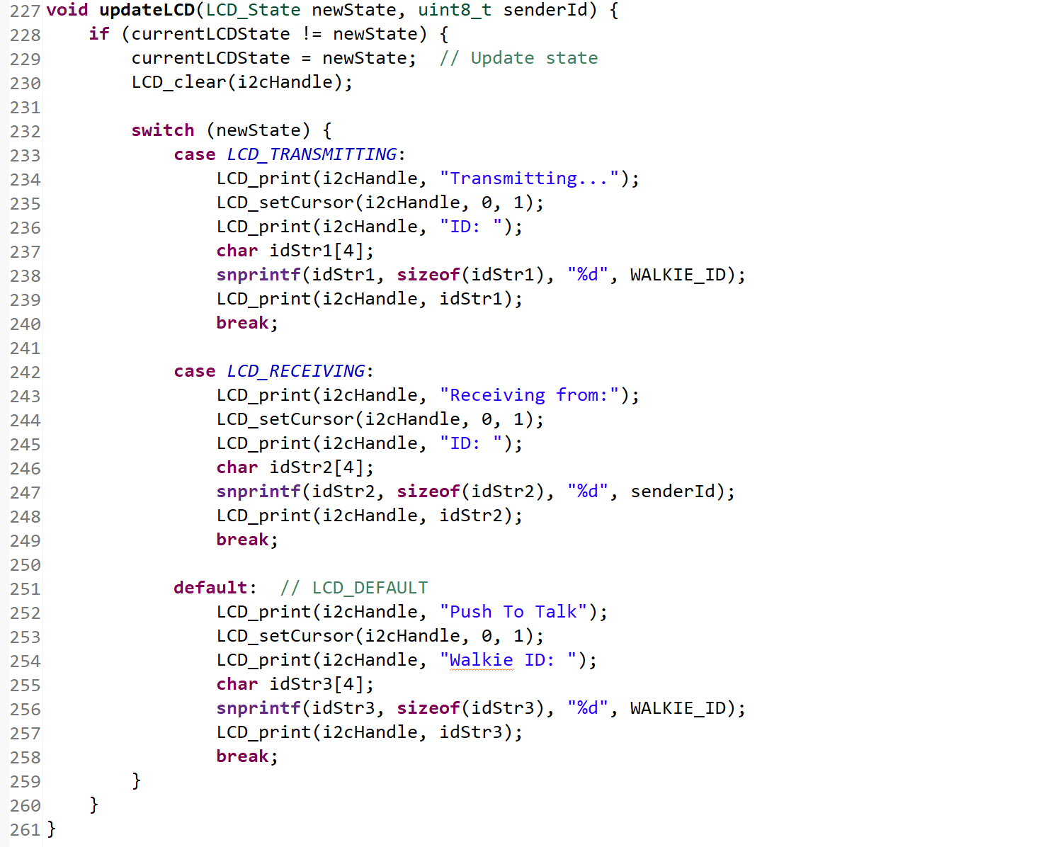
One limitation reflected in the final code is that full real-time voice compression was not achieved. Instead of capturing intelligible speech, the system was validated by transmitting and receiving generated audio tones, representing proof-of-concept communication. Nonetheless, the codebase includes the framework necessary to handle full audio packetization, compression, and transmission, providing a strong starting point for future improvements.
In conclusion, the code structure reflects solid embedded software design principles, balancing modularity, real-time responsiveness, and system-level integration across multiple peripherals. The design successfully demonstrated synchronized audio packet transmission, mesh networking, and user feedback, establishing a scalable foundation for future real-time voice-capable mesh communication systems.

Power System/3D Printed Case Integration
Integrating the power system PCB to all components was as simple as connecting the two boards together. Because all components that are used are all connected through the 3.3V or 5.0V rail on the development board, the integration is only required to send the 3.3V and 5.0V to the development board. The power is connected to the development board through a 20 pin board to board connector. Once the power PCB was connected to the development board, I tested that all components were working as expected. The push to talk button was tested by ensuring that the device goes into transmitting mode when the button is pressed. The microphone and speaker were tested using two devices. When transmitting audio from one device, the other device was able to pick up the audio signal and output the audio signal on the amplified speaker. The LCD was tested by ensuring the LCD dynamically updates during the different modes. The LCD reads “Push to Talk” and “Walkie ID:##” during idle mode and when the push to talk button is pressed the LCD changes to “Transmitting..”. When a device is receiving audio the LCD updates to “Receiving from Walkie:##”. The DPDT power switch was tested by ensuring all components turn off when the slide is in the off position. All in all, every component of the power PCB works as expected when connected to all of the loads.
A 3D printed case was designed to securely enclose all of the components. There are holes at the top face of the case to allow for easier audio flowing in and out of the case. There is also a large rectangular hole properly sized to fit the display of the LCD. There are holes in the side of the case for users to reach the push to talk button as well as the power switch. Lastly, there is a hole at the bottom of the case for users to reach the USB-C port for recharging the battery. The LCD was mounted using bolts, nuts, and washers and the PCBs were mounted using PCB standoffs. The battery was mounted by designing a space that fits the battery perfectly, not allowing it to move around within the case. By the end, all components were mounted and no components came off when shaken.

Conclusion

4.1 Key Decisions
One of the most important decisions made during the project was to transition from TI’s Wi-SUN protocol to TI’s Proprietary Mesh protocol early in development. This decision greatly reduced system complexity, improved packet timing control, and allowed for faster transmission cycles, which were critical for achieving real-time audio relay. Another major decision was the choice to demonstrate tone transmission instead of full speech audio. Given the limitations encountered with real-time compression and buffer handling, this adjustment allowed the project to focus on validating core RF mesh and subsystem integration rather than risking instability with incomplete audio processing. Finally, strict modularity was maintained between subsystems, allowing independent debugging and future system scalability.

4.2 Learnings
The development of the Mesh Walkie-Talkie system revealed several important lessons. Mesh networking, while powerful for extending range, demands precise packet scheduling and error handling to avoid collisions and packet loss as node count increases. Audio compression for real-time communication proved to be much more challenging than initially anticipated, with compression latency, memory use, and processor timing all requiring careful optimization. Additionally, power system design emerged as a critical success factor: seemingly minor inefficiencies in regulation or amplifier current draw could have significantly compromised system lifetime if not addressed early. Overall, the importance of subsystem modularity, timing analysis, and fallback strategies in embedded system design was reinforced throughout the project.

4.3 Future Work
Looking forward, completing the integration of real-time ADPCM or another efficient audio compression scheme remains a primary goal to enable full speech transmission across the mesh network. Additionally, further RF optimization, such as dynamic relay prioritization or packet acknowledgment, could enhance mesh scalability to larger node counts without increasing latency. From a hardware perspective, future iterations should aim to integrate all components into a rugged, weatherproof enclosure suitable for outdoor field testing. Expanding testing scenarios to 5+ node networks and varying topologies will also be critical to fully validate the robustness and utility of the system in real-world applications.

